FS – Traffic Event Sender

Content
1 Introduction 2
2 Function Requirements (Commercial) 2
3 Function Specification (Design Related) 2
3.1 Introduction 2
3.2 Exported Interfaces 2
3.2.1 ITrafficEvent 2
3.2.2 ITrafficEventSender 3
3.2.3 IEventReceiver 3
3.3 Imported Interfaces 3
3.4 Functions 4
3.4.1 Report Traffic Events 4
3.4.2 Available Properties 6
3.4.3 Events 10
3.4.4 Thread Safe 10
3.4.5 Abstract layers and encapsulation 10
4 External Operation Conditions 10
4.1 Configuration 10
4.1.1 General Configuration for RADIUS-MA Usage 10
4.1.2 General Configuration for Email Usage 10
4.1.3 Configuration per Traffic Event Type 11
4.2 Logging 11
5 Capabilities 12
6 References 12
7 Terminology 12

History

Version | Date | Adjustments
PA1 | 2007-08-28 | First version of the document. Original document was found in MAS. (EMAHAGL)

Introduction
This document specifies the function of the Traffic Event Sender component. The Traffic Event Sender can be used by clients to notify that a Traffic Event has occurred. The Traffic Event Sender relays that information to M3 components that are interested in this type of information, e.g. MER or NTF.

Function Requirements (Commercial)
This paragraph is intentionally left blank.

Function Specification (Design Related)

Introduction
Using the Traffic Event Sender, clients can notify M3 components of Traffic Events that have occurred.
The purpose of the Traffic Event Sender is only to relay Traffic Event information to M3 components. Traffic Event information is sent either as an email or using the RADIUS-MA protocol (see [2]).

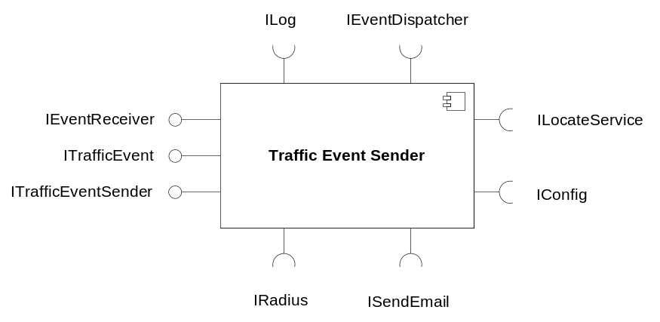
Figure 1 Traffic Event Sender component

Exported Interfaces

ITrafficEvent
This interface is used to create a Traffic Event. Each Traffic Event is uniquely identified by its name. The event name is also used to identify the event configuration.

Methods
ITrafficEvent offers the following methods:
- String getName()
Returns the name defining the type of the Traffic Event.
- Object getProperty(String propertyName)
Returns the specified Traffic Event property.
- void setName(String trafficEventName)
Sets the name of the Traffic Event.
- void setProperty(String propertyName, Object propertyValue)
Sets the specified Traffic Event property to the given value.

ITrafficEventSender
This interface is used to report that a Traffic Event has occurred.

Methods
ITrafficEventSender offers the following methods:
- void reportTrafficEvent(ITrafficEvent trafficEvent)
Sends the Traffic Event to interested parties. How to distribute the Traffic Event is configurable (see 4.1.3.1).
- void reportTrafficEvent(ITrafficEvent trafficEvent, Restrictions restrictions)
Sends the Traffic Event to interested parties. How to distribute the Traffic Event is configurable (see 4.1.3.1). The Restriction parameter is used to list receiving parties that should not receive this Traffic Event, see 3.2.2.2.

Parameter Type Description

Restrictions
The Restrictions parameter is used to control which type of receivers that are not allowed to receive this Traffic Event. With this parameter, the client reporting the Traffic Event can inform Traffic Event Sender that end-users are not allowed to be notified of this Traffic Event. This is used by the Traffic Event Sender to decide on event distribution restrictions, e.g. to avoid sending a specific event as an email.

IEventReceiver
This interface is used to receive events generated by other components. For details in the interface, see [4].

Imported Interfaces
The Traffic Event Sender uses the following external interfaces:
- ILog for logging.
- IConfig for configuration.
- ILocateService for M3 service lookup.
- ISendEmail to send the Traffic Event as an email.
- IRadius to send the Traffic Event over RADIUS-MA.
- IComponentManager to retrieve an instance of another component.
- IEventDispatcher for receiving events, see [4].

Functions

Report Traffic Events
When reporting a Traffic Event, Traffic Event Sender sends the Traffic Event to interested parties using email, RADIUS-MA or both.

Using Email
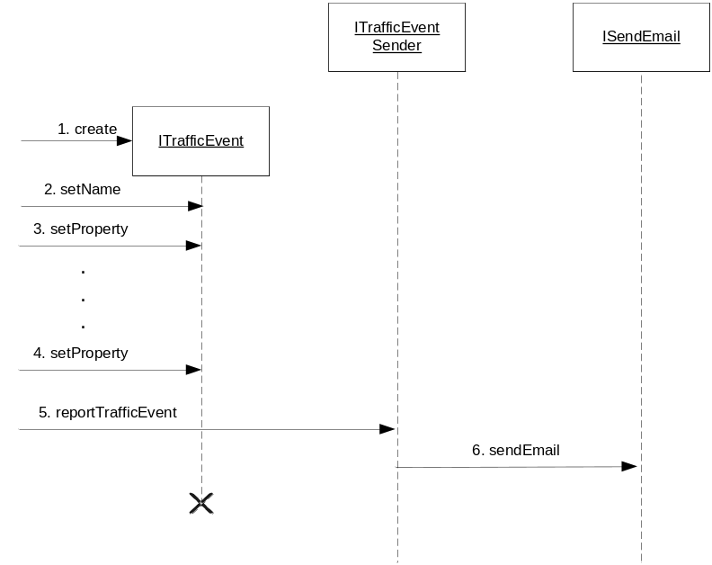
Figure 2 Reporting a Traffic Event using email
Figure 2 exemplifies reporting a Traffic Event that is sent using email:
- A client creates a new Traffic Event.
- The name of the Traffic Event is set by the client.
- Properties of the Traffic Event are set by the client.
- This is done until all properties are set.
- When all the properties have been set, the Traffic Event is reported to the Traffic Event Sender.
- The Traffic Event is sent as an email.
The Traffic Event Sender uses the external interface ISendEmail (see [6]) in order to send the Traffic Event as an email.

Email Host
When the Traffic Event is sent as an email, it is either sent to the preferred host or to a specified host. This depends on the receiver of the event email. If all receivers belong to the same mail host, this specified host is used; otherwise a preferred host is used. If the preferred host is used, the Traffic Event Sender simply lets ISendEmail select a suitable host, see [6]. If a specified host is used, this is submitted to ISendEmail.
If the sending of the email is unsuccessful, this is logged as an error. No retries are performed by the Traffic Event Sender since they have already been performed by the Message Sender.

Buffering of Traffic Events
The Traffic Event Sender can be configured to buffer Traffic Events of the same type before sending them together in one email. The Traffic Events are buffered until a certain amount of messages have been buffered or a certain amount of time has elapsed since the last email was sent. The message limit and time limit are configurable both generally (see 4.1.2) and per Traffic Event type (see 4.1.3.1.1).

Using RADIUS-MA
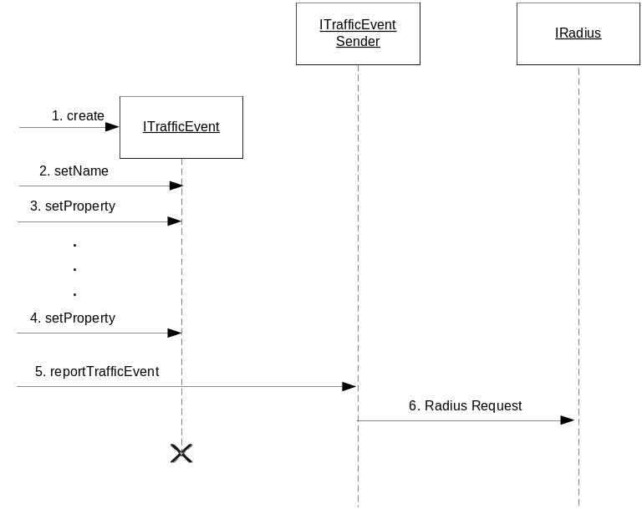
Figure 3 Reporting a Traffic Event using RADIUS-MA
Figure 3 exemplifies reporting a Traffic Event that is sent using RADIUS-MA:
- A client creates a new Traffic Event.
- The name of the Traffic Event is set by the client.
- Properties of the Traffic Event are set by the client.
- This is done until all properties are set.
- When all the properties have been set, the Traffic Event is reported to the Traffic Event Sender.
- The Traffic Event is sent using RADIUS-MA.

Radius Host
The Traffic Event Sender uses the external interface ILocateService (see [5]) to retrieve MER service instance. In case of a MER failure, this is logged as an error and the MER host is reported using the ILocateService interface.

Queuing Traffic Events
When a Traffic Event shall be sent using RADIUS-MA, the Traffic Event Sender uses a “fire-and-forget” mechanism, i.e. the Traffic Event will be put on a queue and the reportTrafficEvent method will return immediately.
The Traffic Events are then popped from the queue in the order they arrived and sent over RADIUS-MA to MER. In case of a RADIUS failure, the event is resent a configurable amount of times, before another MER is tried. This is logged as an error and the failing MER is reported using the ILocateService interface. In case of a MER failure, the Traffic Events are kept in the queue. The RADIUS counter for the failed event is retained. The queue size is configurable (see 4.1.1) and when the queue limit is reached, the received Traffic Event will be dropped.
The queue is not persistent, i.e. all Traffic Events are lost if the Traffic Event Sender is restarted.

Available Properties
The available Traffic Event properties vary depending on if the Traffic Event shall be sent using email or RADIUS-MA.
The event properties are defined in the configuration, see 4.1.1 and 4.1.3.2. Table 1 lists the initially required properties which will be supported and suggests in which situations they would be used; email, RADIUS-MA or both.
Table 1 Initially required properties
Property Name | Type | Used in email | Used in RADIUS-MA | Description
sessionid | String |  | X | Uniquely identifies a session in the system.
username | String | X | X | Identifies a user, e.g. a phone number or an email address
callednumber | String | X | X | The called phone number involved in the Traffic Event.
callingnumber | String | X | X | The calling phone number involved in the Traffic Event.
product | Integer |  | X | Specifies the client product.
operation | Integer |  | X | The type of operation used in the Traffic Event.
messagesize | Integer |  | X | The size of a message or part of a message.  Only of interest if the Traffic Event regards a message.
terminatecause | Integer |  | X | The reason for a Traffic Event indicating failure.  Only of interest if a Traffic Event indicates a failure.
accesstype | Integer | X | X | The type of access into the M3 system.
objecttype | Integer |  | X | The type of object involved in the Traffic Event, e.g. a user or a message.
objectid | String |  | X | The identifier of the object involved in the Traffic Event.
description | String |  | X | A description of the Traffic Event.
messagetype | Integer |  | X | Type of message.  Only of interest if the Traffic Event regards a message.
messageencoding | Integer |  | X | The encoding of the message.  Only of interest if the Traffic Event regards a message.
mailhost | String | X |  | Subscriber’s mail host, see [3].
sender | String | X |  | The phone number of the sender of the message, see [3].
destination | String | X |  | The phone number of a recipient, see [3].
language | String | X |  | The language of the receiver of the message, see [3].
date | Date | X |  | A date and time regarding the Traffic Event, see [3].
action | String | X |  | An action regarding the Traffic Event, see [3].
forwardingnumber | String | X |  | The number that should be used to forward calls to the voice mail system, see [3].
unsetforwards | String | X |  | The forwards that were turned off, see [3].
emailaddress | String | X |  | The receivers email address, see [3].
mediacontent | MediaObject | X |  | A media content, e.g. a voice or video message.
additionalstatistics information | String |  | X | Statistical information, e.g. for CAT.
ownername | String |  | X | See ref. [2].
sssporttype | Integer |  | X | See ref. [2].
accountcurrency | String |  | X | See ref. [2].
accountmoney | String |  | X | See ref. [2].
accounttype | Integer |  | X | See ref. [2].
accountreason | String |  | X | See ref. [2].

Mapping to RADIUS-MA
Table 2 illustrates how the initially required properties are mapped to attributes in RADIUS-MA. The value ranges for the properties are defined in [2]. The indicated default value is used when the property has not been set in the Traffic Event. It is considered a failure if mandatory properties are not set by entities using the Traffic Event Sender.
Table 2 Mapping of required properties to RADIUS-MA attributes
Property Name | Mapped to RADIUS-MA attribute | Required  M=Mandatory, O=Optional, C=Conditional
sessionid | Acct-Multi-Session-Id | O
username | User-Name | O
callednumber | Called-Station-Id | O
callingnumber | Calling-Station-Id | O
product | Product-Tag | O  If not set, the default value 4 (MoIP) will be used.
operation | Event-Type | M
messagesize | Message-Size | C  Mandatory if ObjectType is set to Message.
terminatecause | Terminate-Cause | O
accesstype | SAS-Port-Type | O  If not set, the default value 7 (TUI) will be used.
objecttype | Object-Type | O
objectid | Object-Id | O
description | Event-Description | M
messagetype | Message-Type | C  Mandatory of ObjectType is set to Message.
messageencoding | Message-Encoding | C  Mandatory of ObjectType is set to Message.
additionalstatisticsinformation | Owner-Name | O
ownername | MAE-Owner-Name | O
sssporttype | SSS-Port-Type | O
accountcurrency | MAE-Account-Currency | O
accountmoney | MAE-Account-Money | O
accounttype | MAE-Account-Type | O
accountreason | MAE-Account-Reason | O
Apart from the initially required properties, it is possible to add additional properties using the configuration, see 4.1.3.

Mapping to Email
How Traffic Event properties are mapped to email content is configurable, see 4.1.3.2. This configuration varies between different types of Traffic Events. The email content when notifying NTF of a Traffic Event is described in [3].
In the configuration both the required properties as well as optionally added properties are mapped to email content, e.g. a specific email header.
It is also possible to map Media Objects (see [7]) to an email. It will be added to the email as a MIME part with the Media Object’s corresponding content type as Content-type header. Mapping of Media Objects to RADIUS events is not supported.

Events

Consumed
The Traffic Event Sender registers itself (using IEventDispatcher, see [4]) as a receiver of the following events:
- Configuration has changed (indicates that configuration should be re-read)

Produced
None

Thread Safe
The Traffic Event Sender is thread safe.

Abstract layers and encapsulation
The parts of the component handling the RADIUS communication are encapsulated.

External Operation Conditions

Configuration
The configuration of the Traffic Event Sender is divided into three parts:
- General configuration for the RADIUS-MA usage
- General configuration for the email usage
- Configuration per Traffic Event type

General Configuration for RADIUS-MA Usage
The following is configurable for usage of the RADIUS-MA protocol:
- Globally unique instance name
- Vendor information
- Size of the Traffic Event queue
- Mapping of Traffic Event properties to RADIUS-MA
- Service name to use in the ILocateService interface

General Configuration for Email Usage
The following is configurable for email usage:
- Receivers email address
- Maximum number of Traffic Events in buffered email
- Maximum amount of time to wait before sending a buffered email
The above attributes are also configurable per Traffic Event type. The general values are used as default if not specified for a specific Traffic Event type.

Configuration per Traffic Event Type
Each Traffic Event that shall be possible to report must be configured. The type of the Traffic Event is given by its name. For each Traffic Event type the following is configured:
- The name (used to identify the Traffic Event type)
- A number of configuration parameters (described below)
- Mapping of Traffic Event properties to email (only if the Traffic Event shall be sent using email)
- If the Traffic Event should be transmitted, i.e. it is possible to suppress sending of certain events.

Traffic Event Distribution Type
It is configurable per Traffic Event type if the Traffic Event should be sent using email, RADIUS-MA or both.

Email
The following is configurable per Traffic Event type if it shall be sent using email:
- If preferred storage or a specific storage should be used (as described in 3.4.1.1.1)
- Whether or not the Traffic Events should be buffered before sent
- Maximum number of Traffic Events in a buffered email
- Maximum amount of time to wait before sending a buffered email
- Receivers mail address

Mapping of Traffic Event Properties
The available Traffic Event properties and how they are mapped to an email and to the RADIUS-MA protocol are configurable in the Traffic Event Sender. For email, this mapping is done per Traffic Event type. For the RADIUS-MA protocol, this mapping is done once, see 4.1.1.
How to configure the mapping of properties to email content depends on the receiver of the email. For example, for emails sent to NTF the content of the email is described in [3].
To allow for easier configuration, it shall be possible to use templates for events sent as email.

Logging
- Host errors are logged using the IHostedServiceLogger interface, see [8].
- All calls to interface methods are logged at info level. Method name and parameter values are logged. At return returned value is logged.

Capabilities
This paragraph is intentionally left blank.

References
- IWD – Extensible Messaging Protocol
2/155 19-1/HDB 101 02 Uen
- IWD – RADIUS MA
6/155 19-CRH 109 089 Uen
- IWD – Requesting NTF Services
5/155 19-CRH 109 127 Uen
- FS – Execution Engine
3/FS-MAS0001 Uen
- FS – External Component Register
6/FS-CRH 109 581-1 Uen
- FS – Message Sender
5/FS-CRH 109 581-1 Uen
- FS Media Object
8/FS-CRH 109 581-1 Uen
- FS Log Manager
2/FS-CRH 109 581-1 Uen

Terminology
MER Message Event Repository
NTF Notification Component

