Component Description –MAS

Content

1 Introduction 2
2 Requirements 2
3 Functions 2
3.1 Application Execution 2
3.2 Access to System services 3
3.3 Management Information Base (MIB) 3
3.3.1 Supervision 3
3.3.2 Operation 4
3.4 Call monitor 4
3.4.1 Current calls 4
3.4.2 Call Statistics 4
3.5 Application and Media Content Package builder 4
4 Architecture 5
5 Delivery Object(-s) 5
6 Design Object(-s) 5
6.1 Service Enablers 6
6.1.1 Call Manager 6
6.1.2 Service Request Manager 6
6.1.3 Stream 6
6.2 Execution platform 7
6.2.1 Execution Engine 7
6.2.2 Media Content Manager 7
6.2.3 Media Object 7
6.2.4 Media Translation Manager 7
6.3 Business Objects 7
6.3.1 External Component Register 7
6.3.2 Mailbox 7
6.3.3 Message Sender 7
6.3.4 Number Analyses 7
6.3.5 Profile Manager 7
6.3.6 Provisioning Manager 7
6.3.7 Traffic Event Sender 7
6.3.8 Charging Account Manager 8
6.4 Basic Services 8
6.4.1 Configuration Manager 8
6.4.2 O&M Manager 8
6.4.3 Log Manager 8
7 Capabilities 8
8 Third-Party Products and external interfaces 8
8.1 Third-Party Products and Freeware 8
8.2 External Products 12
8.3 External Protocols 12
9 References 12
10 Terminology 12

History

Version | Date | Adjustments
A | 2006-10-11 | First revision. (ERMTERI)
B | 2006-12-04 | Minor changes. Updated 3PP table (ERMKESE)
C | 2007-06-18 | Minor changes. Updated 3PP table (ermkese)
D | 2008-02-03 | Minor changes. Updated 3PP table (emahagl). Added info about Charging Account Manager.

Introduction
This document describes the Media Access Server (MAS) component. MAS is used to execute CCXML/VoiceXML Applications accessed using SIP and XMP.

Requirements
The following requirements have been identified on the MAS component
- Execute VoiceXML documents according to VoiceXML 2.1
- Execute CCXML documents according to CCXML 1.0 2004-04-30
- Concurrently handle voice and video calls.
- Offer a SIP interface for service initiation
- Offer an XMP interface for service initiation
- Offer the Application access to various services in the System

Functions

Application Execution
MAS basic functionality is to execute Voice and Video Applications implemented in one or several CCXML and VocieXML documents.
A CCXML document defines the Call Control e.g. creation, answering calls.
A VoiceXML document drives the dialog towards the caller e.g. playing prompts, interpret DTMF entered by the caller, record messages etc.
Normally the VoiceXML and CCXML documents are compiled when MAS starts, but external documents may be retrieved and compiled at request time.
A MAS without an Application cannot handle any calls at all, not even answer a call. In order to do so an Application package and possibly one or several related Media Content packages has to be installed on top of MAS.
Application execution is initiated in one of two ways:
- A received telephony call via SIP
- A received Service Request via XMP (ref. [1] )
When execution starts, a CCXML document is loaded and executed. Possibly the CCXML document may start a VoiceXML dialog either direct or after it has created an outbound call. Then, MAS executes the VoiceXML document indicated in the start of the dialog. The initial VoiceXML document then may refer to other precompiled or external VoiceXML documents.
Because of the characteristics of VoiceXML MAS also offers Text to Speech and Automatic Speech Recognition services through external interfaces to such engines.

Access to System services
MAS publish an interface, Platform Access, used to access various services in the System framework.
The following services are available through this interface:
- User register in order to retrieve and set subscriber profiles
- Provisioning in order to create and delete subscribers
- Storage in order to manage a subscribers mailbox
- SMTPStorage in order to send messages to subscribers in the system or external subscribers.
- Event reporting in order to send traffic events to the event repository
- Service Requests in order to receive or send requests from services defined in the XMP spec.

Management Information Base (MIB)
MAS publish a Management Information Base (MIB) accessible through SNMP.

Supervision
The MIB contains the following supervision information.
- General information such as component name, installation date etc.
- Status such as operation state, uptime etc.
- Provided Services such as number of current call, peak calls, if the service is operational etc.

Operation
The MIB also contains entries for operating the MAS. Using SNMP, an operator can set the administrative state (locked/unlocked/shutdown) and issue a reload of the MAS configuration.

Call monitor

Current calls
MAS include a Call monitor which is used in run-time to monitor active calls. The tool has a textual interface.
When used, the tool presents information about involved telephone numbers, call initiator, call state etc for each current call.

Call Statistics
The tool also provides statistical information about number of historical calls (accumulated calls, peak calls etc.).

Application and Media Content Package builder
When an Application package or a Media Content Package is needed Appliction and Media Content Package builder is used.
For Application Package creation the builder takes a set of CCXML and VoiceXML documents and creates a MAS installable package.
For Media Content Package creation the builder takes a set of media definition files and the media files themselfes and creates a MAS installable package.
This process is described in detail MAS Customization Guide.

Architecture
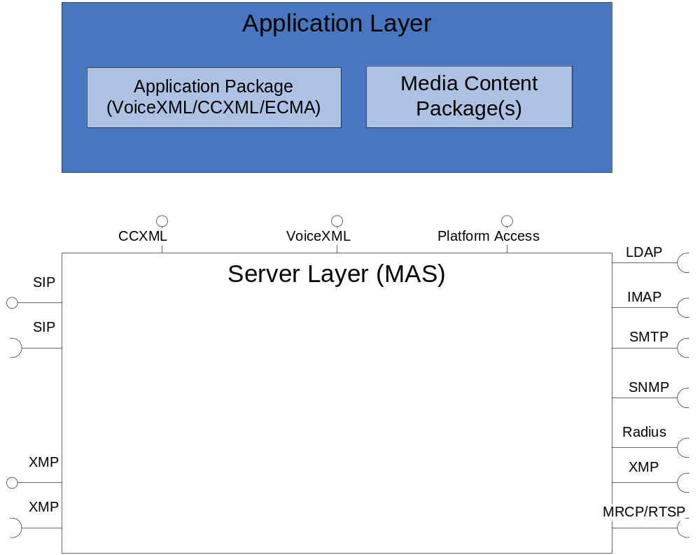
Figure 1 MAS environment and architecture
The figure above shows the MAS external interfaces and the basic architecture with Application and Media Content packages.
Note that for the SIP and XMP interfaces MAS plays the role both as a server and as a client.

Delivery Object(-s)
MAS include the following delivery objects:
- MAS component, used for Application execution
- Application and Media Content builder used for Application and Media Content Package creation.

Design Object(-s)
The internal architecture is shown in Figure 2.
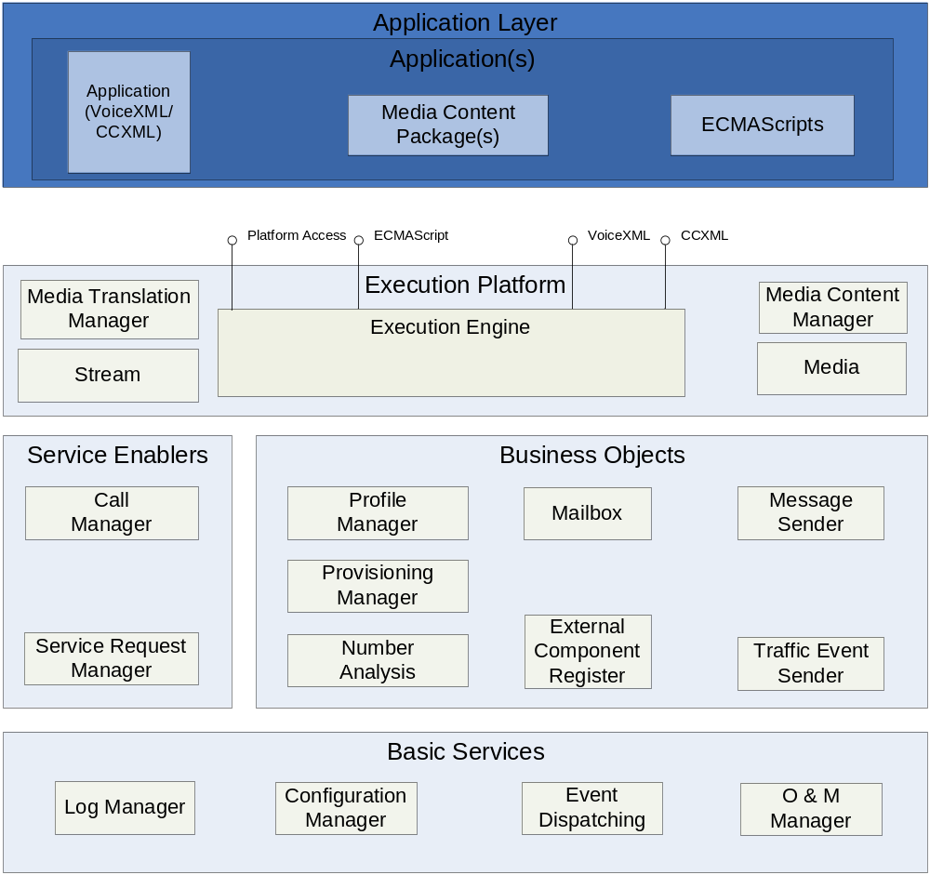
Figure 2 Internal architecture

Below follows a brief description of each design objects. For details see ref. [2]

Service Enablers
The Service Enablers are used to initiate Application execution.

Call Manager
Handles the SIP interface

Service Request Manager
Handles the inbound and outbound XMP interface

Stream
Handles the RTP interface

Execution platform
The Execution platform is used to execute Applications written in VoiceXML/CCXML and Platform Access requests.

Execution Engine
Handles application execution i.e. CCXML and VoiceXML applications. Is also the main part of MAS that takes care of the startup procedure.

Media Content Manager
Handles Media Content Packages.

Media Object
Is an internal representation of different media such as WAV-, MOV- and text-files etc.

Media Translation Manager
Handles the interfaces for media translation i.e. Text to Speech and Automatic Speech Recognition.

Business Objects
The Business Objects are used to access business related information in the System such as user register information and end user messages.

External Component Register
Handles the interface to the Component Register.

Mailbox
Handles the interface to Message Store e.g. to access a subscribers messages.

Message Sender
Handles sending of messages to Message Store.

Number Analyses
Handles number analyses.

Profile Manager
Handles the interface to the User Register to retrieve a subscriber’s profile.

Provisioning Manager
Handles the interface to CAI in order to create subscriptions in the system.

Traffic Event Sender
Handles traffic events and send those to the Event Repository and to Notification.

Charging Account Manager
This component is used to handle the access to an Account Information and Refill server (AIR).

Basic Services
Basic Services are used for common functionality of a System component, hence could be used in any such.

Configuration Manager
Handles all configuration which is XML based.

O&M Manager
Handles MIB and perform self diagnostics.

Log Manager
Handles the internal log facilities.

Capabilities
MAS can handle one Application at a time but as many Media Content Packages as allowed by the hardware resources used i.e. amount of physical memory.
MAS is able to concurrently execute a number of service requests initiated either from SIP or XMP. The amount of concurrent service requests possible to execute is defined during load tests with a well defined traffic scenarios. This is done with each hardware used.

Third-Party Products and external interfaces

Third-Party Products and Freeware

Product name | Product version | Company | Licence | Delivered with the component / Used in | ECCN US/EU | Product No. and R-state
Rhino | 1.6R2 | The mozilla project | MPL | Yes / Execution Engine | EAR99 | SWF0055R1A
Used for execution of ECMA script.
XML-RPC | 3.1 | Apache Software Foundation. | Apache | Yes / OM Manager / Charging Account Manager | EAR99 | SWF0056R1A
Used for XMLRPC communication

The Java Curses Library | 4-Beta | sf.net/projects/javacurses | LGPL | Yes / OM Manager | EAR99 | SWF0057R1A
Used as terminal based windowing toolkit for UNIX.
Dom4j | 1.6.1 | Apache Software Foundation. | Apache | Yes / Execution Engine, Configuration Manager | EAR99 / 0 | SWF0051R1A
Used for VoiceXML and CCXML parsing.
Log4j | 1.2.9 | Apache Software Foundation. | Apache | Yes / All | EAR99 / 0 | SWF0003R2A
Used for logging facilities for MAS.
Commons-Collections | 3.1 | Apache Software Foundation. | Apache | Yes / Config Manager | EAR99 / 0 | SWF0053R1A
Used for improved collections.
Emanate JSADK | 16.0.1.61 | SNMP Research | Commercial | Yes / Operate and Maintain Manager | EAR99 / 0 | SWT0031R1A
SNMP Subagent.
log4cxx | 0.9.7 | Apache | Apache | Yes / Stream | EAR99/0 | N/A
Used for logging in C++.
ShiftOne Java Object Cache | 2.0b | ShiftOne | LGPL | Yes / Media Content Manager | EAR99 / 0 | SWF0052R1A
Used to cache Media Objects.
FoundationJava XMP | P1A_05 | (Internal) |  | Yes / Service Req Manager | EAR99 / 0 | SWF0059R1A
XMP server and client implementation.
GNU ccRTP | 1.3.6 | www.GNU.org |  | Yes / Stream | EAR99 / 0 | SWF0061R1A
Used for handling the RTP protocol.
GNU Common CPP Framework | 1.3.22 | www.GNU.org |  | Yes / Stream | EAR99 / 0 | SWF0062R1A
Required by GNU ccRTP.
Expect | 5.40 | Sun |  | Yes / Stream | EAR99 / 0 | SWF0063R1A
Used for Self Diagnostics.
SUN Javamail API | 1.4 | Sun Microsystems, inc |  | Yes / Profile Manager, Mailbox and Message Sender | 5D002 / 5D002.c1 | SWF0004R1C
Retrieving e-mail with IMAP, parsing and composing Mime formatted messages.
Jakarta Commons Net | 1.4.1 | Apache Software Foundation | Apache | Yes / Message Sender | EAR99 / 0 | SWF0066R1A
Sending Mime messages with SMTP
XML Beans | 2.1.0 | Apache Software Foundation | Apache | Yes / Call Manager | EAR99 / 0 | SWF0033R2A
Generation and parsing of media control XML documents in SIP messages.
Spring | 1.2.7 | Spring Framework | License | Yes / Execution Engine, External Component Register | EAR99 / 0 | SWF0060R1A
Dynamic resolution of class dependencies.
Velocity, velocity-1.4.jar | 1.4 | Apache Software Foundation |  | Yes / Traffic Event Sender | EAR99 / 0 | SWF0064R1A
Creating emails for requesting NTF services.
Xpp | 3-1.1.4c | Indiana university |  | Yes / Execution Engine | EAR99 / 0 | SWF0070R1A
Pull parser for parsing XML files.
NIST-SIP | 1.2 | National Institute of Standards and Technology | Public domain (Not copyrighted) | Yes / Call Manager | EAR99 / 0 | SWF0054R1A
SIP stack
Java 2 Platform, Standard Edition (J2SE) | 1.5 | Sun Microsystems, inc. |  | No / All | 5D992 / 5D992.b.1 | SWT0032R1A
Used both in development and runtime, but MAS assume a Java environment already exists on the host.
JavaBeans Activation Framework | 1.0.2 | Sun Microsystems inc. | License | Yes / Execution Engine, Mailbox, Message Sender, Profile Manager | 5D002 / 5D002.c1 | SWF0007R1A
Mimetype handling, needed by Javamail

External Products

Product Name | Company | Used for | Version of the integration tested product
Radvision Gateway | Radvision | Gateway for video calls | GW N-30  SW-Version 2.5.0.21

External Protocols

Product Name | Specification | Used for | Version of the protocol
SIP | IWD-SIP | SIP access | RFC 3261

References
- IWD-XMP
2/155 19-1/HDB 101 02
- FD-MAS
1/FD-MAS0001

Terminology
Application Package A set of VoiceXML and CCXML documents together with its configuration files.
MAS Media Access Server
Media Content Package A set of media files and their corresponding definition files. One Media Content Package characteristic is e.g. language, media encoding, purpose etc.

