FD – Call Manager

Content
1 Introduction 3
1.1 Glossary 3
1.1.1 External Client 3
1.1.2 Dialog/Call 3
1.1.3 Re-INVITE 3
1.1.4 SIP layers 3
1.1.5 Transaction 4
2 Function Structure 5
2.1 Overview 5
2.1.1 SIP stack 6
2.1.2 SDP stack 6
2.1.3 SIP stack handling 6
2.1.4 SDP stack handling 7
2.1.5 Call Manager Core 7
2.1.6 SSP registration 8
2.1.7 Notification 8
2.1.8 Call handling 9
2.1.9 Statistics 9
2.1.10 Configuration 9
3 Function Behavior 10
3.1 O&M administration 10
3.1.1 Administrative state machine 10
3.2 Load regulation 13
3.2.1 Load regulation state machine 13
3.2.2 Load regulation during startup 14
3.3 SSP registration 15
3.3.1 Registration state machine 16
3.3.2 Registration dispatching 17
3.4 Notification 17
3.4.1 Notification dispatching 18
3.5 Call handling 18
3.5.1 Inbound call state machine 18
3.5.2 Outbound call state machine 35
3.5.3 Call dispatching 50
3.6 SIP message reception 50
3.7 SIP stack configuration 52
3.8 Statistics calculation 53
3.9 Threads and event queues 54
3.10 Configuration 55
3.11 Reliable provisional responses 55
3.11.1 Inbound calls 55
3.11.2 Outbound calls 55
4 Third-Party Products and external interfaces 56
4.1 Third-Party Products and Freeware 56
4.2 External Products 56
4.3 External Protocols 56
5 References 56
6 Terminology 57

History

Version | Date | Adjustments
A | 2006-10-03 | First reversion. (MMAWI)
B | 2006-12-07 | Updated disconnect event for:  - inbound call states: Alerting-New Call, Alerting-Accepting and Alerting-Early Media.  - outbound call states: Progressing-Calling, Progressing-Proceeding and Progressing-Early Media. (MANDE)  Updated join/unjoin handling.  The following items were updated:  - Table 7, 8, 18, 31, 32, 39, 42  - Figure 7, 8  - Text in sections 3.4.1.3 and 3.4.2.3  Removed the following sections:  - 3.4.1.3.4 Transfer state  - 3.4.2.3.4 Transfer state (MMANY)  Updated administrative states in section 3.1 and statistics in section 3.8. (MMAWI)
C | 2007-06-13 | CallManager no longer waits a short time after “close(unforced)” before unregistering from SSP; now unregistering is done immediately. Administrative state machine in section Administrative state machine3.1.1 updated (ERMKESE).  Updated with:  - unsolicited SIP NOTIFY  - 100rel  - Change in response to SIP OPTIONS  (MMANY)
D | 2008-08-05 | Minor changes. Updated load regulation section. (ekensel)

Introduction
This document describes the Call Manager functions in detail. The Call Manager functions are specified in [1]. The Call Manager implements a user agent SIP interface as specified in [2].
The Call Manager component is from now on referred to as CM.

Glossary

External Client
An external client is a client (e.g. a SIP user agent) that communicates with CM over SIP.

Dialog/Call
Dialog is a term defined in the SIP standard (see [6]).
A session is a peer-to-peer SIP relationship between two user agents that persists for some time. A session is a collection of participants, and streams of media between them, for the purpose of communication. A session is established using the SIP INVITE message, resulting in one or more SIP dialogs (see [6]). A dialog is communication between two parties. Since multicast conferencing is not supported currently one session consists of one single dialog only.
In this document, a dialog is synonym to a call.

Re-INVITE
A re-INVITE is a SIP INVITE request that addresses an already existing dialog, i.e. this is not an INVITE to setup a new dialog but to change the existing dialog.
The handling of INVITE versus a re-INVITE has been separated in this document.

SIP layers
SIP is structured as a layered protocol, which means that its behavior is described in terms of a set of fairly independent processing stages with only a loose coupling between each stage. The layers are defined in [6] and are illustrated in the figure below.
Syntax and encoding
Transport
Transaction
Transaction user
1st layer
2nd layer
3rd layer
4th layer
Figure 1 The four SIP layers
The layers are used in the document to illustrate where specific parts of the SIP specification are implemented in the Call Manager.

Transaction
Transaction is a term defined in the SIP standard (see [6]).
A transaction identifies an ongoing message exchange between two parties. On the client side of the message exchange, there is a client transaction and vice versa for the server side of the message exchange.

Function Structure

Overview
The overall structure of CM is illustrated in the figure below. The dotted arrow in the figure illustrates normal SIP message flow through CM.
Call Manager Core
SIP
stack,
SDP
stack
Message dispatcher
SIP/
SDP
Call
Manager
SIP Stack Handling
SDP Stack Handling
Configuration
Statistics
Controller
FSA
Load Regulator
Event Queue
SSP
Instance
FSA
Event Queue
Registration
Dispatcher
Call
Dispatcher
Call Handling
SSP Registration
Call
FSA
Event Queue
Inbound
Call,
Outbound Call
Outbound
Notification
Event Queue
Notification
Notification
Dispatcher
Figure 2 Structure of the Call Manager component
CM also consists of functionality for diagnosing the service enabled by CM. This functionality is completely separated from the other CM functionality in order to not affect normal CM behavior. The structure of the diagnose service functionality is illustrated below.
SIP Stack
SIP
DiagnoseService
Diagnose Service
SIP Stack Handling
CM Diagnose Service
Figure 3 Structure of the diagnose service part of CM

SIP stack
The SIP Stack is responsible for sending/receiving SIP messages over the SIP interface. It parses messages and maintains transaction state.
NIST-SIP is a third-party product (see [3]) that is used as the SIP stack. The NIST-SIP version used is 1.2. The interface towards NIST-SIP is the standardized JAIN SIP API (see [4]).
The SIP stack implements the SIP layers one to three, i.e. up and including the transaction layer. The SIP stack is also able to implement part of the forth layer (Transaction User) since it is possible to configure it to handle retransmissions. When used in CM, retransmissions in the SIP stack is activated as described in section 3.7
The SIP stack code is found in the jain_sip vob and the version used by CM is built and checked in as jar files in the mas vob.

SDP stack
The SDP Stack is responsible for parsing and generating SDP descriptions.
NIST-SDP is an extension to NIST-SIP (see [3]) that is used as the SDP stack. The interface towards NIST-SDP is implemented in-house and is not standardized. It is however constructed similar to a known example standard called JAIN SDP API (see [5]) in order to be easily exchangeable if JAIN SDP API ever becomes an open standard.
The SDP stack code is found in the jain_sip vob and the version used by CM is built and checked in as jar files in the mas vob.

SIP stack handling
The purpose of the SIP stack handling is to concentrate the use of the SIP stack into one part of CM in order to more easily be able to exchange the SIP stack to another (not using the JAIN SIP API).
There are parts of the implementation in the SIP stack handling that uses code directly from the SIP stack implementation rather than its interface. The implementation has been done this way in order save time and avoid re-implementing code already supported by the stack (although not through the interface). This kind of implementation should normally be avoided, and must be replaced if the SIP stack ever changes its implementation or if the stack is replaced with another product. It is however limited to a very small part of CM.
The SIP stack handling code is found in the package:
- com.mobeon.masp.callmanager.sip

SDP stack handling
The purpose of the SDP stack handling is to concentrate the use of the SDP stack into one part of CM in order to more easily be able to exchange the SDP stack to another.
The SDP stack handling code is found in the package:
- com.mobeon.masp.callmanager.sdp

Call Manager Core
The core is responsible for overall management of CM. It exports the Call Manager interface that is used to create outbound calls, and join/unjoin two calls. The core is also responsible for keeping track of the administrative state and current load situation in order to redirect or reject calls when the situation requires.
The core mainly consists of a controller and multiple message dispatchers.
The code for the CM core is found in the packages:
- com.mobeon.masp.callmanager
- com.mobeon.masp.callmanager.events
- com.mobeon.masp.callmanager.states
- com.mobeon.masp.callmanager.loadregulation
The CM core implements the forth SIP layer; “transaction user”.

Controller
The main purpose if the controller is to keep track of the CM status with regards to administrative state and load situation and handle all incoming events as the current status requires.
All incoming events (received either over SIP or using the CallManager interface) are queued in the controllers’ event queue. From the event queue, one event at a time is handled in the order they arrived. The controller keeps a state machine for the administrative state (see section 3.1) and has a load regulator that keeps a state machine for the current load situation (see section 3.2).
An event is mainly handled either by sending it directly to the corresponding call or SSP instance (if such exists) using message dispatchers or by injecting it to the administrative state FSA (to determine how it should be handled).
The controller is responsible for creating new inbound/outbound calls and outbound notifications when the current CM status allows.

Message dispatcher
The message dispatchers are used to dispatch incoming SIP messages. Three message dispatchers exist:
- SIP request dispatcher
- SIP response dispatcher
- SIP timeout dispatcher
Depending on the SIP procedure (INVITE, REGISTER or other) the message is either dispatched to a call (using the call dispatcher), an SSP instance (using the registration dispatcher) or handled out-of-dialog. An out-of-dialog INVITE will result in a new call being created by the CM controller if the current status allows.

SSP registration
The SSP registration part of CM is responsible for registering to each configured SSP. This part mainly consists of a registration dispatcher and one SSP instance for each configured SSP.
The code for the SSP registration is found in the package:
- com.mobeon.masp.callmanager.registration

Registration dispatcher
The registration dispatcher is responsible for dispatching an incoming SIP message to the corresponding registration procedure for a specific SSP instance. How the dispatching is done is further described in section 3.3.2.

SSP instance
The SSP instance is responsible for the registration procedure for one specific SSP.
The SSP instance consists of an event queue and a state machine containing the current registration state. Incoming events are queued in the event queue and then handled one at a time in the order they arrived. An incoming event could either be a received SIP message belonging to a REGISTER procedure, or a request to initiate register/unregister coming from the CM controller, see usage in section 3.1. When handling an event it is injected to the state machine and the resulting action depends on the state as described in section 3.3.

Notification
The notification part of CM is responsible for sending out unsolicited SIP NOTIFY requests when requested over the CallManager interface. This part mainly consists of a notification dispatcher and one Outbound Notification instance for each ongoing notification.

Notification dispatcher
The notification dispatcher is responsible for dispatching an incoming SIP message to the corresponding ongoing outbound notification. How the dispatching is done is further described in section 3.4.1.

Outbound notification
Each requested unsolicited NOTIFY is represented by an outbound notification.
The outbound notification is responsible for sending the SIP NOTIFY request. The outbound notification also consists of an event queue where incoming events are queued and then handled one at a time in the order they arrived. An incoming event could either be a response to the SIP NOTIFY procedure or an indication that a timeout occurred when sending the NOTIFY request.

Call handling
The call handling part of CM is responsible for call management. This part mainly consists of a call dispatcher and one inbound or outbound call for each active call.
The code for the call handling is found in the package:
- com.mobeon.masp.callmanager.callhandling

Call dispatcher
The call dispatcher is responsible for dispatching an incoming SIP message to the corresponding call. How the dispatching is done is further described in section 3.5.3.

Call
A call represents one active SIP dialog. A call can be one of two types; inbound or outbound. The call provides the InboundCall and OutboundCall interfaces.
The call consists of an event queue and a state machine containing the current call state. Incoming events are queued in the event queue and then handled one at a time in the order they arrived. An incoming event could either be a SIP INVITE, a SIP message received within dialog, a close request from the CM controller or a request from the provided interface.
When handling an event it is injected to the state machine and the resulting action depends on the state as described in section 3.5.1 for an inbound call and in section 3.5.2 for an outbound call.
The call is also a container for all call specific information, e.g. the calling party of a call.

Statistics
CM collects statistics as specified in [1]. The details on how statistics are calculated can be found in section 3.7.
The code for the statistics is found in the package:
- com.mobeon.masp.callmanager.statistics

Configuration
The configuration of CM is handled by a configuration reader and a configuration container. The details on how configuration is handled can be found in section 3.10.
The code for the configuration handling is found in the package:
- com.mobeon.masp.callmanager.configuration

Function Behavior

O&M administration
CM implements the ServiceEnabler interface (as specified in [1]) for O&M administration. A state machine is used to keep track of the administrative state.

Administrative state machine
This section describes the state machine for the administrative state of CM.

States
The table below lists the states that exist for the administrative state machine.
Table 1 States in administrative state machine
State | Description
Closed | In the Closed state a previous forced close or unforced close request by O&M has completed and all calls have terminated. No new calls are accepted by CM.
ClosedForcing | In the ClosingForced state CM has been requested to force close by O&M. For CM this implies immediately terminating all active calls and not accepting any new calls. As soon as all calls have terminated a transition is made to the Closed state.
ClosingUnforcedRejecting | In the ClosingUnforcedRejecting state CM has been requested to unforce close by O&M. For CM this implies unregistering from all SSPs and not accepting new calls. Currently active calls to keep running until terminated by end-user.
Opened | In the Opened state CM are able to accept traffic from an O&M point of view. However, the load situation may still affect the ability to accept new calls as described in section 3.2.

Events
The table below lists the events that exist for the administrative state machine.
Table 2 Events in administrative state machine
Event | Description
closeForced | O&M has requested CM to force close.
open | O&M has requested CM to open.
closeUnforced | O&M has requested CM to unforce close.
addInboundCall | A session creating SIP INVITE has been received by CM.
checkCallAction | A SIP OPTIONS request has been received by CM. The response to a SIP OPTIONS request should (according to specification) reflect how a SIP INVITE request would be handled. The purpose of this event is therefore to check what would happen if an inbound call where to be added but without actually performing the changes done for the addInboundCall event.  According to specifications, a SIP OPTIONS request should be responded in the same way as for a SIP INVITE. However, CM responds to SIP INVITE and OPTIONS requests in the following way:  - A SIP INVITE will be accepted until max load has been reached.  - A SIP OPTIONS request will be rejected as soon as high water mark has been reached.  The above is not entirely according to specification since the specification states that the response to a SIP OPTIONS request should be the same had it been a SIP INVITE request. However, the reason for not following the specification in this situation is to be able to send out an early warning that the system is experiencing high load.
addOutboundCall | A request to create a new outbound call has been received by CM over the CallManager interface.
removeCall | A call has completed execution due to for example hang up or failure and requests to be removed. This event is the only one not initiated by events over external interfaces such as SIP or CallManager. This event is needed by the administrative FSA to be able to control load regulation and SSP registration.
updateThreshold | O&M has requested to update the threshold used during load regulation.

FSA
The complete administrative state machine is illustrated in the figure below.
All events not included in the figure results in no action. Therefore checkCallAction is not included in the figure since it always results in no action but merely indicates whether a new inbound call would be accepted or not.
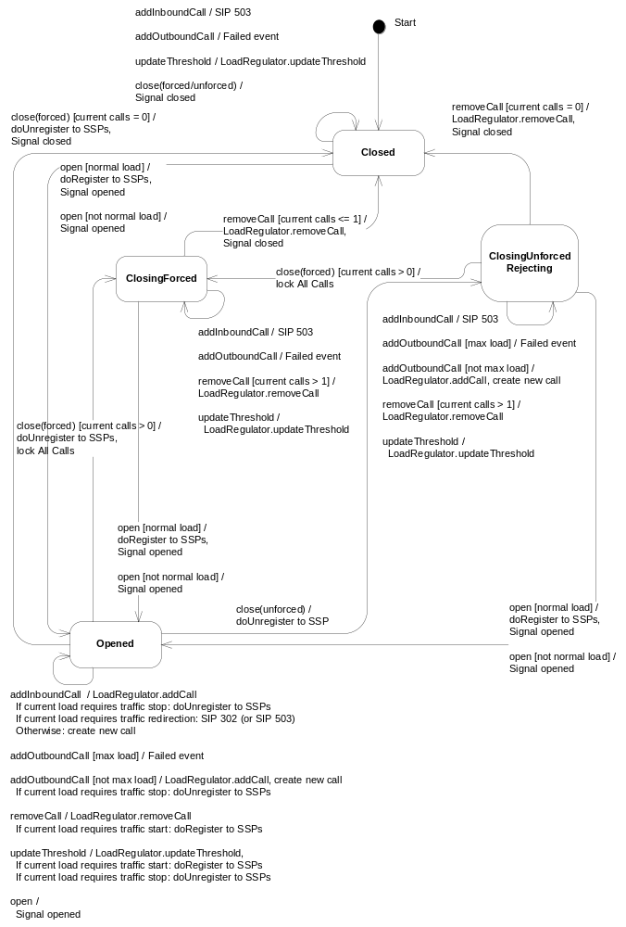

Figure 4 Administrative state machine

Load regulation
CM uses a state machine to keep track of the current load situation.

Load regulation state machine
This section describes the state machine for the CM load regulation.

States
The table below lists the states that exist for the load regulation state machine.
Table 3 States in load regulation state machine
State | Description
High load | The amount of current calls has reached high water mark (HWM).
Normal load | The amount of current calls is below high water mark (HWM).
Max load | The amount of current calls has reached the max amount of calls.

Events
The table below lists the events that exist for the load regulation state machine.
Table 4 Events in load regulation state machine
Event | Description
addCall | A new inbound or outbound call is added.
removeCall | An existing call is removed.
updateThreshold | The thresholds for low water mark, high water mark and maximum calls are updated.

FSA
The complete load regulation state machine is illustrated in the figure below.
All events not included in the figure results in no action.
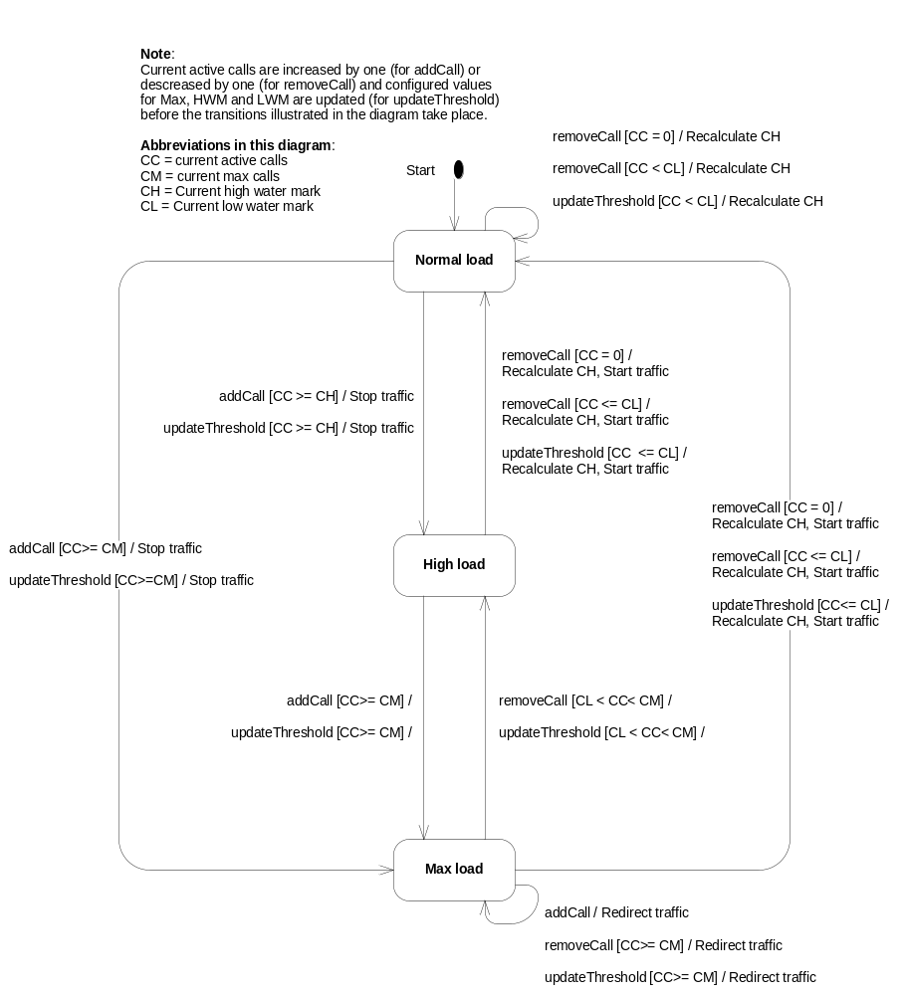

Figure 5 Load regulation state machine

Load regulation during startup
During startup, MAS cannot take the maximum amount of load immediately. This is because of the JIT compiler of the JVM. A slow ramp up of the load is required.

Algorithm
MAS has a set of configured values: threshold, hwm and lwm. In addition to these, MAS also has a currentThreshold, currentHwm and currentLwm which are the limits currently used.
The current-limits will move towards the configured values by a ramp factor n/m channels when the high load state ceases.
threshold is the absolute maximum numbers of channels the MAS will accept.
currentThreshold is the current maximum number of channels the MAS will accept. This value will move from a low initial value towards threshold.
n/m is the fraction to increase currentThreshold. It is calculated as n channels per m high load state ceases.
Startup:
- threshold, hwm and lwm are set by OMM according to the configuration.
- Initial currentHwm is given by configuration, typically 1.
- currentLwm is calculated from currentHwm - (hwm - lwm). If the result is below 0, 0 is used.
- currentThreshold is calculated from currentHwm + (threshold - hwm). If the result is below 0, 0 is used.
- n and m are given by configuration.
When the number of channels exceeds currentHwm:
- MAS unregisters from the SSP.
When the number of channels exceeds currentThreshold:
- MAS starts to redirect incoming SIP INVITEs to the SSPs.
When the number of channels reaches currentLwm (after recently have reached currentHwm):
- currentHwm is increased by n/m channels. If the result is higher than hwm, hwm is used.
- currentLwm is calculated from currentHwm - (hwm - lwm). If the result is below 0, 0 is used.
- currentThreshold is calculated from currentHwm + (threshold - hwm). If the result is below 0, 0 is used.
- If currentThreshold reaches threshold, currentThreshold is set to threshold, currentHwm is set to hwm and currentLwm is set to lwm.
- MAS registers in an SSP.
The load regulation ramp up can be disabled by configuring the initial currentHwm to 0. The values from OMM are then used as threshold, hwm and lwm.

SSP registration
CM is configured with a list of SSPs to use for outbound calls. CM registers itself in the SSPs to be able to receive inbound calls.
CM is configured with a list of all SSP:s to register with. Therefore, when CM sends a SIP REGISTER request the Max Forwards header is set to zero in order to make sure that the SSP does not forward the request on to another SSP.
CM uses a state machine for each configured SSP to keep track of the current registration procedure.

Registration state machine
This section describes the state machine for the SSP registration.

States
The table below lists the states that exist for the registration state machine.
Table 5 States in registration state machine
State | Description
Unregistered | In the Unregistered state CM is not registered in the SSP and there is no ongoing registration procedure. No outbound calls are initiated to this SSP.
Unregistering | In the Unregistering state CM is in an ongoing procedure to unregister from an SSP. No outbound calls are initiated to this SSP.
Registered | In the Registered state CM is registered in the SSP. Outbound calls can be initiated to this SSP.
Registering | In the Registering state CM is in an ongoing procedure to register in an SSP. If the previous state was Registered, outbound calls can be initiated to this SSP. Otherwise, no outbound calls are initiated to this SSP.

Events
The table below lists the events that exist for the registration state machine.
Table 6 Events in registration state machine
Event | Description
doRegister | A registration procedure shall be initiated to the SSP.
doUnregister | An unregistration procedure shall be initiated to the SSP.
SIP OK | A SIP 2xx response has been received for the registration procedure.
SIP Error | A SIP 3xx or 4xx-6xx response has been received for the registration procedure.
SIP Timeout | A SIP timeout has occurred for the registration procedure.
Re-register timer expires | The re-register timer has expired which means that a new registration procedure shall be initiated. This timer is used to refresh the current registration in the SSP.
Backoff timer expires | The backoff timer has expired which means a new registration procedure shall be initiated. This timer is used to wait a while before a new registration if an error occurred in the last registration procedure.

FSA
The registration state machine is illustrated in the figure below. Detailed error handling is not shown in the event actions. All events not included in the figure results in no action.
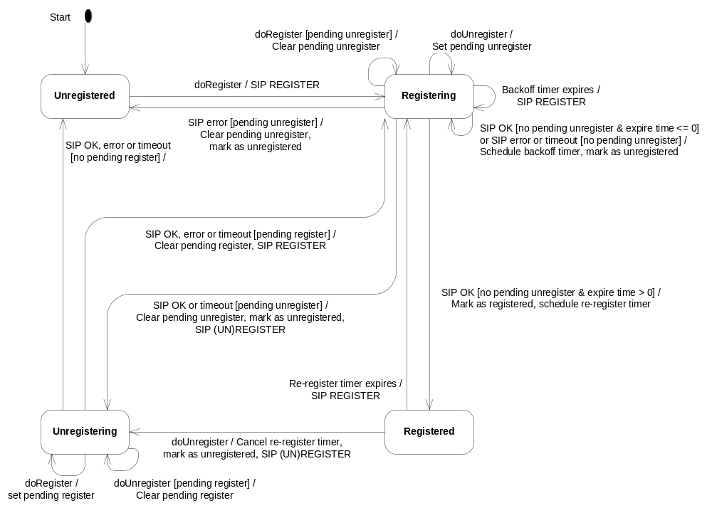
Figure 6 Registration state machine

Registration dispatching
A registration dispatcher is used to dispatch SIP responses and timeout for the SIP REGISTER method to correct registration procedure. The dispatching is done based on an id with the following format:
<call id>:<from tag>
An example is:
b3688e45df9234606cd126fb009bd9d0@10.16.2.97:1837742464
A SIP response or timeout for the SIP REGISTER method for which an ongoing registration procedure cannot be found is ignored.

Notification
For each unsolicited SIP NOTIFY to send there is an instance of an Outbound Notification. CM sends out a SIP NOTIFY and awaits a response or a timeout. After the request has been answered with a final SIP response or has timed out, the Outbound Notification is removed. Any received provisional SIP response is ignored.

Notification dispatching
A notification dispatcher is used to dispatch SIP responses and timeout for the SIP NOTIFY method. The dispatching is done based on an id with the following format:
<call id>:<from tag>
An example is:
b3688e45df9234606cd126fb009bd9d0@10.16.2.97:1837742464
A SIP response or timeout for the SIP NOTIFY method for which an ongoing notification procedure cannot be found is ignored.

Call handling
The call handling part of CM is responsible for active call management. It mainly consists of a call dispatcher and zero or more calls (inbound or outbound).
CM has a state machine for each call (inbound or outbound) to keep track of the current call state.
The names of states and fired events are chosen from the CCXML specification (see [7]) so that there shall be a consistency between CM and a CCXML engine. CM has been designed so that CM and a CCXML engine always are in the same state. This is for example the reason why there are separate states for a call that fails or is disconnected during call setup (Failed state), a call that experiences an unexpected error (Error state) and a call that fails or is disconnected after call setup completed (Disconnected state). It is recommended that if new states are introduced, they should be “CCXML compliant”.
NOTE: There are some rules regarding in what order actions are performed when an event is received in a call state machine:
- Due to the fact that CM when joining/unjoining calls looks at the state of the calls during normal execution it is important that any state transition is performed before firing an external event.
- When deleting streams, make sure that external events are fired first before the streams are deleted. This is to make sure that when a call is disconnected normally, the Disconnected event shall be received by the service before any possible event related to the deleted stream.

Inbound call state machine
This section describes the state machine for an inbound call.

States
The table below lists the states that exist for the inbound call state machine.
Table 7 States in inbound call state machine
State | Sub state | Description
Idle | - | The Idle state is the starting point to the state machine. In this state only the session creating SIP INVITE is allowed.
Alerting | New Call | The Alerting-New Call state is entered when a session creating SIP INVITE has been received and handled. In this state, the service has been loaded, a SIP 100 “Trying” response has been sent and an Alerting event has been fired.
Alerting | Early Media | The Alerting-Early Media state is entered when the service indicates that there is early media to play for the inbound call. In this state, a SIP 183 “Session Progress” response has been sent and an Early Media Available event has been fired.
Alerting | Early Media Wait For Prack | The Alerting-Early Media Wait for Prack state is entered when the service indicates that there is early media to play for the inbound call. In this state, a SIP 183 “Session Progress” response has been sent reliably and CM is waiting for a SIP PRACK before firing an Early Media Available event.
Alerting | Wait For Prack | The Alerting-Wait For Prack state is entered when the service accepts the call and provisional responses shall be sent reliably. In this state, a SIP 180 “Ringing” response has been sent reliably, and CM is waiting for a SIP PRACK before continuing with the call setup.
Alerting | Accepting | The Alerting-Accepting state is entered when the service accepts the call. In this state, a SIP 180 “Ringing” and a SIP 200 “OK” response has been sent. If the “Ringing” response was sent reliably, the SIP PRACK request has also been received and answered. In this state CM is waiting for a SIP ACK before the call becomes connected.
Connected | - | The Connected state is entered when a SIP ACK is received.
Failed | Waiting for Ack | The Failed-Waiting for Ack state is entered when a call in Alerting-Accepting state is disconnected. A SIP BYE request cannot be sent until a SIP ACK has been received.
Failed | Lingering Bye | The Failed-Lingering Bye state is entered when a call in Alerting-Accepting state fails due to unsupported media in SIP ACK. In this state a SIP BYE request has been sent and CM is waiting for a response before the call is completed.
Failed | Completed | The Failed-Completed state is entered for example when a SIP response is received for a SIP BYE request in Failed-Lingering Bye state. No SIP procedures are active and the call is completed.
Disconnected | Lingering Bye | The Disconnected-Lingering Bye state is entered for example when a call in Connected state is disconnected by the service. In this state a SIP BYE request has been sent and CM is waiting for a response before the call is completed.
Disconnected | Completed | The Disconnected-Completed state is entered for example when a SIP response is received for a SIP BYE request in Disconnected-Lingering Bye state. No SIP procedures are active and the call is completed.
Error | Lingering Bye | The Error-Lingering Bye state is entered when an internal error has occurred in Connected state. In this state a SIP BYE request has been sent and CM is waiting for a response before the call is completed.
Error | Completed | The Error-Completed state is entered for example when a SIP response is received for a SIP BYE request in Error-Lingering Bye state. No SIP procedures are active and the call is completed.

Events
The table below lists the events that exist for the inbound call state machine.
Table 8 Events in inbound call state machine
Event | Description
CloseForced | O&M has requested to force close CM. The call shall be immediately terminated.
Play | The service requests to play media on the outbound stream.
Record | The service requests to record media from the inbound stream.
Stop play | The service requests to stop an ongoing play.
Stop record | The service requests to stop an ongoing record.
VFU request | A request to send a Video Fast Update request using SIP INFO has been received.
Accept | The service accepts the call.
Negotiate early media | The service indicates that there is early media to play for the call.
Reject | The service rejects the call.
Disconnect | The service disconnects the call.
SIP ACK | A SIP ACK request is received.
SIP BYE | A SIP BYE request is received.
SIP CANCEL | A SIP CANCEL request is received.
SIP INVITE | A session creation SIP INVITE request is received.
SIP Re-INVITE | A SIP re-INVITE request is received.
SIP OPTIONS | A SIP OPTIONS request is received.
SIP INFO | A SIP INFO request is received.
SIP PRACK | A SIP PRACK request is received.
SIP response | A SIP response is received.
SIP timeout | A SIP timeout has occurred.
“Not Accepted” timeout | The service has not accepted the call within the specified time limit.
Expires timeout | The service has not accepted the call before the Expires time (received in the SIP INVITE) was been exceeded.
“No Ack” timeout | An ACK or PRACK request was not received within the specified time limit.
Abandoned stream | The inbound stream has been silent for a configured amount of time. The call is considered abandoned.

FSA
The inbound call state machine is illustrated in the figure below. The figure only contains a few state transitions for a better understanding of the different states and how the interact. For complete state machine coverage, see the tables below.

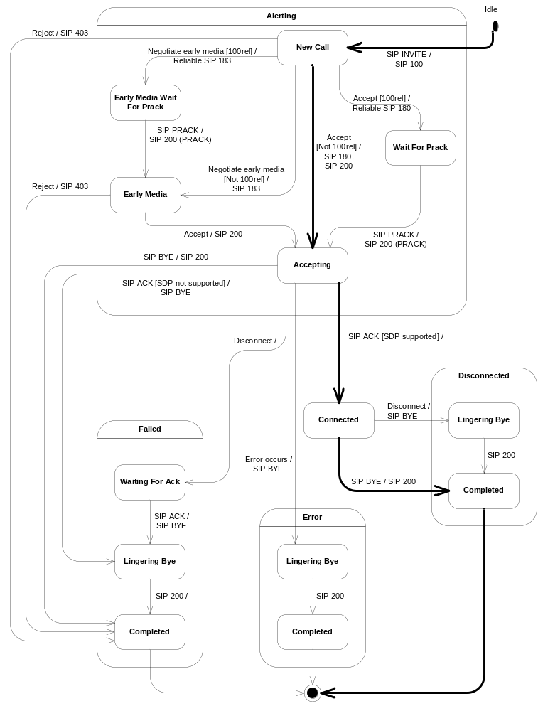
Figure 7 Inbound Call state machine
The path taken in the state machine illustrated above differs depending on if provisional SIP responses shall be sent reliably or not (indicated above with 100rel which is the SIP extension used when sending provisional responses reliably). Whether to send provisional responses reliably or not is determined as described in section 3.11.
Before a SIP request is received at this FSA, it has been validated as described in section 3.6. If the request is not valid it is rejected and will not reach this FSA.
For clarity, a received SIP response is in the tables below denoted with the following format:
SIP <response type> (method)
If the method is not of importance, it is not included. Examples:
SIP 2xx (BYE) – An ok final response has been received for the SIP BYE request.
SIP 408, 481 – A SIP 408 or SIP 481 has been received for any SIP request.
If a SIP message cannot be sent by CM to the SIP stack, the call is considered lost. The state is set to Error-Completed, an Error event is fired and the streams are deleted. This is general error handling behavior in all states and is not shown in the tables below.
All events not included in the tables below results in no action or at most a log.
Apart from what is described above and below, setting the state to Disconnected-Completed, Failed-Completed or Error-Completed will cause the call to be removed from the call dispatcher and the administrative state machine.
Note that a call that is joined when its streams are deleted will be implicitly unjoined.

Idle state
The table below lists the event handling in the Idle state.
Table 9 Event handling in the Idle state
Event | Action | Next State
SIP INVITE | Send SIP 100 “Trying” response.  Parse SDP offer (if any).  Load service and set session data.  Register to receive events.  Start “Not Accepted” timer.  Start Expires timer (if any).  Fire Alerting event. | Alerting-New Call
Play | Fire Play Failed event | -
Record | Fire Record Failed event | -

Apart from the action described in the table above, when a SIP INVITE is received the SIP stack automatically generates a SIP 100 “Trying” response if CM has not within 200 milliseconds. Thus, in some situations two SIP 100 “Trying” responses might be sent for an inbound SIP INVITE.

The table below lists the error scenarios handled in the Idle state.
Table 10 Error handling in the Idle state
Event | Error Scenario | Action | Next State
SIP INVITE | Invalid SDP | Fire Failed event.  Send SIP 488 “Not Acceptable Here” response. | Failed-Completed
SIP INVITE | Service not loaded | Fire Error event  Send SIP 500 “Server Internal Error” response. | Error-Completed

Alerting state
The table below lists the event handling common for all sub states in the Alerting state.
Table 11 Event handling in Alerting state
Event | Action | Next State
Record | Fire Record Failed event. | -
SIP Re-INVITE | Send SIP 491 “Request Pending” response. | -
SIP OPTIONS | Send SIP 200 “OK” response. | -
SIP INFO | Send SIP 405 “Method Not Allowed” response. | -

Alerting-New Call state
The table below lists the event handling in the Alerting-New Call state.
Table 12 Event handling in Alerting-New Call state
Event | Action | Next State
CloseForced | Fire Failed event.  Send SIP 503 “Service Unavailable” response. | Failed-Completed
Play | Fire Play failed event. | -
Accept | If all responses shall be sent reliably (see section 3.11 on when to send responses reliably):  If no SDP offer received in SIP INVITE:  - Retrieve call type from Call-Info header or  configuration.  - Create inbound stream.  - Create SDP offer.  - Send SIP 180 “Ringing” response reliably with sdp. Otherwise:  - Send SIP 180 “Ringing” response reliably, no sdp. | Alerting-  Wait For Prack
Accept | Otherwise:  Send SIP 180 “Ringing” response.  If no SDP offer received in SIP INVITE:  - Retrieve call type from Call-Info header or  configuration.  - Create inbound stream.  - Create SDP offer.  Otherwise:  - Retrieve SDP intersection.  - Create streams.  - Create SDP answer.  Send SIP 200 “OK” response. | Alerting-Accepting
Negotiate early media | If no SDP offer received in SIP INVITE:  Fire Early Media Failed event. | -
Negotiate early media | Otherwise, if no responses shall be sent reliably:  Retrieve SDP intersection.  Create streams.  Create SDP answer.  Send SIP 183 “Session Progress” response.  Fire Early Media Available event. | Alerting-  Early Media
Negotiate early media | Otherwise:  Retrieve SDP intersection.  Create streams.  Create SDP answer.  Send SIP 183 “Session Progress” response reliably. | Alerting-  Early Media Wait For Prack
Reject | Fire Failed event.  Send SIP 403 “Forbidden” response. | Failed-Completed
Expires timeout | Fire Failed event.  Send SIP 487 “Request Terminated” response. | Failed-Completed
Disconnect | Fire Failed event.  Fire Disconnected event.  Send SIP 487 “Request Terminated” response. | Failed-Completed
SIP BYE,  SIP CANCEL | Fire Failed event.  Send SIP 487 “Request Terminated” response for SIP INVITE.  Send SIP 200 “OK” response for SIP BYE/CANCEL. | Failed-Completed
SIP PRACK | Send SIP 403 “Forbidden” response for SIP PRACK. | -
SIP Timeout | Fire Error event. | Error-Completed
“Not Accepted” timeout | Fire Failed event.  Send SIP 408 “Request Timeout” response. | Failed-Completed

The table below lists the error scenarios handled in the Alerting-New Call state.
Table 13 Error handling in Alerting-New Call state
Event | Error Scenario | Action | Next State
Accept,  Negotiate early media | Stream or SDP not created | Fire Error event.  Send SIP 500 “Server Internal Error” response. | Error-Completed
Accept,  Negotiate early media | SDP intersection not found | Fire Failed event.  Send SIP 488 “Not Acceptable Here” response. | Failed-Completed

Alerting-Early Media Wait For Prack state
The table below lists the event handling in the Alerting-Early Media Wait For Prack state.
Table 14 Event handling in Alerting-Early Media Wait For Prack state
Event | Action | Next State
CloseForced | Fire Failed event.  Delete streams.  Send SIP 503 “Service Unavailable” response. | Failed-Completed
Play | Fire Play failed event. | -
Accept,  Negotiate early media | Fire Not Allowed event. | -
Reject | Fire Failed event.  Delete streams.  Send SIP 403 “Forbidden” response. | Failed-Completed
Disconnect | Fire Failed event.  Fire Disconnected event.  Delete streams.  Send SIP 487 “Request Terminated” response. | Failed-Completed
SIP BYE,  SIP CANCEL | Fire Failed event.  Delete streams.  Send SIP 487 “Request Terminated” response for SIP INVITE.  Send SIP 200 “OK” response for SIP BYE/CANCEL. | Failed-Completed
SIP PRACK | If PRACK contains a new SDP offer, parse it and create an SDP answer.  Send SIP 200 “OK” response for SIP PRACK.  Fire Early Media Available event. | Alerting-  Early Media
SIP Timeout | Fire Error event.  Delete streams.  Send SIP 504 “Server time-out” for SIP INVITE. | Error-Completed
Expires timeout | Fire Failed event.  Delete streams.  Send SIP 487 “Request Terminated” response. | Failed-Completed
“Not Accepted” timeout | Fire Failed event.  Delete streams.  Send SIP 408 “Request Timeout” response. | Failed-Completed
“No Ack” timeout | Fire Error event.  Delete streams.  Send SIP 504 “Server time-out” for SIP INVITE. | Error-Completed
The table below lists the error scenarios handled in the Alerting-Early Media Wait For Prack state.
Table 15 Error handling in Alerting-Early Media Wait For Prack state
Event | Error Scenario |  |  | Action |  | Next State
SIP PRACK |  | Error in SDP or SDP not acceptable. | Fire Failed event.  Send SIP 488 “Not Acceptable Here” response. |  | Failed-Completed

Alerting-Early Media state
The table below lists the event handling in the Alerting-Early Media state.
Table 16 Event handling in Alerting-Early Media state
Event | Action | Next State
CloseForced | Fire Failed event.  Delete streams.  Send SIP 503 “Service Unavailable” response. | Failed-Completed
Play | Play media on outbound stream. | -
Stop play | Stop playing media on outbound stream. | -
Accept | Send SIP 200 “OK” response. | Alerting-Accepting
Negotiate early media | Fire Not Allowed event. | -
Reject | Fire Failed event.  Delete streams.  Send SIP 403 “Forbidden” response. | Failed-Completed
Disconnect | Fire Failed event.  Fire Disconnected event.  Delete streams.  Send SIP 487 “Request Terminated” response. | Failed-Completed
SIP BYE,  SIP CANCEL | Fire Failed event.  Delete streams.  Send SIP 487 “Request Terminated” response for SIP INVITE.  Send SIP 200 “OK” response for SIP BYE/CANCEL. | Failed-Completed
SIP PRACK | Send SIP 403 “Forbidden” response for SIP PRACK. | -
SIP Timeout | Fire Error event.  Delete streams. | Error-Completed
Expires timeout | Fire Failed event.  Delete streams.  Send SIP 487 “Request Terminated” response. | Failed-Completed
“Not Accepted” timeout | Fire Failed event.  Delete streams.  Send SIP 408 “Request Timeout” response. | Failed-Completed
The table below lists the error scenarios handled in the Alerting-Early Media state.
Table 17 Error handling in Alerting-Early Media state
Event | Error Scenario | Action | Next State
Play | Error playing media. | Fire Play Failed event. | -

Alerting-Wait For Prack state
The table below lists the event handling in the Alerting-Wait For Prack state.
Table 18 Event handling in Alerting-Wait For Prack state
Event | Action | Next State
CloseForced | Fire Failed event.  Delete streams.  Send SIP 503 “Service Unavailable” response. | Failed-Completed
Play | Fire Play failed event. | -
Accept,  Negotiate early media | Fire Not Allowed event. | -
Reject | Fire Failed event.  Delete streams.  Send SIP 403 “Forbidden” response. | Failed-Completed
Disconnect | Fire Failed event.  Fire Disconnected event.  Delete streams.  Send SIP 487 “Request Terminated” response. | Failed-Completed
SIP BYE,  SIP CANCEL | Fire Failed event.  Delete streams.  Send SIP 487 “Request Terminated” response for SIP INVITE.  Send SIP 200 “OK” response for SIP BYE/CANCEL. | Failed-Completed
SIP PRACK | Send SIP 200 “OK” response for SIP PRACK.  If no SDP offer received in SIP INVITE:  - Retrieve call type from Call-Info header or  configuration. - Create inbound stream. - Create SDP offer.  Otherwise: - Retrieve SDP intersection. - Create streams. - Create SDP answer.  Send SIP 200 “OK” response for SIP INVITE. | Alerting-Accepting
SIP Timeout | Fire Error event.  Delete streams.  Send SIP 504 “Server time-out” for SIP INVITE. | Error-Completed
Expires timeout | Fire Failed event.  Delete streams.  Send SIP 487 “Request Terminated” response. | Failed-Completed
“No Ack” timeout | Fire Error event.  Delete streams.  Send SIP 504 “Server time-out” for SIP INVITE. | Error-Completed
The table below lists the error scenarios handled in the Alerting-Wait For Prack state.
Table 19 Error handling in Alerting-Wait For Prack state
Event | Error Scenario |  |  | Action |  | Next State
SIP PRACK |  | Stream or SDP not created | Fire Error event.  Send SIP 500 “Server Internal Error” response for SIP INVITE. |  | Error-Completed
SIP PRACK |  | SDP intersection not found | Fire Failed event.  Send SIP 488 “Not Acceptable Here” response for SIP INVITE. |  | Failed-Completed

Alerting-Accepting state
The table below lists the event handling in the Alerting-Accepting state.
Table 20 Event handling in Alerting-Accepting state
Event | Action | Next State
CloseForced | Fire Failed event.  Delete streams. | Failed-Waiting For Ack
Disconnect | Fire Failed event.  Fire Disconnected event.  Delete streams. | Failed-Waiting For Ack
Play | Play media on outbound stream. | -
Stop play | Stop playing media on outbound stream. | -
Accept, Reject,  Negotiate early media | Fire Not Allowed event. | -
SIP ACK | If no SDP offer received in SIP INVITE:  Parse SDP.  Retrieve SDP intersection.  Create outbound stream.  Fire Connected event. | Connected
SIP BYE | Fire Failed event.  Delete streams.  Send SIP 200 “OK” response. | Failed-Completed
SIP CANCEL | Send SIP 200 “OK” response. | -
SIP PRACK | Send SIP 403 “Forbidden” response for SIP PRACK. | -
SIP Timeout | Fire Error event.  Delete streams.  Send SIP BYE request. | Error-Lingering Bye
“No Ack” timeout | Fire Error event.  Delete streams. | Error-Completed

The table below lists the error scenarios handled in the Alerting-Accepting state.
Table 21 Error handling in Alerting-Accepting state
Event | Condition | Action | Next State
SIP ACK | Stream not created,  invalid SDP | Fire Error event.  Delete streams.  Send SIP BYE request. | Error-  Lingering Bye
SIP ACK | No SDP answer when expected,  no SDP intersection found,  incompatible call type in SDP | Fire Failed event.  Delete streams.  Send SIP BYE request. | Failed-  Lingering Bye

Connected state
The table below lists the event handling in the Connected state.
Table 22 Event handling in Connected state
Event | Action | Next State
CloseForced, Disconnect,  SIP 408 or 481 (INFO),  Abandoned stream | Fire Disconnected event.  Delete streams.  Send SIP BYE request. | Disconnected-Lingering Bye
Play | Play media on outbound stream. | -
Record | Record media from inbound stream. | -
Stop Play | Stop playing media on outbound stream. | -
Stop Record | Stop recording media from inbound stream. | -
VFU request | Send SIP INFO request. | -
Accept, Reject,  Negotiate early media | Fire Not Allowed event. | -
SIP BYE | Fire Disconnected event.  Delete streams.  Send SIP 200 “OK” response. | Disconnected-Completed
SIP CANCEL, SIP OPTIONS | Send SIP 200 “OK” response. | -
SIP INFO | If the call is joined, forward the SIP request to the other call.  Otherwise, send SIP 405 “Method Not Allowed” response. | -
SIP Re-INVITE | Send SIP 488 “Not Acceptable Here” response. | -
SIP PRACK | Send SIP 403 “Forbidden” response for SIP PRACK. | -
SIP not 408 or 481 (INFO) | If the call is joined, forward the SIP response to the other call.  Otherwise, parse media control information. | -
SIP timeout | If configured to disconnect on SIP timeout:  Fire Error event,  Delete streams. | Error-Completed

The table below lists the error scenarios handled in the Connected state.
Table 23 Error handling in Connected state
Event | Error Scenario | Action | Next State
Play | Error playing media. | Fire Play Failed event. | -
Record | Error recording media. | Fire Record Failed event. | -

Failed state
The table below lists the event handling common for all sub states in the Failed state.
Table 24 Event handling in Failed state
Event | Action | Next State
Play | Fire Play Failed event. | -
Record | Fire Record Failed event. | -
Accept, Reject,  Negotiate early media | Fire Not Allowed event. | -
Disconnect | Fire Disconnected event. | -
SIP CANCEL,  SIP OPTIONS | Send SIP 200 “OK” response. | -
SIP PRACK | Send SIP 403 “Forbidden” response for SIP PRACK. | -
SIP Timeout | Fire Error event.  Delete streams. | Error-Completed
SIP response (INFO) | Parse media control information. | -

Failed-Completed state
The table below lists the event handling in the Failed-Completed state.
Table 25 Event handling in Failed-Completed state
Event | Action | Next State
SIP BYE | Send SIP 200 “OK” response. | -
SIP Re-INVITE | Send SIP 488 “Not Acceptable Here” response. | -

Failed-Lingering Bye state
The table below lists the event handling in the Failed-Lingering Bye state.
Table 26 Event handling in Failed-Lingering Bye state
Event | Action | Next State
SIP BYE | Send SIP 200 “OK” response. | Failed-Completed
SIP response (BYE) |  | Failed-Completed

Failed-Waiting for Ack state
The table below lists the event handling in the Failed-Waiting for Ack state.
Table 27 Event handling in Failed-Waiting for Ack state
Event | Action | Next State
SIP ACK | Send SIP BYE request. | Failed-Lingering Bye
SIP BYE | Send SIP 200 “OK” response. | Failed-Completed
SIP Re-INVITE | Send SIP 491 “Request Pending” response. | -
“No Ack” timeout |  | Failed-Completed

Disconnected state
The table below lists the event handling common for all sub states in the Disconnected state.
Table 28 Event handling in Disconnected state
Event | Action | Next State
Play | Fire Play Failed event. | -
Record | Fire Record Failed event. | -
Accept, Reject,  Negotiate early media | Fire Not Allowed event. | -
Disconnect | Fire Disconnected event. | -
SIP CANCEL,  SIP OPTIONS | Send SIP 200 “OK” response. | -
SIP Re-INVITE | Send SIP 488 “Not Acceptable Here” response. | -
SIP PRACK | Send SIP 403 “Forbidden” response for SIP PRACK. | -
SIP Timeout | Fire Error event.  Delete streams. | Error-Completed
SIP response (INFO) | Parse media control information. | -

Disconnected-Completed state
The table below lists the event handling in the Disconnected-Completed state.
Table 29 Event handling in Disconnected-Completed state
Event | Action | Next State
BYE | Send SIP 200 “OK” response. | -

Disconnected-Lingering Bye state
The table below lists the event handling in the Disconnected-Lingering Bye state.
Table 30 Event handling in Disconnected-Lingering Bye state
Event | Action | Next State
SIP BYE | Send SIP 200 “OK” response. | Disconnected-Completed
SIP response (BYE) |  | Disconnected-Completed

Error state
The table below lists the event handling common for all sub states in the Error state.
Table 31 Event handling in Error state
Event | Action | Next State
Play | Fire Play Failed event. | -
Record | Fire Record Failed event. | -
Accept, Reject,  Negotiate early media | Fire Not Allowed event. | -
Disconnect | Fire Disconnected event. | -
SIP CANCEL,  SIP OPTIONS | Send SIP 200 “OK” response. | -
SIP Re-INVITE | Send SIP 488 “Not Acceptable Here” response. | -
SIP PRACK | Send SIP 403 “Forbidden” response for SIP PRACK. | -
SIP Timeout | Fire Error event.  Delete streams. | Error-Completed
SIP response (INFO) | Parse media control information. | -

Error-Completed state
The table below lists the event handling in the Error-Completed state.
Table 32 Event handling in Error-Completed state
Event | Action | Next State
SIP BYE | Send SIP 200 “OK” response. | -

Error-Lingering Bye state
The table below lists the event handling in the Error-Lingering Bye state.
Table 33 Event handling in Error-Lingering Bye state
Event | Action | Next State
SIP BYE | Send SIP 200 “OK” response. | Error-Completed
SIP response (BYE) |  | Error-Completed

Outbound call state machine
This section describes the state machine for an outbound call.

States
The table below lists the states that exist for the outbound call state machine.
Table 34 States in outbound call state machine
State | Sub state | Description
Idle | - | The Idle state is the starting point to the state machine. In this state only the service command dial is allowed.
Progressing | Calling | The Progressing-Calling state is entered when a session creating SIP INVITE has been sent.
Progressing | Proceeding | The Progressing-Proceeding state is entered when a provisional SIP response (not containing early media indication) is received for the SIP INVITE. In this state a Progressing event may have been fired (depending on the type of response).
Progressing | Early Media | The Progressing-Early Media state is entered when a SIP 183 “Session Progress” response containing an SDP has been received for the INVITE. In this state a Progressing event indicating early media has been fired.
Connected | - | The Connected state is entered when a SIP 200 “OK” response is received. In this state a SIP ACK response has been sent.
Failed | Waiting for Response | The Failed-Waiting for Response state is entered when a call in Progressing-Calling state is disconnected. A SIP CANCEL or BYE request cannot be sent until a SIP response has been received.
Failed | Lingering Bye | The Failed-Lingering Bye state is entered for example when a call in Progressing-Proceeding state fails due to unsupported media in SIP 200 “OK”. In this state a SIP BYE request has been sent and CM is waiting for a response before the call is completed.
Failed | Lingering Cancel | The Failed-Lingering Cancel state is entered for example when a call in Progressing-Proceeding state fails due to unsupported media in SIP 183 “Session Progress”. In this state a SIP CANCEL request has been sent and CM is waiting for a response before the call is completed.
Failed | Completed | The Failed-Completed state is entered for example when a SIP response is received for a SIP BYE request in Failed-Lingering Bye state. No SIP procedures are active and the call is completed.
Disconnected | Lingering Bye | The Disconnected-Lingering Bye state is entered for example when a call in Connected state is disconnected by the service. In this state a SIP BYE request has been sent and CM is waiting for a response before the call is completed.
Disconnected | Completed | The Disconnected-Completed state is entered for example when a SIP response is received for a SIP BYE request in Disconnected-Lingering Bye state. No SIP procedures are active and the call is completed.
Error | Lingering Bye | The Error-Lingering Bye state is entered when an internal error has occurred in Connected state. In this state a SIP BYE request has been sent and CM is waiting for a response before the call is completed.
Error | Lingering Cancel | The Error-Lingering Cancel state is entered for example when an internal error has occurred in Progressing-Proceeding state. In this state a SIP CANCEL request has been sent and CM is waiting for a response before the call is completed.
Error | Completed | The Error-Completed state is entered for example when a SIP response is received for a SIP BYE request in Error-Lingering Bye state. No SIP procedures are active and the call is completed.

Events
The table below lists the events that exist for the outbound call state machine.
Table 35 Events in outbound call state machine
Event | Description
CloseForced | O&M has requested to force close CM. The call shall be immediately terminated.
Play | The service requests to play media on the outbound stream.
Record | The service requests to record media from the inbound stream.
Stop play | The service requests to stop an ongoing play.
Stop record | The service requests to stop an ongoing record.
VFU request | A request to send a Video Fast Update request using SIP INFO has been received.
Disconnect | The service disconnects the call.
Dial | The service initiates the outbound call.
Send token | The service whishes to send a DTMF token on the outbound media stream.
SIP ACK | A SIP ACK request is received.
SIP BYE | A SIP BYE request is received.
SIP CANCEL | A SIP CANCEL request is received.
SIP Re-INVITE | A SIP re-INVITE request is received.
SIP OPTIONS | A SIP OPTIONS request is received.
SIP INFO | A SIP INFO request is received.
SIP PRACK | A SIP PRACK request is received.
SIP response | A SIP response is received.
SIP timeout | A SIP timeout has occurred.
“Max Duration” timeout | The maximum duration for a connected call has been reached. The call is disconnected.
“Not Connected” timeout | The outbound call has not been connected within the specified time limit.
“No Ack” timeout | An ACK request was not received for a SIP re-INVITE within the specified time limit.
“No response” timeout | A SIP response was not received within the specified time limit.
Abandoned stream | The inbound media stream has been silent for a configured amount of time. The call is considered abandoned.

FSA
The outbound call state machine is illustrated in the figure below. The figure only contains a few state transitions for a better understanding of the different states and how the interact. For complete state machine coverage, see the tables below.
Note that SIP ACK requests for error responses are generated automatically by the SIP stack and are therefore not included in the figure or in the tables below.
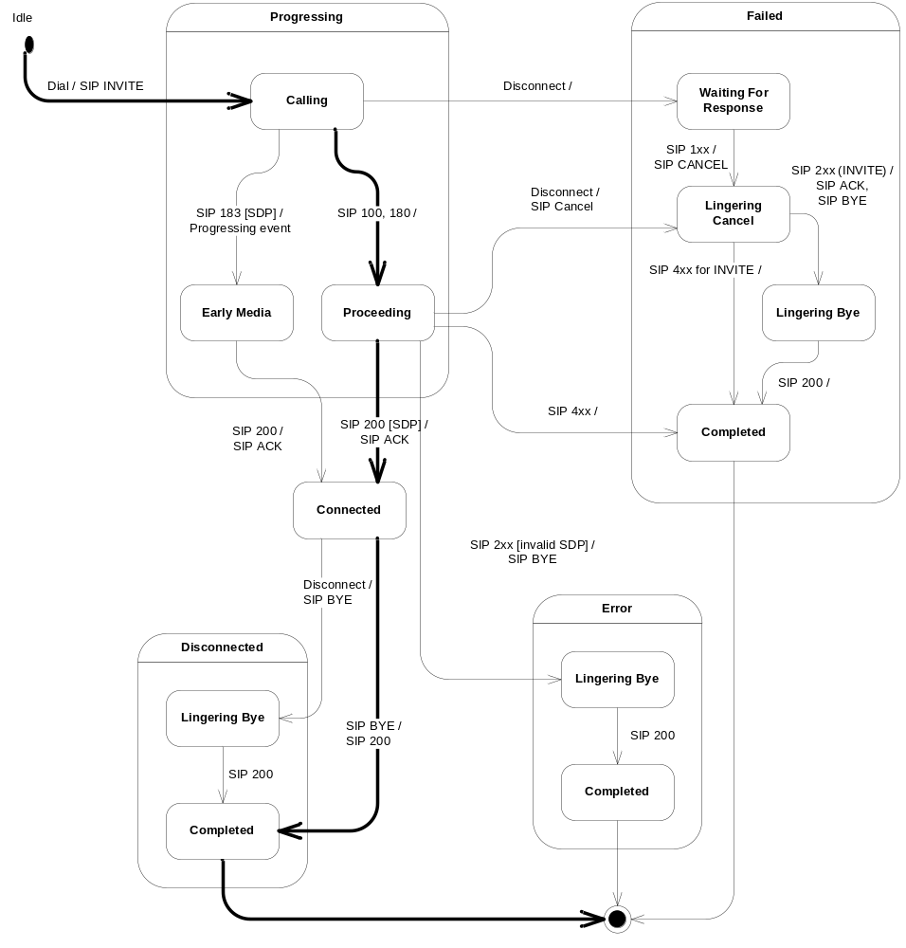
Figure 8 Outbound call state machine
Before a SIP request is received at this FSA, it has been validated as described in section 3.6. If the request is not valid it is rejected and will not reach this FSA.
For clarity, a received SIP response is in the tables below denoted with the following format:
SIP <response type> (method)
If the method is not of importance, it is not included. Examples:
SIP 2xx (BYE) – An ok final response has been received for the SIP BYE request.
SIP 408, 481 – A SIP 408 or SIP 481 has been received for any SIP request.
If a SIP message cannot be sent by CM to the SIP stack, the call is considered lost. The state is set to Error-Completed, an Error event is fired and the streams are deleted. This is general error handling behavior in all states and is not shown in the tables below.
All events not included in the tables below results in no action or at most a log.
Apart from what is described above and below, setting the state to Disconnected-Completed, Failed-Completed or Error-Completed will cause the call to be removed from the call dispatcher and the administrative state machine.
Note that a call that is joined when its streams are deleted will be implicitly unjoined.

Idle state
The table below lists the event handling in the Idle state.
Table 36 Event handling in Idle state
Event | Action | Next State
CloseForced | Fire Failed event. | Failed-Completed
Disconnect | Fire Failed event.  Fire Disconnected event. | Failed-Completed
Dial | Create inbound stream.  Create SDP offer.  Retrieve remote party address to send SIP INVITE to.  Send SIP INVITE request.  Register to receive events.  Start “Not Connected” timer. | Progressing-Calling
Play | Fire Play Failed event | -
Record | Fire Record Failed event | -
Send token | Fire “Not Allowed” event. | -

The table below lists the error scenarios handled in the Idle state.
Table 37 Error handling in Idle state
Event | Error Scenario | Action | Next State
Dial | Stream or SDP could not be created, remote party could not be retrieved or found, INVITE could not be created. | Fire Error event.  Delete streams. | Error-Completed
Dial | INVITE could not be sent. | Fire Failed event  Delete streams. | Failed-Completed

Progressing state
The table below lists the event handling common for all sub states in the Progressing state.
Table 38 Event handling in Progressing state
Event | Action | Next State
Play | Fire Play Failed event. | -
Dial, Send token | Fire “Not Allowed” event. | -
SIP BYE | Fire Failed event.  Delete streams.  SIP 200 “OK” for SIP BYE request. | Failed-Completed
SIP Re-INVITE | Send SIP 491 “Request Pending” response. | -
SIP OPTIONS | Send SIP 200 “OK” response. | -
SIP PRACK | Send SIP 403 “Forbidden” response. | -
SIP Timeout (INVITE) | Retrieve new remote party address to send SIP INVITE to.  Send new SIP INVITE request. | Progressing-Calling
SIP Timeout (PRACK) | Fire Error event.  Delete streams.  Send SIP CANCEL request. | Error-Lingering Cancel
SIP Timeout (Other than INVITE or PRACK) | Fire Error event.  Delete streams. | Error-Completed

The table below lists the error scenarios common for all sub states in the Progressing state.
Table 39 Error handling in the Progressing state
Event | Error Scenario | Action | Next State
SIP Timeout (INVITE) | No new remote party could be found, INVITE could not be sent. | Fire Failed event.  Delete streams. | Failed-Completed
SIP Timeout (INVITE) | INVITE could not be created. | Fire Error event  Delete streams. | Error-Completed

Progressing-Calling state
The table below lists the event handling in the Progressing-Calling state.
Table 40 Event handling in the Progressing-Calling state
Event | Action | Next State
CloseForced,  “Not Connected” timeout | Fire Failed event.  Delete streams. | Failed-Waiting for Response
Disconnect | Fire Failed event.  Fire Disconnected event.  Delete streams. | Failed-Waiting for Response
Record | Fire Record Failed event. | -
SIP INFO | Send SIP 405 “Method Not Allowed” response. | -
SIP 100, 181, or 182 (INVITE) |  | Progressing-Proceeding
SIP 180 (INVITE),  SIP 183 or unknown 1xx (INVITE) without SDP | Fire Progressing event.  If response was sent reliably, send SIP PRACK request. | Progressing-Proceeding
SIP 183 or unknown 1xx (INVITE) with SDP | Retrieve SDP intersection.  Create outbound stream.  Fire Progressing event.  If response was sent reliably, send SIP PRACK request. | Progressing-  Early Media
SIP 2xx (INVITE) | Send SIP ACK request.  Retrieve SDP intersection from SDP answer.  Create outbound stream.  Fire Connected event. | Connected
SIP 3xx (INVITE) | Retrieve contacts from response and select next contact to try.  Send redirected INVITE request to new contact. | Progressing-Calling
SIP 5xx (INVITE)  for redirected call | Select next contact to try from previously received contact list.  Send redirected INVITE request to new contact. | Progressing-Calling
SIP 5xx (INVITE) for non redirected call,  SIP 4xx, 6xx (INVITE) | Fire Failed event.  Delete streams. | Failed-Completed
SIP 408, 481 (PRACK) | Fire Failed event.  Delete streams.  Send SIP CANCEL request. | Failed-Lingering Cancel

The table below lists the error scenarios handled in the Progressing-Calling state.
Table 41 Error handling in the Progressing-Calling state
Event | Error Scenario | Action | Next State
SIP 183, unknown 1xx (INVITE) | Error retrieving SDP answer,  Stream could not be created | Fire Error event.  Delete streams.  Send SIP CANCEL request. | Error-  Lingering Cancel
SIP 183, unknown 1xx (INVITE) | No SDP intersection found | Fire Failed event.  Delete streams.  Send SIP CANCEL request. | Failed-  Lingering Cancel
SIP 2xx (INVITE) | No SDP answer in INVITE,  No SDP intersection found | Send SIP ACK request.  Fire Failed event.  Delete streams.  Send SIP BYE request. | Failed-  Lingering Bye
SIP 2xx (INVITE) | Error retrieving SDP answer,  Stream could not be created | Send SIP ACK request.  Fire Error event.  Delete streams.  Send SIP BYE request. | Error-  Lingering Bye
SIP 3xx (INVITE) | Call already redirected (only one level is supported),  No next contact found,  INVITE could not be sent | Fire Failed event.  Delete streams. | Failed-Completed.
SIP 3xx (INVITE),  SIP 5xx (INVITE) | INVITE could not be created | Fire Error event.  Delete streams. | Error-Completed
SIP 5xx (INVITE) | No next contact found,  INVITE could not be sent | Fire Failed event.  Delete streams. | Failed-Completed
Progressing-Early Media state
The table below lists the event handling in the Progressing-Early Media state.
Table 42 Event handling in the Progressing-Early Media state
Event | Action | Next State
CloseForced,  “Not Connected” timeout,  SIP 408, 481 (INFO) | Fire Failed event.  Delete streams.  Send SIP CANCEL request. | Failed-  Lingering Cancel
Disconnect | Fire Failed event.  Fire Disconnected event.  Delete streams.  Send SIP CANCEL request. | Failed-  Lingering Cancel
Record | Record media from inbound stream. | -
Stop record | Stop recording media from inbound stream. | -
VFU request | Send SIP INFO request. | -
SIP INFO | If the call is joined, forward the SIP request to the other call.  Otherwise, send SIP 405 “Method Not Allowed” response. | -
SIP 180, 183, unknown 1xx (INVITE) | Fire Progressing event.  If response was sent reliably, send SIP PRACK request. | -
SIP 2xx (INVITE) | Send SIP ACK request.  Fire Connected event. | Connected
SIP 3xx, 5xx (INVITE) | Fire Failed event.  Delete streams. | Failed-Completed
SIP 408, 481 (PRACK) | Fire Failed event.  Delete streams.  Send SIP CANCEL request. | Failed-Lingering Cancel
SIP not 408 or 481 (INFO) | If the call is joined, forward the SIP response to the other call.  Otherwise, parse media control information. | -
The table below lists the error scenarios handled in the Progressing-Early Media state.
Table 43 Error handling in the Progressing-Early Media state
Event | Error Scenario | Action | Next State
Record | Error when recording media. | Fire Record Failed event. | -

Progressing-Proceeding state
The table below lists the event handling in the Progressing-Proceeding state.
Table 44 Event handling in the Progressing-Proceeding state
Event | Action | Next State
CloseForced,  “Not Connected” timeout | Fire Failed event.  Delete streams.  Send SIP CANCEL request. | Failed-  Lingering Cancel
Disconnect | Fire Failed event.  Fire Disconnected event.  Delete streams.  Send SIP CANCEL request. | Failed-  Lingering Cancel
Record | Fire Record Failed event. | -
SIP INFO | Send SIP 405 “Method Not Allowed” response. | -
SIP 180, 183, unknown 1xx (INVITE) | Fire Progressing event.  If response was sent reliably, send SIP PRACK request. | Progressing-Proceeding
SIP 183, unknown 1xx (INVITE) with SDP | Retrieve SDP intersection.  Create outbound stream.  Fire Progressing event.  If response was sent reliably, send SIP PRACK request. | Progressing-Early Media
SIP 2xx (INVITE) | Send SIP ACK request.  Retrieve SDP intersection from SDP.  Create outbound stream.  Fire Connected event. | Connected
SIP 3xx (INVITE) | Retrieve contacts from response and select next contact to try.  Send redirected INVITE request to new contact. | Progressing-Calling
SIP 5xx (INVITE)  for redirected call | Select next contact to try from previously received contact list.  Send redirected INVITE request to new contact. | Progressing-Calling
SIP 5xx (INVITE) for a non redirected call,  SIP 4xx, 6xx (INVITE) | Fire Failed event.  Delete streams. | Failed-Completed
SIP 408, 481 (PRACK) | Fire Failed event.  Delete streams.  Send SIP CANCEL request. | Failed-Lingering Cancel

The table below lists the error scenarios handled in the Progressing-Proceeding state.
Table 45 Error handling in the Progressing-Proceeding state
Event | Error Scenario | Action | Next State
SIP 183, unknown 1xx (INVITE) | Error retrieving SDP answer,  Stream could not be created | Fire Error event.  Delete streams.  Send SIP CANCEL request. | Error-  Lingering Cancel
SIP 183, unknown 1xx (INVITE) | No SDP intersection found | Fire Failed event.  Delete streams.  Send SIP CANCEL request. | Failed-  Lingering Cancel
SIP 2xx (INVITE) | No SDP answer in INVITE,  No SDP intersection found | Send SIP ACK request.  Fire Failed event.  Delete streams.  Send SIP BYE request. | Failed-  Lingering Bye
SIP 2xx (INVITE) | Error retrieving SDP answer,  Stream could not be created | Send SIP ACK request.  Fire Error event.  Delete streams.  Send SIP BYE request. | Error-  Lingering Bye
SIP 3xx (INVITE) | Call already redirected (only one level is supported),  No next contact found,  INVITE could not be sent | Fire Failed event.  Delete streams. | Failed-Completed.
SIP 3xx (INVITE),  SIP 5xx (INVITE) | INVITE could not be created | Fire Error event.  Delete streams. | Error-Completed
SIP 5xx (INVITE) | No next contact found,  INVITE could not be sent | Fire Failed event.  Delete streams. | Failed-Completed

Connected state
The table below lists the event handling in the Connected state.
Table 46 Event handling in the Connected state
Event | Action | Next State
CloseForced,  Disconnect,  SIP 408 or 481 (INFO),  “Max Duration” timeout,  Abandoned Stream | Fire Disconnected event.  Delete streams.  Send SIP BYE request. | Disconnected-Lingering Bye
Play | Play media on outbound stream. | -
Record | Record media from inbound stream. | -
Stop Play | Stop playing media on outbound stream. | -
Stop Record | Stop recording media from inbound stream. | -
VFU request | Send SIP INFO request. | -
Dial, Send token | Fire Not Allowed event. | -
SIP BYE | Fire Disconnected event.  Delete streams.  Send SIP 200 “OK” response. | Disconnected-Completed
SIP Re-INVITE | Send SIP 488 “Not Acceptable Here” response. | -
SIP OPTIONS | Send SIP 200 “OK” response. | -
SIP INFO | If the call is joined, forward the SIP request to the other call.  Otherwise, send SIP 405 “Method Not Allowed” response. | -
SIP PRACK | Send SIP 403 “Forbidden” response. | -
SIP response other than 408 or 481 (INFO) | If the call is joined, forward the SIP response to the other call.  Otherwise, parse the received media control information in order to log any errors. | -
SIP timeout | Fire Error event,  Delete streams. | Error-Completed
“No Ack” timeout | Fire Error event.  Delete streams.  Send SIP BYE request. | Error-Lingering Bye
The table below lists the error scenarios handled in the Connected state.
Table 47 Error handling in Connected state
Event | Error Scenario | Action | Next State
Play | Error playing media. | Fire Play Failed event. | -
Record | Error recording media. | Fire Record Failed event. | -

Failed state
The table below lists the event handling common for all sub states in the Failed state.
Table 48 Event handling in Failed state
Event | Action | Next State
Play | Fire Play Failed event. | -
Record | Fire Record Failed event. | -
Disconnect | Fire Disconnected event. | -
Dial, Send token | Fire Not Allowed event. | -
SIP Re-INVITE | Send SIP 488 “Not Acceptable Here” response. | -
SIP OPTIONS | Send SIP 200 “OK” response. | -
SIP PRACK | Send SIP 403 “Forbidden” response. | -
SIP response (INFO) | Parse media control information. | -
SIP Timeout | Fire Error event.  Delete streams. | Error-Completed

Failed-Completed state
The table below lists the event handling in the Failed-Completed state.
Table 49 Event handling in Failed-Completed state
Event | Action | Next State
SIP BYE | Send SIP 200 “OK” response. | -

Failed-Lingering Cancel state
The table below lists the event handling in the Failed-Lingering Cancel state.
Table 50 Event handling in Failed-Lingering Cancel state
Event | Action | Next State
SIP BYE | Send SIP 200 “OK” response. | Failed-Completed
SIP 2xx (INVITE) | Send SIP ACK request.  Send SIP BYE request. | Failed-  Lingering Bye
SIP 3xx-6xx (INVITE) |  | Failed-Completed

Failed-Lingering Bye state
The table below lists the event handling in the Failed-Lingering Bye state.
Table 51 Event handling in Failed-Lingering Bye state
Event | Action | Next State
SIP BYE | Send SIP 200 “OK” response. | Failed-Completed
SIP response (BYE) |  | Failed-Completed

Failed-Waiting for Response state
The table below lists the event handling in the Failed-Waiting for Response state.
Table 52 Event handling in Failed-Waiting for Response state
Event | Action | Next State
SIP BYE | Send SIP 200 “OK” response. | Failed-Completed
SIP 1xx (INVITE) | Send SIP ACK request.  Send SIP CANCEL request. | Failed-  Lingering Cancel
SIP 2xx (INVITE) | Send SIP ACK request.  Send SIP BYE request. | Failed-  Lingering Bye
SIP 3xx , 4xx (INVITE) |  | Failed-Completed
“No Response” timeout |  | Failed-Completed

Disconnected state
The table below lists the event handling common for all sub states in the Disconnected state.
Table 53 Event handling in Disconnected state
Event | Action | Next State
Play | Fire Play Failed event. | -
Record | Fire Record Failed event. | -
Disconnect | Fire Disconnected event. | -
Dial, Send token | Fire Not Allowed event. | -
SIP Re-INVITE | Send SIP 488 “Not Acceptable Here” response. | -
SIP OPTIONS | Send SIP 200 “OK” response. | -
SIP PRACK | Send SIP 403 “Forbidden” response. | -
SIP response (INFO) | Parse media control information. | -
SIP Timeout | Fire Error event.  Delete streams. | Error-Completed

Disconnected-Completed state
The table below lists the event handling in the Disconnected-Completed state.
Table 54 Event handling in Disconnected-Completed state
Event | Action | Next State
BYE | Send SIP 200 “OK” response. | -

Disconnected-Lingering Bye state
The table below lists the event handling in the Disconnected-Lingering Bye state.
Table 55 Event handling in Disconnected-Lingering Bye state
Event | Action | Next State
SIP BYE | Send SIP 200 “OK” response. | Disconnected-Completed
SIP response (BYE) |  | Disconnected-Completed
SIP timeout |  | Error-Completed

Error state
The table below lists the event handling common for all sub states in the Error state.
Table 56 Event handling in Error state
Event | Action | Next State
Play | Fire Play Failed event. | -
Record | Fire Record Failed event. | -
Disconnect | Fire Disconnected event. | -
Dial, Send token | Fire Not Allowed event. | -
SIP Re-INVITE | Send SIP 488 “Not Acceptable Here” response. | -
SIP OPTIONS | Send SIP 200 “OK” response. | -
SIP PRACK | Send SIP 403 “Forbidden” response. | -
SIP response (INFO) | Parse media control information. | -
SIP Timeout | Fire Error event.  Delete streams. | Error-Completed

Error-Completed state
The table below lists the event handling in the Error-Completed state.
Table 57 Event handling in Error-Completed state
Event | Action | Next State
SIP BYE | Send SIP 200 “OK” response. | -

Error-Lingering Bye state
The table below lists the event handling in the Error-Lingering Bye state.
Table 58 Event handling in Error-Lingering Bye state
Event | Action | Next State
SIP BYE | Send SIP 200 “OK” response. | Error-Completed
SIP response (BYE) |  | Error-Completed

Error-Lingering Cancel state
The table below lists the event handling in the Error-Lingering Cancel state.
Event | Action | Next State
SIP BYE | Send SIP 200 “OK” response. | Error-Completed
SIP 2xx (INVITE) | Send SIP ACK request.  Send SIP BYE request. | Error-  Lingering Bye
SIP 3xx-6xx (INVITE) |  | Error-Completed

Call dispatching
The call dispatching is done based on the dialog ID. The dialog ID consists of a Call-ID value, a local tag and a remote tag.
The dialog ID varies over time when a new dialog is setup. For example, for inbound calls the local tag is not set until the first non-trying (i.e. not SIP 100) response is generated. This means that between the initial INVITE and the first non-trying response the dialog ID does not include the local tag. Also, when the local tag has been set in the response there is still a possibility that SIP messages (e.g. a SIP CANCEL) arrives for the call without the tag set due to timing issues.
Thus, the call dispatcher must be able to handle different dialog IDs mapping to the same call for a period of time.
When an initial INVITE is received, the early dialog ID (without local tag) is mapped to the new call. Later, when the first non-trying response is sent the updated dialog ID (with local tag) is also mapped to the call. Finally, when the first SIP message is received that matches the updated dialog ID (with local tag), the mapping for the early dialog ID to the call is removed.
As a safety net, if a matching call is not found based on the dialog ID, or no dialog ID is found, the dispatcher creates an own ID and tries to match the call based on this. The format of the created ID differs for client and server transactions.
The ID format for a client transaction:
<call id>:<from tag>
The ID format for a server transaction:
<call id>:<to tag>
A SIP response or timeout sent within dialog for which an active call cannot be found is ignored.
A SIP request send within dialog for which an active call cannot be found is responded with a SIP 481 “Call/Transaction Does Not Exist”.

SIP message reception
A SIP response or SIP timeout received by CM is dispatched to a corresponding register procedure if the SIP method is REGISTER or otherwise to a corresponding call. If no register procedure or call is found, the SIP response or timeout is ignored.
A SIP request received by CM is handled as illustrated in the figure below.
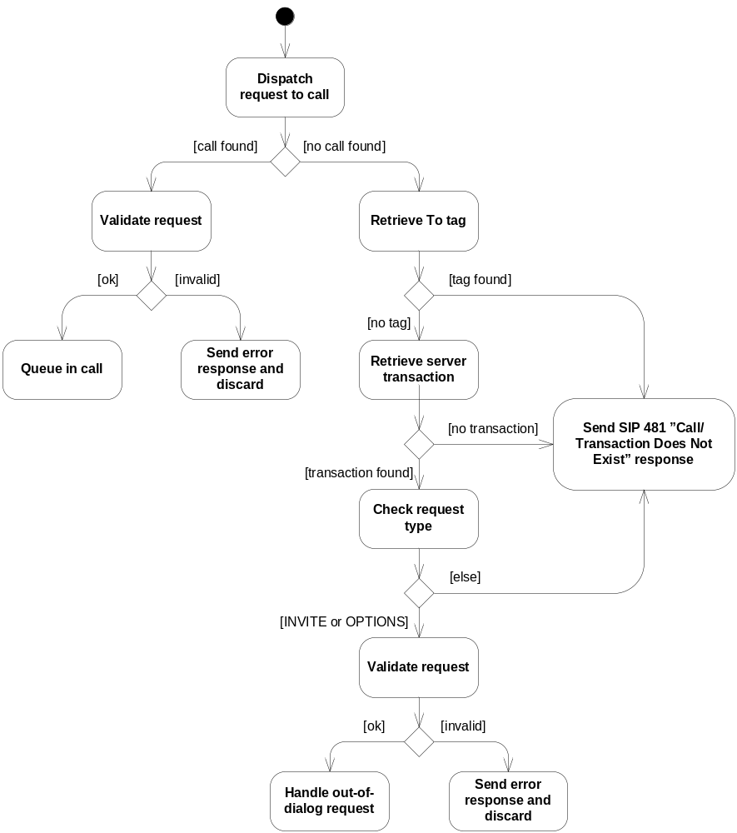
Figure 9 Handling of SIP requests
The request validation is done as described in the table below.
Table 59 Sip request validation
Condition | Action
Request method is known but not allowed, i.e. REGISTER or INFO | Send SIP 405 “Method Not Allowed” response.
Request method is unknown, i.e. differs from INVITE, ACK, BYE, CANCEL, OPTIONS, REGISTER or INFO | Send SIP 501 “Not Implemented” response.
To-header is invalid. | Send SIP 403 “Forbidden” response.
Unsupported URI scheme in Request-URI. | Send SIP 416 “Unsupported URI Scheme” response.
Request-URI is invalid. | Send SIP 404 “Not Found” response.
Unsupported extension is required. | Send SIP 420 “Bad Extension” response.
Unsupported Content-Language, Content-Encoding or Content-Type. | Send SIP 415 “Unsupported Media Type” response.
For information on what is not supported, see [2].
The figure and table above lists situations in which a SIP error response is sent for the request. If the request is a SIP ACK a response is not sent. The SIP ACK is simply ignored.
Only SIP INVITE and SIP OPTIONS are handled out-of-dialog. An out-of-dialog SIP INVITE results in a new inbound call being created (dependant of course on the administrative and load regulation states). An out-of-dialog SIP OPTIONS is handled in the same way as the INVITE with the exception that no new inbound call is created.

SIP stack configuration
The table below lists how the SIP stack is configured by CM.
Table 60 SIP stack configuration
Stack property | Value
javax.sip.IP_ADDRESS | Host name given when CM service is initialized.
javax.sip.STACK_NAME | "NISTv1.2"
javax.sip.RETRANSMISSION_FILTER | true  (Indicates that the SIP stack should handle retransmissions normally handled in the forth SIP layer; Transaction User.)
gov.nist.javax.sip.TRACE_LEVEL | 0
gov.nist.javax.sip.CACHE_SERVER_CONNECTIONS | false  (Caching boosts performance but opens up to possible TCP based Denial of Service attacks. It is therefore turned off.)
gov.nist.javax.sip.CACHE_CLIENT_CONNECTIONS | false  (Caching boosts performance but opens up to possible TCP based Denial of Service attacks. It is therefore turned off.)
gov.nist.javax.sip.READ_TIMEOUT | 1000  (This is a guard against TCP read starvation.)
gov.nist.javax.sip.REENTRANT_LISTENER | true  (Indicates that the listener (in this case CM) is re-entrant. It improves performance.)
gov.nist.javax.sip.THREAD_POOL_SIZE | 8  (Limits the thread pool size to improve performance.)
gov.nist.javax.sip.T2 | Configured value.
gov.nist.javax.sip.T4 | Configured value.
gov.nist.javax.sip.TIMER_B | Configured value.
gov.nist.javax.sip.TIMER_C | Configured value.
gov.nist.javax.sip.TIMER_D | Configured value.
gov.nist.javax.sip.TIMER_F | Configured value.
gov.nist.javax.sip.TIMER_H | Configured value.
gov.nist.javax.sip.TIMER_J | Configured value.

Statistics calculation
CM collects the statistics specified in [1]. CM calculates the statistics based on the events it generates. The table below indicates how statistics is affected due to events.
Table 61 Statistics calculation depending on events
Event | Updated statistics
Statistics event | - Current calls for call type unknown are incremented by one.
Failed event | - Abandoned Rejected calls are incremented by one if the Failed event indicates that the call is far or near end abandoned. Otherwise Rejected calls are incremented by one.  - Current calls for call type unknown are decremented by one.
Error event | - If the call is not already connected or disconnected (i.e. not in states Connected, Failed, Error, or Disconnected) the Current calls for call type unknown are decremented by one and the Rejected calls are incremented by one.  - If the call is connected but not already disconnected (i.e. not in states Failed, Error, or Disconnected) the Current calls for the call type voice or video are decremented by one and Near End Disconnected calls are incremented by one.  - Errors are incremented by one.
Disconnected event | - If the call is not already disconnected (i.e. not in states Failed, Error, or Disconnected) one of Far End Disconnected calls, Near End Disconnected calls, and Abandoned calls is incremented by one depending upon the reason for the failed event.  - If the call has been connected, Current calls for the call type voice or video are decremented by one. Otherwise the Current calls for call type unknown are decremented by one.
Connected event | - Current calls for the call type unknown are decremented.  - Current calls for the call type voice or video are incremented by one.  - Connected calls are incremented by one.
Dropped Packets event  (this is a CM internal event generated when the inbound media stream is deleted) | - Dropped packets are incremented with the amount of dropped packets for the inbound stream during the entire call duration.
When the new call is initiated, the call type is not yet determined. Therefore a Statistics event is generated so the counter for current calls can be increased. When the call type is determined, a Connected event is generated. At this time the statistics is updated with the call type, i.e. the counter for unknown call type is decreased and the counter for voice or video calls is increased.

Threads and event queues
Currently CM uses a thread pool to receive threads in the following situations:
- One for each event queue type; i.e. one for the event queue in the controller, one for the event queue in the calls and one for the event queue in the SSP instances.
- One for global event handling. (Currently only the Configuration Changed event is handled.)
- One for statistics calculation.
An event queue guarantees that the events on the queue are handled in the same order they arrive and that one event is handled at a time (i.e. only one thread at a time handles events from the queue).

Configuration
Each time the configuration is loaded (at initialization and reload config) a new configuration container is created and the configuration variables are stored in it. When CM uses configuration values, it first gets the configuration container from the configuration reader and then reads the values from the configuration container. There are three reasons for this implementation:
- When reading configuration values, there is no need to handle exceptions issued from the configuration component. They are already handled by the configuration reader when it initializes the configuration container.
- To be able to hold two separate views of the configuration when the configuration changed. Active calls keep the old configuration container while new calls get a new.
- The configuration container has setters for all configuration values, so when writing test cases, it is possible to modify some configuration values at runtime. This cannot be done if values are always read from configuration component classes.

Reliable provisional responses

Inbound calls
Whether or not provisional responses shall be sent reliably depends upon the content of a received SIP INVITE request in combination with configuration.
If an inbound SIP INVITE request indicates that the extension “100rel” is required (using the Require header field), CM sends all non-100 provisional responses reliably.
If an inbound INVITE indicates that the extension “100rel” is supported but not required (using the Supported header field), CM looks at a configuration parameter in order to determine whether to send non-100 provisional responses reliably or not. The configuration can have three values: send all unreliably, send all reliably or to send only those carrying SDP information reliably.

Outbound calls
It is the remote party that decides if a provisional response shall be sent reliably or not for a SIP INVITE request initiated by CM. In the outbound SIP INVITE, CM indicates that the extension “100rel” is supported (using the Supported header field) but not required. When CM receives a provisional response sent reliably, a PRACK request is sent to acknowledge the response.

Third-Party Products and external interfaces

Third-Party Products and Freeware

Product name | Product version | Company | License | Delivered with the component | ECCN US/EU | Product No. and R-state
XML Beans | 2.1.0 | Apache Software Foundation. | Apache | Yes | EAR99/0 | SWF0033R2A
Used for generation and parsing of media control XML documents in SIP messages.
NIST-SIP | 1.2 | National Institute of Standards and Technology | Public domain (Not copyrighted) | Yes | EAR99/0 | SWF0054R1A
SIP stack.

External Products

Product Name | Company | Used for | Version of the integration tested product

External Protocols

Product Name | Specification | Used for | Version of the protocol

References
- FS – Call Manager
8/FS-MAS0001
- IWD SIP
7/IWD-1/HDB 101 02
- NIST SIP
http://www-x.antd.nist.gov/proj/iptel/
- JAIN SIP API (JSR 32)
http://www.jcp.org/en/jsr/detail?id=32
- JAIN SDP API (JSR 141)
http://www.jcp.org/en/jsr/detail?id=141
- SIP: Session Initiation Protocol
RFC 3261
http://ietf.org/rfc/rfc3261.txt?number=3261
- CCXML 1.0 specification (working draft)
http://www.w3.org/TR/CCXML/
(as of 2005-08-23)

Terminology
CCXML Call Control XML
CM Call Manager component
FSA Finite State Automaton
JIT Just-in-time compilation
JVM Java Virtual Machine
OMM Operate and Maintain Manager
SDP Session Description Protocol
SIP Session Initiation Protocol
VFU Video Fast Update

