FD – Message Sender

Content
1 Introduction 2
2 Function Structure 2
2.1 Overview 2
2.2 Interface layer 3
2.2.1 Implemented interfaces 3
2.3 Session layer 4
2.3.1 Implemented interfaces 4
2.3.2 Static imports/injected dependencies 4
2.4 Networking layer 4
3 Function Behavior 4
3.1 Message integrity 4
3.2 Sending Internet mail 4
3.2.1 SMTP retries 5
3.2.2 Check current configuration 6
3.2.3 Choosing SMTP host 6
3.2.4 Connect to SMTP service 7
3.2.5 Sending message 7
3.2.6 Closing connection 7
3.2.7 Error handling 7
3.2.8 Configuration 7
3.3 Socket Options 8
4 References 8
5 Terminology 8
6 Appendix B: 3PPs 9
6.1 Third-Party Products and Freeware 9

History

Version | Date | Adjustments
A | 2006-10-03 | First version. (MANDE)

Introduction
Message Sender is a MAS software component providing an interface for sending MIME messages using SMTP for message submission and transport.

Function Structure

Overview
Message sender has a layered structure. Interface layer, Session layer and Networking layer. All layers accept a RFC822 MIME message implemented as a JavaMail Message.
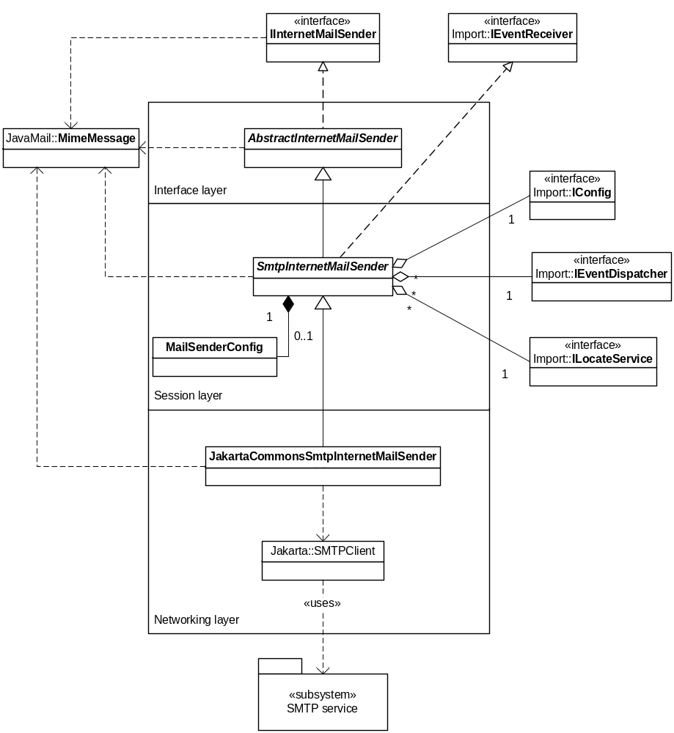
Figure 1 Structure of Message Sender

Interface layer
The interface layer provides the IInternetMailSender interface. Informational logging of interface method calls and return values is carried out in the interface layer.

Implemented interfaces
- IInternetMailSender

Session layer
In the session layer accurate system resources (configuration and SMTP service instance) are allocated for every call to the Message Sender.

Implemented interfaces
- IEventReceiver

Static imports/injected dependencies
- IConfig for configuration.
- ILocateService for locating SMTP service and reporting service errors.
- IEventDispatcher for registering IEventReceiver.

Networking layer
In the Networking layer is the actual SMTP network interaction takes place. The networking layer is implemented with an open source SMTP socket client API.

Function Behavior

Message integrity
The message will in most cases be untouched by the layer and preserved as the caller passed it.
The exception is when a “To” header contains an email address without a domain, e.g. “notification.off”. Message sender will add the receiving mail host as domain to such addresses before sending the message. These addresses will also be used as the RCPT TO header in the SMTP envelope.

Sending Internet mail
Message Sender receives a MIME message from calling object and deals with the transportation over SMTP to message destination.
The Message Sender basically performs the following steps:
- Check current configuration.
- Choose SMTP host.
- Connect to SMTP service at chosen host.
- Send message.
- Close connection.

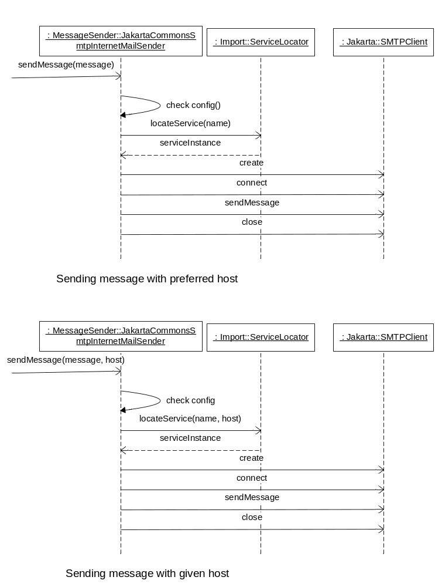
Figure 2 Sending a message with preferred and given host

SMTP retries
If error occurs during step 2-4 Message Sender does a configurable number of retries of step 2-4 until step has passed. If none of the retries are successful the error will be propagated back to the calling object.
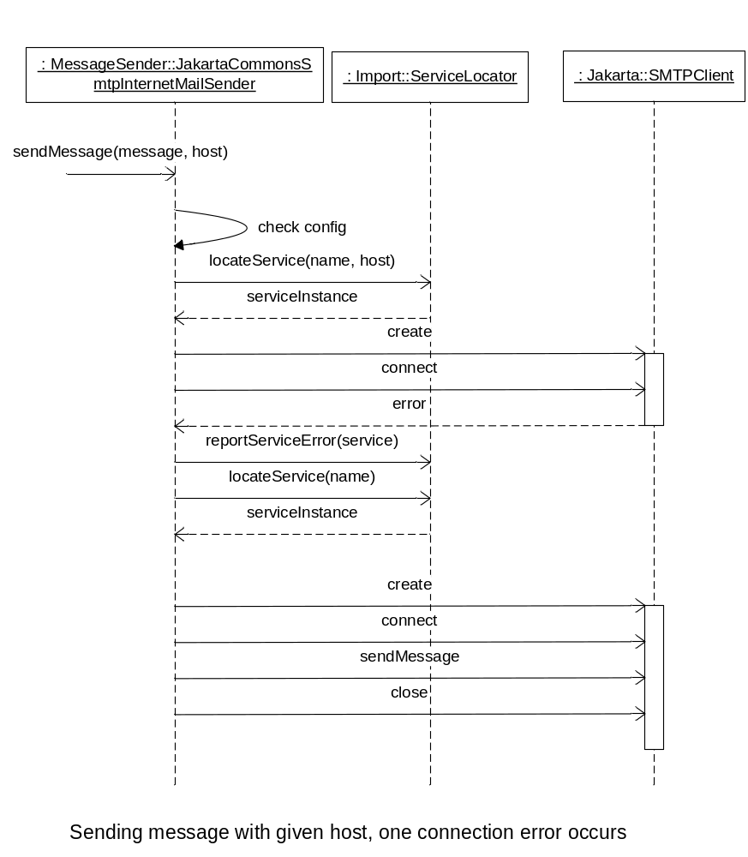
Figure 3 Sending a message with retry

Check current configuration
For each call to send a message, Message Sender checks if it has a Configuration object. If not – the latest Message Sender configuration group is fetched from the injected IConfiguration object and a new Configuration object is constructed. The configuration group is then used to initialize the new Configuration object.

Choosing SMTP host
Message Sender needs a SMTP service to be able to send messages. Calling object may explicitly specify the SMTP host to use. Then Message Sender calls the injected ILocateService object to obtain that specific service instance. If no host is specified by calling object Message Sender calls the injected ILocateService object to obtain a preferred host.

Retry situation
If error has occurred during an earlier try to send the message and the choosing step is done for a retry – a preferred host is always located no matter if a host was specified by the calling object in the first place.

Connect to SMTP service
Message Sender creates a new SMTP client object and connects to the SMTP service at the chosen host.

Sending message
If the SMTP service connection was successful Message Sender starts the SMTP interaction with the service to send the MIME message.

Data terminating dot timeout
The sending step is considered complete if the SMTP data terminating dot is sent. The response from terminating data may timeout. If so - then it is not considered as an error but is Message Sender internally reported as a “likely” success.

Closing connection
Upon a successful termination of data the SMTP service connection is closed.

Closing connection timeout
The response from closing the connection may timeout. If so - then it is not considered as an error but is Message Sender internally reported as a “likely” success.

Error handling
There are several possible errors that can occur during the sending process:
- Connection failure due erroneous SMTP service.
- Connection failure due timeout.
- SMTP Command failures due server problems.
- SMTP Command permanent failures.
- SMTP Command failures due timeout.
When an error occurs (in step 2-4) the error is logged and the service instance is reported as erroneous to the injected ILocateService object and retries is performed as described in 3.2.1

Configuration
Message Sender has the below configuration possibilities. Configuration may be changed during runtime. If Message sender receives an event that configuration has changed, it simply removes its Configuration object. Next time step 1 in the sending process is reached the latest configuration will be loaded.

Setting | Description | Default
SMTP Service name | The name to use for locating a SMTP service with the ILocateService | smtpstorage
Connection timeout | Service socket connection timeout value in milliseconds. | 3000 ms
SMTP timeout | Socket I/O timeout value in milliseconds. | 3000 ms
SMTP retries | Number of attempts to send the message before propagating the errors to calling object | 3

Socket Options
Message Sender has two SMTP socket options. These are implemented as settable properties on the JakartaCommonsSmtpInternetMailSender class.
- SO-Linger time (default value = 5 seconds)
- TCP No delay (default value = false)

References
- TR-FS MessageSender
6/FS-MAS0001 Uen
- JavaMail
http://java.sun.com/products/javamail/
- RFC 822
http://www.ietf.org/rfc/rfc0822.txt
- RFC 2821
http://www.ietf.org/rfc/rfc2821.txt

Terminology
MIME Multipurpose Internet Mail Extension
SMTP Simple Mail Transfer Protocol

Appendix B: 3PPs

Third-Party Products and Freeware
3PPName/ Freeware Name | Version of the product/ freeware | Company | Used for | Delivered with the component | ECCN US/EU | Product No. and R-state
JavaMail API | 1.3.3 | Sun Microsystem, inc | Hold Mime formatted messages. | Yes | 5D002 | SWF0004R1C
JavaBeans Activation Framework | 1.0.2 | Sun Microsystem, inc | Needed by JavaMail. | Yes | 5D002 | SWF0007R1A
Jakarta Commons Net | 1.4.1 | Apache | Sending Mime messages with SMTP | Yes | EAR99 | SWF0066R1A

