FS – Call Manager

Content
1 Introduction 4
1.1 How to read this document 4
2 Definitions 5
2.1 Sessions and Calls 5
2.2 User Agents (UA) 5
2.2.1 User Agent Client (UAC) 5
2.2.2 User Agent Server (UAS) 6
2.3 SIP Serving Proxy (SSP) 6
2.4 Call Client (CC) 6
2.5 Service Enabler 6
3 Function Requirements (Commercial) 6
4 Function Specification (Design Related) 7
4.1 Introduction 7
4.2 Exported Interfaces 7
4.2.1 SIP Interface (SIP) 8
4.2.1.1 Functions 8
4.2.1.2 Parameter type description 8
4.2.1.2.1 Sip data 8
4.2.1.2.2 Sdp data 8
4.2.1.2.3 Gtd data 8
4.2.2 The Call Manager Interface 9
4.2.2.1 Functions 9
4.2.2.1.1 createCall 9
4.2.2.1.2 join 9
4.2.2.1.3 unjoin 9
4.2.2.1.4 setApplicationManagement 10
4.2.2.1.5 setSupervision 10
4.2.2.1.6 sendSipMessage 10
4.2.2.2 Parameter type description 10
4.2.2.2.1 Application management 10
4.2.2.2.2 Call 10
4.2.2.2.3 Call Properties 10
4.2.2.2.4 Event dispatcher 11
4.2.2.2.5 Session 11
4.2.2.2.6 Supervision 11
4.2.2.2.7 Method 11
4.2.2.2.8 Method parameters (for the MWI method) 11
4.2.3 The Inbound Call Interface 12
4.2.3.1 Functions 12
4.2.3.1.1 accept 12
4.2.3.1.2 reject 12
4.2.3.1.3 negotiateEarlyMediaTypes 12
4.2.3.1.4 disconnect 13
4.2.3.1.5 play 13
4.2.3.1.6 record 13
4.2.3.1.7 stopPlay 13
4.2.3.1.8 stopRecord 13
4.2.3.1.9 getCallType 13
4.2.3.1.10 getCallingParty 13
4.2.3.1.11 getCalledParty 14
4.2.3.1.12 getRedirectingParty 14
4.2.3.1.13 getProtocolName 14
4.2.3.1.14 getProtocolVersion 14
4.2.3.1.15 getFarEndConnections 14
4.2.3.2 Parameter type description 14
4.2.3.2.1 Cursor 14
4.2.3.2.2 Id 14
4.2.3.2.3 Play Media Object 14
4.2.3.2.4 Play Options 14
4.2.3.2.5 Record Media Object 14
4.2.3.2.6 Record Properties 15
4.2.4 The Outbound Call Interface 15
4.2.4.1 Functions 15
4.2.4.1.1 disconnect 15
4.2.4.1.2 sendToken 15
4.2.4.1.3 play 15
4.2.4.1.4 record 16
4.2.4.1.5 stopPlay 16
4.2.4.1.6 stopRecord 16
4.2.4.1.7 getCallType 16
4.2.4.1.8 getCallingParty 16
4.2.4.1.9 getCalledParty 16
4.2.4.1.10 getProtocolName 16
4.2.4.1.11 getProtocolVersion 17
4.2.4.1.12 getFarEndConnections 17
4.2.4.2 Parameter type description 17
4.2.4.2.1 Control Token array 17
4.2.4.2.2 Cursor 17
4.2.4.2.3 Id 17
4.2.4.2.4 Play Media Object 17
4.2.4.2.5 Play Options 17
4.2.4.2.6 Record Media Object 17
4.2.4.2.7 Record Properties 17
4.2.4.2.8 Transfer Type 17
4.2.5 The Video Fast Updater Interface 17
4.2.6 The Service Enabler Interface 18
4.2.7 The Service Enabler Operate Interface 18
4.2.8 The Diagnose Service 18
4.3 Imported interfaces 18
4.4 Events 19
4.4.1 Generated 19
4.4.1.1 Alerting 19
4.4.1.2 Connected 19
4.4.1.3 Disconnected 19
4.4.1.4 Early Media Available 19
4.4.1.5 Early Media Failed 19
4.4.1.6 Error 19
4.4.1.7 Failed 20
4.4.1.8 Joined 20
4.4.1.9 Join Error 20
4.4.1.10 Not Allowed 20
4.4.1.11 Play Failed 20
4.4.1.12 Progressing 20
4.4.1.13 Record Failed 20
4.4.1.14 Send Token Error 21
4.4.1.15 Unjoined 21
4.4.1.16 Unjoin Error 21
4.4.1.17 Send SIP message response 21
4.4.2 Consumed 21
4.4.2.1 Configuration has changed 21
4.4.2.2 Abandoned Stream Detected 21
4.5 Function Specification 21
4.5.1 Scenarios 21
4.5.1.1 Initialization of the service enabler 23
4.5.1.2 Inbound call 23
4.5.1.2.1 Without early media 23
4.5.1.2.2 With early media 25
4.5.1.3 Outbound calls with or without early media 27
4.5.1.3.1 Without early media 28
4.5.1.3.2 With early media 29
4.5.1.4 Join/Unjoin of two calls 30
4.5.1.5 Reject an inbound call 30
4.5.1.6 Rejected outbound call 31
4.5.1.7 Inbound call with unsupported media 32
4.5.1.8 Outbound call with unsupported media 34
4.5.1.9 Media renegotiation 34
4.5.1.10 Disconnect a call 34
4.5.1.11 Send outbound DTMF 36
4.5.1.12 Play outbound media 36
4.5.1.13 Record inbound media 37
4.5.1.14 Register/Unregister 37
4.5.1.15 Operational administration 39
4.5.1.15.1 Open 39
4.5.1.15.2 Forced Close 39
4.5.1.15.3 Unforced Close 39
4.5.1.16 Load regulation 40
4.5.1.17 Collecting Statistics 40
4.5.1.18 Failure 42
4.5.1.19 Diagnose Service 42
4.5.1.20 Send SIP Message Waiting Indicator (SIP MWI) 43
4.5.1.21 Send SIP Message Waiting Indicator (SIP MWI) with timeout 44
4.5.2 Session data variables 44
4.5.2.1 Session creation 44
4.5.2.2 Media negotiation 45
4.5.3 Mapping of release cause to Network Status Code 45
4.5.4 Final response handling for outbound calls 46
4.5.5 Compliance to SIP 46
4.5.6 Loop Back Prevention 46
4.5.7 Media Negotiation 47
4.5.7.1 Local SDP creation 47
4.5.7.1.1 Inbound call type 47
4.5.7.1.2 Outbound call type 47
4.5.7.2 Media negotiation failure for inbound calls 48
4.5.7.3 Media negotiation failure for outbound calls 48
4.5.8 Video Fast Update 48
4.5.9 Detection of Outbound Media Connection Already in Use 48
4.5.10 Service loading 48
4.5.11 Logging 48
4.5.11.1 Session logging 48
4.5.11.2 Info logging 49
4.5.12 Protocol Encapsulation 50
4.5.13 Configuration 50
4.5.13.1 Call Related 50
4.5.13.2 Remote Party 50
4.5.13.3 Media Related 51
4.5.13.4 Release Cause Mapping 51
4.5.13.5 Diagnose Service 51
4.5.13.6 Load Regulation 51
5 References 51

History
Version | Date | Adjustments
A | 2006-10-03 | First revision (MMAWI)
B | 2006-12-07 | Added requirement for far end connections.  Minor changes in O&M and Call interfaces.  Minor changes in statistics.  Handle SIP Reason header field with Q.850 cause/location for ViG support.
C | 2007-06-11 | GTD processing is supported. CallManager no longer waits a short time after “close(unforced)” before unregistering from SSP; now unregistering is done immediately. Updates on: service loading, PRACK, load regulation, CallManager interface (ermkese, mmath)
D | 2008-08-05 | Chapter 4.5.13.3 updated to reflect that ptime configuration was moved to Stream.  Updated for RTCP video fast update, FE27 Orange (ematha/estberg).

Introduction
This document specifies the functionality of the Call Manager (CM) component.

How to read this document
This document draws heavily on SIP call scenarios. The amount of call scenarios and variations of those are many and this function specification defines the most common and important ones. However CM must follow the guidelines for a UA in the SIP specification, see [5], where the complete set of scenarios are defined. Those scenarios deal mainly with how to respond, what to do when a certain response arrives and deals also with timeout of requests etc. CM must follow them all and handle all SIP requests and respond in a known way.
All sequence diagrams in this document are on a conceptual level meaning that the exact order of events, especially those dealing with the timings of call control and media stream creations are implementation dependant.

Definitions
This chapter defines some of the terms used in this document to help understand the functional specification and create a common view of the terms used. All figures unless specified otherwise uses the UML 2.0 notation.

Sessions and Calls
A session is associated with zero or more calls. Typically there is only one call associated with a session but one session can have more than one call as in the case when dealing with call transfer.
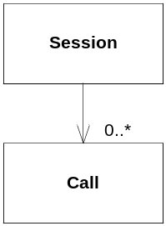
Figure 1 Session and call relationship
The Call is the actual SIP connection between UA:s and in the case of a call transfer (when two calls exist); between the originating UA to CM and from CM to the originated UA. All calls are equivalent to CM. If any call should have precedence over other calls, it is up to the call client (CC).
A Call is referred to as a dialog (or call leg) in the SIP standard, see [5].

User Agents (UA)
As defined by the SIP standard, see [5], user agents (UA) are the endpoints communicating with each other. A UA can be of two types, a user agent client (UAC) or a user agent server (UAS).

User Agent Client (UAC)
A UAC is a UA that creates and sends a SIP request. The user agent has the role of a user agent client for the duration of that initiated transaction. If the user agent receives a SIP request later, it assumes the role of a user agent server for that transaction.

User Agent Server (UAS)
A UAS is a UA that generates a response to a SIP request. The response accepts, rejects or redirects the request. This role lasts only for the duration of that transaction (initiated by the UAC). If the user agent generates a SIP request later, it assumes the role of a user agent client for that transaction.

SIP Serving Proxy (SSP)
A SIP Serving Proxy works in this context as a SIP registrar and as a SIP redirecting server as defined in the SIP standard, see [5].
The registrar service handles registrations of active UA:s and maintains a list of those UA:s used by the redirection service of the SSP.
The redirection service redirects incoming SIP INVITES to the correct UAS by examining the incoming INVITE and selecting the UAS from the list maintained by the registrar service.
For a full function specification of the SIP Serving Proxy, see [1].
The SSP is also used by CM as redirecting server when initiating outbound calls.

Call Client (CC)
A Call Client (CC) is a component using CM in order to receive inbound calls and initiate outbound calls.

Service Enabler
A Service Enabler is a part of a system that implements a protocol server to be used to access a service. CM is a service enabler that allows services in the system it is used in to be access through the SIP protocol.

Function Requirements (Commercial)
The following commercial requirements have been identified.
- The Call Manager component must support the SIP protocol for session initiation, see [5].
- The Call Manager component must support the SDP protocol for media negotiation, see [5].
- The Call Manager component must support the offer/answer model in SDP, see [5].
- The Call Manager component must be able to handle the tel URL, see [5].
- The Call Manager component must support the Cisco Gateway (as used in the MTG-C).
- The Call Manager component must support the Radvision Video Gateway.

Function Specification (Design Related)

Introduction
The Call Manager Component, CM, provides the functionality to handle in- and outbound calls using SIP. It is also responsible for maintaining call state, media negotiation and to initiate media stream creation.
The CM is considered to be both a UAC and a UAS.
The CM is also considered to be a Service Enabler as defined in
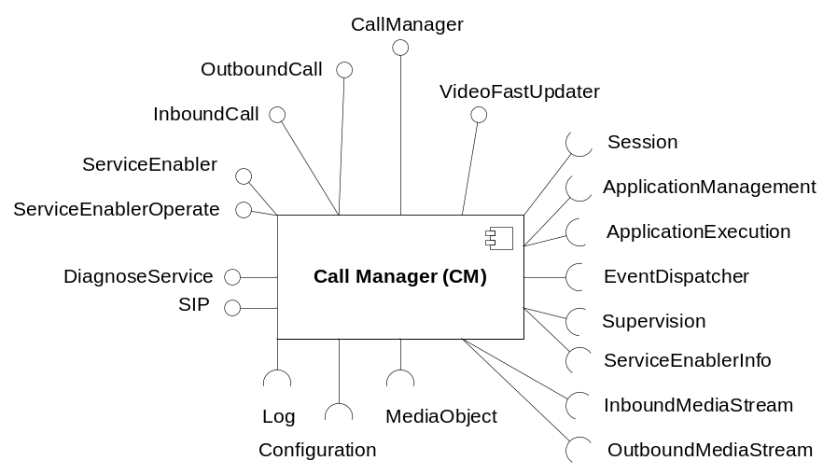
Figure 2 The Call Manager component

Exported Interfaces
CM has the following exported interfaces:
- The SIP interface is the interface towards the phone network via the SIP Serving Proxy (SSP), and the SIP gateway.
- The CallManager, InboundCall, and OutboundCall interfaces where a call is controlled with for example accept or disconnect.
- The VideoFastUpdater interface is used to request CM to send a video fast update request over SIP or to request Stream to send it over RTCP. This interface is defined by [3].
- The ServiceEnabler interface is for controlling the service enabler aspect of CM, e.g. initialize it when it should be used. This interface is defined by [2].
- The ServiceEnablerOperate interface is for operational administration of a service enabler, for example open, close and load regulation. This interface is defined by [4].
- The DiagnoseService interface is for diagnosing the service enabled by CM. This interface is defined by [4] and is completely separate from the other CM functionality in order to not affect normal CM behavior. Thus, the implementation of this interface is distributed separate from all other CM functionality.

SIP Interface (SIP)
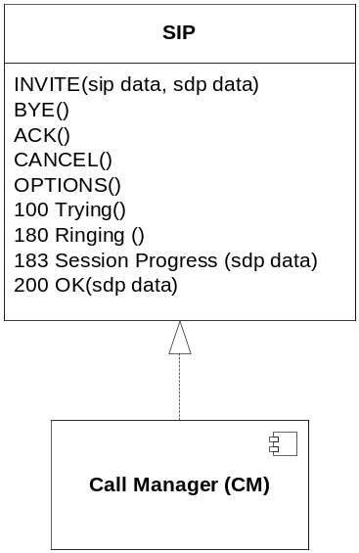
Figure 3 The SIP interface
Through this interface external UA:s can use functions in CM and CM can use functions in external UA:s and an SSP. The figure above illustrates some of the functions in this interface (especially those used in the sequence diagrams in section 4.5.1). For a full description of the SIP protocol see [5].

Functions
For a list of all possible SIP requests and responses, see the SIP Protocol described in [5].

Parameter type description

Sip data
This is the data contained in the SIP header of any request or response. For a full description see the SIP Protocol described in [5].
Necessary parts of this data are made available to the CC.

Sdp data
This is the data contained in the SDP attachment in a SIP request or response. It contains media related information.
For a full description of the SDP see [5].

Gtd data
This is a proprietary data used to convert ISDN data to SIP. It is optional. It contains information about the involved parties. See ref. [13]

The Call Manager Interface
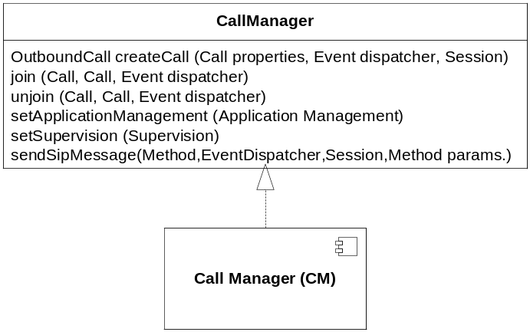
Figure 4 The Call Manager interface
This interface provides call management functionality not related to an active call.

Functions

createCall
OutboundCall createCall (Call properties, Event dispatcher, Session)
This function is used by CC to make an outbound call using the given call properties. This method creates an outbound call and initiates the call setup. The new outbound call is returned.
Zero or more Progressing events (see section 4.4.1.11) and eventually also a Connected event (see section 4.4.1.2) is generated as a result of the call setup. If the call setup cannot be performed due to the load situation, a Failed event is generated. The first event may be generated before this function returns and the CC must be able to handle that.
The media properties to use for the outbound call are retrieved from the given session as described in section 4.5.7.
The given event dispatcher indicates which event dispatcher to use when issuing call related events to the CC.

join
join (Call, Call, Event dispatcher)
This function is used by CC to join two calls together. The media streams of the two calls are joined full duplex. If the calls were joined ok a Joined event (see section 4.4.1.8) is generated, otherwise a Join Error event (see section 4.4.1.9) is generated. The events are sent using the event dispatcher.

unjoin
unjoin (Call, Call, Event dispatcher)
This function is used by CC to unjoin two calls that was previously joined. The media streams of the two calls are unjoined full duplex. If the calls were unjoined ok an Unjoined event (see section 4.4.1.15) is generated, otherwise an Unjoin Error event (see section 4.4.1.16) is generated. The events are sent using the event dispatcher.

setApplicationManagement
setApplicationManagement (Application management)
This function shall be used by CC before initializing the service enabler, see section 4.2.5. It sets the application management that is used by CM when a service instance shall be loaded due to a new inbound call.

setSupervision
setSupervision (Supervision)
This function shall be used by CC before initializing the service enabler, see section 4.2.5. It sets the supervision object that is used by CM to report statistics.

sendSipMessage
sendSipMessage (Method, EventDispatcher, Session, Method parameters)
This method is used by CC to send a SIP message. This method creates a SIP request using the provided method and method parameters, sends it to the configured sip proxy and waits for a response. Currently only a method for message waiting indication (MWI) is supported.
One Send Sip Message Response Event is generated as a result of the sent request. A SIP OK response, SIP Error response or SIP timeout will all generate the same kind of event. The event may be generated before this function returns and the CC must be able to handle that.
The session is used for logging purposes.
The given event dispatcher indicates which event dispatcher to use when issuing call related events to the CC.

Parameter type description

Application management
The Application Management interface is specified in [2] and is used to load a new service instance due to an inbound call.

Call
The call parameter contains another call, either inbound or outbound.

Call Properties
Call properties contain calling party and called party in one of the following formats:
- Telephone number (format as specified in reference [8])
- SIP user (format as the user info part of a SIP or SIPS URI, see [5])
- URI (format as specified in [9])
For the calling party, the call data may also contain a presentation indication which can be Unknown, Allowed or Restricted.
The call properties also contains the max call duration, max waiting time before the call is connected and whether or not loop back prevention shall be done (see section 4.5.6).
Finally, the call properties contain the call type, i.e. whether it should be a voice or video call.

Event dispatcher
During the call, CM will send events to the CC in certain scenarios (see section 4.5.1). The events are sent using this event dispatcher. The event dispatcher is defined in [2].

Session
During the call, CM will retrieve and set data in the relating session. An example of this is when the media properties to use for the call are retrieved from the given session as described in section 4.5.7. The session is defined in [2].

Supervision
The Supervision interface is specified in [2] and is among other things used to report statistics.

Method
The method controls what kind of SIP message that is sent by the sendSipMessage method. Currently only a method for message waiting indication (MWI) is supported. The MWI method implies sending a SIP NOTIFY containing information for SIP MWI.

Method parameters (for the MWI method)
Method parameters are controlling the behaviour of the sendSipMessage method. The parameters are specific to a given method. The only method currently supported is message waiting indication (MWI). The method parameters for MWI contain information about:
- The receiver of the SIP MWI request.
- The mailbox that the MWI is for.
- The current MWI status flag (on/off).
- The number of new and old messages for different media types.

The Inbound Call Interface
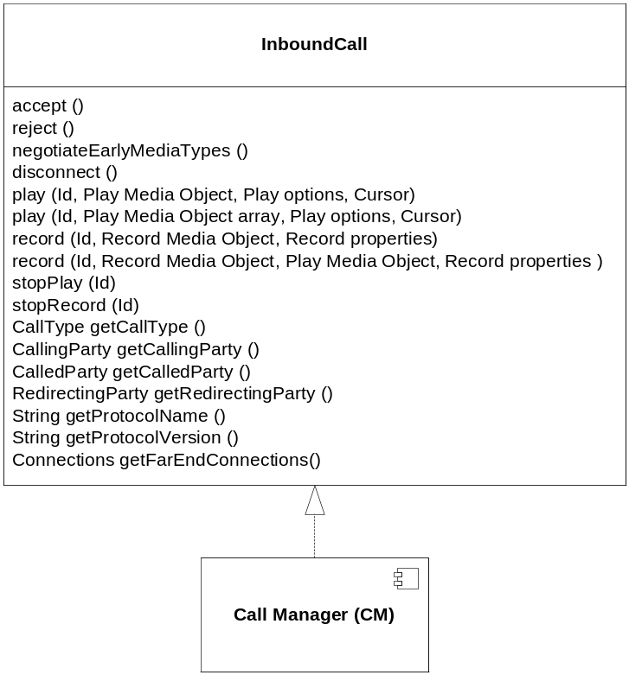
Figure 5 The Inbound Call interface
This interface provides call management related to an active inbound call.

Functions

accept
accept ()
This function is used to accept the inbound call. The media properties to use for the inbound call are retrieved from the given session as described in section 4.5.7.

reject
reject ()
This function is used to reject the inbound call before it is accepted.

negotiateEarlyMediaTypes
negotiateEarlyMediaTypes ()
This function is used to indicate to the inbound call that early media will be played and that which media types to use for the call must be negotiated now. The media properties to use in the negotiation for the inbound call are retrieved from the given session as described in section 4.5.7.
An Early Media Available event (see section 4.4.1.4) is generated when the negotiation has completed.

disconnect
disconnect ()
This function is used to disconnect a connected inbound call.
A Disconnected event (see section 4.4.1.3) is generated when the disconnect has completed.

play
play (Id, Play media object, Play option, Cursor)
play (Id, Play media object array, Play option, Cursor)
Plays the media object or an array of media objects on the call’s outbound stream using the play option and starts from the cursor. For further details on the play function, see [3].

record
record (Id, Record media object, Record properties)
record (Id, Record media object, Play media object, Record properties)
Records media received on the inbound stream and stores it in the provided record media object. The recording properties indicate how the recording is to be done with regards to for example silence detection.
If a play media object is included, it is played until end and then the audio recording starts. A video recording starts when a video fast update is received.
For further details on the record function, see [3].

stopPlay
stopPlay (Id)
The play matching the received Id is stopped.

stopRecord
stopRecord (Id)
The record matching the received Id is stopped.

getCallType
CallType getCallType ()
Returns the type of call, i.e. whether the call is a voice or a video call. The call type is not determined until the media is negotiated. This means that the call type shall not be retrieved until an Early Media Available or Connected event is received.

getCallingParty
CallingParty getCallingParty ()
Returns the calling party, i.e. the party that initiated the call.

getCalledParty
CalledParty getCalledParty ()
Returns the called party, i.e. the party that received the call.

getRedirectingParty
RedirectingParty getRedirectingParty ()
Returns the redirecting party, i.e. the party that redirected the call.

getProtocolName
String getProtocolName ()
Returns the name of the protocol used for call setup.

getProtocolVersion
String getProtocolVersion ()
Returns the version of the protocol used for call setup.

getFarEndConnections
Connections getFarEndConnections ()
Returns the far end connections of a call, i.e. the IP addresses and ports for all SIP and RTP connections. All far end connections are not determined until the outbound streams has been created. This means that the far end connections should not be retrieved until an Early Media Available or Connected event is received.

Parameter type description

Cursor
The cursor is described in [3].

Id
Id identifies a specific play or record request.

Play Media Object
A Play Media Object contains the actual media that will be played on the outbound stream (see [10] for details on the media object).

Play Options
The play options are described in [3].

Record Media Object
A Record Media Object contains the actual media that has been recorded from the inbound stream (see [10] for details on the media object).

Record Properties
The record properties are described in [3].

The Outbound Call Interface
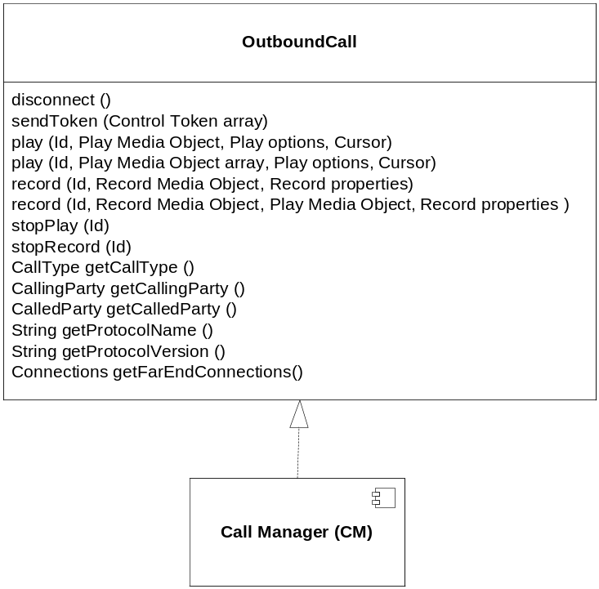
Figure 6 The Outbound Call interface
This interface provides call management related to an active outbound call.

Functions

disconnect
disconnect ()
This function is used to disconnect a connected outbound call.
A Disconnected event (see section 4.4.1.3) is generated when the disconnect has completed.

sendToken
sendToken (Control token array)
This function takes the control token and sends it according to the negotiated method, see section 4.5.1.11.

play
play (Id, Play media object, Play option, Cursor)
play (Id, Play media object array, Play option, Cursor)
Plays the media object or an array of media objects on the call’s outbound stream using the play option and starts from the cursor. For further details on the play function, see [3].

record
record (Id, Record media object, Record properties)
record (Id, Record media object, Play media object, Record properties)
Records media received on the inbound stream and stores it in the provided record media object. The recording properties indicate how the recording is to be done with regards to for example silence detection.
If a play media object is included, it is played until end and then the audio recording starts. A video recording starts when a video fast update is received.
For further details on the record function, see [3].

stopPlay
stopPlay (Id)
The play matching the received Id is stopped.

stopRecord
stopRecord (Id)
The record matching the received Id is stopped.

getCallType
CallType getCallType ()
Returns the type of call, i.e. whether the call is a voice or a video call. The call type is not determined until the media is negotiated. This means that the call type shall not be retrieved until a Connected event is received.

getCallingParty
CallingParty getCallingParty ()
Returns the calling party, i.e. the party that initiated the call.

getCalledParty
CalledParty getCalledParty ()
Returns the called party, i.e. the party that received the call.

getProtocolName
String getProtocolName ()
Returns the name of the protocol used for call setup.

getProtocolVersion
String getProtocolVersion ()
Returns the version of the protocol used for call setup.

getFarEndConnections
Connections getFarEndConnections ()
Returns the far end connections of a call, i.e. the IP addresses and ports for all SIP and RTP connections. All far end connections are not determined until the outbound streams has been created. This means that the far end connections should not be retrieved until a Progressing event indicating Early Media or a Connected event is received.

Parameter type description

Control Token array
The control token is specified in [3].

Cursor
The cursor is described in [3].

Id
Id identifies a specific play or record request.

Play Media Object
A Play Media Object contains the actual media that is played on the outbound stream (see [10] for details on the media object).

Play Options
The play options are described in [3].

Record Media Object
A Record Media Object contains the actual media that has been recorded from the inbound stream (see [10] for details on the media object).

Record Properties
The record properties are described in [3].

Transfer Type
The transfer type specifies if the transfer is blind or bridged (bridged is the only supported transfer so far).

The Video Fast Updater Interface
CM exports the VideoFastUpdater interface as defined in [3].
The VideoFastUpdater interface is used to instruct CM to request a Video Fast Update over SIP, or to instruct Stream to request it over RTCP.

The Service Enabler Interface
CM exports the ServiceEnabler interface as defined in [2].
The ServiceEnabler interface is for controlling the service enabler aspect of CM, e.g. initialize it when it should be used.

The Service Enabler Operate Interface
CM exports the ServiceEnablerOperate interface as defined in [4].
The ServiceEnablerOperate interface is for operational administration of a service enabler, for example open, close and load regulation. It is for example used to control the amount of active calls using a threshold indicator (see [4]). CM uses this threshold to regulate its load according to the method described in section 4.5.1.11.

The Diagnose Service
CM exports the DiagnoseService interface as defined in [4].
The DiagnoseService interface is for diagnosing the service enabled by CM. This interface is completely separate from the other CM functionality in order to not affect normal CM behavior. Thus, the implementation of this interface is distributed separate from all other CM functionality. How this interface is used is illustrated in section 4.5.1.16.

Imported interfaces
CM imports the following interfaces:
- The ApplicationManagement and ApplicationExecution interfaces (see [2]) are used by CM to load a service when an inbound call arrives.
- The Session interface (see [2]) is used to set/retrieve session information for a call.
- The EventDispatcher interface (see [2]) is used to generate call related events, e.g. that a call was disconnected.
- The InboundMediaStream and OutboundMediaStream interfaces (see [3]) are used to create media streams and to play and record media.
- The MediaObject interface (see [10]) is used when playing and recording media on the streams.
- The Supervision and ServiceEnablerInfo interfaces (see [4]) are used to report statistics.
- The Configuration interface (see [7]) is used to retrieve configuration.
- The Log interface (see [6]) is used to generate logging information.
Note that not all interfaces are used during the scenarios and sequences in this document. Configuration, logging and event dispatching are understood to be used whenever needed and not shown in the scenarios here.

Events
Any events generated or consumed by this component is sent or received through the event mechanism described in [2].

Generated

Alerting
This event is generated when a new inbound call has been created. It contains the new call.

Connected
This event is generated when a call has been connected and all media streams are available. It contains the affected call.

Disconnected
This event is generated when either party disconnects the call. It contains the affected call.
The event also contains the reason for the disconnect:
- Far end disconnect
- Near end disconnect
- Call abandoned by far end
The event also indicates if the call already was disconnected when the event occurred. This is the case if CC disconnects a call that already was disconnected by remote party.

Early Media Available
This event is generated when early media types have been negotiated for an inbound call and the call is now ready to be used to play media. It contains the affected call.
How CM selects the call media types to use is described in section 4.5.7.

Early Media Failed
This event is generated when early media cannot be negotiated for an inbound call due to the fact that the inbound INVITE contained no SDP offer. It contains the affected call. The call is still active and the CC can choose between continuing the call setup (although early media cannot be played) or to reject the call.

Error
This event is generated when an error occurs that causes the call to immediately disconnect. It contains the affected call, the direction of the call (inbound/outbound), whether the call already was considered disconnected when the event occurred, and an error message.

Failed
This event is generated when an outbound call has been rejected (i.e. disconnected before connected) by either the UAS or the UAC. It contains the affected call, the direction of the call (inbound/outbound) and an error message.
The event also contains the reason for the reject:
- Far end reject
- Near end reject
- Call abandoned by far end
- Call abandoned by near end
- Media negotiation failed
If the reason indicates a far end reject, the event also contains a Network Status Code (see [11]). The reason for the reject (indicated either by a SIP Reason header or by a SIP response code) that caused the reject is mapped to a Network Status Code through configuration as described in section 4.5.3

Joined
This event is generated when joining two calls was done successfully. It contains the two calls that were joined.

Join Error
This event is generated when joining two calls fails. It contains the two calls that should have been joined and an error message describing the error.

Not Allowed
This event is generated when CC makes a call requests that is illegal in the current call state, e.g. if the CC tries to accept an inbound call that already is connected. It contains the affected call and an error message.

Play Failed
This event is generated when playing media on an outbound stream fails, e.g. if the call was disconnected. The event is defined in [3].

Progressing
This event is generated when a progressing response (such as SIP 180 Ringing or SIP 183 Session Progress) is received for an outbound call. It contains the affected call and whether or not early media is available for the call.

Record Failed
This event is generated when recording media from an inbound stream fails, e.g. if the call was disconnected. The event is defined in [3].

Send Token Error
This event is generated when sending tokens on an outbound call fails. It contains the affected call.

Unjoined
This event is generated when unjoining two calls was done successfully. It contains the two calls that were unjoined.

Unjoin Error
This event is generated when unjoining two calls fails, e.g. if the calls are already unjoined. It contains the two calls that should have been unjoined and an error message describing the error. If unjoin fails, the two calls are treated as unjoined henceforth.

Send SIP message response
This event is generated as a result of the sendSipMessage method. The event corresponds to a successful SIP response, a SIP error response or a SIP timeout. The event will contain the received SIP response code. If the sent SIP request resulted in a timeout it is regarded as if a 408 Request Timeout was received.

Consumed

Configuration has changed
This event is consumed by the CM and signals that CM must reread its configuration. This event is defined in [7].

Abandoned Stream Detected
This event is consumed by CM and signals that the inbound RTP stream of a call has been abandoned. CM will disconnect the call. This event is defined in [3].

Function Specification

Scenarios
The following scenarios are described:
- Initialization of the service enabler
- Inbound call with and without early media
- Outbound call with and without early media
- Join/unjoin of two calls
- Reject inbound call
- Rejected outbound call
- Inbound call with unsupported media
- Outbound call with unsupported media
- Media renegotiation
- Disconnect call
- Send outbound DTMF
- Play outbound media
- Record inbound media
- Register/Unregister
- Operational administration
- Load regulation
- Collecting statistics
- Error handling
- Diagnose service
To be able to describe the scenarios a SIP gateway, a SIP Serving Proxy (SSP), a Call Client (CC), an Operate & Maintain Client (OMC), and a Stream component (SC), are introduced as endpoints to the CM interfaces.
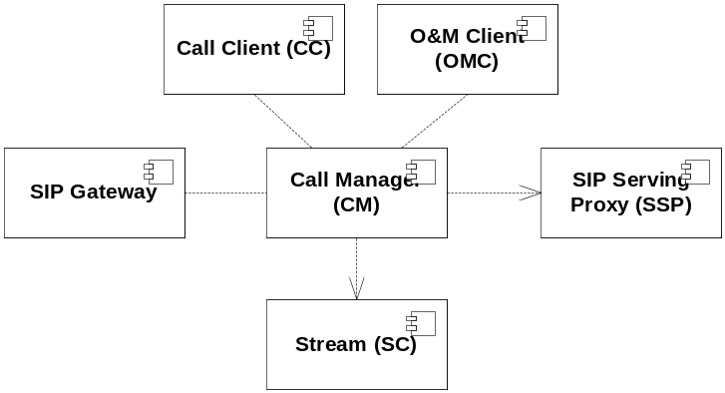
Figure 7 Call Manager dependencies
CM needs a SIP Gateway, CC, OMC, SSP and a SC as shown in the figure above. The CC uses most of CM’s interfaces and provides the ApplicationManagement, ApplicationExecution, Session and EventDispatcher interfaces. The OMC uses the ServiceEnablerOperate, and DiagnoseService interfaces and provides the Supervision interface. The SC provides the InboundMediaStream and OutboundMediaStream interfaces. The SSP provides the SIP interface for load balancing and to redirect inbound and outbound calls. Finally, the SIP Gateway provides and consumes the SIP interface for call control.
Note! that PRACK is not included in the described scenarios. For PRACK scenarios, refer to IWD-SIP [5].

Initialization of the service enabler
Before CM opens its SIP service it needs to be initialized. In the initialization, CM is given the host and port to use for the SIP service. It is also given the name of the service to load when a new inbound call is received.
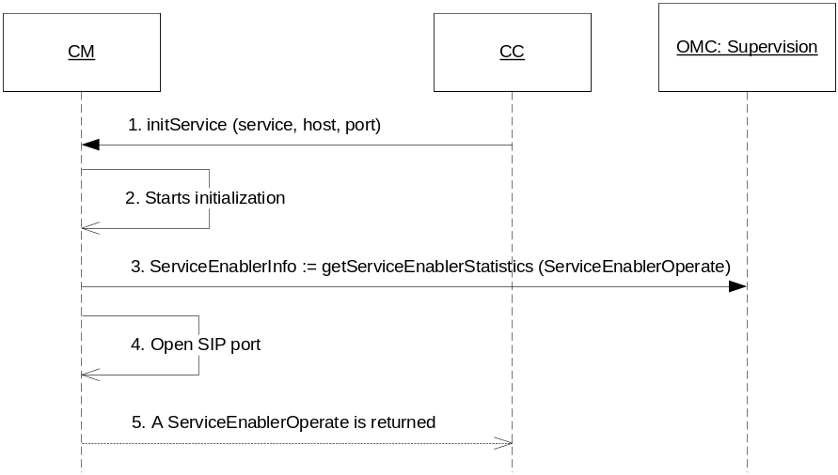
Figure 8 Initiation of Service Enabler
The initialization is performed in the following steps:
- The CC initializes the CM service enabler. CM is given the name of the service to load and the host and port to use for the service. This method is synchronous and when it returns in step 5, CM is initialized.
- CM starts it initialization, e.g. the configuration is read at this point.
- CM asks OMC for an object to use when reporting call statistics.
- When CM is at the last phase of initialization, the host and port to use for the SIP service is opened.
- CM is now completely initialized and returns a ServiceEnablerOperate instance that can be used by OMC to operate CM.

Inbound call
An inbound call is a call that is originating outside of CM and ends up in CC. Usually it originates from a SIP gateway. In this scenario the CM acts as a UAS.
An inbound call both with and without early media is illustrated.

Without early media
The scenario for an inbound call without early media is illustrated in the figure below.
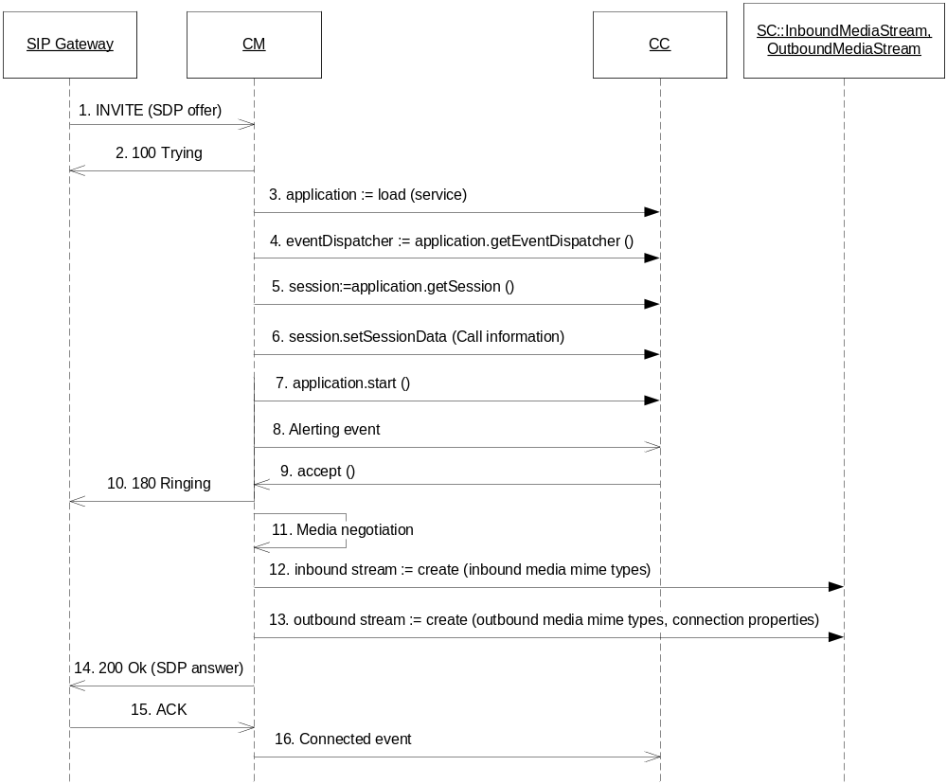
Figure 9 Inbound call without early media
In the figure above the call is answered with no early media by the CC and the media streams are established after the final ACK from the SIP Gateway. The 100 Trying is needed to inform the SIP Gateway that the INVITE has reached CM and that the SIP Gateway does not need to resend it in case of timeout.
- The UAC sends an INVITE with the UAC:s SDP offer (containing inbound media codecs and protocols) as attachments in the INVITE.
- CM answers the INVITE with a 100 “Trying” response to signal to the UAC that the INVITE has arrived.
- CM tells the CC to load the service, it returns with an application instance. Refer to chapter 4.5.10 for details on service loading.
- CM retrieves the event dispatcher from CC.
- CM retrieves the session from CC.
- CM sets call related data into the session. The information that is set is described in section 4.5.1.19.
- CM starts the application.
- CM indicates that a new inbound call is received by sending an Alerting event containing the new call.
- CC accepts the call.
- CM sends a 180 “Ringing” response to signal that the UAS has been located and is processing the call.
- CM performs a media negotiation as described in section 4.5.7 which results in an SDP intersection that is used to create an SDP answer and to retrieve connection properties for inbound and outbound media streams.
- CM creates the inbound stream based on the intersected SDP.
- CM creates the outbound stream based on the intersected SDP.
- CM sends a 200 “OK” response containing an SDP answer that was the result of the media negotiation.
- The UAC responds with an ACK to signal that the 200 OK has arrived.
- CM signals to the CC that the call is connected by sending a Connected event. It is now possible to play media.
If there is no SDP offer in the inbound INVITE, media negotiation and stream creation is not performed in step 11-13. Instead CM creates an SDP offer (as described in 4.5.7) which is sent in the 200 “OK” response. An SDP answer is then received in the ACK which results in a media negotiation and stream creation at that point instead.

With early media
The scenario for an inbound call with early media is illustrated in the figure below.

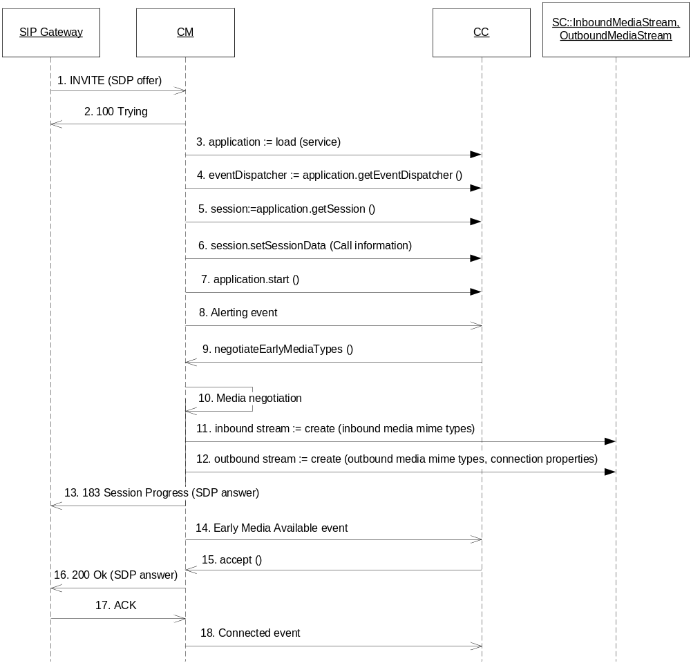
Figure 10 Inbound call with early media
In the figure above the CC indicates that early media should be used. The media negotiation and stream creation is performed at this point and a 183 “Session Progress” response is sent instead of the 180 “Ringing”.
- The UAC sends an INVITE with the UAC:s SDP offer (containing inbound media codecs and protocols) as attachments in the INVITE.
- CM answers the INVITE with a 100 “Trying” response to signal to the UAC that the INVITE has arrived.
- CM tells the CC to load the service, it returns with an application instance.
- CM retrieves the event dispatcher from CC.
- CM retrieves the session from CC.
- CM sets call related data into the session. The information that is set is described in section 4.5.2.
- CM starts the application.
- CM indicates that a new inbound call is received by sending an Alerting event containing the new call.
- CC indicates to CM that it whishes to send early media and that the media types to use for early media must be negotiated.
- CM performs a media negotiation as described in section 4.5.7 which results in an SDP intersection that is used to create an SDP answer and to retrieve connection properties for inbound and outbound media streams.
- CM creates the inbound stream based on the intersected SDP.
- CM creates the outbound stream based on the intersected SDP.
- CM sends a 183 “Session Progress” response containing an SDP answer that was the result of the media negotiation.
- CM sends an Early Media Available event to signal to CC that CM is available for playing early media.
- When the CC has finished playing the early media it accepts the call.
- CM sends a 200 “OK” response containing the same SDP answer as was sent in the 183 “Session Progress” response.
- The UAC responds with an ACK to signal the arrival of the 200 OK.
- CM signals to the CC that the call is connected by sending a Connected event.
If there is no SDP offer in the inbound INVITE, early media cannot be supported. In that case, an Early Media Failed event is sent immediately after step 9 above and the CC can choose between continuing the call setup without early media or to reject the call.

Outbound calls with or without early media
Outbound calls are originated from the CC. CC uses the CM to make the calls. In this case CM acts as a UAC.
All outbound calls are sent from CM to an SSP which redirects CM to the proper SIP Gateway. The SSP responds with a SIP redirection response (3xx) containing the contact information for the SIP gateway, see the figure below.
If CM is registered towards multiple SSP:s (see section 4.5.1.11) one SSP is randomly selected for the outbound call.

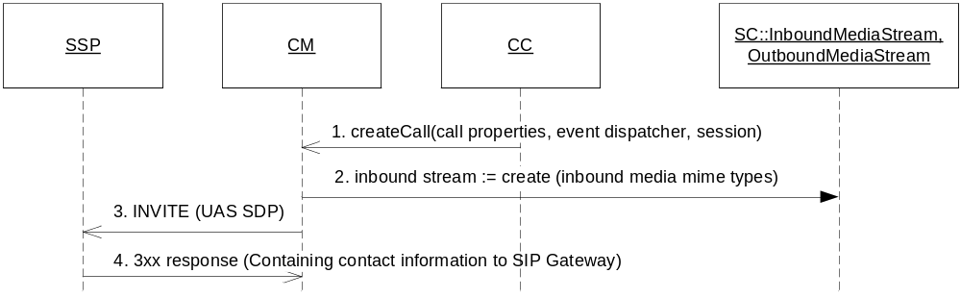
Figure 11 SSP redirection of outbound calls
The above create call request and call redirection is excluded in the call scenarios below which starts by sending a redirected INVITE to the SIP Gateway.
An outbound call both with and without early media is illustrated.

Without early media
The scenario for an outbound call without early media is illustrated in the figure below.
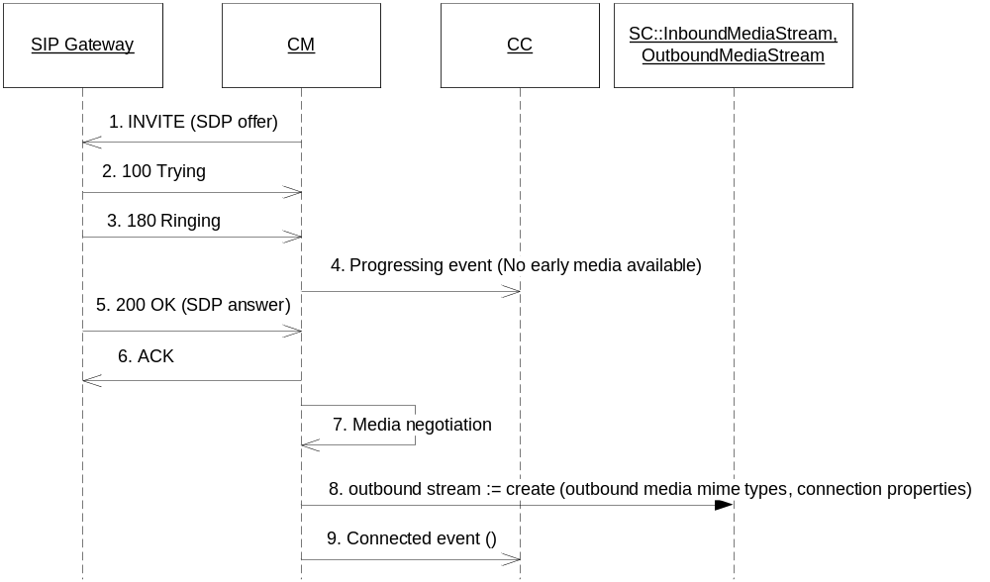
Figure 12 Outbound call with no early media
An outbound call without inbound early media is performed in the following steps:
- CM sends an INVITE with media information in an SDP offer.
- The UAS sends a 100 “Trying” to signal the arrival of the INVITE.
- The UAS sends a 180 “Ringing” to inform the CM that the endpoint has been located and that there is no early media available.
- CM sends a Progressing event to the CC indicating no early media is present.
- The UAS accepts the call by sending a 200 “OK” with an SDP answer.
- CM sends an ACK to the UAS to signal the arrival of the 200 “OK” message.
- CM performs a media negotiation as described in section 4.5.7 which results in an SDP intersection between the SDP offer and the SDP answer.
- CM creates the outbound stream based on the intersected SDP.
- CM signals to the CC that the call is connected by sending a Connected event.

With early media
The scenario for an outbound call with early media is illustrated in the figure below.
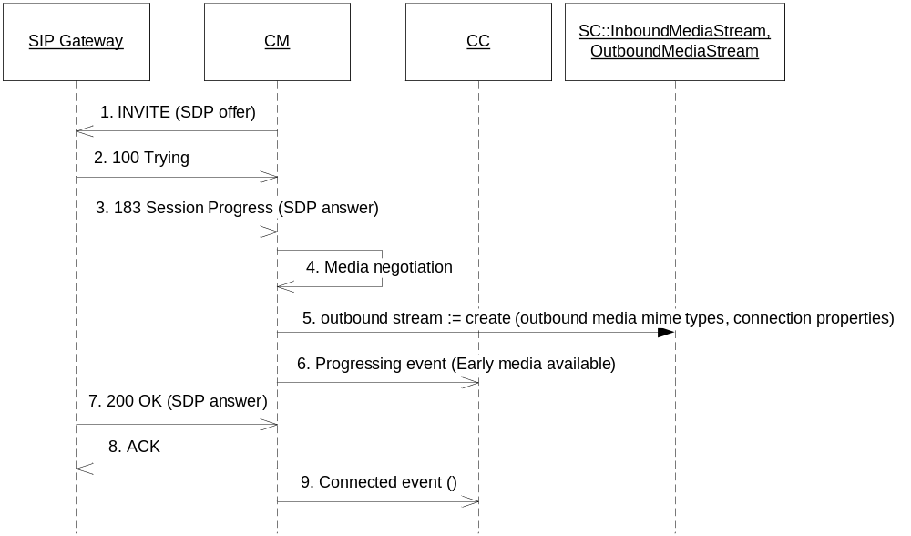
Figure 13 Outbound call with incoming early media
An outbound call with inbound early media is performed in the following steps:
- CM sends an INVITE with media information in an SDP offer.
- The UAS sends a 100 “Trying” to signal the arrival of the INVITE.
- The UAS sends a 183 “Session Progress” with an SDP answer indicating that early media is available.
- CM performs a media negotiation as described in section 4.5.7 which results in an SDP intersection between the SDP offer and the SDP answer.
- CM creates the outbound stream based on the intersected SDP.
- CM sends a Progressing event to the CC indicating that early media is available. It is now ok for the CC to retrieve media from the call or to join the media streams of this call to another.
- The UAS accepts the call by sending a 200 “OK” with the same SDP answer as in the “Session Progress”.
- CM sends an ACK to the UAS to signal the arrival of the 200 “OK” message.
- CM signals to the CC that the call is connected by sending a Connected event.

Join/Unjoin of two calls
For a call transfer, the media streams of one call shall be joined with the media streams of another call. CM supports a full duplex join (and corresponding unjoin) between two calls.
An inbound call can be joined with another call when it has been connected, i.e. when a Connected event has been generated for the call.
An outbound call can be joined with another call when it is connected or when there is early media available, i.e. when a Connected event or a Progressing event indicating early media has been generated for the call.
A join results in the inbound media stream of one call being connected to the outbound media stream of the other call and vice versa.
When a join is completed a Joined event is sent. If the join failed, a Join Error event is sent.
An unjoin has the opposite effect and shall be used when the two calls no longer should be joined together.
When an unjoin is completed an Unjoined event is sent. If the unjoin failed, an Unjoin Error event is sent.

Reject an inbound call
Whenever the CC does not want to accept an inbound call it must reject it. The call reject is done instead of accepting the call.
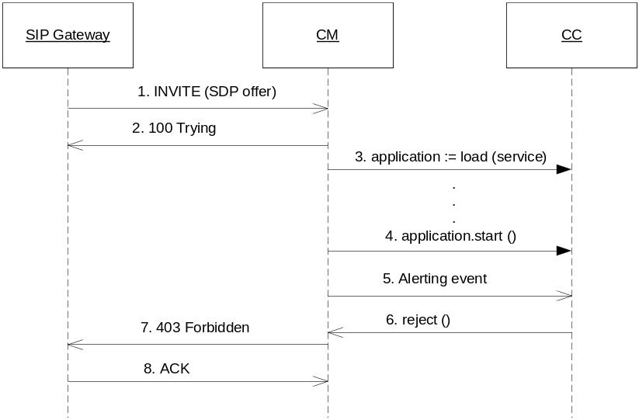
Figure 14 Reject an inbound call
Rejecting an inbound call is performed in the following steps:
- The UAC sends an INVITE to CM.
- CM answers the INVITE with a 100 “Trying” response to signal to the UAC that the INVITE has arrived.
- CM loads the application and sets session data as described earlier for an inbound call.
- When session data has been set, CM starts the application instance.
- CM indicates that a new inbound call is received by sending an Alerting event containing the new call.
- CC decides to reject the call.
- CM sends a 403 “Forbidden” response indicating to the UAC that the call failed.
- The UAC responds with an ACK to signal the arrival of the SIP final response.

Rejected outbound call
Any outbound call can be rejected by the UAS (e.g. by the end user) and the UAS will in that case answer with a SIP final response. Which final responses that are handled as a call reject is described in section 4.5.4.
The create call request and SSP call redirection illustrated in Figure 11 is excluded in the call scenario below which starts by sending a redirected INVITE to the SIP Gateway.

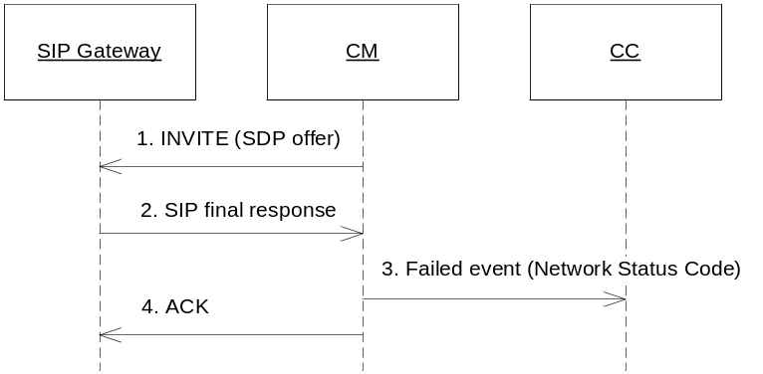
Figure 15 Rejected outbound call
The outbound call is rejected in this scenario immediately after the INVITE. The reason for the reject is then mapped to a Network Status Code based on configuration as described in section 4.5.3.
- CM sends an INVITE with media information in an SDP offer.
- The UAS declines the call with a SIP final response. The content of the response is then mapped to a Network Status Code using the CM configuration.
- CM sends a Failed event together with the Network Status Code to the CC.
- CM acknowledges the arrival of the response.

Inbound call with unsupported media
For an inbound call the SDP answer created by CM must be the intersection between the desired media types given by CC and the UAS SDP offer as described in section 4.5.7. If this intersection is empty the call cannot be completed.
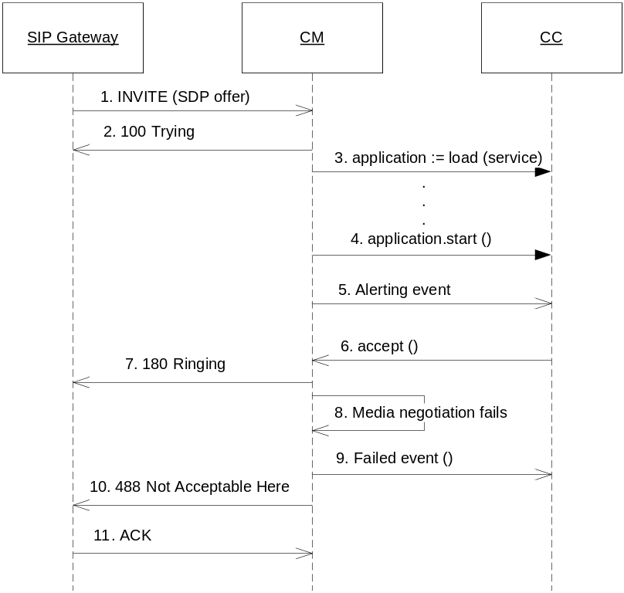
Figure 16 Unsupported media for inbound call
In this scenario the intersection of the UAC SDP offer and the desired media types from the CC is empty and CM must respond with a 488 “Not Acceptable Here” response.
- The UAC sends an INVITE to CM.
- CM answers the INVITE with a 100 “Trying” response to signal to the UAC that the INVITE has arrived.
- CM loads the application and sets session data as described earlier for an inbound call.
- When session data has been set, CM starts the application instance.
- CM indicates that a new inbound call is received by sending an Alerting event containing the new call.
- CC accepts the call.
- CM sends a 180 “Ringing” response to signal that the UAS has been located and is processing the call.
- CM performs a media negotiation as described in section 4.5.7 which results in no SDP intersection found.
- CM signals to CC that the call failed due to media negotiation failure by sending a Failed event.
- CM sends a 488 “Not Acceptable Here” response indicating to the UAC that the media suggestion was unacceptable.
- The UAC responds with an ACK to signal the arrival of the SIP final response.

Outbound call with unsupported media
An outbound call can also fail because the UAS does not support the media requested by CM. This is the same scenario as illustrated in section 4.5.1.6. In this situation the SIP Gateway send a 488 “Not Acceptable Here” response.

Media renegotiation
In SIP media renegotiation is possible and done by sending a new INVITE after a call has been entirely established. In SIP media renegotiation does not have to be supported and may be rejected.
Media renegotiation is not supported by CM. The new INVITE is rejected by CM as illustrated in the figure below.
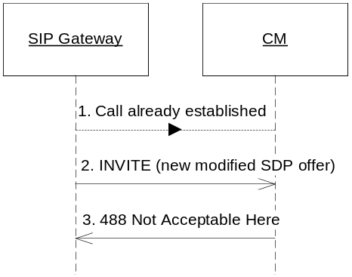
Figure 17 Media renegotiation
- A call has already been established according to earlier scenarios for call setup.
- The UAC sends an INVITE containing new inbound media codecs and protocols to use in an SDP offer.
- CM rejects the INVITE with a 488 Not Acceptable Here response to signal to the UAC that media renegotiation not is allowed.

Disconnect a call
A call disconnect can be initiated from both sides, i.e. both from the terminal or from the CC. The scenarios below apply to both inbound and outbound calls.
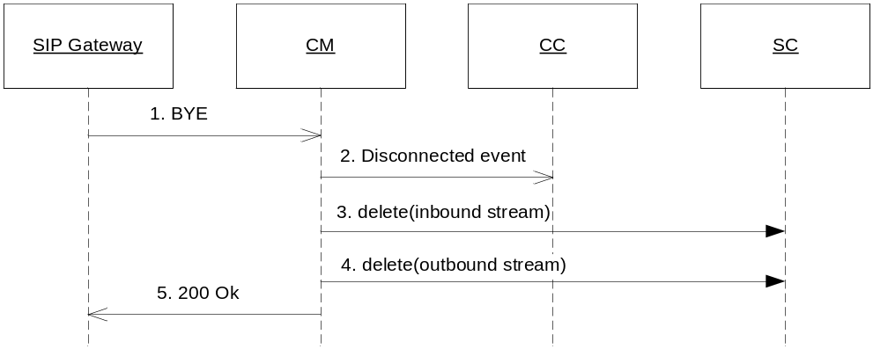
Figure 18 Terminal initiated disconnect of inbound or outbound call
The above sequence diagram shows the terminal initiated disconnect procedure for both inbound and outbound calls.
- The UA sends a BYE request to CM.
- CM sends a Disconnected event to the CC.
- CM deletes the inbound stream.
- CM deletes the outbound stream.
- CM sends a 200 “OK” message back to the UA to signal that the call has been released.

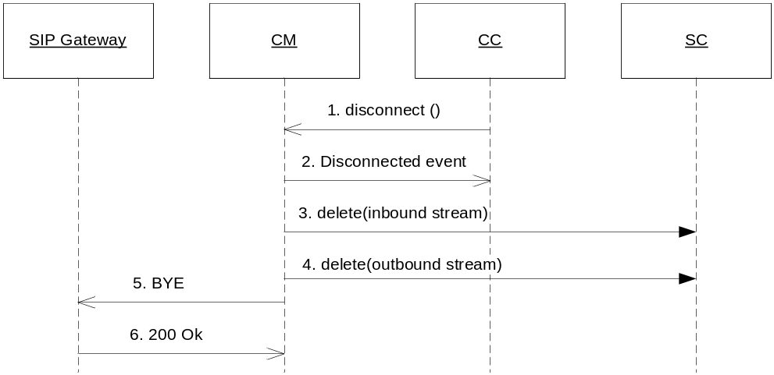
Figure 19 CC initiated hang-up of inbound or outbound call
The above sequence diagram shows the CC initiated disconnect procedure for both inbound and outbound calls.
- CC calls the disconnect function in CM to disconnect the call.
- CM sends a Disconnected event to the CC.
- CM deletes the inbound stream.
- CM deletes the outbound stream.
- CM sends the BYE request to the UA.
- The UA sends a 200 “OK” message back to CM to signal that the call has been released.

Send outbound DTMF
Outbound DTMF can currently only be sent in one way by CM; as a packet with a specific payload type in the outbound RTP stream. If the media type indicating outbound DTMF using this mechanism (i.e. the media type “audio/telephone-event”) is configured mandatory in CM, CM will check if the peer UA supports this media type or not during the media negotiation. If this method is not supported by the peer UA but configured mandatory in CM the call will be rejected due to unsupported media type as described in sections 4.5.1.7 and 4.5.1.8.
Outbound DTMF can only be sent for outbound calls.

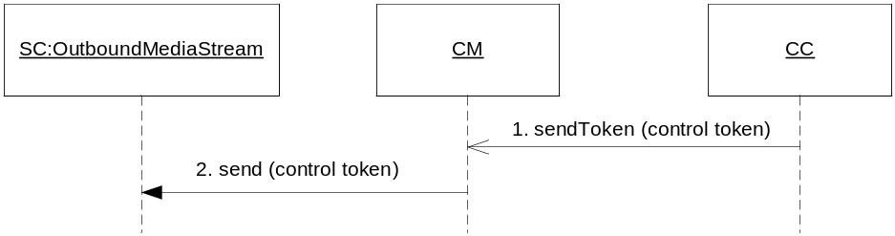
Figure 20 Outbound DTMF using RTP
CC sends a token to CM which uses SC to send DTMF over RTP:
- CC wants to send an outbound control token on an outbound call.
- CM sends the control token to SC which is responsible for sending it over the outbound stream.
If CM fails to send the tokens, a Send Token Error event is sent.

Play outbound media
When media has been negotiated for a call (inbound or outbound) it is possible to play media on the outbound stream.
For an inbound call media can be played when the call is connected or if early media types have been negotiated, i.e. when a Connected event or an Early Media Available event has been generated for the call.
For an outbound call media can be played when the call is connected, i.e. when a Connected event has been generated for the call.

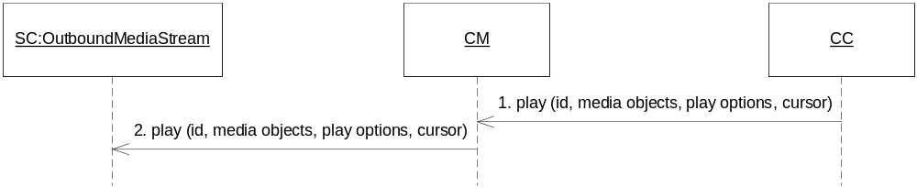
Figure 21 Play media
CC requests media to be played on the outbound media stream:
- CC wants to play outbound media on a call.
- CM requests the OutboundMediaStream in SC to play media.
If CM fails to play media, a Play Failed event is sent.

Record inbound media
When media has been negotiated for a call (inbound or outbound) it is possible to record media from the inbound stream.
For an inbound call media can be recorded when the call is connected, i.e. when a Connected event has been generated for the call.
For an outbound call media can be recorded when the call is connected or when there is early media available, i.e. when a Connected event or a Progressing event indicating early media has been generated for the call.

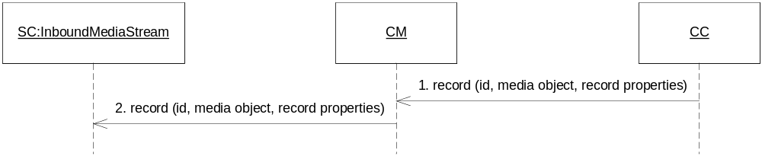
Figure 22 Record media
CC requests media to be recorded from the inbound media stream:
- CC wants to record inbound media on a call.
- CM requests the InboundMediaStream in SC to record media.
If CM fails to record media, a Record Failed event is sent.

Register/Unregister
CM registers its presence to an SSP by sending a SIP REGISTER request to the SSP. This means that the SSP can start redirecting calls to the CM. CM only sends outbound calls to SSP:s to which it is registered.
When CM registers itself in the SSP it includes no expiration time indicating that it is up to the SSP to decide how long the registration shall be valid.
Which SSP to register to is configurable and CM supports multiple SSP:s.
The scenario for the register procedure:

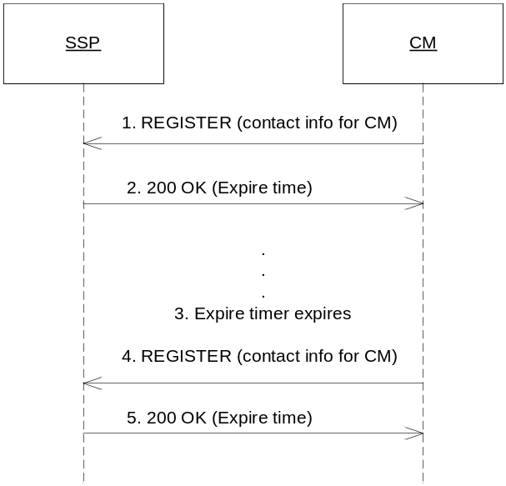
Figure 23 CM registers in SSP
- CM sends a SIP REGISTER request to the SSP with its contact address.
- The SSP sends back a 200 OK when the registration has been completed containing the expire time after which the registration will be removed. CM schedules a timer with the expire time.
- The expire timer expires.
- CM resends the same SIP REGISTER request to the SSP to renew its registration.
- The SSP sends back a 200 OK when the registration has been completed with the expire time for the current registration.

CM unregisters from an SSP when it no longer whishes to establish calls. This is the method for telling the SSP that the CM can take no more calls. Both receiving inbound calls and initiating outbound calls will be impossible if CM is not registered in any SSP. This mechanism is used for load regulation, see section 4.5.1.15.
The scenario for the unregister procedure:

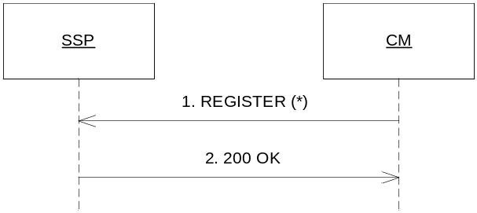
Figure 24 CM unregisters from SSP
- CM sends a SIP REGISTER request to the SSP with its contact address set to “*” which indicates an unregister.
- The SSP sends back a 200 OK when the unregister has been completed.

Operational administration
Using the ServiceEnablerOperate interface of CM it is possible to administer CM with respect to O&M.
When to register/unregister towards an SSP depends upon the administrative state of CM. It is possible to modify the administrative state using the methods close and open. CM always starts up in closed state. When CM is in opened state it will try to register towards the configured SSP:s, otherwise it will make sure it is unregistered.

Open
When CM shall be able to accept inbound calls and send outbound calls, OMC can use the open method in the ServiceEnablerOperate interface. CM immediately registers towards the configured SSP:s.
When the open is complete, this is reported to OMC using the method opened on the ServiceEnablerInfo instance received at initialization (see section 4.5.1.1).

Forced Close
When all current calls shall be immediately discarded and no more calls shall be accepted, OMC can use the close method in the ServiceEnablerOperate interface with the forced parameter set to true. All current calls are immediately disconnected by CM using the scenario described in 4.5.1.10 (except for the disconnect request from CC which does not occur in this scenario) and CM unregisters from SSP to avoid new calls. New incoming calls that are received after the forced close has been requested are rejected.
When the forced close is complete, this is reported to OMC using the method closed on the ServiceEnablerInfo instance received at initialization (see section 4.5.1.1).

Unforced Close
When no more calls shall be accepted, but all current calls are allowed to complete, OMC can use the close method in the ServiceEnablerOperate interface with the forced parameter set to false. CM unregisters from SSP to avoid receiving new calls, but all current calls are allowed to run until completed.
When the unforced close is complete, this is reported to OMC using the method closed on the ServiceEnablerInfo instance received at initialization (see section 4.5.1.1).

Load regulation
Using the ServiceEnablerOperate interface of CM it is possible to regulate the amount of concurrent calls.
When to register/unregister towards an SSP depends upon the administrative state of CM (as described in 4.5.1.15) but also on the maximum amount of concurrent calls that can be supported.
It is possible to modify the amount of concurrent calls using the method updateThreshold.
If the amount of active calls is above the threshold, CM unregisters from the SSP so the SSP will stop redirecting calls to this CM. When the amount of active calls falls below the threshold, CM will register its location to the SSP again so the SSP can start redirecting calls to this CM assuming of course that the administrative state of CM is opened. Otherwise no registration is performed until the administrative state becomes opened.
To obtain a more stable load regulation, there is not just one threshold but also a high watermark (HWM) and a low watermark (LWM) where the following rule applies:
LWM <= HWM <= max threshold
When the amount of concurrent calls rises to HWM, CM unregisters from SSP:s. When the amount of concurrent calls falls to the LWM, CM registers in SSP:s.
When the amount of concurrent calls is larger or equal to HWM, CM will reject incoming OPTIONS requests but still accept incoming INVITE requests.
When the amount of concurrent calls is larger or equal to max threshold, CM will reject all incoming requests.
At startup of CM HWM, LWM and max threshold is set to a low initial value and after time ramped up to the configured values.

Collecting Statistics
CM updates status and counters available to the OMC using the ServiceEnablerInfo instance received at initialization (see section 4.5.1.1).
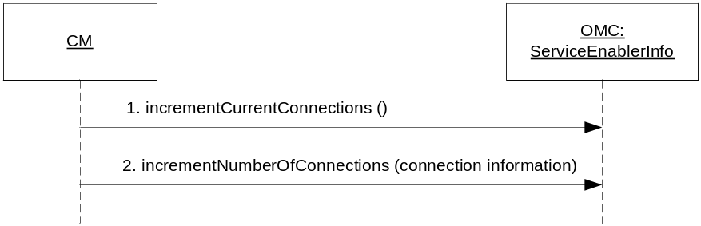
Figure 25 Update statistics
The scenario shows how CM updates the ServiceEnablerInfo instance with information regarding statistics. The updates are done when any of the counters changes to be able to show real time values for the SNMP supervision and ISP calculations.
Whenever statistical information changes (e.g. a new call is received or a call is disconnected) the service enabler statistics is updated for the amount of current connections. Statistics is also updated for the current event, e.g. statistics is incremented each time a call becomes connected.
The current calls statistics shall be increased for each new call. Since the call type is not determined until the media negotiation has been performed, this statistics is first incremented with the call type unknown. When the call becomes connected the statistics is updated with the correct call type. If the call is rejected or fails due to an error prior to connected, current calls are decremented for the call type unknown. If the error occurred after connect was complete, current calls are decremented for the known call type.
Statistics is collected for the following types of calls/events:
- Current calls:
Incremented as soon as a call is initiated. When a call becomes connected the call type is updated.
Decremented when a call becomes rejected, disconnected or an error occurs while not already disconnected, rejected or in error state.
- Connected calls:
Incremented when a call becomes connected and a Connected event is sent.
- Rejected calls:
Incremented when the call is rejected prior to connect (as described in sections 4.5.1.5 and 4.5.1.6) and a Failed event is generated.
- Abandoned calls:
Incremented when the Abandoned Stream Detected event is received for a connected call. At this point the call is disconnected (generating a Disconnected event). The event contains information indicating if the call was abandoned.
- Abandoned Rejected calls:
Incremented when the Abandoned Stream Detected event is received during early media of an outbound call or when an inbound call has been abandoned by the CC (i.e. the call has not been accepted in time). At this point the call is cancelled or rejected (generating a Failed event). The event contains information indicating if the call was abandoned.
- Far end disconnected calls:
Incremented when the peer UA disconnects a call using a SIP BYE request. A Disconnected event containing information indicating that the call was disconnected by far end is generated.
- Near end disconnected calls:
Incremented when the CC disconnects a call. A Disconnected event containing information indicating that the call was disconnected by near end is generated.
- Errors:
Incremented when an error occurs for the call and an Error event is generated.
- Dropped packets:
At the end of a call before streams are deleted, CM asks SC for the amount of dropped RTP packets on the inbound media stream and this statistics is updated.
For inbound calls, the sum of connected calls, rejected calls and abandoned rejected calls shall be equal to the total amount of received inbound calls.
The sum of far end disconnected calls, near end disconnected calls and abandoned calls shall be equal to the amount of connected calls.
The above describe statistics is collected separately for each call type and call direction. This is done in order to be able to separate e.g. the amount of rejected inbound video calls from the amount of rejected outbound voice calls.

Failure
In a failure situation one of two types of events is generated by CM: Not Allowed event and Error event.
A Not Allowed event is generated when CC requests some action that is not allowed in the current call state, e.g. if CC tries to accept a call that already is disconnected.
An Error event is generated due to one of the following situations and results in the call being rejected or disconnected:
- Internal Error:
This type of error is non-recoverable.
- Timeout Error:
The CM experienced a non-recoverable timeout or transaction error.

Diagnose Service
CM provides means to survey its operational status with the DiagnoseService interface. The OMC can request to send a diagnosing request and observe the result of that request as illustrated in the figure below.
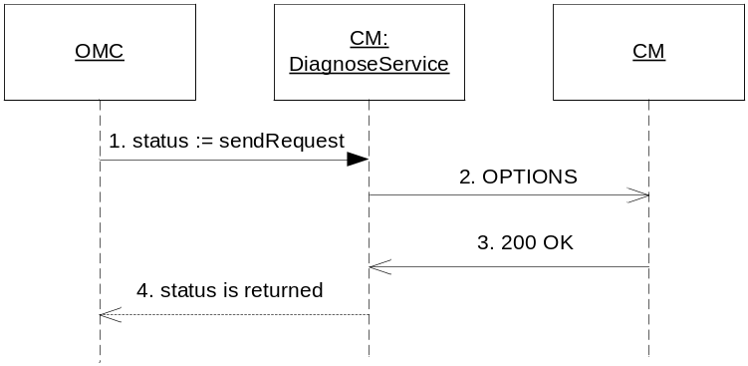
Figure 26 Diagnose CM service
- The OMC sends a diagnose request to CM using the DiagnoseService interface. The implementation of this interface is completely separate from the other CM functionality. The call to sendRequest is blocking, and does not return until the status is retrieved or a timeout occurred.
- A SIP OPTIONS request is sent to CM using the SIP interface.
- A 200 OK response is returned containing the header Experienced-Operational-Status with the value set to up, down or impaired.
- When the diagnose request has completed, the status of the request is returned.
The 200 “OK” response from CM contains the Experienced-Operational-Status header indicating the status as one of up or down. If no response is received in time, a timeout occurs and the status is considered down.

Send SIP Message Waiting Indicator (SIP MWI)
The following scenario describes the usage of the send SIP message method with the message waiting indication (MWI) method. A SIP NOTIFY is sent to a remote SIP user agent. The remote user agent responds with a SIP final response, either an OK response or an error response.
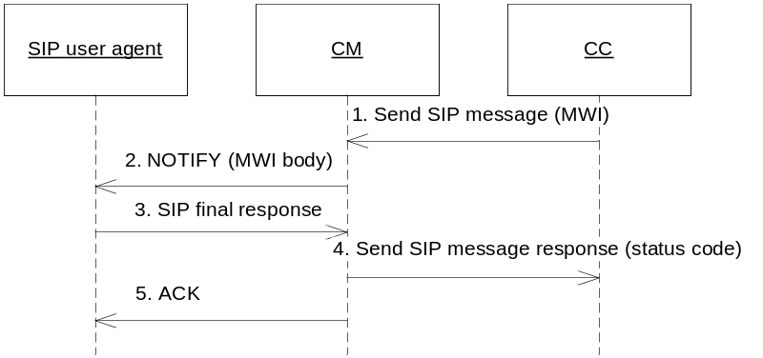
Figure 27 Send SIP MWI
The SIP MWI (sent as a SIP NOTIFY request) is responded to with either an OK response or an error response. The result of the NOTIFY is sent back as a status code in the Send SIP message response event.
- CC request that a SIP MWI shall be sent.
- CM sends a SIP NOTIFY request containing MWI parameters.
- The SIP UA responds to the request.
- CM sends a Send SIP message response event containing the SIP response code from the response. If the SIP response contain a Retry-After header, the retry-after value is also included in the event.
- CM acknowledges the arrival of the response.

Send SIP Message Waiting Indicator (SIP MWI) with timeout
The send SIP message method sends a SIP NOTIFY to a remote SIP user agent. The remote user agent does not respond. The CM timeout and generates a Send SIP message response event containing a SIP Request timeout error code.
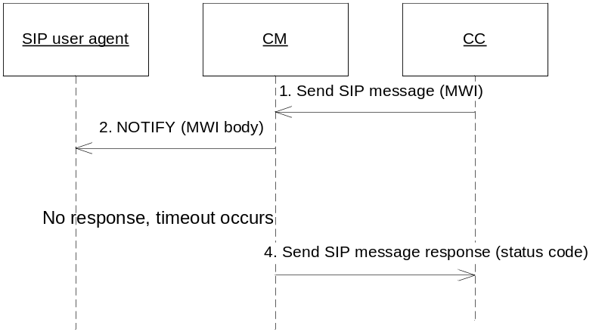
Figure 28 Send SIP MWI message
The SIP MWI (sent as a SIP NOTIFY request) times out. The timeout is handled as if a response with a 408 Request timeout was received. The 408 Request timeout is sent back in the Send SIP message response event.
- CC request that a SIP MWI shall be sent.
- CM sends a SIP NOTIFY request containing MWI parameters.
- The SIP UA does not respond.
- After a timeout, CM sends a Send SIP message response event with the status code for a Request timeout.

Session data variables

Session creation
The following session data variables are set by the Call Manager when starting a service instance due to a new inbound call:
- Session Id:
When a new inbound call is created, a new session id is generated by Call Manager and set in the session when loading a new service instance. The type of this variable is Id<ISession> and is exported by [2].
- Session MdcItems:
Contains call related information that can be used to filter the session logging further. The information contained in this item is telephone numbers for calling, called and redirecting parties if present. The type of this variable is SessionMdcItems and is exported by [2].
- Variable sessioninitiator:
Contains the name of the protocol that initiated the session and is set to “sip”. The type if this variable is String.

Media negotiation
CM reads the following parameters; callmediatypesarray and selectedcallmediatypes, and writes the following parameters; selectedcallmediatypes during media negotiation (see section 4.5.7).

Mapping of release cause to Network Status Code
When a call is rejected by the remote party prior to connect, the reason for the call reject is mapped to a Network Status Code (see [11]) using configuration. The call reject can be done with a SIP BYE, a SIP CANCEL or a SIP error response depending on the call direction.
The reason for the call reject is retrieved in the following order:
- If the SIP message causing the reject contains a SIP Reason header field with Q.850 cause/location information, this information is used as release cause.
- Otherwise, if the SIP message causing the reject is a SIP error response, the response code is used as release cause.
The default configuration is illustrated in the table below.
Table 1 Default mapping of release cause to Network Status Code
Scenario | Network Status Code | SIP response codes | Q.850 cause values | Q.850 location values
User Busy | 603 | 486 | 17 | 1-15 or unknown
No Reply | 610 | 408, 480 | 18-19 | 0-15 or unknown
Not Reachable | 613 | 301, 403-404, 410, 484, 501-502, 603 | 1-9, 20-23, 25-31 | 0-15 or unknown
User Suppressed | 614 | 600 | 17 | 0
Congestion | 620 | 503 | 39-44, 46 | 0-15 or unknown
Default | 621 | The rest. | The rest. | 0-15 or unknown

Final response handling for outbound calls
The table below lists how CM handles different final responses to an outbound call.
Response | Condition | Action
2xx | - | The call is connected.
3xx | No previous redirection. | A new INVITE is sent to the first contact in the 3xx response.
3xx | There is a pending redirection. | The call is considered rejected.
4xx | - | The call is considered rejected.
5xx | No previous redirection. | The call is considered rejected.
5xx | There is a pending redirection and there is another contact to try from the previous 3xx response. | A new INVITE is sent to that contact.
5xx | There is a pending redirection but there is no more contacts left from the previous 3xx response to try. | The call is considered rejected.
6xx | - | The call is considered rejected.

Note: CM only supports one level of redirection, i.e. the one from the SSP.

Compliance to SIP
How we comply with the SIP specification is described in detail in an IWD, see [5].

Loop Back Prevention
The CC is able to indicate if loop back prevention shall be done when creating a new outbound call. If loopback shall be prevented, Call Manager adds a SIP Diversion header (as described in [5]) to the outbound SIP INVITE.

Media Negotiation
All media negotiation is handled transparent to CM with regards to supported codecs. The codec negotiation is done based on the input from the CC, configured values (see section 4.5.13.3) and the peer UA. Thus, CM has no limitation regarding which codecs to support.
If CC has any requirements on the media types to use, it will give a possible list of media types in the session parameter callmediatypesarray.
CM will then perform media negotiation and choose one of the given media types and store it in the session parameter selectedcallmediatypes.
When CM is about to start media negotiation, is first checks the session parameter selectedcallmediatypes to see if one specific call media type already has been selected for the session. If that parameter is not set, it then checks the session parameter callmediatypesarray to see if CC has any requirements on the media types to use. If that parameter is not set CC has no requirements on the media types to use and CM will base the media negotiation on the configured media types only (see section 4.5.13.3).
When a remote SDP is received, the configured required outbound media types and the selected CC media type (if one exists) or the list of media types from CC (if one exists) will be matched to find an SDP intersection. The configured required outbound media types and the selected CC media type (if one exists) must be supported by the remote SDP. If there is no selected (see section 4.5.13.3) but there is a list of media types from CC at least one media type in that list must be supported by the remote SDP. The first match in the list will be set as the selectedcallmediatypes in the session.
First after the media negotiation has been performed, the call type is determined. This means that the call type is determined when the call has been connected for non-early media calls. For early media calls, the call type is determined when the early media has been established.

Local SDP creation
The local SDP is created using the inbound media types given in the configuration (see section 4.5.13.3). For voice calls only the audio media type is included, for video calls both the audio and video media types are included.
The type of call is determined as described below.

Inbound call type
An inbound SIP INVITE that contains an SDP offer is considered a video call if the media type video is contained in the SDP, otherwise it is considered a voice call.
If the inbound SIP INVITE lacks an SDP offer, Call Manager checks to see if there is a SIP header Call-Info present that describes the call type (as described in [5]). If the call type still cannot be determined, the configured default call type is used (see section 4.5.13.1).

Outbound call type
For an outbound call, the call type can be given by CC at call creation. If no call type is given, the configured default call type is used (see section 4.5.13.1).

Media negotiation failure for inbound calls
If the media negotiation fails, i.e. the required outbound media types were not supported by the remote SDP, a Failed event is generated and the call is rejected (for the early media scenario) or disconnected (for the non-early media scenario).
Note that even if the SDP offer is sent in the SIP 200 OK response and the SDP answer is received in the SIP ACK, the call is considered failed and a Failed event is generated. According to SIP the call actually has been connected although it is immediately disconnected, but the Call Manager considers the media negotiation as part of the call setup and therefore the call is considered failed rather than disconnected.

Media negotiation failure for outbound calls
If the media negotiation fails, i.e. the required outbound media types were not supported by the remote SDP, a Failed event is generated and the call is canceled (for the early media scenario) or acknowledged and disconnected (for the non-early media scenario).

Video Fast Update
Full picture video fast update as described in [12] is supported by CM.
When CM is requested (using the VideoFastUpdater interface, see section 4.2.5) a Video Fast Update request is sent over SIP as described in [12] – unless it is offered/accepted in SDP that Video Fast Update is to be done as RTCP feedback (see [14]), in that case Stream sends the request over RTCP.

Detection of Outbound Media Connection Already in Use
When an SDP is received from a peer UA, connection properties are given for the outbound media streams. CM checks if the ports suggested for the outbound media streams already are used by another call. If there is a collision, i.e. the host + port combination already is used by an existing call; this call is rejected.

Service loading
When an inbound call is received the CM loads a service to be used for that call. The following procedure is used when loading a service:
- Try to load the service based on the called party number or PSI (Public Service Identity).
- If the above fails, a default service is loaded instead.

Logging

Session logging
When a new thread is selected from a thread pool, the first thing that is done is that the active session (if any) is registered in the logger to enable session logging. There is an active session available for every function that is call related. Examples of functionality that are not call related is registration in an SSP or answering a SIP OPTIONS request.

Info logging
Informational logging is used by Call Manager in the following situations:
- When CC creates a new outbound call
- When creation of a new outbound call is rejected due to one of the following situations:
  - Mandatory parameters to create call is null, e.g. the event dispatcher, the session or the called party.
  - Internal error occurs when creating the call.
  - The current amount of calls exceeds the maximum threshold.
  - The administrative state of CM is not opened.
- When one of the following timers expires:
  - Call not accepted timer (see 4.5.13.1).
  - SIP INVITE expire timer.
  - Max call duration timer (see 4.2.2.2.3).
- To inform of which remote party (host and port) that has been selected for an outbound SIP INVITE.
- When CC requests a join or unjoin.
- When CC accepts or rejects a call or negotiates early media types for a call.
- When a SIP request, response or timeout event is received.
- When a SIP request is validated not ok and rejected as described in [5].
- How a SIP message received within a call is handled, e.g. if it is rejected.
- How a SIP message received out-of-dialog is handled, e.g. if it is rejected.
- When a SIP request or response is sent by CM.
- When OMC requests open, close or update threshold.
- The result of a requested open, close or update threshold, e.g. if registration or un-registration towards SSP:s is initiated.
- When CM is considered registered towards an SSP.
- When CM is considered un-registered from an SSP.
- When a new inbound call is created due to a session creating SIP INVITE.
- When creation of a new inbound call is rejected (with SIP INVITE) is rejected due to one of the following situations:
  - The administrative state of CM is not opened.
  - Internal error occurs when creating call.
- When a SIP OPTIONS request is rejected due to the administrative state of CM (i.e. the state is not opened).
- When an event is fired to an event dispatcher.
- When a service is loaded or cannot be loaded.

Protocol Encapsulation
The implementation of the protocols SIP and SDP is encapsulated. This is done to easily be able to exchange the current protocol stacks with others. For SIP this is done using the API JAIN SIP which could be kept even if the stack implementation was changed.

Configuration
When configuration has changed, the configuration is re-read as follows:
- For a call, the active configuration at call creation time is used and never re-read during the lifetime of the call.
- For a register/un-register procedure that is initiated, the active configuration is selected and not re-read until the next transaction.
- The active configuration is read directly at events not related to registration or call handling, e.g. when rejecting an inbound SIP request.
- The part of CM responsible for keeping track of all configured SSP:s and their status is updated as soon as the configuration is re-read.

The configuration need of CM is listed below.

Call Related
Call related configuration:
- Call not accepted timer:
The time within which CC must have accepted an inbound call. If no accept is made, the call is considered abandoned.
- Default call type:
The call type to use for a call when none is given in the inbound INVITE or by CC for an outbound call.

Remote Party
A remote party is mandatory in the configuration. The remote party could either be a phone or a list of SSP:s. A host and port is mandatory configuration for a phone or an SSP.
Optional configuration used if the remote party is an SSP list:
- Register backoff timer:
The time to wait before trying again if a register request failed.
- Register before expiration time:
The time before the registration will expire that a re-registration should be started.
- Registered name:
The name with which CM registers itself in SSP.

Media Related
Media related configuration:
- Inbound audio media:
The media type for recorded audio.
- Inbound video media:
The media type for recorded video.
- Required outbound audio media:
A list of audio media types that must be possible to play on an outbound stream.
- Required outbound video media:
A list of video media types that must be possible to play on an outbound stream.

Release Cause Mapping
Mapping of release cause to Network Status Code (see [11]) can be configured. The configuration is optional and the default mapping is described in section 4.5.3.

Diagnose Service
The host and port to open for service diagnosing over SIP can be configured.

Load Regulation
Configuration related to load regulation during start up:
- Initial HighWaterMark
- Number of channels for ramp factor
- Number of increments for ramp factor
The ramp factor is then calculated by CM as Number of channels / Number of increments.

References
- FS - SIP Serving Proxy
1/FS-SWU0045 Uen
- FS - Execution Engine
3/FS-MAS0001 Uen
- FS - Stream
7/FS-MAS0001 Uen
- FS - Operate and Maintain Manager
17/FS-MAS0001 Uen
- IWD – SIP
7/IWD-1/HDB10102 Uen
- FS - Log Manager
2/FS-MAS0001 Uen
- FS - Configuration Manager
16/FS-MAS0001 Uen
- ITU-T Recommendation E.164
Assigned Country Codes
- Uniform Resource Identifiers (URI): Generic Syntax
RFC 2396
- FS - Media Object
13/FS-MAS0001 Uen
- UCD – Outdial Notification
11/155 53 – HDB 101 02 Uen
- Internet Draft: XML Schema for Media Control
draft-levin-mmusic-xml-media-control-03
- ITU-T Recommendation Q1980.1
http://www.itu.int/itudoc/itu-t/aap/sg11aap/history/q1980.1/index.html
- IWD – SIP Telephony
1/IWD-MAS0001 Uen

