FS –Media Content Manager

Content
1 Introduction 2
1.1 Glossary 2
1.1.1 Media Object 2
1.1.2 Media Content 2
1.1.3 Media Content Resource 3
1.1.4 Media Content Package 4
2 Function Requirements (Commercial) 4
3 Function Specification (Design Related) 4
3.1 Introduction 4
3.1.1 Media Content Manager 4
3.1.2 Relationships in a Media content resource 5
3.2 Exported Interfaces 5
3.2.1 IMediaContentManager 5
3.2.2 IMediaContentResource 6
3.3 Imported Interfaces 9
3.4 Functions 10
3.4.1 Install Media Content Package 10
3.4.2 Uninstall a Media Content Package 10
3.4.3 Get Media Content Resource 10
3.4.4 Retrieve Media Content from a particular Media Content Resource and issue a play on an IStream object 11
3.4.5 Get Media Content for specific conditions 13
3.4.6 Get all Media Content from a resource 14
3.5 Events 15
3.5.1 Produced Events 15
3.5.2 Consumed Events 15
4 External Operation Conditions 15
4.1 Configuration 15
5 Capabilities 15
6 References 15
7 Terminology 15

History

Version | Date | Adjustments
A | 2006-09-19 | First revision. (MMAWI)
B | 2007-07-11 | Minor changes. Codec of a language package is now decided per file extension (ermkese)
C | 2008-03-18 | Updated after review. (emahagl)

Introduction
This document specifies the Media Content Manager component. It provides interfaces to language dependent media content.
Basically the client can retrieve a particular media by specifying its identity and possibly dynamic information using qualifiers containing numbers or text strings.

Glossary

Media Object
A Media Object (MO) is an atomic part of media with information intended for humans. Defined in [1] .

Media Content
A Media Content uses a set of Media Objects and has an identity, Media Content Id. The Media Content Id type is an arbitrary human readable tag.
When requesting a Media Content the request is possible to qualify with additional qualifiers.
What Media Objects a Media Content uses is predefined to be in one of the following ways:
- A sequence of Media Objects (i.e. it is always the same Media Objects in the same order used).
- Depending on the value on the qualifier provided at the request use different lists of Media Objects
The qualifier themselves can also be in the list of Media Objects and at request time be converted to their Media Object representation (using actual values at that time).
Examples on Media Contents are:
- A Media Content intended to be presented via the telephony interface telling the minimum number of digits for pin code:
“Your pin must be <number> digits long”.
This Media Content consists of three Media Objects:
  - “Your pin must be”
  - <number> (a qualifier)
  - “digits long”
- A Media Content intended for the Subject of an email containing a voice message accessed via the web interface: “Röstmeddelande från <number>”. This Media Content consists of two Media Objects
  - “Röstmeddelande från”
  - <number> (a qualifier)
- A Media Content to be presented via the telephony interface telling how many new messages a person has. Depending on the qualifier value use one of the following list of Media Objects:
  - Qualifier value is 0: “You have no messages”
  - Qualifier value is 1: “You have one new message”
  - Qualifier value is >1: “You have”, <number>, “new messages”

Media Content Resource
A Media Content Resource is a set of Media Content and has an identity.
A Media Content Resource has the following characteristics:
- Language as specified in ref. [2]
- Type as an arbitrary human readable tag. For example “Prompt”, “System Wide Announcement”, “Fun Greeting” etc.
- Voice variant as an arbitrary human readable tag. For example “Female”, “Male”, “Bob”.
- Video variant as an arbitrary human readable tag. For example “Blue”, “Green”, “Flowers”.
- Media Properties as defined for Media Objects in ref. [1] .
It is possible to mix Media Objects of different encodings within a Media Content Resource, but only in the following ways:
  - If Voice Media Objects are mixed with Video Media Objects the voice encoding must be the same as the voice part of the video.
  - Text Media Object is seen as compatible with any encoding format.
A client may have any number of Media Content Resources for a certain session.
The relation between Media Object, Media Content and Media Content Resource is shown in Figure 1.
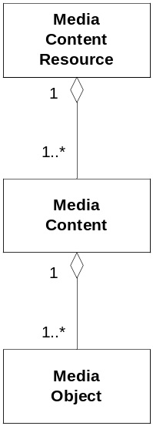
Figure 1 Media

Media Content Package
A Media Content Package is a deliverable that contains a set of media files together with their configuration. A Media Content Package has a one-to-one relation to a Media Content Resource as defined in ref. [4]

Function Requirements (Commercial)
The following commercial requirements have been identified:
- It must be possible to handle any language as defined ref. [2]
- It must be possible to handle any number of concurrent languages.

Function Specification (Design Related)

Introduction

Media Content Manager
The Media Content Manager component provides the Media Content Manager and Media Content Resource interfaces. These interfaces are used by its clients to install and retrieve Media Content.
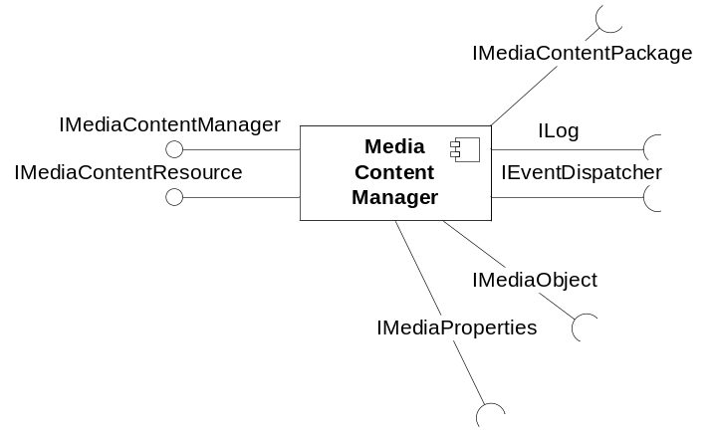
Figure 2 Media Content Manager component

Relationships in a Media content resource
A Media content resource may have several file extensions (for example wav).
A file extension has one and only one content type. A Content type has one and only one set of codecs. Hence, a file extension may only have one set of codecs. A set of codecs can have two codecs: one for voice and one for video.
Note that the mappings above are common for all media content resources. For example, if there is a media content resource with the file extension “wav” and codec G711 u-law, there can not be another media content resource having another codec for wav-files.

Exported Interfaces

IMediaContentManager
This interface is used when the client needs to manage Media Content Resources and Media Content Packages.

Methods

Install Media Content Package
MediaContentResourceId installMediaContentPackage(MediaContentPackage pkg)
This method is used when the client wants to add a Media Content Package in the Media Content Manager. The resulting resource identity is returned when the package has been installed.

Uninstall Media Content Package
void uninstallMediaContentPackage(MediaContentResourceId resourceId)
This method uninstalls the specified package. The behavior is undefined if a language package used by a client is uninstalled.

Get Media Content Resource
IMediaContentResource[] getMediaContentResource(MediaContentResourceProperties mcpProp)
This method returns a list of Media Content Resources that fulfills the MediaContentResourceProperties criteria.
The MediaContentResourceProperties may be empty which imply that all Media Content Resources will be returned. The order in which the Media Content Resources are returned is significant i.e. the first one in the list has highest priority and the rest in a descending order. The priority is decided when the resource is created.

Parameter type description

MediaContentResourceId
A, within a particular instance of Media Content Manager, unique identity of a Media Content Resource.

MediaContentResourceProperties
The MediaContentResourceProperties contains any combination of the characteristics listed in section 1.1.3.

IMediaContentResource
This interface allows a client to request a Media Content by specifying its identity and possibly a number of qualifiers (for example a date or a number) to be used for this Media Content. The Media Content Resource returns a list of IMediaObjects to the client.

Methods

Get Media Content
MediaObject[] getMediaContent(MediaContentId id Qualifier[] q).
This method returns a list of IMediaObjects representing the media content identity. The optional Qualifier argument passed is used to qualify the request for example when an actual number is needed for the mediaContentId in question (see section above).

Get Media Content Ids with qualifiers
MediaContentId[] getMediaContentId(Qualifier[], q).
This method returns a list of all Media Content ids for this resource. The optional Qualifier argument passed is used here to select only those Media Content Ids where the condition matches the Qualifier list (see section 3.2.2.2.2, the condition part for details). In case the Qualifier is empty all Media Content Ids are returned. The list is alphanumerically sorted on Id.

Get Media Properties
MediaProperties getMediaProperties().
This method returns the Media Properties of this resource.

Parameter type description

MediaContentId
The MediaContentId is the identifier to the MediaContent and is an arbitrary human readable tag. For certain content the string may contain a number, for other content a mnemonic may be used to identify a specific content. In any case the id must be unique within the Media Content Resource.

Qualifier
A Qualifier is used in two ways, either to be converted to its corresponding IMediaObjects representation or to be used in a condition to select the correct list of IMediaObjects. It is possible to use both methods concurrently.
A Qualifier used when requesting a Media Content is one of the following types: Number, CompleteDate, DateDM, Weekday, Time12, Time24, String, IMediaObject. These types are defined as follows:
Number A positive integer e.g. “101” and possibly a gender (female, male and neutral)
CompleteDate A complete date in the form of “YYYY-MM-DD HH:MM:SS +-UTC” e.g. 2005-08-12 23:13:23 +0200”. Conversion is only supported for the YYYY-MM-DD part, the time string is ignored.
DateDM A date in the form of “YYYY-MM-DD” e.g. “2005-08-12”
Weekday A date in the form of “YYYY-MM-DD” e.g. “2005-08-12”
Time12 A time in the form “HH:MM:SS” e.g. 23:13:23”
Time24 A time in the form “HH:MM:SS” e.g. 23:13:23”
String String in UTF-8 e.g. “John Doe”
IMediaObject An arbitrary IMediaObject e.g. the recorded name of a subscriber.
A) Qualifier conversion to its corresponding IMediaObject(s):
When the qualifier is supposed to be converted to its IMediaObjects corresponding representation, Table 1 shows examples on the conversion functionality:
Qualifier Type | Input | Output
Number | 101 | The following list of IMediaObjects: “one”, “hundred”, “and”, “one”
DateDM | DateDM('2005-01-01') | The following list of IMediaObjects: “January”, “1st”
CompleteDate | CompleteDate('2005-01-01') | The following list of IMediaObjects: “2005”, “January”, “1st”
Weekday | WeekDay('2005-08-12') | The following IMediaObjects: “Friday”
Time12 | Time12('23:13:23') | The following list of IMediaObjects: “Eleven”, “thirteen”, “PM”
Time24 | Time24('23:13:23') | The following list of IMediaObjects “Twenty”, ”three”, “thirteen”
String | 'John Doe' | The following list of IMediaObjects: “J”, “o”, “h”, “n”, “D”, “o”, “e”
IMediaObject | The recorded name of a subscriber. | The IMediaObject itself.  The purpose here is when a IMediaObject must be inserted in a language dependant context. A IMediaObject qualifier cannot be used as a condition.
Table 1 Qualifier conversion

Grammar Rules
The Media Content Manager uses Grammar Rules that defines rules for how natural numbers, date, time is played in spoken words.
This support means that a client can pass a Qualifier and have that qualifier converted to a list of IMediaObject that represents the words for this qualifier in the specified language.
For instance if the Qualifier is a Number, the number is not read back digit-by-digit but is read back in a natural format and in the correct gender as appropriate.
For example in US English, "101" won't be voiced as "one zero one", it will be
voiced as "one hundred one". In Danish, this will be voiced as "Et hundrede og
et" (that is, "one hundred and one").
The same principles apply to the DateDM, CompleteDate, Time12, and Time24 Qualifiers.
The following types must be supported for conversion using the grammar file:
- Number
- DateDM
- CompleteDate
- Time12
- Time24

String and Weekday qualifiers are converted according to Table 1.

B) Qualifier used as a condition
When the Qualifier is used as a condition to select one of the predefined IMediaObject lists, the following Boolean operators are supported: ==, !=, <, >, <=, =>, &&, ||. The Boolean expression can be nested by use of parentheses. Certain arithmetic is also supported i.e. addition and subtraction. For strings, addition means concatenation of two strings. The Boolean operators can be used on all Qualifier types except IMediaObjects but only between Qualifiers of the same type.
Prescendence when an expression contains several operators are the same as defined in ref. [3]

Example (‘Q1’ means qualifier 1):
Q1 > 1 (Q1 is a Number)
Q2-Q1 > 604800 (Q2 and Q1 is a Date and the subtraction results in number of milliseconds)
Q1 == “Goodmorning” (Q1 is a String)
(Q1 == “2005-08-12 23:13:23 +0200”) && (Q2 == “Prepaid”) (Q1 is a CompleteDate and Q2 is a String)

If the evaluation of the condition fails for all predefined IMediaObject lists, an empty list is returned.

MediaContentPackage
This parameter is defined in ref. [4]

MediaContentId
A, within a particular instance of a Media Content Resource, unique identity of a Media Content.

MediaProperties
The MediaProperties is defined in ref. [1] .

Imported Interfaces
The Media Content Manager uses the following external interfaces:
- ILog for logging purposes.
- IEventDispatcher for notifying on new Media Content Resources installed.
- IMediaObject for storing media
- IMediaProperties used for identifying the media properties of a Media Content Resource.
- IMediaContentPackage for installing Media Content Packages.

Functions

Install Media Content Package

Figure 3 Install a Media Content Package
- Any component issues an installation request of a Media Content Package.
- The Media Content Manager returns with the resulting Media Resource Identity.
The new Media Content Package is not available until the Media Content Manager is reinitialized (restart).

Uninstall a Media Content Package
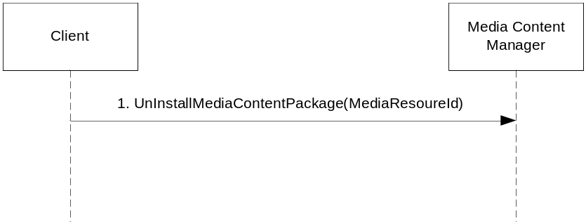
Table 2 Uninstall a Media Content Package
- Any component issues an un-installation of a Media Content Package and specifies its identity.

Get Media Content Resource
This function shows how a client can retrieve a particular Media Content Resource with correct Media Properties for the media context of the client.
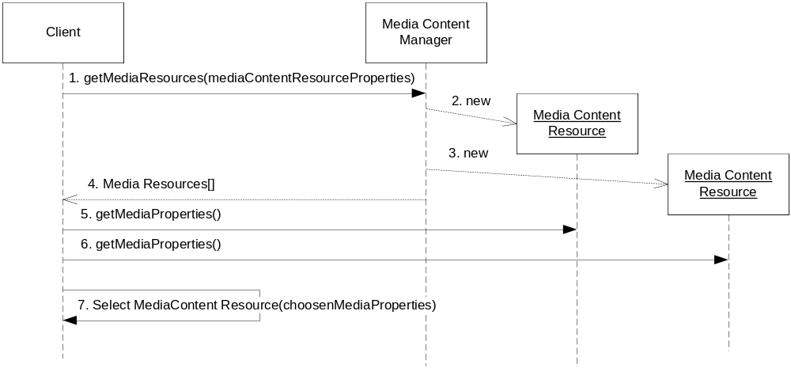
Figure 4 Get Media Properties list
- The client issues a request to retrieve a list of all Media Content Resources that matched the MediaContentResourceProperties.
- The Media Content Manager instantiates …
- … the Media Content Resource that matched the MediaContentResourceProperties.
- The Media Content Manager returns the list of Media Content Resources.
- The client retrieves the Media Properties of all …
- … Media Content Resources returned
- The client uses the Media Properties to select which Media Content Resource to use (e.g. based on the result from a codec negotiation with a remote client).

Retrieve Media Content from a particular Media Content Resource and issue a play on an IStream object
This function shows how a client can retrieve IMediaObjects for a particular Media Content and then play them on an IStream object.
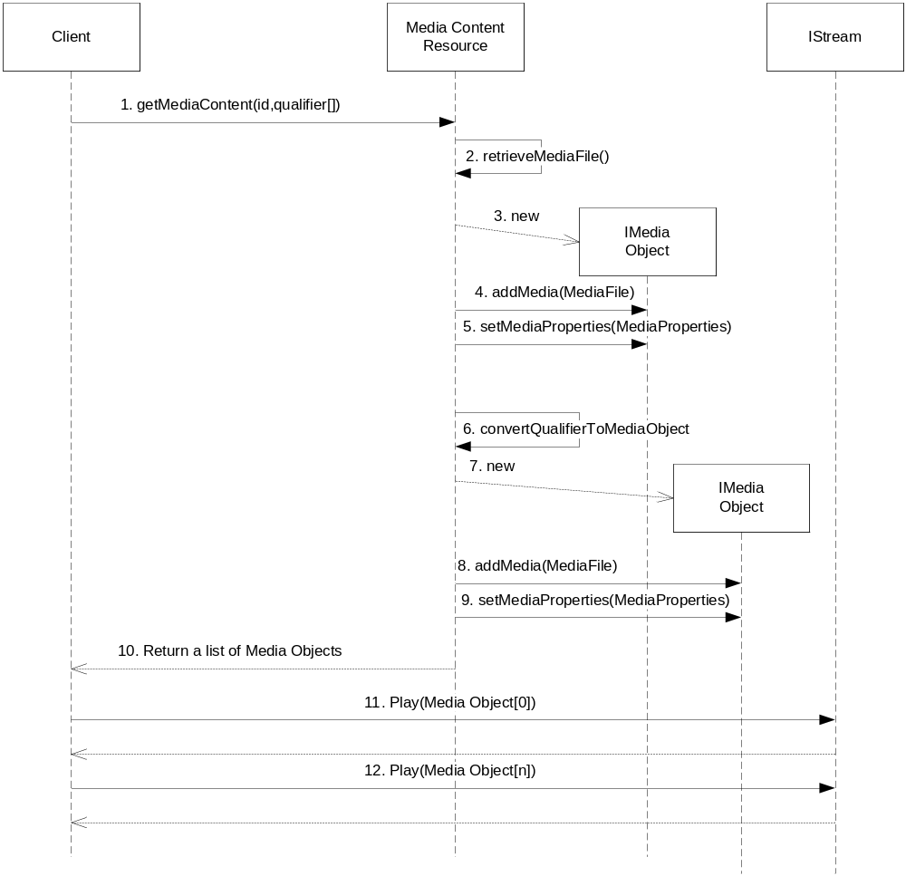
Figure 5 Retrieve and play a Media Content
- The client requests a particular Media Content by specifying its identity and provides its qualifiers.
- The Media Content Resource retrieves the first media and …
- … instantiate an IMediaObject.
- The client add Media File and …
- … sets the Media Properties the corresponding Media Properties.
- The Media Content Resource converts the second media (which in this case is a qualifier) and converts this qualifier to a media using Grammar Rules and …
- … instantiate IMediaObjects.
- The client add a Media File and …
- … sets the corresponding Media Properties.
- The Media Content Resource returns the list of IMediaObjects.
- – 12. The Client issues the play request to IStream in a sequential order for each IMediaObject retrieved.

Get Media Content for specific conditions
This function shows how a client to Media Content Manager can retrieve media content from a second Media Content Resource which has the same media characteristics as an existing Media Content Resource. This second resource is then used to filter out only those Media Content Ids matching a specific condition. For example the client might have an established session using a resource with the “Prompt” type, and need another resource with type “System Wide Announcement”. In this case the Media Content Resource typically is created with conditions for each Media Content Id.
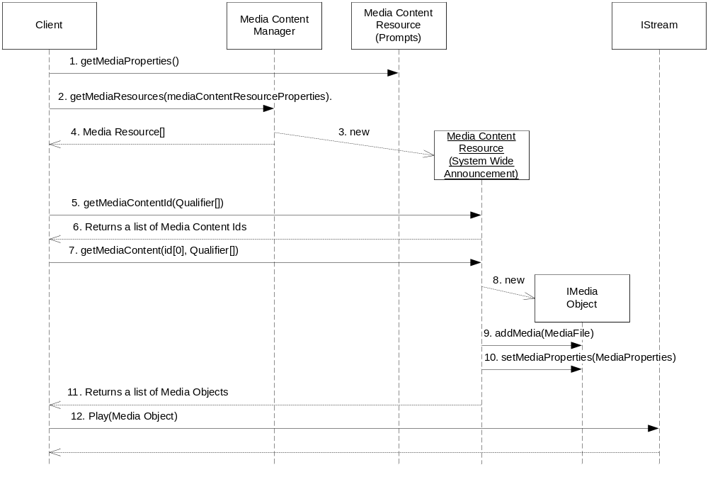
Figure 6 Get media content for specific conditions
- The client requests the media property on an existing Media Content Resource used for Prompts.
- The client use parts of this media property (i.e. language, codec) to create a new MediaContentResourceProperties to retrieve the Media Content Resource for a System Wide Announcement.
- The Media Content Manager instantiates Media Content Resource matching the MediaContentResourceProperties.
- The Media Content Manager returns the list of Media Content Resources (which in this case should be only one instance).
- The client requests a list of Media Content Ids that match the conditions qualified with the list of Qualifiers (see section 3.2.2.2.2 for details on conditions) and the …
- … list is returned to the client. The list is sorted on Id.
- For each Media Content returned the client requests its list of IMediaObjects possibly by use of the same or other Qualifers.
- The Media Content Resource creates the IMediaObject …
- … adds the Media File and …
- … optionally sets the Media Properties and …
- … returns the list to the client.
- The client issues a play on an IStream for each IMediaObject.

Get all Media Content from a resource
This function is very similar to the one in section 3.4.5. However in this case the Qualifiers used when retrieving the list of Media Content Ids is empty which means that all Media Content is returned. In this scenario the additional Media Content Resource has the type set to “Fun Greeting”.
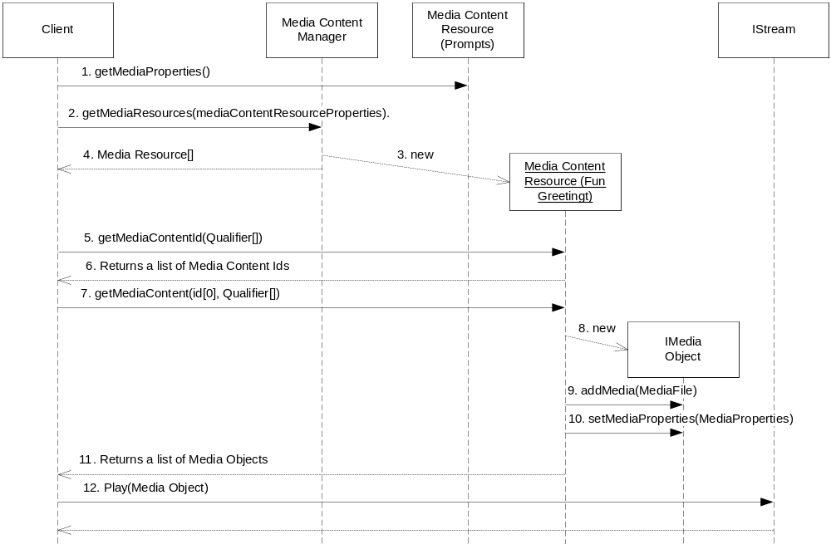
Figure 7 Get all Media Content from a resource
- The client requests the media property on an existing Media Content Resource used for Prompts.
- The client use parts of this media property (i.e. language, codec) to create a new MediaContentResourceProperties to retrieve the Media Content Resource for a System Wide Announcement.
- The Media Content Manager instantiates Media Content Resource matching the MediaContentResourceProperties.
- The Media Content Manager returns the list of Media Content Resources (which in this case should be only one instance).
- The client requests a list of Media Content Ids that match the conditions qualified with the list of Qualifiers (see section 3.2.2.2.2 for details on conditions) and the …
- … list is returned to the client. The list is sorted on Id.
- For each Media Content returned the client requests its list of IMediaObjects possibly by use of the same or other Qualifers.
- The Media Content Resource creates the IMediaObjects …
- … adds the Media File and …
- … optionally sets the Media Properties … and
- … returns the list to the client.
- The client issues a play on an IStream for each IMediaObject.

Events

Produced Events
The Media Content Manager produces no events.

Consumed Events
The Media Content Manager consumes no events.

External Operation Conditions

Configuration
This paragraph is intentionally left blank.

Capabilities
This paragraph is intentionally left blank.

References
- FS-Media Object
13/FS-MAS0001
- Codes for Definition of the inetOrgPerson LDAP Object Class
RFC 2798 (http://www.ietf.org)
- Java
http://java.sun.com
- FS-Application and Media Content Package Manager
1/FS-SWU0044

Terminology
This paragraph is intentionally left blank.

Highest here means the preferred one.
The Number Qualifier can also be further qualified with a gender. This means that different Media Objects will be returned depending on the gender qualifier. For example in Spanish the number one (1) has three different representations depending on gender: un, una and uno.

