FS – MAS Operate and Maintain Manager

Content
1 Introduction 2
2 Definitions 2
2.1 External Service Consumer 2
2.2 External Service Provider 2
2.3 Service 2
2.4 Service Consumer 2
2.5 Service Enabler 2
2.6 Service Provider 3
3 Function Requirements (Commercial) 3
4 Function Specification (Design Related) 3
4.1 Introduction 3
4.2 Exported interfaces 4
4.2.1 CfgTool 4
4.2.2 IInstall 5
4.2.3 IOperate 5
4.2.4 IBackupRestore 5
4.2.5 ISupervision 5
4.2.6 IProvidedService 6
4.2.7 ServiceEnablerInfo 7
4.2.8 IMIB 8
4.2.9 IMonitor 10
4.3 Imported interfaces 11
4.3.1 IEventDispatcher 11
4.3.2 IConfiguration 11
4.3.3 IConnectionMonitor 11
4.3.4 ServiceEnablerOperate 12
4.3.5 IDiagnoseService 13
4.4 Function Specification 14
4.4.1 Installation 14
4.4.2 Operation 14
4.4.3 Load regulation 17
4.4.4 Supervision 18
4.4.5 Connection Monitoring 20
4.4.6 Watchdog 21
4.5 Events 21
4.5.1 Produced events 21
4.5.2 Consumed events 21
5 External Operation Conditions 21
5.1 Configuration 21
6 Capabilities 22
7 References 22
8 Terminology 22

History

Version | Date | Adjustments
A | 2006-10-16 | First version (MHATU).
B | 2006-12-05 | Second version (MHATU)
C | 2007-06-15 | Minor changes. Removed check OMManager used to do to check process memory (ermkese).

Introduction
This document specifies the functionality of the Operate and Maintain Manager component (OMM) in a MAS. The design of OMM is generic even though parts are very specific to MAS.

Definitions

External Service Consumer
An entity in a system that utilize a service provided by the Application running on MAS.

External Service Provider
An entity in a system that the Application running on MAS utilizes.

Service
Service in this document refers to a service as registered in the Component Registry (MCR).

Service Consumer
An entity in MAS that consumes a Service.

Service Enabler
An entity in MAS that enables a Service to an External Service Consumer.

Service Provider
An entity in MAS that provides a Service.

Function Requirements (Commercial)
The following commercial requirements have been identified.
- The system shall run on Solaris 10.
- The system shall be easy to install and maintain
- The system shall be easy to trouble shoot

Function Specification (Design Related)

Introduction
The OMM handles the following basic functions:
- Installation/uninstallation/upgrade of software and patches
- Operation (start/restart, lock/unlock, configuration change etc.)
- Load regulation
- Provide supervision information on provided services through MIB. It is the responsibility of the Application to define what services it provides, i.e. the MAS don’t provide any services by itself.
- Provide supervision information on Service Enablers used for MAS provided services.
- Provide a monitoring function of Service Enabler statistics and connection information details
- Watchdog
- Backup/Restore
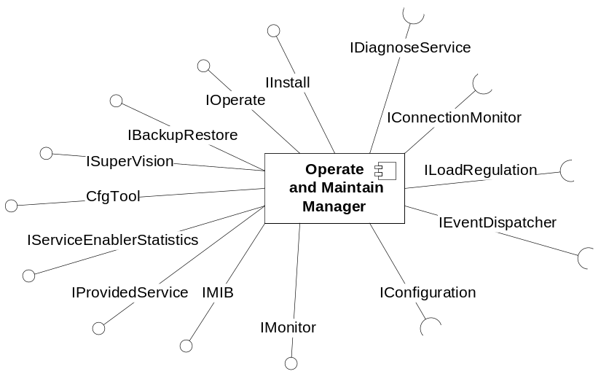
Figure 1 The Operate and Maintain component
The OMM exports the following interfaces. IInstall interface for installation, uninstallation and upgrade procedures, IOperate for operation of the provided functionality, IBackupRestore for backup and restore, ISupervision, IProvidedService, CfgTool and IServiceEnablerStatistics for providing supervision information, IMIB for providing supervision and other information to external systems and finally IMonitor for monitoring of active sessions.

The IOperate, IMIB interfaces executes separately from the MAS traffic handling process because the OMM must be able to report problems in the traffic part of MAS even if it has severe problem or even crashed.

Exported interfaces

CfgTool
This tool is used to manipulate the XML configuration files.
This is a manual interface i.e. the interface is used by a human being by using this tool to manipulate the configuration files.
Syntax:
CfgTool [-g param [-q][-v] <input file>]
[-s param=value [-v] <input file> [output file]]
[-m [-v] <old file> <new file> [output file]]
[-l <input file>]
[-h]

Options:
-g param - Print the value of one or more parameters.
-q "Quiet mode", only print the value.
-s param=value - Set one or more parameters to the specified value. The result
is stored in <output file> if it has been specified. If not
<input file> is overwritten.
-m Merge <old file> into <new file>. The result is store in <output file>
If it has been specified. If not <input file> is overwritten.
-v Validate the XML file against its schema.
-l List all parameters in the configuation file.
-h Print this message.
The -g, -s, -m, and -l parameters are mutually exclusive and can't be
used simultaneously.

IInstall
This interface is used by an operator when the MAS component shall be installed, uninstalled.
This is a manual interface i.e. the interface is used by a human being by sending commands to the OMM as specified in ref. [1] and ref. [4]

IOperate
This interface is used by an operator when the MAS component shall be operated for example started, stopped etc.
This is a manual interface i.e. the interface is used by a human being by sending commands to the OMM as specified in ref. [3] .

IBackupRestore
This interface is used by an operator when the MAS component shall be backup and restored.
This is a manual interface i.e. the interface is used by a human being by sending commands to the OMM as specified in ref. [2]

ISupervision
This interface is used to create entries in OMM to be used by a client to provide supervision information.

Create Provided Service Entry
IProvidedService createProvidedServiceEntry(Service s, Host h, port p, ServiceEnabler se);
This method returns a reference to a service entry for this Provided Service. If this is the first time since install time this request is done, OMM creates a new service entry otherwise it returns an existing one.
For each ServiceName there can be only one entry in O&M.

The entry will continuously be updated by the client to reflect the Provided Service actual status.

Get service enabler statistics
ServiceEnablerInfo getServiceEnablerStatistics(ServiceEnabler);
This method returns a reference to a statistics entry for this enabler.
The entry will continuously be updated by the client to reflect the Service Enabler statistics.

Get session info factory
SessionInfoFactory getSessionInfoFactory();
This method returns a reference to a factory.
The factory will be used when execution engine handles call sessions.
Execution engine will ask the factory for a session object that continuously will be updated.

Parameter type description

Service
Service contains the service as defined in MCR.

Host
Host contains the name of the host including the domain that provides the service.

Port
Port contains the port on the host that provides the service.

Service Enabler
Service Enabler contains the name of the service enabler.

Connection Monitor
A Connection Monitor is a reference to a part of MAS that provide Connection information.

IProvidedService
This interface is used to provide supervision information on provided services to OMM. The interface offers the following methods. Even if the Provided Service is unable to use (corrupted, invalid etc.), OMM expects the entry to be created anyway. Its state is then initially set to down. The purpose of this is that OMM needs to communicate this problem in the MIB.

Set Status
void setStatus(Status s);
Set’s the status of the provided service.

Set Application
void setApplication(ApplicationName an, ApplicationVersion av);
Set’s the Application information. This information will be used to provide the Application version in the MIB.

Set Current time
void setCurrentTime();
Set’s the current time. This is a kind of heartbeat that OMM can use to check that the Service Provider is alive. This time is updated each second.

Parameter type description

Status
Contain the status of the provided service. Can be one of:
Up The service is fully operational
Down The service is completely non-operational

ServiceEnablerInfo
This interface is used to provide statistical information on a Service Enabler and offers the following methods.

Set protocol
void setProtocol(Protocol p);
Set’s the protocol used by this Service Enabler.

Set Max connections
void setMaxConnections(int mc);
Set’s the max allowed number of connections (i.e. the value currently used by the Service Enabler). This value is updated whenever changed in the client (e.g. due to values provided in the load regulation interface).
Increment current connections
void incrementCurrentConnections(Type t, Direction d);
Increments the number of connections currently active in the Service Enabler by one for the specific type and direction.

Decrement current connections
void decrementCurrentConnections(Type t, Direction d);
Decrements the number of connections currently active in the Service Enabler by one for the specific type and direction.

Increment number of connections
void incrementNumberOfConnections(Type t, Result r, Direction d);
Increments number of started connections in the Service Enabler by one for the specific type, result and direction.

Parameter type descriptions

Protocol
Protocol contains the literal name of the protocol used e.g. “sip” or “xmp”.

Type
Type contains the type of connection. Can be one of Voice, Video or Service Request.

Result
Variant contains the result of a connection. Can be one of:
Connected The connection has reached connected state
Failed The connection was rejected.
Abandoned The connection was abandoned.
Far End Disconnected The connections that were dropped by the far end
Near End Disconnected The connections that were dropped by the near end
Dropped entities Dropped entities for this connection. For example RTP packets.
Error Connection was dropped due to failure.

Direction
Direction contains the direction of the connection. Can be one of Out or In.

IMIB
The IMIB interface allows an SNMP client to access the following Management Information Base (MIB) using the SNMP protocol as defined in ref. [7] .
The top OID for the MIB is:
- enterprises.24261

General Attributes
The following general information is supported.
Type | Description
Name | The name of the MAS component as registered in MCR i.e. <component_instancename>@<hostname> e.g. mas1@host1.com
Version | The version of the MAS component as registered in MCR.
Operational State | The operational state of MAS. One of Enabled or Disabled.
Administrative State | The Administrative state of MAS. One of Locked, Unlocked or Shutdown.
Install Date | The date the MAS was installed.
Current Up-Time | The time MAS has been up since last start of MAS
Accumulated Up-Time | The total up time of MAS since install date.
Reload configuration | A writeable attribute that instructs MAS to reload its configuration
Reload configuration time | The time in hundredths of seconds since the last successful reload configuration was performed
Reload configuration ticks | This variable shows the time in number of hundredths of a second  since the last time the configuration was loaded
Table 1 General attributes

Provided Services
For each provided service the following information is supported as defined in ref. [6] (except the Application information):
Type | Description
Name | The name of the service as defined in MCR
Status | The status of the service as defined in section 4.2.6.4.1.
Host name | The host providing the service (i.e. the host MAS executes on)
Port | The port on the host providing the service
Zone | The logical zone of the Service Provider i.e. this MAS instance.
Application name | The name of the Application that provides the service. This is defined within each Application
Application version | The R-state of the Application that provides the service.
Table 2 Provided Services in the MIB

Service Enabler Statistics
For each Service Enabler the following information is supported.
Type | Description
Protocol | The protocol used by this Service Enabler i.e. a literal name with the name of the protocol e.g. “sip”, “xmp” etc.
MaxConnections | Max number allowed connections for this Service Enabler.
Connections | An entry for each type with information as defined in Table 4.
Table 3 Service Enabler Statistics in the MIB

For each connection type the following information is supported.

Type | Description
Connection type | The type of this connection, one of Voice, Video or Service Request
Current connections | Current active connections
Peak Connections | Peak connections since restart
Peak Time | The time when Peak Connections occurred. If no connections have been active since restart this time will indicate start time.
Total Connections | The number of connections since last restart
Accumulated Connections | The number of connections since install
Table 4 Connection details

IMonitor
This interface is used by an operator when the active connections or connection statistics are to be monitored.
The interface must be able to provide the information in a textual form i.e. possible to view over a telnet connection.
This is a manual interface i.e. the interface is used by a human being by sending commands to the OMM with the following syntax:
Rc.mas monitor
Monitor has two views, connections and statistics. When connections is used, O&M retrieves details on each connection as specified in section 4.3.3.

When statistics is used, O&M retrieves the following statistics for each Service Enabler and presented per connection type (as defined in section 4.2.7.5.2).

Type | Description
Current connections | Number of current connections that are at least in the initiated state and until they are terminated.
Current inbound connections | Out of Current connections the number of inbound connections.
Current outbound connections | Out of Current connections the number of outbound connections.
Total connections | Number of connections since the last restart (with the same definition as Current connections)
Total inbound connections | Out of Total connections the number of inbound connections.
Total outbound connections | Out of Total connections the number of outbound connections
Total connected connections | Out of Total connections the number of connections that have been answered since the last restart.
Total connected inbound connections | Out of Total answered connections the number of inbound connections
Total connected outbound connections | Out of Total answered connections the number of outbound connections
Total abandoned connections | Number of abandoned connections since restart. The definition of an abandoned connection is done by the Service Enabler.
Total abandoned inbound connections | Out of Total abandoned connections the number of inbound connections.
Total abandoned outbound connections | Out of Total abandoned connections the number of outbound connections.
Total failed connections | Numbers of connections since restart that where rejected by the near or far end for any reason.
Total failed inbound connections | Out of Total rejected connections the number of inbound connections.
Total failed outbound connections | Out of Total rejected connections the number of outbound connections.
Total disconnected connections | Number of connections since restart that were terminated by the near end.
Table 5 Connection statistics

Imported interfaces

IEventDispatcher
Used to handle events.

IConfiguration
Used to retrieve configuration as defined in ref.[9]

IConnectionMonitor
This interface is used by the OMM to retrieve connection related information. The interface implements the following methods.

Start monitor
void startMonitor();
StartMonitor instructs the client to start collecting information on the connection.

Stop monitor
void stopMonitor();
StopMonitor instructs the client to stop collecting information on the connection.

Get Connection Info
IConnectionInfo[] getConnectionInfo();
GetConnectionInfo retrieves the information about all current connection.

Parameter type description

IConnectionInfo
ConnectionInfo contains the following information:
Type | Description
Session Id | The identity of the session using this connection. This information can be used to see which connections are used for a particular session.
Service | The Service using this connection
Session initiator | The initiator of the session that created this connection. One of:  ”sr:<xmpclientid>” for Service Requests  ”sid:<session id>” when initiated by another session  ”tel:” when initiated by a telephony session.
Connection type | One of Voice or Video
Connection State | The state of the connections as defined in ref. [8]
Direction | One of Inbound or Outbound
Outbound activity | One of Idle or Play.
Inbound activity | One of Idle or Record.
ANI | The telephone number of the calling party
DNIS | The telephone number of the called party
RDNIS | The telephone number of the redirected called party
Far end connection properties | A list of the far end IP address and ports (for the outbound traffic) used for this connection and protocol. E.g. “RTP:123.4.56.127:2080:2082, SIP:123.4.56.24:5060”

Table 6 Connection info

ServiceEnablerOperate
This interface is used by the OMM to operate and set the load threshold for Service Enablers. The interface implements the following methods:

Open
void open();
Unlock the Service Enabler and allows it to accept traffic according to the value earlier set by the setThreshold method.

Close
void close(forced);
When close(true) is called (Forced):
Lock the Service Enabler immediately. All ongoing sessions are interrupted and terminated (with respect to the semantics in the protocol used to access the service). All new service requests are rejected. When all service sessions has terminated the client calls the closed on the ServiceEnablerInfo interface.
When close(false) is called (Unforced):
Close the Service Enabler unforced, which means that all ongoing service sessions continue until normally ends, but all new service requests are rejected. When all service sessions has terminated the client calls the closed on the ServiceEnablerInfo interface.

Set Threshold
void setThreshold(Threshold th);
Update the threshold for the Service Enabler. If the client’s current sessions are greater than threshold, it will act to prohibit that new sessions are started until current sessions is equal or less than the threshold.

IDiagnoseService
This interface is used by OMM to check if a service offered by a Service Enabler is functional. The interface implements the following methods:

Service Request
Status Boolean serviceRequest(ServiceInstance si);
Check if the service enabled by the Service Enabler is functional. Return the service status.
Note: These Service Requests shall not in any way affect any counters or thresholds that are used for normal Service Requests.

Parameter type description

Status
Status can be one of
Up The Service Enabler was able to fully perform the Service Request
Down The Service Enabler completely failed to perform the Service Request

Function Specification

Installation
The installation of MAS is as specified in ref. [1] . The installation procedure register the MAS with the mas1@<domain> Service.

Operation

Managing Administrative state

The Administrative state only concerns the Provided Services. 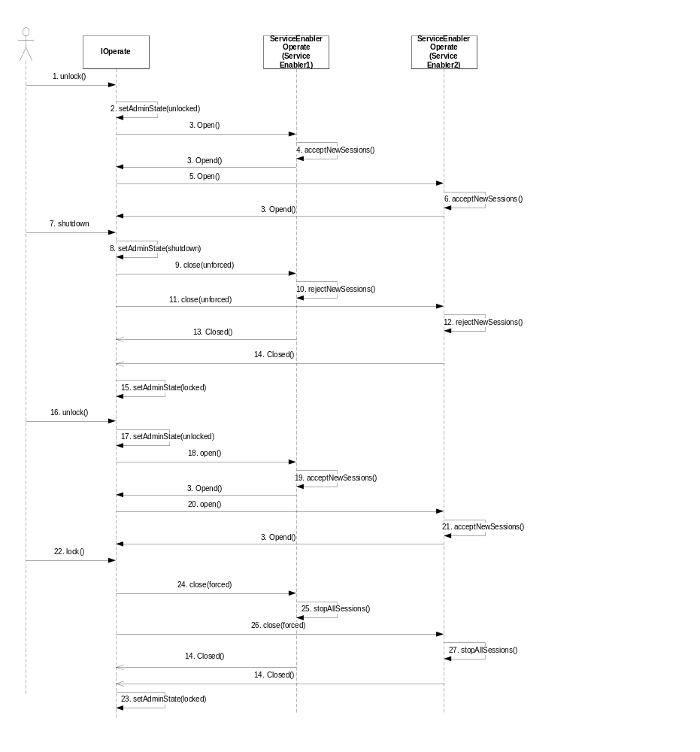
Figure 2 Operating Administrative state
- The operator performs an unlock request on MAS.
- OMM sets the Administrative State to unlocked.
- OMM check the Provided Service entries and for each Service Enabler found issues an open() request.
- The Service Enabler 1 starts accepting new session (if the current threshold value is > 0, see section 4.4.3 how threshold is set).
- Similar …
- … as for Service Enabler 1.
- The operator performs a shutdown request on MAS
- OMM sets the Administrative State to Shutdown.
- OMM issues a close(unforced) request for each Service Enabler.
- Service Enabler 1 stops accepting new sessions.
- OMM issues a close(unforced) request for the next Service Enabler
- Service Enabler 2 stops accepting new sessions.
- When all sessions has finished it calls closed() on OMM.
- Similar as for Service Enabler 1.
- When all Service Enabler is closed, the OMM sets the Administrative state to Locked.
- The operator performs an unlock request on MAS.
- OMM sets the Administrative State to unlocked.
- OMM issues an open() request for each Service Enabler.
- Service Enabler 1 starts accepting new session.
- Similar …
- … as for Service Enabler 1.
- The operator performs a lock request on MAS
- OMM sets the Administrative state to locked.
- OMM issues a close(forced) request for each Service Enabler.
- Service Enabler 1 stop all current sessions
- Similar …
- … as for Service Enabler 1.

Operational state
The operational state of MAS is set by OMM to “disabled” if one of the following statements is true otherwise the operational state is “enabled”:
- If one of the Provided Services is in state “down” either if itself reports “down” or if the service diagnose shows that the service is “down”.
- No Service Provider has created a Provided Service Entry.
- If the load criterion for one of the Provided Services results in a threshold value equals to zero.
- The communication with the ILoadRegulation interface is broken (e.g. not responding etc.)
- .
At any time when the operational state goes from enabled to disabled, an info log entry is created describing the cause why it happened (i.e. one of the reasons above). When the state then later on goes from disabled to enabled a info log tells that the MAS is now operational.

Dynamic load of configuration
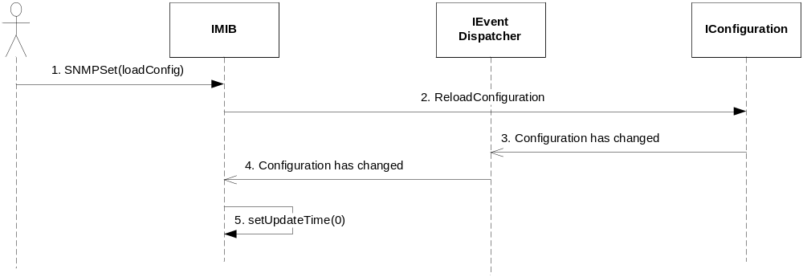
Figure 3 Reload configuration
- The operator, using an SNMP request issues a load configuration request
- OMM request a configuration load
- IConfiguration sends the Configuration has changed event
- OMM receives the Configuration has changed event.
- OMM sets the update time to zero. This time then starts to increase each hundredths of a second.

Load regulation
OMM handles load regulation on Service Enablers. The Load regulation loads the threshold as soon as the service enabler is registered. The load regulation determines the status for each registered provided service and update the operational status for MAS
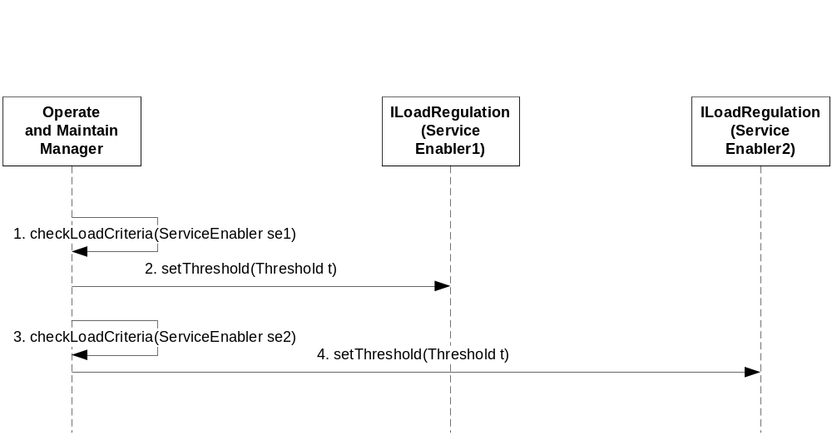
Figure 4 Load regulation
- For each Service Enabler OMM checks load criteria. Load criterion is currently based on configuration only.
- The OMM sets the threshold value Service Enabler 1
- Similar …
- … as for Service Enabler 1.

Supervision
Supervision conforms to the directions specified in [5] as defined in this section.

Provided Services
OMM maintains a list of Provided Services created by the Service Provider. The Service Provider updates the status.
For each Provided Service the OMM monitors the function of the service by performing tests at a regular interval. This test is also part of the installation procedure i.e. if the test fails the installer will be notified. How often this shall occur is configurable and defaults to once each 60 seconds.
An SNMP client can retrieve certain information from the Provided Services list based on the MIB definition (see section 4.2.7.).
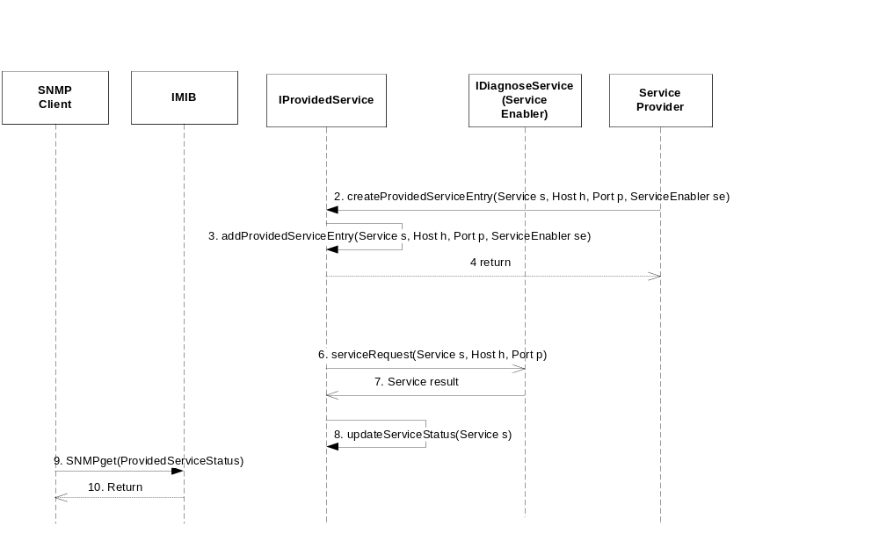
Figure 5 Provided Service supervision
- The Service Provider initiates the service Enabler and receives a ServiceEnabler.
- The Service Provider requests that a Provided Service entry is created in the OMM.
- OMM creates the entry using that information (if it doesn’t exist otherwise the existing entry is used) and …
- … returns a reference to the entry to the Service Provider
- The Service Provider updates service status on the reference.
- The OMM at a regular interval checks the Provided Service list and for each entry performs a Service Request to the Service Enabler passing the host and port in the request. This Service Request is a normal such. The request is asynchronous because some service may take some time to perform.
- OMM receives the result after some time and …
- … if the service request succeeds, the status of Provided Service is left unchanged otherwise the entry is updated, i.e. based on “worst case” scenario, only if both the Service Provider and OMM test shows that the service is up, the resulting state will be up.
- The SNMP client retrieves the information from the Provided Service list as defined in the MIB and …
- … returns.

Service Enabler
OMM maintains a list of Service Enablers. There is only one entry for each Service Enabler.
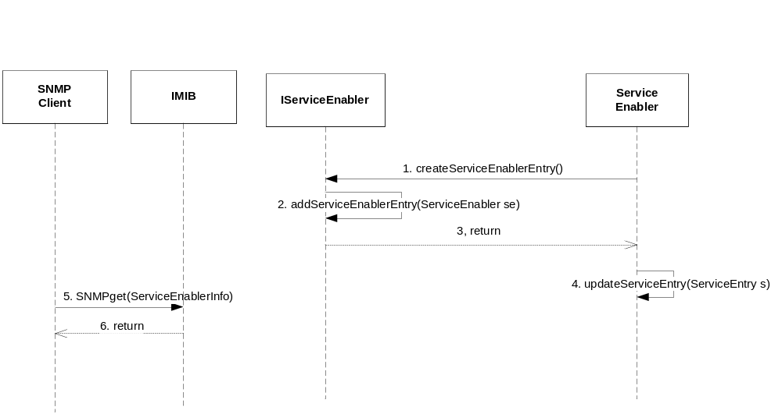
Figure 6 Service Enabler supervision
- The Service Enabler requests that Service Enabler entry is created in the OMM.
- OMM creates the entry (if it doesn’t exist otherwise the existing one is used) and …
- … returns a reference to the entry to the Service Enabler
- The Service Enabler continuously updates Service Enabler entry on the reference.
- The SNMP client retrieves the information from the Service Enabler list as defined in the MIB.
- And returns the information to the SNMP Client

Connection Monitoring
The OMM provides a monitoring tool that displays information on current connection.
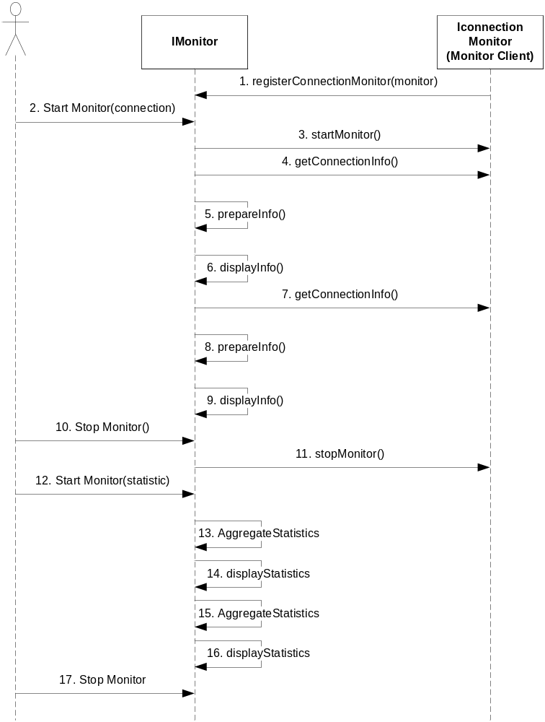
Figure 7 Connection monitoring
- The Monitor Client at startup of MAS registers itself to OMM as a Connection Monitor
- The operator starts the monitor to show connection details.
- The OMM requests a monitor client to start a monitor.
- The OMM requests connection information regularly …
- … prepares the information and …
- … displays the information to the operator.
- … and…
- … once …
- … again
- The operator stops the monitor and …
- … OMM requests the Monitor client to be stop its monitor
- The operator starts the monitor to show connection statistics.
- OMM aggregates Service Enabler information
- OMM displays the statistical information
- … and …
- … once again
- The operator stops the monitor

Watchdog
The OMM supervises the processes involved in MAS and when a process un-expectantly for some reason terminates, OMM restarts this process. The watchdog starts its supervision as soon as the MAS component is started.

Events

Produced events
OMM produce no events.

Consumed events
The OMM consumes the following events
Service result Contains the result of the service request, one of “up”, “down” or “impaired”.
Shutdown completed The Service Enabler has completed the shutdown request and got into locked state.
Configuration Change The operator has issued a reload of the configuration.

External Operation Conditions

Configuration
The following properties of OMM are possible to configure:
- The interval in which the self monitoring occurs, defaults to 60 seconds.
- The interval the Monitor poll is performed, defaults to 1 second.
- The interval in which different counters are stored persistent.

Capabilities
This paragraph was intentionally left blank.

References
- UCD Install Component
12/155 53-1HDB 101 02 Uen
- UCD Backup and Restore Component
13/155 53-1HDB 101 02 Uen
- IWD Component Start & Restart
17/155 19-1HDB 101 02 Uen
- Patch handling
2/000 21-FCP 101 1154 Uen
- FS Supervision
15/155 17-1HDB 101 02 Uen
- IWD-Managed Object Interface
2/155 19 CRH 109 083 Uen
- RFC 3416 Operations for SNMP
http://www.ietf.org/rfc/rfc3416.txt?number=3416
- CCXML
www.w3c.org
- FS-Configuration
16/FS-MAS0001 Uen
- In Service Performance
3/1551-2/HDB 101 02 Uen
- Application Packaging Developers Guide
ftp://docs-pdf.sun.com/817-0406/817-0406.pdf

Terminology
MAS Media Access Server
MIB Management Information Base
OMM Operate and Maintain Manager
SNMP Simple Network Management Protocol

