IWD – Media Streaming

Content
1 Introduction 1
1.1 Purpose 1
1.2 Versions 1
1.3 Related Protocols 2
2 RTP packet 2
2.1 RTP header 2
2.2 RTP payload format for AMR 2
2.3 RTP payload format for H.263 5
2.4 RTP payload format for G.711 6
3 References 6
4 Terminology 6

History

Version | Date | Adjustments
A | 2007-06-29 | First version.

Introduction
This document specifies the payload format in an RTP packet.

Purpose
The purpose of this document is to specify the payload information that is used in Moip.

Versions
This paragraph is intentionally left blank.

Related Protocols
IP Internet Protocol
RTP Real-Time Transport Protocol
SDP Session Description Protocol
UDP User Datagram Protocol

RTP packet
The protocol RTP is used to carry the voice and video streams between the gateway and MAS. An RTP packet may be used to transmit media, coded in several methods i.e. different codecs. The codecs used by MoIP is G.711 and AMR for voice and H.263 for video.
An RTP packet contains of a header and a payload section. The header structure is equal for all different codecs, but the payload structure differs.
Before sending or receiving RTP packets, some set-ups must be done to make the applications understanding the RTP packet. This is normally done through SDP.
For example, the following has to be defined before sending the RTP packets:
Which codec shall be mapped to which number in the “Payload Type” field?

RTP header
Below follows a short explanation of the RTP header structure. More information can be found in Ref. [1]
The header of an RTP packet has the following format:
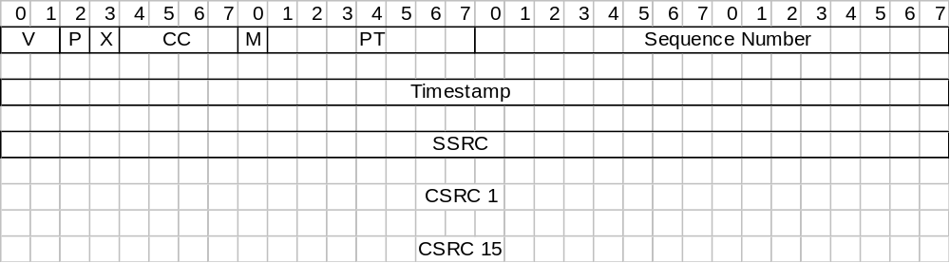Figure 1

V = Version | 2 bits | Shall be 2.
P = Padding | 1 bit | If the padding bit is set, the packet contains one or more additional padding octets at the end which are not part of the payload.
X = Extension | 1 bit | Indicates if header extension is used. See Ref. [1].
CC = CSRC count | 4 bits | The number of CSRC identifiers that follow the fixed header. Always 0 in MoIP.
M = Marker | 1 bit | The interpretation is defined by the SDP negotiations.
PT = Payload type | 7 bits | The format of the payload. The SDP negotiation determines which payload type that shall be matched by the number specified here.  The recommendation in MoIP is as follows:  If G.711 μ-law, use 0.  If G.711 A-law, use 8.  If H.263, use 34.  If AMR, use 97.
Sequence Number | 16 bits | The sequence number increments by one for each RTP data packet sent.  The initial value of the sequence number SHOULD be random
Timestamp | 32 bits | The timestamp of the first octet in the RTP data packet.  The initial value of the timestamp SHOULD be random. Several consecutive RTP packets will have equal timestamps if they are generated at once, e.g., belong to the same video frame.
SSRC =  Synchronization Source | 32 bits | An identifier of the current RTP packet.
CSRC = Contributing sources | 0 to 15 items, 32 bits each. | Information about the sources used to create the current audio or video media. Not used in MoIP.
Table 1

RTP payload format for AMR
There exist two types of payload formats, AMR-NB and AMR-WB. (NB=Narrow Band and WB=Wide band.) This document only covers AMR-NB, called just AMR further on.
The payload format for AMR looks different if in “Bandwidth-Efficient Mode” or “Octet-Aligned Mode”. The knowledge of which mode used, is determined in the set-up by SDP. In MoIP, only Octet-Aligned Mode is supported and described below.
In octet-aligned mode, the payload header consists of a 4-bit CMR, 4 reserved bits, and optionally, an 8-bit interleaving header. Interleaving is not supported and therefore not described here.
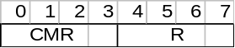
Figure 2

CMR = Codec Mode Request | 4 bits | In MoIP, the CMR shall always have the value 15. The value 15 indicates that it is not allowed to have different bitrates in the same RTP packet.
R = Reserved | 4 bits | Reserved bits that shall be ignored.
Table 2

The payload header is followed by a Table of Contents (ToC) which is a list of ToC entries. There exists one ToC entry for each frame in the payload. Below is the format of one ToC entry.
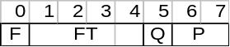
Figure 3

F | 1 bit | Indicates if this this ToC entry is followed by another ToC entry. If set to 0, indicates that the entry is the last one.
FT = Frame type | 4 bits | Indicates the coding mode for the corresponding frame. The following modes are valid in MoIP:  The default mode is 7.  SID is used to send frames containing only silence.
  Mode | Bitrate | bits/frame | Bytes/frame
  0 | 4,75 kbit/s | 95 | 12
  1 | 5,15 kbit/s | 103 | 13
  2 | 5,90 kbit/s | 118 | 15
  3 | 6,70 kbit/s | 134 | 17
  4 | 7,40 kbit/s | 148 | 19
  5 | 7,95 kbit/s | 159 | 20
  6 | 10,2 kbit/s | 204 | 26
  7 | 12,2 kbit/s | 244 | 31
  8 | SID | 39 | 5
Q = Quality | 1 bit | Frame quality indicator. If set to 0, indicates if the corresponding frame is severely damaged.
P = Padding | 2 bits | Padding bits to fill up the octet. These padding bits shall be ignored by the receiver.
Table 3
After the ToC list, a CRC list may follow. (The presence of a CRC list is defined in the set-up). It exist one CRC entry (8 bits) for each frame in the payload. The CRC is a checksum calculation for the corresponding frame. The CRC list is not supported by MoIP.
Direct after the ToC list the frames follow. The frames contain the actual media data from the AMR codec. The number of bits per frame is shown in Table , and the ordering of the bits is shown in ref [3]. In MoIP, each RTP packet may contain 1 to 10 frames. Padding bits are used to make the payload octet-aligned.
Below is an example of a payload with two frames and FT=1:
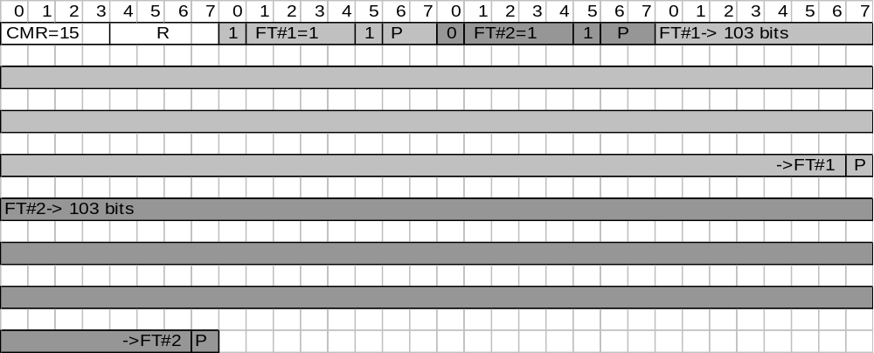
Figure 4

For more detailed information about the payload format for AMR, see [2] and [3].

RTP payload format for H.263
The payload header for H.263 has the following structure:
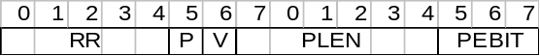
Figure 5

RR = Reserved | 5 bits | Reserved bits. Shall be ignored by the receiver.
P | 1 bit | Indicates the picture start or a picture segment start or a video sequence end. For more info. See ref. [4].
V | 1 bit | Indicates if information about “Video Redundancy Coding” is present. Always set to 0 in MoIP.
PLEN | 6 bits | Indicates the length of an extra payload header. Always set to 0 in MoIP.
PEBIT | 3 bits | Indicates the number of bits that shall be ignored in the last byte of the picture header. Always set to 0 in MoIP.
Table 4

The payload header is then followed by the data stream described in Ref. 6.

RTP payload format for G.711
The payload format for G.711 (which includes both A-law and μ-law) is described in ref. [6].

References
<event>

<event>

<event>

- RTP: A Transport Protocol for Real-Time Applications
RFC 3550
- RTP Payload Format and File Storage Format for the Adaptive Multi-Rate (AMR) and Adaptive Multi-Rate Wideband (AMR-WB) Audio Codecs
RFC 4867
- 3GPP TS 26.090, "Adaptive Multi-Rate (AMR) speech transcoding", version 4.0.0 (2001-03), 3rd Generation Partnership Project (3GPP)
- RTP Payload Format for ITU-T Rec. H.263 Video
RFC 4629
- Real-time Transport Protocol (RTP) Payload for Comfort Noise (CN)
RFC 3389
- Appendix II to Recommendation G.711 (02/2000) - A comfort noise payload definition for ITU-T G.711 use in packet-based multimedia communication systems.

Terminology
AMR Adaptive Multi-Rate
SID Silence Indicator

