Component DescriptioN –NTF

Content
1 Introduction 2
2 Requirements 2
3 Functions 2
3.1 System Functions 2
3.2 Component Functions 5
4 Architecture 6
4.1 External View 6
4.2 Internal View 9
5 Delivery Object 9
6 Design Objects 10
7 Capabilities 11
7.1 Notification 11
7.2 Subagent 12
7.3 Watchdog 12
7.4 High-Availability 12
8 Third-Party Products and External Interfaces 12
8.1 Third-Party Products and Freeware 12
8.2 External Products 13
8.3 External Protocols 13
9 References 13
10 Terminology 13

History

Version | Date | Adjustments
A | 2004-11-18 | Preliminary version converted to new template and .doc format. Info about 3pp is added.
B | 2005-04-10 | Rewrite of all sections except third party products.
C | 2005-06-24 | Updated after system comments.
D | 2006-03-27 | Updated for 14.1.
PE1 | 2007-10-04 | Updated MMS notification chapter.

Introduction
This document describes the component Notification Component (NTF) from a sub system point of view. The component environment and basic functionality are described. The document also provides a top-level view of the inside of NTF.
NTFs job is to send notifications to subscribers, to inform them of various events. The most important event is arrival of a new message in the subscriber’s inbox. Other events are for example reception of a slamdown call for the subscriber, or that the subscriber’s inbox is becoming full.

Requirements
The target environment for the NTF component is based on Solaris 10 and Java 1.5.
NTF depends on a number of components for its operation. These are described in section 4, Architecture.
To send notifications, NTF often depends on one or more external systems. These are also described in section 4, Architecture.
For installation and runtime requirements see [1] and [2].

Functions

System Functions
This section describes NTFs role in the implementation of system-level functions. If there is a system-level function description for the function, only the header is present, since the description is in the FD.
The set of functions is not an official list for the system, but selected from the functions, system services, customer-specific functions and potential functions where NTF is involved.
This sections needs to be updated continuously as the system documentation evolves, to ensure that the set of functions becomes more correct, and that redundant descriptions are removed.

Notify Subscriber

Outdial Notification

Edit Notification Filter
NTF interprets settings in the user and CoS entries in MUR, to determine the notification filter that controls notification.

Message Retrieval
NTF cancels pending outdial notifications and sends an MWI off event to the subscriber’s phone, when the subscriber hangs up.

Fax Retrieval

MMS Notification
In addition to the common handling of notifications, NTF uses MCC to transcode voice messages from WAV format to AMR and video messages from MOV format to 3GP.
MCC is only used if the voice or video messages are not in AMR format already.
NTF sends out SMIL-based MMS messages.

Supervision
NTF monitors and reports the states of its interfaces (consumed services). The NTF processes are monitored by the Solaris cluster or a watchdog process to ensure that NTF is running.

Configuration
Many services provided by NTF are disabled by default, and are enabled via configuration. Timeout and other time parameters can be tuned by configuration. NTF can be requested, via the MIB, to reload its main configuration file. The log level can be controlled dynamically via the MIB.

Video Mailbox
NTF provides notification functionality for the deposit type video.

Slamdown Information
NTF collects information about slamdown calls to a subscriber. If slamdown information shall be sent as a list, NTF determines when the phone is turned on, using SMS type 0. NTF formats and sends slamdown information messages via SMS.

Multiline Mailbox
Regardless of which of the lines the subscriber uses to listen to messages, NTF turns MWI off when the subscriber logs out.

Mailbox Full Warning
NTF formats and sends quota warning SMS on request from MS (using NTFs general function System Notification (3.2.5).
NTF checks mailbox full conditions (number of messages or size of mailbox content) when a subscriber receives a message and formats and sends quota warning SMS.

Call MWI Notification
In addition to the usual notification processing, NTF determines the notification content and requests MVAS to deliver the Call MWI notification to the user.

Fixed Network MWI Notification
In addition to the usual notification processing, NTF requests MC7 to deliver the MWI notification to a fixed network telephone.

Pager Notification
In addition to the usual notification processing, NTF determines the destination and content of the pager notification, and requests MVAS to deliver the pager notification to the subscriber.

WAP Push Notification
In addition to the usual notification processing, NTF creates a HTTP or WTAI link to the subscriber’s inbox and sends it to the WAP push gateway.

Missed Call Information
NTF extracts all Missed Call Information requests bundled in one Missed Call Information Message and formats and sends one SMS message for each request.

Cut through Paging
NTF recognizes the Cut Through Paging Information Message and formats and sends an SMS with cut-through paging content to the subscriber. This function is implemented in NTF purely by configuring the general system notification feature.

CLI via SMS

NTF recognizes the CLI Information Message and formats and sends an SMS with CLI content to the subscriber. This function is implemented in NTF purely by configuring the general system notification feature.

Greetings
NTF sends the reminder if the subscriber does not de-activate the temporary greeting.

Self Provisioning
NTF sends the reminder or automatically de-activates the feature if the subscriber does not de-activate call-forwarding unconditional or voice mail off.
NTF sends the reminder if the subscriber does not de-activate temporary greeting.

Component Functions
This section describes functions available in NTF where the documentation on the system level is not enough. It can be functions that are not visible on the system level, functions where the NTF implementation offers more functionality than required by the system, or functions where a single implementation covers several system level functions.

Backup and Restore Component
NTF backs up its own configuration and notification data. NTF provides an interface that lets the Toolbox back up NTF.

Install Component
NTF provides software and documentation for installation.

Examine MoIP Log Files
NTF logs information to files in the MoIP Log Directory.

Component Start and Restart
In a standard system, NTF implements the commands start, stop, status, restart, enableautostart, disableautostart, register and unregister for the NTF processes.
In a HA system, NTF implements the cluster methods check, start, stop, update and validate.

System Notification
The system notification function looks at the headers of every incoming mail to identify mail of a certain type. If the mail is of that type, the normal notification processing stops and NTF sends an SMS to the subscriber instead.
The power in the function lies in that the rules for recognizing the mail type are configurable, and that the SMS content is also configurable.
It is possible to define many mail types, each with its own set of rules and its own SMS content.

Delayed Action
NTF can be requested to send SMS or perform other actions at a later time. The function is suitable for both short (seconds) and long (weeks or longer) time intervals, since the data is persistently stored in a database.

The only externally available requests today are the mail-based “CFU On” and “Temporary Greeting On” messages. The only externally available actions are to send a reminder SMS or to de-activate “call-forwarding unconditional”. These are used in the implementation of the functions Greetings and Self-administration. The function is used internally in the implementation of Outdial Notification.
Since the base functionality exists, new types of delayed actions can be added at low cost.

SMS Templates per CoS
It is possible to customize SMS templates, not only for different languages and countries, but also for different CoSes.

Receive SMS
NTF can receive incoming SMS messages. Responses to SMS type 0 are used as an indication that the subscribers phone is on. The arrival of other incoming messages is logged and the message is ignored. The function can be extended to handle the incoming messages in a more useful way.

Architecture

External View
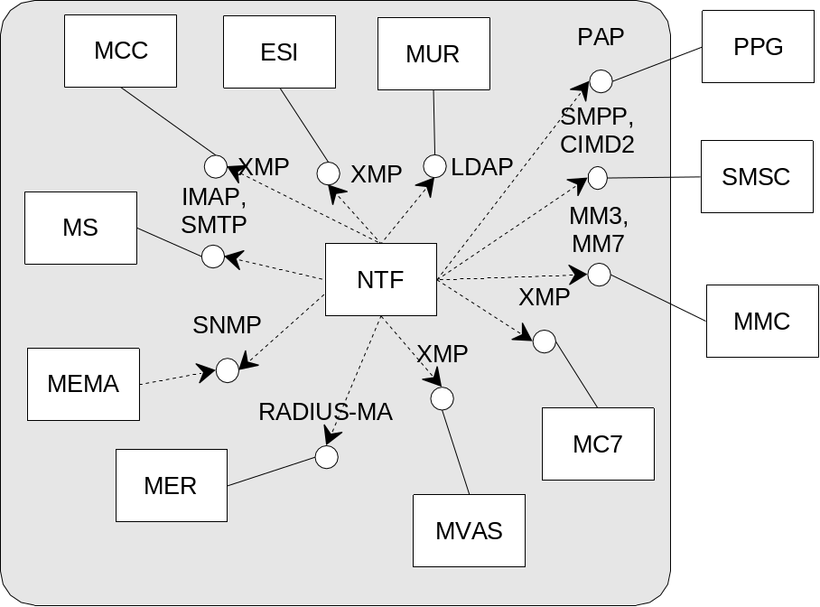

Figure 1 NTF and Environment

ESI, XMP
ESI provides NTF with subscriber information from sources external to the system.
NTF uses XMP over HTTP to communicate with ESI using the ExternalSubscriberInformation service of XMP.

MUR, LDAP
MUR provides information about subscribers and components to NTF.
NTF uses LDAP to communicate with MUR, when adding its own gnotification subscribers at installation, and when searching for subscribers during operation.

MC7, XMP
MC7 delivers fixed MWI notifications to switches in fixed telephone networks. Development of MC7 is not completed.
NTF uses XMP over HTTP to communicate with MC7. It uses the XMP service MWINotification to request that a PSTN switch activates the subscriber’s message waiting indication.

MMC, XMP
MMC provides a conversion service that converts wav-files to amr and mov-files to 3gp.
NTF uses XMP over HTTP to communicate with MMC. It uses the XMP service MediaConversion.

MVAS, XMP
MVAS makes outgoing calls for NTFs outdial, pager and call MWI notifications.
NTF uses XMP over HTTP to communicate with MVAS. It uses the XMP services OutdialNotification, PagerNotification and CallMWINotification to request that MVAS delivers a notification to the subscriber by making some kind of phone call.

MER, RADIUS-MA
MER receives and stores traffic information events from NTF.
NTF uses RADIUS-MA to send event information to MER.

MEMA, SNMP
MEMA makes NTFs MIB available to management clients.
The NTF management subagent communicates with MEMA via the Emanate master agent using the proprietary form of SNMP used for communication between Emanate entities. MEMA reads and writes MIB variables and NTF sends start and stop traps.

MS, IMAP, SMTP
MS makes a copy for NTF in a gnotification mailbox, of each incoming message. NTF polls these mailboxes to find new messages to notify subscribers about. NTF accesses the subscriber’s inbox to count new messages. Finally, NTF uses the MS to send mail:
- in rare cases error messages to the postmaster if a messages is impossible to notify about
- fax print requests to the fax gateway
- sometimes, messages to the subscriber when there is no use even to try fax print.
NTF communicates with MS using IMAP and SMTP. IMAP is used for managing the gnotification mailboxes and for message count. SMTP is used to send mail.

SMSC, SMPP, CIMD2
NTF sends short messages (SMS, MWI and Flash Message Notification) for new message notifications and other information to the subscribers, via the SMSC. The SMSC also supports NTF in providing presence information about the user’s terminal with the SMS type 0 feature.
NTF communicates with the SMSC using either SMPP or CIMD2, both over TCP/IP. The protocols can be mixed in one NTF, but each SMSC in MCR can only use one protocol.

MMC, MM3, MM7
NTF sends MMS notifications about new messages via the MMCs.
NTF communicates with the MMC using MM3 over SMTP or MM7 over SOAP over HTTP.

PPG, PAP
NTF sends WAP push notifications via Push Proxy Gateways. Voice mail notifications are sent as WTAI links that make the phone call the system. Other notifications are sent as HTTP links that direct the phone to MEC.
NTF communicates with the PPG using PAP over HTTP.

Internal View
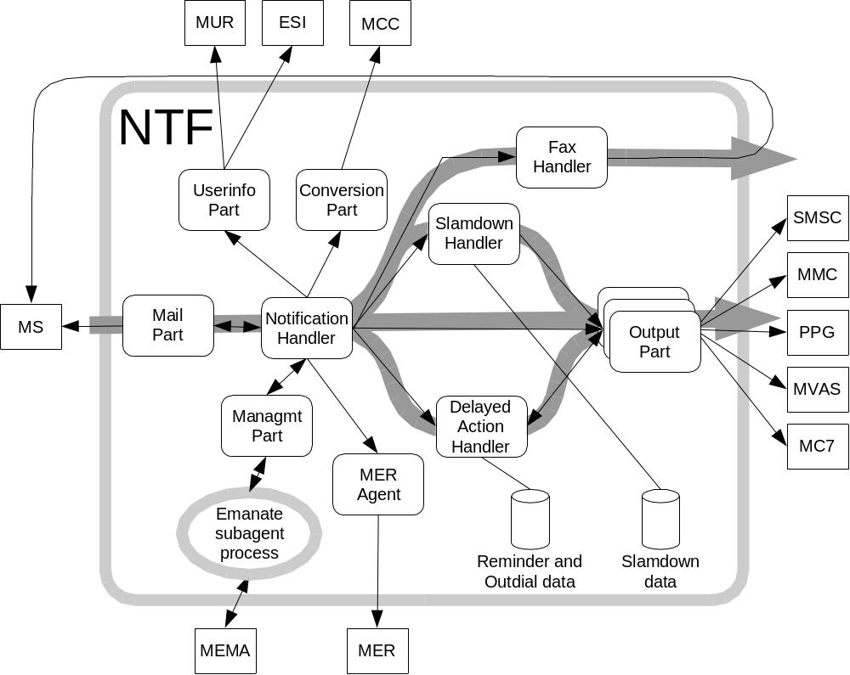

Figure 2 Main parts of NTF

The thin black arrows point from the part that initiates some action. The grey arrows indicate the main traffic flows.
As the figure shows, NTF polls MS for new messages. Mostly these messages are converted to notifications and flow straight through NTF to an output part for the notification types.
Faxes that are autoprinted do not go to an output part, but are sent by the fax part directly to MS.
Reminders, slamdown information and outdial notifications are stored in a database and sent to an output part when it is appropriate.

Delivery Object
NTF contains a single delivery object; a compressed tar file. The file contains
- The NTF package (LMENtf.pkg)
- The NTF high-availability package (LMEAntf.pkg)
- A response file and a shell script (install.sh) for installation of the NTF package.
The NTF package is installed on all systems. The high-availability package is only installed when NTF is running in a cluster.

Design Objects
A running NTF instance consists of three processes:
- The NTF traffic process, which is a java program.
- The Emanate subagent, which is a C++ program that implements the NTF MIB.
- A process that monitors the other NTF processes, and restart them if they stop. In a standard configuration, this is done by a watchdog process which is part of NTF. In a HA-configuration, this is done by the process monitoring facility of the cluster, via a probe process that is part of NTF.

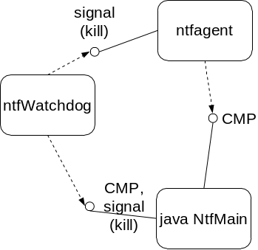
Figure 3 Processes in a Standard Configuration

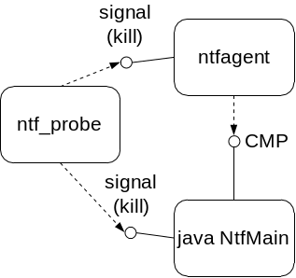
Figure 4 Processes in an HA Configuration

Capabilities

Notification

Configuration
NTF contains lots of functionality. Each customer uses only a subset, depending on preferences and licensed services. Configuration parameters control activation and customization of the functionality. Thus, there are many (>160) configuration parameters, and you need to read Operation and Maintenance NTF 1/1543-CRH 109 127, to understand all possibilities. The rest of this section lists a selection of the options.

User Visible Configurations
The configuration options that affect the end-user experience are listed below in no particular order:
- The outdial sequence is completely configurable.
- The text in SMS messages is configurable, per language and CoS.
- NTF can be configured to check the user’s mail quota.
- NTF can be configured to notify only if the subscriber has received the message.
- NTF can be configured to make some SMS messages replace older ones in the users phone, so only the most up-to-date information is shown to the user.
- NTF can be configured to turn MWI off only when the user has read all messages. If the network supports MWI with message count, the count is updated if the user listens to some of the new messages.
- NTF can be configured to send one SMS with slamdown information for each slamdown call, or to collect information about several slamdown calls in one SMS.
- The sender of SMS messages can be configured for various types of messages.
- The size and number of SMS per notification is configurable.

Major Internal Configurations
The configuration options that significantly change the way the system operates without being visible to the user are listed below in no particular order:
- If users are assigned SMSCs automatically by NTF, NTF can be configured to select the SMSC from a subset of the SMSCs registered in MCR.
- NTF can be configured so that location information in the HLR affects the type of notification.
- NTF can be configured to send MWI and SMS in one message or separately. NTF can also be configured to send MWI to one set of SMSCs and SMS to another set of SMSCs.
- NTF can be configured to use another SMSC as a backup in case an SMSC fails.

Limitations
NTF can only handle mails of up to 10 MB. Users will not be notified about mails larger that that. The limit is configurable.

Subagent
The NTF subagent is only an adapter which makes NTFs management information available to the Emanate master agent. The operation of the subagent is controlled by the NTF MIB, and there are no interesting configurations or limitations.

Watchdog
The watchdog monitors the NTF traffic process and the subagent, and restarts them if they stop. It has no interesting configurations or limitations. The watchdog is not used when NTF runs in a cluster.

High-Availability
The NTF probe monitors the NTF traffic process and the subagent, so that the cluster can take action if either of them stops. The HA-part of NTF has no interesting configurations.

Third-Party Products and External Interfaces

Third-Party Products and Freeware

3PPName/ Freeware Name | Version of the product/  freeware | Company | Used for | Delivered with the component | ECCN US/EU | Product Number and  R-state
Xerces | v.2.2.1 | Apache | Dev. | Yes | EAR99/0 | SWF0025R1A
Netscape LDAP SDK | v.4.1 | IPlanet | Dev. | Yes | 5D002/  5D002c1 | SWF0023R1B
Java Activation Framework | v.1.0.2 | SUN | Dev. | Yes | EAR99/0 | SWF0007R1A
Java mail | v.1.3.1 | SUN | Dev. | Yes | EAR99/0 | SWF0004R1B
Hsqldb | v.1.7.2.11 | The Hypersonic SQL Group/The HSQL Development Group | Dev. | Yes. | 5D002/  5D002c1 | SWF0046R1A

External Products

Product Name | Company | Used for | Version of the integration tested product
None

External Protocols

Protocol Name | Specification | Used for | Version of the protocol
SNMP | RFC 1901 | Monitoring | V2c

References
- Operation and Maintenance NTF
1/1543-CRH 109 127
- Installation Guide NTF
1/1531-CRH 109 127
- Component Management Protocol
6/155 19-CRH 109 127

Terminology
CMP Component Management Protocol, protocol between the NTF traffic process and the NTF subagent process.
MM4 MMS protocol based on SMTP.
MM7 MMS protocol based on HTTP, XML and SOAP.

