CommandHandler

Introduction
CommandHandler is a subsystem in NTF that allows its clients to define state machines where the state machine can be asked what command that are defined in a given state for a given code. The commands and operations are currently limited to those that are of interest when doing outdial. This limitation may be removed by generalizing the CommandHandler class to allow other operation names.

The subsystem does NOT handle the running of the state machine, only the construction of the state machine from a Property object and returning Command and Operation objects from the state machine. The Command and Operation objects can store and retrieve themselves from byte arrays. This makes it simple to have commands that are saved within the Store&Delay handling.

Class overview

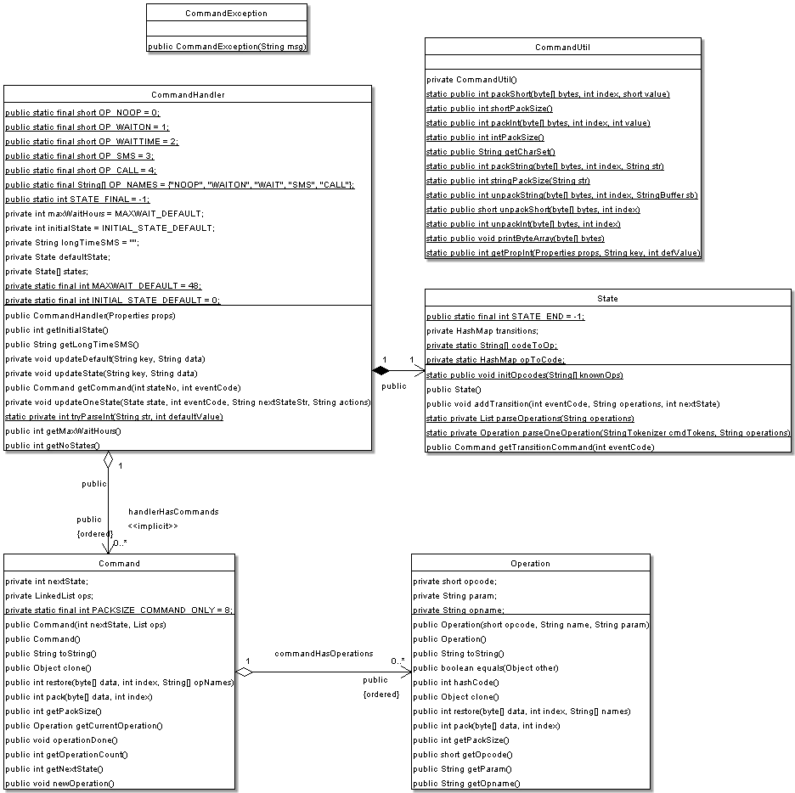

Classes and Interfaces

Operation
This class contains information about one operation that the executor of the state machine should perform. An operation is identified by its opcode, it can also have a name that is a readable representation of what it does. The name is not used for equality checks and similar, it is only there for user convenience. An operation can have a parameter string. The meaning of the parameter depends on the operation. An operation can be stored to and retrieved from a byte array with the operations pack and restore. Note that an array that maps from opcodes to operation names must be given when restoring, that is the operation name is not stored in the byte array.

Command
This class represents a transition in the state machine. A command contains the next state to go to, and a list of operations to perform during the transition. A client of the class can get the next Operation to perform from the Command. When the Operation is done, the client tells the Command and the Command removes the first Operation from the list so that the next Operation can be returned next.

CommandHandler
This class represents the whole state machine, with states and transitions. It can initialize itself from a property object that describes the machine. (For description of the properties see the O&M Manual). If there are syntax errors in the properties or some needed property is missing an exception will be thrown and the command handler object will not be created. The CommandHandler determines the allowed operations (only those for outdial) since it defines the allowed operation names. To make the subsystem more general this would have to be externalized from the command handler.

State
This class is internal in the state machine handling and is not visible by clients.
A state has a number and contains all the event codes that the state understands and for each event code the associated Command is known.
A state knows about the possible opcodes and operation names since they are given to the State by the CommandHandler. This means that this class in principle can be used for other state handling than outdial.

Runtime considerations
No special runtime considerations.

License Information

No external software is used by this subsystem.

