**Appendix 4: Domain modelling**

1. **The domain**

The company ‘X’ is large beverage manufacturer which produces carbonate drinks and squashes. The production department is the heart of manufacturing process. Within this department soft drinks, production and packaging are maintained. Four teams where each team represents a separate shift are directly involved in the process. Within each production team, there are several different roles with a variety of responsibilities. Shift operations manager (SOM) ensures that its team delivers the desired output accordingly to the plan. Manufacture team leaders (MTL) are responsible for production lines. Each team leader is assigned to one production line, however, in some circumstances, he/she might take the responsibility for two or more lines if required. Machine operators are people who operate the machinery and perform other associated tasks such as changeovers or quality checks. Engineering team leader (ETL) manages shift engineers and shift electricians to ensure that machinery and equipment are maintained appropriately, and members of engineering team are responding to machine failures in a timely manner. Shift engineers and shift electricians perform machinery repairs and scheduled maintenance.

One of the factors which influence the timely delivery of the final product is machine downtime. Currently, downtime is reported through stoppage sheets for each machine within the production line. The typical production line is divided into five areas: bottle blower, filler, labeller, case packer and palletiser. Each area has few sections which are represented in the stoppage sheets via indexes with names. When the stoppage occurs machine operators, using appropriate stoppage sheet, record the start time, index, and description of the issue and when it is resolved, the duration. MTL can inspect stoppage sheets at any time. The inspection usually takes place afterwards, so team leader can’t assist machine operator during the downtime and therefore some stoppages might take more time to resolve.

To inform the need for assistance machine operators use phones located in filler areas. When the operators can’t resolve the issue, they can put a call out for engineer or electrician depending on the nature of the issue. If necessary, the machine operator can also call the office or other lines to seek for a team leader.

Recently, the company is implementing Perfect Flow system (PF) which is an advanced software that gathers and interpret readings from PLC’s (programmable logic controller). Perfect flow is an ongoing, time-consuming project and it will take several years until it’s fully functional. The system delivers real-time data about the machine’s status. The status is showed at LED displays located in the filler and palletiser area within each line where the system is functional. More detailed information can be read on computers available in the production area. PF system has its limits, for example, it is unable to reflect the nature of the problem. It can only tell which part of the machine has stopped and assumed why it has happened. Therefore, some problems like quality issues won’t be reported.

1. **Initial problem statement**

The company’s approach to dealing with stoppages leaves a room for a new system to be introduced. There are few problems that could be addressed using the new system. It should resolve communication issues by alerting management team and engineering team about downtime. It should support team leaders and shift managers by reducing the amount of information that needs to be manually typed in at the end of each shift. The system could also register how the issues were resolved so when they reoccur the downtime could be reduced by using an existing solution. Descriptions for reoccurring stoppages could be standardised so the operators (especially important for those with non-technical background) wouldn’t have to retype it every time.

1. **Stakeholders**

Stakeholders of a new system include:

* End-users – team leaders, managers, engineering team leaders, engineers, electricians, and machine operators
* Senior management of large manufacturing organisation
* System administrators

1. **Business rules and processes**

Downtime resolution business rules:

* When downtime occurs machine operator must record its start time. When it is resolved the duration must be recorded.
* If the solution to the problem can’t be found within a reasonable time (10 minutes) the operator must seek for assistance appropriate to the nature of the problem (mechanical, electrical etc.).
* If the issue is other than electrical or mechanical (e.g. quality, health, and safety) it should be reported to the MTL.
* If the problem is electrical or mechanical the operator should put a call out for electrician or engineer appropriately.
* The operator should make three callouts within 15 minutes. If there is no support for 15 minutes, the team leader must be informed.
* MTL should contact engineering team leader asking for engineer or electrician.
* If there is no support after 30 minutes since team leader was informed about the issue SOM should be informed so he can take further actions.

The above rules might not apply in some circumstances, these include:

* All engineers and electricians have been allocated to other tasks and management team is aware of it.
* There are not enough engineers or electricians on shift hence those available are performing repairs accordingly to the line’s priority.

Downtime resolution business process:

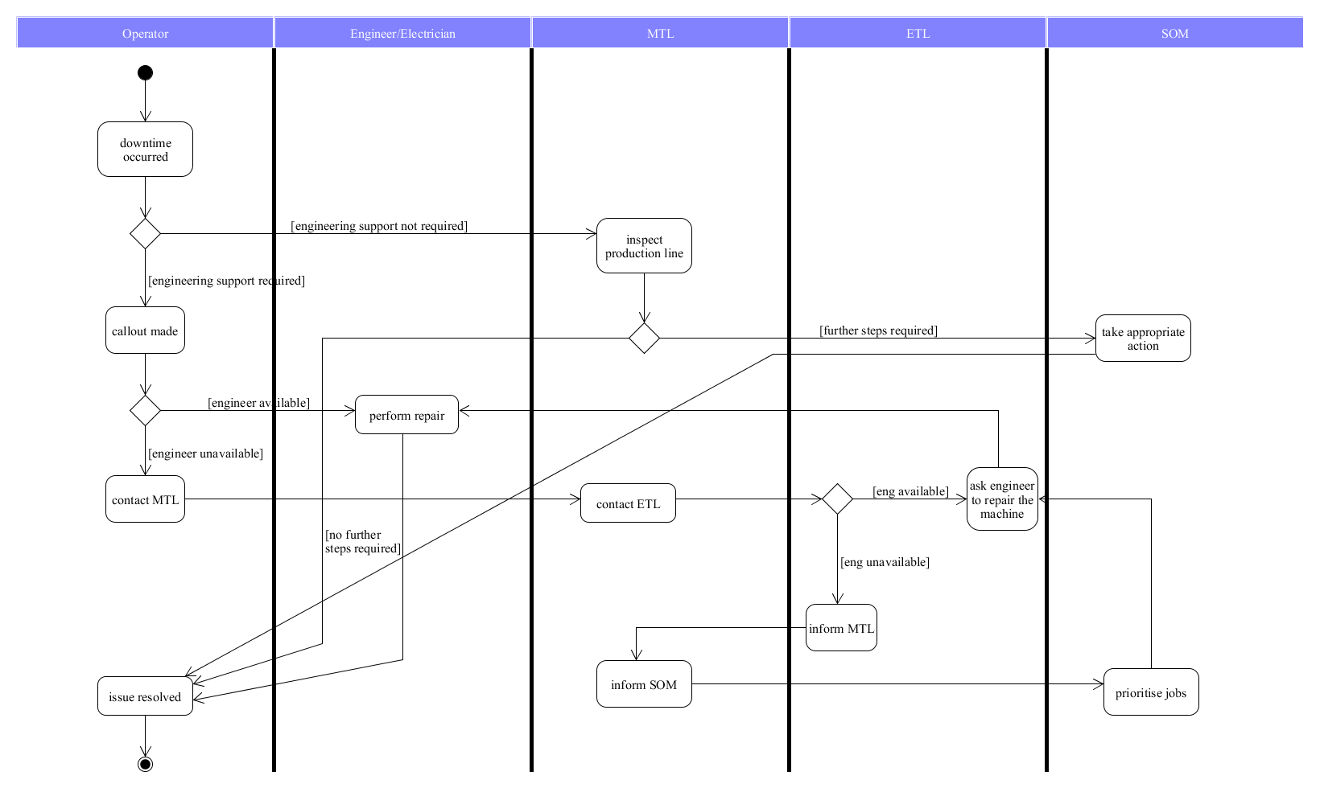

**Figure 1** Activity diagram showing the downtime resolution business process.

1. **Project constraints**

* The prototype of the system should be developed in 300 hours.
* The prototype should work on all types of devices and up to date web browsers.
* The system should be flexible, so it could be used in various manufacturing organisations.

1. **Assumptions**

* Large manufacturing organisations will have an organisational structure similar to the one presented above.
* Communication issues in large manufacturing organisations can be resolved with a standardised approach.

1. **Use cases**

The system’s interface tasks by role:

* Machine operator
  + Stoppage time recording
  + Stoppage description
  + Area index
  + Stoppage duration
  + Callouts
  + Informing team leader
* Team leader
  + Line inspection
  + Checking line status
  + Contacting engineering team leader
  + Contacting manager
  + Providing production output status
* Engineering team leader
  + Controlling availability of engineers and electricians
  + Scheduling repairs
* Manager
  + Monitoring line status
  + Monitoring line performance
  + Reporting issues to other managers
* System administrator
  + Add/remove staff
  + Add/remove production line

Identified use cases:

*Activate downtime.* Operator or team leader interacts with the system to activate stoppage timer. They choose the area code and provide the fault description.

*Contact team leader*. Operator contacts team leader providing information about the nature of the problem.

*Request repair*. Team leader or operator contacts engineering team leader to receive engineering support.

*Contact manager*. Team leader informs manager about unavailability of engineers/electricians.

*Deactivate downtime*. Operator or team leader deactivates the downtime when the machine is operational.

*Monitor performance*. Team leader inputs hourly scores (number of pallets, cases etc.). Manager or team leader can view performance data.

*Create daily report.* Manager or team leader can produce daily report containing performance data.

*Add user*. System’s administrator adds users to the system.

*Remove user*. System’s administrator removes users from the system.

*Review performance.* Manager can review historical performance and efficiency data.

The use cases below were removed due to low frequency of usage. The production lines are likely to be hardcoded into solution.

*Add line*. System’s administrator adds lines to the system.

*Remove line*. System’s administrator removes lines from the system.

The figure below shows use case diagram for the new system.

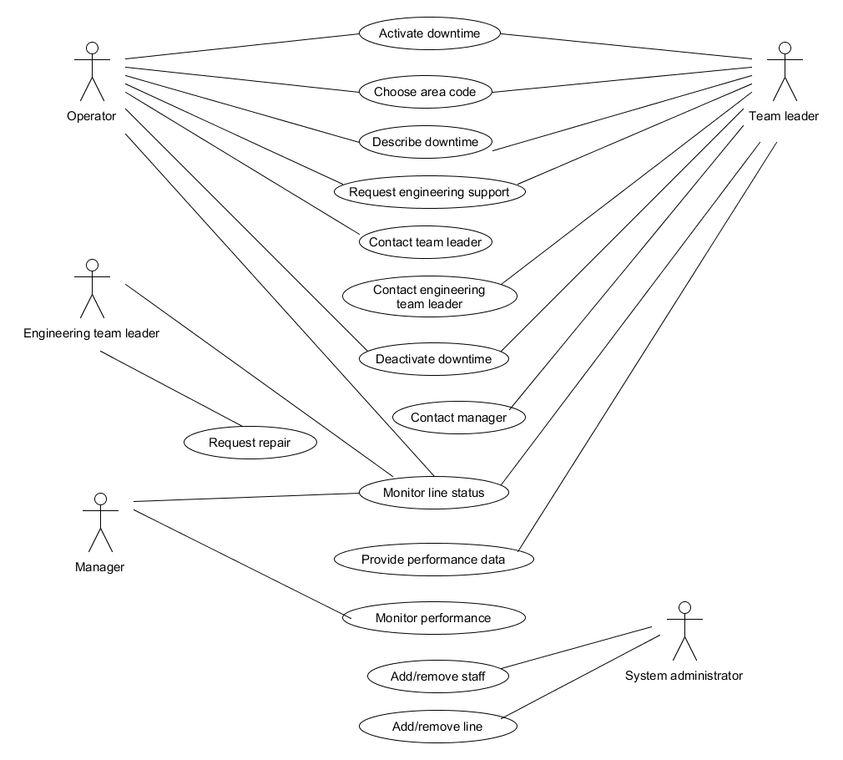

**Figure 2** Use case diagram for the new system.

The above analysis of the business process and feedback from users uncovered the initial set of functional and non-functional requirements.

**Appendix 5: Requirements elicitation 2**

1. **Functional requirements**

The system shall:

* Activate and record stoppage time, description, and machine index
* Alert team leader allocated to the line about an issue
* Alert manager about multiple lines status
* Notify if engineer/electrician have been sent to perform repair
* On request alert engineering team leader about the problem
* Display existing solution to a reoccurring problem
* Gather performance data by manual input
* Display performance data
* Create daily reports
* Deactivate stoppage and provide duration
* Indicate occurrences of each stoppage
* Show performance efficiency rating for the equipment
* Prioritise repairs
* Allow selection of line number for operators and team leaders
* Allow addition of comments by team leaders and engineering team leaders
* Save downtime data in a database
* Allow access to historical downtime data
* Add and remove users

1. **Non-functional requirements**
2. Look-and-feel requirements

LF1: The system shall allow straightforward navigation.

LF2: The system shall have a modern look-and-feel.

1. Usability and humanity requirements

UH1: The system shall be easy to use for team leaders, operators, and managers.

UH2: The system shall be easy to learn for all users.

UH2.1: Typical user who previously dealt with stoppage sheets should be able to learn the main features of the UI without prior training.

UH2.2: All users should understand all the features of UI after training no longer than 15 minutes.

1. Performance requirements

P1: The system shall have high availability.

P2: The system shall respond to user requests immediately.

1. Operational and environmental requirements

OE1: The system shall operate within large manufacturing environment and a single on-premises server.

1. Security requirements

S1: The system shall limit the information displayed depending on the user’s role.

S2: Only managers/team leaders shall be able to update performance data.

S3: Only system’s administrator shall be able to add/remove users.

S4: Only system’s administrator shall be able to add/remove production line.

S5: Historical data should not be alterable.

S6: The system shall provide password protected access at different levels.

1. Legal requirements

L1: The system shall operate in accordance with local law.

1. **Elaborating the use cases**

**Table 1** Textual representation of the activate downtime use case.

|  |  |
| --- | --- |
| **Identifier and name** | UC1 *activate downtime* |
| **Initiator** | *operator or team leader* |
| **Goal** | The downtime is activated, and timer shows duration of the stoppage. |
| **Precondition** | There is no active stoppage within the area. |
| **Postcondition** | The downtime and timer will be activated. The line’s status will change. |
| **Assumptions** | The expected initiator is an operator or team leader using web browser. Multiple stoppages can occur within the same production line but not within the same area. The system can display multiple downtime information. |
| **Main success scenario**  1 The operator/team leader inputs stoppage time, area index and fault description.  2 The user activates downtime.  3 The system activates timer.  4 The system displays active downtime status.  5 The system displays possible solution for reoccurring stoppage.  **Extensions**  1.a.1 *The downtime activated in a real time.* The system sets current time as stoppage start time.  1.b.1 *The downtime activated with delay*. The system sets time provided by the user as stoppage start time.  1.c.1 *Fault description has been previously registered in the system*. The operator/team leader selects appropriate description.  2.a.1 *There is an active downtime for the selected area*. The system alerts the user that the downtime for the given area is active. The use case terminates.  3.a.1 *The downtime activated in a real time*. The system calculates duration starting from 0.  3.b.1 *The downtime activated with delay*. The operator/team leader inputs stoppage start time. The system calculates stoppage duration from the time provided by initiator. | |

**Table 2** Textual representation of the *contact team leader* use case.

|  |  |
| --- | --- |
| **Identifier and name** | UC2 *contact team leader* |
| **Initiator** | *operator* |
| **Goal** | The team leader is notified about an issue. |
| **Precondition** | The downtime must have been activated by operator. |
| **Postcondition** | Team leader receives notification with stoppage details including time of occurrence and description. |
| **Assumptions** | The expected initiator is operator using web browser to send downtime notification to team leader. The system can send notification automatically if the stoppage time exceeds 15 minutes. |
| **Main success scenario**  1 Using the system the operator sends notification.  2 The system displays notification status.  3 The team leader acknowledges that notification was received.  **Extensions**  1.a.1 *The downtime exceeded 15 minutes, no notification requested by operator*. The system automatically sends notification to team leader. | |

**Table 3** Textual representation of the *request repair* use case.

|  |  |
| --- | --- |
| **Identifier and name** | UC3 *request repair* |
| **Initiator** | *operator or team leader* |
| **Goal** | The engineering team leader is notified about the need for engineering support and schedules repair. |
| **Precondition** | The downtime must have been activated. No engineering support have been previously requested for the issue. |
| **Postcondition** | The engineering team leader is informed about the problem and its nature and schedules repair allocating engineer or electrician. The repair status is changed. |
| **Assumptions** | The duration of the downtime is more than 10 minutes. There is an engineer or electrician available to perform repair. |
| **Main success scenario**  1 Operator or team leader requests engineering support via the system.  2 The system sends request to the engineering team leader providing location and fault description.  3 ETL accepts the request and allocates engineer/electrician.  4 The repair status is changed.  **Extensions**  3.a.1 *No engineer/electrician available, the line is at low priority*. The ETL via the system informs that no support is available at the time of request. The use case terminates.  3.a.2 *No engineer/electrician available, the line is at high priority*. The ETL moves engineer/electrician from low priority line to high priority line. The repair status for high priority line is activated. The repair status for low priority line is deactivated. | |

**Table 4** Textual representation of the *contact manager* use case.

|  |  |
| --- | --- |
| **Identifier and name** | UC4 *contact manager* |
| **Initiator** | *team leader* |
| **Goal** | The manager is informed about persisting issue and takes appropriate action. |
| **Precondition** | The downtime is activated, and its duration exceeds 30 minutes. There is no scheduled repair after the given period. |
| **Postcondition** | The manager acknowledges the issue and reacts accordingly to the priorities. |
| **Assumptions** | ETL did not respond to the operator/team leader request. |
| **Main success scenario**  1 When the duration of the downtime exceeds 30 minutes team leader contacts shift manager via the system.  2 The manager confirms that request was received.  3 Manager requests immediate action from ETL.  4 ETL confirms request and schedules repair.  **Extensions**  4.a.1 *Engineer/electrician unavailable*. The manager checks the priorities and requests engineering support if appropriate. | |

**Table 5** Textual representation of the *deactivate downtime* use case.

|  |  |
| --- | --- |
| **Identifier and name** | UC5 *deactivate downtime* |
| **Initiator** | *operator or team leader* |
| **Goal** | The downtime is deactivated and information about the problem is saved in database. |
| **Precondition** | The machine is operational. |
| **Postcondition** | The downtime is deactivated. The machine status is changed. The stoppage duration, description, and solution (if available) are saved in the database. |
| **Assumptions** | The expected initiator is operator/team leader using the web browser to deactivate downtime when the machine is operational. |
| **Main success scenario**  1 Operator/team leader deactivates downtime.  2 The system calculates total duration of the stoppage.  3 The system saves all details in the database.  4 The system changes line status.  **Extensions**  1.a.1 *Operator/team leader provides the solution*. The operator/team leader inputs textual description of possible solution.  1.a.2 *The stoppage is reoccurring the solution requires an update*. The operator/team leader updates existing solution via the system.  3.a.1 *The reason for stoppage is unrecognised.* The system records all the details and assigns a new stoppage ID for future reference.  3.b.1 *The stoppage is reoccurring.* The system records all the details using the existing stoppage ID. The number of occurrences shall be updated. | |

**Table 6** Textual representation of the *monitor performance* use case.

|  |  |
| --- | --- |
| **Identifier and name** | UC6 *monitor performance* |
| **Initiator** | *team leader* |
| **Goal** | The machine’s performance and efficiency can be monitored. |
| **Precondition** | The machine is operating during the shift. |
| **Postcondition** | The system displays performance and efficiency data based on manual input, calculations and provided constants. |
| **Assumptions** | The expected initiator is team leader using web browser to input hourly scores. The system calculates performance and efficiency. |
| **Main success scenario**  1 Using the system team leader inputs hourly scores.  2 The system calculates the performance based on target and actual scores.  3 The system displays performance data.  4 The system calculates efficiency based on downtime.  5 The system displays efficiency data.  6 The system displays top three issues for the line.  7 The manager/team leader can view performance and efficiency data.  **Extensions**  1.a.1 *No hourly score provided*. The system sets hourly score to 0.  3.a.1 *Performance lower than target, no downtime registered.* The system indicates that the target is not achieved while no stoppages are reported. The system indicates the poor downtime communication as an issue. | |

**Table 7** Textual representation of the *create daily report* use case.

|  |  |
| --- | --- |
| **Identifier and name** | UC7 create daily report |
| **Initiator** | manager or team leader |
| **Goal** | The daily report is produced and can be printed out if required. |
| **Precondition** | The report can be produced 15 minutes before the end of the shift. The production line has been operating during the shift. |
| **Postcondition** | The system will summarise daily performance and efficiency. The report containing performance data will be produced. All the details will be saved for future reference. It will be possible to print out the report. |
| **Assumptions** | The expected initiator is manager or team leader using web browser to perform the use case. There is a 15 minutes grace period to make amendments otherwise the system will produce report automatically at the end of the shift. |
| **Main success scenario**  1 Manager/team leader reviews the summary of daily performance and efficiency.  2 Manager/team leader confirms that performance and efficiency data is correct.  3 Using the system manager/team leader produces the report.  4 The system saves daily summary.  5 Manager/team leader prints out the report.  **Extensions**  1.a.1 *Shift has ended*. The use case terminates, and the daily report is produced automatically by the system with the details provided during the shift.  2.a.1 *The performance data requires modification*. The manager/team leader amends incorrect details. | |

**Table 8** Textual representation of the *add user* use case.

|  |  |
| --- | --- |
| **Identifier and name** | UC8 *add user* |
| **Initiator** | *team leader* |
| **Goal** | A new user is added to the system. |
| **Precondition** | None |
| **Postcondition** | The system will register a new user allowing access to resources specific for the user’s role. |
| **Assumptions** | The expected initiator is team leader requesting a new profile from system administrator via web browser. |
| **Main success scenario**  1 Team leader requests new profile.  2 Team leader provides new user’s name and role and confirms request.  3 System’s administrator acknowledges request.  4 The system allocates user ID to the new profile.  5 The system sets user ID as a password for the new profile.  6 The system sets permissions accordingly to the user’s role.  7 The new user can log in and use the system.  **Extensions**  4.a.1 *User’s name already exists*. The system informs administrator that the user with the given name already exists.  4.a.2 *The new user has the same name as existing user*. The administrator confirms that a new profile is required. The system creates new profile with the same name but different ID.  4.a.3 *The user has been previously registered*. The administrator cancels request. The use case terminates.  6.a.1 *Additional permissions required*. The team leader informs system’s administrator that the new user must obtain additional permissions. The system’s administrator unlocks requested permissions for the user. | |

**Table 9** Textual representation of the *remove user* use case.

|  |  |
| --- | --- |
| **Identifier and name** | UC9 *remove user* |
| **Initiator** | *team leader* |
| **Goal** | The user’s profile is removed from the system. |
| **Precondition** | The user’s profile must exist. |
| **Postcondition** | The user is removed from the system and can’t log in and use the system. |
| **Assumptions** | The expected initiator is team leader requesting removal of an existing user from system administrator via web browser. |
| **Main success scenario**  1 Team leader requests removal of user’s profile.  2 Team leader provides user’s details.  3 Using the system, administrator locates the user.  4 Using the system, administrator removes user.  5 Removed user can’t log into the system.  **Extensions**  None | |

**Table 10** Textual representation of the *review performance* use case.

|  |  |
| --- | --- |
| **Identifier and name** | UC10 *review performance* |
| **Initiator** | *manager* |
| **Goal** | To review historical performance and efficiency data. |
| **Precondition** | The data for selected line and date must exist. |
| **Postcondition** | The historical performance and efficiency data will be displayed. |
| **Assumptions** | The expected initiator is manager using web browser to select and view performance and efficiency data. |
| **Main success scenario**  1 Manager selects the production line for which performance data needs to be reviewed.  2 Manager selects date.  3 Manager confirms selection.  4 The system displays performance and efficiency data.  5 Manager finishes review.  **Extensions**  4.a.1 *No data for the given date*. No performance and efficiency data will be displayed. The use case terminates. | |