Programming Assignment #4

2018-14029 김나현

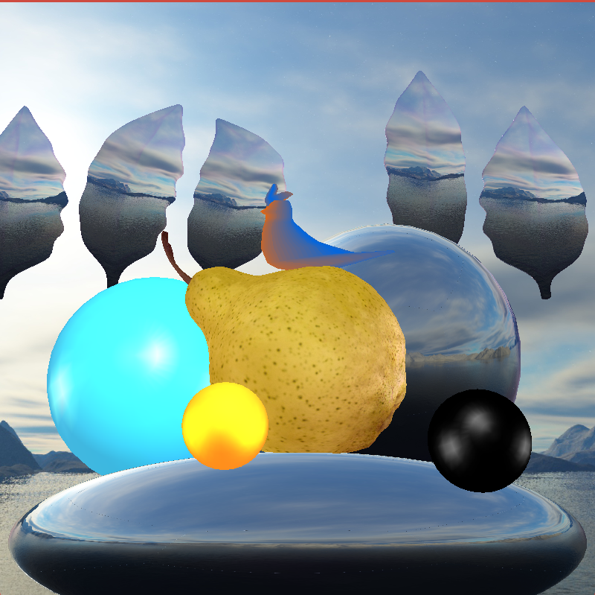

* Explain what type of geometric objects in your scene
  + Spheres : Implicit surface.
  + Bird : Polygonal object.
  + Pear, Leafs : Polygonal object, external import.
* Explain material properties of each surface
  + What material do you want to simulate?
    - Yellow rubber (yellow small sphere)
    - Emerald (cyan sphere)
    - black plastic (black sphere)
    - pearl (bottom flat sphere)
    - ruby (pear and bird)
    - silver (right mirroring sphere)
    - jade (background leafs)
  + Describe all coefficients of the illumination model for each material

|  |  |  |  |  |  |  |  |  |  |  |
| --- | --- | --- | --- | --- | --- | --- | --- | --- | --- | --- |
| **Name** | **Ambient** | | | **Diffuse** | | | **Specular** | | | **Shininess** |
| emerald | 0.0215 | 0.1745 | 0.0215 | 0.07568 | 0.61424 | 0.07568 | 0.633 | 0.727811 | 0.633 | 0.6 |
| jade | 0.135 | 0.2225 | 0.1575 | 0.54 | 0.89 | 0.63 | 0.316228 | 0.316228 | 0.316228 | 0.1 |
| pearl | 0.25 | 0.20725 | 0.20725 | 1 | 0.829 | 0.829 | 0.296648 | 0.296648 | 0.296648 | 0.088 |
| ruby | 0.1745 | 0.01175 | 0.01175 | 0.61424 | 0.04136 | 0.04136 | 0.727811 | 0.626959 | 0.626959 | 0.6 |
| silver | 0.19225 | 0.19225 | 0.19225 | 0.50754 | 0.50754 | 0.50754 | 0.508273 | 0.508273 | 0.508273 | 0.4 |
| yellow rubber | 0.05 | 0.05 | 0.0 | 0.5 | 0.5 | 0.4 | 0.7 | 0.7 | 0.04 | .078125 |

* Explain the lighting configuration
  + How many light sources do you use?
    - I used 3 sources
  + Where do you put the light sources?
    - LIGHT0: x:0 y:90 z:-90
    - LIGHT0: x:-10 y:0 z:0
    - LIGHT0: x:10 y:0 z:0
    - LIGHT0: x:0 y:0 z:-60
  + What is the type of each light source?
    - The types and characters of light sources are like below.
* glLightfv(GL_LIGHT0, GL_POSITION, [0, 40, -70, 1]) # area point light
* glLightfv(GL_LIGHT0, GL_AMBIENT, 0.6*diffuse)
* glLightfv(GL_LIGHT0, GL_DIFFUSE, 0.6*diffuse)
* glLightfv(GL_LIGHT1, GL_POSITION, [-1, 0, 0, 0]) # directional light
* glLightfv(GL_LIGHT1, GL_AMBIENT, 0.3*ambient0)
* glLightfv(GL_LIGHT1, GL_DIFFUSE, 0.3*ambient0)
* glLightfv(GL_LIGHT1, GL_SPECULAR, (1,1,1, 0))
* glLightfv(GL_LIGHT2, GL_POSITION, [1, 0, 0, 0]) # directional light
* glLightfv(GL_LIGHT2, GL_AMBIENT, 0.3*ambient1)
* glLightfv(GL_LIGHT2, GL_DIFFUSE, 0.3*ambient1)
* glLightfv(GL_LIGHT2, GL_SPECULAR, (1,1,1, 0))
  + - We can change viewpoint by dragging
* Python main.py를 터미널에 입력하여 실행할 수 있습니다.
* 클릭후 드래그로 시점 방향을 변경할 수 있습니다.
* a키로 왼쪽으로, d키로 오른쪽으로 시점을 translation할 수 있습니다.
* q키로 위쪽으로, e키로 아래쪽으로 시점을 translation할 수 있습니다.
* w키로 앞쪽으로, s키로 뒤쪽으로 시점을 translation할 수 있습니다. (dolly in / out)
* shift+w키, shift+s키로 zoom in , zoom out을 실행할 수 있습니다.
* esc키를 누르면 프로그램이 종료됩니다.

