ClubUML

CSYE7945 spring 2013

[**New database structure**]

[Yidu Liang]

[Xuesong Meng]

[Feb 24, 2013]

Revision: [1.1]

Table of Contents

Revision History 3

Introduction 4

[The new database structure] 5

[Improved detail] 6

1. [Modification for USER - PROJECT - DIAGRAM] 6

2. [Modification for DIAGRAM table] 7

3. [Modification for DIAGRAM - REPORT] 7

4. [Modification for user - comment] 8

[SQL Query] 9

1. [Project] 9

2. [User] 9

3. [Diagram] 10

4. [Combined result] 11

5. [Report] 11

6. [Comment] 12

# Revision History

|  |  |  |  |
| --- | --- | --- | --- |
| **Revision** | **Date** | **Author(s)** | **Notes** |
| 1.0 | 2/17/13 | Yidu Liang, Xuesong Meng | Design new database structure |
| 1.1 | 2/24/13 | Yidu Liang, Xuesong Meng | Update SQL Query |
| 1.2 | 4/11/13 | Yidu Liang, Xuesong Meng | Update Structure of diagram table |
| 1.3 | 4/14/13 | Yidu Liang, Xuesong Meng | Update SQL Query, set PK AI |
|  |  |  |  |
|  |  |  |  |
|  |  |  |  |

# Introduction

* New database structure.
* The detail about how did each part get improved.
* SQL query about new database.

# [The new database structure]

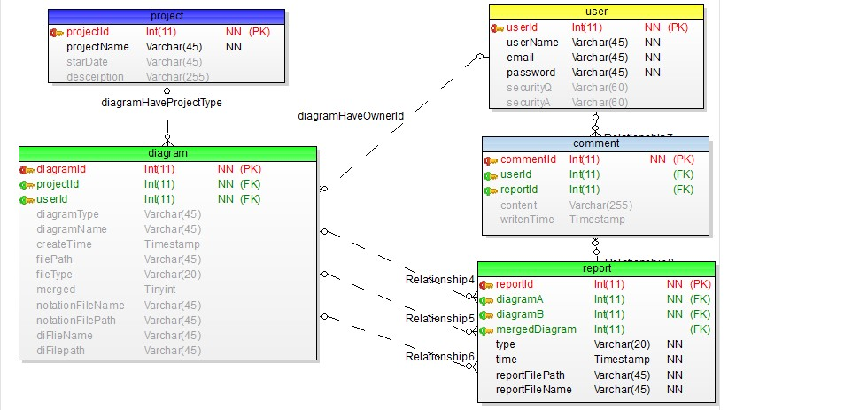

Figure : [Created by Toad Data Modeler MySQL 5.0]

## [Improved detail]

### 1. [Modification for USER - PROJECT - DIAGRAM]

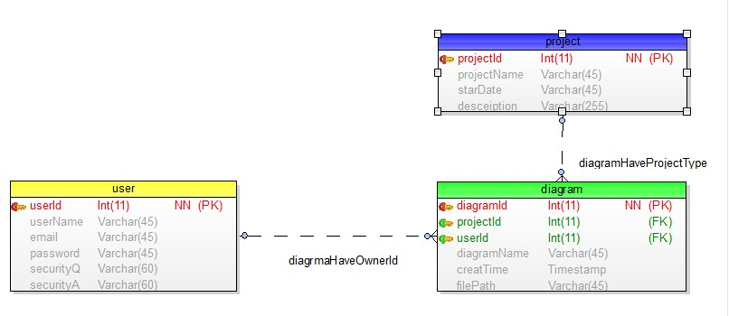

Figure 2: [user-project-diagram data model]

**Changed:**

* ProjectId used to be put in the user table. Now put diagram table in the middle of user and project, in that case user table and project table do not have any relationships anymore. Diagram table contains both projectId and userId.
* Add start date in the project table.

**Benefit:**

* Improved the old version that one user could only join in one project. Now one user could join as many projects as he/she wants.
* Diagrams can be grouped by projects. So the user could choose diagrams from the same project to compare or merge.

### 2. [Modification for DIAGRAM table]

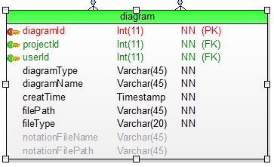

Figure 3: [diagram data model]

**Changed:**

* Add diagram type attribute. (class diagram or sequence diagram)
* Add file type attribute. (Ecore file or UML file)
* Add notation file name and file path

**Benefit:**

* Make the diagram table suit for new functions and data type.

### 3. [Modification for DIAGRAM - REPORT]

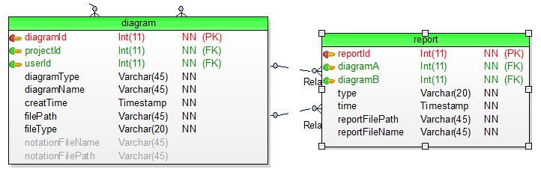

Figure 3: [diagram-report data model]

**Changed:**

* Add type attribute to report table. (compare or merge)
* Add reportFileName attribute to report table.
* Switch comparedTime attribute to time.

**Benefit:**

* Make the report table suit for new functions and data type.

### 4. [Modification for user - comment]

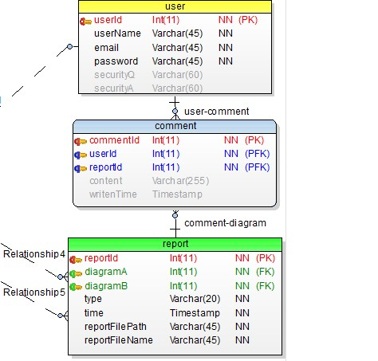

Figure 3: [user-comment data model]

Changed:

* Comment table connects to the report table instead of diagram table.
* Comment table contains reportId instead of diagramId.

Benefit:

* User could leave his/her comment under the compare or merge result. Old version database could only let user leave the comments under on diagram.

## [SQL Query]

### 1. [Project]

Insert query:

Insert into project VALUES (000001, 'projectA', 'Jan2013', 'projectDesceiption')

select \* from project

C:\Users\yidu1_000\AppData\Roaming\Tencent\Users\974671991\QQ\WinTemp\RichOle\2A7BV`}DNHU$QDOE7M]JQ50.jpg

**Figure 4: [project table result]**

### 2. [User]

Insert query:

insert into user VALUES (000001, 'admin', 'admin@clubuml.com', 'adminpd','','')

select \* from user

C:\Users\yidu1_000\AppData\Roaming\Tencent\Users\974671991\QQ\WinTemp\RichOle\GS3@TZMZXBTOJ3{DTX%CSO2.jpg

**Figure 5: [user table result]**

Update query:

setsecurityQ='security question', securityA='security answer' where userId = 000001

select \* from user

C:\Users\yidu1_000\AppData\Roaming\Tencent\Users\974671991\QQ\WinTemp\RichOle\P2LKTTXTTO6@ZMOE9YGFSQP.jpg

**Figure 6: [project table result]**

### 3. [Diagram]

Insert query:

insert into diagram (diagramId, projectId, userId, diagramType, diagramName, filePath, fileType, notationFileName, notationFilePath)

VALUES (000001, 000001, 000001, 'use case','2013 use case','../xxx/xxx.xmi','xmi', 'natationA' ,'../xxx/xxx')

select \* from diagram

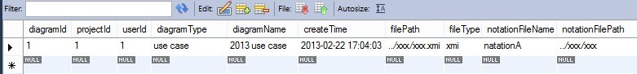

**Figure 7: [diagram table result]**

### 4. [Combined result]

Show diagram table:

select \* from diagram

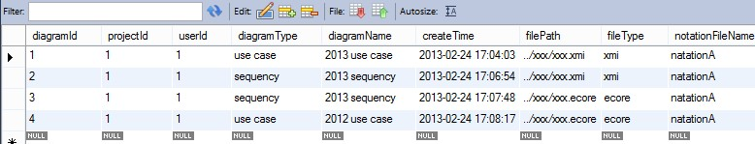

**Figure 8: [combined result 1]**

Show diagrams with owner name:

selectdiagramName, diagramType, username from diagram d, user uwhere d.userId = u.userId

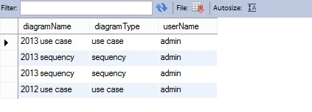

**Figure 8: [combined result 2]**

### 5. [Report]

Insert query:

insert into report (reportId, diagramA, diagramB, type, reportFilePath, reportFileName)

VALUES (000001, 000001, 000004, 'compare','../xxx/xxx.pdf','compare\_report\_1')

insert into report (reportId, diagramA, diagramB, type, reportFilePath, reportFileName)

VALUES (000002, 000001, 000004, 'merge','../xxx/xxx.pdf','merge\_report\_1')

select \* from report

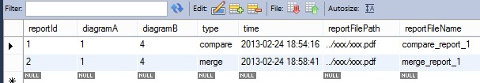

**Figure 9: [report table result]**

### 6. [Comment]

Insert query

insert into comment(commentId, userId, reportId, content)

VALUES (000001, 000001, 000001, 'comment1')

select \* from comment

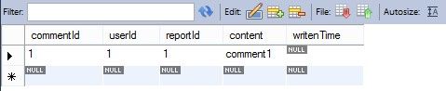

**Figure 10: [comment table result]**

Show who leave what comment on which diagrams:

selectuserName, diagramA, diagramB, type, content from user, report, comment

wherecomment.userId = user.userIdand comment.reportId = report.reportId

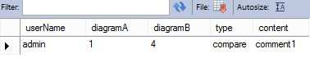

**Figure 11: [comment table result]**