18/09/2019

1. Create new repository on GitHub
2. **curl** is a tool to transfer data from or to a server, using one of the supported protocols (DICT, FILE, FTP, FTPS, GOPHER, HTTP, HTTPS, IMAP, IMAPS, LDAP, LDAPS, POP3, POP3S, RTMP, RTSP, SCP, SFTP, SMB, SMBS, SMTP, SMTPS, TELNET and TFTP). The command is designed to work without user interaction.

curl offers a busload of useful tricks like proxy support, user authentication, FTP upload, HTTP post, SSL connections, cookies, file transfer resume, Metalink, and more. As you will see below, the number of features will make your head spin!

1. Request
2. Dd
3. cURL makes request form single element at a time. DOesn’t show CSS, JavaScript – require additional requests
5. 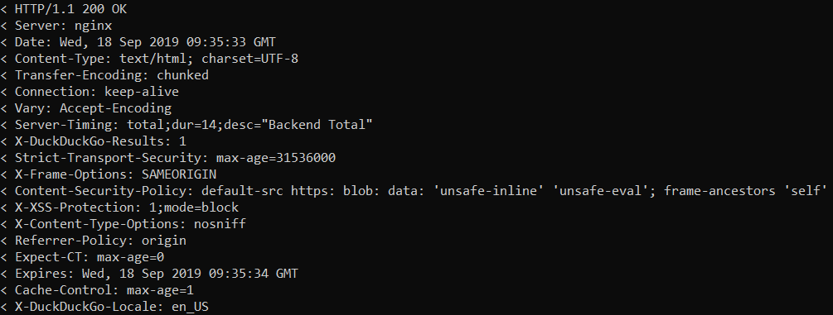

< HTTP/1.1 200 OK

< Server: nginx

< Date: Wed, 18 Sep 2019 09:35:33 GMT

< Content-Type: text/html; charset=UTF-8

< Transfer-Encoding: chunked

< Connection: keep-alive

< Vary: Accept-Encoding

< Server-Timing: total;dur=14;desc="Backend Total"

< X-DuckDuckGo-Results: 1

< Strict-Transport-Security: max-age=31536000

< X-Frame-Options: SAMEORIGIN

< Content-Security-Policy: default-src https: blob: data: 'unsafe-inline' 'unsafe-eval'; frame-ancestors 'self'

< X-XSS-Protection: 1;mode=block

< X-Content-Type-Options: nosniff

< Referrer-Policy: origin

< Expect-CT: max-age=0

< Expires: Wed, 18 Sep 2019 09:35:34 GMT

< Cache-Control: max-age=1

< X-DuckDuckGo-Locale: en_US