Class Diagram:

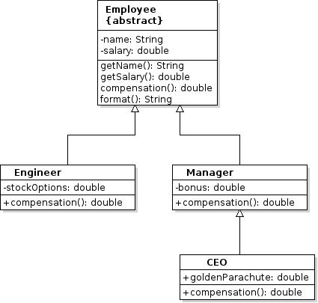

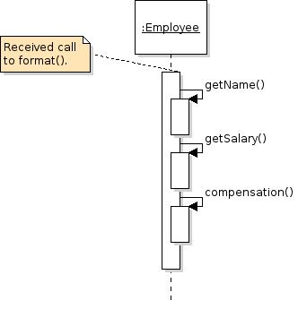
Sequence Diagram
Pattern Mapping:
Name in Design Pattern Actual Name (Selectable shapes)
AbstractClass Employee
ConcreteClass Engineer,Manager, CEO
templateMethod() format()

