Local Server Setup Guide

Nodejs, mysql and metabase

Leonard Meerwood

2018

# Overview

Pharmacy Error Tracker (hereafter referred to as P.E.T.) requires the use of three different pieces of software to run. This software is run on a server in the cloud. While this is good for production, it does make it hard to test changes. To remedy that it is often useful to host a copy of the server on the developer’s local machine. This document will help explain what each piece of software does and how to get them running on a local machine.

To host the actual webpages and respond to user input P.E.T. makes use of NodeJS. NodeJS is a web server that utilizes the JavaScript language. NodeJS has become quite popular over the last few years do to its ability to handle many connections concurrently, as well as allowing developers to utilize the same language in both the backend and the frontend.

While it is possible to create nice data visualizations with nothing more than HTML, CSS and JavaScript, it is a very intensive job. In order to ease the burden, it has been decided to use a third-party program that is designed with this purpose in mind. Metabase is an open-source software that is written in Java. It is free to use as long as the user hosts Metabase themselves.

Finally, to store the entries P.E.T. makes use of MySQL. *Research about MySQL*

# Set Up

## NodeJS Server

There are two parts to setting up NodeJS. The first is installing all the prerequisites. Afterwards the current code base must be downloaded and configured.

### Prerequisites

For this step we need NodeJS and Git.

#### NodeJS

Go to <https://nodejs.org/> and download the current version. As of writing the current version is 9.11.1. Note, there is also a LTS (Long Term Support) version available for download. Avoid this, we do not need the extended support it provides for our project. Once it is downloaded run the installation file.

Follow the prompts and accept all default settings. Once installed you can verify your installation by opening up Command Prompt and running a few commands. To verify successful installation of NodeJS type the following into Command Prompt:

node --version

If installation was successful you should see the version printed out. There’s a second software package that is installed with NodeJS called NPM. NPM stands for Node Package Manager, and it is this program that we will be using mostly. To verify it is installed type:

npm --version

If installation was successful you will see the version of NPM installed.

#### Git

Git for Windows can be found here <https://git-scm.com/download/win>. Once downloaded install it and select all default prompts. Once installed you can launch Git from the start menu, or by right-clicking in a blank spot on File Explorer and selecting “Git Bash Here”

### Download Codebase

Now that NodeJS, NPM and Git are all installed on our machine we need get the code from the repository onto our local machine. Create a folder somewhere you will remember and open it up. Right-click on an empty space and select “Git Bash Here”. Once open type the following command:

git clone [https://*UsernameHere*@bitbucket.org/itc303teampharmacon/pharmacy_app.git](https://*UsernameHere*@bitbucket.org/itc303teampharmacon/pharmacy_app.git)

Where you replace *UsernameHere* with your own username that you use to log in to BitBucket. In the author’s case it would be

git clone <https://LennyMeerwood@bitbucket.org/itc303teampharmacon/pharmacy_app.git>

Once the folder has finished downloading open up the folder called “pharmacy_app”.

### Install NodeJS libraries

For this whole section we will be working in the folder ***pharmacy_app >*** ***code > server.***

#### Explanation of NodeJS Packages

NOTE: *if you are not interested in a brief overview of how the packages are saved then please skip ahead to “How to Install Libraries”.* You do not need to run any commands in this section. They are there to help explain how NPM works.

NodeJS makes use of libraries to achieve different functionalities. For instance, in the pharmacy app we are using Vue.js to do our frontend layout. Even simple websites can have many plugins, and these plugins can require other plugins. This is where NPM comes into play. NPM is a package (package can be thought of as another term for library) manager that is connected to the npmjs.org website. There, people will upload packages they have made for others to use. Without this great collaboration tool, it is extremely unlikely that NodeJS would be as popular as it is today.

When we need to use a package for our application we use NPM to install it. For instance, we make use of a “mysql” package to interact with our MySQL database. To install that would be as follows.

npm install mysql

After writing this NPM goes out and downloads the mysql package. It will also download any package that the mysql package depends on. This can result in our package folder getting quite large. In order to avoid this, we do not commit our package folder to the repository. So, how do we save which packages we need in order to run our server? We add a tiny bit to the end of our command:

npm install mysql --save

Adding the save flag on the end tells NPM that we want to keep track of this package in our repository. So, as well as downloading all the packages like normal it also saves it to a file called ***package.json***. If you look in the folder you can see the file. Open it up with your favourite text editor and you can see all the packages that have been currently added, as well as a few other details. So now, instead of committing many packages to the repository and many files (at the time of writing there are 5,460 files in the libraries used) we are committing a single file. Cool, huh?

“I’ve just downloaded the code, I have no packages but this one file. What do I do now?” Well, it’s easy. You simply run the command:

npm install

As you may have noticed this is the exact same as last time we looked at npm install, but this time there is no commands following install. This tells NPM to look into the package.json and download all the packages that are saved in there.

#### How to Install Libraries

Open a Command Prompt and navigate to ***pharmacy_app/code/server.*** Once there run

npm install

### Running the NodeJS Server

Not only is NPM used for downloading of packages, it can also be used for managing the running of the server itself. In our case, to run the server we simply write

npm start run

This will start the server on the port we have selected. In our case it is usually port 3000. This means to visit the running page you open up a webpage and go to:

<http://localhost:3000>

Now you have the server running on your machine. The next steps involve setting up Metabase and MySQL.

## MySQL

MySQL is a database that utilizes SQL for its queries. While it has commercial versions, it also has a free, open-source, community-supported version. This is what we will be utilizing.

### Prerequisites

One of the prerequisites for MySQL is Python 2.7 32-bit edition. You can download that here:

<https://www.python.org/downloads/release/python-2714/>

Make sure you select ***Windows x86 MSI installer.*** It is VERY important to select x86 as and x86-64 as this is the 32-bit version of Python. If you select the 64-bit version of Python it will not work. Once you download the file run the installer. You can use just the defaults that are selected.

### Installation

Installation for MySQL is quite straightforward and simple. Go to the MySQL website and download the installer. One thing with MySQL is that it needs to use the 5.7 version, the latest version 8 does not work. If you have installed the latest version, then you can rerun the installer and choose to uninstall everything else instead.

<https://dev.mysql.com/downloads/windows/installer/5.7.html>

I chose the 354.6M file. This is the full installer and doesn’t need to download anything from the web during installation. I have not tried the web installer version, but I feel it should do the same job. It will prompt you to log in or sign up. If you look down the bottom there is a link that says, “No Thanks, just take me to the download.” Use that.

Once you have acquired the downloaded file run it. I just selected all the defaults and went with those. After selecting all the options you’ll get to a stage where it installs each module individually. This may take some time. Once this is completed you will be prompted to configure a few of the products. For MySQL Server I chose the default settings. When prompted to enter a password enter anything that you will remember, it’s just for you no one else. Also, in the Windows Service section I disabled ***Start the MySQL Server at System Startup***.I didn’t really want it running every time I used my laptop.

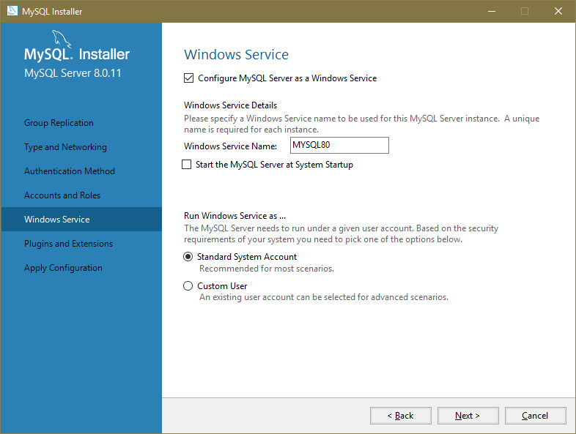

For the MySQL Router and the third option just cancel out of the setup for those. We don’t need those.

### importing existing database

Start up MySQL Workbench. Once it opens click on the only database that is there. Up the top left click on the “Open a SQL Script” button.

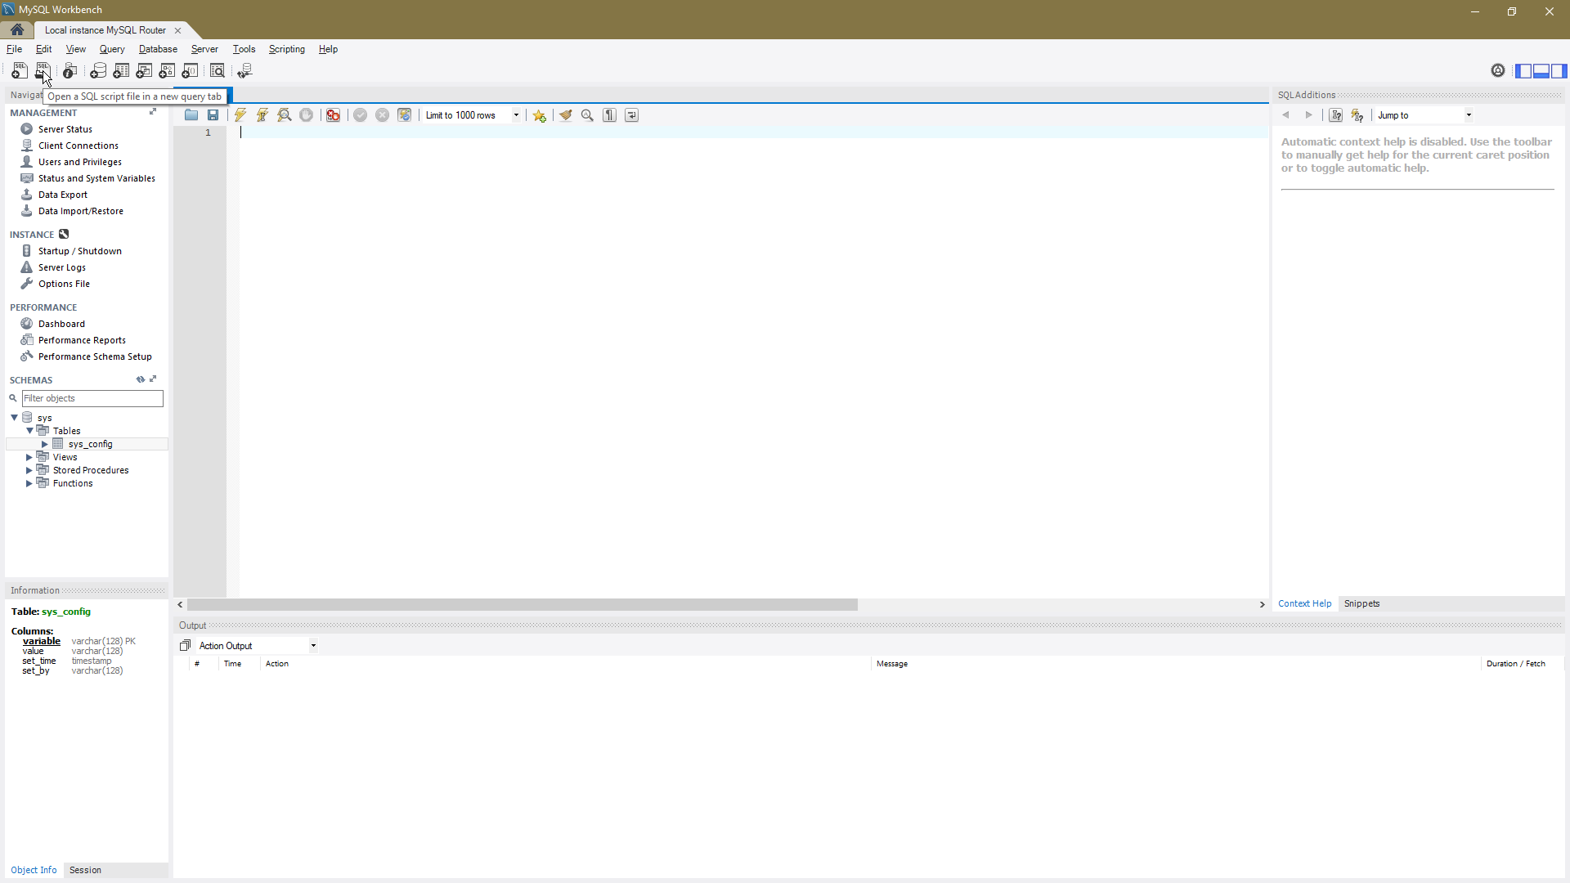

Once open, navigate to “\pharmacy_app\code\Database PET”. This folder can be found wherever you have cloned the code repository to. Once there, open up “PETDatabaseScript.sql”. A new tab will appear containing a bunch of SQL commands to create the new tables. Without selecting anything click the lightning bolt icon up the top. This will execute the SQL.

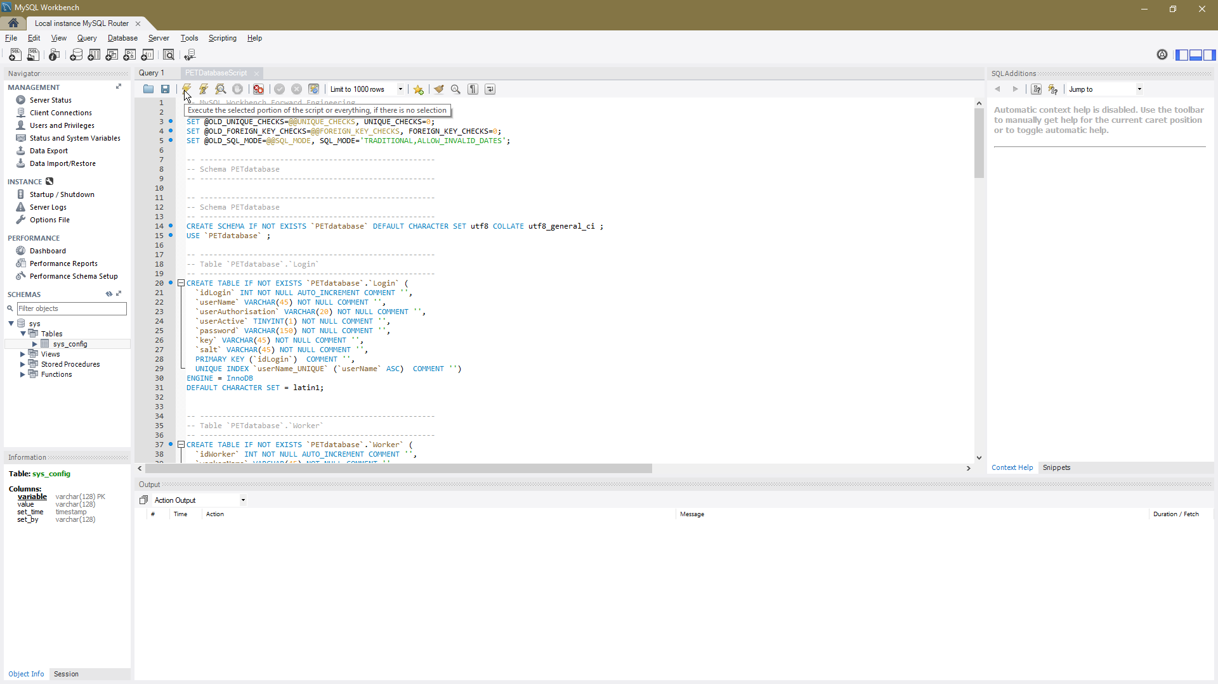

Success! On the left hand side of your screen is a section called ‘Schemas’. Click the refresh icon and you should see the petdatabase database appear.

## Metabase

Metabase is a free and open source platform that allows users to easily disaply visual representations of statistical data.

### Prerequisites

The only prerequisite needed for Metabase is the Java JRE (Java Runtime Environment). However, if you have the Java JDK (Java Development Kit) installed instead, that will work fine too. The version of Java needs to be version 7 or later. Here’s a link to latest version of the Java JRE (at the time of writing):

<http://www.oracle.com/technetwork/java/javase/downloads/jre10-downloads-4417026.html>

Make sure you select the one for Windows with the file name of “jre-10.0.1_windows-x64_bin.exe”. Once downloaded run the installation file. Installation is straight forward. Just follow the prompts and then you will have Java installed. Once installed you will need to download Metabase:

<https://www.metabase.com/start/jar.html>

Click the big button that says “Download Metabase.jar”

Once you’ve downloaded it copy the file somewhere you will remember. When that’s done open the folder containing metabase.jar. You will need to Shift + Right Click somewhere in the folder that is empty. Doing so will give you an extra option in the context-menu.

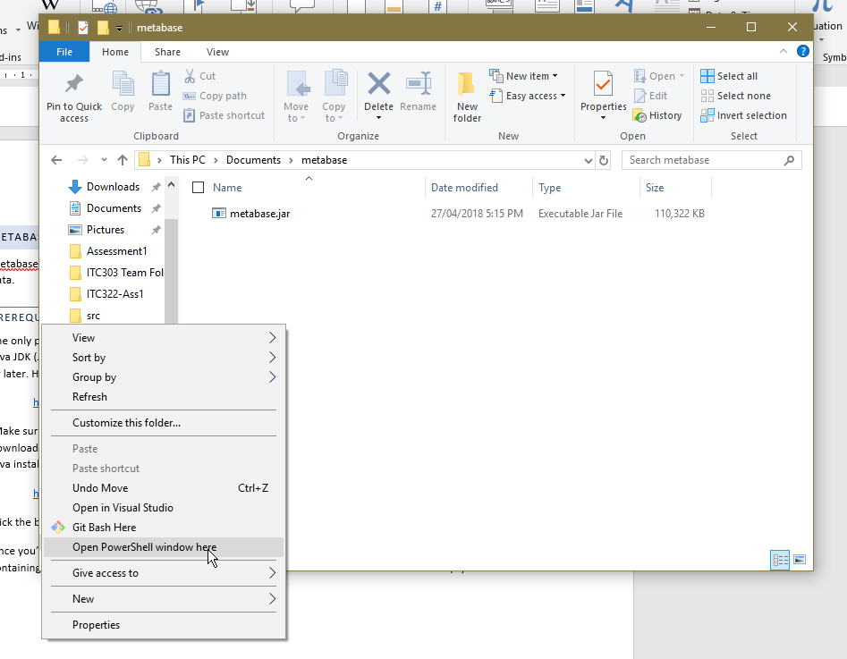

On mine you can see I now have an option called “Open PowerShell window here”. However, some versions of Windows will say something like “Open command window here” instead. Either are fine for our purposes.

Once you have opened a command prompt or PowerShell session you will need to type

java -jar metabase.jar

It will run a few commands and then after awhile it should say:

Please use the following url to setup your Metabase installation:

<http://localhost:3000/setup/>

Go to that page to continue set up.

Setup is very straight forward. Select “MySQL” for the database type then fill out the rest of the fields. For user put ‘root’ and the password is whatever you set up in the MySQL installation process.

# Conclusion

So far, we have set up NodeJS for the server, MySQL for the database and Metabase for data analytics. This document may change in the future as I believe how we use NodeJS might change slightly.