

FINAL REPORT

Course Title:： | Big Data Application Cases and Practices
Student Name： | 高明敏
Student ID：
Major： | Data Science and Big Data Technology
Semester： | Second Semester of Academic Year 2025-2026

June 2026

Steam Review Analysis
This report analyzes the Kaggle Steam Store Games dataset using a big data workflow designed around HDFS storage, PySpark preprocessing, Spark SQL aggregation, and Python-based visualization. The public dashboard is available at https://steam-review-analysis-lmeonleo.streamlit.app/.
Item | Description
Dataset | Steam Store Games by Nik Davis on Kaggle
Records | 27,075 game-level records after cleaning
Review outcomes | 32,803,682 positive/negative rating outcomes
Team | Steam Insight Lab - 高明敏
Tools | HDFS, PySpark, Spark SQL, Pandas, Matplotlib/Seaborn, Streamlit

1. Dataset Introduction
The selected topic is Steam Review Analysis. The source data comes from the real Kaggle dataset 'Steam Store Games', which contains game metadata, prices, genres, platforms, SteamSpy tags, and aggregate positive and negative review counts. Because the available review fields are aggregate ratings rather than individual text reviews, the project focuses on review outcome analysis: how many users responded positively or negatively, and how those outcomes vary by year, genre, price band, publisher, and tag.
The cleaned game table contains 27,075 games and 32.8 million review outcomes. The overall weighted positive rate is 82.58%, while the median number of review outcomes per game is 36, indicating a long-tail catalogue in which a small number of games receive very high attention.
2. HDFS Storage and Access Strategy
The project separates raw, curated, and analytical data zones so that the pipeline is reproducible and safe to rerun. Raw CSV files are copied into HDFS without modification, cleaned game records are written as partitioned Parquet, and final analysis outputs are materialized as compact CSV result tables for reporting and the dashboard.
Layer | HDFS / Local Path | Purpose
Raw zone | /projects/steam/raw | Immutable Kaggle CSV files
Curated zone | /projects/steam/curated/games | Cleaned Parquet table partitioned by release year
Result zone | output/results/spark | Aggregated CSV outputs from Spark SQL
Web layer | output/results/local | Small pre-aggregated files read by Streamlit

3. Data Preprocessing
The preprocessing pipeline is implemented in PySpark with an explicit schema. Key steps include parsing release dates, converting price and rating fields to numeric types, handling missing or malformed values, deriving total review counts and positive-rate percentages, splitting semicolon-delimited genres, and exploding platform indicators for analysis.
1. Load CSV files from HDFS using explicit Spark schemas.
2. Normalize release dates, prices, platforms, genres, publishers, and rating counts.
3. Remove or repair invalid rows while preserving the original raw zone.
4. Derive analytical fields: release year, review total, positive percentage, price band, and Wilson lower bound.
5. Write curated records to Parquet and run Spark SQL aggregations.
4. Analytical Questions and Methods
- How did the Steam catalogue expand over time, and how did average reception change?
- Which genres combine broad coverage with reliable user reception?
- How do price bands relate to positive rates and review attention?
- Which games rank highest after accounting for uncertainty in small samples?
- Which publishers and tags dominate the reviewed catalogue?
Spark SQL is used for grouping, filtering, ranking, and producing final result tables. The ranking method uses the 95% Wilson lower confidence bound rather than raw positive rate alone, because a game with 3 positive reviews out of 3 should not outrank a game with hundreds of thousands of highly positive reviews.
5. Key Findings and Visualizations
5.1 Catalogue Growth
The number of games released per year rises sharply in the later years of the snapshot, especially after the mid-2010s. Mean positive reception remains within a relatively stable band, suggesting that the platform's growth reflects market expansion rather than a simple collapse in average user satisfaction.
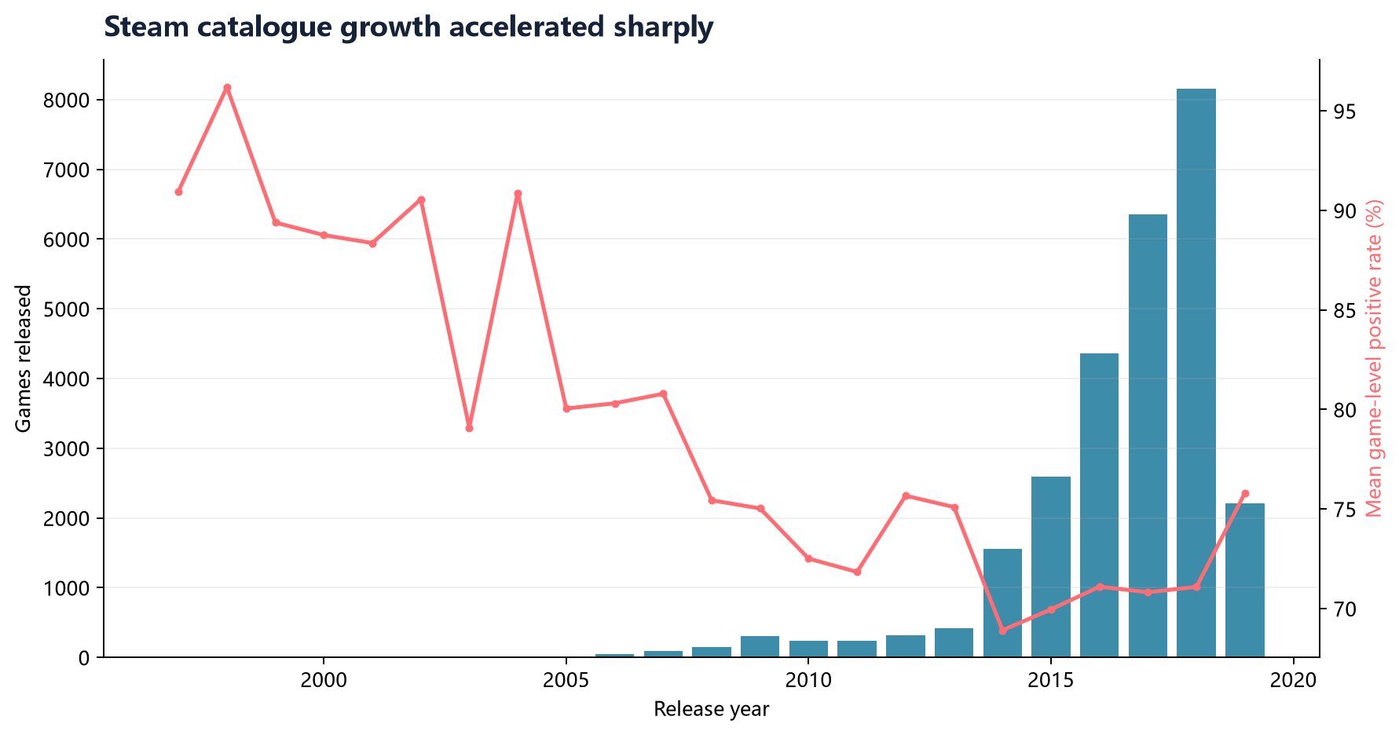
Figure 1. Steam catalogue growth and rating trend by release year.
5.2 Genre-Level Reception
Genre analysis shows that genre labels overlap substantially, so one game can contribute to multiple categories. Wilson-adjusted genre scores make the comparison more conservative by considering both rating level and sample reliability.
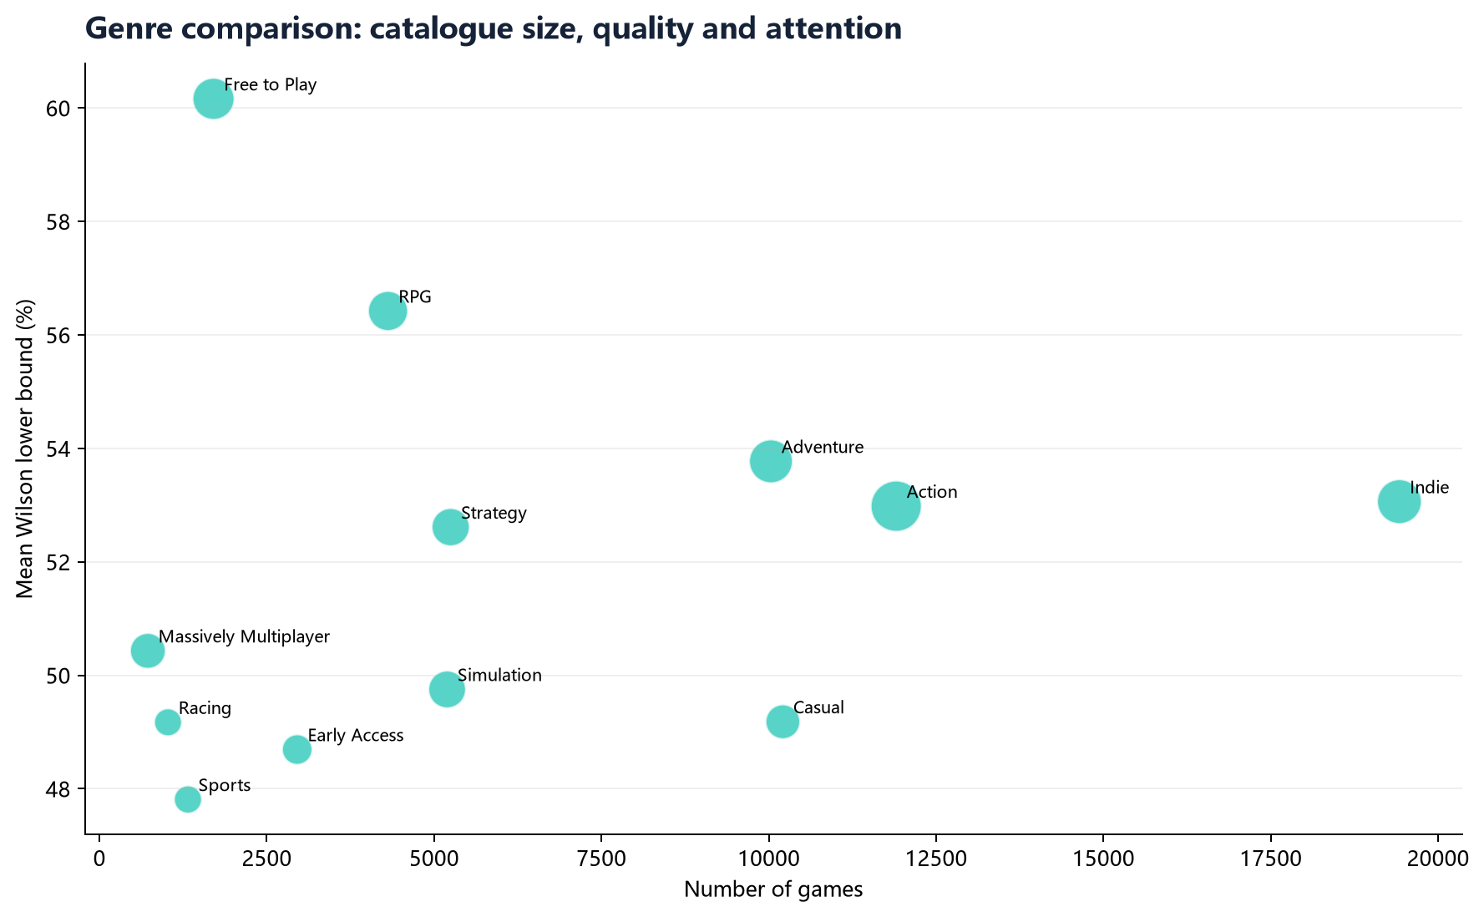
Figure 2. Genre coverage and Wilson-adjusted reception.
Genre | Games | Total reviews | Mean rating % | Mean Wilson %
Free to Play | 1,704 | 8,941,644 | 69.95 | 60.16
Sexual Content | 245 | 175,111 | 73.02 | 58.27
Nudity | 266 | 275,115 | 70.91 | 56.85
RPG | 4,311 | 7,005,218 | 71.63 | 56.42
Adventure | 10,032 | 11,063,037 | 71.38 | 53.77
Indie | 19,421 | 12,265,253 | 72.15 | 53.06

5.3 Price Bands
Price bands are interpreted descriptively rather than causally. Mid-priced games tend to receive more review attention than very low-priced games, while free games show broad catalogue coverage and high median review counts.
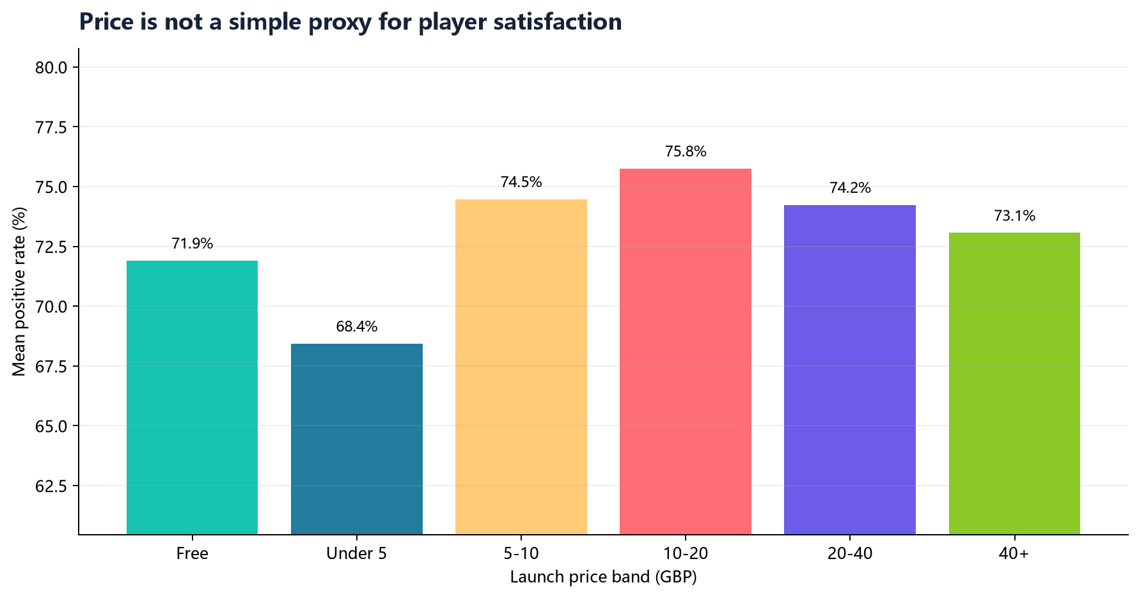
Figure 3. Rating level and review attention by price band.
Price band | Games | Mean price | Mean rating % | Median reviews
Free | 2,560 | 0.00 | 71.91 | 87
Under 5 | 13,286 | 2.63 | 68.44 | 21
5-10 | 6,303 | 7.08 | 74.48 | 36
10-20 | 4,001 | 13.62 | 75.76 | 121
20-40 | 810 | 28.28 | 74.24 | 471
40+ | 115 | 65.85 | 73.07 | 463

5.4 Reliable Game Rankings
The highest-ranked game by Wilson lower bound is Portal 2. This confirms that the ranking is not simply rewarding small-sample perfect scores; it favours games with both strong reception and sufficient review volume.
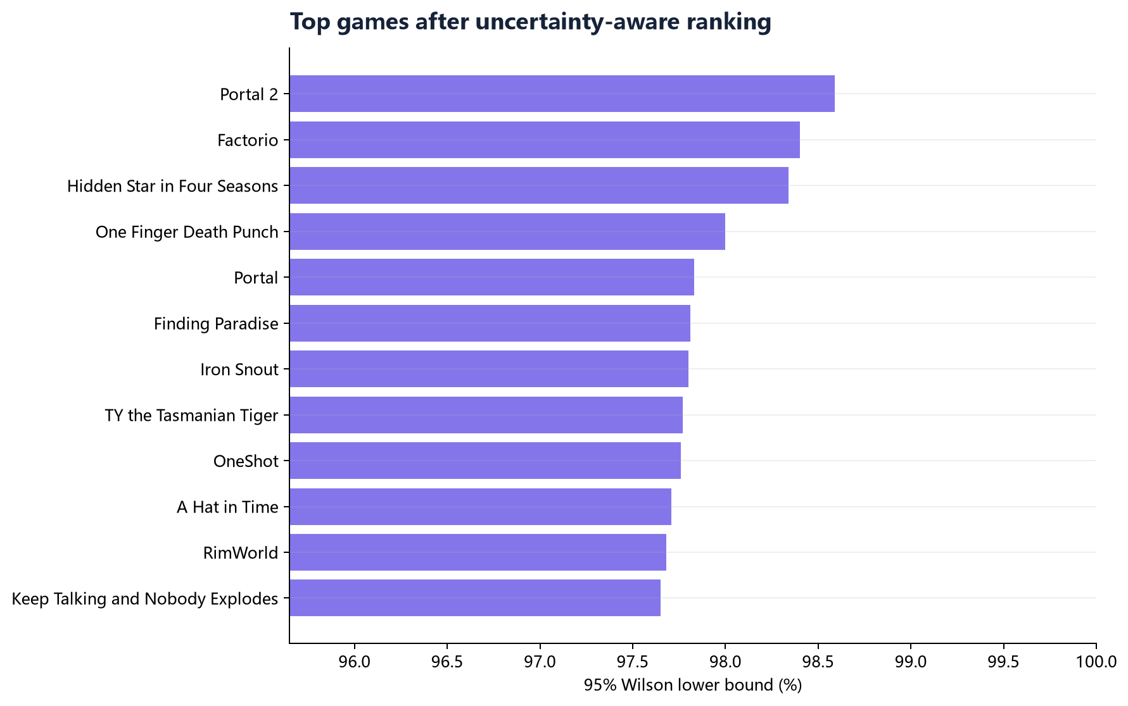
Figure 4. Most reliable highly rated games by Wilson lower bound.
Rank | Game | Reviews | Rating % | Wilson %
1 | Portal 2 | 140,111 | 98.65 | 98.59
2 | Factorio | 48,641 | 98.51 | 98.40
3 | 東方天空璋 ～ Hidden Star in Four Seasons. | 4,167 | 98.73 | 98.34
4 | One Finger Death Punch | 14,437 | 98.23 | 98.00
5 | Portal | 52,881 | 97.96 | 97.83
6 | Finding Paradise | 6,701 | 98.16 | 97.81
7 | Iron Snout | 14,166 | 98.04 | 97.80
8 | TY the Tasmanian Tiger | 1,702 | 98.47 | 97.77

5.5 Publishers and Tags
Publisher portfolio analysis identifies publishers with both sufficient catalogue size and strong user reception. SteamSpy tags show the market's dominant content signals, with Action, Indie, Adventure, Multiplayer, and Singleplayer among the most-voted tags.
Publisher | Games | Total reviews | Mean Wilson %
Valve | 30 | 5,910,808 | 88.86
CAPCOM Co., Ltd. | 13 | 209,151 | 86.31
Spike Chunsoft Co., Ltd. | 15 | 27,421 | 85.64
Quiet River | 21 | 26,456 | 83.85
XSEED Games;Marvelous USA, Inc. | 18 | 13,352 | 83.08
id Software | 19 | 19,075 | 82.75

Tag | Tagged games | Total tag votes | Mean rating %
action | 13,136 | 763,849 | 71.20
indie | 20,782 | 730,458 | 72.19
adventure | 11,572 | 563,927 | 71.86
multiplayer | 3,111 | 415,341 | 73.86
singleplayer | 6,779 | 403,390 | 76.39
casual | 11,449 | 327,532 | 71.50
rpg | 4,900 | 318,176 | 71.97
strategy | 6,000 | 312,526 | 69.74
open_world | 1,564 | 312,337 | 71.15
simulation | 5,855 | 282,366 | 66.44

6. Dashboard Implementation
The optional dashboard is implemented with Streamlit and deployed to Streamlit Community Cloud. It reads only pre-aggregated result files, which keeps the web application lightweight while preserving the full big-data workflow behind the analysis. Public URL: https://steam-review-analysis-lmeonleo.streamlit.app/.
7. Conclusion and Reflection
The project demonstrates a complete analytical workflow from raw data storage to cleaned distributed processing, SQL-based aggregation, visualization, interpretation, and web presentation. The strongest methodological choice is the use of Wilson lower-bound ranking, which makes the results more reliable than a raw percentage ranking. A limitation is that the dataset contains aggregate review outcomes rather than individual review texts, so sentiment analysis of written review content is outside the scope of this project.
8. Team Roles
Member | Main responsibilities
高明敏 | HDFS ingestion, PySpark ETL design, Spark SQL analysis, visualization, interpretation, report and dashboard

References
- Nik Davis. Steam Store Games. Kaggle. https://www.kaggle.com/datasets/nikdavis/steam-store-games/data
- Apache Spark documentation. https://spark.apache.org/docs/latest/
- Apache Hadoop HDFS documentation. https://hadoop.apache.org/docs/
- Streamlit documentation. https://docs.streamlit.io/

