

FINAL REPORT

Course Title:： | Big Data Application Cases and Practices
Student Name： | Gao Mingmin
Student ID：
Major： | Data Science and Big Data Technology
Semester： | Second Semester of Academic Year 2025-2026

June 2026

Steam Review Analysis
This report analyzes the Kaggle Steam Store Games dataset using a big data workflow designed around HDFS storage, PySpark preprocessing, Spark SQL aggregation, and Python-based visualization. The public dashboard is available at https://steam-review-analysis-lmeonleo.streamlit.app/.
Item | Description
Dataset | Steam Store Games by Nik Davis on Kaggle
Records | 27,075 game-level records after cleaning
Review outcomes | 32,803,682 positive/negative rating outcomes
Team | Steam Insight Lab - Gao Mingmin
Tools | HDFS, PySpark, Spark SQL, Pandas, Matplotlib/Seaborn, Streamlit

1. Dataset Introduction
The selected topic is Steam Review Analysis. The source data comes from the real Kaggle dataset 'Steam Store Games', which contains game metadata, prices, genres, platforms, SteamSpy tags, and aggregate positive and negative review counts. Because the available review fields are aggregate ratings rather than individual text reviews, the project focuses on review outcome analysis: how many users responded positively or negatively, and how those outcomes vary by year, genre, price band, publisher, and tag.
The cleaned game table contains 27,075 games and 32.8 million review outcomes. The overall weighted positive rate is 82.58%, while the median number of review outcomes per game is 36, indicating a long-tail catalogue in which a small number of games receive very high attention.
Two source files are used most heavily in the analysis. The first is steam.csv, which acts as the main game-level fact table and contains release date, price, platform, genre, publisher, and positive/negative rating counts. The second is steamspy_tag_data.csv, which stores tag vote counts in a wide format and is normalized into a tag-level analytical table. Other raw files are retained as part of the dataset package, but the core questions can be answered from these two tables with a clear and reproducible pipeline.
2. HDFS Storage and Access Strategy
The project separates raw, curated, and analytical data zones so that the pipeline is reproducible and safe to rerun. Raw CSV files are copied into HDFS without modification, cleaned game records are written as partitioned Parquet, and final analysis outputs are materialized as compact CSV result tables for reporting and the dashboard.
This layout follows a common big-data lake pattern. The raw zone is append-only, which protects the original Kaggle files and makes it possible to audit every transformation. The curated zone stores typed and cleaned Parquet records, improving I/O efficiency compared with repeatedly scanning CSV. The result zone contains only small aggregates, so downstream visualization does not need to reprocess the full dataset.
Layer | HDFS / Local Path | Purpose
Raw zone | /projects/steam/raw | Immutable Kaggle CSV files
Curated zone | /projects/steam/curated/games | Cleaned Parquet table partitioned by release year
Result zone | output/results/spark | Aggregated CSV outputs from Spark SQL
Web layer | output/results/local | Small pre-aggregated files read by Streamlit

3. Data Preprocessing
The preprocessing pipeline is implemented in PySpark with an explicit schema. Key steps include parsing release dates, converting price and rating fields to numeric types, handling missing or malformed values, deriving total review counts and positive-rate percentages, splitting semicolon-delimited genres, and exploding platform indicators for analysis.
1. Load CSV files from HDFS using explicit Spark schemas.
2. Normalize release dates, prices, platforms, genres, publishers, and rating counts.
3. Remove or repair invalid rows while preserving the original raw zone.
4. Derive analytical fields: release year, review total, positive percentage, price band, and Wilson lower bound.
5. Write curated records to Parquet and run Spark SQL aggregations.
A local Pandas-based verification script is also included. It is not used as a replacement for the PySpark pipeline; instead, it independently recomputes the reported aggregates on a machine without Hadoop. Matching results between the local verification output and the Spark design increases confidence that the business logic is correct.
Quality check | Result | Interpretation
Primary key | 27,075 unique games | No duplicate game rows after cleaning
Review fields | 32.8M outcomes | Positive and negative counts are numeric and non-negative
Release year | 1997-2019 | 2019 is treated as an incomplete snapshot year
Ranking eligibility | >= 1,000 reviews | Small samples are excluded from reliable top-game ranking

4. Analytical Questions and Methods
- How did the Steam catalogue expand over time, and how did average reception change?
- Which genres combine broad coverage with reliable user reception?
- How do price bands relate to positive rates and review attention?
- Which games rank highest after accounting for uncertainty in small samples?
- Which publishers and tags dominate the reviewed catalogue?
Spark SQL is used for grouping, filtering, ranking, and producing final result tables. The ranking method uses the 95% Wilson lower confidence bound rather than raw positive rate alone, because a game with 3 positive reviews out of 3 should not outrank a game with hundreds of thousands of highly positive reviews.
The main analytical measures are total review outcomes, raw positive percentage, mean genre-level rating, median review attention, and Wilson lower-bound score. Together these measures separate popularity from reliability: review volume captures attention, while the Wilson score provides a conservative estimate of user satisfaction when sample sizes differ strongly across games.
Question | Method | Output
Catalogue growth | Group by release_year | yearly.csv and market evolution figure
Genre reception | Explode genres, aggregate rating and Wilson metrics | genre.csv
Price association | Bucket numeric prices into bands | price_band.csv
Reliable ranking | Filter by review volume and sort by Wilson bound | top_reliable.csv
Tag attention | Unpivot SteamSpy tag columns | top_tags.csv

5. Key Findings and Visualizations
5.1 Catalogue Growth
The number of games released per year rises sharply in the later years of the snapshot, especially after the mid-2010s. Mean positive reception remains within a relatively stable band, suggesting that the platform's growth reflects market expansion rather than a simple collapse in average user satisfaction.
This pattern is important for interpretation. If catalogue growth were accompanied by a dramatic fall in average ratings, it would suggest that easier publishing reduced observed quality. Instead, the result is more nuanced: the catalogue grows quickly, while rating averages move within a moderate range. The platform therefore appears to become broader and more diverse rather than simply worse.
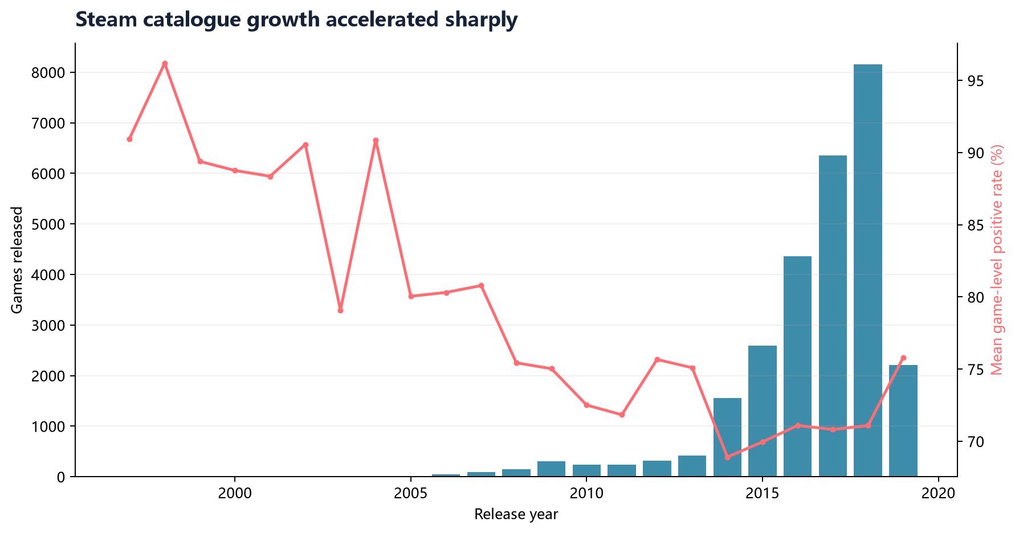
Figure 1. Steam catalogue growth and rating trend by release year.
5.2 Genre-Level Reception
Genre analysis shows that genre labels overlap substantially, so one game can contribute to multiple categories. Wilson-adjusted genre scores make the comparison more conservative by considering both rating level and sample reliability.
Because many Steam games are tagged with multiple genres, genre-level results should be read as overlapping market segments rather than mutually exclusive categories. This is why the report emphasizes relative patterns and reliable reception instead of treating genres as isolated groups.
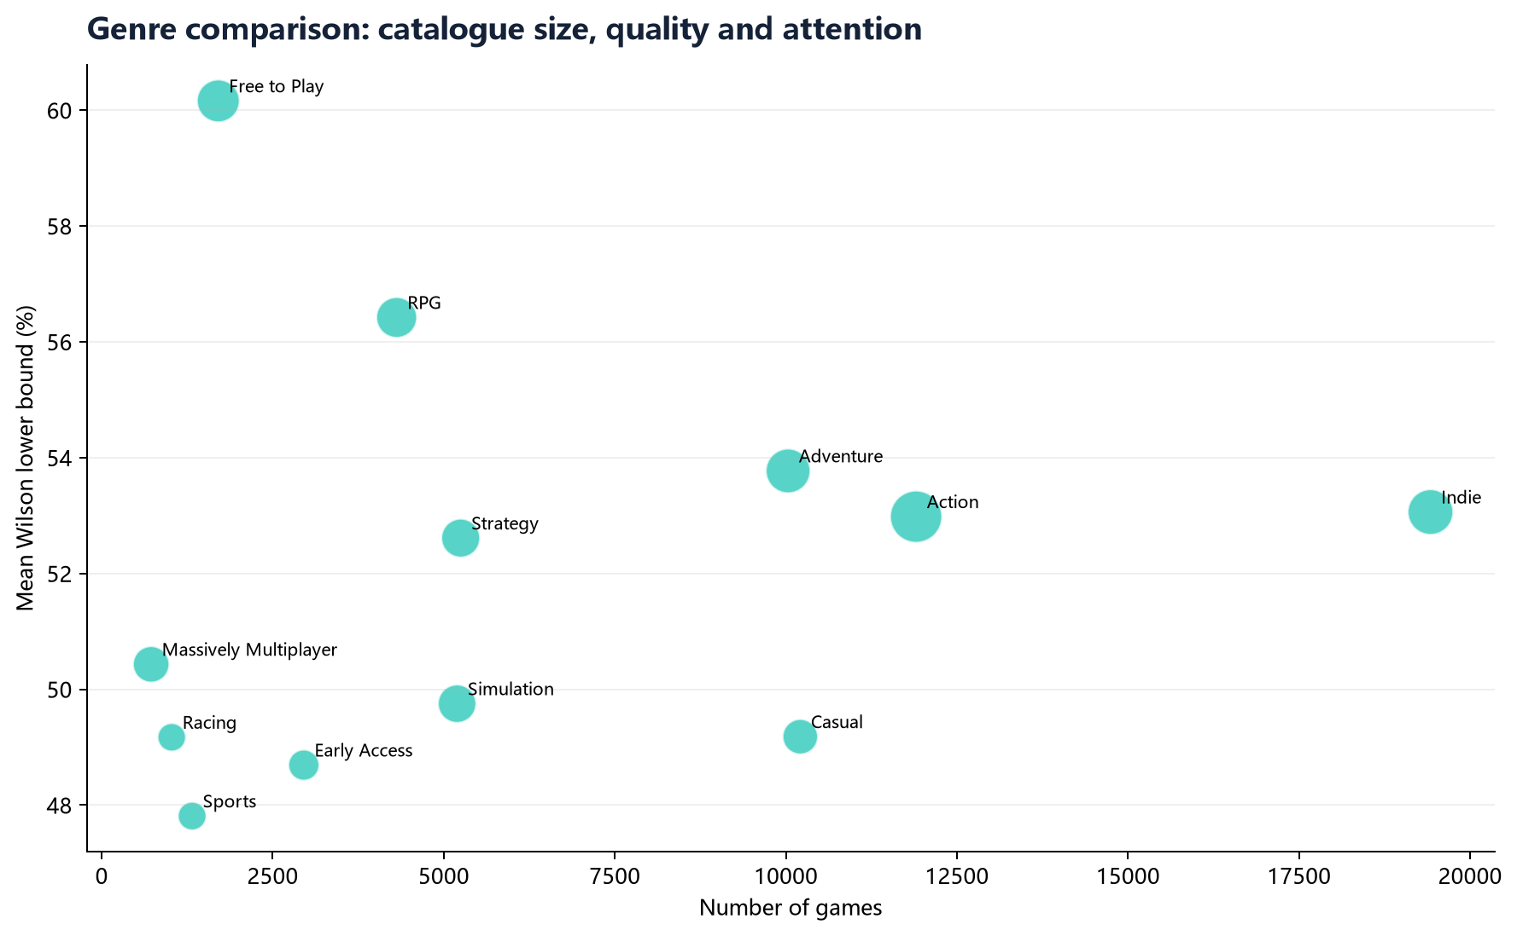
Figure 2. Genre coverage and Wilson-adjusted reception.
Genre | Games | Total reviews | Mean rating % | Mean Wilson %
Free to Play | 1,704 | 8,941,644 | 69.95 | 60.16
Sexual Content | 245 | 175,111 | 73.02 | 58.27
Nudity | 266 | 275,115 | 70.91 | 56.85
RPG | 4,311 | 7,005,218 | 71.63 | 56.42
Adventure | 10,032 | 11,063,037 | 71.38 | 53.77
Indie | 19,421 | 12,265,253 | 72.15 | 53.06

5.3 Price Bands
Price bands are interpreted descriptively rather than causally. Mid-priced games tend to receive more review attention than very low-priced games, while free games show broad catalogue coverage and high median review counts.
The price analysis does not prove that price causes higher or lower satisfaction. Different price bands may also differ by marketing budget, production quality, genre mix, and release strategy. However, the comparison is still useful because it shows how review attention and user reception are distributed across commercial segments of the Steam catalogue.
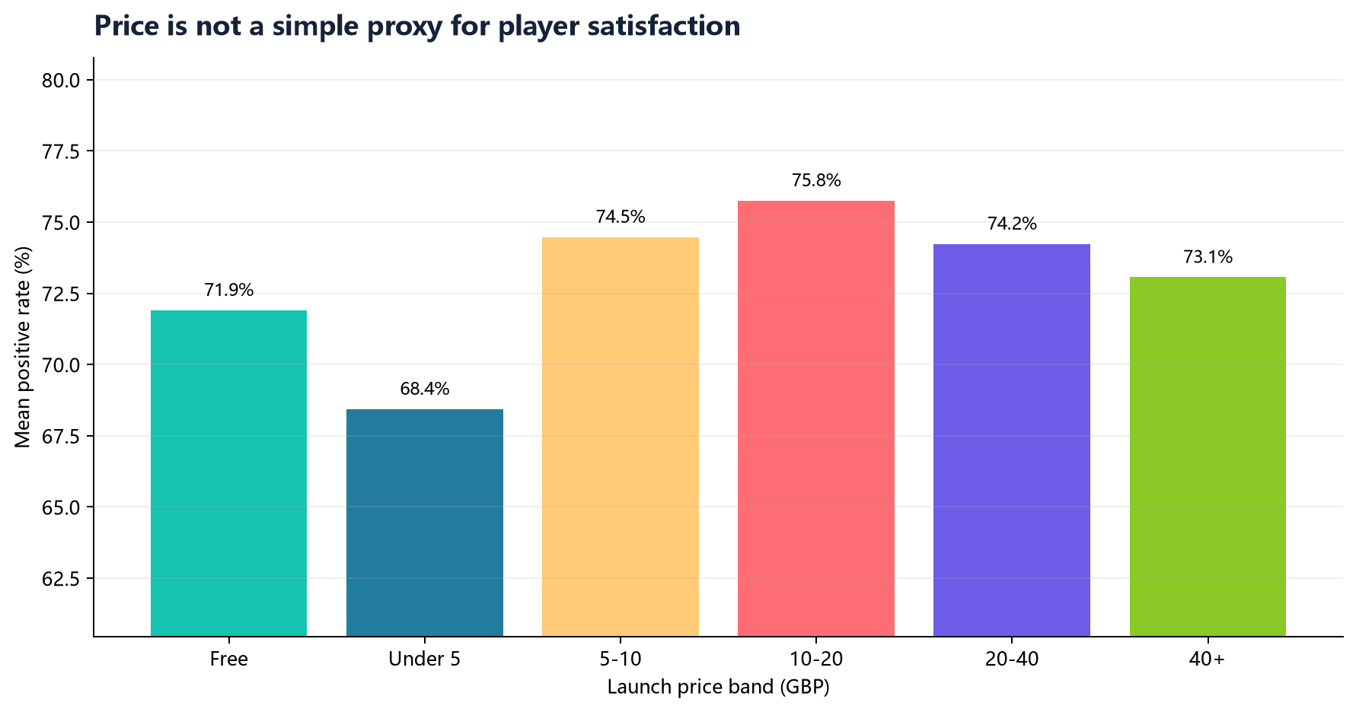
Figure 3. Rating level and review attention by price band.
Price band | Games | Mean price | Mean rating % | Median reviews
Free | 2,560 | 0.00 | 71.91 | 87
Under 5 | 13,286 | 2.63 | 68.44 | 21
5-10 | 6,303 | 7.08 | 74.48 | 36
10-20 | 4,001 | 13.62 | 75.76 | 121
20-40 | 810 | 28.28 | 74.24 | 471
40+ | 115 | 65.85 | 73.07 | 463

5.4 Reliable Game Rankings
The highest-ranked game by Wilson lower bound is Portal 2. This confirms that the ranking is not simply rewarding small-sample perfect scores; it favours games with both strong reception and sufficient review volume.
This ranking is more suitable for recommendation-style interpretation than a raw positive-rate ranking. A plain percentage can be unstable when a game has very few reviews, while the Wilson lower bound penalizes uncertainty and rewards consistent performance at scale.
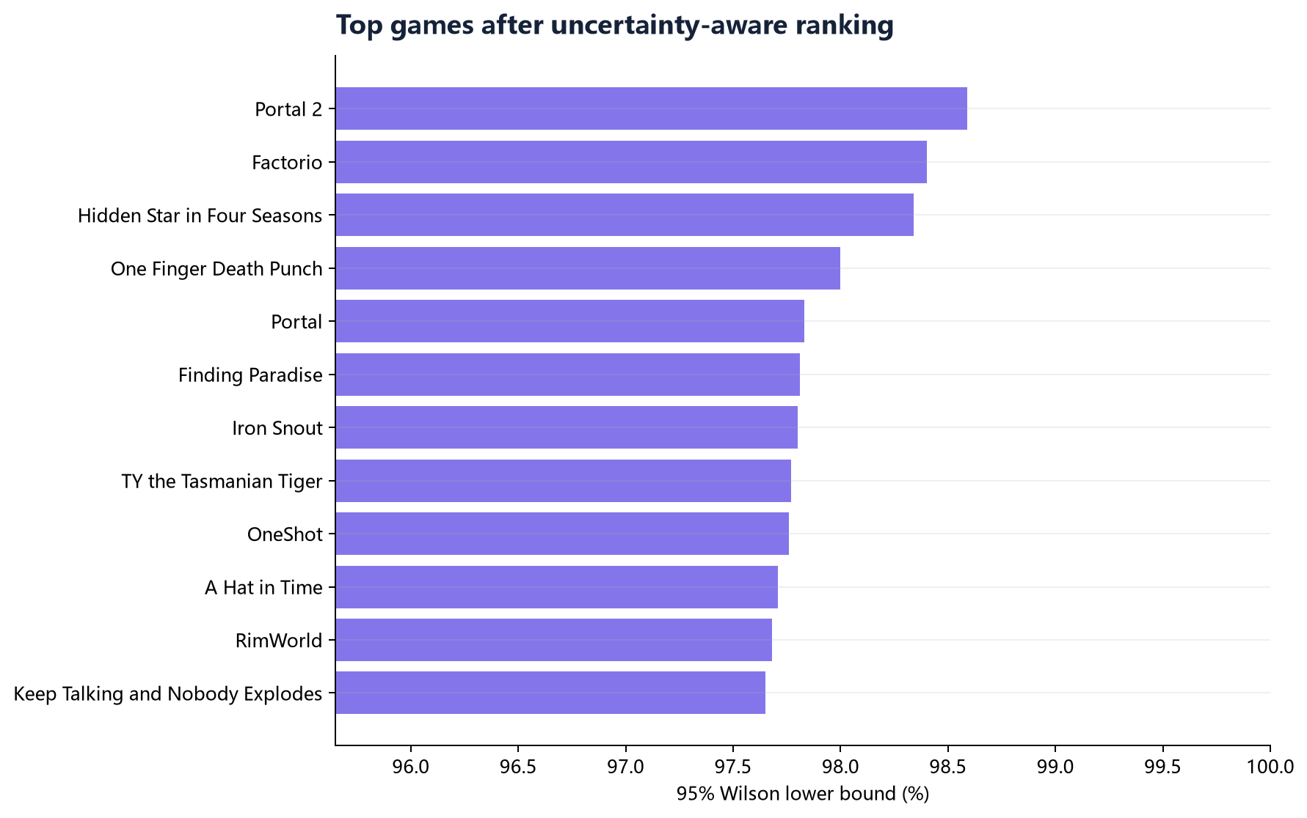
Figure 4. Most reliable highly rated games by Wilson lower bound.
Rank | Game | Reviews | Rating % | Wilson %
1 | Portal 2 | 140,111 | 98.65 | 98.59
2 | Factorio | 48,641 | 98.51 | 98.40
3 | 東方天空璋 ～ Hidden Star in Four Seasons. | 4,167 | 98.73 | 98.34
4 | One Finger Death Punch | 14,437 | 98.23 | 98.00
5 | Portal | 52,881 | 97.96 | 97.83
6 | Finding Paradise | 6,701 | 98.16 | 97.81
7 | Iron Snout | 14,166 | 98.04 | 97.80
8 | TY the Tasmanian Tiger | 1,702 | 98.47 | 97.77

5.5 Publishers and Tags
Publisher portfolio analysis identifies publishers with both sufficient catalogue size and strong user reception. SteamSpy tags show the market's dominant content signals, with Action, Indie, Adventure, Multiplayer, and Singleplayer among the most-voted tags.
Publisher | Games | Total reviews | Mean Wilson %
Valve | 30 | 5,910,808 | 88.86
CAPCOM Co., Ltd. | 13 | 209,151 | 86.31
Spike Chunsoft Co., Ltd. | 15 | 27,421 | 85.64
Quiet River | 21 | 26,456 | 83.85
XSEED Games;Marvelous USA, Inc. | 18 | 13,352 | 83.08
id Software | 19 | 19,075 | 82.75

Tag | Tagged games | Total tag votes | Mean rating %
action | 13,136 | 763,849 | 71.20
indie | 20,782 | 730,458 | 72.19
adventure | 11,572 | 563,927 | 71.86
multiplayer | 3,111 | 415,341 | 73.86
singleplayer | 6,779 | 403,390 | 76.39
casual | 11,449 | 327,532 | 71.50
rpg | 4,900 | 318,176 | 71.97
strategy | 6,000 | 312,526 | 69.74
open_world | 1,564 | 312,337 | 71.15
simulation | 5,855 | 282,366 | 66.44

6. Dashboard Implementation
The optional dashboard is implemented with Streamlit and deployed to Streamlit Community Cloud. It reads only pre-aggregated result files, which keeps the web application lightweight while preserving the full big-data workflow behind the analysis. Public URL: https://steam-review-analysis-lmeonleo.streamlit.app/.
The dashboard is designed as a demonstration layer rather than the primary processing engine. It exposes the final aggregates through interactive tabs for market growth, genres, price bands, rankings, and methodology. This separation keeps the web application fast while making the HDFS/PySpark/Spark SQL workflow clear to evaluators.
7. Conclusion and Reflection
The project demonstrates a complete analytical workflow from raw data storage to cleaned distributed processing, SQL-based aggregation, visualization, interpretation, and web presentation. The strongest methodological choice is the use of Wilson lower-bound ranking, which makes the results more reliable than a raw percentage ranking. A limitation is that the dataset contains aggregate review outcomes rather than individual review texts, so sentiment analysis of written review content is outside the scope of this project.
Future work could extend the analysis in three directions. First, a larger review-text dataset could support NLP sentiment modeling and topic extraction. Second, joining Steam data with external sales or player-count data would help distinguish attention from commercial success. Third, a scheduled pipeline could refresh the dashboard automatically when new catalogue snapshots become available.
8. Team Roles
Member | Main responsibilities
Gao Mingmin | HDFS ingestion, PySpark ETL design, Spark SQL analysis, visualization, interpretation, report and dashboard

References
1. Davis, N. Steam Store Games [Dataset]. Kaggle. https://www.kaggle.com/datasets/nikdavis/steam-store-games/data
2. Apache Software Foundation. Apache Spark Documentation. https://spark.apache.org/docs/latest/
3. Apache Software Foundation. Apache Hadoop HDFS Documentation. https://hadoop.apache.org/docs/
4. Streamlit. Streamlit Documentation. https://docs.streamlit.io/

