**CHAPTER I**

**INTRODUCTION**

Tasks are designed in a fast-paced environment such as in project management and need to be done methodically and efficiently for the purpose of completing tasks and goals. As project complexity increases across various industries so does the need for digital tools that help streamline workflow and improve collaboration. Traditional ways of managing project deadlines and a lack of communication. To address all of these challenges, technology-based systems have been adopted in order to facilitate project tracking, workflow streamlining as a unit. This capstone project aims to create a Project Management System (PMS) that increases efficiency, accountability and communication on project execution.

Project management systems were born as a groundbreaking tool for organizations, educational institutions, and corporate establishments that were looking to improve the productivity of their teams. These systems offer features such as task tracking, role assignment, file sharing, and progress monitoring in real-time. A well-planned project management system deployed and adapted for your team can be an immensely useful tool, and even single-handedly responsible for reducing project delays. However, it can be hard to find the right project management solution in the market as most of them are either too complex for small teams to use or lack key functionalities required for successful project implementation. So this project has been started to design a custom-built Project Management System that is easy to use, efficient, and flexible enough to best suit different project environments.

The main goal of this capstone project is to make a more accessible project management system, where users can create, assign and track tasks easily from one intuitive project management system. It will have the functionality for sign-up of an account, reallocation of tasks, monitoring of project status, real-time notification, etc. to enable seamless flow of work. Project managers will be able to make data-driven decisions, while the platform does not disturb team members or allow them to get diverted from their work with a tool based on automation and data-driven insights. This Project's Purpose: Achieving a Stable System to Prevent Human Errors and Provide Collaboration in Team Projects.

Additionally, it will not only minimize the chances of project management issues like visibility of work, communication gaps and inability to meet deadlines. Most of the conventional project management methodologies are based on spreadsheets and manual tracking that consume time and are prone to error. A centralized digital platform provides teams with a single source where they can see real-time data, record what they're working on, and get timely reminders—ensuring accountability and productivity. It is meant to lessen the burden on project managers as well as instill a systematic approach to work. This capstone project defines a new direction in project management technology by delivering a solution unique to current project needs. This system will set a new standard of efficiency in a project with the tech species being applied to allow task monitoring and communication. This project’s research and development will provide insight into automated features, data-based decision-making, and human-centered design that will help project managers. This project will give teams a reliable, lightweight solution to manage workflow processes and will lead to greater success overall.

**Project Context**

The "Nexora: An Extensive Project Management System for Proficient Team Collaboration and Task Monitoring and Tracking" is a web-based software project that has been developed to maximize project management effectiveness in different organizations. The system seeks to simplify task management, enhance collaboration, and offer real-time tracking capabilities to facilitate different users in efficiently managing their projects. Project implementation started in March 2025, targeting the completion period as November 2025 to be implemented timely. The system provides sophisticated functions in order to suit the diversified demands of the users, including providing real-time status, performance-based analytics to judge the efficiency of the work done, and an efficient platform that allows collaborative effort and effortless task tracking.

The project is not institution-specific but is meant for general use, and hence it is flexible enough to be used across various industries and organizational frameworks. It is useful for teams, students’ project leaders, project managers, freelancers, and companies seeking a productive project management tool. By offering a systematic framework for task planning, monitoring progress, and collaboration, the system facilitates higher productivity and successful project delivery. The development procedure is a structured approach, starting with requirement analysis, system design, development, implementation, and testing. It ensures that the system is designed to meet the performance criteria and deliver an ideal user experience.

**Purpose and Description**

The development of a Project Management System (PMS) holds significant implications for organizations, project managers, and team members alike. Implementing a well-designed PMS provides several benefits which include streamlined administrative functions together with enhanced task transparency and better workflow efficiency. Through its design the system serves to enable task distribution alongside team collaboration and workflow monitoring functions which help deliver automated projects of high quality at the appropriate times.

The project will establish a web-based PMS platform which will merge effectively with current organizational structures. The proposed system will present a complete set of features which combine tasks allocation functions with ongoing project monitoring alongside data synchronization with adjustable project configurations for different needs. The system will include convenient graphical interfaces which managers use to distribute assignments track team accomplishments and maintain effective communication with their members.

List the persons who will be benefited and how they will be benefited;

**Owner:** The system enables the owner to monitor overall project performance in real time, supporting strategic decisions and ensuring efficient resource allocation.

**Co-Managers:** Through improved project progress understanding the organization can make better decisions and reduce manual labor costs. Within the system users can get immediate access to project information which stays updated in real-time fashion.

**Team Members:** Members receive specific assignments and get prompt alerts that streamline their organization and work efficiency. The workflow organization allows users to manage their tasks more easily while it facilitates better group work.

**Researchers:** The analysis of Nexora implementation requires thorough research regarding its development process. The research will offer deep understanding of how technology integrates with project management along with generation of new insights about efficient teamwork and task monitoring practices.

**Future Researchers:** The framework along with documentation that researchers obtain will provide them with a solid base for conducting advanced investigations in project management system development. Future researchers will benefit from the established framework because it serves as a base to improve project management solutions tailored to different organizational requirements.

**Objectives of the System**

Aligned with the goal of improving efficiency and organization in project management, this study outlines the general and specific objectives that will guide the development and implementation of the Project Management System. These goals as a basis for the purpose of project coordination, prevent unnecessary delays, and improving the collaboration between teams.

**General Objectives**

The general objective of this capstone project is to design and implement an efficient web-based Project Management System that will enable users to plan  
projects, assign tasks, monitor progress, and track deadlines in an organized .The system also allow projects to streamline, work together, and ensure project completion on time.

**Specific Objectives**

Specifically, the project sought to accomplish, design, and develop a software application that would;

● Provide an organized platform where users can create, assign, and manage tasks in an organized way.

● Send automated reminders and notifications to ensure deadlines and milestones are met.

● Provide real-time progress tracking to allow users to stay on top of their projects and make updates as needed.

● Facilitate teamwork among members of the team by allowing them to send documents and collaborate on the same system.

● Create an interface with easy navigation, which is accessible across devices.

**Scope and Limitation of the System**

The study proposes the creation of a web-based Project Management System (PMS) to enhance project organization and management efficiency for teams and organizations.

**Scope of the Project.**

The proposed project focuses on the following:

●The system will offer Task management such as assigning tasks, tracking, reassigning, and updating task status.

●Users can get notifications combined with reminders which help to sustain timely project activities.

●The site will provide document sharing and file uploads for project tasks and updates.

●There will be a progress tracking system to monitor task completion and project status.

●The system will feature account registration, login, and verification processes to validate users.

●The project code validation option will allow users to verify and check project information prior to joining.

●The Nexora is intended for organizations and project teams that require structured and organized project management.

**Limitations of the Project.**

This project is bounded by the following limitations:

●The system requires an internet connection to function.

●It will be available only via web browsers

●The platform would only be accessed by registered members like project managers, team members.

●Only authenticated users within an organization will be permitted to view and manage projects within the system.

**Definition of Terms**

**Nexora: An Extensive Project Management System for Proficient Team Collaboration and Task Tracking and Monitoring.** It is a Project Management System

(PMS) which is a comprehensive software solution designed to enhance project planning, execution, and monitoring for teams and organizations. This system automates task assignment, progress tracking, and collaboration, ensuring that projects are completed efficiently and on schedule.

**Project Member.** A user who either joined the facility or was being invited by Project Manager. They’re roles inside the facility is to communicate, collaborate, and complete their assigned task on time.

**Project Manager.** A user who created the facility; the one who handles the whole project production. They are responsible for project creation, inviting members, and assigning tasks within the defined project to each member inside the facility.

**Facility.** It's a whole production place of a user (usually a manager) who created the facility which s/he can create multiple projects inside the facility and task within the projects, accordingly.

**Code.** A random combination of letters and numbers used by an external user who wants to join an existing facility, usually distributed by the manager of the facility.

**Project.** A set of predefined milestones within the facility which is usually composed of multiple tasks that must be completed within a defined timeline to accomplish a specific set of goals.

**Task.** Specific goals inside a project which was created.

**CHAPTER II**

**REVIEW OF RELATED LITERATURE AND SYSTEMS**

According to Project Management Institute, Inc. (2025), project management is an application of knowledge, skills, tools, and techniques to project activities to meet project requirements. It is an activity which involve different professionals and stakeholders who work behind the scene to prosper the shared goals to meet the project objectives. It is also cited by Atlassian (2025), project management uses skills, tools, and techniques to plan, execute, monitor, and complete projects within their timeframes and ensures that a team’s work aligns with the organizations’ goals and meets the criteria for success within given constraints. In developing a project, challenges and issues during the production is inevitable. Indeed Editorial Team (2025) stated that, a project is successful if it meets all of the agreed requirements, it gets finished on time and its expenses are within budget.

However, in the process of project development, problems are ineluctable it is supported by Danielle Tawfik in Monday.com blogs. In Tawfik blogs (2024), he cited multiple challenges of a project management may encounter. Among the list, the most crucial one that needs serious concern are: lack of communication, resource deprivation, and lack of stakeholders’ engagement or collaboration. On the other concern, one of the most important ingredients for the success of a project development is the proper use of technology equipment (i.e. project management software). This claim was supported by

Project Management Institute, Inc. study (2024), the study stated “companies that use project management technology are more likely to hit objectives (76%) than those that don’t (61%)”.

**The Critical Importance of Communication in Project Management**

This study examines the importance of effective communication in project management, particularly in ensuring project success. According to Shayna Joubert (2020) from Northeastern University, clear and continuous communication is crucial for aligning team members, maintaining project goals, and minimizing misunderstandings. Without proper communication, project tasks can become disjointed, leading to costly delays and a deviation from the original objectives. The study emphasizes that frequent and transparent communication enables managers to track progress, resolve issues quickly, and foster collaboration among stakeholders. It highlights the necessity of using project management tools that support seamless communication. Features such as real time updates, task tracking, and collaborative workspaces are essential for managing complex projects. Implementing these tools can significantly improve accountability and enhance overall project efficiency. The findings underscore that successful project management relies heavily on robust communication strategies and tools.

According to Nadege Minois (20 March, 2023), this study, it involves conveying ideas, sharing progress updates, addressing challenges, and seeking feedback from team members, stakeholders, and clients. Effective communication ensures everyone is on the same page, enabling seamless coordination and preventing misunderstandings that can lead to project delays or failures. Communications is the keystone upon which every project is propped up, enabling teams to collaborate, align their efforts, and achieve their goals. They must establish communication norms, tools, and platforms to facilitate seamless interactions. They must understand their team members and their expectations in terms of communication to communicate efficiently to each member of the team.

**The Value of Stakeholder Collaboration in Achieving Project Success**

This study examines the impact of task management platforms on workplace collaboration, particularly in the Philippine context. Cruz and Angeles found that features like synchronized updates, shared task boards, and real-time communication improve accountability and teamwork. However, the study notes that many platforms lack localization, making them less effective for Filipino work environments. Cruz, A., & Angeles, J. (2019). The findings highlight the potential for task management systems to incorporate culturally relevant features, such as multilingual support and user-friendly designs, to better serve diverse professional settings in the Philippines.

According to Allison Hendricks Stakeholder collaboration means working with these people or groups to get their input on the project. Their involvement could include sharing feedback, offering skills, contributing knowledge, sharing resources, and more. It could mean working together towards the broader project goals, or sub-goals. There are many ways you might collaborate with a community and allow members of the public to participate in your project or share their thoughts. A study identified that stakeholder collaboration was also helpful for risk prevention, making it easier to implement mitigation strategies and ensure they were carried out.

**The Significance of Effective Resource Allocation in Project Development**

Efficient resource allocation is another critical factor in ensuring project success. According to Samuel Acosta (2023) on LinkedIn, proper resource management involves strategically assigning the right resources to the right tasks at the right time. This approach helps prevent resource underutilization or over allocation, ensuring balanced workloads and maintaining productivity. Acosta highlights best practices such as using resource management software, conducting regular capacity assessments, and maintaining transparent communication with team members. These strategies enable project managers to identify resource constraints early, adjust plans accordingly, and ensure that project milestones are achieved efficiently. Effective resource allocation not only improves project timelines but also enhances overall team satisfaction and productivity.

Effective Resource Allocation in Project Management, according to Sonia Ria, resource allocation assigns and manages the resources needed to complete a project successfully. Resources can include anything from personnel and equipment to time and budget. Effective resource allocation is crucial for the success of a project as it ensures that resources are used efficiently and effectively to meet the project’s objectives. It can be challenging, as project managers must balance competing demands for resources while also ensuring that the project stays within budget and on schedule. It can lead to significant benefits such as improved project outcomes, better use of resources, and increased efficiency and productivity.

**Synthesis**

An efficient project manager requires good communication, stakeholder coordination, and resource management to keep the project on the right track to achieve the mentioned objectives. Communication should be effective and ongoing so that everyone in the team is aligned, minimizing misunderstandings and complexities that lead to project delays. Communication tools for project management can also enhance transparency, accountability, and coordination among team members and stakeholders. Stakeholder collaboration will enhance your capacity to gather input, distribute some of the resources you are utilizing in order to deliver the project, and minimize possible project risks, resulting in improved decision-making.

Resource allocation ensures that, despite considering what is in the best interest of the project, your equipment, budget, and manpower are utilized effectively, hence hindering or ending possible project delays. If you incorporate these practices into a project management framework, you leverage task management tools, common real time communication instruments, and develop a real-time resource tracking platform. Technology facilitates the capacity to connect everyone or broadcast messages in order to enhance workflow, enhance coordination with vice presidents, directors, or stakeholders, and enhance overall project success by making certain that you're finishing tasks within time, cost, and scope.

**CHAPTER III**

**TECHNICAL FOUNDATION OF THE SYSTEM**

SDC Organization is a small-medium enterprise company that has a growing number of clients from the food industry and were run by approximately 100+ staff and operated since 1999. SDC Organization is a small-medium size business company with a growing customer base in the food industry and were operated about 100+ workers and operated since 1999.The business undertakes various projects involving food/delicacy manufacturing, stock management, and delivery services. It has numerous departments, such as operations, logistics, and accounting that are responsible for running smooth processes and satisfying clients. The personnel execute their tasks in a hierarchical manner in which each department has distinct functions. The Operation Manager oversees the Commissary Manager, Delicacy Manager, Logistics Coordinator, and Inventory-In-Charge to coordinate daily operations. Bookkeeping is overseen by the Bookkeeping Head to ensure proper payment and bookkeeping are made. Formal reporting cascades through information in which managers submit reports to higher executives.

But the existing operations are beset by some challenges. The departments mainly communicate through manual update, which is time-wasting. The tracking of tasks and monitoring of progress have no centralized control, making it difficult to identify bottlenecks. There communication and delegation of task were just lack of foundation because the head and manager only depend on messenger. To correct such issues, the introduction of a project management system would automate communication, consolidate tracking of tasks, and deliver real-time project insight. Workers can follow assignments, deadlines, and dependencies while supervisors can follow development and detect upcoming risks. Redundancy would be minimized, coordination enhanced, and project delivery achieved in time.

**Organizational Chart**

**1. CEO**

The CEO is the backbone of SDC Organization, laying out the general vision and making key decisions to ensure the company's development in the food distribution and catering sector. In project implementation, the CEO manages high-level operations, signs off on major resource assignments, and sees to it that the efforts of each department complement the company's long-term vision. The CEO also forms partnerships with clients and suppliers, promoting easy collaboration and business growth.

**2. Vice President**

The Vice President takes the strategic objectives and turns them into actionable plans. In the process of executing projects, the VP oversees the performance of the departments, seeing that the day-to-day operations go smoothly and the project deadlines are achieved. The VP also comes in to tackle interdepartmental issues, ensuring smooth communication and that all the teams have what they require to provide high-quality food production and delivery services.

**3. Operation Manager**

The Operation Manager is responsible for coordinating the commissary, delicacy, logistics, and inventory teams' daily operations. From coordinating food preparation to planning delivery schedules, the Operation Manager ensures that each department functions smoothly to achieve project deadlines. This role in the fast-paced catering business concentrates on streamlining workflow, solving operating bottlenecks, and maintaining customer orders in a timely manner and with high accuracy.

**4. Bookkeeping Head**

The Bookkeeping Head takes care that each financial transaction is properly accounted for. Whether monitoring expenses that go into purchasing and delivering food or making on-time payments to vendors, the Bookkeeping Head plays an integral part in bringing financial transparency to the organization. In the execution of operation, they prepare cost and revenue reports and present findings to top-level management to help facilitate data-based decision making.

**5. Commissary Manager**

The Commissary Manager supervises the center of SDC Organization's food manufacturing — the kitchen. Charged with food safety and quality, the Commissary Manager coordinates the kitchen workers, directs preparation of bulk orders, and checks that ingredients in the correct amount are in the right place to prepare each item. The Commissary Manager works closely with the Inventory-In-Charge in tracking the quantities of stocks in hand and controlling food waste without compromising production timely for catering operations and deliveries.

**6. Delicacy Manager**

The Delicacy Manager provides the freshness and uniqueness of such products. He oversees station supervisors and packers to deliver every delicacy made and packed carefully. On execution the operation, the Delicacy Manager liaises with logistics in fixing timely delivery to ensure special items reach fresh and in intact form to the client.

**7. Logistics Coordinator:**

The Logistics Coordinator coordinates SDC Organization's catering and distribution operations to perform effectively. He/she maps out delivery routes, schedules drivers, and monitors shipments to ensure timely service. In the course of delivery, the Logistics Coordinator collaborates with other departments to coordinate delivery schedules such that food products are moved under the right conditions and delivered to destinations fresh and on time.

**8. Inventory-In-Charge:**

The Inventory-In-Charge has proper records of inventory levels, keeping the commissary and delicacy departments adequately supplied with ingredients and materials at all times. They arrange for restocking with the Raw Materials Supervisor to avoid shortages in busy production periods. During the course of operation, they are instrumental in avoiding disruptions by ensuring that the kitchen is properly stocked and in order, thus facilitating smooth production. S/he are also in-charge in keeping record of the company stocks the “the input and the output” of their products before distributing it to their customer.

**9. Raw Materials Supervisor**

The duty of Raw Materials Supervisor is to see that only top materials reach the production line. They receive and inspect raw materials and verify their freshness and quality. At the time of execution of operation, they coordinate with Inventory-In-Charge to take good records and keep ingredients in good supply for food preparation. Their job plays a crucial part in maintaining product consistency and ensuring quality control.

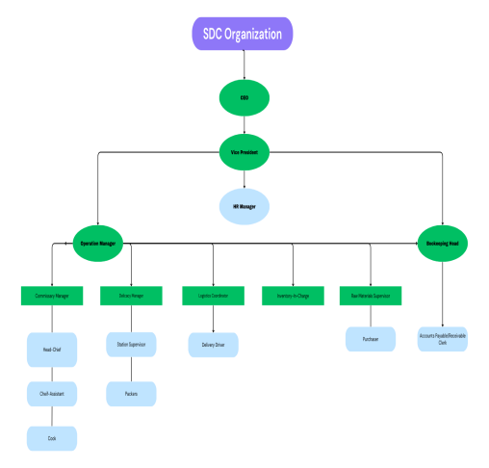

*Figure 1: SDC Organizational Chart*

**Environment**

The research will be undertaken at Sandria's Delicious Concept (SDC Organization), an established company based in Purok 7, Ward IV, Minglanilla, Cebu, which has been proudly running for more than 26 years. The company has diversified its services in the food sector, undertaking food production, stock management, and distribution services. They run various project and task daily. The organization's long-standing presence in the local market provides a rich context for studying operational efficiencies and potential areas for innovation. This established operational history offers a valuable dataset for analyzing long-term trends and identifying sustainable growth strategies.

**Sources of Data**

The following sources will be used to gather data for the study:

**Website**

The researchers will utilize online resources, such as articles, case studies, industry reports, and social media platforms to gather insights and best practices related to project management systems, catering operations, and food distribution.

**Sandria’s Delicious Concept**

The researchers will conduct interviews and observations with the company’s key personnel to understand their workflow, identify challenges, and gather feedback that will help in designing a system tailored to their needs.

**Published/Unpublished Materials**

The researchers will review previous thesis papers, journals, and other academic works that discuss similar systems, project management methodologies, and solutions in the food industry to support their study.

**Corporate Employees**

The researchers will perform benchmarking or interviews with professionals in the business and food industry to gain insights into project execution, operational challenges, and best practices.

**Saint Cecilia’s College – Cebu, Inc. Department Officers**

The researchers will conduct surveys and interviews with department officers within the university to collect additional data and gather diverse perspectives on project management and system implementation.

**System Users and Clients**

Feedback from end-users, such as SDC employees and clients, will be gathered to understand their expectations, usability concerns, and potential impact on their daily operations.

**On-Site Observations**

Direct observation of daily operations at Sandria’s Delicious Concept will be conducted to gather firsthand insights into workflow processes, bottlenecks, and areas for improvement.

**Tools and Technologies**

***“****Nexora: An Extensive Project Management System for Proficient Team Collaboration and Task Tracking and Monitoring*” is a built using a combination of reliable tools and technologies that ensure fully and secure platform for the user. The system integrates frontend, backend, database management, and development tools to serve its user a quality performance.

|  |  |
| --- | --- |
| Frontend | HTML (v5) - Structures web pages and content.  CSS (v3) - Enhances visual presentation and ensures responsive design.  JavaScript (vES6+) - Provides interactivity and dynamic behavior on web pages.  AJAX - Enables asynchronous data loading without refreshing the page.  jQuery (v3.7) - Simplifies DOM manipulation and event  handling. Font Awesome (v6) - Provides scalable vector icons for UI enhancement. |
| Backend | PHP (v8.2) - Handles server-side logic and dynamic content generation.  XAMPP (v8.2.0) - Provides a local server environment with Apache, MySQL, PHP, and Perl.  Composer (v2.5) - Manages PHP libraries and dependencies. |
| Database | MySQL (v8.0) - Manages structured data storage and retrieval. phpMyAdmin (v5.2) - Simplifies database  management and queries through a web interface. |
| Development Tools | VS Code (v1.80+) - Serves as the code editor with extensions for PHP, HTML, and CSS.  Git (v2.42) - Version control system to track changes and collaborate.  Composer (v2.5) - Manages PHP dependencies and packages. GitHub: Hosts project repositories for collaboration and backup.  Node.js (v20) - Supports task automation and package management. |
| Testing/Debugging | PHP Error Reporting: Identifies and resolves runtime errors.  Xdebug 3: Facilitates advanced debugging in PHP. Browser Developer Tools: Inspects page elements and fixes layout or scripting issues. |
| Security | HTTPS - Encrypts data transmission for security.  PHP Sessions and Cookies - Manages user authentication and session tracking.  Input Validation - Prevents SQL injection and cross-site scripting (XSS) attacks. |
| Data Interchange | JSON (JavaScript Object Notation) - Enables lightweight data exchange. |
| Session Management | PHP Sessions - Maintains user authentication and data persistence across pages.  Local Storage/Session Storage - Handles client-side data storage. |
| Compatibility | Cross-Browser Support - Ensures proper functionality across Chrome, Firefox, Edge, and Safari.  Cross-Platform Support - Operates seamlessly on Windows, macOS, and Linux. |
| Mobile Support | Responsive Design - Ensures accessibility across different screen sizes and mobile devices. |

Table 1: Tools and Technologies

*“Nexora: An Extensive Project Management System for Proficient Team Collaboration and Task Tracking and Monitoring”* employs a wide variety of tools and technologies to provide an effortless and consistent user experience. HTML5, CSS3, and JavaScript (ES6+) are used to create the frontend, which serves as the basis for structure, visual layout, and interactivity. Event handling is made easy with jQuery, and AJAX provides efficient data loading without reloading the page. In addition, Font Awesome beautifies the user interface with scalable vector icons, offering a clean and contemporary appearance on all devices.

On the server side, PHP 8.2 drives the server-side programming, processing data and generating content effectively. XAMPP is a local server environment, combining Apache, MySQL, and PHP to simplify development and testing. MySQL 8.0 is used to manage the database, providing safe storage and retrieval of data, and phpMyAdmin provides a friendly web interface for database operations and queries. Coding and version control are facilitated through  development tools like VS Code and Git, while Node.js provides support for automating tasks to  increase productivity across the entire project life cycle.

Security and performance are top of the list, with HTTPS providing data encryption in transit and PHP sessions handling user login. Other security features such as input validation protect against bugs such as SQL injection and XSS attacks. The system is cross-browser and cross-platform compliant for seamless operation on different operating systems and web browsers. Responsive design features ensure mobile device accessibility, with the system proving convenient and accessible for on-the-go project management.

**CHAPTER IV**

**METHODOLOGY**

In this chapter, the method by which we are solving the problem with Agile development Agile is a flexible, step by step approach that focuses feedback in the real world and delivers incremental improvements in the process. Agile means more of an ad-hoc approach where we also change things as we go, instead of planning everything upfront to ensure that the end product satisfies real needs of the users. It is not with software projects where requirements cannot be locked down, which is precisely why it fits us so nicely. This approach allows us to adapt to changes quickly and efficiently as new information becomes available. By using Agile we can make sure our solutions remain relevant and effective throughout the development process.

We do this by working very closely with our stakeholders (developers, testers and end users) over short increments called Sprints. A Sprint is a few weeks long and gives us stuff that works we can do Testing so the ideas can get implemented immediately so we can tweak things fast. We want this approach so that we do not get large surprises later and end up building both realistic and a bit more elegant down from the start. Each Sprint allows us to gather feedback and make adjustments before moving forward, which reduces risks and improves outcomes. This cycle of collaboration and review ensures we are always aligned with stakeholder expectations.

Most commonly the Scrum framework (Agile) will be utilized by us. In few’s it will be a daily standup meeting where the team (Product owner, scrum master and all your developers together) meet to look at the progress iterations and take out blockers. We will use Trello/ to manage tasks and also burn-down charts to make sure we haven't missed anything. These tools and practices allow us transparency so everyone knows where the project is at. Back-channel clarity and regular check-ins are the lifeblood of managing through shit.

Continuous testing meaning quality is part of the product from when the feature is implemented versus bolted on after development is done. Agile keeps us sprinting with speed-to-market and our customers get early valuable & actionable feedback. Finally, it derives from the effective and grounded product that will deliver the problem it was derived from. This loop continues with the testing and feedback creates an enhanced product to customer satisfaction. By embedding quality assurance seamlessly, we guarantee less defects delivered to user needs and solve problems.

**Software Methodology**

**Research Approach**

  Nexora, a project management system takes a quantitative research approach to systematically assess the effectiveness of current project management tools in aiding team collaboration and task tracking.  Through the application of techniques such as structured surveys and statistical analysis, the quantitative methodology enables researchers to measure levels of user satisfaction, identify common issues, and quantify the demand for additional features. By comparing quantifiable statistics and trends of user feedback, the Nexora team is able to identify targeted areas for improvement within the system and create custom solutions to help streamline team efficiency. This analytical inquiry is a natural fit for the research agenda of building an enhanced project management platform that provides real-world solutions to workflow inefficiencies.

Survey methodology is used because it is the best method in this research due to the central aim of gauging the performance of existing project management tools among professionals, students, and project teams. The study collects data using a researcher-designed questionnaire distributed to selected participants, including project managers, team members, and student leaders, to gather insights about tool usability, collaboration features, and tracking capabilities. The survey technique enables extensive data gathering and statistical analysis, yielding quantifiable evidence regarding system strengths and weaknesses as well as user preferences for future-generation project management solutions.

The study design, utilizing a quantitative method through survey technique, is effective in collecting actionable information regarding project management systems. With statistical analysis and data visualization, the researchers can easily detect trends, compare tool performance, and rank development features that will most effectively improve team collaboration and project management for various user groups.

|  |  |  |
| --- | --- | --- |
| **Input** | **Process** | **Output** |
| * Selection of Research Approach:   **Quantitative**   * Selection of Research Method:   **Purposive Sampling**   * Researcher-designed Questionnaire * Selected Participants (project managers, team leaders, IT professionals, and employees) | 1.    Data Collection:   * Distributing online/offline surveys * Utilizing Structured Questionnaire   2.    Data Analysis:   * Applying Statistical Analysis * Generating Data Visualizations   3.    Findings:   * Evaluating Tool Satisfaction Levels * Identifying System Limitations and User Needs | * Insights into Project Management Tool Effectiveness * Recommendations for Nexora System Development |

## System Development Methodology

  In this research, the development of the Nexora system was undertaken using the Agile Methodology, a dynamic and iterative approach to software development. Unlike the traditional waterfall model, Agile promotes a flexible and collaborative process. It comprises a series of iterative cycles known as sprints, where each sprint encompasses planning, analysis, design, development, testing, and implementation. This iterative nature allows for continuous refinement and adjustment based on ongoing feedback and changing requirements. Agile was chosen for this project because it fits the goal of Nexora: to support task assignment, real-time tracking, and user-centered collaboration.

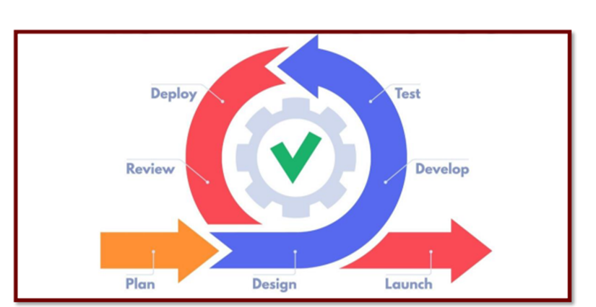

*Figure 2 – Agile Project Development Cycle*

  In this research, the development of Nexora, a web-based Project Management System (PMS), was undertaken using the Agile Methodology, a dynamic and iterative approach to software development. Unlike the traditional waterfall model, Agile encourages a more flexible and collaborative process. It is structured around iterative cycles called sprints, where each sprint involves stages such as planning, analysis, design, development, testing, and implementation. This process allows for ongoing adjustments based on user feedback and changing requirements, making it well-suited for Nexora's goal of real-time task tracking, team collaboration, and continuous improvement.

**Planning Phase**

|  |
| --- |
| **ACTIVITIES** |
| **1. Brainstorming and Idea Generation**  The group held several brainstorming sessions to come up with a system idea that would be impactful and useful. After evaluating multiple suggestions, the team agreed to develop a web-based Project Management System and name it “Nexora” that could support collaboration, task monitoring, and real-time progress tracking. |
| Significance:  This activity allowed the team to explore real challenges faced in project handling and identify a solution that could improve workflow and productivity. It also ensured that the system they would develop was realistic, feasible, and aligned with user needs. |
| **2. Initial Research and Feasibility Study**  To understand how project management tools work, the group explored various existing systems and reviewed related literature and case studies. This helped the team gather insights into best practices, common features, and user expectations. |
| Significance:  By analyzing existing platforms, the team was able to draw inspiration and determine what features were essential and which ones needed improvement. This provided a strong foundation to build a system that was not only functional but competitive. |
| **3. Setting Project Goals and Objectives**  The group clearly defined what Nexora should accomplish — such as real-time tracking, task assignment, user roles, and communication tools. These goals served as a blueprint for what the system must deliver by the end of development. |
| Significance:  Having specific goals gave the project direction and clarity, preventing confusion during the development process. It also helped align every decision the team made with the intended purpose of the system. |
| **4. Role Assignment and Task Distribution**  After meeting with the teams, Elmer Rapon was appointed as project manager and each member was assigned a specific role, such as frontend developer, backend developer, documenter, and designer. This allowed the team to work efficiently and focus on individual tasks while still contributing to the whole. |
| Significance:  Assigning roles early created a sense of ownership and accountability among team members. It also streamlined communication and minimized overlapping responsibilities during the development stages. |

*Table 2 – Planning Phase Activities*

|  |
| --- |
| **DELIVERABLES** |
| ·  Defined project scope and objectives based on the needs of project managers, users, and other stakeholders  ·  Initial project plan outlining key features such as task assignment, progress tracking, and user role management  ·  Formal agreement to adopt the Nexora Project Management System as the group's capstone project  ·  Assignment of roles and responsibilities within the team, including frontend, backend, documentation, and design  ·  Initial documentation outlining the system’s purpose, goals, core modules, and expected user experience |

*Table 3 – Planning Phase Deliverables*

## Design Phase

  After gathering the necessary requirements, the team moves forward to create the initial drafts for the system's interface and structural designs.

|  |
| --- |
| **ACTIVITIES** |
| **1. Requirement Analysis and Design Planning**  The design team began by analyzing the requirements gathered during the initial phase. They mapped out the essential features and functionality of the web-based system, creating a roadmap for the design phase. |
| Significance:  This activity allowed the team to break down the requirements and establish a clear plan for the design, ensuring that the system would meet user needs and project objectives. |
| **2. Information Architecture Design**  The team focused on creating the system’s information architecture, which involved organizing and structuring the content, features, and navigation in a logical and user-friendly way. |
| Significance:  A well-structured information architecture ensures that users can easily navigate the system and find the content or features they need, which enhances overall user experience. |
| **3. UI Design and Layout Planning**  The design team worked on the user interface (UI) design, focusing on the layout, color schemes, typography, and other visual elements. They made design decisions that would ensure a clean, modern, and accessible user experience. |
| Significance:  Establishing the UI layout early helped the team visualize how users would interact with the system and how the information would be presented in a visually appealing way. |
| **4. Wireframing and Flow Mapping**  In this step, the team created basic wireframes, focusing on the layout of key pages such as the homepage, dashboard, and other main sections of the system. They also mapped the user flow to understand how users would move from one page or feature to another |
| Significance:  The wireframes and flow mapping helped visualize the flow of interactions across the web platform, ensuring a logical and intuitive user experience. |
| **5. Collaborative Design Review and Refinement**  The team held internal discussions to review the design drafts, focusing on aspects such as user experience, visual consistency, and ease of navigation. The design was refined through these discussions to address any gaps or improvements. |
| Significance:  Collaborative reviews ensured that the design was well-aligned with the project’s goals and that all team members contributed to refining the final concept. |

*Table 4 – Design Phase Activities*

|  |
| --- |
| **DELIVERABLES** |
| · Detailed design plan outlining the layout, features, and navigation flow of the system.  · Information architecture documentation showing the content structure and how users will interact with the system.  · UI design drafts illustrating the visual style, color schemes, typography, and general layout.  · Wireframe designs depicting key pages and layout structure for the system.  · Design review summary that includes feedback and refinements from collaborative design reviews. |

*Table 5 – Design Phase Deliverables*

**Development Phase**

|  |
| --- |
| **ACTIVITIES** |
| **1. Documentation Preparation**  The team started writing technical specifications, architecture and DB structure as well UI designs from scratch. |
| Significance:  It was a way for developers to keep their development aligned with project objectives. |
| **2. System Prototyping and Coding**  Development began with the creation of prototypes and coding of necessary features taking the final design and with it implemented into operational components. |
| Significance:  Prototyping allowed for early validation of ideas and an iterative process enabled iterations and small changes. |
| **3. Testing and Debugging**  We performed rigorous testing — unit and integration tests combined to find and squash bugs. |
| Significance:  Maintained system stability & reliability, deflated risks before deployment, improved user experience. |
| **4. Iterative Development and Feature Enhancement**  System development was done iteratively, incorporating feedback and improving functionality over the time. Issues were prioritized features according to user feedback, project requirements. |
| Significance:  It was a fluid process to save the system operable and ready with whatever changing stakeholder requirement between states. |

*Table 7 – Development Phase Activities*

|  |
| --- |
| **DELIVERABLES** |
| • System prototypes: working examples of key features.  • Complete back and frontend codebase.  • Extensive test reports and regressions.  • User and stakeholder input will drive a series of incremental feature enhancements. |

*Table 7 – Development Phase Deliverables*

**Project Management**

*Insert Paragraph Here – Brief Context or Information about your project management strategies or usage in this section*

**Gantt Chart**

*Use Jira Charts / Screenshots*

**Project Cost Estimate**

|  |  |  |  |  |  |
| --- | --- | --- | --- | --- | --- |
| **SOFTWARE COST** | | | | | |
| **Item** | **Quantity** | **Description** | **Cost per Month** | **Number of Month** | **Total Cost** |
| Visual Studio Code | 1 | Oper cource based | ₱0.00 | 0 | ₱0.00 |
| XAMMP | 1 | Database | ₱0.00 | 0 | ₱0.00 |
| GitHub | 1 | Open source alternatives available | ₱0.00 | 0 | ₱0.00 |
| Canva | 1 | Free graphic design tool with optional premium features | ₱753.42 | 12 | ₱6,959.42 |
| Copilot | 1 | Open source with paid plans per month | ₱580.00 | 12 | ₱5,800.00 |
| Trello | 1 | Limited features with subcription per month | ₱348.00 | 12 | ₱3,480.00 |
|  |  |  |  |  |  |
| **OVERALL TOTAL** |  |  |  |  | **₱16,239.42** |
| **HARDWARE COST** | | | | | |
| **Item** | **Quantity** | **Description** | **Cost per Month** | **Number of Month** | **Total Cost** |
| Laptop | 1 | Device Name: LAPTOP-GSG16Q6G Processor: Intel(R) Core(TM) i3-10110U CPU @ 2.10GHz 2.59 GHz Installed RAM: 8.00 GB (7.84 GB usable) Storage: 238 GB SSD SAMSUNG MZVLQ256HAJD-00000 Graphics Card: Intel(R) UHD Graphics (128 MB) | ₱25,000.00 | 1 | ₱25,000.00 |
| Personal Computer | 1 |  |  | 1 |  |
| Components: |  |  |  |  |  |
| Monitor |  | ASUS | ₱5,000.00 | 1 | ₱5,000.00 |
| Mouse |  | Arc Angle Mouse | ₱150.00 | 1 | ₱150.00 |
| Keyboard |  | Zues K004 | ₱250.00 | 1 | ₱250.00 |
| System Unit |  | DESKTOP - SIOEBIS RAM 4GB Processor AMD A6-640K APU Graphics 3.90 GHz | ₱10,000.00 | 1 | ₱10,000.00 |
| **OVERALL TOTAL** |  |  |  |  | **₱30,400.00** |
|  |  |  |  |  |  |
|  |  |  |  |  |  |
| **OTHER COST** | | | | | |
| **Item** | **Quantity** | **Description** | **Cost per Month** | **Number of Month** | **Total Cost** |
| Electricity | 1 |  | ₱250.00 | 12 | ₱3,000.00 |
| Internet | 1 |  | ₱400.00 | 12 | ₱4,800.00 |
| Load | 1 |  | ₱500.00 | 12 | ₱6,000.00 |
| **OVERALL TOTAL** |  |  |  |  | **₱7,800.00** |

|  |  |  |  |
| --- | --- | --- | --- |
| Cost | Total Amount | COC | Total |
| Software Cost | ₱16,239.42 | 30% | ₱4,871.83 |
| Hardware Cost | ₱30,400.00 | 30% | ₱9,120.00 |
| Other Cost | ₱7,800.00 | 30% | ₱2,340.00 |
| **Total:** | **₱54,439.42** |  | **₱16,331.83** |
|  |  |  |  |
| **Future Value:** | **₱38,107.59** |  |  |

|  |  |  |  |  |
| --- | --- | --- | --- | --- |
| **Year** | **FV** | **(1+i)n** | **PV** | **Accumulated Value** |
| 1 | ₱38,107.59 | 1.11 | ₱34,331.16 | ₱34,331.16 |
| 2 | ₱38,107.59 | 1.21 | ₱31,493.88 | ₱65,825.04 |
| 3 | ₱38,107.59 | 1.31 | ₱29,089.76 | ₱94,914.80 |

**Cost and Benefit Analysis**

**Requirements Analysis and Documentation**

The following section outlines the functional and non-functional requirements for the Nexora Project Management System (PMS). The system is designed to help teams plan, track, and manage projects efficiently. The requirements are categorized based on different user roles (actors) and system behaviors to ensure clarity and alignment.

**Functional Requirements**

### Owner's Side:

* Owners can create accounts.
* Owners can log in to their account.
* Owners can manage the facility dashboard.
* Owners can invite new members.
* Owners can promote/demote members.
* Owners can manage all project/task.
* Owners can manage task.
* Owners can remove member.
* Owners can collaborate via messages/comments.
* Owners can track progress.
* Owners can monitor deadlines.
* Owners can receive notifications.
* Owners can receive reminders.
* Owners can track project progress.

Co-Manager’s Side:

* Co-Managers can create accounts.
* Co-Managers can log in to their accounts.
* Co-Managers can manage tasks.
* Co-Managers can track projects.
* Co-Managers can monitor deadlines.
* Co-Managers can receive notifications.
* Co-Managers can receive reminders.
* Co-Managers can track project progress.

### Member’s Side:

* Members can create an account.
* Members can log in to their accounts.
* Members can view assigned tasks.
* Members can update task status.
* Members can search/filter task.
* Members can collaborate via messages/comments.
* Members can track progress.
* Members can monitor deadlines.
* Members can receive notifications.
* Members can receive reminders.
* Members can track project progress.

### System’s Side:

* The system receives notifications.
* The system receives reminders.
* The system tracks project progress.

**Non-functional Requirements**

Performance

* The system supports OS: Windows XP, Windows Vista.
* The system should handle at least 100 concurrent users without performance degradation.
* The response time for user actions should not exceed 2 seconds under normal load conditions.

Security

* User data must be encrypted during transmission using HTTPS.
* Access controls should be implemented to ensure data privacy and prevent unauthorized actions.

Usability

* Browser compatibility must include Chrome, Firefox, Edge, and Safari.
* The interface must adapt seamlessly to different screen sizes for mobile responsiveness.

Reliability

* System uptime should be maintained at 99.9% availability.
* Backup and recovery procedures must ensure no data loss greater than 1 hour in the event of failure.

Scalability

* The architecture should support scaling up to accommodate future growth in user base and data volume.
* Database and server configurations should be optimized for horizontal and vertical scalability as needed.

**Design of Software, System Product Processes**

The design of the Nexora Project Management System is to design an effective, collaborative, and user-centric solution for teams. It includes the integration of task management modules, real-time progress tracking features, and automated notification systems to enhance project workflows. The system is built using a modular architecture with clear separation between the user interface, business logic, and data layers. Key design elements include Agile-based sprint planning facilities, role-based access control, and comprehensive dashboards for tracking project metrics. The design is based on ensuring flexibility, performance under load, and secure data handling, enabling smooth team collaboration and adaptive project planning in dynamic work environments.

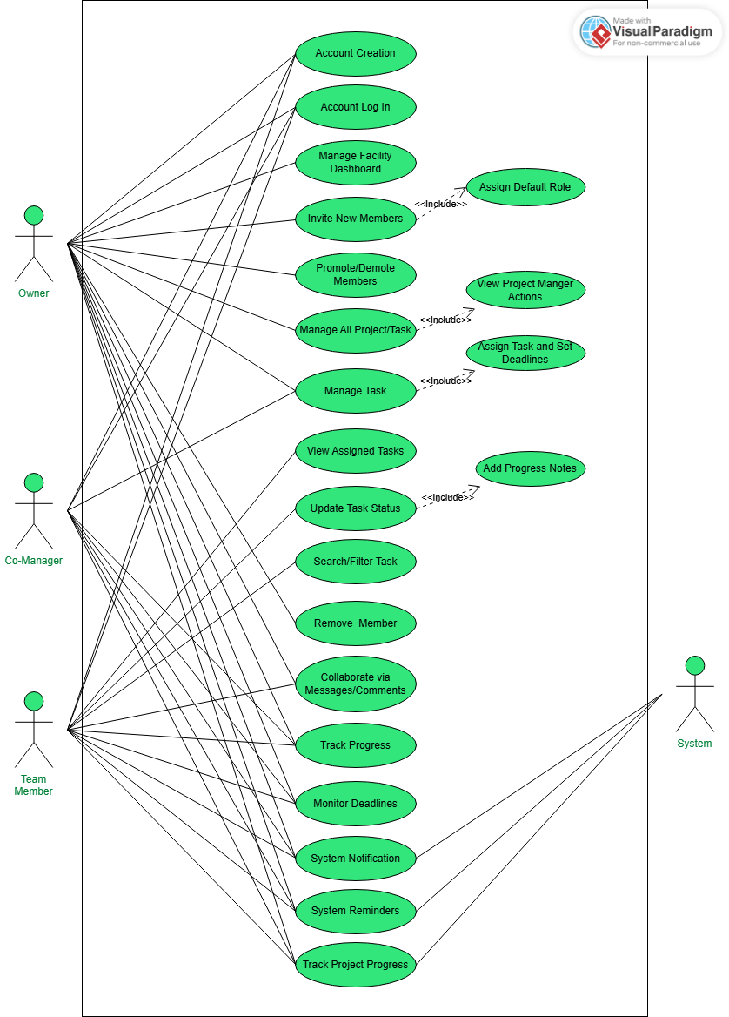**Use-Case Model**

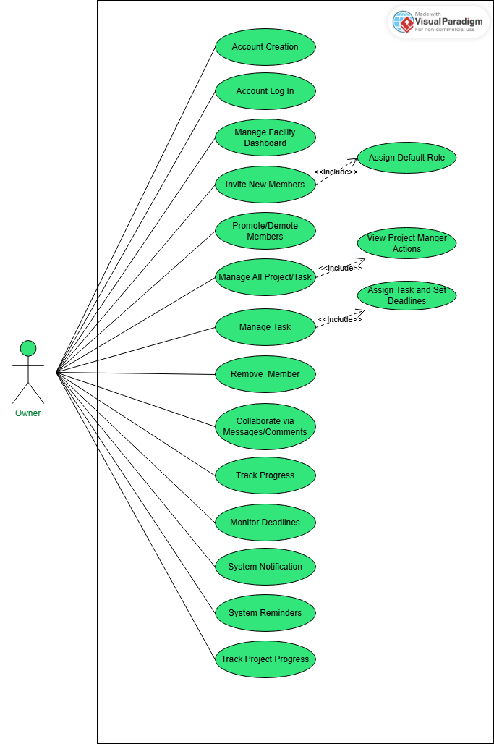

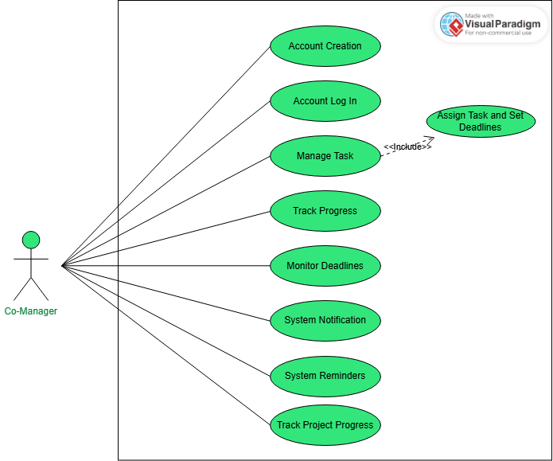

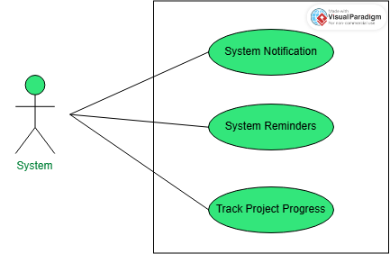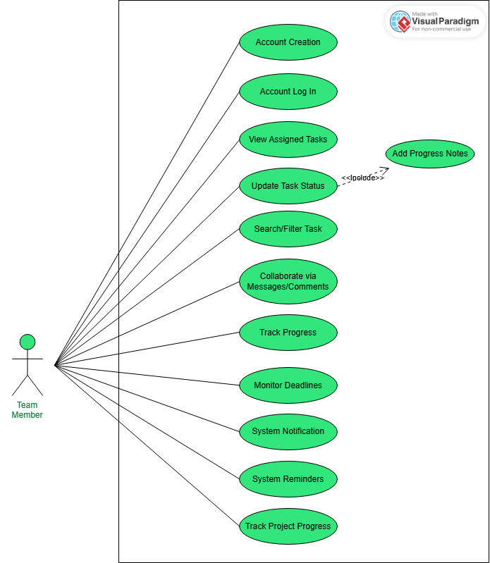

**Use-Case Narrative**

**Entity Relationship Model**

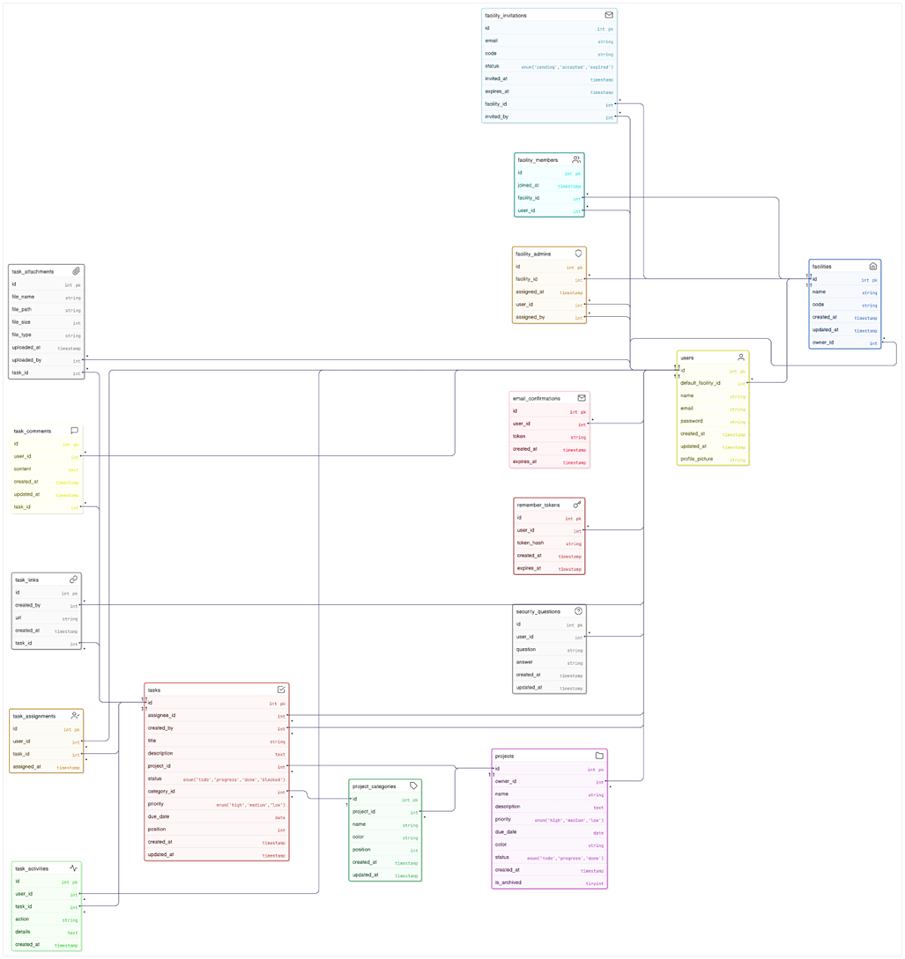

**Data Dictionary**

**Email Confirmations**

|  |  |  |  |  |  |
| --- | --- | --- | --- | --- | --- |
| **Field Name** | **Data Type** | **Data Format** | **Field Size** | **Description** | **Example** |
| id | INT | NNNN | 11 | Auto-incrementing unique ID | 1 |
| user_id | INT | NNNN | 11 | References users.id | 40 |
| token | VARCHAR | XXXXXXXXXXXXXXXX | 64 | Random confirmation token | “a1b2c3d4…” |
| created_at | TIMESTAMP | YYYY-MM-DD HH:MM:SS | 19 | Record creation time | 2025-05-18 03:00:00 |
| expires_at | TIMESTAMP | YYYY-MM-DD HH:MM:SS | 19 | Token expiration time | 2025-05-18 03:05:00 |

**Facilities**

|  |  |  |  |  |  |
| --- | --- | --- | --- | --- | --- |
| **Field Name** | **Data Type** | **Data Format** | **Field Size** | **Description** | **Example** |
| id | INT | NNNN | 11 | Auto-incrementing unique ID | 27 |
| name | VARCHAR | Text | 255 | Facility name | “Calista Herman’s Facility” |
| code | VARCHAR | XXXXXXXXXXXX | 12 | Unique facility code | “KJ9KEG5K” |
| owner_id | INT | NNNN | 11 | References users.id | 40 |
| created_at | TIMESTAMP | YYYY-MM-DD HH:MM:SS | 19 | Record creation time | 2025-04-25-03:00:23 |
| updated_at | TIMESTAMP | YYYY-MM-DD HH:MM:SS | 19 | Last update time | 2025-04-25-03:00:23 |

**Facility Admins**

|  |  |  |  |  |  |
| --- | --- | --- | --- | --- | --- |
| **Field Name** | **Data Type** | **Data Format** | **Field Size** | **Description** | **Example** |
| id | INT | NNNN | 11 | Auto-incrementing unique ID | 1340 |
| facility_id | INT | NNNN | 11 | References facilities.id | 27 |
| user_id | INT | NNNN | 11 | References users.id | 40 |
| assigned_by | INT | NNNN | 11 | References users.id | 40 |
| assigned_at | TIMESTAMP | YYYY-MM-DD HH:MM:SS | 19 | Assignment time | 2025-04-25 03:00:23 |

**Facility Invitations**

|  |  |  |  |  |  |
| --- | --- | --- | --- | --- | --- |
| **Field Name** | **Data Type** | **Data Format** | **Field Size** | **Description** | **Examples** |
| id | INT | NNNN | 11 | Auto-incrementing unique ID | 1 |
| facility_id | INT | NNNN | 11 | References facilities.id | 27 |
| email | VARCHAR | Email format | 255 | Invited email address | “user@example.com” |
| code | VARCHAR | XXXXXXXXXXXX | 12 | Invitation code | “ABC123” |
| status | ENUM | 'pending','accepted','expired' | - | Invitation status | “pending” |
| invited_by | INT | NNNN | 11 | References users.id | 40 |
| invited_at | TIMESTAMP | YYYY-MM-DD HH:MM:SS | 19 | Invitation time | 2025-04-25 03:00:00 |
| expires_at | TIMESTAMP | YYYY-MM-DD HH:MM:SS | 19 | Expiration time | 2025-04-25 03:00:00 |

**Facility Members**

|  |  |  |  |  |  |
| --- | --- | --- | --- | --- | --- |
| **Field Name** | **Data Type** | **Data Format** | **Field Size** | **Description** | **Example** |
| id | INT | NNNN | 11 | Auto-incrementing unique ID | 13 |
| facility_id | INT | NNNN | 11 | References facilities.id | 27 |
| user_id | INT | NNNN | 11 | References users.id | 40 |
| joined_at | TIMESTAMP | YYYY-MM-DD HH:MM:SS | 19 | Join time | 2025-04-25 03:00:23 |

**Projects**

|  |  |  |  |  |  |
| --- | --- | --- | --- | --- | --- |
| **Field Name** | **Data Type** | **Data Format** | **Field Size** | **Description** | **Example** |
| id | INT | NNNN | 11 | Auto-incrementing unique ID | 176 |
| name | VARCHAR | Text | 255 | Project name | “Hope Oconnor” |
| description | TEXT | Plain text | 65,535 chars | Project description | “Pariatur Ducimus d” |
| priority | ENUM | 'high','medium','low' | - | Priority level | “low” |
| due_date | DATE | YYYY-MM-DD | 10 | Project due date | 2025-05-10 |
| color | VARCHAR | #RRGGBB | 7 | Hex color code | “#167f6a” |
| status | ENUM | 'todo','progress','done' | - | Project status | “todo” |
| owner_id | INT | NNNN | 11 | References users.id | 44 |
| created_at | TIMESTAMP | YYYY-MM-DD HH:MM:SS | 19 | Creation time | 2025-04-27 19:06:12 |
| is_archived | TINYINT | 0/1 | 1 | Archived flag | 0 |

**Project Categories**

|  |  |  |  |  |  |
| --- | --- | --- | --- | --- | --- |
| **Field Name** | **Data Type** | **Data Format** | **Field Size** | **Description** | **Example** |
| id | INT | NNNN | 11 | Auto-incrementing unique ID | 90 |
| project_id | INT | NNNN | 11 | References projects.id | 224 |
| name | VARCHAR | Text | 255 | Category name | “CAT1” |
| color | VARCHAR | #RRGGBB | 7 | Hex color code | “#3b82f6” |
| position | INT | NN | 11 | Display order | 1 |
| created_at | TIMESTAMP | YYYY-MM-DD HH:MM:SS | 19 | Creation time | 2025-05-11 16:06:50 |
| updated_at | TIMESTAMP | YYYY-MM-DD HH:MM:SS | 19 | Update time | 2025-05-11 16:08:02 |

**Remember Tokens**

|  |  |  |  |  |  |
| --- | --- | --- | --- | --- | --- |
| **Field Name** | **Data Type** | **Data Format** | **Field Size** | **Description** | **Example** |
| id | INT | NNNN | 11 | Auto-incrementing unique ID | 1 |
| user_id | INT | NNNN | 11 | References users.id | 40 |
| token_hash | VARCHAR | XXXXXXXXXXXXXXXX | 64 | Hashed token | “a1b2c3d4” |
| created_at | TIMESTAMP | YYYY-MM-DD HH:MM:SS | 19 | Creation time | 2025-05-18 03:00:00 |
| expires_at | TIMESTAMP | YYYY-MM-DD HH:MM:SS | 19 | Expiration time | 2025-06-17 03:00:00 |

**Security Questions**

|  |  |  |  |  |  |
| --- | --- | --- | --- | --- | --- |
| **Field Name** | **Data Type** | **Data Format** | **Field Size** | **Description** | **Example** |
| id | INT | NNNN | 11 | Auto-incrementing unique ID | 21 |
| user_id | INT | NNNN | 11 | References users.id | 42 |
| question | VARCHAR | Text | 255 | Security question | “what city were you born in” |
| answer | VARCHAR | Hashed string | 255 | Hashed answer | “2y10$x517d…” |
| created_at | TIMESTAMP | YYYY-MM-DD HH:MM:SS | 19 | Creation time | 2025-05-01 17:14:55 |
| updated_at | TIMESTAMP | YYYY-MM-DD HH:MM:SS | 19 | Update time | 2025-05-01 17:14:55 |

**Tasks**

|  |  |  |  |  |  |
| --- | --- | --- | --- | --- | --- |
| **Field Name** | **Data Type** | **Data Format** | **Field Size** | **Description** | **Example** |
| id | INT | NNNN | 11 | Auto-incrementing unique ID | 96 |
| category_id | INT | NNNN | 11 | References project_categories.id | 93 |
| project_id | INT | NNNN | 11 | References projects.id | 224 |
| title | VARCHAR | Text | 255 | Task title | “TASK G” |
| description | TEXT | HTML text | 65,535 chars | Task description | “<p>fgxgfh<?p>” |
| status | ENUM | 'todo','progress','done','blocked' | - | Task status | “done” |
| priority | ENUM | 'high','medium','low' | - | Task priority | “high” |
| due_date | DATE | YYYY-MM-DD | 10 | Task due date | 2025-05-30 |
| assignee_id | INT | NNNN | 11 | References users.id (nullable) | NULL |
| position | INT | NN | 11 | Display order | 2 |
| created_by | INT | NNNN | 11 | References users.id | 42 |
| created_at | TIMESTAMP | YYYY-MM-DD HH:MM:SS | 19 | Creation time | 2025-05-11 16:06:53 |
| updated_at | TIMESTAMP | YYYY-MM-DD HH:MM:SS | 19 | Update time | 2025-05-17 15:48:530 |

**Task Activities**

|  |  |  |  |  |  |
| --- | --- | --- | --- | --- | --- |
| **Field Name** | **Data Type** | **Data Format** | **Field Size** | **Description** | **Example** |
| id | INT | NNNN | 11 | Auto-incrementing unique ID | 136 |
| task_id | INT | NNNN | 11 | References tasks.id | 98 |
| user_id | INT | NNNN | 11 | References users.id | 42 |
| action | VARCHAR | Text | 50 | Activity type | “priority_updated” |
| details | TEXT | JSON | 65,535 chars | Change details | “{“old_priority”:”medium”…}” |
| created_at | TIMESTAMP | YYYY-MM-DD HH:MM:SS | 19 | Activity time | 2025-05-12 07:30:545 |

**Task Assignments**

|  |  |  |  |  |  |
| --- | --- | --- | --- | --- | --- |
| **Field Name** | **Data Type** | **Data Format** | **Field Size** | **Description** | **Example** |
| id | INT | NNNN | 11 | Auto-incrementing unique ID | 5 |
| task_id | INT | NNNN | 11 | References tasks.id | 103 |
| user_id | INT | NNNN | 11 | References users.id | 40 |
| assigned_at | TIMESTAMP | YYYY-MM-DD HH:MM:SS | 19 | Assignment time | 2025-05-16 10:10:58 |

**Task Attachments**

|  |  |  |  |  |  |
| --- | --- | --- | --- | --- | --- |
| **Field Name** | **Data Type** | **Data Format** | **Field Size** | **Description** | **Example** |
| id | INT | NNNN | 11 | Auto-incrementing unique ID | 4 |
| task_id | INT | NNNN | 11 | References tasks.id | 103 |
| uploaded_by | INT | NNNN | 11 | References users.id | 42 |
| file_name | VARCHAR | Text | 255 | Original filename | “TEAM NEXORA.docx” |
| file_path | VARCHAR | File path | 255 | Storage path | “uploads/tasks/_6826f17fab44a.docx” |
| file_size | INT | Bytes | 11 | File size in bytes | 49302 |
| file_type | VARCHAR | MIME type | 100 | File content type | “application/vnd.openxmlformats…” |
| uploaded_at | TIMESTAMP | YYYY-MM-DD HH:MM:SS | 19 | Upload time | 2025-05-16 08:04:15 |

**Task Comments**

|  |  |  |  |  |  |
| --- | --- | --- | --- | --- | --- |
| **Field Name** | **Data Type** | **Data Format** | **Field Size** | **Description** | **Example** |
| id | INT | NNNN | 11 | Auto-incrementing unique ID | 42 |
| task_id | INT | NNNN | 11 | References tasks.id | 99 |
| user_id | INT | NNNN | 11 | References users.id | 42 |
| content | TEXT | Plain text | 65,535 chars | Comment text | “aerer” |
| created_at | TIMESTAMP | YYYY-MM-DD HH:MM:SS | 19 | Creation time | 2025-05-12 08:45:03 |
| updated_at | TIMESTAMP | YYYY-MM-DD HH:MM:SS | 19 | Update time | 2025-05-12 08:45:03 |

**Task Links**

|  |  |  |  |  |  |
| --- | --- | --- | --- | --- | --- |
| **Field Name** | **Data Type** | **Data Format** | **Field Size** | **Description** | **Example** |
| id | INT | NNNN | 11 | Auto-incrementing unique ID | 7 |
| task_id | INT | NNNN | 11 | References tasks.id | 100 |
| url | VARCHAR | URL | 255 | Link URL | “http://localhost/nexora/view/facility.php” |
| created_by | INT | NNNN | 11 | References users.id | 42 |
| created_at | TIMESTAMP | YYYY-MM-DD HH:MM:SS | 19 | Creation time | 2025-05-12 09:58:31 |

**Users**

|  |  |  |  |  |  |  |
| --- | --- | --- | --- | --- | --- | --- |
| **Field Name** | **Data Type** |  | **Data Format** | **Field Size** | **Description** | **Example** |
| id | INT |  | NNNN | 11 | Auto-incrementing unique ID | 40 |
| name | VARCHAR |  | Text | 50 | User's full name | “Calista Herman” |
| email | VARCHAR |  | Email format | 100 | User's email address | “fino@mailinator.com” |
| password | VARCHAR |  | Hashed string | 255 | Password hash | “2y10$z.z/Bj…” |
| created_at | TIMESTAMP |  | YYYY-MM-DD HH:MM:SS | 19 | Creation time | 2025-04-25 03:00:23 |
| updated_at | TIMESTAMP |  | YYYY-MM-DD HH:MM:SS | 19 | Update time | 2025-04-25 03:00:44 |
| profile_picture | VARCHAR |  | File path | 255 | Image path |  |
| default_facility_id | INT |  | NNNN | 11 | References facilities.id |  |

**Development and Testing Procedure Plan**

Developing a testing and procedure plan for a project management system begins with defining clear objectives and scope. In the first stage, the stakeholders should be engaged in identifying the essential functions of the system, which include the following primary features, tracking the tasks, allocating resources, and reporting. In addition, a risk assessment is completed to determine testing priorities for the high-risk modules, ensuring that they align with all customer needs and compliance standards. Methodologies such as Agile are outlined in the plan. Timelines are then established along with attributable roles for the developers, QA teams, and end users to facilitate responsibility and end-to-end execution.

The next stage looks into designing in depth test cases along with detailed scenarios based on actual usage. Where the edge situations such as redundancy of data or concurrent user entering are considered, these user stories are converted into test scripts with which the workflows of the application are validated. Automated test frameworks are used in repetitive work, yet manual testing concentrates on exploratory testing and usability testing. Penetration tests and role-based access verification do security testing, which ensures integrity of data and resilience of the system. It also formalized procedures for logging, prioritizing, and resolving a defect, while also specifying contingency plans for rollback or downtime of systems during deployment.  
  
 The final testing plan which would execute on all trial runs again is analyzing the outcomes and creates improvements very iteratively. Continuous integration pipelines conduct automated testing on every code commit to detect issues very early in stage development. The last stage of UAT is collecting the information from stakeholders to certify that the business need is met before the system is released after testing, there is a review meeting in which all lessons learned will be documented, thus optimizing future cycles of testing. The approved procedure plan will thus be archived to serve as a reference for changes, ensuring scalability and adaptability along with the evolution of the project management system.

**Implementation Strategies Narrative**

  To ensure a smooth and effective transition from development to operational use, the Nexora Project Management System will follow these five core implementation strategies:

|  |
| --- |
| **Implementation Strategies** |
| **1. Pilot Testing and Phased Deployment**  The system will first be introduced to a small group of users such as selected faculty or department heads for pilot testing. This controlled rollout will allow the team to identify and resolve potential issues before full implementation. The phased approach ensures minimal disruption while validating performance in real-world conditions. |
| **2. User Training and Support Materials**  Comprehensive user training will be conducted through workshops, video tutorials, and a detailed user manual. These resources aim to familiarize users with core features like task tracking, notifications, and project monitoring. Ongoing support will be available via helpdesk channels and built-in guidance features. |
| **3. Data Integration and System Configuration**  To support real use, the system will be configured to reflect actual organizational workflows. This includes setting up user roles, importing relevant project data, and ensuring compatibility with existing platforms (e.g., institutional calendars or communication tools). Configuration ensures Nexora fits seamlessly into daily operations. |
| **4. Continuous Monitoring and Feedback Collection**  After deployment, the implementation team will monitor system performance, user behavior, and feedback. Regular surveys and support logs will help identify usability issues or needed enhancements. These insights will guide iterative updates and continuous improvement of the platform. |
| **5. Scalability Planning and Post-Implementation Review**  Nexora is built with scalability in mind, allowing it to grow with user needs. Three months post-deployment, a formal review will evaluate system adoption, effectiveness, and areas for enhancement. This ensures the system remains adaptable and aligned with organizational goals over time. |

**BIBLIOGRAPHY**

Project Management Institute. (n.d.). What is project management? Project Management Institute.Retrieved March 21, 2025, from

<https://www.pmi.org/about/whatis-projectmanagement>

Atlassian. (n.d.). Project management: Definition, processes, and best practices. Atlassian. Retrieved March 21, 2025, from <https://www.atlassian.com/workmanagement/project-management>

Indeed Editorial Team. (2025, March 3). 12 project management challenges and how to solve them. Indeed. Retrieved March 21, 2025, from

<https://www.indeed.com/careeradvice/career-development/challenges-in-project>

Tawfik, D. (2024, September 4). 12 project management challenges and how

to overcome them. monday.com. Retrieved March 21, 2025, from

[https://monday.com/blog/project management/project-management-challenges/](https://monday.com/blog/project%20management/project-management-challenges/)

Project Management Institute. (2024, March 5). Future of project work: Moving past

office centric models. Project Management Institute. Retrieved March 21, 2025, from

<https://www.pmi.org/learning/thought-leadership/pulse/future-of-project-work>

Joubert, S. (2020). The Value of Communication in Project Management. Northeastern

University Retrieved from

<https://graduate.northeastern.edu/knowledgehub/communication-inprojectmanagement>=

Digital Collaboration in the workplace Cruz, A., & Angeles, J. (2019), Digital Solutions for

Collaborative Work in the Philippines

<https://www.studocu.com/ph/institution/ateneo-dezamboanga-university/7789>

Acosta, S. (2023). How to Ensure Efficient Resource Allocation in Project Management:

Best Practices. LinkedIn. Retrieved from

<https://www.linkedin.com/pulse/how-ensureefficient-resource-allocation-project-best-sam-acosta_>

Allison Hendricks (2023). Stakeholders Collaboration: Benefits, Examples, and Tips https://simpl ystakeholders.com/stakeholder-collaboration/

SoniaRai – Effective Resource Allocation in Project Management

<https://gururo.com/effective-resource-allocation-in-project-management/>

Nadege Minois (20 March, 2023), The Importance of Communication in Project

Management |IPM

<https://instituteprojectmanagement.com/blog/the-crucial-role-ofcommunication-in-project-management/>