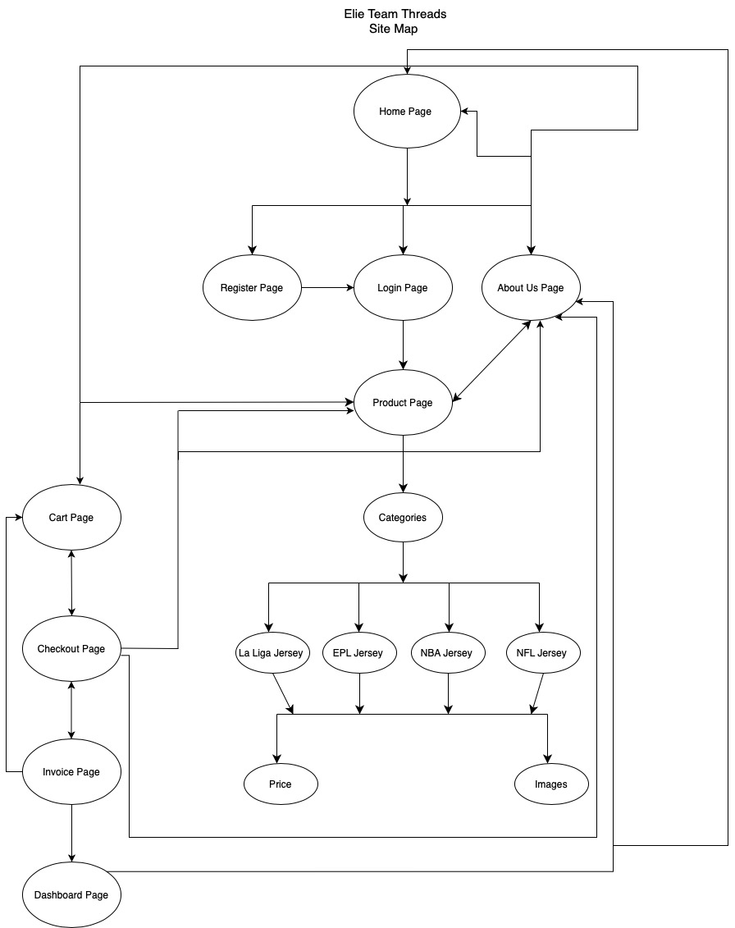

Wireframes

Home Page

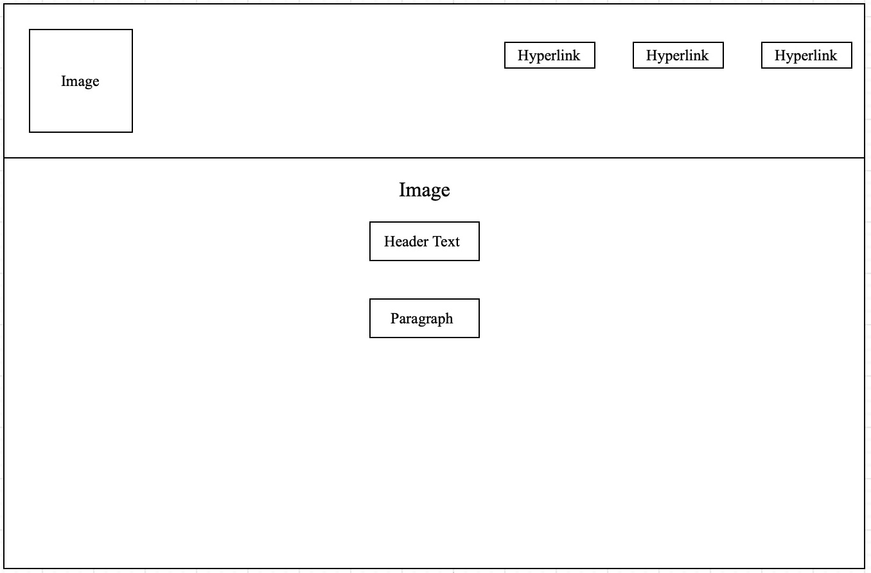

Login Page

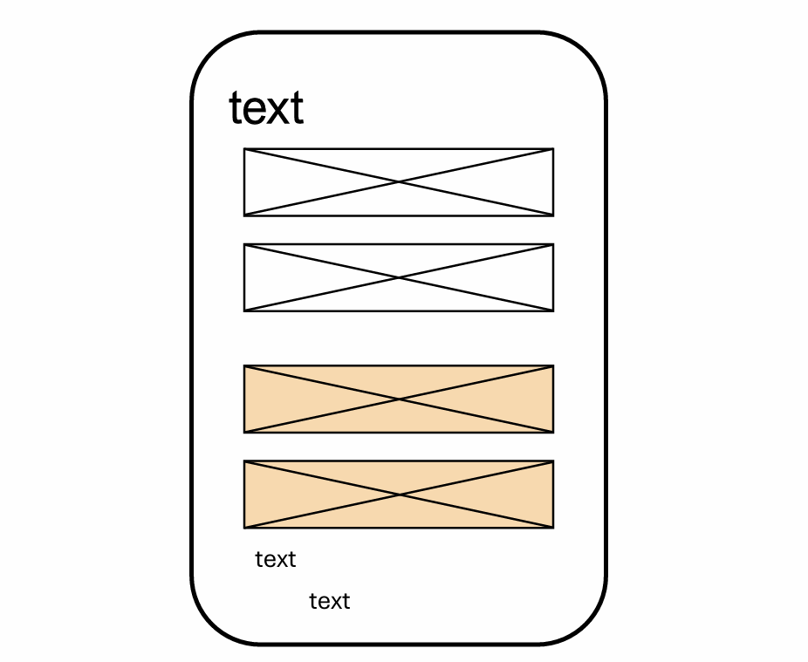

Registration Page

Product Page

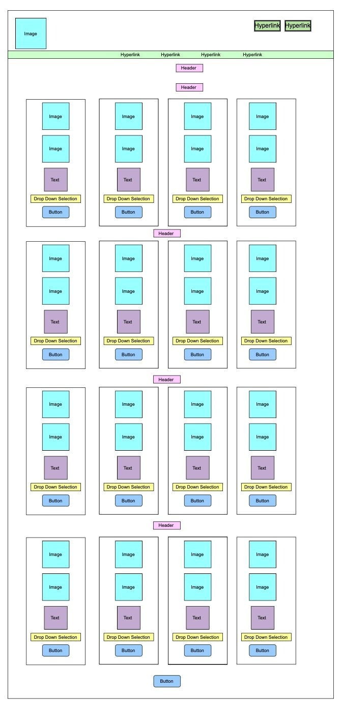

Cart Page

Checkout Page

Invoice Page

Check Out

Cart

Dashboard Page

About us Page

Hyperlink to website:

<https://lmg-ri.github.io/GRP_EWEBSITE/>