1) Set Breakpoints in Chrome Dev tools.

1. Right click and select “inspect element”
2. Click on the sources panel and select the file you are working with

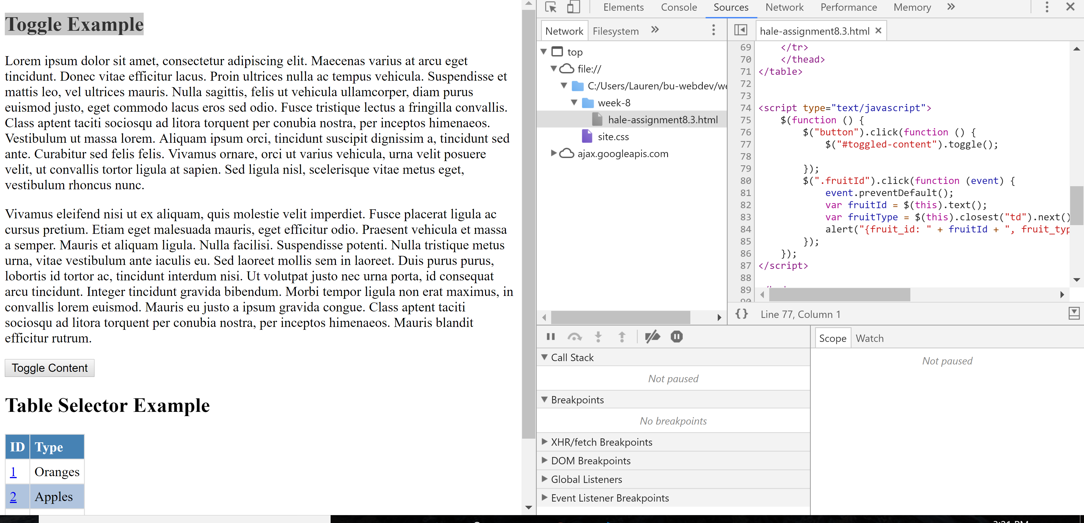

1. Find the line of code where you want to set a breakpoint
2. Click on the number to left (it should turn blue). The breakpoint will be visible on the bottom panel.

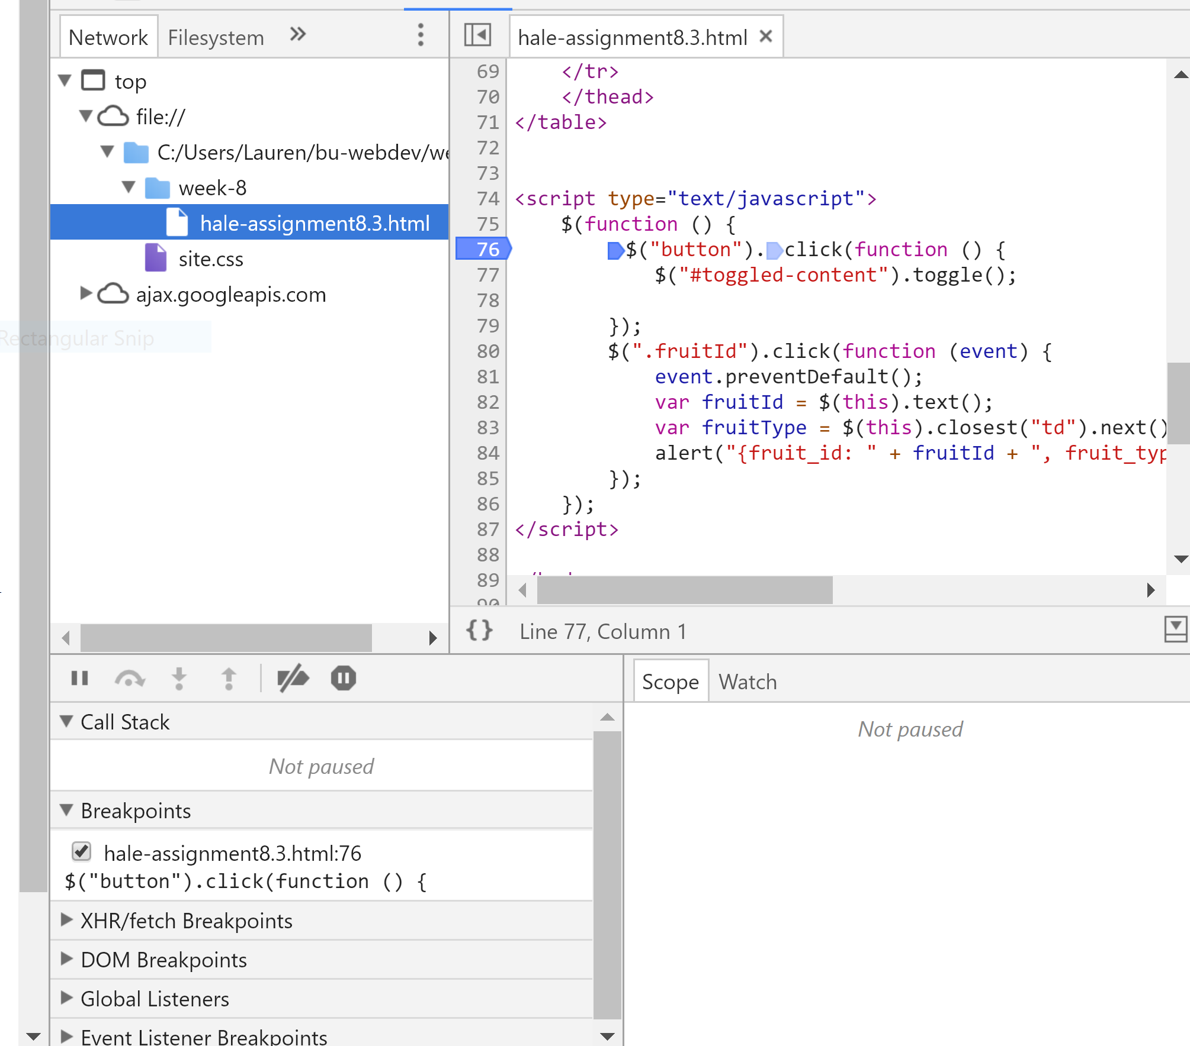

2) Use the console to log and read messages

1. Select the console panel after opening up the developer tools.
2. Type console.log(“hi”); to log hi to the console

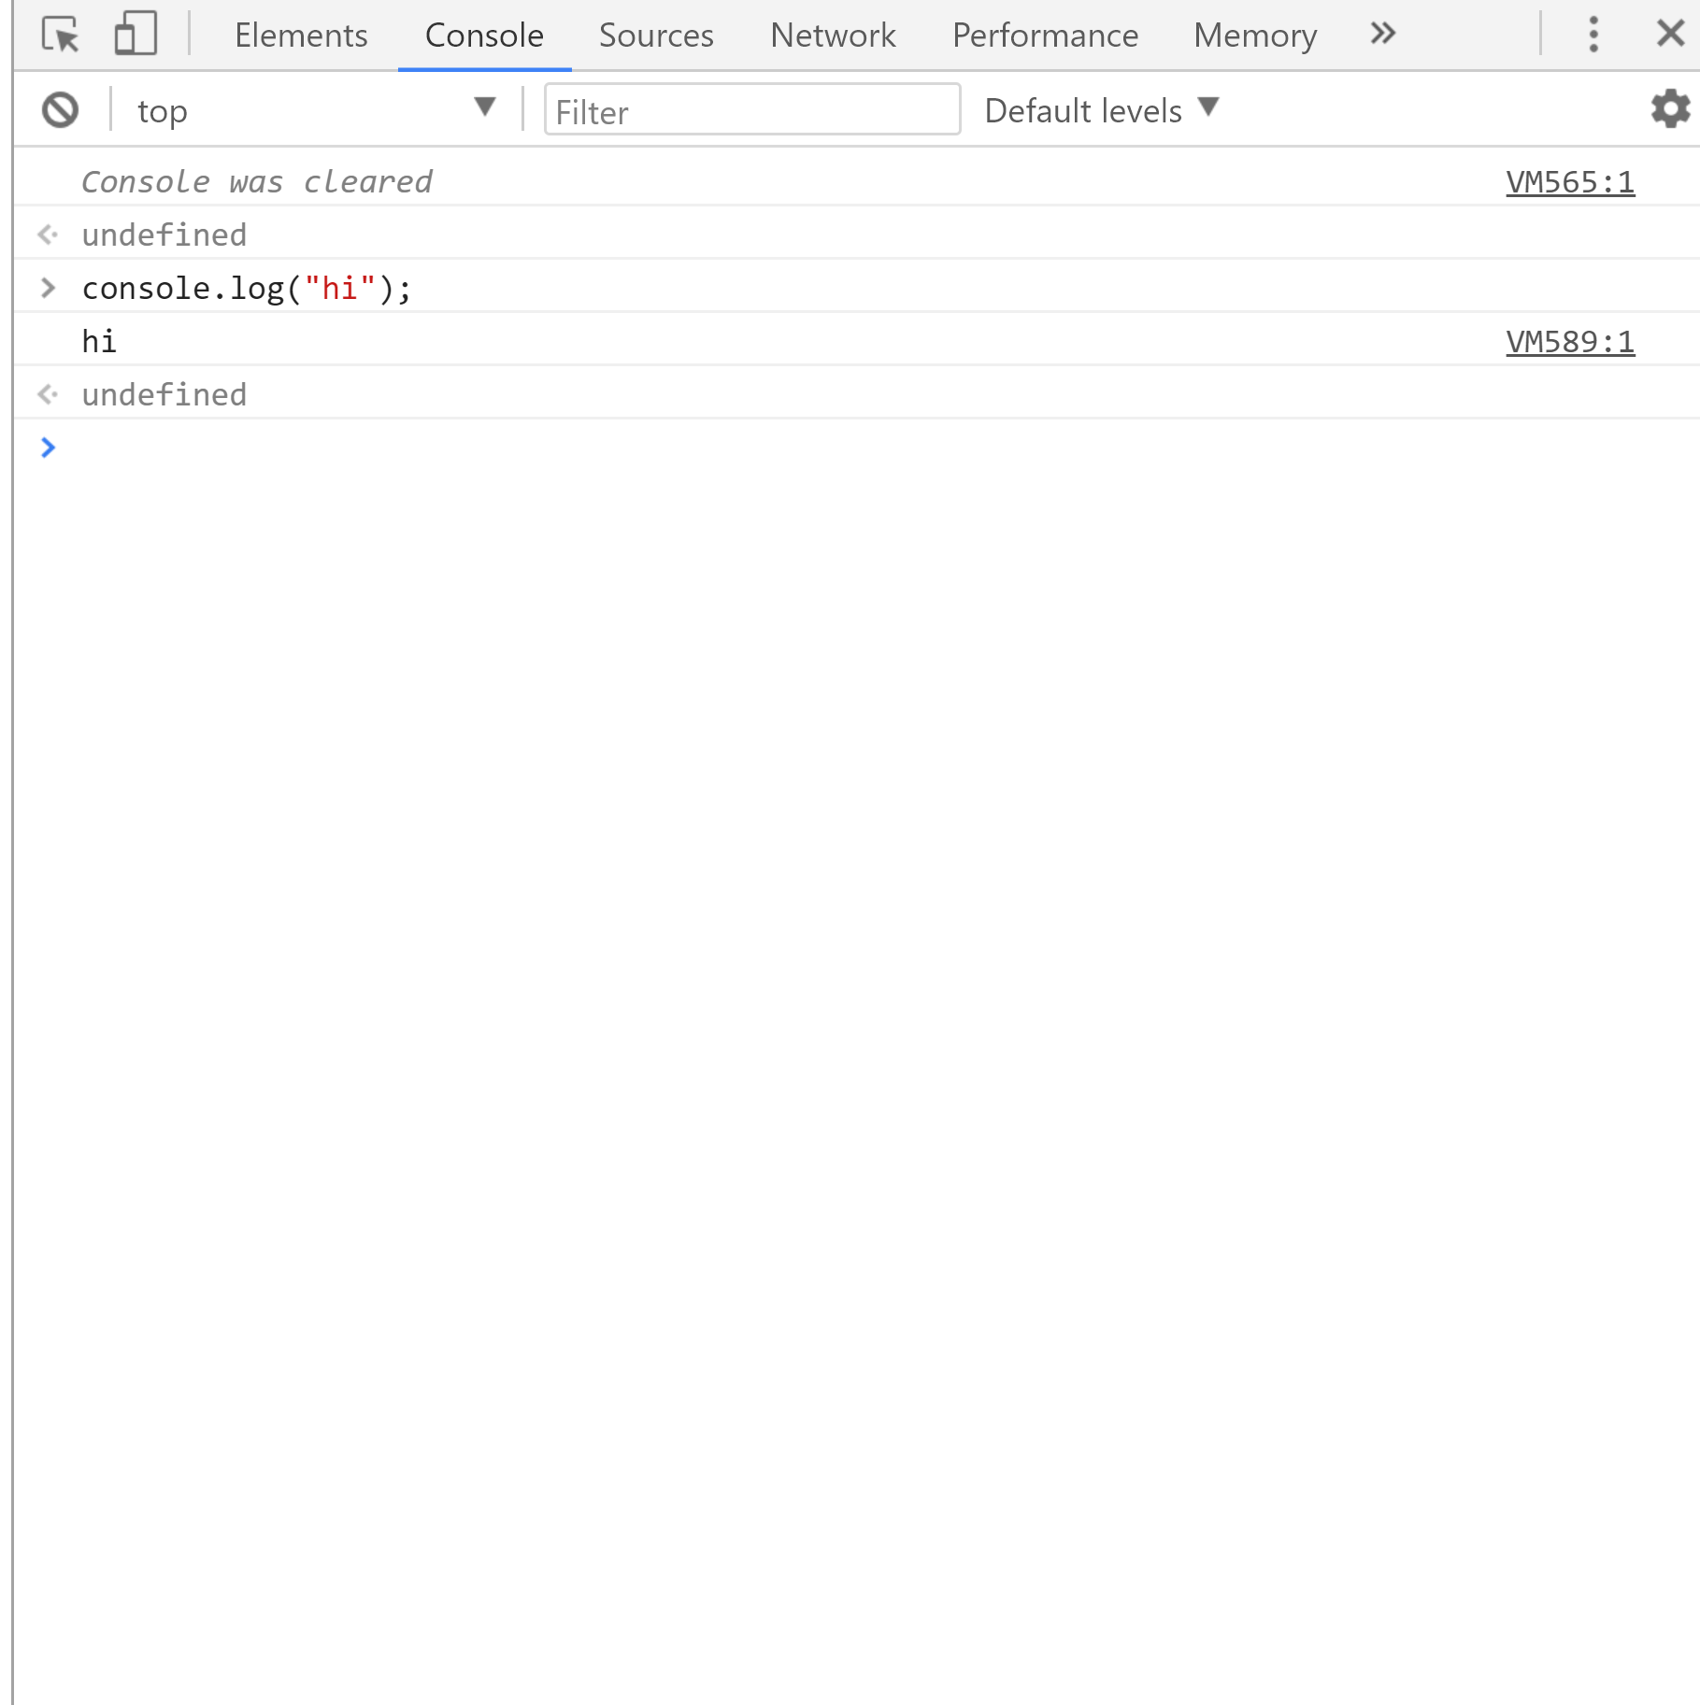

1. Type console.log(firstName); (an error message will appear “Uncaught ReferenceError: firstName is not defined at <anonymous>:1:13(anonymous) @ VM513:1”)

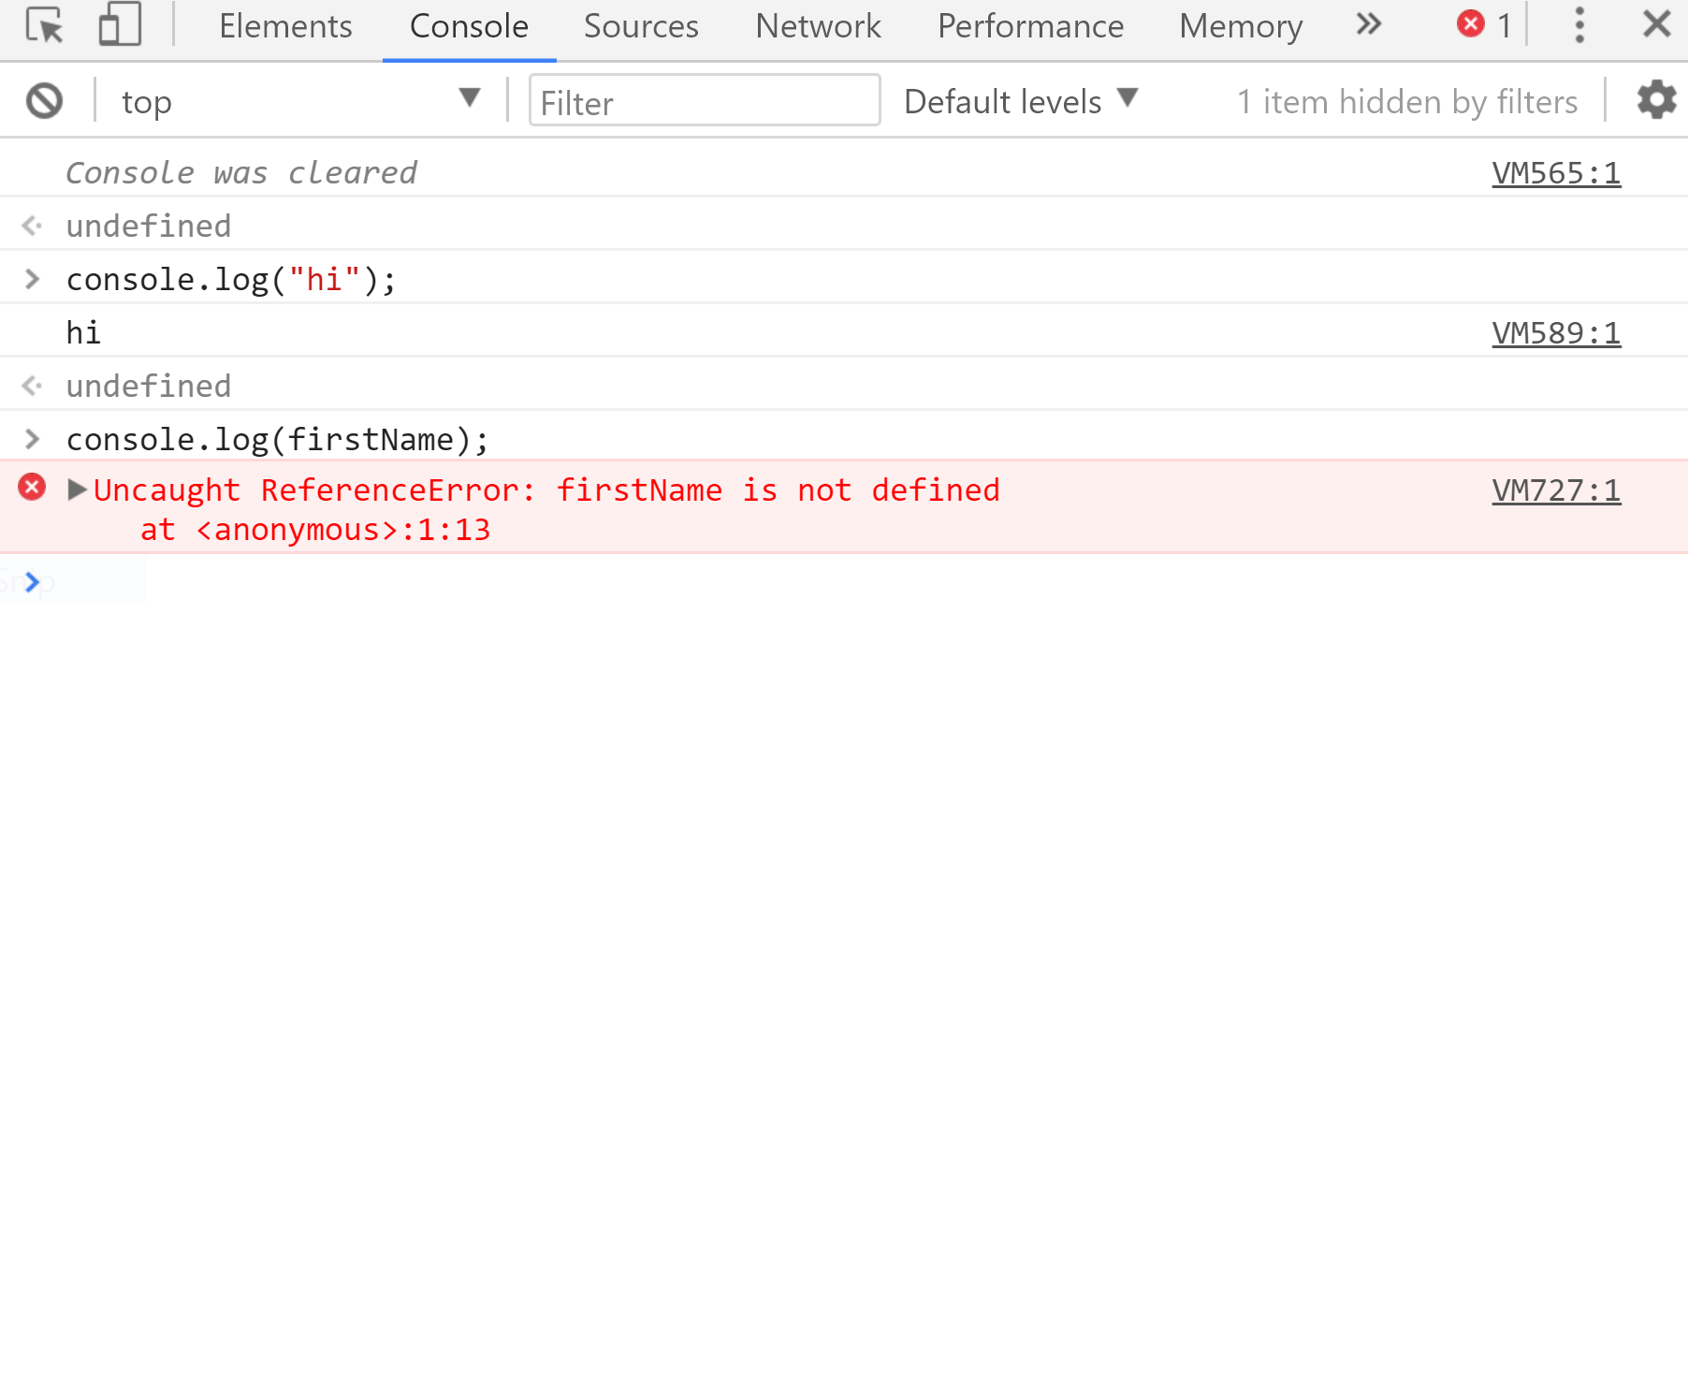

3) Select html elements in console window

A. Open up your developer tools and click on the console panel.

B. type in document.querySelector('h1'); which will selects an element by its tag name (in this case header 1);

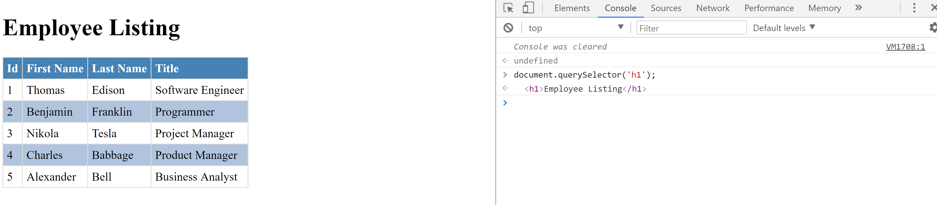

4) Simulate CSS states (hover, focus) on live HTML element

A. Open up developer tools

B. Open the Elements panel and click on Html element you want to simulate a css state for.

C. In the Styles pane click on “:hov’ located next to “filter.”

D. Click the checkbox for hover to simulate the hover state

