**Ewen Maddock Dam Upgrade – Draining down the risk (with siphons)**

**Anna Hams 1 Lindsay Millard 1**

**Elizabeth Jackson 1 Zara Bostock 2 Helena Sutherland1**

*1 Seqwater, Queensland*

*2 GHD, Queensland*

*The Queensland dam regulator requires that dam safety risk during construction must not increase from its existing profile. The Stage 2A upgrade of Ewen Maddock Dam required excavation of its homogeneous embankment to retrofit chimney and filter blankets, and also the construction of a concrete parapet wall. Due to the constraints of the embankment profile and a constricted site, it was necessary to excavate the downstream face of the embankment. This excavation increased the risk of embankment failure due to overtopping, piping and instability. This paper discusses the measures taken to manage those dam safety risks, and includes:*

* *use of a temporary system consisting of six large siphons to regulate the lake level to a Restricted Full Supply Level (Restricted FSL). This encompassed the optimisation of lake level and capacity of siphons required to balance competing risks; dam safety, environmental, community and water security. This optimisation was based on a probabilistic assessment of hydrological inflows and lake levels, the development of a flow management plan;*
* *implementation of a Dam Safety Management Plan which outlined the roles and responsibilities for managing dam safety during construction at each pre-determined lake level trigger levels. This includes how the contractor was involved to ensure quick response from the “eyes and ears on the ground”; and,*
* *development of recommended construction methodologies including a “rolling front” and placing filters vertically to increase production, maintain quality and limit the extent of embankment excavation underway.*

***Keywords:*** *dam safety upgrades, dam safety management plans, siphons, risk management, regulatory compliance,*

# Introduction

Ewen Maddock Dam is a homogeneous earthfill embankment dam 10.5 m high and 724 m long. The Dam is located approximately 12.0 km west of Caloundra, in the Sunshine Coast area of Southern Queensland. It is located approximately 3 km upstream of the Bruce Highway on Addlington Creek, which is a tributary to the Mooloolah River, refer **Figure 1**.  
The dam was constructed from 1973 to 1976 and in 1982 the ogee spillway was raised to the current elevation of 25.3 mAHD to nearly double its water storage capacity to its current capacity of 16 587 ML. In 2012, the Stage 1 upgrade was constructed along the left abutment of the embankment and consisted of pressure relief wells, partial height filter buttress and a weighting berm. This stage of works was to address the immediate concern over potential piping through the alluvial foundations.

Mooloolah River

Ewen Maddock Dam

Bruce Highway

Mooloolaba

Caloundra

Figure 1: Locality map of Ewen Maddock Dam on the Sunshine Coast, Queensland

In 2013, Seqwater commissioned a Portfolio Risk Assessment (PRA) for 26 referable dams which included Ewen Maddock Dam. The PRA concluded that Ewen Maddock Dam had an unacceptable risk profile with the F-N Curve for the dam plotting more than one order of magnitude above the Australia National Committee on Large Dams (ANCOLD) limit of tolerability. GHD was engaged by Seqwater in 2017 to develop concept options to upgrade the dam in order to reduce its risk profile to as low as reasonably practicable (ALARP) as defined by the ANCOLD guidelines. A number of upgrade options were developed and shortlisted with the preferred one being the Stage 2 upgrade works which consisted of:

* installation of an internal chimney filter to existing dam crest level and reinstatement of the outer earthfill zone to buttress the new filter;
* construction of a reinforced concrete parapet wall along the crest of the dam, linked into the new filter zone to raise the crest and provide the required additional flood capacity;
* modifications to the existing spillway Ogee Crest to installation sluice gates with the ability to undertaken an emergency lowering of the reservoir; and,
* raising of the spillway training walls to contain the PMF flows.

Due to an unexpected outcome of the development application (DA) due to the requirement for the Stage 2 works to provide fish passage. Seqwater in consultation with Department of Fisheries developed an alternative option of delivering the works in two separate phases (Stage 2A Embankment Works and Stage 2B Spillway Works). This approach allowed the majority of the dam safety risk work to be completed while deferring agreement on the fish passage matter to the Stage 2B portion of the works. Further details of this work are described in a separate ANCOLD 2021 submission by the Authors.

This paper discusses the planning portion of the Stage 2A Embankment Works project lifecycle which revolves around dam safety and understanding of project risks and remaining uncertainties. Management of the dam safety risks during construction required the Authors to develop documentation in a modern professional and collaborative environment between all parties, being the owner (Seqwater), designer (GHD) and contractor (Hall Contracting). The documents developed were:

* ***Dam Safety Management Plan*** (DSMP) developed by Seqwater, that stipulated the measures that would be undertaken during construction to manage dam safety risks, such that the Population at Risk (PAR) were not exposed to a greater life safety risk during construction than the current dam safety risk profile. The DSMP outlined the roles and responsibilities for managing dam safety during construction of the upgrade works and in the unlikely event of an incident, to coordinate an appropriate response in conjunction with the Emergency Action Plan’s requirements;
* ***Flow Management Plan*** (FMP)developed by Seqwater, set forth the philosophy, roles, responsibilities and procedures were to be followed by parties of the project. This involved outlining the siphon operation itself, as well as the management of the water supply treatment plant, community engagement and environmental impacts as a direct result of the lowering. This document was underpinned with hydrologic scenario modelling and sub-daily stochastic analysis based on a 120 year inflow estimates calibrated with 40 years of observational flow data. Each scenario (sizing and operational regime) tested impacts on siphon’s performance at lowering risk. Integration of numerous modelling packages [URBS, GoldSim, WaterCAD, Tuflow and HEC-RAS] was required to determine the safe siphon operation for a variety of weather scenarios;
* ***Design Documentation*** including Dam Safety Risk Assessments, the siphon’s Standard Operating Procedures, Construction Drawings and Technical Specifications provided the ‘why’ and ‘what are we doing’ in order to manage the dam safety risks. With the Technical Specifications and the Drawings being contractual documents for the construction tender it was imperative that they stipulated the requirements of the contractor to undertake the works in a manner that managed the dam safety risk.
* A phased ***Emergency Action Plan*** (EAP)used to communicate risks across the lifecycle of the project to all external stakeholders; Sunshine Coast Regional Council, Department of Transport and Main Roads, residents, and the Dam Safety Regulator.
* ***Construction Documentation*** which included the overarching Construction Management Plan, task orientated Construction Procedures and for each Lot, an Inspection and Test Plan. These documents referenced back to the Design Documentation, DSMP and the FMP and provided the ‘control’ of the onsite activities.

The key technique adopted to managing dam safety risk was by lowering the lake level by two metres to a Restricted Full Supply Level (Restricted FSL) which corresponds to approximately 55% of the existing lake’s capacity. The intent of lowering the lake was to mitigate the risk of embankment failure due to overtopping, piping or stability, that may occur during flood or sunny day conditions. The Stage 2A works were phased as follows:

* Phase 1: excavation of the downstream face to install the chimney filter. Lake level target is Restricted FSL for this phase of the works; then,
* Phase 2: Excavation of the embankment crest to install the parapet wall.

The construction of the parapet wall was only permitted to proceed once the embankment was restored to its design dam crest level. This ensured that overtopping risk was not increased due to a lowered crest level. Because of the ‘rolling front’ nature of the works, both phases 1 and 2 works were undertaken concurrently at different sections of the embankment as the excavation front progressed along the embankment. The commencement of this embankment work was contingent on the lake level being at, or below the Restricted FSL. Subsequent inflows and changes to lake level would restrict the limits of embankment excavation as defined by trigger levels in the DSMP. To achieve the initial lowering and regulate the lake to the Restricted FSL, the project utilised a system comprising of 6 x DN710 HDPE siphons, knife gates, NASH valves, inlet floats and fish curtains. The siphons were located on the left spillway abutment and discharged into the existing dissipator basin as shown in **Figure 2**.

**Figure 2: Key components of Ewen Maddock Dam Siphon arrangement used to lower the lake**

# PART ONE – Draining down the risk of embankment failure

Any dam project entails inter-dependencies between engineering disciplines with the overarching requirements of dam safety. To successfully address the dam safety risk, all elements of the planning lifecycle required contribution, namely, conceptualisation, detailed design, tender and contract award phases.

### Detailed Design and planning - ‘So how do we build this?’

The release of the construction tender package included the DSMP, which required thorough alignment across the standard contract documentation, drawings and the technical specification. By incorporating this document into the tender package, the bidding contractors were cognisant of their requirements to manage the risks to dam safety and could therefore develop a realistic construction price and schedule. As the owner, Seqwater then had assurance the successful Contractor was aware of the stringent restrictions regarding the construction methodology and construction sequence. Collaboration between GHD and Seqwater was valuable during the design phase to ensure the drawings and specification were consistent with the dam safety management plan which was being concurrently refined.

The maximum excavation extent was determined by back calculating the volume of material that could be backfilled within an eight-hour working shift should the ‘Emergency Backfill’ procedure be directed. Noting that the embankment backfill specification was relaxed accordingly to be 0.5m horizontal lifts, track rolled. Production rates of the likely equipment to be used for the construction of a small sized embankment were adopted from manufacturer's manuals, estimated circuit times and mobilisation time of the construction crew to site all being considered. An appropriate level of conservatism was adopted with this assessment given the works would likely be undertaken in inclement weather.

This maximum allowable excavation extent was incorporated into the technical specification by the designation of the allowable longitudinal length measured at the same elevation as the Restricted FSL (as shown in **Figure 3** below) with the assumption that materials were placed at the Technical Specification maximum excavation and placement slopes. This gave a practical requirement that could be easily verified in-the-field without the need for a daily surveyor’s take-off.

Indicative illustrations of one feasible construction sequence that complied with these dam safety restrictions as well as the Technical Specification were included in the Construction Drawings. A sample of these drawings are shown as **Figure 3** through **Figure 5** below. Providing a visualisation of a conforming construction sequence assisted the Contractor to understand the critical elements of the design and demonstrate how the adopted dam safety measures would constrain their approach.

Once a feasible construction methodology was established, the DSMP was drafted by Seqwater. The DSMP included minimum requirements for plant and equipment onsite and also the minimum onsite stockpile requirements of filter, backfill and rockfill materials which was based on the maximum allowable excavation extent. The available plant and stockpiled material were included in the weekly report to stakeholders, along with instrumentation measurements, construction progress and observations. This ensured that if an incident was to occur, all stakeholders would be appropriately informed and up to date, and the on-site team would be able to respond appropriately. The benefits of developing this plan during detailed design was it:

* allowed for any minor modifications required to the design to incorporate the dam safety requirements without the need for subsequent project documentation revision;
* gave time for engagement with the Seqwater Dam Safety Team within the operations side of the Seqwater business and the Queensland Dam Safety Regulator so that the plan could be approved in principle prior to issuing the tender documents. This significantly reduced the risk of delays of Contract Award; and
* the EAP for the construction period was drafted and reviewed by the Queensland Dam Safety Regulator prior to its submission so that the approval was received prior to contract award.

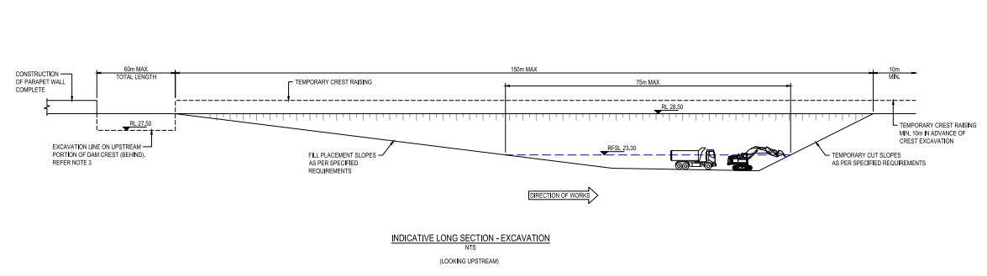

**Figure 3: Typical open excavation longitudinally showing “rolling front” - continuous excavation on the right, and final placement on the left**

|  |
| --- |
|  |
| **Figure 4 Indicative embankment construction methodology section showing staged excavation and filling of downstream embankment** |
| |  |  | | --- | --- | |  | Embankment reinstated as per Figure 5 opposite  Excavation of embankment as shown Figure 4 above | | **Figure 5: Indicative embankment construction methodology – embankment construction complete to the underside of the parapet wall** | **Figure 6: Drone photo of the ‘rolling front’ taken during construction** | |

### Tender Phase - ‘How do we manage our commercial risk?'

Seqwater’s Project Planning and the Project Delivery divisions worked collaboratively during this phase of the project to execute the tender process. The award of the construction contract placed the management of dam safety as a priority alongside commercial risk. Key points included:

* Gaining the required internal and external approvals to release the tender for the Stage 2A construction contract with sufficient time to allow for the contract award to maximise the window of the embankment works construction in the nominal ‘dry’ months. The ‘dry’ months for this site were determined by a hydrologic modelling approach that estimated probabilistic sub-daily flows and durations of lake levels by each month.
* The commencement of the works was also aligned so that the embankment construction would be largely completed prior to the scheduled commencement of another dam upgrade located within the same region reducing the risk of interruptions to the water supply network.
* The shortlisted tenderers were required to demonstrate their knowledge and appreciation of the project technical requirements, their approach and methodology inclusive of meeting the dam safety requirements and the experience with dam construction of key personnel. The importance of this to Seqwater was demonstrated with a high weighting on the non-price bid of sixty percent.
* The Independent Expert Reviewers for the design were also consulted extensively during the tender phase and they provided the tender evaluation team with additional technical support by analysing the proposed construction methodologies, production rates, technical compliance of the materials proposed and how they tied into the management of dam safety during construction.
* The design consultants GHD were invited to the tender meetings with potential contractors to provide confidence to Seqwater that the preferred candidate has the capabilities and willingness to deliver the design safely, with quality and a thorough understanding of the high-risk nature of the work.
* The tender interview’s questions were framed with particular focus on the understanding of methodology and the traceability of quality control, both key to management of dam safety risk.
* With the availability of in compliant filter materials being critical to dam safety, GHD and Seqwater undertook a scoping exercise of the potential source materials available within a reasonable haul distance of the dam. This gave Seqwater and the designers a valuable insight to the number of potential sources and their respective QA/QC compliance.
* Concurrently with the tender process, Seqwater and GHD collaboratively designed, modelled and developed an alternative reservoir lowering methodology in lieu of the method initially proposed (sheet pile cofferdam), to use a series of siphons, that would reduce the overall Stage 2A project costs, expedite the reservoir lowering time and reduce the overall dam safety construction delivery risk by maximising the use of the dry season. The short-listed tenderers were then requested to price the alternate preliminary design.
* Seqwater and GHD undertook collaborative quarry site visits of the proposed material suppliers in order to assess the products and capabilities of the quarries. A key project risk was consistent material supply of the natural sand filter material for the duration of the works. Being proactive in the tender phase allowed for a quick source approval mid construction when a secondary supplier was required.

***Contract Award - ‘How do we refine the design and support construction with a pragmatic approach?’***

On contract award Seqwater made the decision to pivot from the steel sheet pile cofferdam to a siphon arrangement. It was motivated by substantial reduction in construction timeframe and project costs. This decision also lowered construction and safety risk regarding the complexity of constructing a sheet pile cofferdam in a sandstone foundation and safety-in-design considerations. The design of the siphons was finalised post contract award and fortunately the successful tenderer, Hall Contracting, had extensive experience in large siphon construction and operation in dredging applications. Given this, they were able to work collaboratively with GHD to arrive at a pragmatic solution. Seqwater, as the owner and operator of the dam, formulated the Flow Management Plan (FMP) for the siphon operation.

On contract award the Seqwater and GHD planning team maintained close involvement through the project delivery. Seqwater engaged GHD to provide full time presence on site as the owner’s engineer and was delegated the Superintendents Representative for signing off all hold points during construction. Transferring responsibility of all inspections and hold point sign offs to the owner’s engineer ensured the design intent was consistently met and construction issues or technical queries were resolved promptly. GHD brought extensive dam construction experience to the project and were able to provide continual guidance to both Seqwater and the Contractor on construction methodology, quality and dam safety. Seqwater also allocated sufficient resources to construction supervision and support roles with one full-time planning engineering based onsite whose primary role was to manage the execution of the Flow Management Plan and the DSMP as well as engagement with Operations being the dam operators and the dam safety division.

Sufficient allocation of resources to this role on-site meant that the appropriate due diligence in reviewing the construction methodologies and hold point documentation could be undertaken by experienced dam engineers, setting the project up for success. Seqwater and GHD were continued to be supported by the Independent Expert Reviewer’s from the design phase so their construction experience could also be utilised.

# PART TWO – Siphoning out the risk

## Determining risks and managing uncertainty during construction

One of the dam safety risks being managed during construction is failure of the embankment due to overtopping. For an overtopping event to occur there must first be a flood initiating event. Compliant with the dam safety regulator’s requirement, the likelihood of failure of the embankment during the works was not increased. This was due to measures implemented as part of the DSMP as explained above.

**Management of lake levels using siphons**

Using substantial siphons, instead of a slotted ogee/bulkhead arrangement, was a novel concept for Seqwater’s approach to dam upgrades. Due to the novel approach, Seqwater undertook a probabilistic assessment of hydrologic inflows, seasonal variability and capacity of siphons necessary works to demonstrate the concept was feasible. This modelling effort sought a solution that could maintain appropriate lake levels without undue delay for construction work or excessive downstream flows impacting highway upgrade works and other downstream receptors.

A key difference for managing siphon flows at Ewen Maddock dam, against larger catchments and with gated dams, was the implementation of local and reactive approach based on observed reservoir levels. Predictive approaches, such as using forecast hydrologic models and initial loss estimates, are not feasible due to the short response time of the Ewen Maddock Dam catchment.  When significant runoff led to inflows and rising lake levels, it was not known if the Seqwater Flood Operations Centre would always be able to resource and communicate with the Ewen Maddock Superintendent. During large weather system events and having only finite resources, the focus of the Flood Operations Centre would be Seqwater’s gated dams. Therefore, the Ewen Maddock team determined the safest approach was to devolve the estimation of lake levels and control of siphons to the Superintendent, assuming support may be available from the Flood Operations Centre. This is summarised in **Figure 7** showing how control of the siphons was centred on the Site Superintendent.

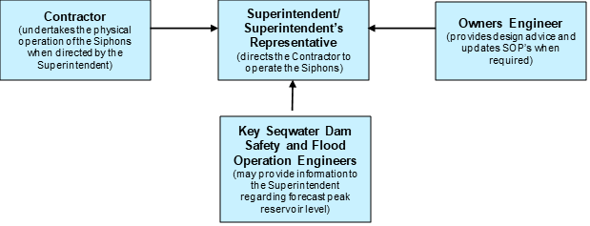

**Figure 7: Management inter-relationship for managing siphons at Ewen Maddock Dam**

The Flow Management Plan remained in effect from the commencement of the Siphon Commissioning (including the required preparatory measures prior to the first day of the commissioning) until the existing dam crest level was reinstated across the full length of the embankment as part of the Stage 2A Embankment Works.

The final design iteration required six siphons, each capable of 1.8m3/s (approximately 10m3/s in total) depending on the reservoir level and total length of that siphon. Seqwater and GHD developed a nominal siphon rating curve and then downstream impacts for each siphon configuration. Flow rate variation is achieved by bringing additional siphons into operation, or by shutting down siphons.   It must be emphasised that safe operation of siphons meant that the total flow rate could only be increased or decreased with the discrete addition or removal of a single siphon’s full capacity.

The flow management plan specified that all six siphons were to be primed and functioning within a normal 10 hour working day. Available vacuum pump capacity meant that priming of each siphon was sequential. Until commissioning, it was uncertain how quickly a siphon might be able to be primed, and so the initial commissioning phase required verification of likely start-up durations. As an aside, this site commissioning commenced in March 2020, just as SARS-COV2 2019 began to sweep over the world disrupting global supply chains and making sourcing of the priming valves quite difficult. This resulted in an alternative type and a reduced number of priming valves installed in the siphon system, proving effective during commissioning of the siphons

Collaboration between Seqwater, GHD and the Contractor during the design phase ensured practical solutions were adopted that could be constructed within the limited timeframe. Multiple siphon design review meetings and constructability workshops were held between the three parties. Collaborating early with the Contractor reduced the amount of design rework required and allowed GHD to directly communicate key design elements that were critical in terms of the design intent and dam safety. Construction of the siphons took approximately two months including commissioning of the siphons. Standard Operating Procedures (SOPs), available in the Flow Management Plan, allowed the Contractor key understanding on the operation of the siphons including start up, shutdown, emergency shut down and monitoring. The commissioning process was used to test the efficiency of the siphon SOPs. Checklists within the SOPs cross-referenced Seqwater’s DSMP to ensure all relevant dam safety procedures were being implemented.

To remove the initial volume of water from FSL to the desired Restricted FSL, the Flow Management Plan specified a gradual increase in individual siphon commencement to limit downstream environmental impacts and provide confidence in their safe operation.  During this initial lowering phase, the Flow Management Plan specified that the siphons have full time (24 hour) attendance of a trained operator for the first 48 hours of operation. This ensured that an emergency shutdown could be affected if an unanticipated incident occurred. These incidents may be something that led the siphons to: output unacceptable flow rates to a downstream receptor, partial or catastrophic damage to the siphons or associated infrastructure and/or damage to the spillway structure or adjacent water treatment plant. Following the first 48-hour overnight operation and for routine siphon operations after most of the lake volume was removed, the monitoring was undertaken via the onsite CCTV at agreed timings, with aim for emergency first response attendance onsite within two hours. Seqwater’s policy to only have manual intervention on outflow infrastructure meant that the CCTV system only had remote monitoring capability, it did not have any form of remote operation capability.

The number of siphons in concurrent operation was gradually increased during commissioning. Ultimately, four siphons were determined as the optimal number when balancing downstream concerns with level reduction rates. The initial draining of the lake took two weeks to lower from approximately 80% capacity to 60%. A faster lake lowering was possible, but the drawdown proceeded in parallel with the embankment works, and as such avoided minimal impacts downstream.

The use of siphons provided a unique learning for the project, particularly for hydraulic modellers. In the case of floodplain models, it is very rare that modellers can observe steady flow rates maintained within a watercourse. This allows adjustment of key calibration parameters and assumptions at hydraulic controls. Flood wave travel time, used in hydrologic and hydraulic models also provided Seqwater with a greater understanding of the speed at which the catchment might react under emergency conditions when observations are not usually available. The hydraulic modelling of the peak water levels for each flow rate, at key downstream locations, was compared to site observation at key hydraulic controls on the road network. The volume of water being released would rise and then stabilise as the downstream floodplain accepted the constant flow rate. These adjustments would then be incorporated into future revisions of the EAP.

Once lowered, the lake was still subject to evaporation and demands from the water treatment plant and required environmental releases. As it transpired, the inflows to the lake over the course of the construction works were never sufficient to raise the water level above the Restricted FSL. That is not to imply there were no rain delays on the project, as the mean rainfall totals for all months except August and November were met. The rainfall in November in the concluding stages of the project was a third of the average and so was quite beneficial to the project completing early. Had the project commenced a month later or experienced any delays it would have shifted into the December to March period where average rainfall totals are three to four times that of the July to November period. This would have required frequent operations of the siphons as mean rainfall totals were observed for those subsequent months. Higher than average rain fell in December. However, the main embankment excavation had been reinstated to dam crest level by this time, so the risk of embankment overtopping was returned to pre-construction risk. The project team was able to modify the DSMP to allow the FSL to be safely reinstated with the rainfall, ensuring no inflow was unnecessarily wasted.

# PART THREE – Resilience to the failure

The purpose of Emergency Action Plans (EAP) is to reduce the risk of harm to downstream persons and property in the event of a dam hazard event or dam emergency event. It is an emergency management tool that reduces risk by outlining a framework for the dam owner to respond to a dam hazard, including working with the relevant disaster management agencies to warn and notify downstream residents. EAP’s in Queensland are regulated under the *Water Supply (Safety and Reliability) Act*2008. Among other things, the EAP must identify the relevant dam hazards and actions the dam owner will undertake in response to a dam hazard occurring. In Queensland the Dam Safety Regulator has the authority to hold construction works on a dam if the regulator had not approved the DSMP and EAP, or if the plans in place are not being complied with. The DSMP and EAP were structured so there was cohesion between the two process which provided the highest level of response to a dam hazard event. The DSMP provides site specific risk reduction measures, where the EAP provides risk reduction to communities through disaster management planning including the communication of risk to impacted stakeholders. **Figure 8** outlines the communication process between the EAP and DSMP. The communication process was also used to communicate the dam safety risk during construction and the risk reduction measures in the DSMP.

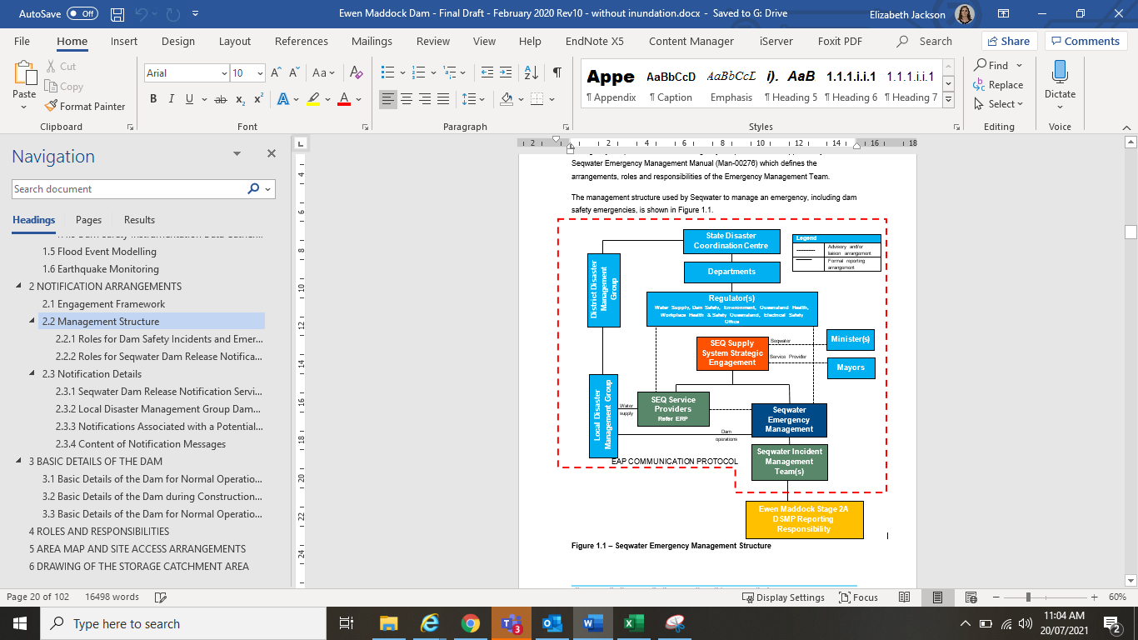

**Figure 8 Seqwater communications protocol during construction**

The EAP was divided into two sections Normal Operations and Construction Operations with a different set of triggers for each section. The EAP was written to be a live document which would allow transition between the EAP triggers for Normal Operations and Construction Operations. The Normal Operation and Construction Operations sections were tied to the Full Supply Level (FSL). While the reservoir level was restricted for construction the EAP would operate using the Construction Operation triggers. This ensured that the legislated consultation and assessment period only need to be observed once in the project, rather than when the Restricted FSL was applied and released again when the embankment was reinstated. Having a rolling EAP minimised the risk to the project due to approval delays. Stakeholder engagement was maintained via weekly progress reports for the duration of the project to ensure that all parties were aware of the section of the EAP Seqwater was operating under.

The identification of a dam hazard onsite (increased seepage, structural movement etc) would trigger the DSMP. DSMP reports to Dam Safety Engineer. The EAP would be activated and incident management team created. The Seqwater incident management team would manage the dam safety event. The DSMP outlined actions for on-site contractors and Seqwater representatives to complete. The EAP outlined actions for the incident management team and emergency manager to complete. These include notification to relevant stakeholders including disaster management groups, the dam safety regulator and population downstream of the dam.

The EAP is a tool that enables Seqwater and stakeholders to plan for and communicate dam failure impact to downstream communities. The EAP outlines the roles and responsibilities of different agencies in response to a dam safety emergency event. As part of the EAP consultation process Seqwater presented an information session to the potentially impacted council and local disaster management group on the risk associated with the dam construction project, the EAP, the DSMP and the risk reduction measures employed.

Prior to the contractor undertaking any works on the embankment, an information session was held with all members of the contractor's staff, designers and owners involved with the upgrade works. This session highlighted the main aspects from the DSMP to the group and how to respond. This was key to the works, as the personnel in the excavator and on the ground would be the first to notice any potential dam safety incidents such as seepage or cracking. Sharing this information ensured that the response time of a potential incident was reduced, and also provided the staff the “why” which helped them to understand the importance of following the DSMP.

# Lessons Learned

This project has highlighted the importance of resourcing and collaborating amongst the owner, designer, builder, and the personnel on the ground. In particular:

* Use of substantially sized temporary siphons in dam safety improvement works is possible but requires substantial understanding of the trade-offs and probable outcomes.
* Working with an informed owner, cooperative designer and amenable contractor can achieve excellent outcomes as project success should always come first.
* Success is not due to good fortune, it takes forward planning to set up a project for success. Support from Owner Management to recognise this investment in the planning phase of a dam safety upgrade is key to a project’s success during Construction.
* Consultation and communication with all stakeholders is vital and the use of modelling and mapping tools is an excellent communication tool to keep discussions objective and focussed.

# Acknowledgements

The authors gratefully acknowledge Seqwater for permission to publish these details. In addition, this project was a team effort and the input and counsel to this project, especially that of Nigel Smith, Senior Project Manager (Seqwater) Michel Raymond, Senior Operations Engineer (Seqwater) Barton Maher, Engineering and Technical Manager (Seqwater), John Tibaldi, Principal Engineer Dam Safety Operations (Seqwater) Malcolm Barker, Principal Risk Analyst (GHD) Jon Williams, Senior Principal Dam Engineer (GHD) and Lachlan Blanch (Hall Contracting) is duly acknowledged.

# References

ANCOLD (Australian National Committee on Large Dams). (1983a, May). Guidelines for Dam Instrumentation and Monitoring Systems.

ANCOLD (Australian National Committee on Large Dams). (2000, March). Guidelines on Selection of Acceptable Flood Capacity for Dams.

ANCOLD (Australian National Committee on Large Dams). (2003, August). Guidelines on Dam Safety Management.

ANCOLD (Australian National Committee on Large Dams). (2003a, October). Guidelines on Risk Assessment.

ANCOLD (Australian National Committee on Large Dams). (2012, October). Guidelines on the Consequence Categories for Dams.

Department of Natural Resources, Mines and Energy. (2019, December). *Guidelines on Acceptable Flood Capacity for Water Dams.* Retrieved from Acceptable flood capacity of referable dams: <https://www.rdmw.qld.gov.au/__data/assets/pdf_file/0003/78834/acceptable-flood-capacity-dams.pdf>

Department of Natural Resources, Mines and Energy. (2020, October). *Dam Safety Management Guideline.* Retrieved from Dam safety management: <https://www.resources.qld.gov.au/__data/assets/pdf_file/0007/78838/dam-safety-management.pdf>

Department of Regional Development, Manufacturing and Water. (2020, May 25). *Water Supply (Safety and Reliability) Act 2008.* Retrieved from Queensland Legislation: <https://www.legislation.qld.gov.au/view/html/inforce/current/act-2008-034>

Department of Regional Development, Manufacturing and Water. (2021, June). *Emergency Action Plan for Referable Dam Guideline.* Retrieved from Emergency Action Plan guideline and templates: <https://www.rdmw.qld.gov.au/__data/assets/pdf_file/0018/84015/eap-guideline.pdf>

GHD. (2020, November). *Construction Risk FSL Reinstatement Memorandum Revision A.*

Millard, Roberts, Cox, Berghuis, Hams, (September 2021) *A tale of two sites, siting optimal fish passage location at Ewen Maddock Dam* ANCOLD submission

Seqwater (Bulk Water Supply Authority). (2020, March 10). Ewen Maddock Dam Emergency Action Plan Revision 10. Brisbane, Queensland, Australia.