Login in on Higher Logic and consuming identity

The third-party website that you would like to consume HL identity used below is [www.futureearth.org](http://www.futureearth.org), but this will work for ANY page on the futureearth domain.

To make these requests, you will need a IAM Key. Yours has been generated and the value you will use is:

69e59615-6e3b-4904-a147-19be267d699a

1. From your site, redirect the user to the HL login page with a “ReturnUrl” query string parameter of the page you would like to redirect to after login:

<http://network.futureearth.org/login?ReturnUrl=http%3A%2F%2Fwww.futureearth.org%2F>

1. User will log in:

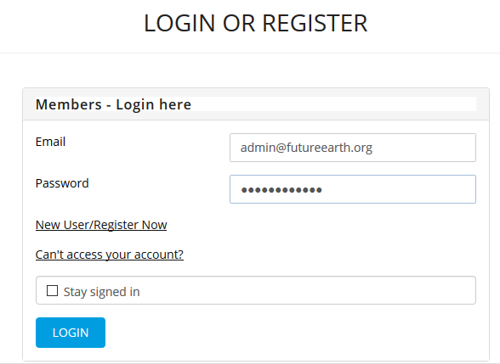

1. Upon logging in, the browser will be redirected to the “ReturnUrl”, with a domain cookie called “HLAuthToken” set as a side effect of login:

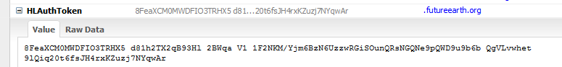

1. You can then retrieve the identity of the user that has logged in by making a call to our API as:

URL: <https://api.connectedcommunity.org/api/v2.0/Contacts/GetWhoAmI> , <https://api.connectedcommunity.org/Help/Api/GET-api-v2.0-Contacts-GetWhoAmI>

Content Type: application/json

Required Headers:

HLIAMKey: [Your IAM Key above, currently 69e59615-6e3b-4904-a147-19be267d699a]

HLAuthToken: [The value of the token specific to this session]

1. You will get a response containing all contact information, the schema can be seen [here](https://api.connectedcommunity.org/Help/Api/GET-api-v2.0-Contacts-GetWhoAmI).