Week 4 - Project Mockups
[COMP 424]
Purpose of website
The rideMyBike website will allow people around the country to share bicycles without spending money on it. Besides allowing people to ride a bicycle anywhere, another goal of this kind of system is increase and consolidate the idea of sharing.
The platform will provide an easy and intuitive way of listing bicycles and booking them around the country. Functionalities as filtering by location and dates, bicycle size and possibility of delivery in a pre-established place will be available.
Pages
- User registration: A new user interested in using rideMyBike will fill a form with some informations in order to create a profile. The required informations will be:
  - Name
  - E-mail
  - Address
  - Phone number
  - Profile picture (not mandatory)
  - Password
- Bicycle registration: If in addition to borrow a bicycle the intent of the user is also lend your own bicycle to other users then the additional step of registering the bicycle information is required. For this step the following informations are required:
  - Bicycle pictures
  - Type
  - Model
  - Frame size
  - Description of the current state of the bicycle (any brake issues or old tires for instance)
  - Nickname
  - Pickup address
  - Possibility of delivering the bicycle in a pre-established place
- Login: Initially the application will only provide login functionality through pre-registered email and password. In a second moment the use of existing social media account will be added to ease user’s life.
- Bicycle search: This will be the main page of the website. Every person that visits the website will be able to search for available bicycles in a certain place during a date interval. The pre-registration is not required to use this functionality. The required fields to perform the search are:
  - Location: This field will use Google maps API to validate the information entered by the user.
  - Pick up and drop off dates
  - Bicycle type
  - Frame size
The search results will only display bicycles that will be available during the specified date interval. The available bicycles will be shown as boxes that will display key information such as picture, rating and a brief description.
- Bicycle details page: This page will show all the available information about a specific bicycle, including pictures, rating and reviews written by users that have already borrowed it.
In addition to the information there will also be available buttons to contact the bicycle owner and to reserve the bicycle during the specified period.
- User and Bicycle Reviews: After finished the borrowing period both users will receive an email asking them to answer some pre-determined questions about the deal. In specific, the user that borrowed the bike will also be asked to write his/her feelings about the bicycle. All this information together will construct both user reputation and bicycle ratings.
As rideMyBike will create an open community of bikers without hierarchical mediation this feature is of the most importance to the healthy of the website. Every issue that a user experiences during any step of the process of sharing a bicycle must be reported as soon as possible in order to help other users to not going through the same problems.

Appendix 1 – Mockups

- User registration:
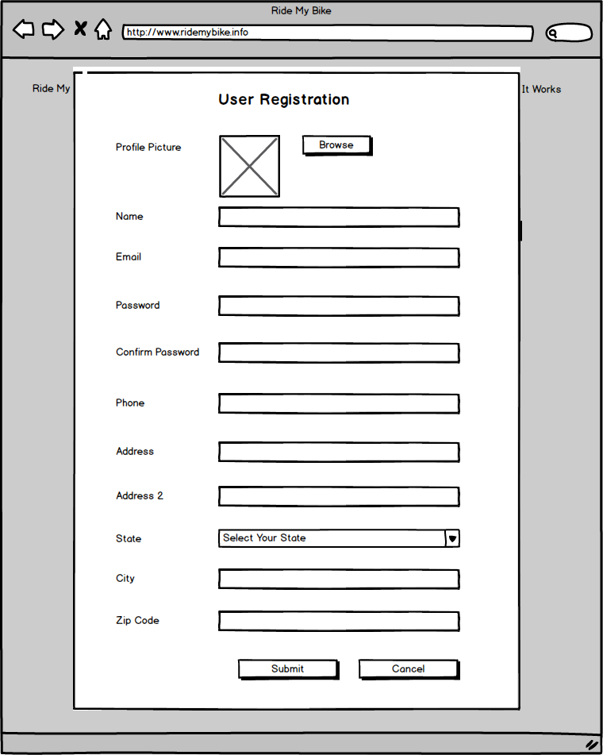

- Bicycle registration:
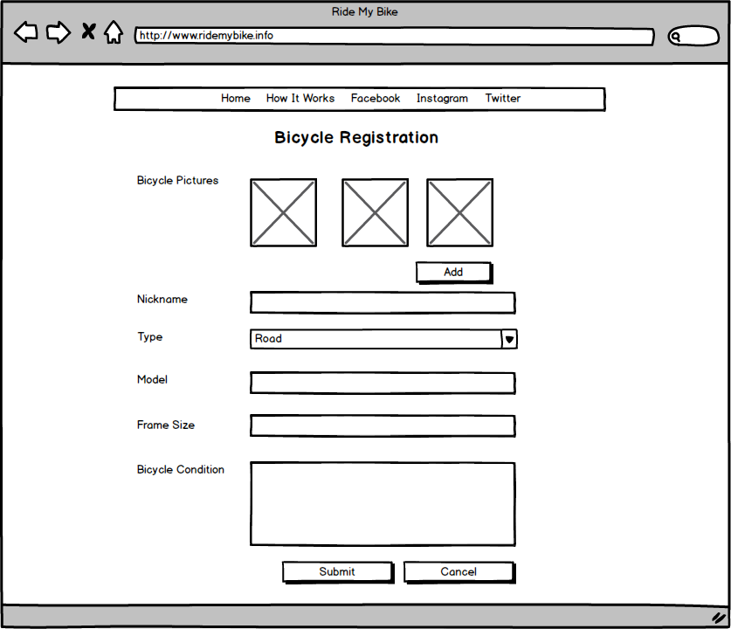

- Login:
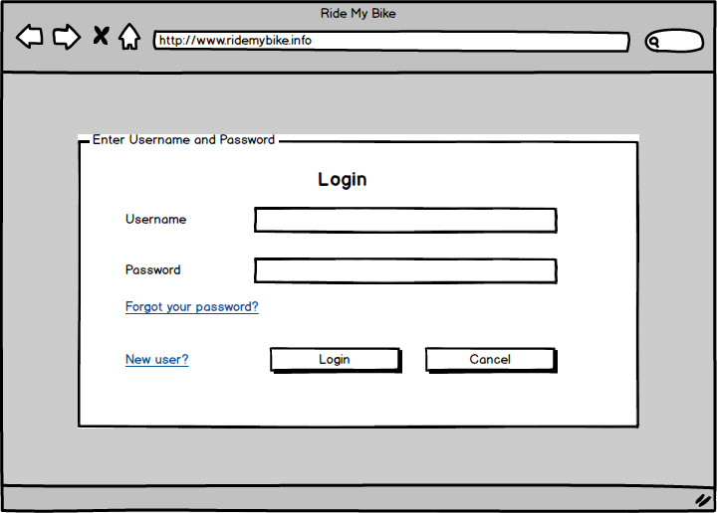

- Bicycle search:
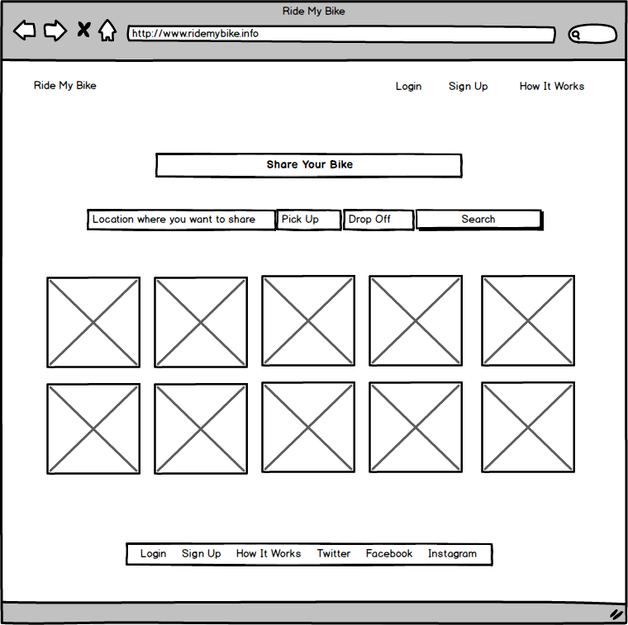

- Bicycle details page (including reviews):
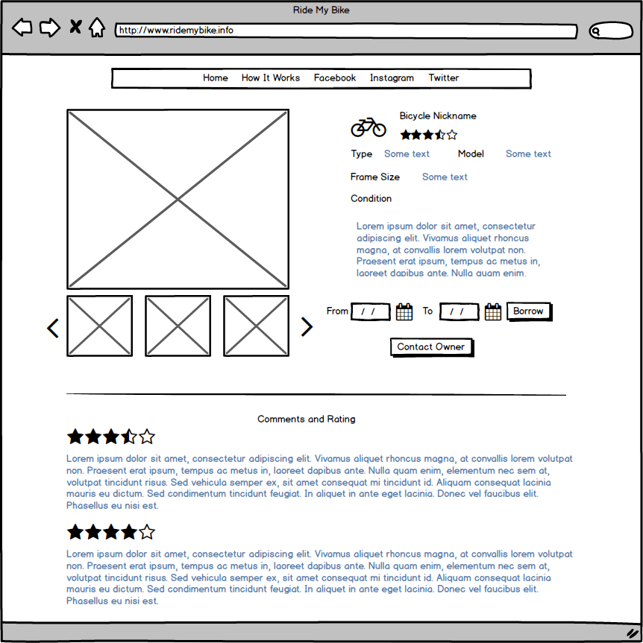

- User Reviews:

