Class 4 R Intro
Leah Johnson
January 15th, 2026
x <- 1:50
plot(x, sin(x))
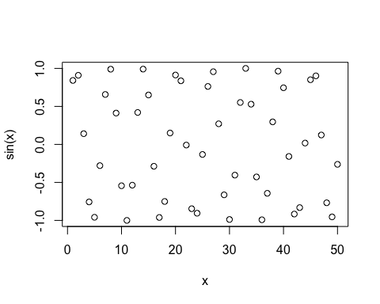
plot(x, sin(x), typ="l", col="darkgreen", lwd=2)
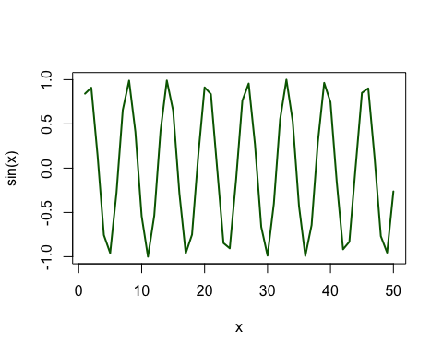
log(10, base = 10)
## [1] 1

