实验四

1.展示图

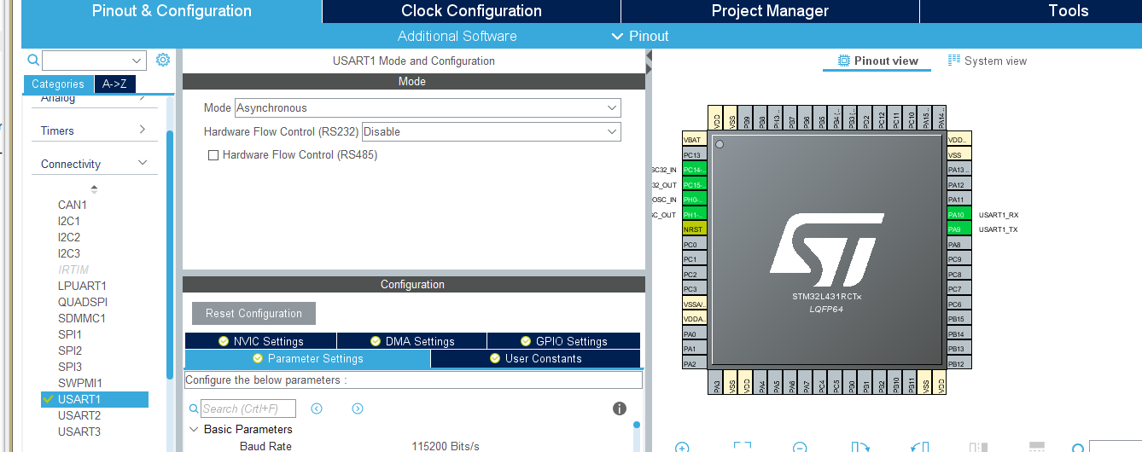

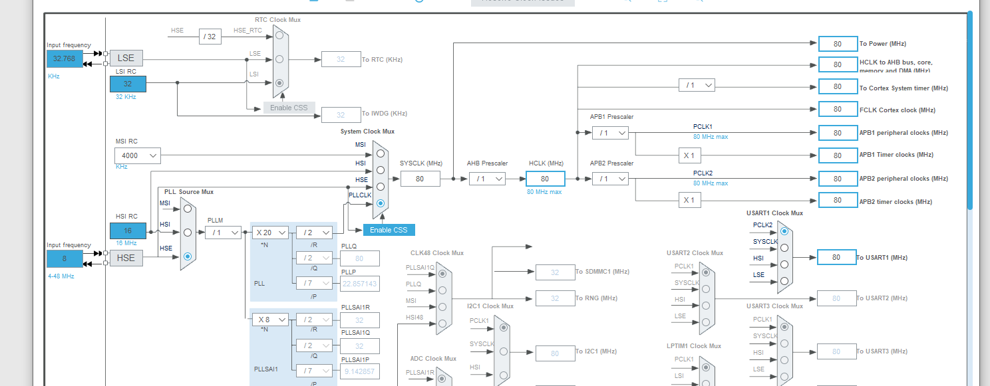

2.执行代码：

/* USER CODE BEGIN Header */

/**

******************************************************************************

* @file : main.c

* @brief : Main program body

******************************************************************************

* @attention

*

* <h2><center>&copy; Copyright (c) 2020 STMicroelectronics.

* All rights reserved.</center></h2>

*

* This software component is licensed by ST under BSD 3-Clause license,

* the "License"; You may not use this file except in compliance with the

* License. You may obtain a copy of the License at:

* opensource.org/licenses/BSD-3-Clause

*

******************************************************************************

*/

/* USER CODE END Header */

/* Includes ------------------------------------------------------------------*/

#include "main.h"

#include "usart.h"

#include "gpio.h"

/* Private includes ----------------------------------------------------------*/

/* USER CODE BEGIN Includes */

/* USER CODE END Includes */

/* Private typedef -----------------------------------------------------------*/

/* USER CODE BEGIN PTD */

/* USER CODE END PTD */

/* Private define ------------------------------------------------------------*/

/* USER CODE BEGIN PD */

/* USER CODE END PD */

/* Private macro -------------------------------------------------------------*/

/* USER CODE BEGIN PM */

/* USER CODE END PM */

/* Private variables ---------------------------------------------------------*/

/* USER CODE BEGIN PV */

/* USER CODE END PV */

/* Private function prototypes -----------------------------------------------*/

void SystemClock_Config(void);

/* USER CODE BEGIN PFP */

/* USER CODE END PFP */

/* Private user code ---------------------------------------------------------*/

/* USER CODE BEGIN 0 */

/* USER CODE END 0 */

/**

* @brief The application entry point.

* @retval int

*/

int main(void)

{

/* USER CODE BEGIN 1 */

/* USER CODE END 1 */

char str[12] = "Hello World\n";

char recv_buf[12] = {0};

/* MCU Configuration--------------------------------------------------------*/

/* Reset of all peripherals, Initializes the Flash interface and the Systick. */

HAL_Init();

/* USER CODE BEGIN Init */

/* USER CODE END Init */

/* Configure the system clock */

SystemClock_Config();

/* USER CODE BEGIN SysInit */

/* USER CODE END SysInit */

/* Initialize all configured peripherals */

MX_GPIO_Init();

MX_USART1_UART_Init();

/* USER CODE BEGIN 2 */

/* USER CODE END 2 */

/* Infinite loop */

/* USER CODE BEGIN WHILE */

/* USER CODE BEGIN 2 */

HAL_UART_Transmit(&huart1, (uint8_t*)str, 12, 0xFFFF);

/* USER CODE END 2 */

while (1)

{

/* USER CODE END WHILE */

/* USER CODE BEGIN 3 */

//接收12个字节的数据，不超时

if(HAL_OK == HAL_UART_Receive(&huart1, (uint8_t*)recv_buf, 12, 0xFFFF))

{

//将接收到的数据发送

HAL_UART_Transmit(&huart1, (uint8_t*)recv_buf, 12, 0xFFFF);

}

}

/* USER CODE END 3 */

}

/**

* @brief System Clock Configuration

* @retval None

*/

void SystemClock_Config(void)

{

RCC_OscInitTypeDef RCC_OscInitStruct = {0};

RCC_ClkInitTypeDef RCC_ClkInitStruct = {0};

RCC_PeriphCLKInitTypeDef PeriphClkInit = {0};

/** Initializes the CPU, AHB and APB busses clocks

*/

RCC_OscInitStruct.OscillatorType = RCC_OSCILLATORTYPE_HSE;

RCC_OscInitStruct.HSEState = RCC_HSE_ON;

RCC_OscInitStruct.PLL.PLLState = RCC_PLL_ON;

RCC_OscInitStruct.PLL.PLLSource = RCC_PLLSOURCE_HSE;

RCC_OscInitStruct.PLL.PLLM = 1;

RCC_OscInitStruct.PLL.PLLN = 20;

RCC_OscInitStruct.PLL.PLLP = RCC_PLLP_DIV7;

RCC_OscInitStruct.PLL.PLLQ = RCC_PLLQ_DIV2;

RCC_OscInitStruct.PLL.PLLR = RCC_PLLR_DIV2;

if (HAL_RCC_OscConfig(&RCC_OscInitStruct) != HAL_OK)

{

Error_Handler();

}

/** Initializes the CPU, AHB and APB busses clocks

*/

RCC_ClkInitStruct.ClockType = RCC_CLOCKTYPE_HCLK|RCC_CLOCKTYPE_SYSCLK

|RCC_CLOCKTYPE_PCLK1|RCC_CLOCKTYPE_PCLK2;

RCC_ClkInitStruct.SYSCLKSource = RCC_SYSCLKSOURCE_PLLCLK;

RCC_ClkInitStruct.AHBCLKDivider = RCC_SYSCLK_DIV1;

RCC_ClkInitStruct.APB1CLKDivider = RCC_HCLK_DIV1;

RCC_ClkInitStruct.APB2CLKDivider = RCC_HCLK_DIV1;

if (HAL_RCC_ClockConfig(&RCC_ClkInitStruct, FLASH_LATENCY_4) != HAL_OK)

{

Error_Handler();

}

PeriphClkInit.PeriphClockSelection = RCC_PERIPHCLK_USART1;

PeriphClkInit.Usart1ClockSelection = RCC_USART1CLKSOURCE_PCLK2;

if (HAL_RCCEx_PeriphCLKConfig(&PeriphClkInit) != HAL_OK)

{

Error_Handler();

}

/** Configure the main internal regulator output voltage

*/

if (HAL_PWREx_ControlVoltageScaling(PWR_REGULATOR_VOLTAGE_SCALE1) != HAL_OK)

{

Error_Handler();

}

}

/* USER CODE BEGIN 4 */

/* USER CODE END 4 */

/**

* @brief This function is executed in case of error occurrence.

* @retval None

*/

void Error_Handler(void)

{

/* USER CODE BEGIN Error_Handler_Debug */

/* User can add his own implementation to report the HAL error return state */

/* USER CODE END Error_Handler_Debug */

}

#ifdef USE_FULL_ASSERT

/**

* @brief Reports the name of the source file and the source line number

* where the assert_param error has occurred.

* @param file: pointer to the source file name

* @param line: assert_param error line source number

* @retval None

*/

void assert_failed(char *file, uint32_t line)

{

/* USER CODE BEGIN 6 */

/* User can add his own implementation to report the file name and line number,

tex: printf("Wrong parameters value: file %s on line %d\r\n", file, line) */

/* USER CODE END 6 */

}

#endif /* USE_FULL_ASSERT */

/************************ (C) COPYRIGHT STMicroelectronics *****END OF FILE****/

3.效果图

按下复位键

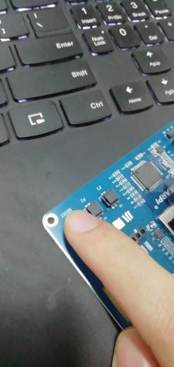

串口显示：

