x

First trigger

Table of Contents
Call stack 1
Analysis 1
nt!NtPowerInformation 1
Code snippets 1
Analysis 3
Summary 4
nt!PopPowerRequestActionInfo 4
Code Snippets 4

Call stack
- nt!EtwWriteEx
- nt!EtwWrite
- nt!PopDiagTracePowerRequestChange
- nt!PoSetPowerRequestInternal
- nt!PopPowerRequestActionInfo
- nt!NtPowerInformation
- nt!KiSystemServiceCopyEnd
- ntdll!NtPowerInformation

Analysis

nt!NtPowerInformation
This function has a BIG switch (90 cases) in which we are interested (so far) in only one of them. The case number 0x2c (44).

Code snippets

Illustration 1: Function layout
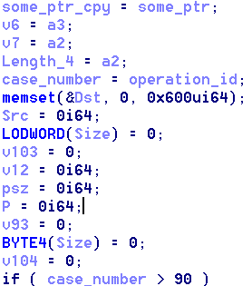
Illustration 2: Definition of init vars

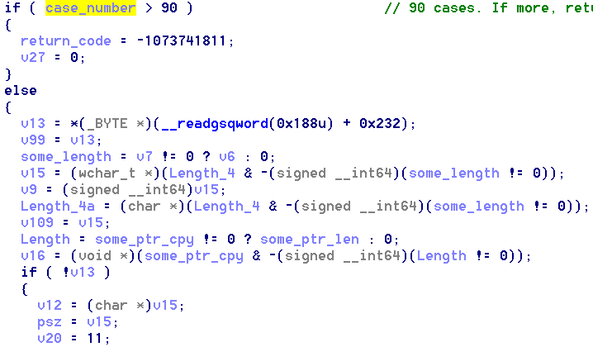
Illustration 3: Values assing

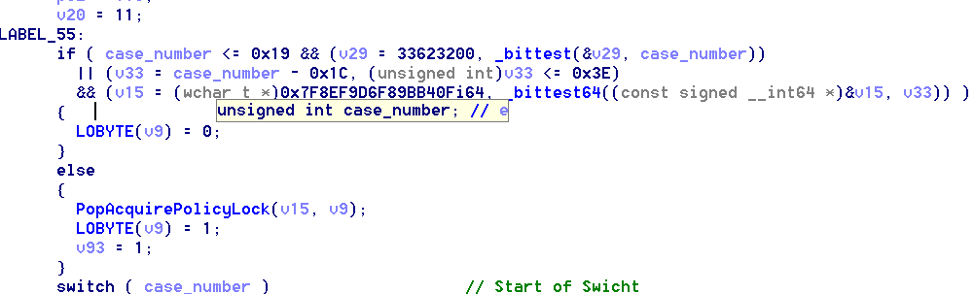
Illustration 4: Previous step to switch

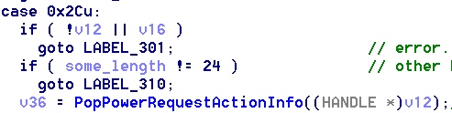
Illustration 5: Switch option we want to reach

Analysis
From [5] we can get that, in order to get the PopPowerRequestActionInfo we should meet the following conditions:
- some_length == 24
- v16 == 0
- case_number == 0x2c (case_number is the var that holds the value queried by the switch)
- v12 != 0 & v12 should be a Handler * to our object.

- some_length should be 24. Therefore, according to [3], either v7 should exists and v6 should be 24. According to [2], v6 is a3 and v7 is a2. Which means that both of them are controlled by the user (they’re parameters).
- v16 should be 0. Which means, according to [3], that some_ptr_copy should be 0. From [2] , we can get that some_ptr_copy, is just a copy of the 4th parameter of the function (a4) which was renamed as some_ptr. Therefore, is user controlled.
- case_number should be 0x2c (44). This value is directly taken from the first parameter (a1) renamed as operation_id according to [2]. Therefore, it’s also user controlled.
- This is maybe the most difficult one to trace. According to [2], due to we need to enter to that IF because inside of it resides the switch, two things must happen:
  - v13 should be 0
This condition I GUESS is not controllable. I should make a little more of research regarding this function, but anyways I think it will usually be accomplished.
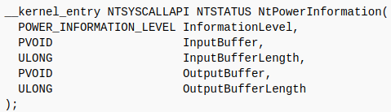
  - v15 should be the pointer to our object. According to [2], v15 is crated by performing an and between two variables length_4 and the negate form of some_length. The latter, because of our 1 condition, it will be 24. The former, length_4, which according to [1] is the second parameter of the function, I really think that IDA has make something wrong when disassembling it, because MSDN documentation specifies that the second parameter of this function should be an InputBuffer:
So basically our second parameter (after performing the and) should have the pointer to our object.

Summary
A1 = 0x2c
A2 = Pointer to our object (?)
A3 = 24
A4 = 0
A5 = 0

nt!PopPowerRequestActionInfo
This function is called with the handle as parameter.

Code Snippets

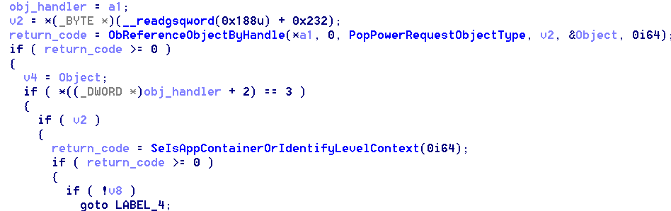

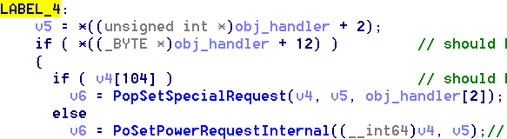
Analysis
First, in order to achieve LABEL_4, we should met:
- Our handler must have a 3 in the third dword
- v2, which according to MSDN doc of ObReferenceObjectByHandle and the type which v2 was defined, seems to be the KPROCESSOR_MODE, should be different from 0. I don’t think it is user controlled.
- v8 should be different from 0. According to [1] v8 seems to be some variable a inside the stack.
Once in LABEL_4:
- (byte) Handler +0xc should be different from 0
- Object[104] should be 0.

Summary
A1 (handler):
- Handler + 0xc (bytes) should be 0 (NOT NECESSARY)
- Handler + 2 (dword) should be 3 (NOT NECESSARY)
- Object pointed by Handler in position 104 should have a 0
- Object pointed by Handler should be of type PopPowerRequestObjectType (Kernel structure: _OBJECT_TYPE)
- WHAT ABOUT V8?????

nt!PoSetPowerRequestInternal
This function is called with the pointer to the object as first parameter, and the value of the third unsigned int from the the handler.

