EtwpEventWriteFull

What is enable mask?

Event descriptor:
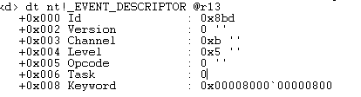

IMPORTANT, WHEN CALLING ETWPEVENTWRITEFULL , ALTHOUGH IT IS CALLING IT THROUGH BECAUSE OF THE GROUP, THE GUID ENTRY THAT IT GIVES, IS THE PROVIDER GUID!!!
GUID_PROVIDER_ENTRY
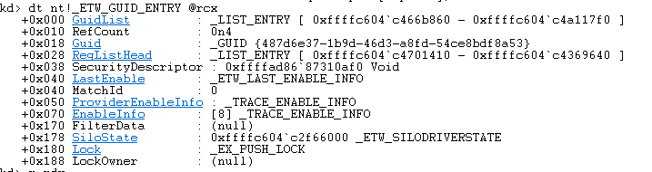
GUID_GROUP_ENTRY (dont pay attention to @rdx.. is the correct one, checked)
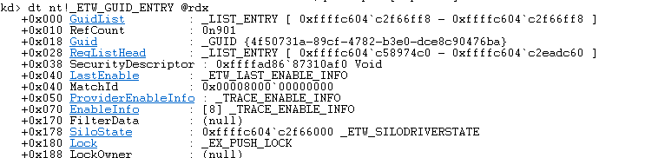

REG_ENTY
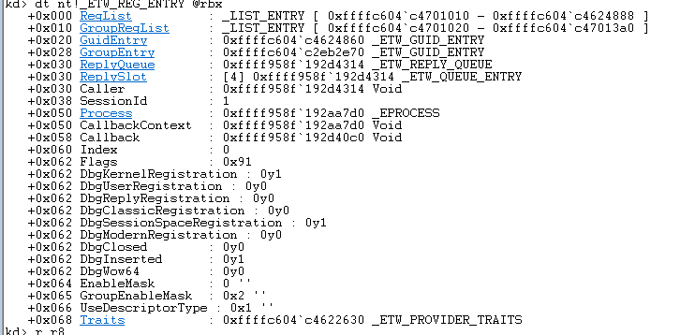

We should investigate more about FILTER and ENABLE MASK.. may there is something interesting therea bout filtering that wearent taking into account (ETWpWRITEFULL+162)
and also FILTER_DATA of the guid entry.

