Reversing EtwpRegisterProvider

Table of Contents
EtwpFindGuidEntryByGuid(ptr_silo, guid, 0) 3
Summary 5
EtwpAddGuidEntry(ptr_silo_globals, ptr_guid, 0) 5
EtwpAllocGuidEntry(ptr_guid) 5
Summary 6
EtwpAddKmRegEntry(p1, p2, p3, p4, p5) 8
Handler structure 11

According to EtwRegister, first parameter of EtwpRegisterProvider is some result of the function PsgetCurrentSiloGlobals()

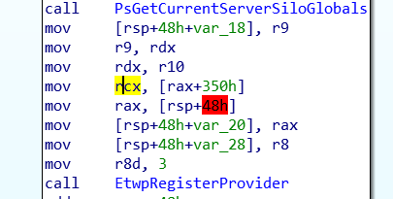

After coming back we can see that RCX contains the value of rax+0x350. This pointer was pointing to some place that seemed to be some structure.. I tried to find one and got some lucky:
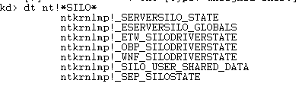

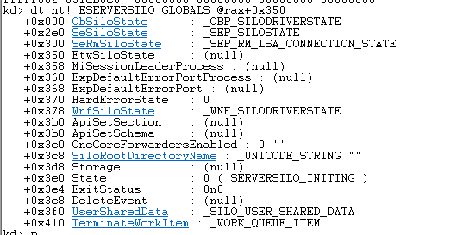

Apparently this is used by the following function to manage guids.. In this time EtwSilOstate was null I think because it was the first provider that triggered me the breakpoint. After a some ‘continue’ that structure was filled in with some information.

EtwRegisterClassicProvider EtwRegister
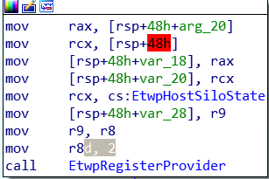
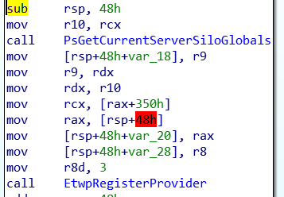

EtwpRegisterProvider(ptr_silo, guid, id_code ...)
The name id_code was arbitrary chosen by me.
id_code == 2 for EtwRegisterClassicProvider
id_code == 3 for EtwRegister (look r8!)

EtwpRegisterProvider --> EtwPFindGuidEntryByGuid
r8d is 0!
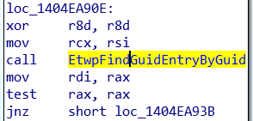

EtwpFindGuidEntryByGuid(ptr_silo, guid, 0)
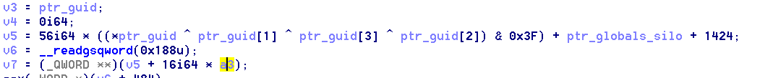
Illustration 1: HexRays 1
One of the first things it does is to xor each dword of the guid, then apply a mask of 0x3F (get only last 6 bits), sum that to the ptr_globals_silo + 0x590 (BECAUSE IS THE OFFSET OF _ETWP_GUID_HASH_TABLE IN THE STRUCTURE _ETW_SILO_STATE) and finally multiplies it for 56 (BECAUSE IS THE LEN OF THE _ETW_HASH_BUCKET STRUCTURE!).
A3 is 0
Effectively, after all that sum, the pointer points to a another _ESERVERSILO_GLOBALS structure.
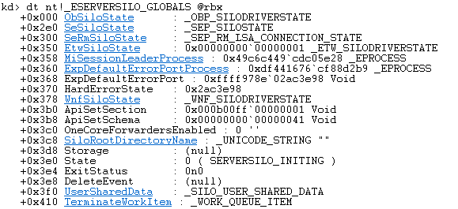
This is how the function flows afterwards:
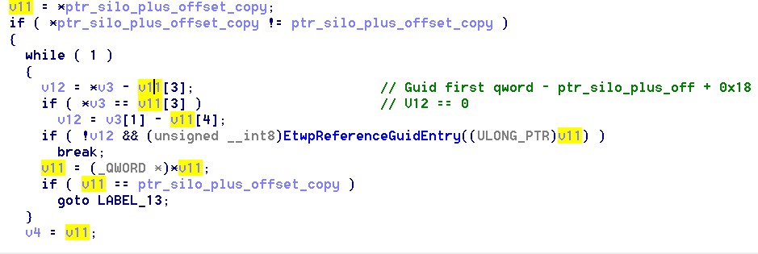
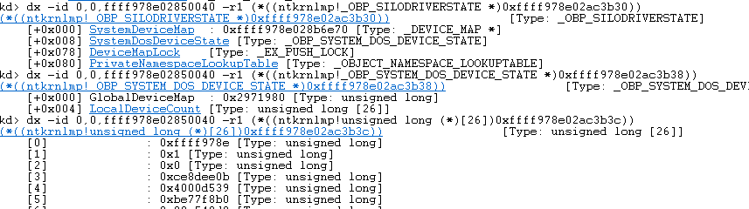
Following with the function flow, if the values doesn’t match, it will de-reference v11 and take the concrete value of that pointer. Seems to be a double -linked list:
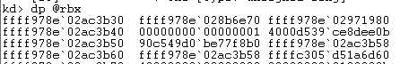

In fact, if we display the pointer pointed by rbx (v11):
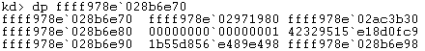

we found almost same structure with the same pointer in the two first qwords. Which adds strength to our hypothesis of a double linked list.

The while, has two conditions to exit. The first one is triggered when the GUIDS are equal. In that case the function EtwPReferenceGuidEntry() is called and then the break is performed. The other one, is when the value of the iterator (v11) is the same as the the initial pointer (ptr_silo_after_offset_copy). This means that the whole list was iterated, but the GUIDS were “not found”?. Therefore the label13 is executed.

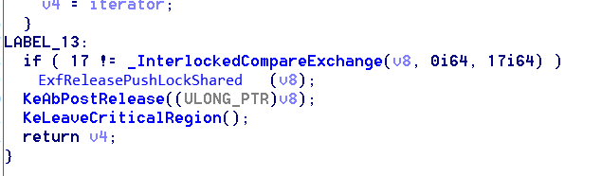
Label13 is executed after the while is completed, ALWAYS, no matter what branch was followed.
V4 has two possibles values:
- If the GUIDS were the same, then is the value of V11.
- Otherwhise is 0 (see #Image5|graphic).

Summary
This function receives the pointer to the SILO GLOBALS structure and the GUID of the provider we are looking for. It adds an offset to this pointer of the structure taking into account the GUID and a mask and a fixed number. Once it finishes with that math, the outcome pointer points to a _ETW_GUID_ENTRY structure. Once on it, it looks for the GUID in a double-linked list that this last structure has in a particular offset. If the GUID is there, then the return value of the function is the pointer to it. Otherwise, the return value is 0.

If the GUID wasn’t found, it seems to create a new entry by calling:

EtwpAddGuidEntry(ptr_silo_globals, ptr_guid, 0)
One of the very first things this function does is to call EtwpAllocGuidEntry() with the ptr_guid as parameter in order to allocate memory for it. Let’s look to that function:

EtwpAllocGuidEntry(ptr_guid)
The first part of the function is :
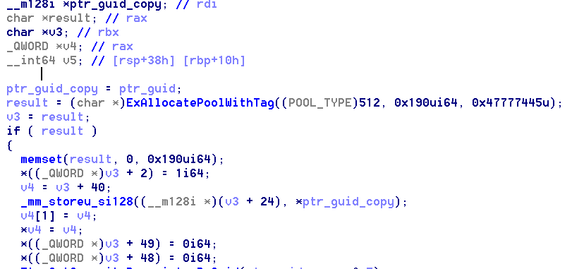
After obtaining a valid memory to the heap, it fills it with 0. The interesting thing here is that is not only allocating the guid size, but 0x190 bytes, which is much more that just the guid value. So clearly, here is initializing some kind of structure.

Some points about this code:
- The third qword will have a 1 . (seems to be equal to the SILO_GLOBAL)
- Starting from offset (0x18) the GUID will be stored. (seems to be equal to SILO_GLOBAL) (starting to think that is not SILO_GLOBAL the correct structure but some thing inside of it) .
- V4 points exactly to where the GUID ends. (GUID is 16 bytes long). That place is full with 0. The rest, also, all with 0’s.
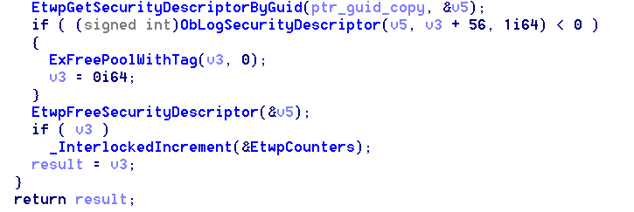
The if body continues (we’re still inside the body of the if) with a call to a function that returns the descriptor of the guid. This part is not critical for us right now, and therefore I’ll analyze it later.

Summary
The EtwpAllocGuidEntry() as expected, when successful, returns a pointer to a kind of structure. This structure seems to be almost the same as we were talking before (SILO_GLOBALS). The thing is that this structure has only 0x190 bytes of length. Which means that is not SILO_GLOBALS but is maybe some structure that is inside it.

Returning back to the main function we want to analyze now (EtwpAddGuidEntry):
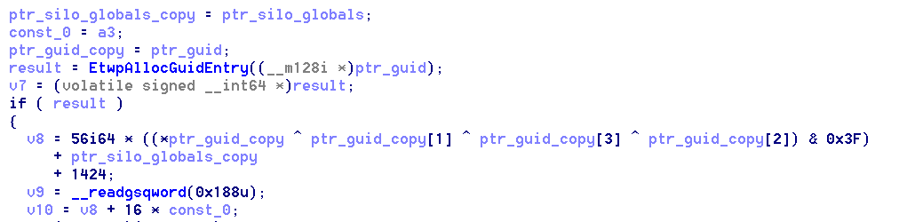
This is the first part of the code it shows. As we can here, after getting a successful pointer to the “GUID structure”, it calculates, the same way as we analyzed in the first part, the pointer to (I supposed) the GUID will be written to.
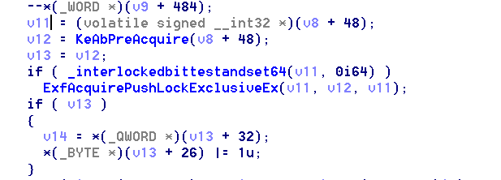
The code continues like this (still inside the if). No so sure but I think this is not relevant. Should pay into account later.

Last part of the code (and the most important one) is:
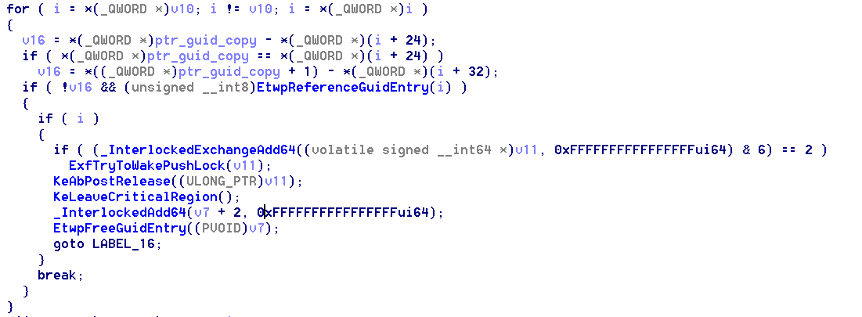
Basically here. What is happened is that if the GUID is already in this double-linked list of GUIDS, then it replaces it (goto LABEL_16). If it’s not there:
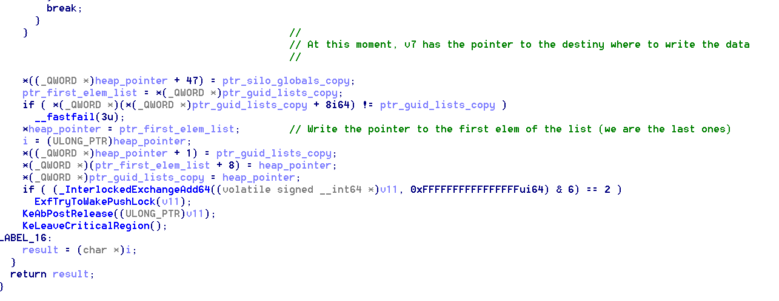
(this code is once the for is ended)
So if the GUID wasn’t found, it means that this GUID structure should be included in the double-linked list, and therefore it makes all this tasks in order to add it. One key thing here is the first line. The first line shows that ALL this structures will have the pointer to the SILO_GLOBALS structure at offset 47.

Continuing with the flow of the functionality, after some couples of calls, it calls the function
EtwpAddKmRegEntry, which was crucial in this analysis because it clarified a lot of things. Before going in depth with that function let’s recap:
Throughout this analysis, we believed that the structure of interest was SILO_GLOBALS. Although everything started there, the truth is that that is not our structure. Our structure of interest is _ETW_GUID_ENTRY. After some time understanding how this structure was filled, I realized that was totally different to the one that we used to think. Then, I started thinking that it was a undocumented structure. Once I managed to understand which was each object, I found the documentation online. This structures explained the weird offsets that the previous functions were trying to calculate (summing 0x590), (multiplying by 56) etc.
The analysis of the following function was worth due to it allowed us understand a second structure crucial in this analysis, which so far, I think is isn’t documented.

For the sake of understanding and tidiness I’ll add a full explanation on how this process works at the end of the document.

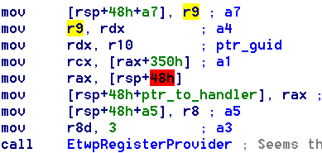

EtwpAddKmRegEntry(p1, p2, p3, p4, p5)
Before going in details to the code, let’s see something.
EtwpRegisterProviders must return a handler to the _ETW_GUID_ENTRY in some moment due to that’s the return value of EtwRegister and EtwRegisterClassicProvider.
In order to do this, EtwRegister, passes by reference the position where this handler should be placed (it cames in r9 according to MSDN documentation):
EtwpRegisterProvider, saves this pointer in a local variable in the stack and also reserves a variable to store the actual value of the handler. (4 lines in the first basic block of the function / last 3 lines of the BB)
Before calling EtwpAddKmRegEntry, we can see how this variable is passed to the function as the fifth parameter:
Once the value is written in the local variable, then it finally stores is in the address that was provided by EtwRegister or any other caller:
Now that we understand all (almost) the parameters, let’s see the code.
It receives 5 parameters:
- ptr_to_guid_entry (p1): Pointer to the Guid entry structure
- id_code(p2): I’ve called like that. It’s the number that sends the caller of EtwpRegisterProvider in R8 (EtwRegister sends a 3, EtwRegisterClassicProvider a 2)
- ptr_enable_cback: Pointer to (function?) for using callbacks. Second parameter of EtwRegister (look msdn documentation)
- a4: No so sure what it is yet.
- local_var_addr_4_handler: This parameter is the address were the handler will be placed. It’s a local variable of the function EtwpRegisterProvider.

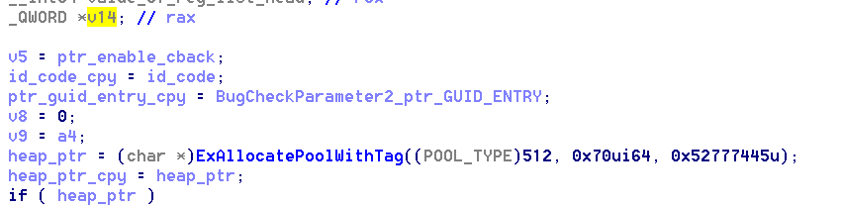
This first part is simple. Some copies of the parameters, to local variables and, the most important thing here, a memory allocation of 0x70 bytes.
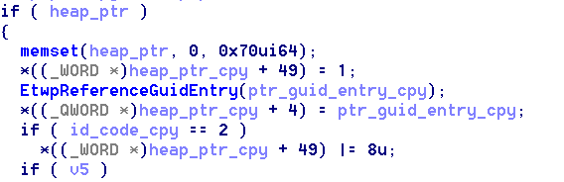
Once we get a valid pointer to the heap, it initializes it with 0’s.
Then:
- Sets the base+0x62 with 1.
- Sets the base+0x20 with the ptr_to_guid
- Depending on the id_code it xors the stored 1 with 8.
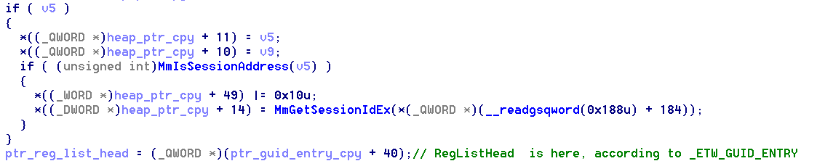
If v5 (copy to the ptr_enable_cback) was set, then some other stuff from this structure will be filled in. For the sake of the analysis we want to do right now, is not crucial to understand it. Anyways, I should continue with this part In the future.
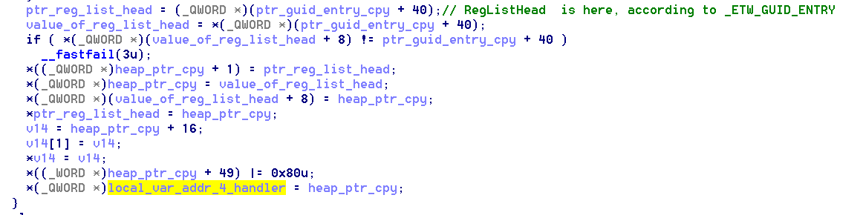
Once that if is ended (but we’re still in the big if) this code is executed.
Basically speaking, what this piece of code is doing until the (v14 = …) line is reached is to add the ptr_guid_entry in the double linked list (adding it before the first one and after the last one, as the last element of the list). An it also saves the value to previous and the next of the ptr_guid_entry in the current structure with offsets 0x0, and 0x8 .
I’m not so sure what is doing this but seems that with the 3 lines regarding v14, I t is filling base+0x10 and base+0x18 with the pointer to base+0x10.
It xors again the value of 0x62 with 0x80 this time.
And finally, maybe the most crucial part, it saves the pointer to this structure in the local variable of EtwpRegisterProvider. Return value is 0 if success.

Handler structure (partial)
Seems that we have here a kind of structure (undocumented?) that we successfully reverse some part of it, at least the most important for us:

- LEN == 0x70
- 0x00: Pointer to previous in the list
- 0x08: Pointer to next in the list
- 0x10: Pointer to 0x10?
- 0x18: Pointer to 0x10
- 0x20: Pointer to _ETW_GUID_ENTRY
- …
- …
- 0x62: Some special number

