nt!NtPowerInformation

Code Analysis
This function is pretty big:
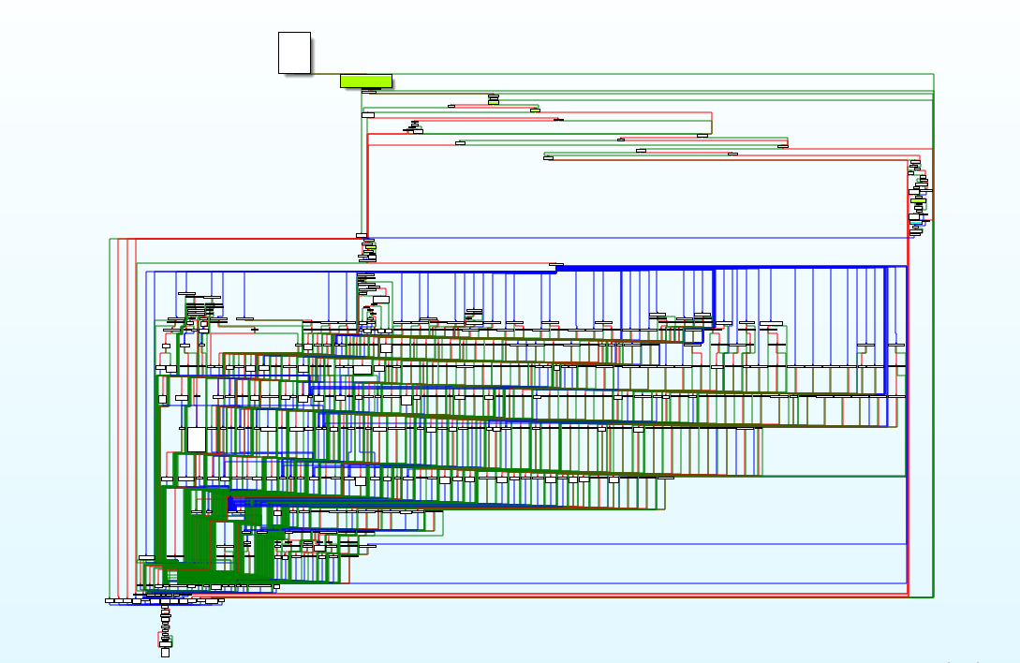
So i’ll be focusing not in the details but in the important things of this function.
It receives 5 parameters:
- Operation id will be the number to indicate what action we should do.
- A2 is the key argument. Will explain why in seconds
- A3 it’s a length, strongly related with A2
- some_ptr and some_ptr_len are not too important for us.
According to the function definition, A2 should be of type SIZE_T. In fact, the problem here is that this function has a switch of 90 cases, an A2 is used in different ways depending on the case. In order to decide which case to use, the Operation ID (id from now on) parameter is used.
Tracing a real execution of this callstack with windbg a figure it out some interesting stuff..
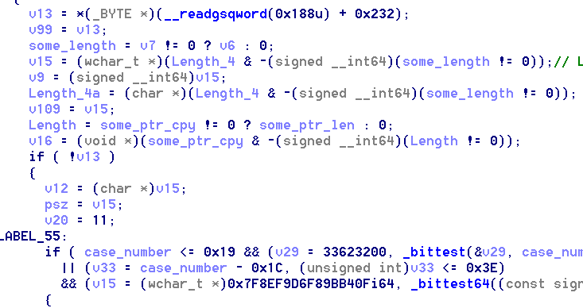
This code shows some actions that only performed if the id is < than 90. In our case the value is 0x2c. As we can see there v13 gets some value from some fixed thing.
What is that? I guess (from reading some blogs) it’s a kind of pointer to the ETHREAD structure which is always(?) allocated in the position 0x188 of the GS (segment). In particular the first part of the structure of ETHREAD, is another structure KTHREAD, which in the position 0x232 has a field called “previousMode”. Something related to user/kernel?
In our case, this value is filled with something different from 0, therefore the the execution doesn’t enters here. FYI, In LABEL_55 after the if, it starts the big switch.
Continuing the execution without that if we can find a bunch of other if’s asking for the value of the id (renamed as case_number):

Our execution finally ends in :
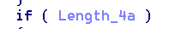

Length_4a is a copy of A2 casted to char *.
After a couple of other conditions, it finally gets:
which basically, stores the some_length bytes (in our case 0x18) of Length_4a inside v12. And almost immediately goes to LABEL_55 (switch part)

Inside this LABEL_55 after accomplishing some other if conditions, it finally start switching, and once the 0x2c case is reached, it executes:
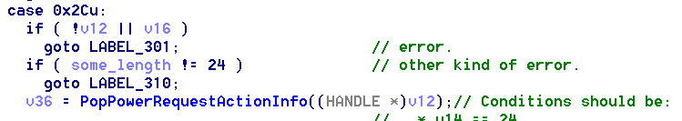

General picture analysis
So as summary:
It receives something in A2 which seems to be HANDLER *. It copies it to the variable v12, and finally it calls the PopPowerRequestActionInfo() which this value as parameter.
I tried to get the object from this handler without too much luck:

Recovering object from handler
My idea was to see the information that the object has because in the further functions, some conditions about it area required.

Object type
From source code, we can gather the execution of following function:
where a1 is the content of the handler (in our case, 0x2d8). So that’s a clue for the type of object..
I afterwards executed:
kd> !object \objecttypes
where one of the outputed lines was:
This means that once we have the object header of the object, we can just check that the type of it ‘PowerRequest’.

Object header to object type (object type table)
Although the object header holds the object type, it’s not direct. The object header has a field called typeIndex, which is and index inside a table of types. So first, we should understand how which is the typeIndex for our type PowerRequest.

The address of the type table is exported by a symbol called nt!ObTypeIndexTable. Therefore:
kd > dp nt!ObTypeIndexTable
Executing this line allowed me to get the address of this table (0xfffff801`dc1ad900)
Once I had the address I started iterating this table in order to find the type we were looking for:
kd > dt nt!_OBJECT_TYPE poi(fffff801`dc1ad900+(@$ptrsize * x))
After a couple of minutes, finally we reached our goal:
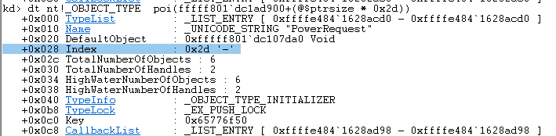
So, once find the object type of the object we are looking for we should check if the typeIndex is the one we are looking.

Getting the handler entry (not working)
The address of the handler was: 0x2d8 (which means it’s a user handler)
I located the Handler table base address of the related process by executing:
kd> r? $t0 = @$proc->ObjectTable
kd> r? $t1 = @$t0→TableCode
kd> r @$t1
$t1=ffffaa0096713000
Both of the two less significant bits seemed to be already cleared so don’t need to mask them.
Once I had that this address, I did the following:
kd>nt!_HANDLE_TABLE_ENTRY ffffaa0096713000+4*(0x2d8&0x3fc)
but the result doesn’t seem to be good:
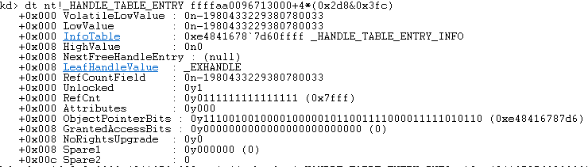

Getting the Object header from the object reference
As I showed before, inside the PopPowerRequestActionInfo() there is a call to the ObReferenceObjectByHandler, which, according to https://docs.microsoft.com/en-us/windows-hardware/drivers/ddi/content/wdm/nf-wdm-obreferenceobjectbyhandle in the fifht parameter it receives a memory address were a pointer to the object body will be placed.
In assembler:

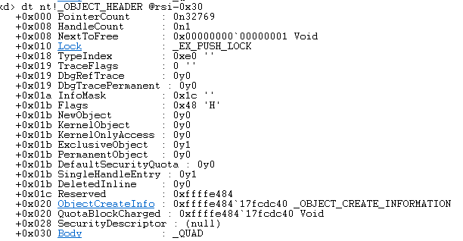
At this moment, the pointer to the object is inside rsi, but , I wasn’t able to get the Object header. What I did PoCreatePowerRequest?
Which at first seems to be valid, but that TypeIndex is not valid at all.

