Orbit’s Magnification Algorithm
Lucas Mendes Menge

Overview

Here is the code to the algorithm:

// general control variables
int MagnificationDelta=ProgramConfig.IconMagSize-ProgramConfig.IconMinSize;
float DistanceFromCursor=(float)Math.Sqrt(Math.Pow(Cursor.Position.X-(ItemRegistry[i].Rectangle.X+ProgramConfig.IconSize/2), 2)+Math.Pow(Cursor.Position.Y-(ItemRegistry[i].Rectangle.Y+ProgramConfig.IconSize/2), 2));

// arbitrary settings for the magnification
float SteepRate=ProgramConfig.IconSize*2/3;
float MagnificationBalance=0.6f;

// calculating the percentage of magnification
float distPercent=(SteepRate/DistanceFromCursor)*MagnificationBalance;
if(distPercent>MagnificationBalance)
distPercent=(SteepRate-DistanceFromCursor)/(SteepRate)*(1-MagnificationBalance)+MagnificationBalance;

// calculating new icon size based on the delta and percentage
float NewIconSize=(float)ProgramConfig.IconMinSize + ((float)MagnificationDelta*(float)distPercent);

// blend with transition effects
float blend=(float)ItemRegistry[i].ColorKey.A/(float)ProgramConfig.IconAlpha.A;
if(blend>1)blend=1;
NewIconSize=NewIconSize*blend+ItemRegistry[i].Rectangle.Width*(1-blend);

// apply
ItemRegistry[i].Rectangle.Width=NewIconSize;
ItemRegistry[i].Rectangle.Height=NewIconSize;

Explanation

The Magnification Formulas

The algorithm base is composed basically of two functions:

From line 12
¹distPercent=(SteepRate/DistanceFromCursor);

From line 14
²distPercent=(SteepRate-DistanceFromCursor)/(SteepRate);

These are shown here in a slightly different form than in the code above. That is because in the code above they are being linearly transformed. We will go into that later.

Function 1 is a function that follows the following graph:

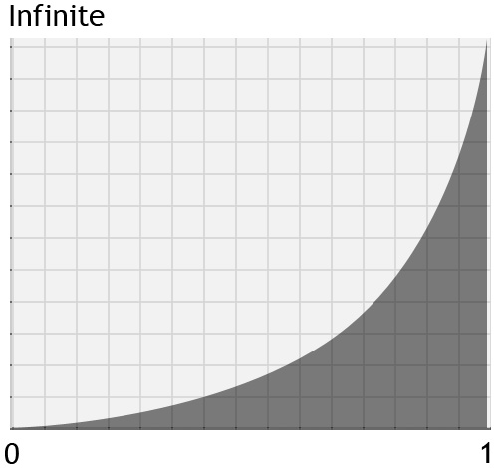
It is a function that starts at zero and, upon reaching one, tends to infinite.

Function 2 is a function that follows the following graph:

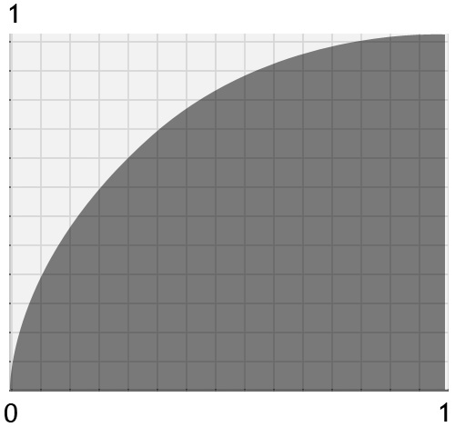
It is a function that starts at zero and, upon reaching one, tends to one.

SteepRate

This formula defines the curvature of the Magnification Functions. The higher the value of this, the more curved the Magnification functions are. The lesser this value is, the more straight lines those are. Here I use the Icon Size as reference so that it adapts to the Orbit size. This is the mechanism used to determine the smoothness of the magnification, but the linear transformation of the functions can also be used to regulate different nuances of the magnification, which is the next topic covered.

The Transformation

These functions are, in the code, being linearly transformed. Here is their transformed form:
¹distPercent=(SteepRate/DistanceFromCursor)*MagnificationBalance;
And
²distPercent=(SteepRate-DistanceFromCursor)/(SteepRate)*(1-MagnificationBalance)+MagnificationBalance;

Putting the math in words, what the code above does is: It transforms the first function to the first 60% of its original value, thus becoming this:

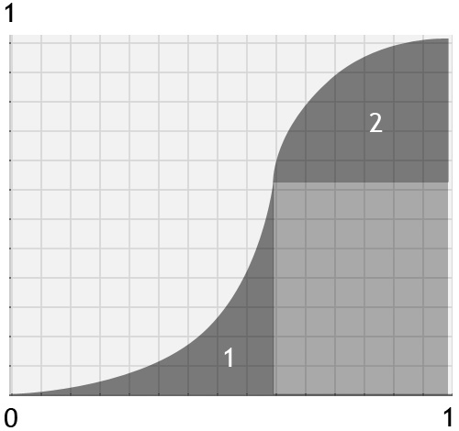
This clearly represents how the magnification will be. From far (0), icons will be very little magnified and from close (1), they will have full magnification but softer than in the middle/approximation phase.

By changing the MagnificationBalance value to another value between 0 and 1, you can re-balance the equations as wished. These values are taken into consideration in the following conditional sentence:

if(distPercent>MagnificationBalance)

For this sentence is what defines what math should be done.

Defining The Icon Size

float NewIconSize=(float)ProgramConfig.IconMinSize + ((float)MagnificationDelta*(float)distPercent);

The earlier sentence defines the final size of the magnified icons (not considering the transition effects which are done in another process). Going into more depth here, you will notice that the IconMinSize is fixed while only the MagnificationDelta is subject to the magnification ratio. The MagnificationDelta is the delta between the Magnified and the Minified size of the icons. The magnification will only occur in that region.

DistanceFromCursor

This value simply means the distance from the cursor to the very middle of the icon. Since Orbit is round and not a straight line. It takes into consideration the position of the cursor being anywhere around it. This formula is simply Pythagoras, where the X and Y position of the mouse on screen subtracted by the X and Y position of the middle of the icon are the sides of the triangle and the distance from the mouse to the middle of the icon is the hypotenuse.

Blending With Transition Effects

The blending process just uses a proportion to blend the magnified size with the size that the transition effects determine. No need to go into this since it is just basic proportions.

Applying The New Size

This region simply transfers the calculated data to the icon.

Copyright ©2004 Lucas Mendes Menge

