Short Hits
Bike tech) From left, Kyle Kozar, Erik Carter, and Noah Silverman wheel and deal.
Written by Kris Vagner Photo by fllicia Santistevan

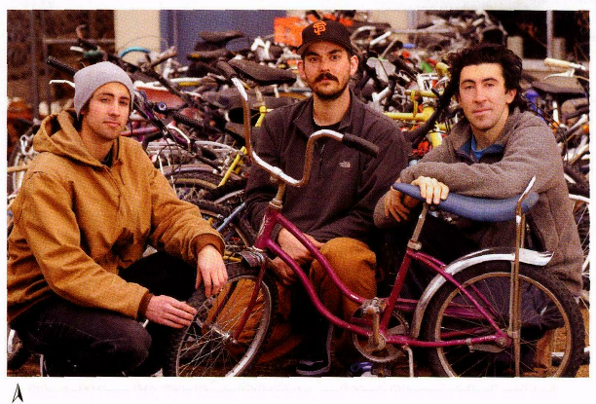

finders keeperspedaling forward
K
Volunteers strive to create a community and support for cyclists.
yle Kozar, co-founder of the Reno Bike Project, and collaborators Noah Silverman and Mike Burke have high hopes for Reno's cycling community. If they get their way, Reno will one day have a place where people can drop by to work on their bikes, learn about fixing bikes, buy a used bike, or donate a bike to charity.
"We want to build a center where any cyclist can come and work on his or her bike and hang out, volunteer, help other people," Silverman says.
The trio wants to make Reno a more eco-friendly, healthy, culturally rich, and communal city. Gathering enough resources might take a while, but ambitious plans always start with small steps, and members of the Reno Bike Project have been gathering momentum by capitalizing on existing resources.
Group members have begun to establish a public profile by distributing stickers, setting up a booth at the California Avenue Holiday Stroll, and holding a benefit Bike Art exhibit at Never Ender Gallery. The Bike Project's 100-subscriber mailing list keeps members in touch. An artfully designed Web log serves as a virtual community where bikers posr photos, event notices, and assorted links to other cycling and art communities. Virtual presence isn't the Bike Project's only public appearance, however. On Tuesday nights, Bike Project volunteers pool efforts with the Reno Sparks Kiwanis Bike Program. They meet at the Kiwanis' warehouse to help repair donated bicycles, which Kiwanis members distribute to elementary schools.
"They help out a lot of people every year with free bikes," Silverman says. "We feel like we can help out a lot just by helping them."
Kiwanis Bike Program Coordinator Ellen Jacobson says Reno Bike Project volunteers' extra hours helped Kiwanis members give away 185 bicycles at Christmastime.
To get involved or stay tuned for volunteer opportunities and fund-raising events, visit renobikeproject.blogspot.com or e-mail renobikeproject@gmail.com.
Kris Vagner, who reports mostly on arts and culture in Reno, is a big bike enthusiast and would rather bike than drive.

Reno Magazine

