
Patient-Independent Multi-Horizon EEG Seizure Prediction: An Event-Level Evaluation of Generalization and Alarm Reliability
Student name | Mohammed Aariff L | Register / Roll No | AM.SC.P2ARI25014
Mtech specialization | Artificial Intelligence | Semester | 3
Project Guide | Dr. Anjali T | Co-Guide (if any)
Architecture Diagram:
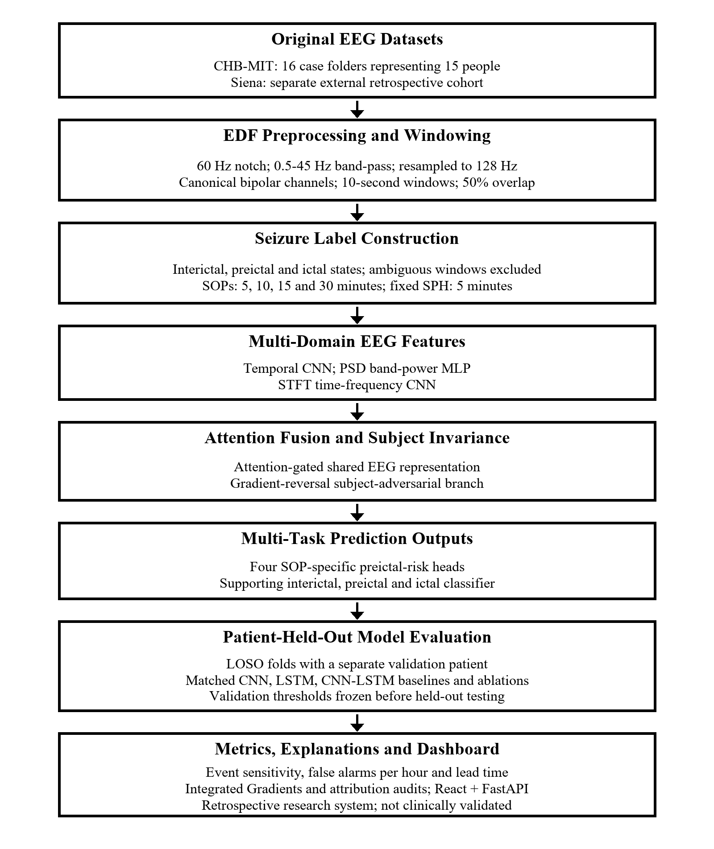

Main Methodology: This project investigates preictal seizure-risk prediction from multichannel scalp EEG with a shared model that produces separate 5-, 10-, 15- and 30-minute SOP outputs at a fixed 5-minute SPH. CHB-MIT is used for patient-held-out LOSO experiments, with one person reserved for validation and another held out for testing; chb01 and chb21 are grouped as one person. Temporal CNN, PSD band-power MLP and STFT CNN branches are fused with learned attention, with a gradient-reversal patient-adversarial branch in the full model. Matched CNN, LSTM and CNN-LSTM baselines and staged ablations are evaluated. Validation-only thresholds target prespecified false-alarm rates, while test results report event sensitivity, observed false alarms per hour and lead time. Integrated Gradients and perturbation audits examine EEG attributions. Siena provides a separate retrospective external check. The React and FastAPI dashboard presents results and EDF analysis. This is research software and is not clinically validated.

Module Description: Main Methodology and EEG Seizure Forecasting Architecture

1. Dataset Construction
The primary training and patient-held-out evaluation cohort is the locally available CHB-MIT scalp EEG subset: 16 case folders containing 463 EDF recordings and representing 15 unique people. Seizure onset times are taken from the accompanying case summaries. Siena is kept as a separate external retrospective cohort with 14 participants, 41 EDF recordings and 47 annotated seizures. The current working datasets are stored in D:\Original_Datasets; model training uses CHB-MIT, while Siena is used only for cross-dataset evaluation.

2. EEG Preprocessing and Window Labels
EDF signals are mapped to the project’s canonical bipolar montage, filtered with a 60 Hz notch and 0.5–45 Hz band-pass, and resampled to 128 Hz. Each recording is divided into 10-second windows with 50% overlap. For each seizure-onset prediction horizon (SOP) of 5, 10, 15 or 30 minutes, the preictal interval is defined using a fixed 5-minute seizure prediction horizon (SPH): [onset − SOP − SPH, onset − SPH). A supporting three-state label distinguishes interictal, preictal and ictal windows. Ictal and ambiguous windows are not treated as binary non-preictal negatives.

3. Patient-Level Splitting and LOSO Evaluation
The CHB-MIT experiments use leave-one-subject-out (LOSO) evaluation to estimate performance on people excluded from model fitting and threshold selection. A separate participant group is reserved for validation within each fold.
- Test group: one unique person is held out and used only for final fold evaluation.
- Validation group: a different person is used for checkpoint selection and alarm-threshold calibration.
- Patient identity: chb01 and chb21 are grouped because they represent the same person; the 16 cases therefore represent 15 people.

4. Shared Multi-Domain Multi-Horizon Model
The proposed model processes multichannel EEG windows through three feature branches. A shared representation combines temporal waveform, spectral power and time-frequency information, then produces seizure-state and horizon-specific prediction outputs. The full model adds an adversarial patient-identity branch through a gradient-reversal layer to encourage features that are less dependent on the training patient.
Temporal, Spectral and Time-Frequency Encoders
- Temporal branch: a one-dimensional CNN learns local waveform patterns from the raw multichannel EEG window.
- Spectral branch: power spectral density and band-power features are processed by an MLP.
- Time-frequency branch: an STFT representation is processed by a two-dimensional CNN to learn changing spectral patterns.
- Attention fusion: learned gates combine the three branch representations into one shared feature vector.
Subject-Invariant Learning
Adversarial branch: a patient-identity classifier is connected through a gradient-reversal layer. Its training objective discourages the shared EEG representation from encoding patient identity; this is an experimental generalization mechanism, not evidence of invariance in clinical populations.

5. Prediction Tasks and Training Objectives
The model has a three-class state output (interictal, preictal or ictal) and four binary preictal-versus-non-preictal outputs, one for each SOP. The training objective combines cross-entropy for seizure state with class-weighted cross-entropy for each valid horizon label. Horizon labels marked invalid because of ictal, ambiguous or exclusion intervals are masked from that head’s loss. Class weights are calculated using training-fold data only.

6. Training, Baselines and Ablations
Training uses patient/state-balanced sampling to address uneven patient and state counts. The ablation sequence adds temporal features, spectral features, full time-frequency and attention fusion, and then the subject-adversarial branch. Matched multi-horizon CNN, LSTM and CNN-LSTM baselines use the same patient folds and horizon labels. Validation mean horizon PR-AUC is used for checkpoint selection. A separate final checkpoint is fitted on all included CHB-MIT people for dashboard inference after evaluation; because it has no held-out test group, it is not used to claim independent performance.

7. Alarm Thresholds and Evaluation Metrics
For each SOP, the validation patient sets a threshold to maximize event sensitivity under 0.1, 0.5 or 1.0 false alarms per eligible interictal hour; the threshold is frozen before testing the held-out patient. Consecutive positive windows are merged, and an event counts as detected only when an alarm begins in its forecast interval. The false-alarm denominator excludes preictal, ictal and ambiguous time. Event sensitivity, observed false alarms per hour and lead time are reported separately from window metrics. Validation budgets are targets, not guarantees on unseen patients. A two-window persistence rule was tested separately.

8. Explainability and React FastAPI Interface
The system provides Integrated Gradients attributions for channels and time segments, time-frequency importance and learned fusion-attention weights. The saved explanation audit tests channel-rank stability across event windows and compares risk reduction from masking the most-attributed channels with random-channel masking. These are model-attribution checks, not proof that an explanation is physiologically meaningful. The React interface is served by a FastAPI backend; it displays stored evaluation results and supports EDF analysis with risk curves, EEG traces, spectral and STFT views, per-window predictions and explanations.

9. Retrospective Evaluation Results and Limitations
The following 30-minute SOP results are person-wise means ± sample standard deviations for the full multi-horizon model across 15 CHB-MIT people (chb01 and chb21 combined). The false-alarm value is measured on the held-out people; the budget is the validation target. Lead time is available for fewer people at some operating points.
- Strict target 0.1/h: event sensitivity 0.6% ± 2.2%; observed false alarms 0.02 ± 0.07/h; 14 of 15 people met the target.
- Target 0.5/h: event sensitivity 78.3% ± 35.2%; observed false alarms 0.81 ± 1.44/h; mean lead time 32.7 ± 2.7 minutes (13 people); 10 of 15 met the target.
- Target 1.0/h: event sensitivity 91.8% ± 14.7%; observed false alarms 0.57 ± 0.54/h; mean lead time 32.6 ± 3.3 minutes; 13 of 15 met the target.
On Siena, one frozen chb08 fold per model was tested using CHB-derived thresholds. At 30-minute SOP, the proposed model detected 0/47 seizures at the 0.1/hour target and 45/47 at 0.5/hour, with 9.13 false alarms/hour. This shows poor threshold transfer; dataset and montage differences are documented, but their role is untested. Fold-wise comparisons, event counts and person-level uncertainty are reported separately. The evaluation is retrospective, not clinically validated, and must not guide patient care.
Signature of Project Guide :
Date of Signature :

