Rédiger une intro un peu plus générale, parler des travaux du groupe de Nassia sur les souris.

The relationship between G-actin and MRTF-A is well documented MRTF-A binds 3 to 5 actin monomeres thourgh 3 RPEL repeats (posern 2004, mouilleron 2008, hirano 2011). The nuclear localization signal (NLS) is embedded inside the 3 RPEL (rajajyla 2010), thus making its availability dependent on G-actin binding. When actin is bound to MRTF-A, the NLS is hidden and MRTF-A is cytoplasmic (posern 2002 & 2004, miralles 2003), whereas when actin is scarce, the NLS is available and MRTF-A can accumulate in the nucleus. On the contrary, a G-actin scarcity in the nucleus has been shown to hinder MRTF-A exiting from the nucleus (baarlink 2012). The localization of MRTF-A in the cell is thus closely linked to the G-actin pool available to bind it and maintain it in the cytoplasm. Actin polymerizing drugs, such as jasplakinolide (miralles 2003, vartiainen 2007), highly polymerizable actin mutants (posern 2004) or actin sequestering drugs such as cytochalasin D empty the G-actin pool and send MRTF-A to the nucleus. On the opposite hand, non polymerizable actin mutants (posern 2002, miralles 2003), actin over-expression (miralles 2003, vartiainen 2007) or latrunculin B, which is compatible with MRTF-A actin binding, participates in sequestering actin in the cytoplasm. While the role of biochemical on this pathway has been widely studied, the influence of mechanical cues on the MRTF-A/SRF pathway through actin organization has been less investigated.

Mechanical cues are well known to induce reorganization of the actin cytoskeleton in a great variety of cell types and conditions (quelles refs ?). Both the mechanical properties of the substrate and the forces and strains the cells are subjected to can promote actin polymerization (idem refs). At the muscle level, MRTF-A and SRF have been shown to control the increase in muscle mass following a mechanical hyperstimulation and the atrophy following an immobilization, linking through this pathway mechanical stimuli and genetic response (Guerci 2012, Collard 2014). Our purpose is thus to bring together those different pieces, from the mechanically induced cytoskeletal reorganization to the MRTF-A/SRF transcription pathway. The main questions we want to address are: What kind of mechanical cues are able to reorganize the actin cytoskeleton enough to induce changes in MRTF-A intracellular localization? What are the timescales involved?

To answer, we used custom-built devices to apply mechanical stimuli at the cell level : a local force through fibronectin-coated microbeads controlled by magnetic tweezers, and a global deformation through stretchable PDMS substrate. The localization of MRTF-A was monitored through time with MRTF-A GFP transfection, and actin polymerization could be assessed through F-actin labelling with SiRactin (ref de la SiRactin).

Figure 1.2 Localization of MRTF-A GFP depending on tranfection reagent, actin overexpression and F-actin stabilizing fluorescent marker SiRactin

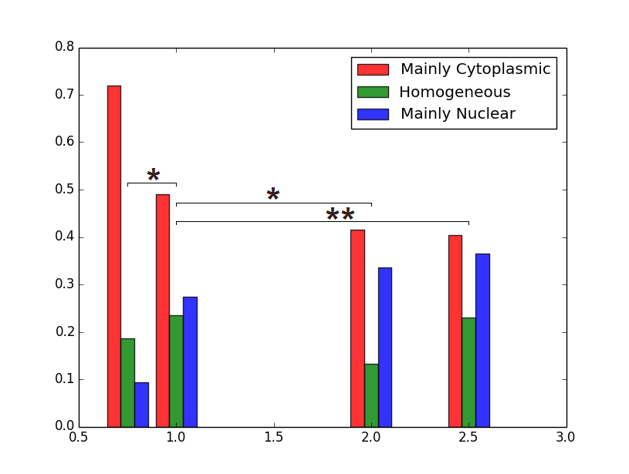

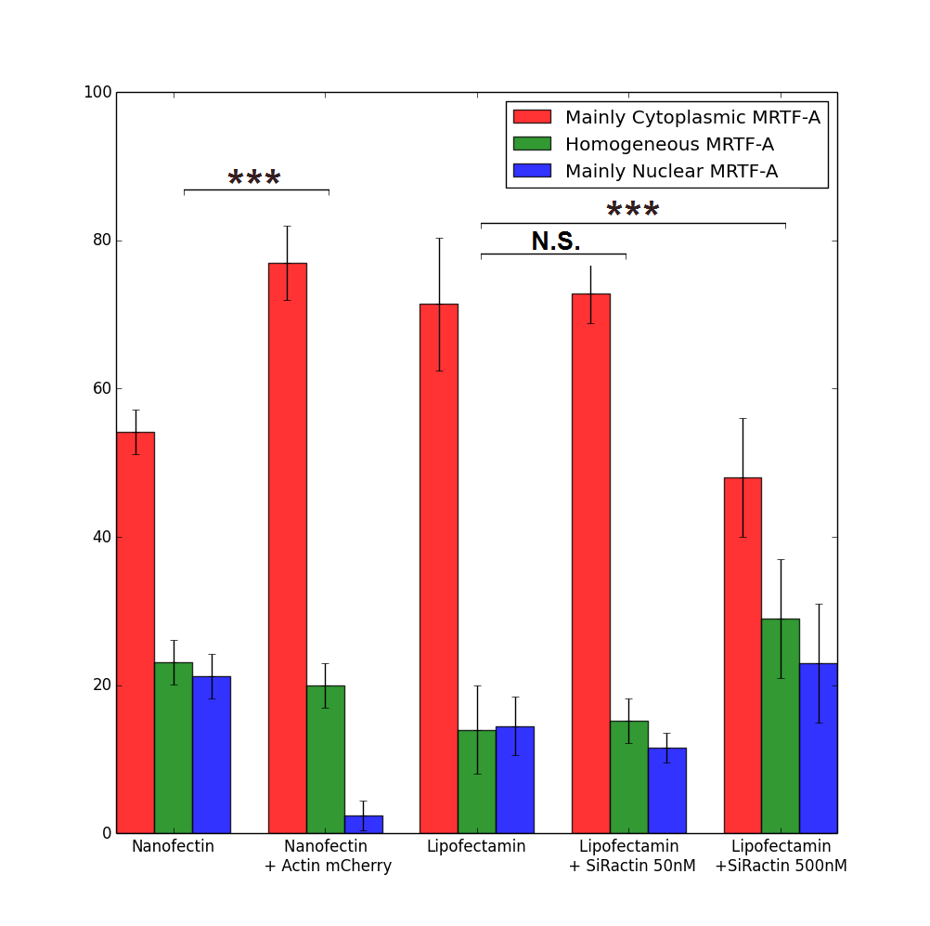

Figure 2.1 Localization of MRTF-A GFP depending on the mass of MRTF-A GFP plasmid DNA used for the transfection with nanofectine. More DNA leads to nuclear accumulation of MRTF-A due to its overexpression compared to the G-actin pool (0.75µg : 75 cells, 1.0µg 260 cells, 2.0µg : 113 cells, 2.5µg 126 cells).

Different levels of plasmid concentration were tested for transfection with nanofection, ranging from 0.75µg to 2.5µg for 110 000 cells. The localization of MRTF-A GFP in the cell was then observed by epifluorescence microscopy, and the cells were classified between three categories according to the main localization of MRTF-A GFP signal : mainly cytoplasmic, mainly nuclear or homogeneously distributed. At the lowest level of plasmid, MRTF-A GFP is mainly cytoplasmic in more than 70% of the cells, whereas at the highest levels, it drops to less than 40% of the cells. The more plasmid is supplied, the more nuclear MRTF-A is. This is consistent with the mechanisms known for the regulation of MRTF-A intracellular organization through G-actin binding : when MRTF-A is overexpressed due to many plasmid copies, there are not enough G-actin monomers to bind it and maintain it in the cytoplasm. The excess in MRTF-A is thus free to accumulate in the nucleus. For the following experiments, we always used the 1µg of MRTF-A GFP DNA dose, as a compromise between sufficient transfection efficiency and low overexpression.

For better transfection efficiency, we also tried lipofectamin 3000 with the same MRTF-A GFP dosage (1µg DNA for 110 000 cells). In the same experimental conditions, the localization of MRTF-A GFP was significantly more cytoplasmic (p=3.10-4) while the number of MRTF-A GFP expressing cells increased. Consistently with the previous dose-response experiment, the difference between the two transfection methods can be understood as lipofectamin 3000 delivering the same amount of plasmid to more cells, each of them experiencing less MRTF-A overexpression, leading to more cytoplasmic localization of the protein.

The same effect could be obtained by playing with the availability of MRTF-A partner G-actin. Co-transfection of mCherry actin leads to overexpression of actin and to a larger G-actin pool, contributing to the sequestration of MRTF-A in the cytoplasm as can be seen in the marked increase of cytoplasmic localization (figure 2), close to the results obtained with lipofectamin 3000. The opposite effect can be seen when using large concentration of SiRactin, a fluorescent F-actin marker derived from F-actin stabilizing drug jasplakinolide, on lipofectamin-transfected cells: the G-actin pool is reduced by the F-actin stabilization, and MRTF-A is accumulated in the nucleus, with only one cell out of two displaying a MRTF-A successfully maintained in the cytoplasm. A 10-fold lower level of SiRactin caused no measurable change in the initial localization of MRTF-A and was subsequently used for F-actin labelling.

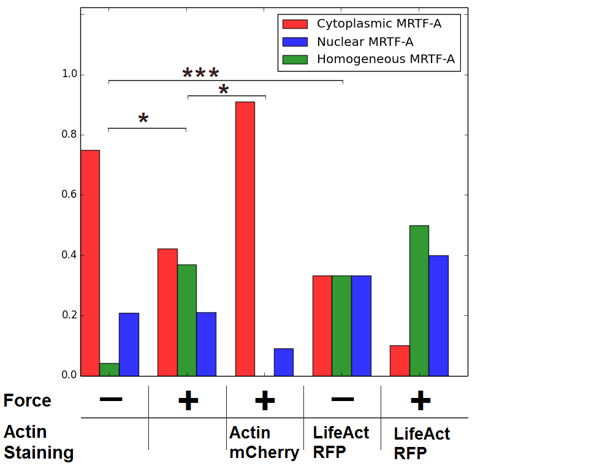

Figure 3 Final state of MRTF-A localization in cells subjected to 1nN force through a fibronectin-coated adherent microbead. The force was applied for 125 seconds repeated 6 times. Number of cells : 29 for the control, 23 with force, 11 with mCherry actin and force, 10 for control with LifeAct and 6 for force with LifeAct. P values were calculated with Fisher’s exact test (\*: p<0.05, \*\*:p<0.01, \*\*\*:p<0.0001). 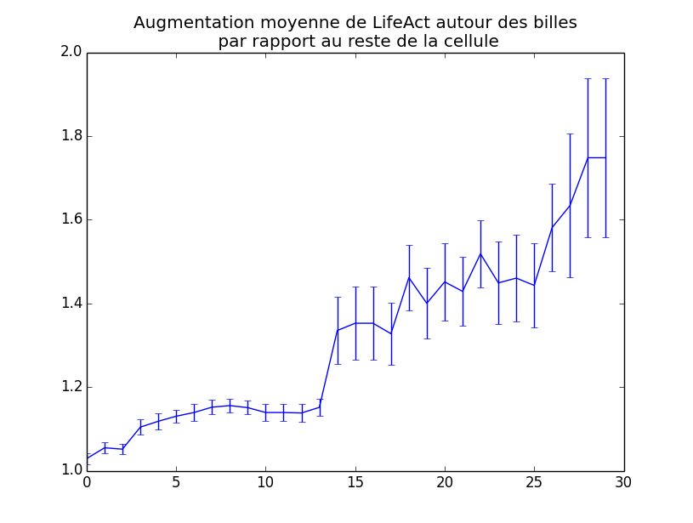

Figure 4 Increase of LifeAct fluorescent intensity around beads compared to the whole cell (6 cells).

The first experiments were done using magnetic tweezers which apply a 1nN force on adherent superparamagnetic fibronectin-coated microbeads (4.5µm diameter). The force was applied for 2 minutes, and then released for 2 minutes and this cycle repeated 6 times. The localization of MRTF-A GFP was observed at the end of each force application. The final localization of MRTF-A in different experimental conditions is shown on figure 3. Initially, the localization of MRTF-A is not significantly different in any of the condition, though the mCherry actin expressing cells already displays a more cytoplasmic localization (not shown). At the end of 6 cycles of force application, MRTF-A is significantly more nuclear in mechanically stimulated cells compared to control cells as expected if the 1nN force applied promotes F-actin polymerization. This effect can be blocked by overexpressing actin through mCherry actin co-transfection, for the bigger G-actin pool cannot be efficiently emptied by force-induced F-actin polymerization. In order to visualize increased actin polymerization in response to force, fluorescent LifeAct was cotransfected with MRTF-A GFP. Unfortunately, LifeAct had a strong F-actin stabilizing effect in our cells, causing MRTF-A to accumulates in the nucleus even in the absence of mechanical stimulation. However, a marked increase of LifeAct fluorescence intensity was measured around beads, with actin forming a ring at the attachment zone. A similar effect was previously observed on the same cell type with optical tweezers and RGD-coated microbeads (Icard 2008).

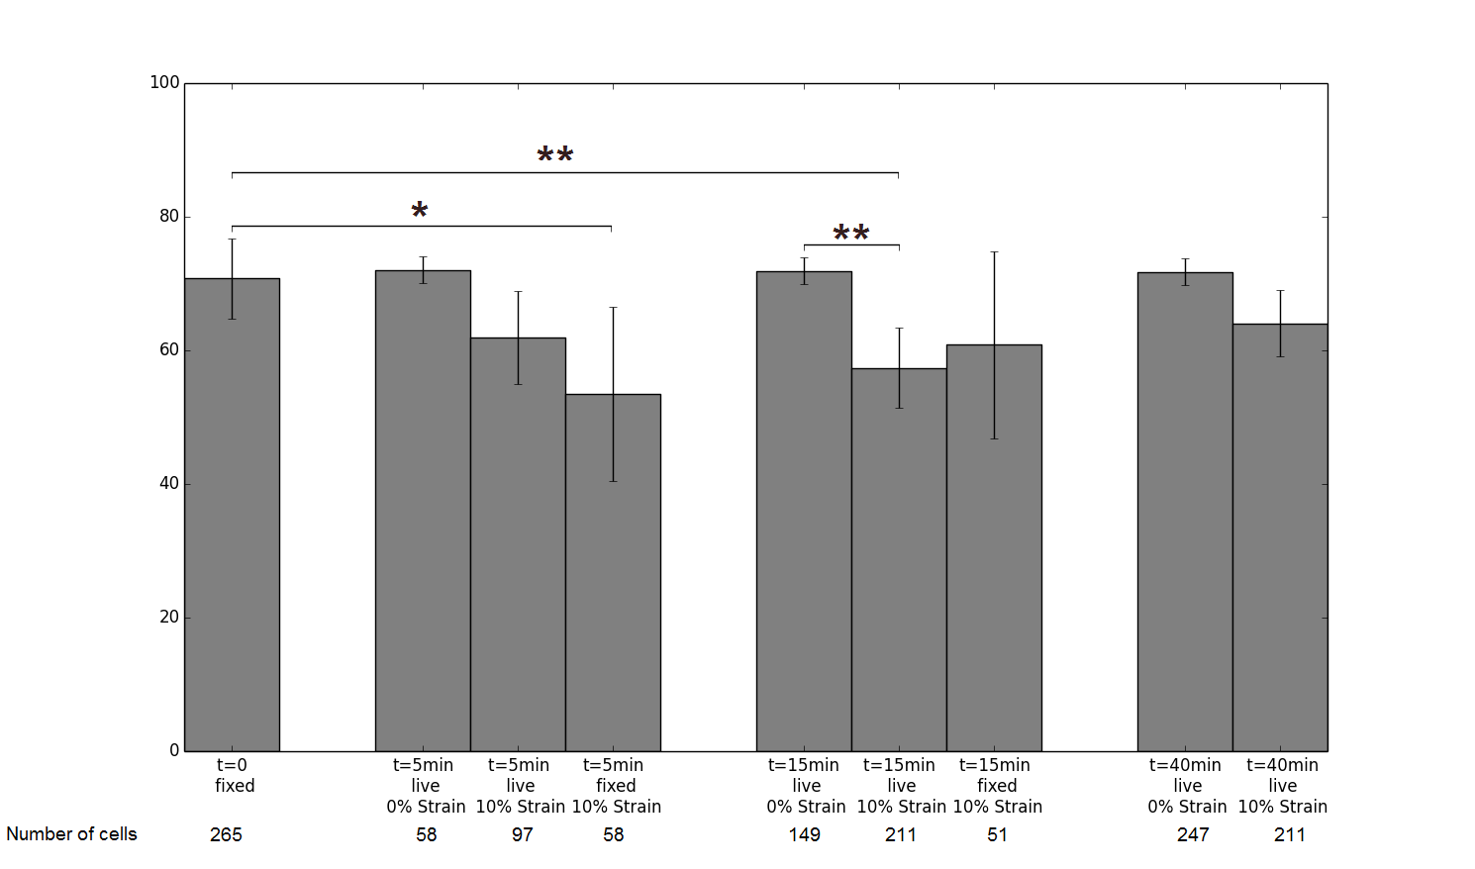

Figure 5 Proportion of cells where MRTF-A is mainly cytoplasmic at different times after the start of stretching.

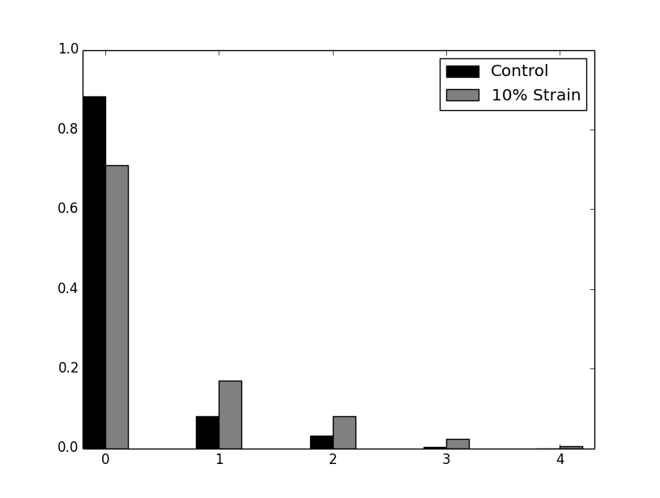

Figure 6 Proportion of cells experiencing 0 to 4 changes in MRTF-A main localization during the 120 minutes of observation (249 cells for the control, 211 for 10% Strain). p=2.10-5 (G-test).

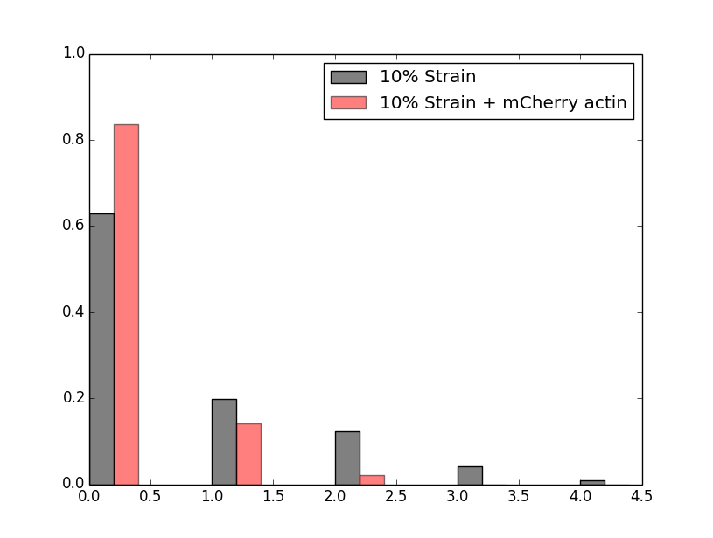

Figure 7 Proportion of cells experiencing 0 to 4 changes in MRTF-A main localization during the 120 minutes of observation after 10% stretching, with or without mCherry actin co-transfection. p=2.10-4 (G-test).

Trouver une transition entre les pinces et l’étirement.

Cells were seeded on stretchable fibronectin-coated PDMS disks, and subjected to 0 to 30% static strain at time t=0. They could be then fixed for further staining and observation after some time of stretching, or observed live to follow the changes of localization of MRTF-A through time after the start of stretching. Two different strain rates were explored, a moderate strain of 10% increase in area and a higher 30% strain.

The proportion of cells displaying a cytoplasmic localization of MRTF-A after 5, 15 and 40 minutes of stretching are shown on figure 5. Fixed experiments show a significant decrease in cytoplasmic localization as soon as 5 minutes after the stretch, whereas for live experiments, the number of cells observed at that time is not sufficient to conclude. However, at 15 minutes, when more cells could be found, live cells also display a marked decrease in cytoplasmic localization of MRTF-A. This is consistent with a mechanically-induced polymerization of actin which exhaust the G-actin pool, causing MRTF-A to relocate to the nucleus. The details of actin polymerization in response to strain will be addressed later in the text. During live experiments, the rate of changes in localization of MRTF-A can also be measured, for example by counting the number of times the localization changed for the 120 minutes of observation (figure 6). The number of cells exhibiting a relocation of MRTF-A is significantly higher when stretching.

We had two different ways to try and observe a more radical effect of the mechanics on MRTF-A localization: adding more MRTF-A so that the cells have a smaller G-actin pool, or applying a greater strain.

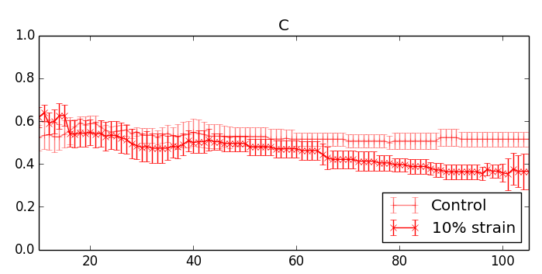

Figure 8 Proportion of cells with cytoplasmic MRTF-A through time after applying 10% strain at t=0 versus control.

Repeating the same 10% Strain experiment on nanofectin-transfected cells with a smaller G-actin pool, we observed a nuclear accumulation at longer timescales, up to a minimum in cytoplasmic localization of roughly one cell out of three around 90 minutes after stretching. The nuclear accumulation seems more durable and more important than for lipofectamin-transfected cells, consistently with higher MRTF-A to G-actin ratio. Dynamically, there is no significant difference in the number of relocation per cell between nanofectin and lipofectamin transfected cells. However, cells with mainly cytoplasmic MRTF-A accumulates MRTF-A in the nucleus more often when nanofectin is used, as expected when the G-actin pool is easier to empty, and cells with mainly nuclear MRTF-A expel it less often, as expected when MRTF-A is overexpressed. Altogether, a mechanical stimulation of 10% strain can induce nuclear accumulation of MRTF-A in myoblasts, and the scarcer the G-actin, the easier and more durable this effect can be. To test this hypothesis, mCherry actin is co-transfected with MRTF-A, in order to enrich the G-actin pool, which should lead to a reduction of the nuclear accumulation of MRTF-A. As expected, the nuclear accumulation and its dynamics is completely abolished, as the G-actin pool is too large.

Stretching at higher strain rates was expected to induce more polymerization of actin and a stronger nuclear accumulation of MRTF-A. However, though the initial response at t=5 minutes seems to be close to the one previously observed with 10% strain, the following events are very different. The nuclear accumulation at t=5minutes does not last, and is followed by a nuclear expulsion, so that at t=40 minutes the localization of MRTF-A is identical to the one of non-stretched cells. At longer timescales (t=80minutes), the cytoplasmic localization of MRTF-A is higher in cells subjected to 30% strain. The number of relocating cells is not significantly different than for 10% strain, but the relocation events are more often MRTF-A accumulating in the cytoplasm instead of in the nucleus. The response at higher strain is thus widely different from the one at moderate strain.

