The cytoskeleton defines the mechanical properties of the cell, such as its rheology and mechanosensitivity. Its state is highly dynamical, as the result of a constant interplay between the mechanical environment and the cytoskeletal genes.

The mechanical properties of the environment such as the rigidity of the substrate, the deformation or stress the cells are subjected to, are able to influence development and differentiation of the cells [reviewed in Janmey 2013]. Changes on the mechanical properties of the surrounding matrix or tissue can change cellular fate in diseases such as fibrosis, atherosclerosis or cancer, and the other way around changes in cell fate such as differentiation of immune cells can drastically modify their rheology [Bufi2015].
An increasing number of regulation pathways are linked with mechanical cues such as armadillo, YAP/TAZ and MRTF/SRF [reviewed in Mendez and Janmey 2012]. In development, the interplay between forces and deformation of the tissue organizes the embryo through gastrulation or neural closure [Li 2005], pointing towards the importance in following the mechanics of morphogenesis.

Adhesion proteins are in first line of the mechanosensory apparatus of the cell, cross-talking with the actin cytoskeleton. It ranges from the single protein scale, where cryptic sites can be unraveled by traction forces [reviewed in Janostiak 2014], to the global network scale with the reorganization of the lamellipodium during motion [review Blanchoin2014] or the realignment of stress fibers in response to cyclic strain [Mayakawa 2001, Ahmed 2010, Iba1991]. The main part of this signal converges towards the actin cytoskeleton as the central agent of mechanical organization.

Serum Response Factor [Sotiropoulos1999] and its cofactor Myocardin-Related Transcription Factor [Wang2002, Cen2003] are actin-sensitive transcription factors regulation diverse biological functions such as neural development [Kalita2006,2012], circadian clock [Gerber2013], fibroblast to myofibroblast transition [Gomez2010, Connelly2010] and muscle differentiation[Selvaraj2003, Guerci2012]. Together they control the expression of hundreds of genes, especially cytoskeletal genes such as actins [Esnault2014]. The MRTF/SRF pathway has been shown to be the main controller of muscle homeostasis in response to mechanical cues: it is mandatory to increase the muscle mass in response to a mechanical overload, and protects from mechanically-induced atrophy [Guerci2012, Collard2014].
The regulation of SRF by MRTF is controlled by the localization of MRTF in the cell: SRF is located in the nucleus where it can bind DNA, whereas MRTF is able to shuttle between the cytoplasm and the nucleus [Miralles2003, Vartiainen 2007]. However, since the bipartite NLS of MRTF is embedded in three G-actin-binding RPEL motifs [Mouilleron2008, Guettler2008, Hirano2011], the NLS is accessible only when actin is not already bound. Thus, the availability of actin monomers will determine the accessibility of the NLS and the intracellular localization of MRTF: when monomers are abundant, the NLS is hidden and MRTF is sequestrated in the cytoplasm, whereas when they are scarce, MRTF can be imported in the nucleus and bind SRF [Vartiainen2007, Rajakyla2010]. Since nuclear actin monomers can prevent SRF-binding even when MRTF-A is accumulated in the nucleus, the localization of actin and its polymerization state in the nucleus are of most importance : over-expression of actin-NLS [Vartiainen2007] blocks MRTF-A from binding SRF, whereas serum-stimulation induce nuclear actin polymerization through RhoA and mDia [Baarlink2013] and MRTF-A nuclear accumulation, and so does nuclear actin expulsion by MICAL-2 [Lundquist2014]

This actin dependence was originally studied mainly in response to biochemical cues such as serum [Sotiropoulos1999, Miralles2003, Vartiainen2007] and growth factor stimulation [Gomez2010, Scharenberg2014], which activates actin polymerization through RhoA pathway and both effectors RhoA [Zhao2007, Albinson2004] and mDia [Staus2007, Baarlink2013]. However, any signaling pathway changing the balance between monomeric and filamentous actin can be suspected to alter MRTF localization activity. Especially, actin polymerization pathways regulated by small GTPases including RhoA have demonstrated to be activated in response to mechanical cues [Zhao2007, Kuwahara2010]. Changes in the cell geometric constraints through micropatterning [Gomez2010] or changes in the rigidity of the substrate [Huang 2012] can alter the F/G actin ratio in fibroblasts and epidermal cells and activate the nuclear localization of MRTF-A and the transcription of SRF target genes. The application of a constant global strain for 24h also induce the transcription of the SRF targets in vascular smooth muscle cells [Albinson2004], and so does application of a cyclic strain of cardiomyocytes [Kuwahara2010]. In fibroblasts, a constant force applied through collagen-coated microbeads activates both RhoA downstream effectors ROCK [Zhao2007] and mDia [Chan2010], and the target genes are activated in hours. More recently, [Iyer2012] investigated a very rapid dynamical regime (less than 5 minutes) in live HeLa cells, and observed a rapid actin polymerization and MRTF-A accumulation upon global force stimulation. All but the last of these studies where realized on fixed samples, with only the last two [Zhao2007 and Iyer2012] exploring the question of the dynamics of the system, and finding very different answers (from 5 to 50 minutes) for the time it takes MRTF-A to be imported in the nucleus and whether there was a delay between actin polymerization and MRTF-A relocation.

Here we investigated the dynamical response of actin and MRTF-A to two different types of mechanical stimulation, local or global, at both timescales, and the unexplored question of the role of the level of force. We used skeletal muscle cells, that have seldom been studied in the context of MRTF-A/SRF, while this pathway is central in skeletal muscle adaptation to force. Using custom-built magnetic tweezers we showed that a local force applied through one bead could polymerize enough actin locally around the bead to relocate MRTF-A in the nucleus. We developed a stretching device able to apply controlled strains while enabling live following of the cells, and observed the relocation of MRTF-A at the two previously described timescales. By following actin in live and fixed samples, we linked those two regimes to the actin reorganization of two different parts on the cytoskeleton, apical stress fibers and basal actin. At higher strains, we showed that the first rapid response is maintained, while later the actin cytoskeleton is disrupted and MRTF-A is relocated in the cytoplasm.

The subcellular localization of MRTF-A is correlated to its expression level and to the globular actin level

To assess for MRTF-A localization during live experiments, C2C12 myoblasts were transfected with a plasmid coding for MRTF-A GFP [described in Vartiainen2007]. The localization of MRTF-A GFP in the cell was observed by confocal microscopy, and the cells were classified between 3 categories according to the main localization of MRTF-A : mainly nuclear, mainly cytoplasmic or homogeneously distributed, as illustrated of figure 1a. Different levels of plasmid concentration were tested with Nanofectin, ranging from 0,75µg to 2,5µg of DNA for 110 000 cells. Endogenous MRTF-A in non-transfected cells was localized through immunostaining to be mainly cytoplasmic for more than 85% of the cells, as expected from the literature. Transfected cells all displayed a less cytoplasmic localization, ranging from 70% for the lowest concentrations of plasmid, down to 40% for the highest concentrations (figure 1b). The more plasmid was supplied, the more nuclear MRTF-A was.
This is consistent with known mechanisms for the regulation of MRTF-A intracellular localization through actin-binding: when MRTF-A is overexpressed due to many plasmid copies, there are not enough actin monomers to bind it and maintain it in the cytoplasm. Exceeding MRTF-A is thus free to accumulate in the nucleus. Even the lowest plasmid concentration tested caused a significant increase in nuclear localization.
For all subsequent experiments, 1µg of plasmid was used, as a compromise between sufficient transfection efficiency and low overexpression.

Transfections were also later performed using Lipofectamin 3000, with the same dose of plasmid per cell. In the same experimental conditions, the localization of MRTF-A was more cytoplasmic than when using Nanofectin (figure 1c), while the number of MRTF-A positive cells was increased (quantification ?). Consistently with the dose-response experiment, the difference can be explained as Lipofectamin 3000 delivering the same amount of DNA to more cells, each of them obtaining less copies, thus experiencing lower overexpression and less nuclear accumulation of MRTF-A.

The hypothesis of MRTF-A over-expression causing the nuclear accumulation can be tested by playing with levels of available G-actin to bind it. Actin mCherry was co-transfected with MRTF-A GFP. As it increases the total amount of actin in the cell, it is expected to counterbalance the overexpression of MRTF-A and restore its cytoplasmic localization. Indeed the localization was very similar to the one in non-transfected cells as can be seen on figure 1c. On the other hand, adding SiRactin, a fluorescent F-actin marker derived from actin-stabilizing drug jasplakinolide caused an increase in nuclear localization of MRTF-A. The G-actin pool is depleted by the stabilizing effect of SiRactin on filaments, and it promotes MRTF-A accumulation in the nucleus. A 10-fold lower dose of SiRactin lead to no measurable effect on MRTF-A localization, and was used for F-actin labeling.

Local force application induces actin polymerization and accumulation of MRTF-A in the nucleus.

The first set of experiments for measuring the impact of mechanical cues on the localization of MRTF-A was performed using magnetic tweezers. A custom-build electromagnet was used to apply 1nN force to 4,5µm diameter super-paramagnetic beads coated with fibronectin. The force was applied for 125s, than released for 125s, and this cycle repeated 6 times. The localization of MRTF-A GFP was observed at the end of each force application (supplementary movie).

Cells transfected with MRTF-A GFP only as well as cells co-transfected either with F-actin labeling LifeAct RFP or actin mCherry all displayed initially mainly cytoplasmic localization of MRTF-A GFP (supplementary fig1). Cells expressing actin mCherry plasmid had a more cytoplasmic localization, though not significantly due to the limited amount of cells observed.

The final localization of MRTF-A after six force applications is shown on figure 2a. In absence of any actin labeling, cells subjected to mechanical stimulation show a marked increase in homogeneous and nuclear localization of MRTF-A. This was expected as optical tweezers experiments on the same cell type have already demonstrated that a polymerized actin ring forms around mechanically stimulated area of contact with the beads (Icard 2008). The increase in F-actin polymerization induces a nuclear accumulation of MRTF-A due to the shortage in G-actin. The overexpression of actin, such as induced by actin mCherry, prevents this shortage and thus completely abolished mechanically induced nuclear accumulation of MRTF-A. Surprisingly, though not causing any measurable changes in MRTF-A localization initially, LifeAct RFP transfection caused nuclear accumulation even in the absence of mechanical stimulation. LifeAct is suspected to stabilize F-actin if overexpressed (van der Honing2011, Courtemanche2016), thus changing the F/G ratio in cells in a way that interferes with MRTF-A regulation. Here the expression of LifeAct could have depleted the G-actin pool just under the nuclear accumulation limit, so that the smallest mechanical events, such as rinsing the cells to remove unattached beads prior to experiments, could trigger nuclear accumulation.

However, the use of LifeAct on mechanically stimulated cells enabled the observation of a forming polymerized actin ring around the beads (supplementary movie 2), through a 80% mean increase in fluorescence intensity compared to the bulk of the cell (figure 2b). Thus, we can confirm the mechanical response of the cytoskeleton even though the localization of MRTF-A is disturbed by the mean of observation itself.

Global cell stretching changes actin polymerization state and MRTF-A sub-cellular localization

Cells were seeded on stretchable PDMS disks coated with fibronectin, and subjected to 0 to 30% static strain starting at time t=0. They could then either be fixed for further staining and observation after some time of stretching, or observed live to follow the changes in localization of MRTF-A through time after the start of stretching. Two different strain rates were explored, a moderate strain of 10% increase in area and a higher 30% strain.

A moderate strain induces actin polymerization and nuclear accumulation of MRTF-A.

The proportion of cells displaying a cytoplasmic localization of MRTF-A after 5, 15, 40 and 90 minutes of stretching at 10% strain rate are shown on figure 3. The localization of MRTF-A is stable through time for non-stretched cells, around 70%±2%. When stretching at 10% strain rate, two phases can be observed through time: a first rapid nuclear accumulation between 5 and 15 minutes after stretching, followed by a partial recovery at 40 minutes, and a second nuclear accumulation at longer timescales, 90 minutes after stretching. The mechanically-induced nuclear accumulation seems to be more rapid in fixed experiments, with a minimum in cytoplasmic localization at t=5minutes, whereas this minimum is reached after 15 minutes in live experiments, though we could find no reason to explain such a difference in dynamics. The short-term results are consistent with the magnetic tweezers experiments, though the design of the later did not allow to prospect longer timescales. The experiment was also performed using Nanofectin with a focus on the longer timescales. Between 40 and 100 minutes after the stretch, the cytoplasmic localization of MRTF-A decreases significantly, down to only 30% of the cells, similarly to the results obtained with Lipofectamin 3000.

A closer look at the dynamics can be obtained by following the cells observed in live experiments changing from one localization of MRTF-A to another, and counting the number of such events. In control experiments (without strain), more than 80% of the cells display the same localization of MRTF-A throughout the whole 120 minutes of observation, whereas when stretched, this proportion is down to around 60% (figure 4). The number of events per cell is thus doubled by the mechanical input, reflecting the changes in localization seen previously. However, the dynamics of those events is evenly distributed through time, and no characteristic time, or synchronization between cells could be detected. Since the cells express MRTF-A-GFP and actin at their own levels, each one has its own threshold for nuclear accumulation of MRTF-A. Overexpressing actin through actin mCherry, as previously observed for magnetic tweezers experiments, completely inhibits the response to mechanical stimulation: the proportion of cells displaying a cytoplasmic localization of MRTF-A remains constant as in control experiments, and the number of events is also very similar (figure 4b). As expected, increasing the G-actin pool prevents its mechanically induced depletion, and confines MRTF-A in the cytoplasm.

In order to investigate actin dynamics and test our hypothesis regarding polymerization, the cells were strained with the new F-actin marker SiRactin [Lukinavicius2014]. As a derivative of jasplakinolide, SiRactin can be added to the cell medium directly and stain all the cells. Its fluorescence is higher when attached to actin filaments, reducing the noise of unattached SiRactin in the bulk. Thus it can be used during live experiments to follow actin polymerization through time: since low-fluorescent SiRactin is still present in the bulk, the presence of new filaments can recruit them, increasing the total fluorescence when they become attached.

The live SiRactin monitoring of stretched cells reveals two quick bursts of polymerization in response to strain, followed by a marked increase in polymerization levels after one hour of stretching (figure5). The polymerization levels are consistent with both the short term, and long term nuclear accumulation of MRTF-A described previously [Zhao2007, Iyer2012], where higher polymerization of actin is linked to more nuclear localization of MRTF-A. It should be noted that even non-stretched cells displayed a small increase in SiRactin intensity at longer timescales, revealing that the effect on the stabilization of filaments is still present event at those very low concentrations of SiRactin.

On fixed cells, SiRactin was used after fixation as a filament marker, and the cells were observed in detail through confocal microscopy. In the initial state, the stress fibers on top of the nucleus of some cells were parallel and organized as an actin cap, though a significant part of them had no stress fibers above the nucleus (figure 6a). After 5 minutes of stretching, nearly all the cell displayed such an organized actin cap, and the number of stress fibers above the nucleus, rescaled by the size of the nucleus, was doubled (figure 6b). This is synchronized with the minimum in cytoplasmic localization of MRTF-A. This actin reorganization is very evanescent, for 10 minutes later the actin cap has been restored to its former level. The overall level of actin in the basal level did not measurably vary, pointing toward the actin cap as the main origin of the early mechanically induced relocalization of MRTF-A.

Higher strains induce actin depolymerization and nuclear expulsion of MRTF-A

Following the same experimental protocol, cells were also stretched at higher strain rate, here 30% increase in area. The behavior of both actin and MRTF-A remains similar as 10% strain experiments for the very early stage of the experiment (figure 7). A well-characterized actin cap was formed at t=5min, with more than doubled number of stress fibers/micrometer above the nucleus, as shown on figure 6. However, shortly after this early response, the cytoskeleton seemed to fail sustaining such a high deformation. SiRactin levels start decreasing as soon as 10 minutes after the start of stretching, up to 30 minutes (figure 7b), alongside with a marked decrease in area (Supplementary ou insert), pointing towards damaged cytoskeleton and detachment from the stretched substrate. From t=20min, cytoplasmic localization of MRTF-A also become more frequent, with a rapid increase between 20 and 40 minutes after the start of stretching, and keep increasing as long as 80 minutes (Figure 8). The cumulated number of event per cell represented on figure 9, had increased nearly linearly at roughly 0,007 event per cell and per minute for 10% Strain experiments, showing equal distribution of events through time. For 30% strain experiments, events happens faster, at the rate of 0,01 event per cell and per minutes, from 20 to 40 minutes after the start of stretching. After t=40min, the rate of events resumes to the level of 10% strain experiments. Around 30 minutes after the start of stretching, at the time where actin polymerization and cell area reach their lowest point, there is a simultaneous increase in observed expulsion of MRTF-A from the nucleus. Thus, at higher strains, after an expected early response, the cytoskeleton is damaged, causing an increase in G-actin availability, leading to a more cytoplasmic localization of MRTF-A.

Discussion

Though all types of cell are now demonstrated to be sensitive to their mechanical stimuli and environment, muscle cells are a type specialized in exerting and feeling forces. As organs, the muscles grow and shrink depending on the amount of forces and deformation they are subjected to, implying the existence of a mechanotransduction pathway from the stimulus to the gene expression. On mice, the key regulator of this pathway was shown to be the SRF transcription factor and its coactivator MRTF (Guerci 2012, Collard 2014), which control together a number of muscle differentiation genes and cytoskeletal genes (Esnault 2014, Selvaraj 2003). This pathway has been widely studied in response to serum stimulation (Sotiropoulos 1999, Miralles 2003, Vartiainen 2007, Baarlink 2013), and RhoA activated polymerization through activation of the formins (Baarlink 2013, Staus 2007) and deactivation of cofilin through ROCK (). The pathway has been revealed to be controlled by the subcellular localization of MRTF-A , which can only meet and link with SRF in the nucleus when not bound to actin, but can be sequestered in the cytoplasm by binding monomeric actin (Posern 2002, Miralles 2003, Vartiainen 2007). MRTF has 3 actin-binding RPEL domains (Hirano 2011, Mouilleron 2011) embedding a two-part Nuclear Localization Signal (Rajakylä 2010). Thus, monomeric actin bound to MRTF masks the NLS, blocking its nucleo-cytoplasmic shuttling (Posern 2002, Miralles 2003). Serum induced RhoA activation, by polymerizing the cytoskeleton, can deplete the monomeric actin pool and activate MRTF nuclear accumulation.

Serum is far to be the only way to activate actin polymerization through small GTPases, and several of them, including RhoA, are already known to be mechano-sensitive (Zhang 2010). A response of RhoA/MRTF to different mechanical cues, in diverse cell types has already shown the pathway to be mechanosensitive at different timescales. Keratinocytes on micropatterned surfaces have displayed altered MRTF-A localization depending on the surface they have to spread (Conelly 2010). In cardiomyocytes subjected to cyclic stretch for 4 hours MRTF-A accumulates in the nucleus (Kuwahara 2010). HeLa cells subjected to a dorsal traction through hundreds of microbeads attached to their dorsal surface displayed an increase in actin polymerization and MRTF-A accumulation at a very short timescale of 2 minutes (Iyer 2012), whereas similar kind of stimulation on fibroblasts induced changes in actin polymerization at both short (5 to 15 minutes) and long (60 minutes) timescale, but on MRTF-A localization on longer than one hour (Zhang 2010). Of all those studies, only Iyer 2012 observed live cells, and only a small number of them (<12) at a very short timescale (<500s), though Zhao 2010 use fixed samples at different time points to investigate the dynamics of the RhoA/ROCK pathway. Here we wanted to explore the dynamical response at 5 to 100 minutes after the mechanical stimulation in live and fixed muscle cells, focusing on actin cytoskeleton modifications and its repercussions on MRTF-A subcellular localization, when they were subjected to different kinds and levels of mechanical stimulation.

The actin/MRTF-A balance was seen to be very sensitive to any perturbation of the polymerization dynamics of actin: every marker tested for actin visualization impacted of the localization of MRTF-A. Use of live filament markers such as LifeAct, F-tractin (not shown) or SiRactin enhanced MRTF-A nuclear localization because of their stabilizing effect on filaments, whereas the overexpression of actin by a fluorescent actin plasmid sequestered MRTF-A in the nucleus by increasing the G-actin pool. A locally induced actin polymerization around a mechanically stimulated bead was also sufficient to cause significant increase in MRTF-A nuclear localization, even though the global actin pool of the cell was not mobilized. Those elements show clearly how sensitive to modifications of actin dynamics MRTF-A is.
In response to a global strain or to a locally applied force, SiRactin revealed a significant increase in polymerized actin, depleting the monomeric actin pool enough to cause a nuclear accumulation of MRTF-A in the population of cells. As each cell has its own actin pool and MRTF-A overexpression level, the turning point is individual to each cell and only by comparing population of cells can we deduce the effect on our system. By the end of observation 90 minutes after the start of a 10% static strain application, about half the cells that initially sequestered MRTF-A in the cytoplasm displayed a nuclear accumulation. (More contrasted results were obtained previously on fibroblasts by Zhao et al, however fibroblasts can be starved beforehand to discard all serum-linked activity, which was not suitable for myoblast as it could partially activate differentiation pathways; moreover the force applied was more intense.) A reduced but noticeable effect was also observed for a force locally applied through an adherent microbead actuated by magnetic tweezers. As the actin polymerization is localized around the force application point, the effect on MRTF-A is expected to be less important, as the G-actin pool depletion is. At higher strains, though the start is similar to that of a moderate strain, the long term behavior is very different, as the cell partially detach from the substrate, actin cytoskeleton is depolymerized and the afflux of G-actin created cause a increase in the cytoplasmic confinement of MRTF-A. Thus, levels of strain can change completely the information transduced to the nucleus, with only a short time window of MRTF-A in the nucleus.
Interestingly, stretching and local force induced cytoskeletal reorganization with very different dynamics, depending on the parts of the cytoskeleton implicated. Local force experiment caused accumulation of actin around the bead in a thick dense layer within 30 minutes. In stretching experiments, the elements affected by the mechanical cues where mainly stress fibers, with apical stress fibers affected first and at short timescales from 1 to 10 minutes after the start of stretching, whereas the basal network of stress fibers was affected at longer timescales starting from 30 minutes to 100 minutes. The rapid apparition of stress fibers over the top of the nucleus resembled the actin cap creation under shear observed by Chambliss et al, and occurred within the same timescales. The creation of the actin cap was similar at both strain rates, with a slightly stronger reaction for the higher stain. The actin cap creation depleted the G-actin pool enough so that MRTF-A started to accumulate in the nucleus. It can be noted here that the MRTF-A relocation is very fast. That could be related to the actin cap being very close from the nucleus, thus the depletion of actin is localized in the perinuclear region, where MRTF-A can enter directly the nucleus. It could be also linked to a mechanically induced deformation of the nucleus, which could increase the opening of nuclear pores and facilitate MRTF-A transport. Further investigations are needed to test those hypotheses.
At longer timescale, the basal stress fibers reorganizes, polymerizing at moderate strain, depolymerizing at higher strain. The increase in actin filament fluorescence in moderate strain experiments is progressive, starting around 40 minutes after stretching and continuing for one hour. At the same time, MRTF-A relocates to the nucleus at a constant rate for the whole duration of the actin polymerization, as expected, and stabilizes when the polymerization stops. On the contrary, at higher strain, the cytoskeleton does not cope well with the imposed deformation: their area decrease rapidly between 20 and 40 minutes after the start of stretching, along with a depolymerization of basal actin. As the process liberates actin monomers, MRTF-A can be efficiently sequestered in the cytoplasm.
The two different strain rates induced different dynamical patterns in the localization of MRTF-A: in the case of a moderate strain, the protein will be transported to the nucleus from the start and confined inside at longer timescales of at least two hours, while subjected to a higher strain, MRTF-A is sent to the nucleus only for 10 to 20 minutes and the excluded. It is possible that the transcription activated by those two dynamical signals is indeed different, for in the case of higher strains, only the genes whose transcription can be activated en less than 15 minutes could be expressed, and even those activated would be for shorter times, and this should be the subject of future works. The static study of MRTF-A localization at a given time could thus not be sufficient to apprehend the activation of SRF target genes.

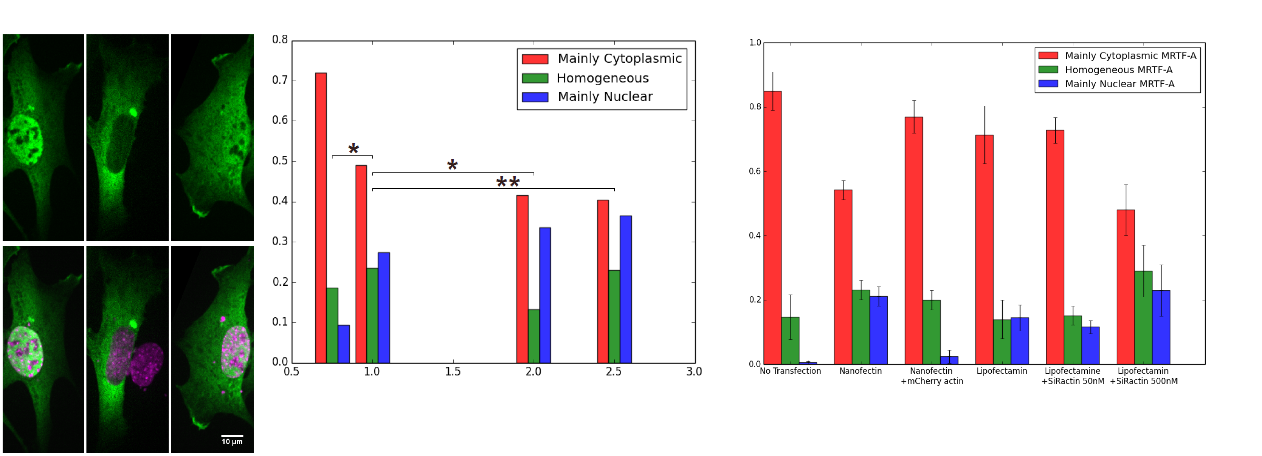
Figure 1

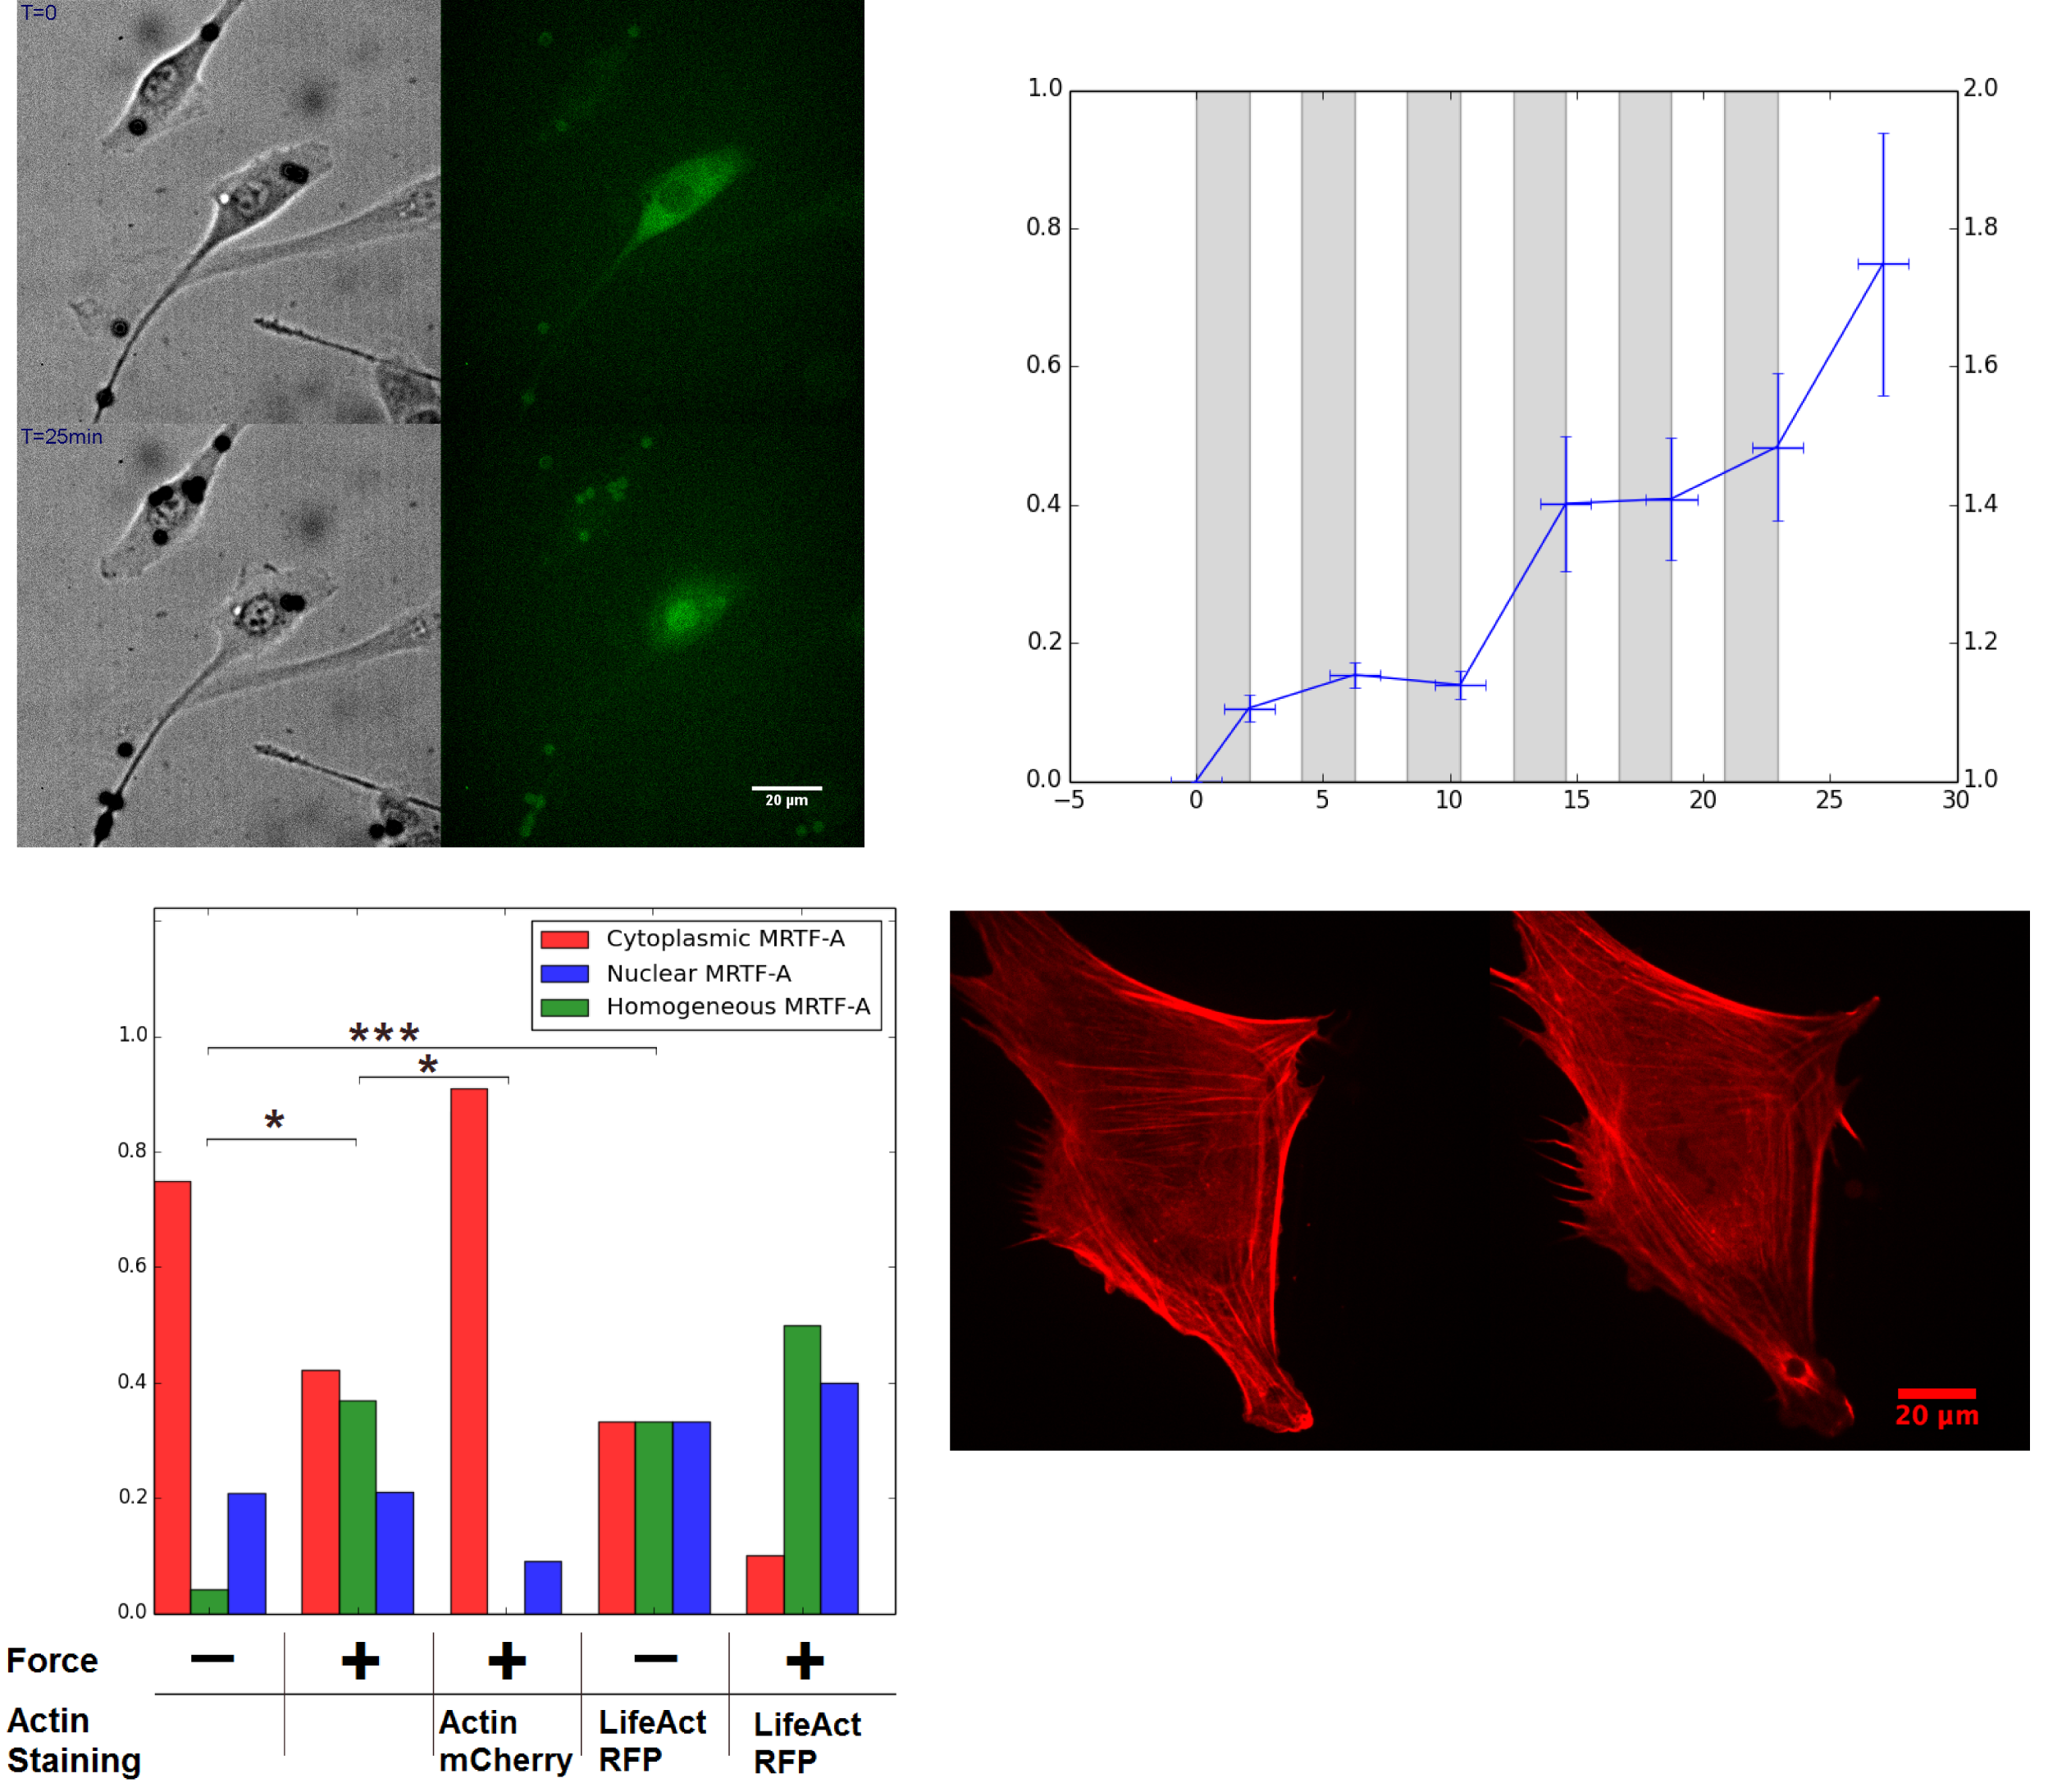
Figure 2

