

OMEdit
OpenModelica Connection Editor
User Manual
Version 1.7.0

April 2011

This Description is Extracted
from Chapter 2 of the OpenModelica 1.7 User's Guide

Copyright by

Open Source Modelica Consortium

Table of Contents
Table of Contents 2
Chapter 1 : Getting Started 3
1.1 About OMEdit 4
1.2 How to Start OMEdit? 4
1.2.1 Windows 4
1.2.2 Linux 4
1.2.3 Mac OS X 5
1.3 Introductory Model in OMEdit 5
1.3.1 Creating a New File 5
1.3.2 Adding Component Models 6
1.3.3 Making Connections 6
1.3.4 Simulating the Model 7
1.3.5 Plotting Variables from Simulated Models 8
1.4 How to Create User Defined Shapes – Icons 9
Chapter 2 : OMEdit Views, Windows and Dialog Boxes 11
2.1 Views 12
2.1.1 Modeling View 12
2.1.2 Plotting View 12
2.1.3 Interactive Simulation View 12
2.2 Windows 12
2.2.1 Library Window 12
2.2.1.1 Viewing Models Description 13
2.2.1.2 Viewing Models Documentation 13
2.2.1.3 How to Check a Model? 13
2.2.1.4 How to Instantiate a Model? 13
2.2.1.5 How to Rename a Model? 13
2.2.1.6 How to Delete a Model? 13
2.2.2 Designer Window 13
2.2.3 Plot Variables Window 14
2.2.4 Messages Window 14
2.2.5 Documentation Window 14
2.3 Dialogs 15
2.3.1 New Dialog 15
2.3.2 Simulation Dialog 15
2.3.3 Model Properties Dialog 15
2.3.4 Model Attributes Dialog 16
Chapter 3 : Interactive Simulation in OMEdit 17
3.1 OpenModelica Interactive 18
3.2 Invoking Interactive Simulation 18
3.3 Interactive Simulation View 18

: Getting Started
- A brief introduction of OMEdit
- How to start OMEdit?
- How to create a DCmotor model in OMEdit?
- How to create user defined shapes in OMEdit?

About OMEdit
OMEdit - OpenModelica Connection Editor is the new Graphical User Interface for graphical model editing in OpenModelica. It is implemented in C++ using the Qt 4.7 graphical user interface library and supports the Modelica Standard Library version 3.1 that is included in the latest OpenModelica (version 1.6.0) installation. This chapter gives a brief introduction to OMEdit and also demonstrates how to create a DCmotor model in it.
OMEdit provides user friendly features like;
- Modeling – Easy model creation for Modelica models.
- Pre-defined models – Browsing the Modelica Standard library to access the provided models.
- User defined models – Users can create their own models for immediate usage and later reuse.
- Component interfaces – Smart connection editing for drawing and editing connections between model interfaces.
- Simulation – Subsystem for running simulations and specifying simulation parameters start and stop time, etc.
- Plotting – Interface to plot variables from simulated models.

How to Start OMEdit?

Windows
OMEdit can be launched using the executable placed in OpenModelicaInstallationDirectory/bin/OMEdit/OMEdit.exe. Alternately, choose OpenModelica > Open Modelica Connection Editor from the start menu in Windows. A splash screen similar to the one shown in Figure 1-1 will appear indicating that it is starting OMEdit. After the splash screen the main OMEdit window will appear; see Figure 1-2.
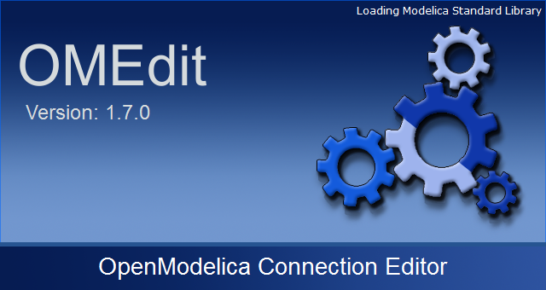
Figure 1-1: OMEdit Splash Screen.

Linux
?? fill in

Mac OS X
?? fill in

Introductory Model in OMEdit
In this section we will demonstrate how one can create Modelica models in OMEdit, e.g. a DCmotor.
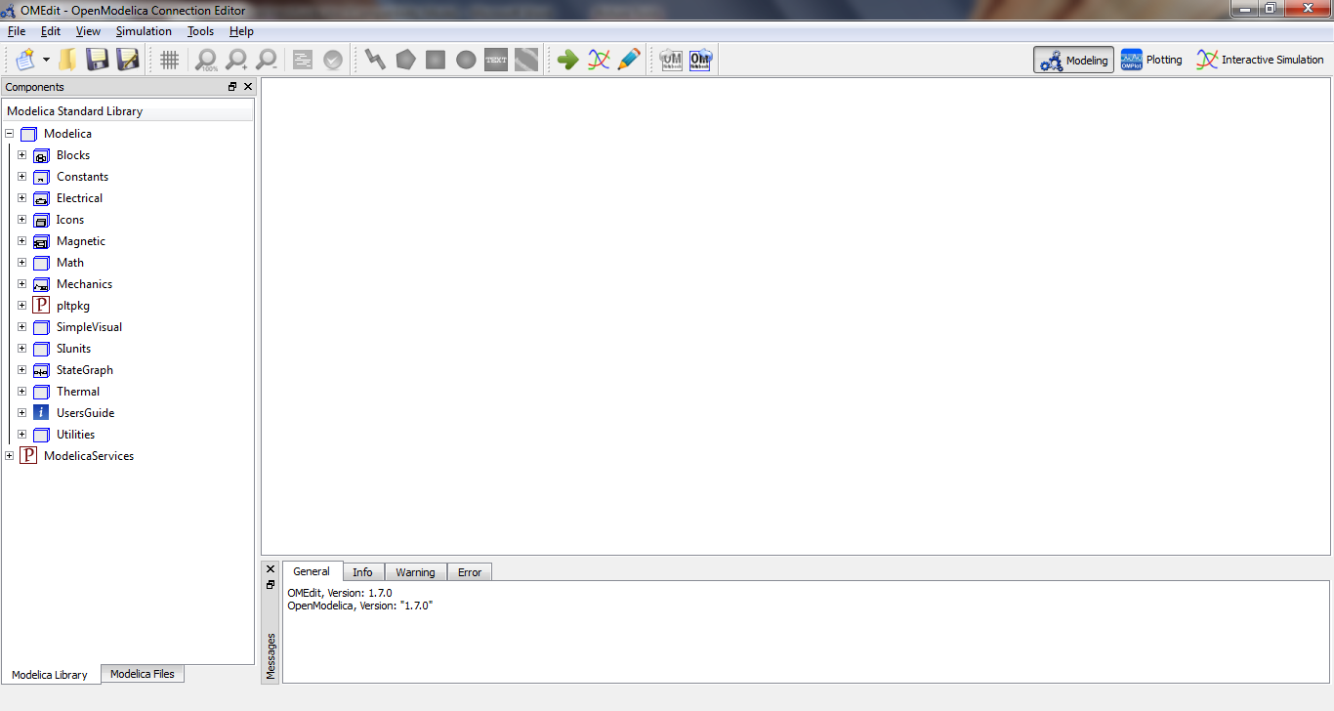
Figure 1-2: OMEdit Main Window.

Creating a New File
Creating a new file/model in OMEdit is rather straightforward. In OMEdit the new file can be of type model, class, connector, record, block, function and package. User can create any of the file types mentioned above by selecting File > New from the menu. Alternatively, you can also click on the drop down button beside new icon shown in toolbar right below the File menu. See Figure 1-4.
For this introductory example we will create a new model named DCmotor. By default the newly created model will open up in the tabbed view of OMEdit, also called Designer Window (see Chapter 2 section 2.2.2), and become visible. The models are created in the OMC global scope unless you specify the parent package for it.
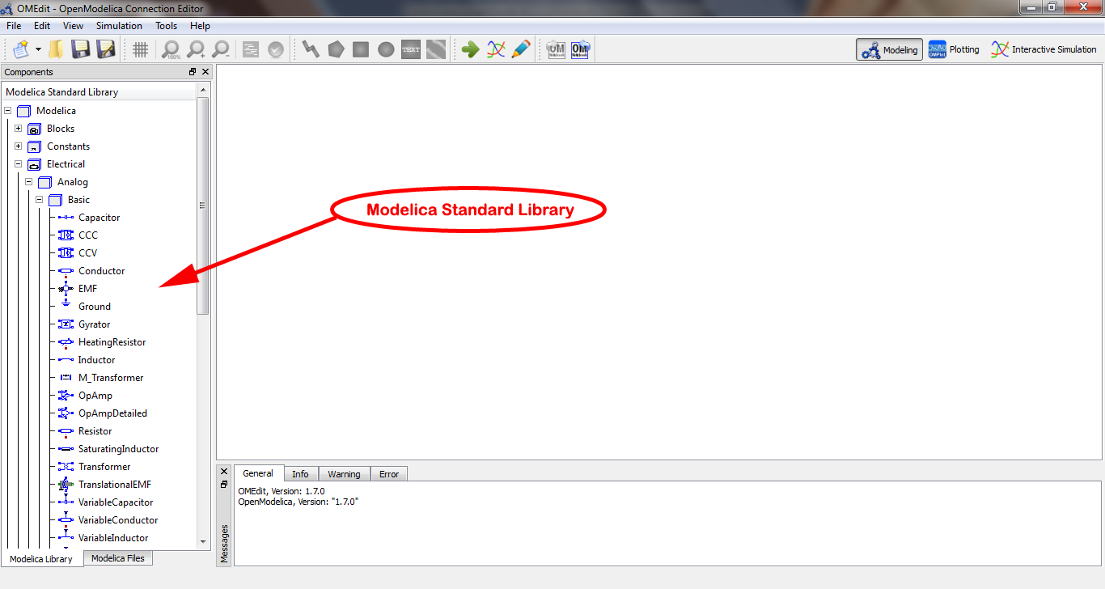
Figure 1-3: Modelica Standard Library.

Adding Component Models
Modelica standard library is loaded automatically and is available in the left dock window. The library is retrieved through the loadModel(Modelica) API call and is loaded in the OMC symbol table and workspace after the command execution is completed. Component models available in the Modelica standard library are added to the models by doing a drag and drop from the Library Window (see Chapter 2 section 2.2.1). Navigate to the component model in the library tree, click on it, drag it to the model you are building while pressing the mouse left button, and drop the component where you want to place it in the model.
For this example we will add four components as instances of the models Ground, Resistor, Inductor and EMF from the Modelica.Electrical.Analog.Basic package, an instance of the model SignalVoltage from the Modelica.Electrical.Analog.Sources package, one instance of the model Inertia from the Modelica.Mechanics.Rotational.Components package and one last instance of the model Step from the Modelica.Blocks.Sources package.

Making Connections
In order to connect one component model to another the user simply clicks on any of the ports. Then it will start displaying a connection line. Then move the mouse to the target component where you want to finish the connection and click on the component port where the connection should end. You do not need to hold the mouse left button down for drawing connections.
In order to have a functioning DCmotor model, connect the Resistor to the Inductor and the SignalVoltage, EMF to Inductor and Inertia, Ground to SignalVoltage and EMF, and finally Step to SignalVoltage. Check Figure 1-5 to see how the DCmotor model looks like after connections.
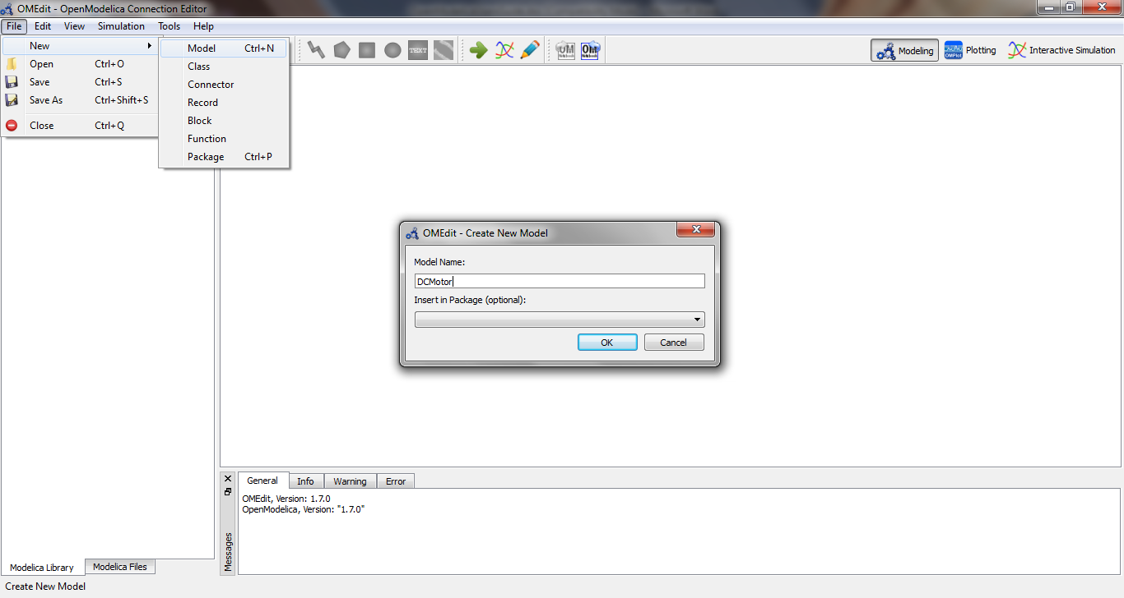
Figure 1-4: Creating a new model.

Simulating the Model
The OMEdit Simulation dialog (see Chapter 2 section 2.3.2) can be launched either from Simulation > Simulate or by clicking the simulate icon from the toolbar. Once the user clicks on Simulate! button, OMEdit starts the simulation process, at the end of the simulation process the Plot Variables Window (see Chapter 2 section 2.2.3) useful for plotting will appear at the right side. Figure 1-6 shows the simulation dialog.
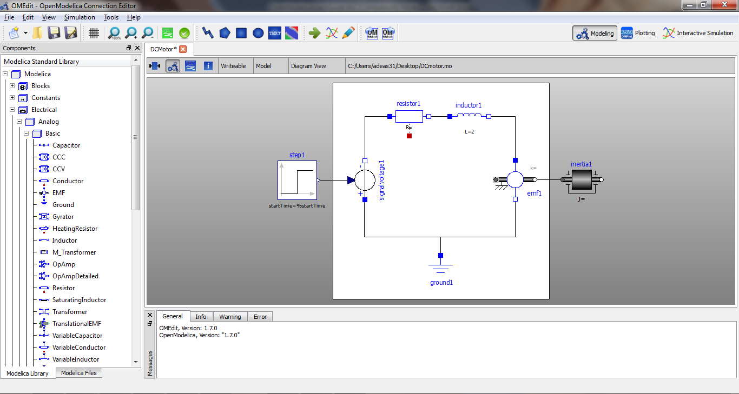
Figure 1-5: DCmotor model after connections.

Plotting Variables from Simulated Models
The instance variables that are candidate for plotting are shown in the right dock window. This window is automatically launched once the user simulates the model; the user can also launch this window manually either from Simulation > Plot Variables or by clicking on the plot icon from toolbar. It contains the list of variables that are possible to use in an OpenModelica plot. The plot variables window contains a tree structure of variables; there is a checkbox beside each variable. The user can launch the plotted graph window by clicking the checkbox.
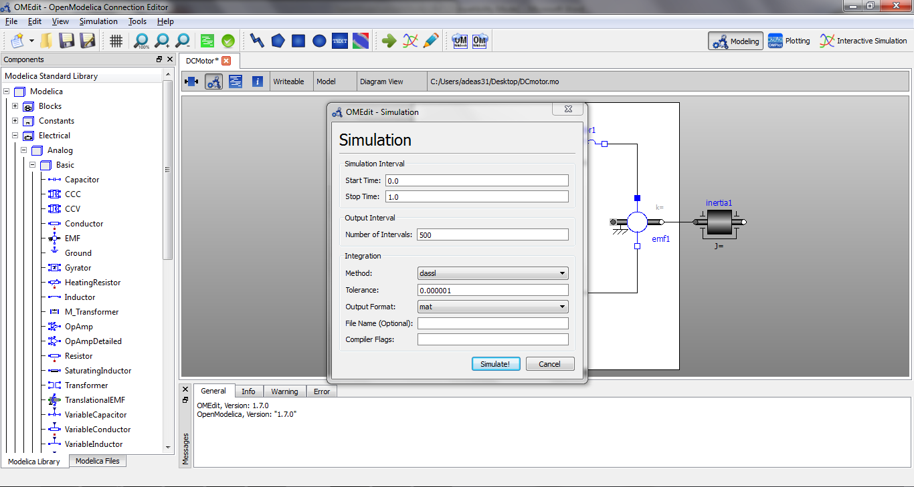
Figure 1-6: Simulation Dialog.
Figure 1-7 shows the complete DCmotor model along with the list of plot variables and an example plot window.
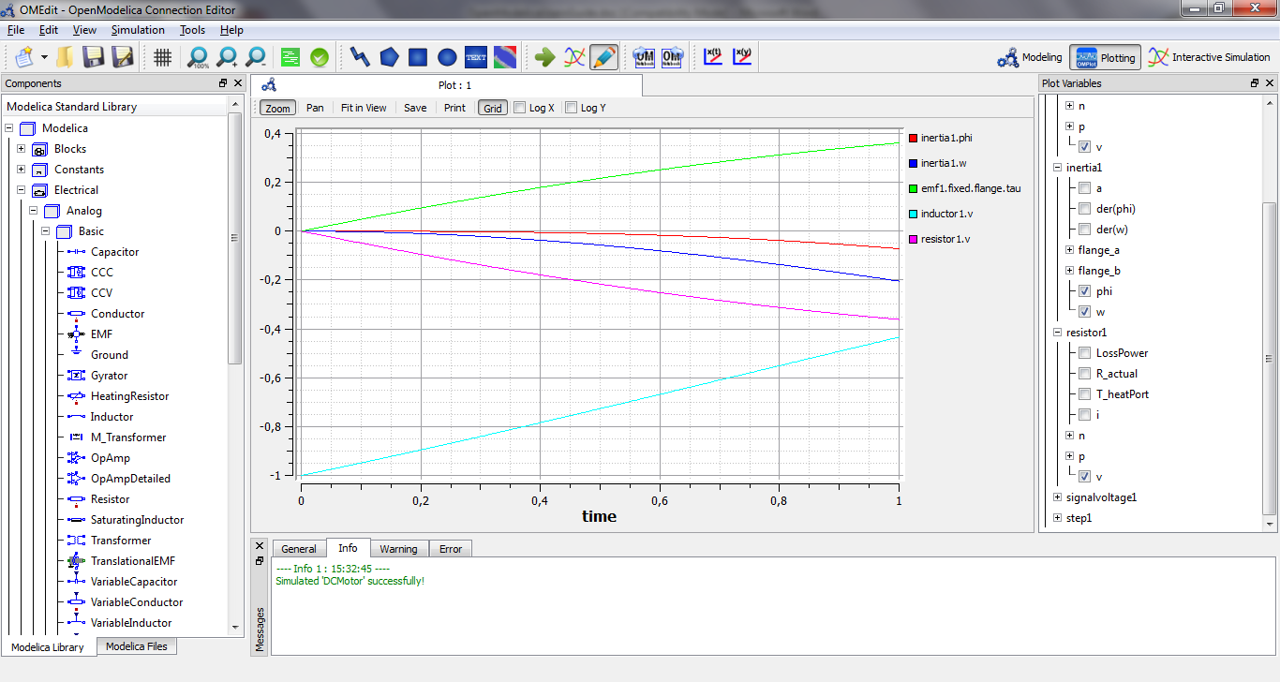
Figure 1-7: Plotted variables.

How to Create User Defined Shapes – Icons
User can create shapes of their own by using the 6 types of shape tools available in OMEdit.
- Line Tool – Draws a line. A line is created with a minimum of two points. In order to create a line, the user first selects the line tool from the toolbar and then click on the Designer Window; this will start creating a line. If a user clicks again on the Designer Window a new line point is created. In order to finish the line creation, user has to double click on the Designer Window.
- Polygon Tool – Draws a polygon. A polygon is created in a similar fashion as a line is created. The only difference between a line and a polygon is that, if a polygon contains two points it will look like a line and if a polygon contains more than two points it will become a closed polygon shape.
- Rectangle Tool – Draws a rectangle. The rectangle only contains two points where first point indicates the starting point and the second point indicates the ending the point. In order to create rectangle, the user has to select the rectangle tool from the toolbar and then click on the Designer Window, this click will become the first point of rectangle. In order to finish the rectangle creation, the user has to click again on the Designer Window where he/she wants to finish the rectangle. The second click will become the second point of rectangle.
- Ellipse Tool – Draws an ellipse. The ellipse is created in a similar way as a rectangle is created.
- Text Tool – Draws a text label.
- Bitmap Tool – Draws a bitmap container.
The shape tools are located at the top in the toolbar. See Figure 1-8.
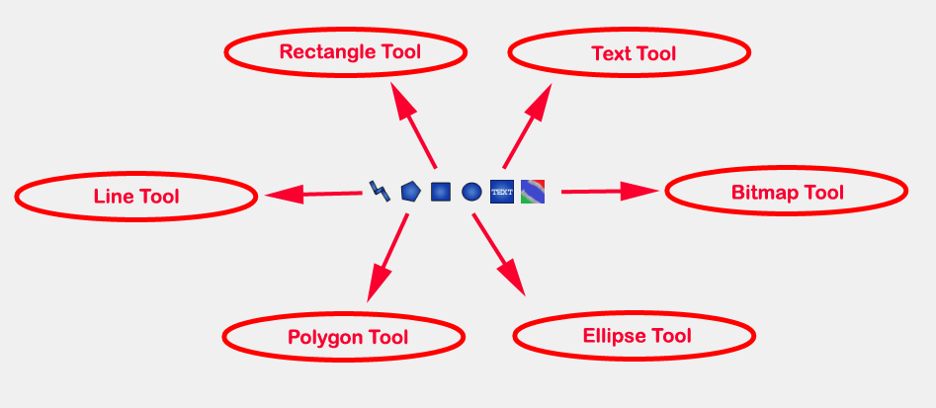
Figure 1-8: User defined shapes.
The user can select any of the shape tools and start drawing on the Designer Window. The shapes created on the Diagram View of Designer Window are part of the diagram and the shapes created on the Icon View will become the icon representative of the model.
For example, if a user creates a model with name testModel and add a rectangle using the rectangle tool and a polygon using the polygon tool, in the Icon View of the model. The model’s Modelica Text will look like,
model testModel
annotation(Icon(graphics = {Rectangle(rotation = 0, lineColor = {0,0,255}, fillColor = {0,0,255}, pattern = LinePattern.Solid, fillPattern = FillPattern.None, lineThickness = 0.25, extent = {{ -64.5,88},{63, -22.5}}),Polygon(points = {{ -47.5, -29.5},{52.5, -29.5},{4.5, -86},{ -47.5, -29.5}}, rotation = 0, lineColor = {0,0,255}, fillColor = {0,0,255}, pattern = LinePattern.Solid, fillPattern = FillPattern.None, lineThickness = 0.25)}));
end testModel;
In the above code snippet of testModel, the rectangle and a polygon are added to the icon annotation of the model. Similarly, any user defined shape drawn on a Diagram View of the model will be added to the diagram annotation of the model.

: OMEdit Views and Windows/Tabs
- Modeling, Plotting and Interactive Simulation Views.
- Library Window for Modelica Standard Library.
- Drawing interface in the form of Designer Window.
- Plot Variables Window contains the list of instance variables.
- Messages Window displays the informational, warning and error messages.
- Documentation Window displays the Modelica annotations based documentation in a QWebView.
- New Dialog for creating Modelica models.
- Simulation Dialog for simulating Modelica models.

Views
OMEdit has three kinds of views.

Modeling View
This is the default view. This view shows the Designer Window and allows users to create their models.

Plotting View
This view is used for showing plot graphs. The user can launch this view anytime by using the views button in the tool bar. This view also becomes active automatically when user simulates the model successfully.

Interactive Simulation View
This view is quite similar to Plotting View. One of the primary differences is that Plotting View is used to show graphs of pre-built models that cannot be changed. However, in the Interactive Simulation View the user can change the values of variables and parameters of the model on the runtime.

Windows
OMEdit consists of number of windows that shows different views to users.

Library Window
The Modelica Standard Library is automatically loaded in OMEdit and is located on the left dock window. Once a Modelica model has been created then the user can just drag and drop components into the model from the MSL, the Library Window. The available libraries in the MSL are:
- Blocks
- Constant
- Electric
- Icons
- Magnetic
- Math
- Mechanics
- SIunits
- Thermal
- UsersGuide
- Utilities
Library Window consists of two tabs one shows the Modelica Standard Library and is selected by default the other tab shows the Modelica files that user creates in OMEdit.

Viewing Models Description
In order to view the model details, double click the component and details will be opened in Designer Window. Alternative way is to right click on the component and press Show Component, it will do the same.

Viewing Models Documentation
Right click the model in the Library Window and select View Documentation; it will launch the Documentation Window. See Figure 2-9.

How to Check a Model?
Right click the component in the library window and select Check; it will launch the Check Dialog. See Figure 2-9.

How to Instantiate a Model?
Right click the component in the library window and select Instantiate Model; it will launch the Instantiate Model Dialog. See Figure 2-9.

How to Rename a Model?
Right click the model in the Library Window and select Rename; it will launch the Rename Dialog. See Figure 2-9.

How to Delete a Model?
Right click the model in the library window and select Delete; a popup will appear asking “Are you sure you want to delete?”
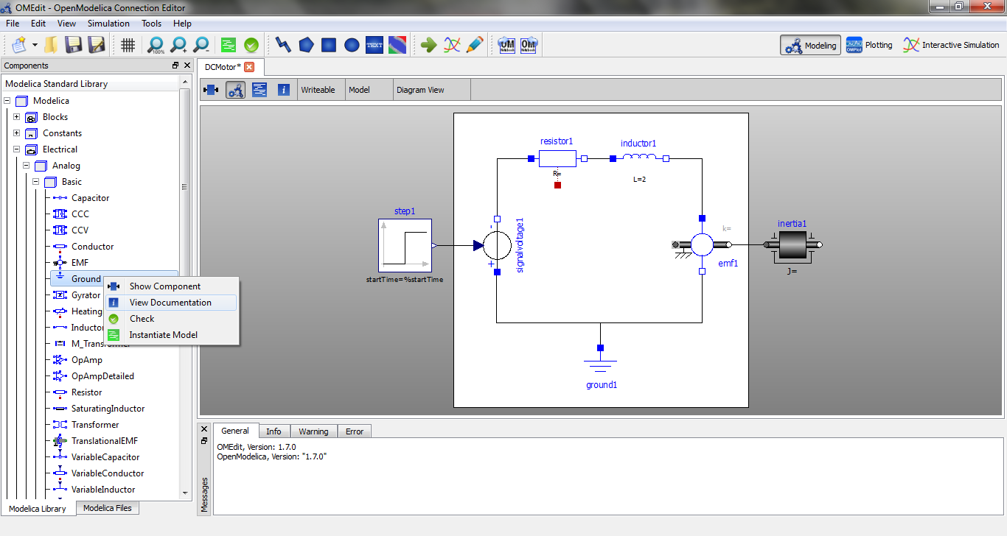
Figure 2-9: Context menu to view component model details.

Designer Window
Designer Window is the main window of OMEdit. It consists of three views,
- Icon View - Shows the model icon view.
- Diagram View - Shows the diagram of the model created by the user.
- Modelica Text View - Shows the Modelica text of the model.

Plot Variables Window
The right dock window represents the Plot Variables Window. It consists of a tree containing the list of instance variables that are extracted from the simulation result. Each item of the tree has a checkbox beside it. The user can click on the check box to launch the plot graph window. The user can add/remove the variables from the plot graph window by marking/unmarking the checkbox beside the plot variable.

Messages Window
Messages Window is located at the bottom of the application. The Messages Window consists of 4 types of messages,
- General Messages – Shown in black color.
- Informational Messages – Shown in green color.
- Warning Messages – Shown in orange color.
- Error Messages – Shown in red color.

Documentation Window
This window is shown when a user right clicks the component in the library window and selects View Documentation. This shows the OpenModelica documentation of components in a web view. All externals links present in the documentation window are opened in the default browser of the user. All local links are opened in the same window. Figure 2-10 shows the Documentation Window view.
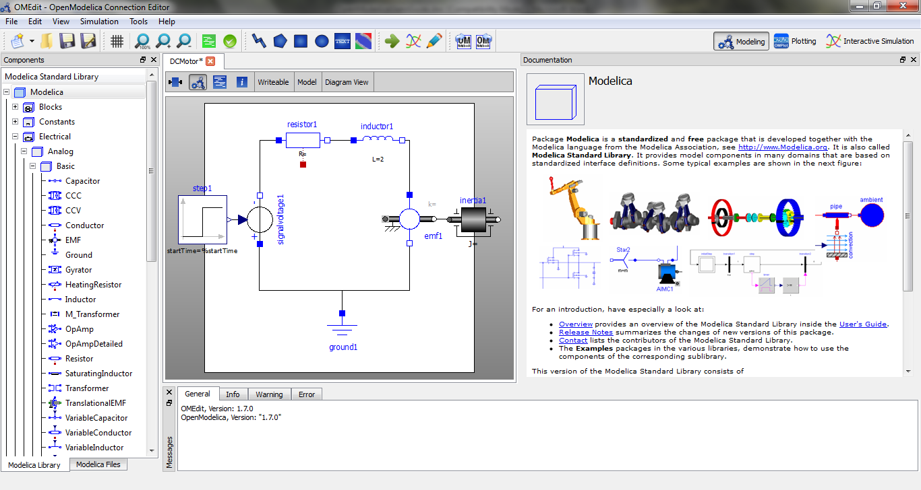
Figure 2-10: Documentation Window.

Dialogs
Dialogs are the sub kind of windows that are not visible by default. The user has to launch them or they will automatically appear due to some user action.

New Dialog
The New Dialog can be launch from File > New > Model Type. Model type can be model, class, connector, record, function and package.

Simulation Dialog
Simulation Dialog can be launched either from Simulation > Simulate or by clicking on the Simulate! button in the toolbar. Figure 1-6 shows a simulation dialog. The simulation dialog consists of simulation variables. You can set the value of any variable, depending on the simulation requirement. Simulation variables are,
- Simulation Interval
- Start Time
- Stop Time
- Output Interval
- Number of Intervals
- Output Interval
- Integration
- Method
- Tolerance
- Fixed Step Size
- File Name
- Compiler Flags

Model Properties Dialog
The models that are placed in the Designer Window can be modified by changing the properties. In order to launch the Model Properties Dialog of a particular model right click the model and select Properties. See Figure 2-11. The properties dialog contains the name of the model, class name the model belongs to and the list of parameters of the component.
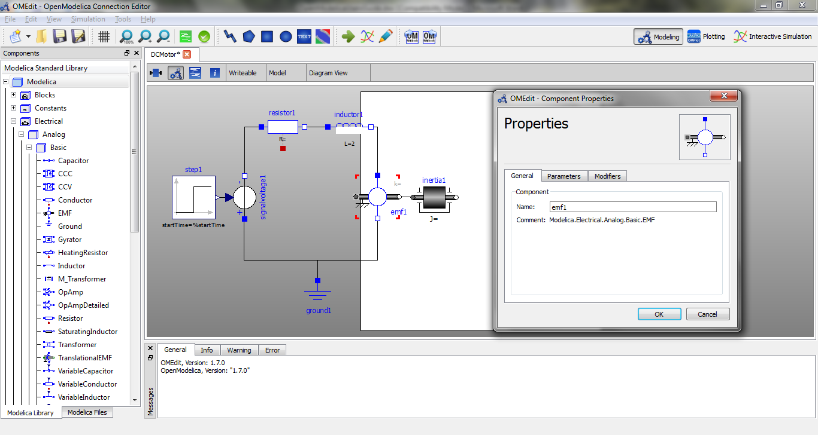
Figure 2-11: Properties Dialog.

Model Attributes Dialog
Right click the model placed in the Designer Window and select Attributes. It will launch the attributes dialog. Figure 2-12 shows the Model Attributes Dialog.
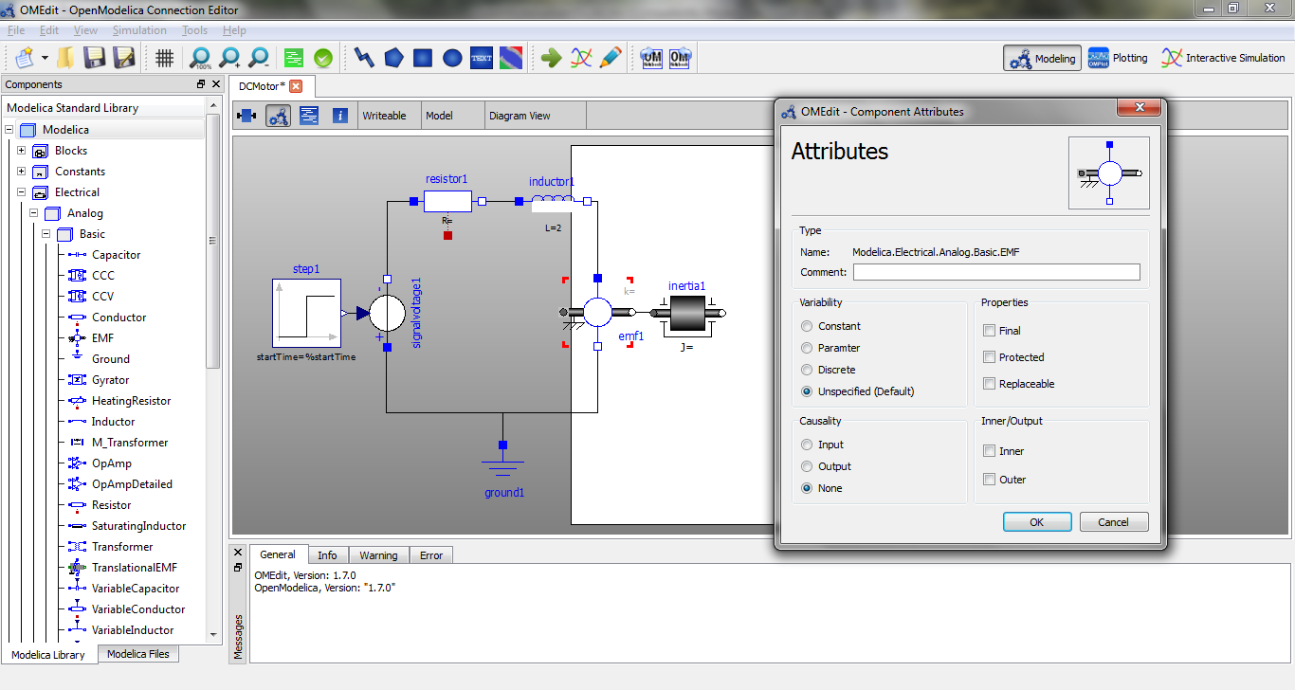
Figure 2-12: Attributes Dialog.

: Interactive Simulation in OMEdit
- OpenModelica Interactive subsystem
- Starting Interactive Simulation.
- Interactive Simulation options.

OpenModelica Interactive
OMEdit uses the OpenModelica Interactive (OMI) subsystem to perform the interactive plotting. The OMI uses the TCP/IP technique to transfer data back and forth. OMEdit connects with OMI through TCP sockets.

Invoking Interactive Simulation
Interactive Simulation Dialog can be launched either from Simulation > Interactive Simulation or by clicking on the Interactive Simulation! button in the toolbar. Interactive Simulation Dialog looks similar to the Simulation Dialog but it differs in functionality, instead of performing normal pre-built simulation it performs online interactive simulation where simulation responds in real-time to user input and changes to parameters.
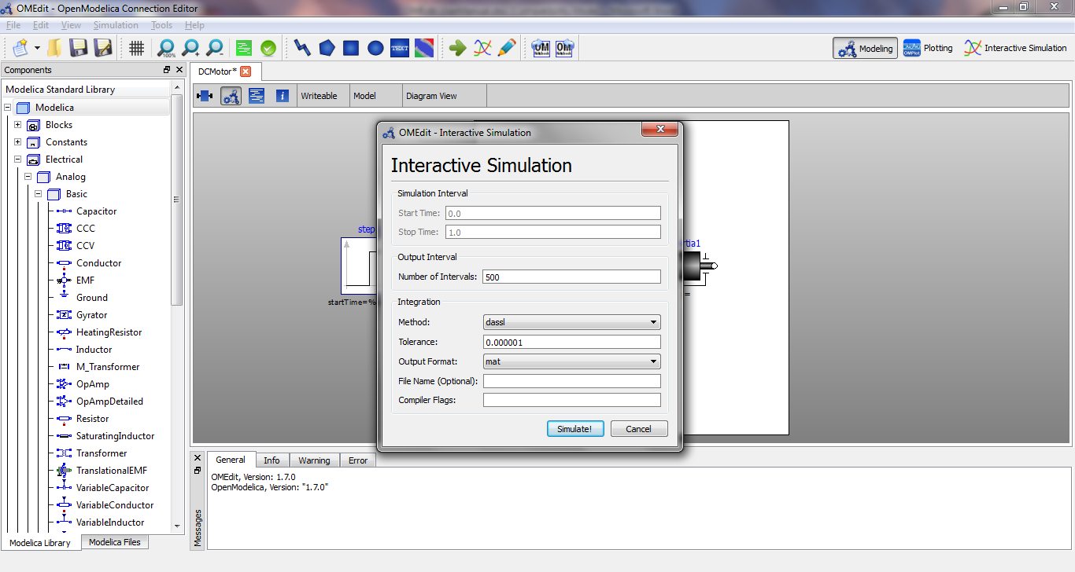
Figure 3-13: Interactive Simulation Dialog.

Interactive Simulation View
Once your model was successfully built using the Interactive Simulation Dialog, the Interactive Simulation View will become active automatically. Interactive Simulation View contains,
- Graph – It contains a graph which is used to display the values of selected variables over the time.
- Parameters – The parameters of the model are shown on the right top section with the default values.
- Variables – The right bottom section contains the list of variables that user can select for interactive plotting.
- Initialize Button – This button is used to send the information of changed parameters and checked variables to the OpenModelica Interactive subsystem.
- Start Button – Once the parameters and variables are initialized and sent to the OMI. Then the user can click on start button and start the interactive plotting.
- Pause Button – This button pauses the running interactive plotting.
- Stop Button – Clears everything but does not remove the connection with OMI. After clicking stop button user has to reinitialize everything and start the interactive plotting again.
- Shut Down Button – Disconnects from OMI and closes the interactive simulation session.
- Show OMI Log Button – Pops up a log window which displays the messages exchanged between OMEdit and OMI.
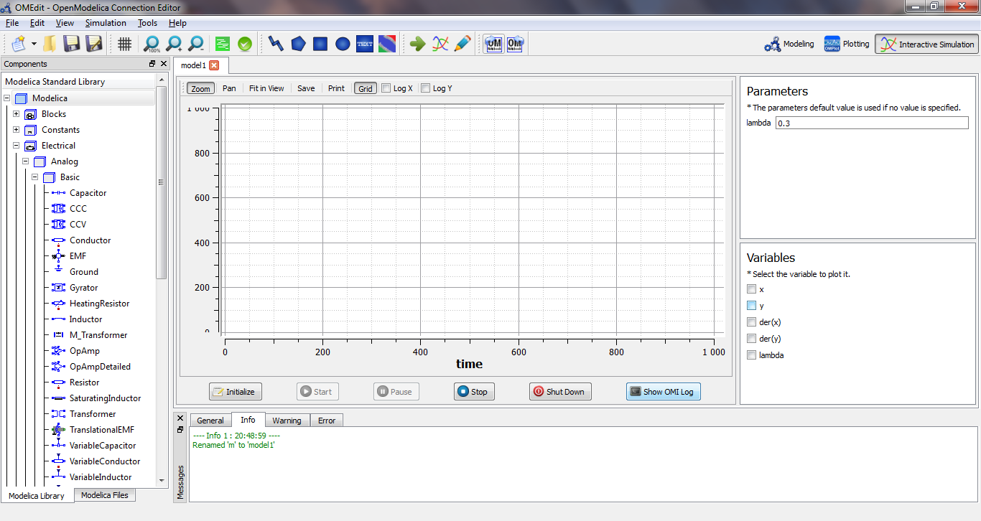
Figure 3-14: Interactive Simulation View.

