

OMEdit
Open Modelica Connection Editor
User Manual
Version 1.0

Copyright by:
Linköping University, Sweden
Department of Computer and Information Science
Supported by:
Open Source Modelica Consortium
Contents
1. Chapter 1: Overview 3
1.1. Modelica - introduction 3
1.2. Modelica - versions 3
1.3. Features of Modelica 4
2. Chapter 2: Getting Started 5
2.1. Introduction 5
2.2. How to start OMEdit 5
2.3. Modelica Standard Library 5
2.4. Hello World model in OMEdit 6
2.4.1. Creating a new file 6
2.4.2. Adding components 6
2.4.3. Making connections 7
2.4.4. Simulating the model 8
2.4.5. Plotting variables from simulated models 8
3. Chapter 3: OMEdit Windows & Dialogs 10
3.1. Windows 10
3.1.1. Library Window 10
3.1.1.1. Viewing components description 10
3.1.1.2. Viewing components documentation 10
3.1.1.3. How to check a component? 11
3.1.1.4. How to rename a component? 11
3.1.1.5. How to delete a component? 11
3.1.2. Designer Window 11
3.1.3. Plot Window 11
3.1.4. Messages Window 12
3.1.5. Documentation Window 12
3.2. Dialogs 12
3.2.1. New Dialog 13
3.2.2. Simulation Dialog 13
3.2.3. Component Properties Dialog 13
3.2.4. Component Attributes Dialog 14

Chapter 1: Overview

Modelica - introduction
Modelica is a freely available, object-oriented language for modeling of large, complex, and heterogeneous physical systems. It is suited for multi-domain modeling, for example, mechatronic models in robotics, automotive and aerospace applications involving mechanical, electrical, hydraulic and control subsystems, process oriented applications and generation, and distribution of electric power. Modelica is designed such that it can be utilized in a similar way as an engineer builds a real system: First trying to find standard components like motors, pumps and valves from manufacturers catalogues with appropriate specifications and interfaces and only if there does not exist a particular subsystem, a component model would be newly constructed based on standardized interfaces.
Models in Modelica are mathematically described by differential, algebraic and discrete equations. No particular variable needs to be solved for manually. A Modelica tool will have enough information to decide that automatically. Modelica is designed such that available, specialized algorithms can be utilized to enable efficient handling of large models having more than hundred thousand equations.
As we know, Modelica is a free language and it has been derived from many object oriented modeling languages. Modelica community works so hard and give their precious time to provide many services for their users like newsletter, free educational material, mailing lists, lots of freely downloaded papers, training course offers, consultant’s offers and job offering and student work. The key architect of Modelica was Hilding Emqvist who came with this idea in September 1996 when he was doing his PHD but many others also contributed in it. The basic aim was to develop an object-oriented language for modeling technical systems for reprocess and exchange of models of dynamic systems in a standardized format. Modelica helps several automotive companies in designing their energy efficient vehicles furthermore facilitate to enhanced air conditioning systems.

Modelica - versions
The first version 1.0 to model continuous dynamic systems was released in September 1997. After around almost one year the 1.1 version was released which is about the language elements to model discrete systems? Every 6 to 8 months new version is released therefore in year 1999 two versions of Modelica released, Interface to C and FORTRAN, inner/outer for global variables, refined semantics of event handling are in version 1.2 which published in June. In December, 1.3 versions are occurred which is about improved semantics for inner/outer connections, protected elements, array expressions. On Christmas 2000 finally the first application, the 1.4 version is ready for the users which included the features removed declare-before-use rule, refined package concept, refined when-clause. In July 2002 they provide Initialization of models, standardization of graphical appearance, functions with mixed positional and named arguments, record constructor and enumerations. Mechanical systems, enhanced re-declaration of sub-models, array and array indices of enumerations are come up in version 2.1 in March 2004. In version 2.2 which was make public in February 2005, expandable connector to model signal buses, conditional component declarations, arrays with dynamic size changes in functions are included. After two years version 3.0 is releases whose highlights are; clean-up version: specification newly written, type system and graphical appearance refined, language flaws fixed, balanced model concept to detect model errors in a much better way. A lot has happened in 2008 that was an exciting year for the Modelica Association and the Modelica community. The version 3.1 came in 2009 May, main features includes; stream connector to handle bi-directional flow of fluid, operator overloading, mapping model parts to execution environments. 2010 March come with version 3.2 with features like, functions as formal inputs to functions, Unicode support, access control to protect IP, improved support of object libraries.

Features of Modelica
Modelica supports high-level models for the composition and detailed modeling of the library component equations. Models of standard components are usually libraries of models. With a graphical model editor, a model by drawing a composition diagram can be defined, the positioning of the models representing the components, making connections and enter parameter values in the dialogue boxes.

Chapter 2: Getting Started

Introduction
OMEdit - Open Modelica Connection Editor is the new Graphical User Interface for Open Modelica. This chapter gives a brief introduction to OMEdit and also demonstrates how to create a Hello World model. OMEdit is a part of Open Modelica; it is built using Qt 4.7. All the binaries needed to run OMEdit are included in the Open Modelica installer. It uses the Modelica Standard Library that comes with the Open Modelica installation.

How to start OMEdit
OMEdit can be launched using the executable placed in OpenModelicaInstallationDirectory/bin/OMEdit/OMEdit.exe. Alternately, choose OpenModelica > Open Modelica Connection Editor from the start menu in Windows. A splash screen similar to the one shown in figure 2.1 will appear indicating that it is starting OMEdit. After the splash screen the main OMEdit window will appear; see figure 2.2.
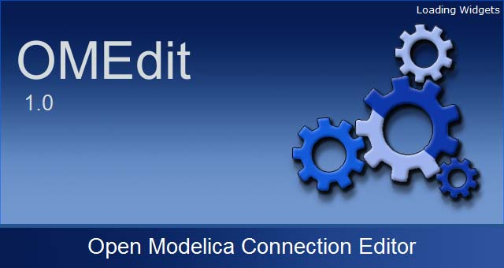
Figure 2.1: OMEdit Splash Screen

Modelica Standard Library
The Modelica Association develops and maintains a growing Modelica standard library because the Modelica is very supportive for model exchange. For sharing the applications it is very important that most frequently used component of that libraries shall be accessible and also ready to use. Moreover many other organization and people are developing free and commercial Modelica libraries. After every 6 to 12 months new version of Modelica is coming out for their users which help them in many different ways like commercial programs etc.

OMEdit comes with a Modelica Standard Library. Its contents are represented in a tree format. Check figure 2.3 to see how does a library structure looks like:
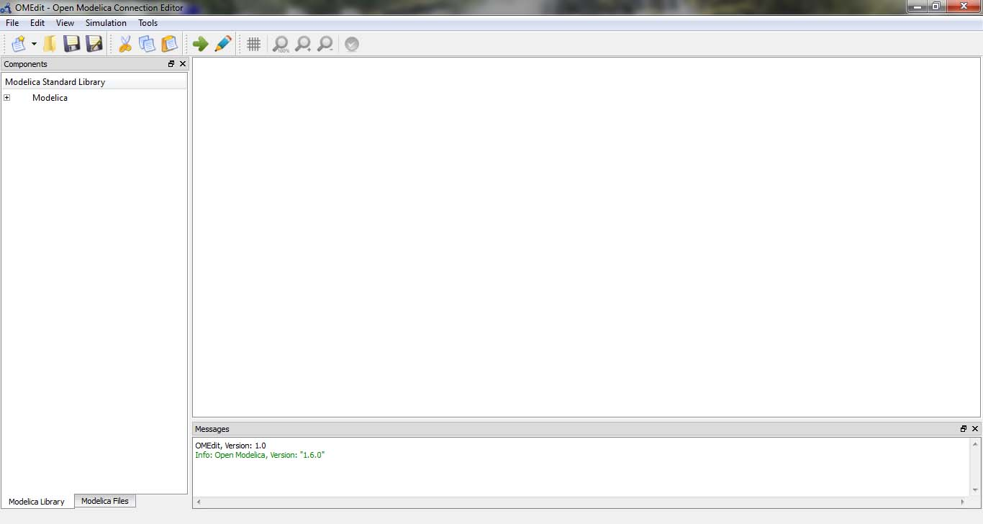
Figure 2.2: OMEdit Main Window

Hello World model in OMEdit
Since, Modelica is an equation-based language and OMEdit is a connection editor so for a hello world model demonstration in OMEdit we will show that how a DC Motor model is created in OMEdit.

Creating a new file
Creating a new file/model in OMEdit is rather straightforward. In OMEdit the new file can be of type model, class, connector, record, block, function and package. Go to File > New and then you can select any of the file types mentioned above. Alternatively, you can also click on the drop down button beside new icon shown in toolbar right below the File menu. See Figure 2.4.
For this hello world example we will create a new model named DCmotor. By default the newly created model will open up in the tabbed view of OMEdit and become visible.

Adding components
Components available in the Modelica Standard Library are added to the model by doing a drag & drop. Navigate to the component in library tree and then click on it, drag it to the model while holding the mouse left button, drop the component where you want to place it in the model.
For this example we will add 4 components, Ground, Resistor, Inductor and EMF from the Modelica.Electrical.Analog.Basic package and 1 component SignalVoltage from the Modelica.Electrical.Analog.Sources package and 1 component Inertia from the Modelica.Mechanics.Rotational.Components package and 1 component Step from the Modelica.Blocks.Sources package.
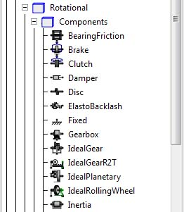
Figure 2.3: Modelica Standard Library

Making connections
To connect one component to another just click on any of the port of the component and it will start connection line, take the mouse to the component where you want to finish the connection and click on the end component port. You don’t need to hold the mouse left button for connections.
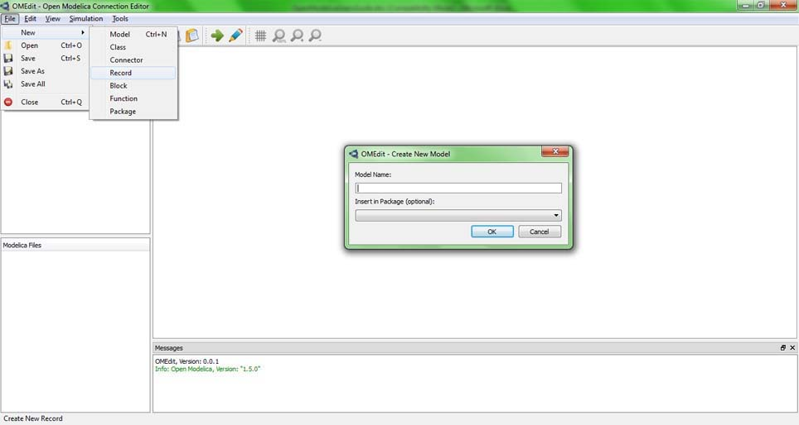
Figure 2.4: Creating a new file
Check figure 2.5 to see how does the DCmotor model components looks like after connections.
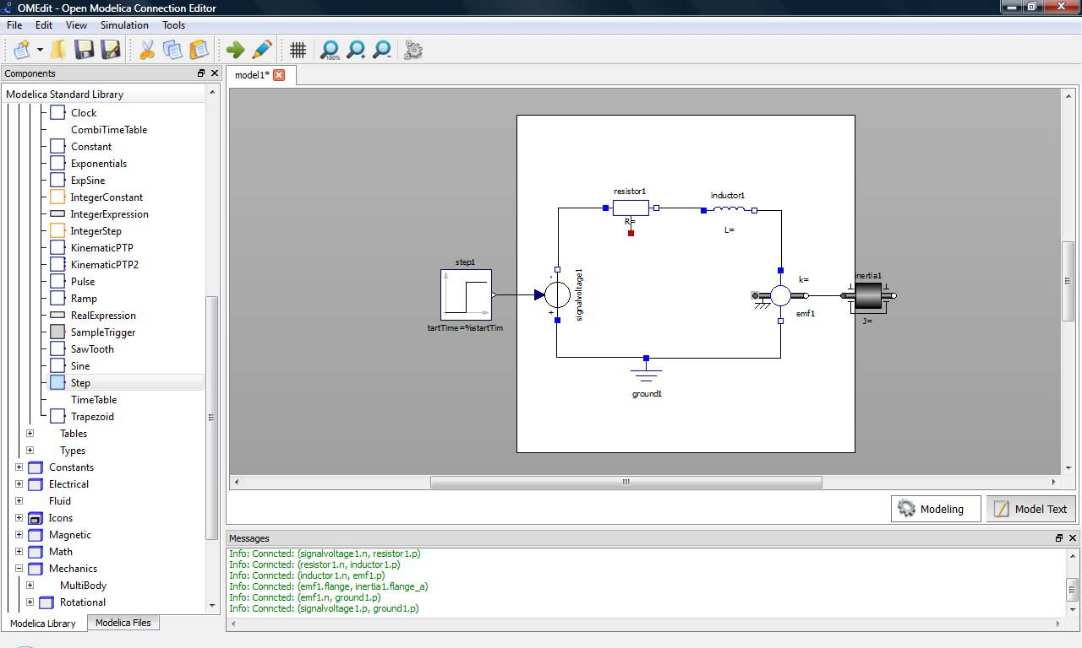
Figure 2.5: DCmotor model after connections

Simulating the model
The OMEdit Simulation Center dialog can be launched either from Simulation > Simulate or by clicking the simulate icon from the toolbar. Once the user clicks on simulate! Button, OMEdit starts the simulation process, at the end of the simulation process the Plot Variables Window useful for plotting will appear at the right side. Figure 2.6 shows the simulation dialog.

Plotting variables from simulated models
The Variables of a model are shown in the right dock window. This window is automatically launched once the user simulates the model; the user can also launch this window manually either from Simulation > Plot Variables or by clicking on the plot icon from toolbar. It contains the list of variables that are possible to use in an Open Modelica Plot. The Variable window contains a tree structure of variables; there is a checkbox beside each variable. The user can view the plotted graph window by clicking the checkbox.
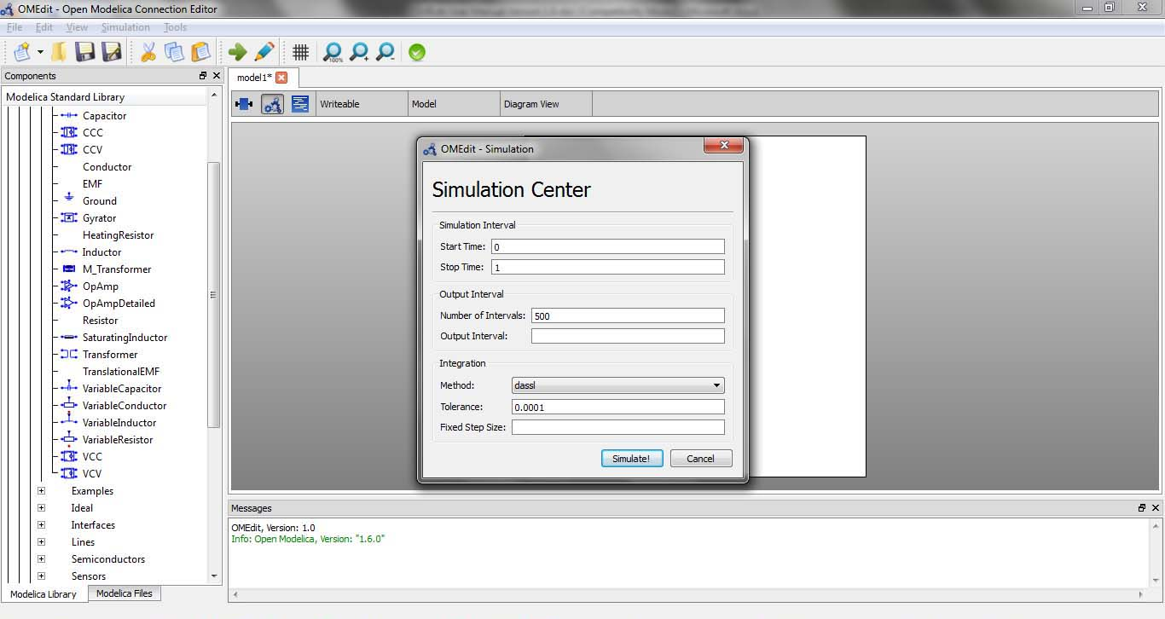
Figure 2.6: Simulation Dialog
Figure 2.7 shows the complete DCmotor model along with the list of plot variables and an example plot window.
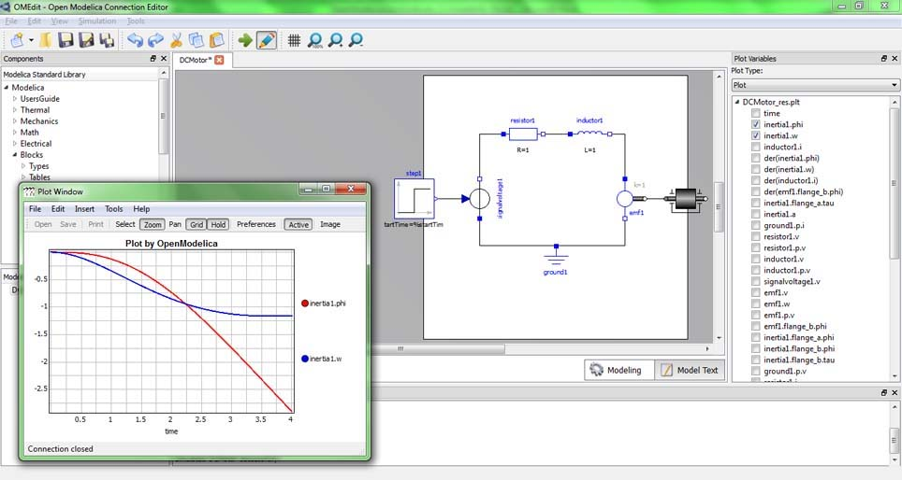
Figure 2.7: Plotted variables

Chapter 3: OMEdit Windows & Dialogs

Windows
OMEdit consists of number of windows that shows different views to users.

Library Window
The Modelica Standard Library is automatically loaded in OMEdit and is located on the left dock window. Once you have created the Modelica model you can drag & drop the components available in the library window.
- Blocks
- Constant
- Electric
- Icons
- Magnetic
- Math
- Mechanics
- SIunits
- Thermal
- UsersGuide
- Utilities
Library Window consists of two tabs one shows the Modelica Standard Library and is selected be default the other tab shows the Modelica Files that user creates in OMEdit.

Viewing components description
In order to view the component details, double click the component and details will be opened in Designer Window. Alternative way is to right click on the component and press Show Component it will do the same.

Viewing components documentation
Right click the component in the library window and select View Documentation; it will launch the Documentation Window. See figure 3.1.

How to check a component?
Right click the component in the library window and select Check; it will launch the Check Dialog. See figure 3.1.

How to rename a component?
Right click the component in the library window and select Rename; it will launch the Rename Dialog. See figure 3.1.

How to delete a component?
Right click the component in the library window and select Delete; a popup will appear asking “Are you sure you want to delete?”
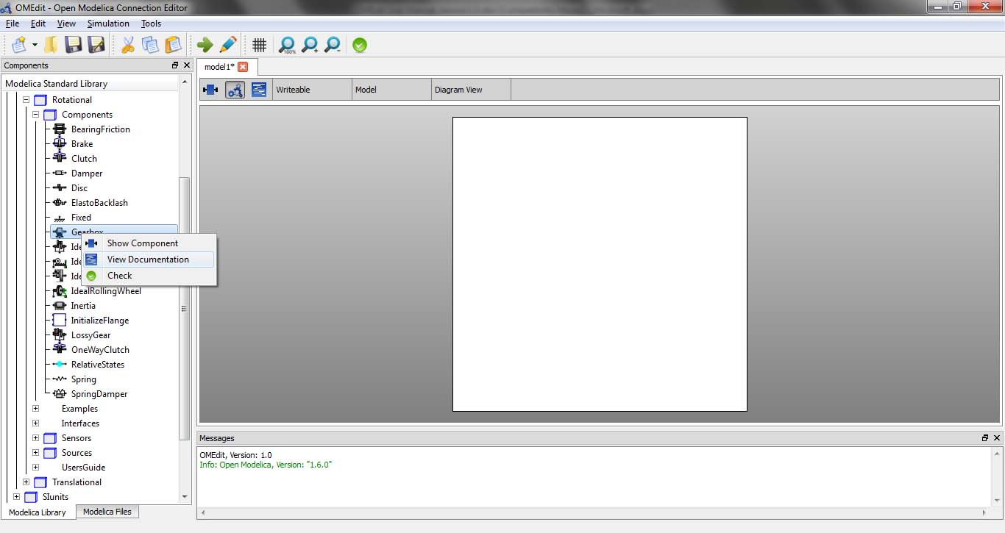
Figure 3.1

Designer Window
Designer Window is the main window of OMEdit. It consists of three views,
- Icon View: Shows the model icon view.
- Diagram View: Shows the diagram of the model created by the user.
- Modelica Text View: Shows the modelica text of the model.

Plot Window
The right dock window represents the Plot Window. It consists of a tree containing the list of plot variables that are extracted from the simulation result. Each item of the tree has a checkbox beside it. The user can click on the check box to launch the plot graph window. The user can add/remove the variables from the plot graph window by marking/unmarking the checkbox beside the plot variable.

Messages Window
Messages Window is located at the bottom of the application. The Messages Window consists of 4 types of messages,
- General Messages: Shown in black color.
- Informational Messages: Shown in green color.
- Warning Messages: Shown in orange color.
- Error Messages: Shown in red color.

Documentation Window
This window is shown when a user right clicks the component in the library window and selects View Documentation. This shows the Open Modelica documentation of components in a web view. All externals links present in the documentation window are opened in the default browser of the user. All local links are opened in the same window. Figure 3.2 shows the Documentation Window view.
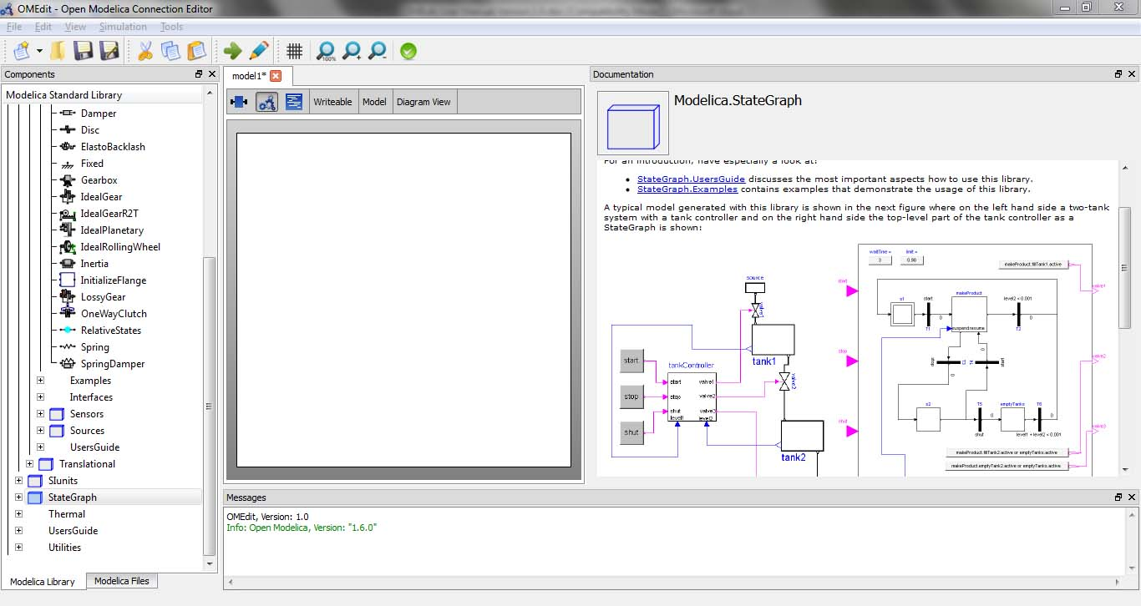
Figure 3.2: Documentation Window

Dialogs
Dialogs are the sub kind of windows that are not shown by default. The user has to launch them or they will automatically appear due to some user action.

New Dialog
The new dialog can be launch from File > New > Model Type. Model type can be model, class, connector, record, function and package.

Simulation Dialog
Simulation dialog can be launched either from Simulation > Simulate or by clicking on the Simulate button in the toolbar. Figure 2.6 shows a simulation dialog. The simulation dialog consists of simulation variables. You can set the value of any variable, depending on the simulation requirement. Simulation variables are,
- Simulation Interval
  - Start Time
  - Stop Time
- Output Interval
  - Number of Intervals
  - Output Interval
- Integration
  - Method
  - Tolerance
  - Fixed Step Size
Once the simulation is started the progress bar is shown to the user indicating that the simulation process is running. When the simulation process is finished the simulation progress bar will disappear and the plot variables window will appear containing the list of variables produced by the simulation process.

Component Properties Dialog
The components that are placed in the Designer Window can be modified by changing the properties. In order to launch the component properties dialog of a particular component right click the component and select Properties. See Figure 3.3.
The properties dialog contains the name of the component, class name the component belongs to and the list of parameters of the component.

Component Attributes Dialog
Right click the component placed in the Designer Window and select Attributes. It will launch the attributes dialog. Figure 3.4 shows the attributes dialog.
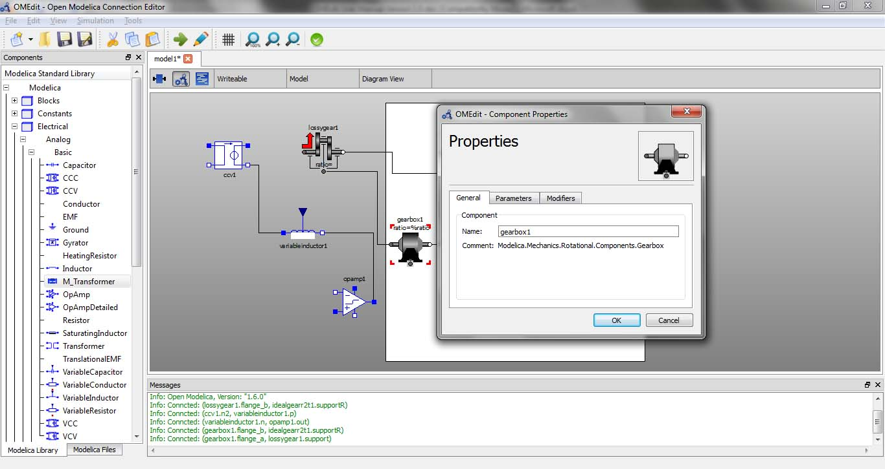
Figure 3.3: Properties Dialog
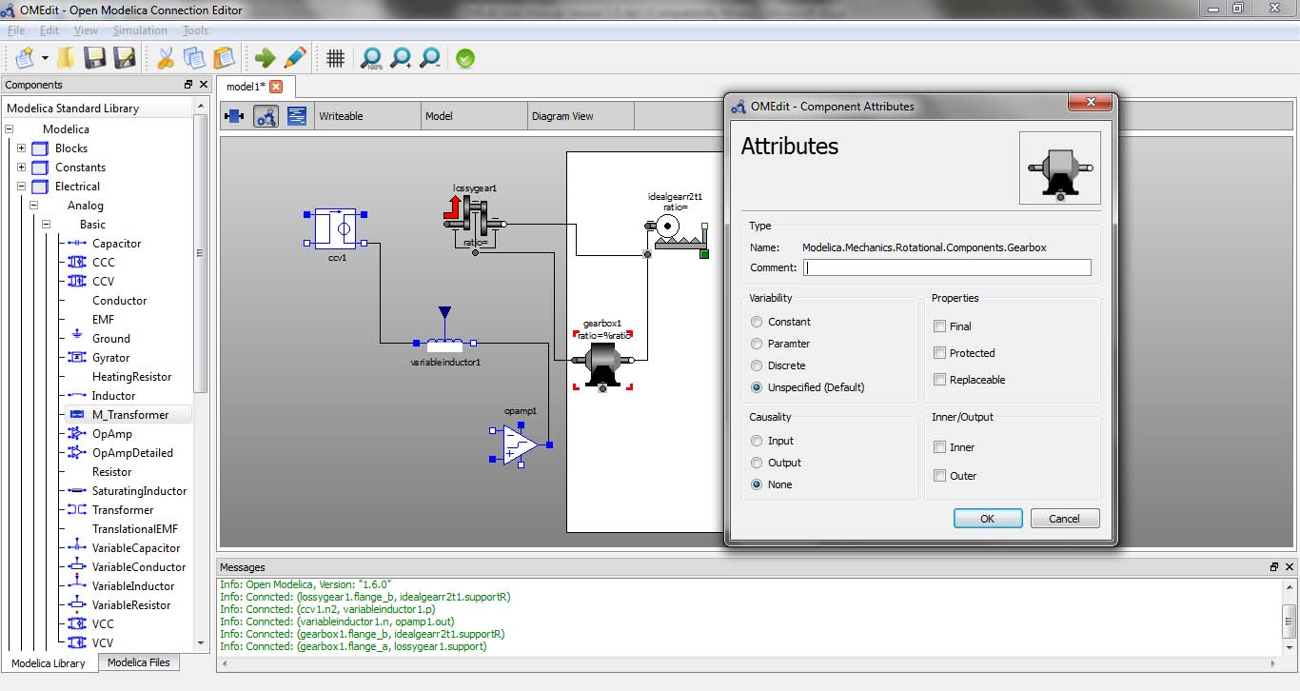
Figure 3.4: Attributes Dialog

