OpenModelica Users Guide

Preliminary Draft, 2006-04-13
for OpenModelica 1.3.2

Version 0.6, April 2006

Peter Fritzson
Peter Aronsson, Adrian Pop, Bernhard Bachmann, David Broman,
Anders Fernström, Daniel Hedberg, Elmir Jagudin, Håkan Lundvall,
Kaj Nyström, Andreas Remar, Levon Saldamli, Anders Sandholm

Copyright by:
Programming Environment Laboratory – PELAB
Department of Computer and Information Science
Linköping University, Sweden

Copyright © 1998-2006, PELAB, Department of Computer and Information Science, Linköpings universitet.
All rights reserved.
This document is part of OpenModelica, www.ida.liu.se/projects/OpenModelica
Contact: OpenModelica@ida.liu.se

(Here using the new BSD license, see also http://www.opensource.org/licenses/bsd-license.php)
Redistribution and use in source and binary forms, with or without modification, are permitted provided that the following conditions are met:
- Redistributions of source code must retain the above copyright notice, this list of conditions and the following disclaimer.
- Redistributions in binary form must reproduce the above copyright notice, this list of conditions and the following disclaimer in the documentation and/or other materials provided with the distribution.
- Neither the name of Linköpings universitet nor the names of its contributors may be used to endorse or promote products derived from this software withoutspecific prior written permission.
THIS SOFTWARE IS PROVIDED BY THE COPYRIGHT HOLDERS AND CONTRIBUTORS "AS IS" AND ANY EXPRESS OR IMPLIED WARRANTIES, INCLUDING, BUT NOT LIMITED TO, THE IMPLIED WARRANTIES OF MERCHANTABILITY AND FITNESS FOR A PARTICULAR PURPOSE ARE DISCLAIMED.
IN NO EVENT SHALL THE COPYRIGHT OWNER OR CONTRIBUTORS BE LIABLE FOR ANY DIRECT, INDIRECT, INCIDENTAL, SPECIAL, EXEMPLARY, OR CONSEQUENTIAL DAMAGES (INCLUDING, BUT NOT LIMITED TO, PROCUREMENT OF SUBSTITUTE GOODS OR SERVICES; LOSS OF USE, DATA, OR PROFITS; OR BUSINESS INTERRUPTION) HOWEVER CAUSED AND ON ANY THEORY OF LIABILITY, WHETHER IN CONTRACT, STRICT LIABILITY, OR TORT (INCLUDING NEGLIGENCE OR OTHERWISE) ARISING IN ANY WAY OUT OF THE USE OF THIS SOFTWARE, EVEN IF ADVISED OF THE POSSIBILITY OF SUCH DAMAGE.

Table of Contents

Table of Contents 5
Preface 9
Chapter 1 Introduction 11
1.1 System Overview 12
1.1.1 Implementation Status 13
1.2 Interactive Session with Examples 14
1.3 Commands for the Interactive Session Handler 23
Chapter 2 Getting Started with the Graphical Model Editor 25
2.1 Your First Model 26
2.1.1 Creating a New Model 27
2.1.2 Changing Parameter Values of Components 30
2.1.3 Translating and Simulating Using the Interactive View 33
2.1.4 Plotting 33
2.1.5 Saving and Loading 33
Chapter 3 OMNotebook with DrModelica 35
3.1 Interactive Notebooks with Literate Programming 35
3.1.1 Mathematica Notebooks 35
3.1.2 OMNotebook 35
3.2 The DrModelica Tutoring System – an Application of OMNotebook 36
3.3 OpenModelica Notebook Commands 42
3.3.1 File Menu 42
3.3.2 Cell Types 42
3.3.3 Cell Commands 43
3.3.4 Edit Menu 43
3.3.5 Cell Menu 44
3.3.6 Format Menu 44
3.3.7 Insert Menu 45
3.3.8 Window Menu 45
3.3.9 Help Menu 45
3.3.10 Additional Features 45
3.4 References 46
Chapter 4 Emacs Textual Model Editor/Browser 48
Chapter 5 MDT – The OpenModelica Development Tooling Eclipse Plugin 50
5.1 Introduction 50
5.2 Installation 50
5.3 Getting started 51
5.3.1 Configuring the OpenModelica Compiler 51
5.3.2 Using the Modelica Perspective 51
5.3.3 Creating a Project 51
5.3.4 Creating a Package 52
5.3.5 Creating a Class 53
5.3.6 Syntax Checking 54
5.3.7 Indentation Support 54
5.3.8 Code Completion 55
Chapter 6 Modelica Algorithmic Subset Debugger 57
6.1 The Debugger Commands 57
6.2 Starting the Modelica Debugging Subprocess 57
6.3 Setting/Deleting Breakpoints 58
6.4 Stepping and Running 58
6.5 Examining Data 59
6.6 Additional commands 61
6.7 Hints for Debugging Large Programs 62
6.8 Summary of Debugger Commands 62
Appendix A Contributors to OpenModelica 65
A.1 OpenModelica Contributors 2006 65
A.2 OpenModelica Contributors 2005 65
A.3 OpenModelica Contributors 2004 65
A.4 OpenModelica Contributors 2003 66
A.5 OpenModelica Contributors 2002 66
A.6 OpenModelica Contributors 2001 66
A.7 OpenModelica Contributors 2000 66
A.8 OpenModelica Contributors 1999 66
A.9 OpenModelica Contributors 1998 66
Index 67

Preface
This users guide provides documentation and examples on how to use the OpenModelica system, both for the Modelica beginners and advanced users.

Introduction
The OpenModelica system described in this document has both short-term and long-term goals:
- The short-term goal is to develop an efficient interactive computational environment for the Modelica language, as well as a rather complete implementation of the language. It turns out that with support of appropriate tools and libraries, Modelica is very well suited as a computational language for development and execution of both low level and high level numerical algorithms, e.g. for control system design, solving nonlinear equation systems, or to develop optimization algorithms that are applied to complex applications.
- The longer-term goal is to have a complete reference implementation of the Modelica language, including simulation of equation based models and additional facilities in the programming environment, as well as convenient facilities for research and experimentation in language design or other research activities. However, our goal is not to reach the level of performance and quality provided by current commercial Modelica environments that can handle large models requiring advanced analysis and optimization by the Modelica compiler.
The long-term research related goals and issues of the OpenModelica open source implementation of a Modelica environment include but are not limited to the following:
- Development of a complete formal specification of Modelica, including both static and dynamic semantics. Such a specification can be used to assist current and future Modelica implementers by providing a semantic reference, as a kind of reference implementation.
- Language design, e.g. to further extend the scope of the language, e.g. for use in diagnosis, structural analysis, system identification, etc., as well as modeling problems that require extensions such as partial differential equations, enlarged scope for discrete modeling and simulation, etc.
- Language design to improve abstract properties such as expressiveness, orthogonality, declarativity, reuse, configurability, architectural properties, etc.
- Improved implementation techniques, e.g. to enhance the performance of compiled Modelica code by generating code for parallel hardware.
- Improved debugging support for equation based languages such as Modelica, to make them even easier to use.
- Easy-to-use specialized high-level (graphical) user interfaces for certain application domains.
- Visualization and animation techniques for interpretation and presentation of results.
- Application usage and model library development by researchers in various application areas.
The OpenModelica environment provides a test bench for language design ideas that, if successful, can be submitted to the Modelica Association for consideration regarding possible inclusion in the official Modelica standard.
The current version of the OpenModelica environment allows most of the expression, algorithm, and function parts of Modelica to be executed interactively, as well as equation models and Modelica functions to be compiled into efficient C code. The generated C code is combined with a library of utility functions, a run-time library, and a numerical DAE solver. An external function library interfacing a LAPACK subset and other basic algorithms is under development.

System Overview
The OpenModelica environment consists of several interconnected subsystems, as depicted in Figure 1-1 below.

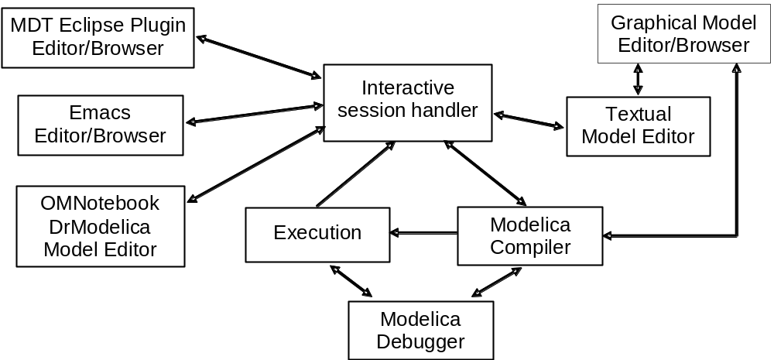
Figure 1-1. The architecture of the OpenModelica environment. Arrows denote data and control flow. The interactive session handler receives commands and shows results from evaluating commands and expressions that are translated and executed. Several subsystems provide different forms of browsing and textual editing of Modelica code. The debugger currently provides debugging of an extended algorithmic subset of Modelica. The graphical model editor is not really part of OpenModelica but integrated into the system and available from MathCore without cost for academic usage.
The following subsystems are currently integrated in the OpenModelica environment:
- An interactive session handler, that parses and interprets commands and Modelica expressions for evaluation, simulation, plotting, etc. The session handler also contains simple history facilities, and completion of file names and certain identifiers in commands.
- A Modelica compiler subsystem, translating Modelica to C code, with a symbol table containing definitions of classes, functions, and variables. Such definitions can be predefined, user-defined, or obtained from libraries. The compiler also includes a Modelica interpreter for interactive usage and constant expression evaluation. The subsystem also includes facilities for building simulation executables linked with selected numerical ODE or DAE solvers.
- An execution and run-time module. This module currently executes compiled binary code from translated expressions and functions, as well as simulation code from equation based models, linked with numerical solvers. In the near future event handling facilities will be included for the discrete and hybrid parts of the Modelica language.
- Emacs textual model editor/browser. In principle any text editor could be used. We have so far primarily employed Gnu Emacs, which has the advantage of being programmable for future extensions. A Gnu Emacs mode for Modelica has previously been developed. The Emacs mode hides Modelica graphical annotations during editing, which otherwise clutters the code and makes it hard to read. A speedbar browser menu allows to browse a Modelica file hierarchy, and among the class and type definitions in those files.
- Eclipse plugin editor/browser. The Eclipse plugin called MDT (Modelica Development Tooling) provides file and class hierarchy browsing and text editing capabilities, rather analogous to previously described Emacs editor/browser. Some syntax highlighting facilities are also included. The Eclipse framework has the advantage of making it easier to add future extensions such as refactoring and cross referencing support.
- OMNotebook DrModelica model editor. This subsystem provides a lightweight notebook editor, compared to the more advanced Mathematica notebooks available in MathModelica. This basic functionality still allows essentially the whole DrModelica tutorial to be handled. Hierarchical text documents with chapters and sections can be represented and edited, including basic formatting. Cells can contain ordinary text or Modelica models and expressions, which can be evaluated and simulated. However, no mathematical typesetting or graphic plotting facilities are yet available in the cells of this notebook editor.
- Graphical model editor/browser. This is a graphical connection editor, for component based model design by connecting instances of Modelica classes, and browsing Modelica model libraries for reading and picking component models. The graphical model editor is not really part of OpenModelica but integrated into the system and provided by MathCore without cost for academic usage. The graphical model editor also includes a textual editor for editing model class definitions, and a window for interactive Modelica command evaluation.
- Modelica debugger. The current implementation of debugger provides debugging for an extended algorithmic subset of Modelica, excluding equation-based models and some other features, but including some meta-programming and model transformation extensions to Modelica. This is conventional full-feature debugger, using Emacs for displaying the source code during stepping, setting breakpoints, etc. Various back-trace and inspection commands are available. The debugger also includes a data-view browser for browsing hierarchical data such as tree- or list structures in extended Modelica.

Implementation Status
In the current OpenModelica implementation version 1.3.2 (April 2006), not all subsystems are yet integrated as well as is indicated in Figure 1-1. Currently there are two versions of the Modelica compiler, one which supports most of standard Modelica including simulation, and is connected to the interactive session handler, the notebook editor, and the graphic model editor, and another meta-programming Modelica compiler version (called MetaModelica compiler) which is integrated with the debugger, Eclipse, and Emacs, supports meta-programming Modelica extensions, but does not allow equation-based modeling and simulation. Those two versions are currently being merged into a single Modelica compiler version.

Interactive Session with Examples
The following is an interactive session using the interactive session handler in the OpenModelica environment, called OMShell – the OpenModelica Shell).

Starting the Interactive Session
The Windows version which at installation is made available in the start menu as OpenModelica->OpenModelica Shell responds with an interaction window:
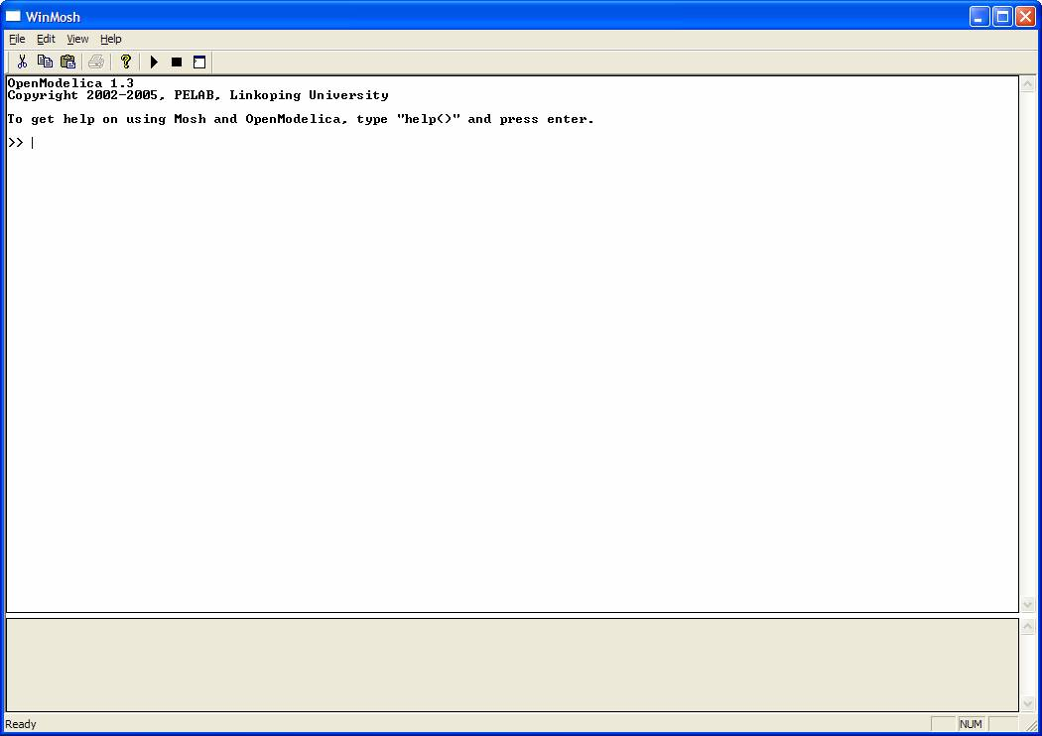
We enter an assignment of a vector expression, created by the range construction expression 1:12, to be stored in the variable x. The value of the expression is returned.
>> x := 1:12
{1, 2, 3, 4, 5, 6, 7, 8, 9, 10, 11, 12}

Trying the Bubblesort Function
Load the function bubblesort, either by using the pull-down menu File->Load Model, or by explicitly giving the command:
>> loadFile("C:/OpenModelica13/testmodels/bubblesort.mo")
true
The function bubblesort is called below to sort the vector x in descending order. The sorted result is returned together with its type. Note that the result vector is of type Real[:], instantiated as Real[12], since this is the declared type of the function result. The input Integer vector was automatically converted to a Real vector according to the Modelica type coercion rules. The function is automatically compiled when called if this has not been done before.
>> bubblesort(x)
{12.0,11.0,10.0,9.0,8.0,7.0,6.0,5.0,4.0,3.0,2.0,1.0}
Another call:
>> bubblesort({4,6,2,5,8})
{8.0,6.0,5.0,4.0,2.0}
It is also possible to give operating system commands via the system utility function. A command is provided as a string argument. The example below shows the system utility applied to the UNIX command cat, which here outputs the contents of the file bubblesort.mo to the output stream. However, the cat command does not boldface Modelica keywords – this improvement has been done by hand for readability.
>> cd("C:/OpenModelica13/testmodels")
>> system("cat bubblesort.mo")
function bubblesort
input Real[:] x;
output Real[size(x,1)] y;
protected
Real t;
algorithm
y := x;
for i in 1:size(x,1) loop
for j in 1:size(x,1) loop
if y[i] > y[j] then
t := y[i];
y[i] := y[j];
y[j] := t;
end if;
end for;
end for;
end bubblesort;

Trying the system and cd Commands
Note: Under Windows the output emitted into stdout by system commands is put into the winmosh console windows, not into the winmosh interaction windows. Thus the text emitted by the above cat command would not be returned. Only a success code (0 = success, 1 = failure) is returned to the winmosh window. For example:
>> system("dir")
0
>> system("Non-existing command")
1
Another built-in command is cd, the change current directory command. The resulting current directory is returned as a string.
>> cd()
"C:\OpenModelica13\testmodels"

>> cd("..")
"C:\OpenModelica13"

>> cd("C:\\OpenModelica13\\testmodels")
"C:\OpenModelica13\testmodels"

Modelica Library and DCMotor Model
We load a model, here the whole Modelica standard library, which also can be done through the File->Load Modelica Library menu item:
>> loadModel(Modelica)
true
We also load a file containing the dcmotor model:
>> loadFile("C:/OpenModelica13/testmodels/dcmotor.mo")
true
It is simulated:
>> simulate(dcmotor,startTime=0.0,stopTime=10.0)
record
resultFile = "dcmotor_res.plt"
end record
We list the source code of the model:
>> list(dcmotor)
"model dcmotor
Modelica.Electrical.Analog.Basic.Resistor r1(R=10);
Modelica.Electrical.Analog.Basic.Inductor i1;
Modelica.Electrical.Analog.Basic.EMF emf1;
Modelica.Mechanics.Rotational.Inertia load;
Modelica.Electrical.Analog.Basic.Ground g;
Modelica.Electrical.Analog.Sources.ConstantVoltage v;

equation
connect(v.p,r1.p);
connect(v.n,g.p);
connect(r1.n,i1.p);
connect(i1.n,emf1.p);
connect(emf1.n,g.p);
connect(emf1.flange_b,load.flange_a);
end dcmotor;
"
We test code instantiation of the model to flat code:
>> instantiateModel(dcmotor)
"fclass dcmotor
Real r1.v "Voltage drop between the two pins (= p.v - n.v)";
Real r1.i "Current flowing from pin p to pin n";
Real r1.p.v "Potential at the pin";
Real r1.p.i "Current flowing into the pin";
Real r1.n.v "Potential at the pin";
Real r1.n.i "Current flowing into the pin";
parameter Real r1.R = 10 "Resistance";
Real i1.v "Voltage drop between the two pins (= p.v - n.v)";
Real i1.i "Current flowing from pin p to pin n";
Real i1.p.v "Potential at the pin";
Real i1.p.i "Current flowing into the pin";
Real i1.n.v "Potential at the pin";
Real i1.n.i "Current flowing into the pin";
parameter Real i1.L = 1 "Inductance";
parameter Real emf1.k = 1 "Transformation coefficient";
Real emf1.v "Voltage drop between the two pins";
Real emf1.i "Current flowing from positive to negative pin";
Real emf1.w "Angular velocity of flange_b";
Real emf1.p.v "Potential at the pin";
Real emf1.p.i "Current flowing into the pin";
Real emf1.n.v "Potential at the pin";
Real emf1.n.i "Current flowing into the pin";
Real emf1.flange_b.phi "Absolute rotation angle of flange";
Real emf1.flange_b.tau "Cut torque in the flange";
Real load.phi "Absolute rotation angle of component (= flange_a.phi = flange_b.phi)";
Real load.flange_a.phi "Absolute rotation angle of flange";
Real load.flange_a.tau "Cut torque in the flange";
Real load.flange_b.phi "Absolute rotation angle of flange";
Real load.flange_b.tau "Cut torque in the flange";
parameter Real load.J = 1 "Moment of inertia";
Real load.w "Absolute angular velocity of component";
Real load.a "Absolute angular acceleration of component";
Real g.p.v "Potential at the pin";
Real g.p.i "Current flowing into the pin";
Real v.v "Voltage drop between the two pins (= p.v - n.v)";
Real v.i "Current flowing from pin p to pin n";
Real v.p.v "Potential at the pin";
Real v.p.i "Current flowing into the pin";
Real v.n.v "Potential at the pin";
Real v.n.i "Current flowing into the pin";
parameter Real v.V = 1 "Value of constant voltage";
equation
r1.R * r1.i = r1.v;
r1.v = r1.p.v - r1.n.v;
0.0 = r1.p.i + r1.n.i;
r1.i = r1.p.i;
i1.L * der(i1.i) = i1.v;
i1.v = i1.p.v - i1.n.v;
0.0 = i1.p.i + i1.n.i;
i1.i = i1.p.i;
emf1.v = emf1.p.v - emf1.n.v;
0.0 = emf1.p.i + emf1.n.i;
emf1.i = emf1.p.i;
emf1.w = der(emf1.flange_b.phi);
emf1.k * emf1.w = emf1.v;
emf1.flange_b.tau = -(emf1.k * emf1.i);
load.w = der(load.phi);
load.a = der(load.w);
load.J * load.a = load.flange_a.tau + load.flange_b.tau;
load.flange_a.phi = load.phi;
load.flange_b.phi = load.phi;
g.p.v = 0.0;
v.v = v.V;
v.v = v.p.v - v.n.v;
0.0 = v.p.i + v.n.i;
v.i = v.p.i;
emf1.flange_b.tau + load.flange_a.tau = 0.0;
emf1.flange_b.phi = load.flange_a.phi;
emf1.n.i + v.n.i + g.p.i = 0.0;
emf1.n.v = v.n.v;
v.n.v = g.p.v;
i1.n.i + emf1.p.i = 0.0;
i1.n.v = emf1.p.v;
r1.n.i + i1.p.i = 0.0;
r1.n.v = i1.p.v;
v.p.i + r1.p.i = 0.0;
v.p.v = r1.p.v;
load.flange_b.tau = 0.0;
end dcmotor;
"
We plot part of the simulated result:
>> plot({load.w,load.phi})
true

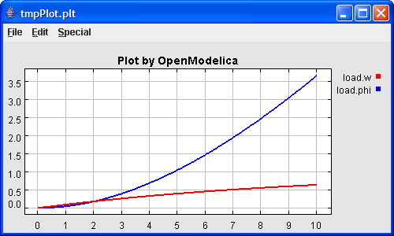

BouncingBall and Switch Models
We load and simulate the BouncingBall example containing when-equations and if-expressions (the Modelica key-words have been bold-faced by hand for better readability):
>> loadFile("C:/OpenModelica13/testmodels/BouncingBall.mo")
true
>> list(BouncingBall)
"model BouncingBall
parameter Real e=0.7 "coefficient of restitution";
parameter Real g=9.81 "gravity acceleration";
Real h(start=1) "height of ball";
Real v "velocity of ball";
Boolean flying(start=true) "true, if ball is flying";
Boolean impact;
Real v_new;
equation
impact=h <= 0.0;
der(v)=if flying then -g else 0;
der(h)=v;
when {h <= 0.0 and v <= 0.0,impact} then
v_new=if edge(impact) then -e*pre(v) else 0;
flying=v_new > 0;
reinit(v, v_new);
end when;
end BouncingBall;
"
Instead of just giving a simulate and plot command, we perform a runScript command on a .mos (Modelica script) file sim_BouncingBall.mos that contains these commands:
loadFile("BouncingBall.mo");
simulate(BouncingBall, stopTime=3.0);
plot({h,flying});
The runScript command:
>> runScript("sim_BouncingBall.mos")
"true
record
resultFile = "BouncingBall_res.plt"
end record
true
true"

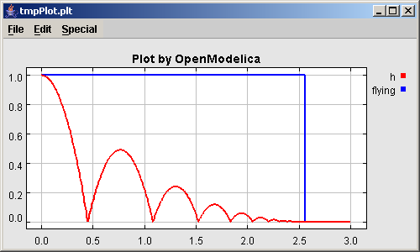
We enter a switch model, to test if-equations (e.g. copy and paste from another file and push enter):
>> model switch
Real v;
Real i;
Real i1;
Real itot;
Boolean open;
equation
itot = i + i1;
if open then
v = 0;
else
i = 0;
end if;
1 - i1 = 0;
1 - v - i = 0;
open = time >= 0.5;
end switch;
Ok
>> simulate(switch, startTime=0, stopTime=1);
>> plot({itot,open})
true

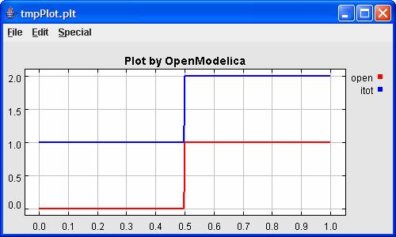
We note that the variable open switches from false (0) to true (1), causing itot to increase from 1.0 to 2.0.

Clear All Models
Now, first clear all loaded libraries and models:
>> clear()
true
List the loaded models – nothing left:
>> list()
""

VanDerPol Model and Parametric Plot
We load another model, the VanDerPol model (or via the menu File->Load Model):
>> loadFile("C:/OpenModelica13/testmodels/VanDerPol.mo"))
true
It is simulated:
>> simulate(VanDerPol)
record
resultFile = "VanDerPol_res.plt"
end record
It is plotted:
plotParametric(x,y); // Error in version 1.3.2: instead use plotParametric({x,y})
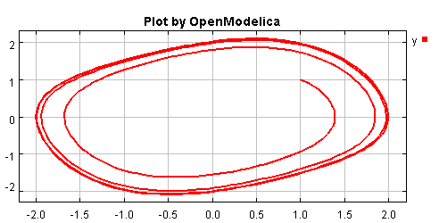
Do code instantiation to flat forrm of the VanDerPol model:
>> instantiateModel(VanDerPol)
"fclass VanDerPol
Real x(start=1.0);
Real y(start=1.0);
parameter Real lambda = 0.3;
equation
der(x) = y;
der(y) = -x + lambda * (1.0 - x * x) * y;
end VanDerPol;
"

Variables, Functions, and Types of Variables
Assign a vector to a variable:
>> a:=1:5
{1,2,3,4,5}
Type in a function:
>> function MySqr input Real x; output Real y; algorithm y:=x*x; end MySqr;
Ok
Call the function:
>> b:=MySqr(2)
4.0
Look at the value of variable a:
>> a
{1,2,3,4,5}
Look at the type of a:
>> typeOf(a)
"Integer[]"
Retrieve the type of b:
>> typeOf(b)
"Real"

What is the type of MySqr? Cannot currently be handled.
>> typeOf(MySqr)
Error evaluating expr.
List the available variables:
>> listVariables()
{currentSimulationResult, a, b}
Clear again:
>> clear()
true

Using External Functions
The following is a small example (ExternalLibraries.mo) to show the use of external functions:

model ExternalLibraries
Real x(start=1.0),y(start=2.0);
equation
der(x)=-ExternalFunc1(x);
der(y)=-ExternalFunc2(y);
end ExternalLibraries;
function ExternalFunc1
input Real x;
output Real y;
external
y=ExternalFunc1_ext(x) annotation(Library="libExternalFunc1_ext.o",
Include="#include \"ExternalFunc1_ext.h\"");
end ExternalFunc1;

function ExternalFunc2
input Real x;
output Real y;
external "C" annotation(Library="libExternalFunc2.a",
Include="#include \"ExternalFunc2.h\"");
end ExternalFunc2;
These C (.c) files and header files (.h) are needed:
/* file: ExternalFunc1.c */
double ExternalFunc1_ext(double x)
{
double res;
res = x+2.0*x*x;
return res;
}

/* Header file ExternalFunc1_ext.h for ExternalFunc1 function */
double ExternalFunc1_ext(double);

/* file: ExternalFunc2.c */
double ExternalFunc2(double x)
{
double res;
res = (x-1.0)*(x+2.0);
return res;
}

/* Header file ExternalFunc2.h for ExternalFunc2 */
double ExternalFunc2(double);
The following script file ExternalLibraries.mos will perform everything that is needed, provided you have gcc installed in your path:
loadFile("ExternalLibraries.mo");
system("gcc -c -o libExternalFunc1_ext.o ExternalFunc1.c");
system("gcc -c -o libExternalFunc2.a ExternalFunc2.c");
simulate(ExternalLibraries);
We run the script:
>> runScript("ExternalLibraries.mos");
and plot the results:
>> plot({x,y});
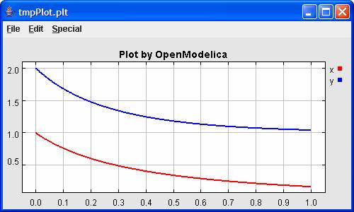

Quit OpenModelica
Leave and quit OpenModelica:
>> quit()

Commands for the Interactive Session Handler
The following is the complete list of commands currently available in the interactive session hander.
simulate(modelname) Translate a model named modelname and simulate it.
simulate(modelname[,startTime=<Real>][,stopTime=<Real>][,numberOfIntervals
=<Integer>]) Translate and simulate a model, with optional start time, stop time, and optional number of simulation intervals or steps for which the simulation results will be computed. Many steps will give higher time resolution, but occupy more space and take longer to compute. The default number of intervals is 500.
plot(vars) Plot the variables given as a vector or a scalar, e.g. plot({x1,x2}) or plot(x1).
cd() Return the current directory.
cd(dir) Change directory to the directory given as string.
clear() Clear all loaded definitions.
clearVariables() Clear all defined variables.
instantiateModel(modelname)Performs code instantiation of a model/class and return a string containing the flat class definition.
list() Return a string containing all loaded class definitions.
list(modelname) Return a string containing the class definition of the named class.
listVariables() Return a vector of the names of the currently defined variables.
loadModel(classname) Load model or package of name classname from MODELICAPATH.
loadFile(str) Load Modelica file (.mo) with name given as string argument str.
readFile(str) Load file given as string str and return a string containing the file content.
runScript(str) Execute script file with file name given as string argument str.
system(str) Execute str as a system(shell) command in the operating system; return integer success value. Output into stdout from a shell command is put into the console window.
timing(expr) Evaluate expression expr and return the number of seconds (elapsed time) the evaluation took.
typeOf(variable) Return the type of the variable as a string.
saveModel(str,modelname) Save the model/class with name modelname in the file given by the string argument str.
help() Print this helptext (returned as a string).
quit() Leave and quit the OpenModelica environment

Getting Started with the Graphical Model Editor
This chapter gives a very short introduction to graphical modeling. You will learn how to build your own model using the graphical model editor by using the drag-and-drop technique of already developed and freely available components from the Modelica Standard Library.
NOTE: This chapter is an out-ouf-date preliminary description which in the near future will be replaced by a separate manual for the Graphical Model Editor. See www.mathcore.com for a more recent update and reference to the current manual and users guide.
The Modelica Standard Library is loaded into the OpenModelica environment when the model editor is started and can be browsed using the class browser visible at the left of Figure 2-2 below.
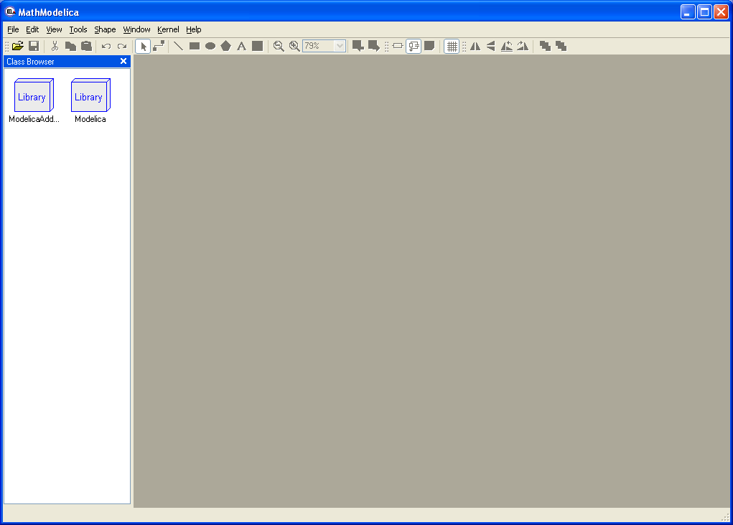
Figure 2-2. The Graphical Model Editor with the class browser to the left, showing icons for the ModelicaAdditions library and the Modelica Standard library.
To open the library, double click on the Modelica package icon in the class browser to the left. As shown by Figure 2-3, the Modelica Standard Library is hierarchically structured into sublibraries.
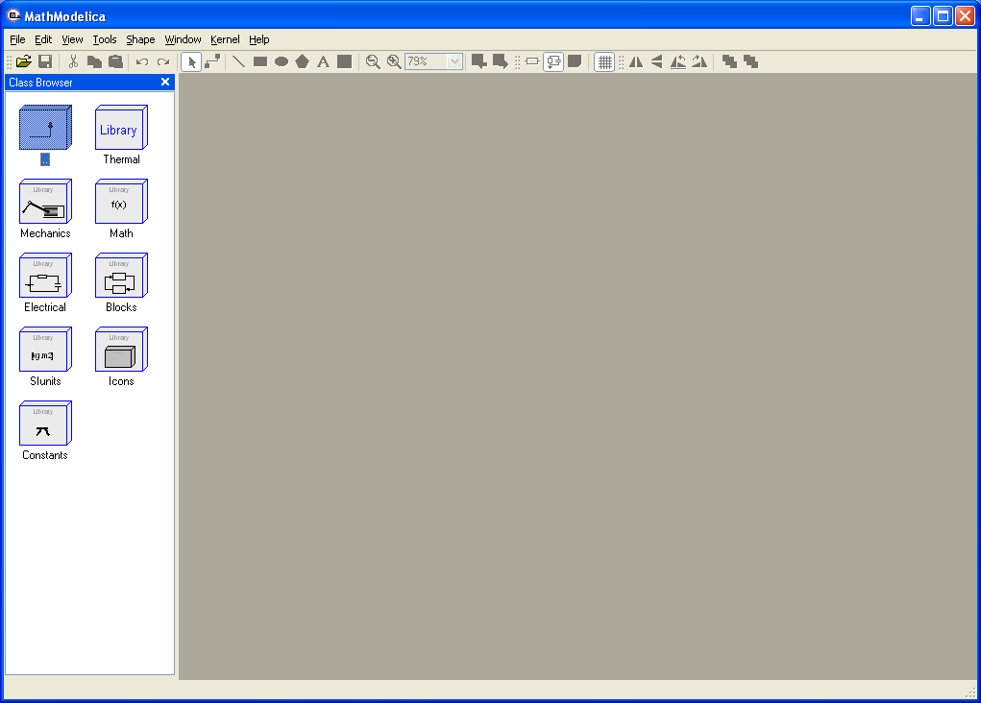
Figure 2-3. The Graphical Model Editor with the class browser showing the Modelica Standard library opened up into sublibraries.
The following list briefly describes the most important sublibraries in the Modelica standard library:
Thermal Components for thermal systems.
Mechanics Mechanical rotational and translational components.
Math Definitions of common mathematical functions, such as sin, cos, and log.
Electrical Common electrical components, such as resistors and transistors.
Blocks Continuous and discrete input/output blocks for use in block diagrams.
SIunits Type definitions with SI standard names and units.
Icons Graphical layout for many component icons
Constants Common constants from mathematics, physics, etc.

Your First Model
We will introduce the model editor by showing how to build a model of a simple DC motor. Since the DC motor includes both electrical and rotational mechanical components the example also illustrates multi-domain modeling.

Creating a New Model
To create a new model, select New Model in the File menu. A dialog box will appear, in which you will be able to specify a name of the new model. Enter Motor as Model name.
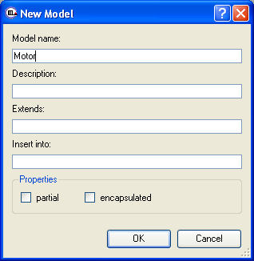
Figure 2-4. Dialog box for creating a new model.
When clicking on the OK button of the dialog box a new window will appear. This window presents different views of the model. A model has two graphical views (Icon and Diagram), and one text view (ModelicaText).
Your new Motor model will also appear at the top package level in the class browser. Since no icon for the model has yet been created it is assigned a default icon (a question mark).

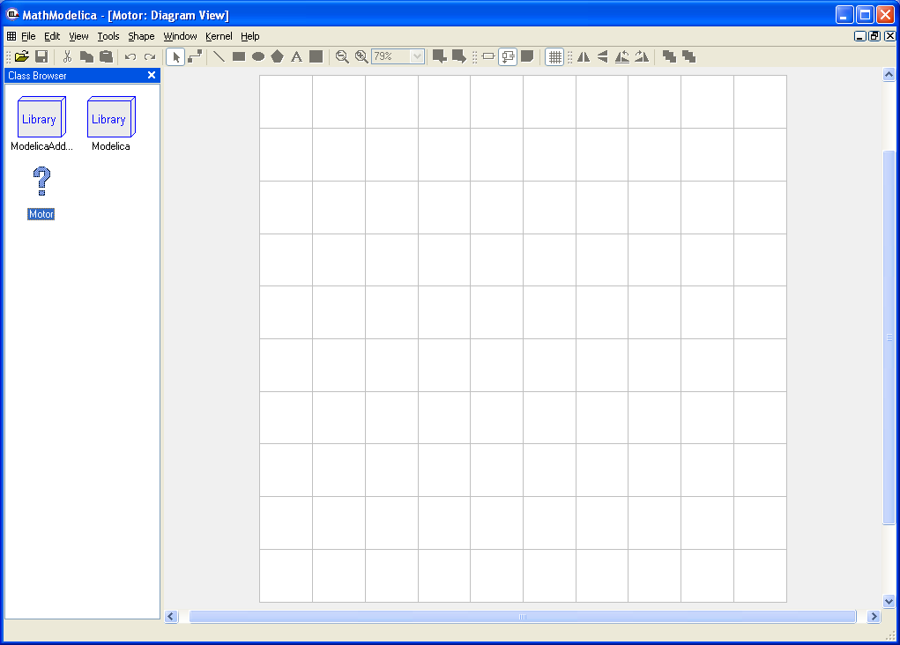
Figure 2-5. The Graphical Model Editor with the new Motor model appearing as a question mark icon in the class browser window to the left.
Now you can assemble the DC motor by drag-and-drop of components from the class browser to the diagram view window to the right. The constant voltage source component can be found in the Modelica.Electrical.Analog.Sources package whereas the rotational mass representing the motor shaft is located in the Modelica.Mechanics.Rotational package. The other electrical components needed are located in the Modelica.Electrical.Analog.Basic package.
Components placed in the diagram layer window can be graphically transformed using the mouse and keyboard. To move a component, select it and hold down the left mouse button while moving the mouse. The component will follow the mouse cursor. Release the mouse button when the component is located at the desired position. If more than one component is selected, all of them will be moved simultaneously.
Scaling of components is done using the handles that are visible when a component is selected. Place the mouse cursor over one of the handles, click and hold down the left mouse button while moving the mouse.
Components can also be rotated freely using the handles visible when a component is selected. Place the mouse cursor over one of the handles, click and hold down the left mouse button and the shift button on the keyboard while moving the mouse. The mouse cursor will change its appearance while rotating the component.
Pressing the right mouse button when the mouse cursor is placed over a component brings up a menu with suitable operations.
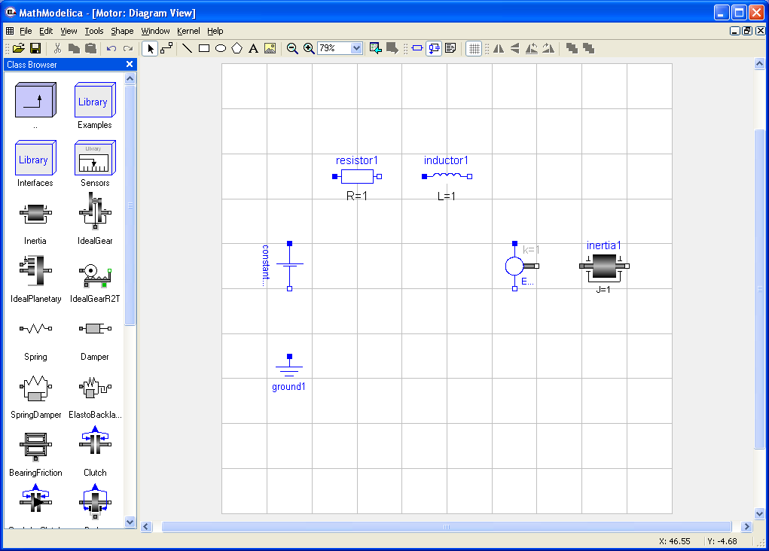
Figure 2-6. The Graphical Model Editor with several components dragged into the diagram view, and several sublibraries and model classes visible in the class browser window to the left.
When the components have been placed on the drawing area, similar to the figure above, you have to draw the lines that connect the components. This is done using the connector tool from the toolbar:
To connect two components, select the connector tool and place the mouse cursor over a connector, i.e., the square symbol on either side of the component. When you are close enough, the mouse cursor will change into a cross. Click and a hold down the left mouse button, drag the cursor to the other connector and then release the mouse button when the mouse cursor turns into a cross. Continue to connect all components until the model diagram resembles the one in Figure 2-7 below.

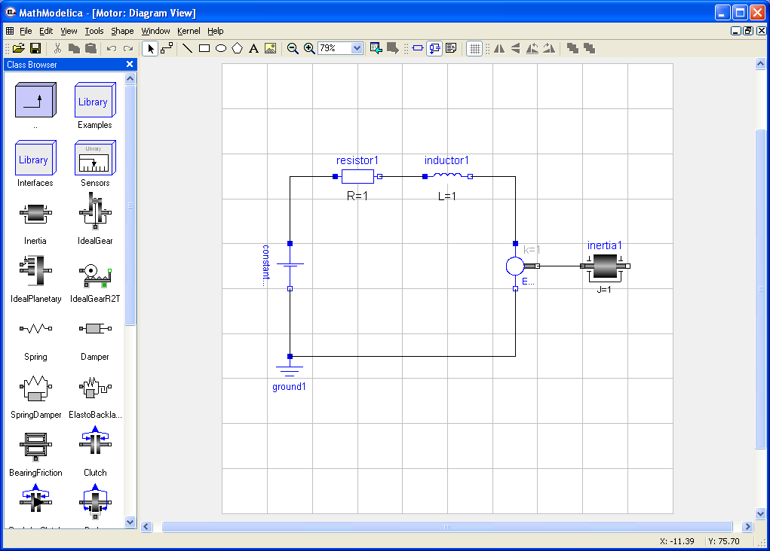
Figure 2-7. The Graphic Model Editor with components connected into a simple DC motor model.

Changing Parameter Values of Components
To change a parameter value of a component, e.g. the resistance of the resistor, we need to switch to the Modelica Text View of the class. Click on the Modelica Text View button in the toolbar to switch to text mode:
Whenever we switch from the graphical view to the Modelica Text View after making any changes to the model in the graphical layers we need to update the text view. Click on the Refresh Class button, also found in the toolbar:
After the text view has been updated it should look similar to the one in Figure 2-8. The order of the component declarations and connection equations depend on in which order you placed them on the drawing area and connected them.

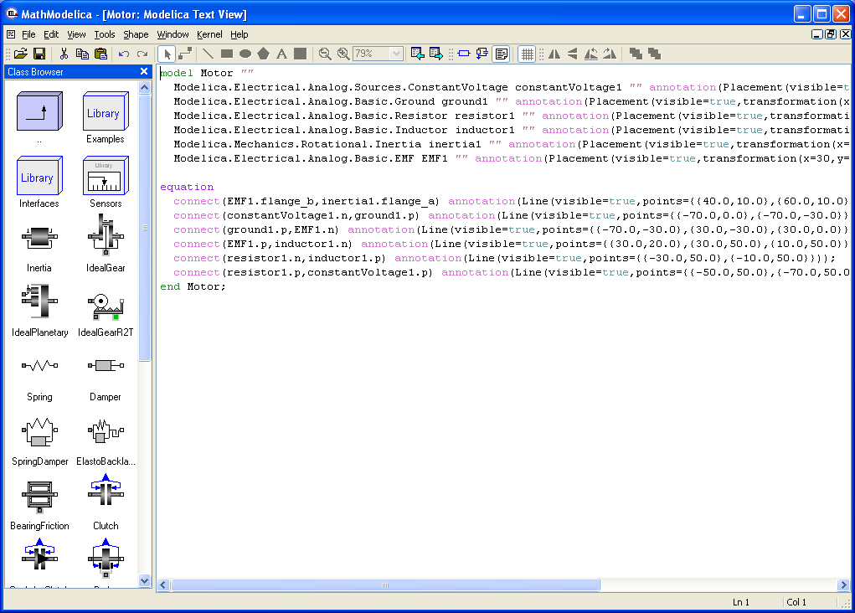
Figure 2-8. The Graphical Model Editor with the Modelica Text View mode showing the new Motor model. This view also allows text editing of the model.

Locate the line that starts with Modelica.Electrical.Analog.Basic.Resistor. Put the text cursor right after resistor1 and add the text (R=20). This text is a modification of the resistor component, changing its parameter R (resistance) from the default value of 1 to 20. The Modelica Text View should now look similar to the one found in Figure 2-9 below.

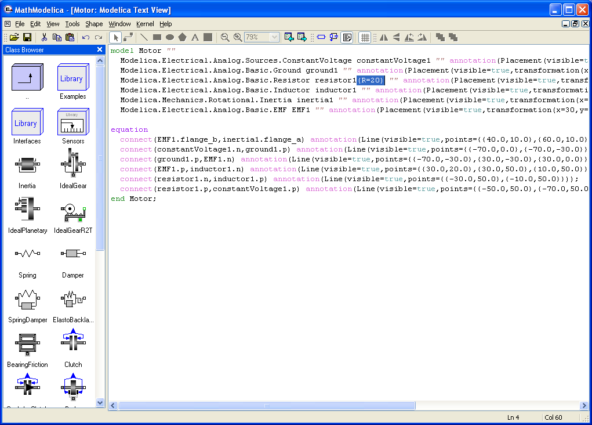
Figure 2-9. The Modelica Text View of the Motor model, with a modifier R=20 added for the resistor1 component.
When you make any changes to the model in the Modelica Text View you need to click on the Apply Class Definition button in the toolbar to confirm the changes:

When you have done this, change class view back to the Diagram View and study the icon of the resistor component. It should show R=20 instead of R=1, i.e., the resistance of the resistor is now 20 ohm.

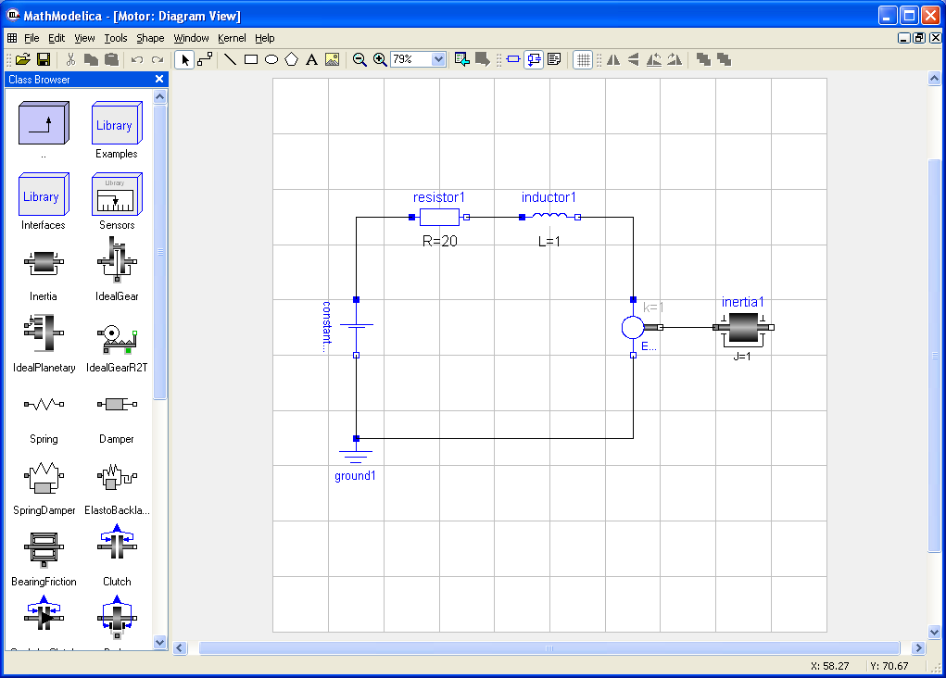
Figure 2-10. The Diagram View showing R=20 for the resistor1 component.

Translating and Simulating Using the Interactive View
Translating and simulating is performed using the Interactive View of the simulation kernel window in the OpenModelica edition of the Graphic Model Editor (a more convenient interface is available in the professional version). To open the kernel window, select Open Kernel Window in the File menu. Enter the command simulate(Motor) in the interactive view to translate and simulate the model.
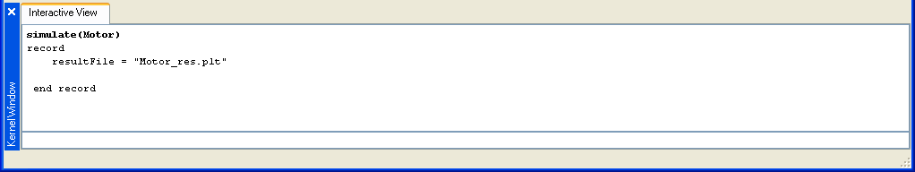
Figure STYLEREF 1 \s 2- SEQ Figure \* ARABIC \s 1 10. The interactive view of the simulation kernel window, with the simulation command simulate(Motor).

Plotting
After the model has been translated and simulated, any of its variables can be plotted using the OpenModelica plot command. Giving the command plot({inductor1.w, inertia1.a}) will bring up the window below.
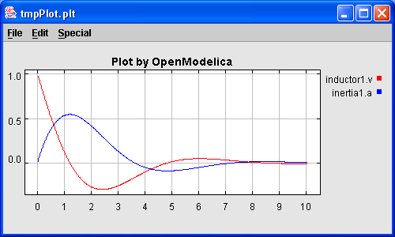
Figure 2-11. OpenModelica plot window created by the command: plot({inductor1.w, inertia1.a}), after a simulation of the Motor model.

Saving and Loading
It is possible to save a model from the model editor. Saving a model will create a Modelica 2.2 standard output file with the extension .mo. This file can later be loaded back into the model editor.

OMNotebook with DrModelica
This chapter covers the OpenModelica electronic notebook subsystem, called OMNotebook, together with the DrModelica tutoring system for teaching Modelica, which is using such notebooks.

Interactive Notebooks with Literate Programming
Interactive Electronic Notebooks are active documents that may contain technical computations and text, as well as graphics. Hence, these documents are suitable to be used for teaching and experimentation, simulation scripting, model documentation and storage, etc.

Mathematica Notebooks
Literate Programming (Knuth 1984) is a form of programming where programs are integrated with documentation in the same document. Mathematica notebooks (Wolfram 1997) is one of the first WYSIWYG (What-You-See-Is-What-You-Get) systems that support Literate Programming. Such notebooks are used, e.g., in the MathModelica modeling and simulation environment, e.g. see Figure 3-12 below and Chapter 19 in (Fritzson 2004)

OMNotebook
The OMNotebook software (Axelsson 2005, Fernström 2006) is a new open source free software that gives an interactive WYSIWYG (What-You-See-Is-What-You-Get) realization of Literate Programming, a form of programming where programs are integrated with documentation in the same document.
The OMNotebook facility is actually an interactive WYSIWYG (What-You-See-Is-What-You-Get) realization of Literate Programming, a form of programming where programs are integrated with documentation in the same document. OMNotebook is a simple open-source software tool for an electronic notebook supporting Modelica.
A more advanced electronic notebook tool, also supporting mathematical typesetting and many other facilities, is provided by Mathematica notebooks in the MathModelica environment, see Figure 3-12.
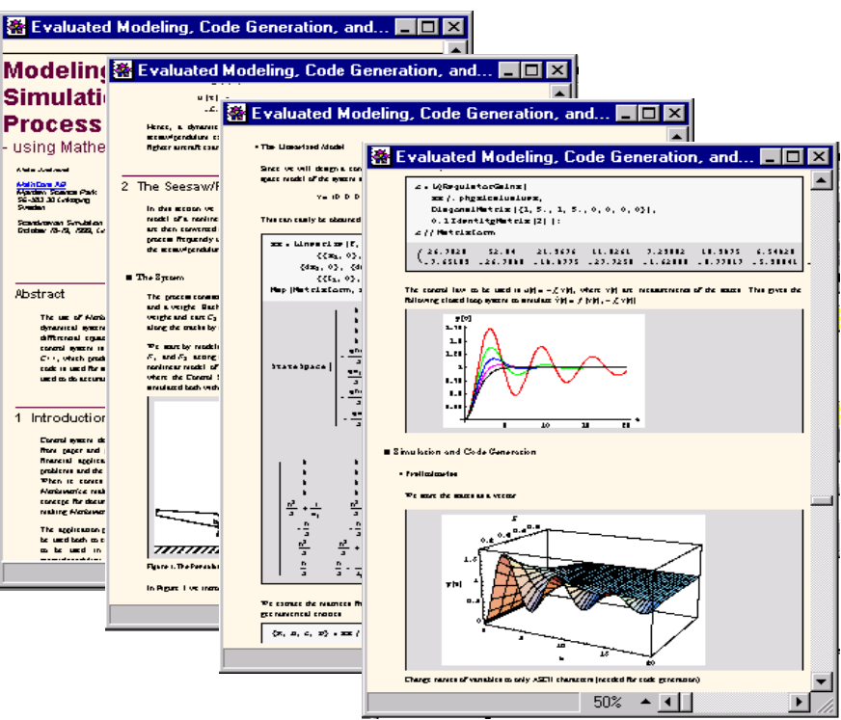
Figure 3-12. Examples of Mathematica notebooks in the MathModelica modeling and simulation environment.
Traditional documents, e.g. books and reports, essentially always have a hierarchical structure. They are divided into sections, subsections, paragraphs, etc. Both the document itself and its sections usually have headings as labels for easier navigation. This kind of structure is also reflected in electronic notebooks. Every notebook corresponds to one document (one file) and contains a tree structure of cells. A cell can have different kinds of contents, and can even contain other cells. The notebook hierarchy of cells thus reflects the hierarchy of sections and subsections in a traditional document such as a book..

The DrModelica Tutoring System – an Application of OMNotebook

Understanding programs is hard, especially code written by someone else. For educational purposes it is essential to be able to show the source code and to give an explanation of it at the same time.
Moreover, it is important to show the result of the source code’s execution. In modeling and simulation it is also important to have the source code, the documentation about the source code, the execution results of the simulation model, and the documentation of the simulation results in the same document. The reason is that the problem solving process in computational simulation is an iterative process that often requires a modification of the original mathematical model and its software implementation after the interpretation and validation of the computed results corresponding to an initial model.
Most of the environments associated with equation-based modeling languages focus more on providing efficient numerical algorithms rather than giving attention to the aspects that should facilitate the learning and teaching of the language. There is a need for an environment facilitating the learning and understanding of Modelica. These are the reasons for developing the DrModelica teaching material for Modelica and for teaching modeling and simulation.
An earlier version of DrModelica was developed using the MathModelica environment. The rest of this chapter is concerned with the OMNotebook version of DrModelica and on the OMNotebook tool itself.
DrModelica has a hierarchical structure represented as notebooks. The front-page notebook is similar to a table of contents that holds all other notebooks together by providing links to them. This particular notebook is the first page the user will see (Figure 3-13).
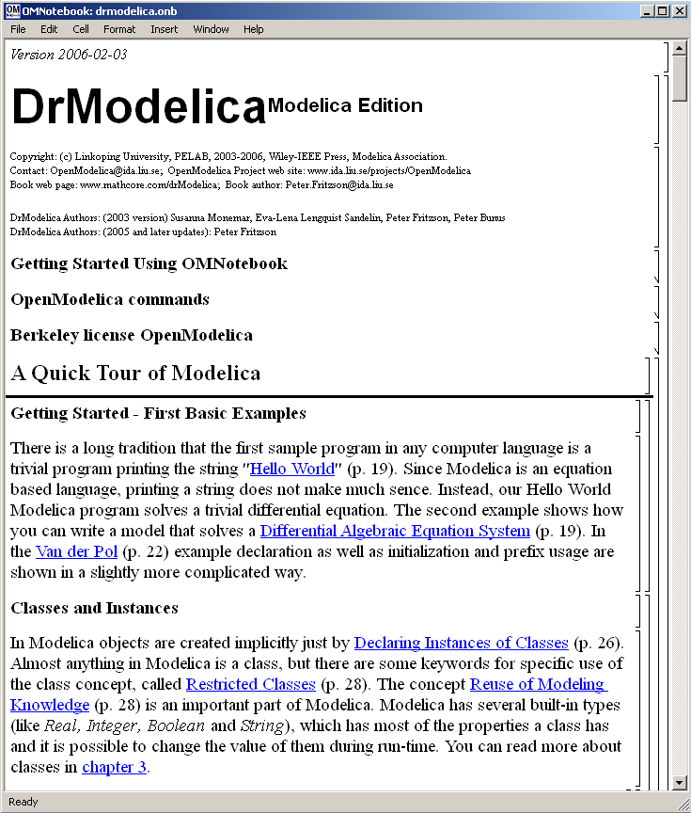
Figure 3-13. The front-page notebook of the OMNotebook version of the DrModelica tutoring system.
In each chapter of DrModelica the user is presented a short summary of the corresponding chapter of the book “Principles of Object-Oriented Modeling and Simulation with Modelica 2.1” by Peter Fritzson. The summary introduces some keywords, being hyperlinks that will lead the user to other notebooks describing the keywords in detail.

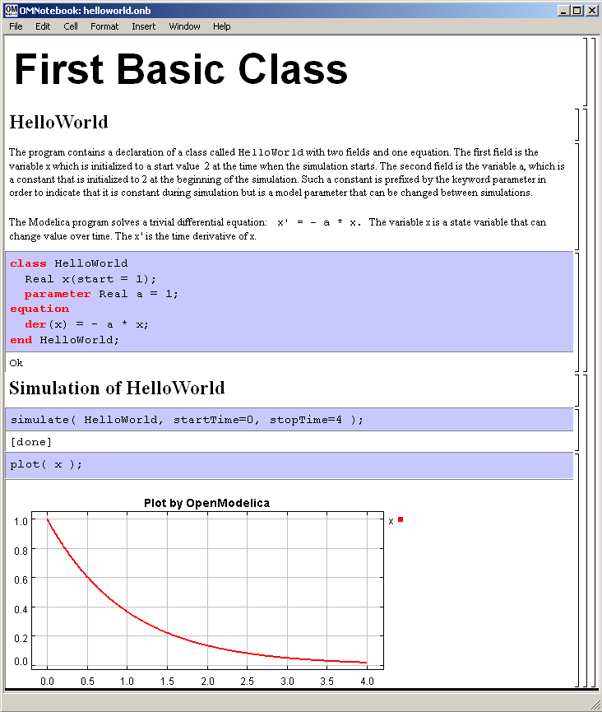

Figure 3-14. The HelloWorld class simulated and plotted using the OMNotebook version of DrModelica.
Now, let us consider that the link “HelloWorld” in DrModelica Section is clicked by the user. The new HelloWorld notebook (see Figure 3-14), to which the user is being linked, is not only a textual description but also contains one or more examples explaining the specific keyword. In this class, HelloWorld, a differential equation is specified.
No information in a notebook is fixed, which implies that the user can add, change, or remove anything in a notebook. Alternatively, the user can create an entirely new notebook in order to write his/her own programs or copy examples from other notebooks. This new notebook can be linked from existing notebooks.

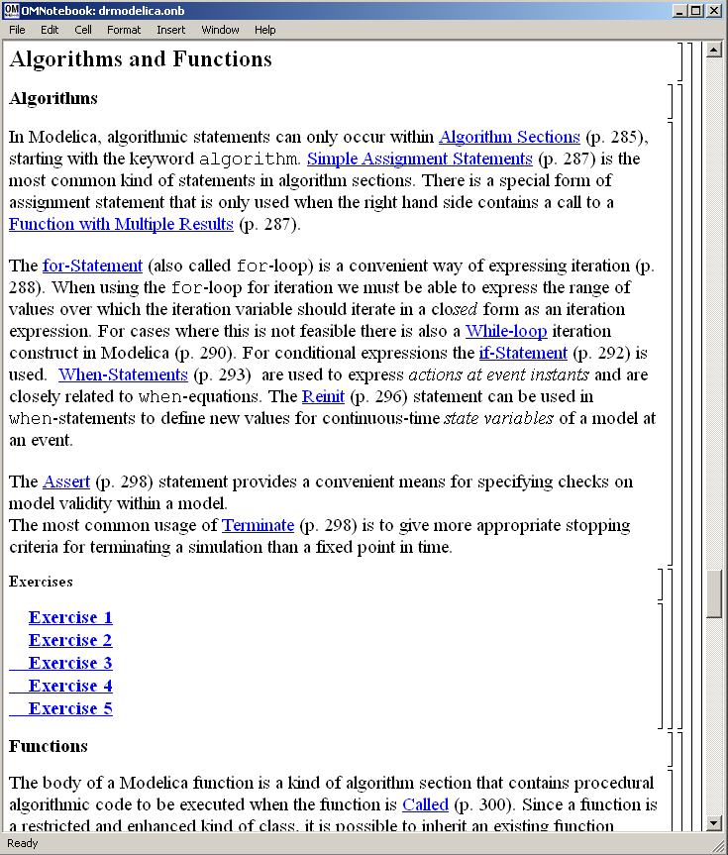

Figure 3-15. DrModelica Chapter on Algorithms and Functions in the main page of the OMNotebook version of DrModelica.
When a class has been successfully evaluated the user can simulate and plot the result, as previously depicted in Figure 3-14 for the simple HelloWorld example model..

After reading a chapter in DrModelica the user can immediately practice the newly acquired information by doing the exercises that concern the specific chapter. Exercises have been written in order to elucidate language constructs step by step based on the pedagogical assumption that a student learns better “using the strategy of learning by doing”. The exercises consist of either theoretical questions or practical programming assignments. All exercises provide answers in order to give the user immediate feedback.
Figure 3-15 shows part of Chapter 9 of the DrModelica teaching material. Here the user can read about language constructs, like algorithm sections, when-statements, and reinit equations, and then practice these constructs by solving the exercises corresponding to the recently studied section.

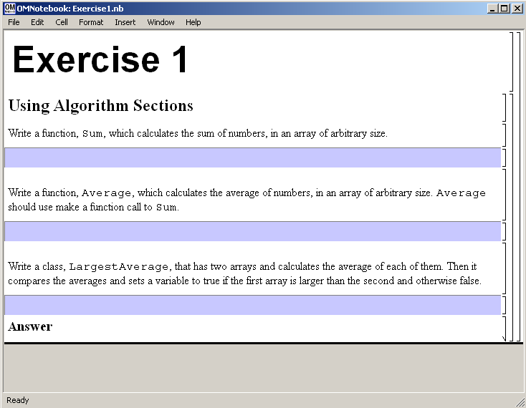
Figure 3-16. Exercise 1 in Chapter 9 of DrModelica.

Exercise 1 from Chapter 9 is shown in . In this exercise the user has the opportunity to practice different language constructs and then compare the solution to the answer for the exercise. Notice that the answer is not visible until the Answer section is expanded. The answer is shown in .

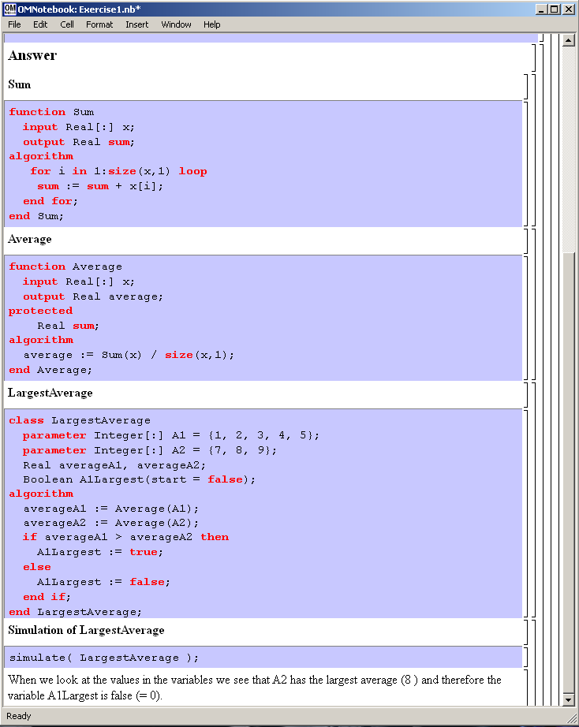
Figure 3-17. The answer section to Exercise 1 in Chapter 9 of DrModelica.

OpenModelica Notebook Commands
The current version of OMNotebook supports the following operations:

File Menu
- Create a new notebook – A new notebook can be created using the menu c or the key combination Ctrl+N. A new document window will then open, with a new document inside.
- Open a notebook – To open a notebook use File->Open in the menu or the key combination Ctrl+O. Only files of the type .onb or .nb can be opened. If a file does not follow the OMNotebook format or the FullForm Mathematica Notebook format, then a message box will be displayed telling the user that it is in the wrong. Mathematica Notebook form and must be converted to fullform before it can be opened in OMNotebook.
- Save a notebook – To save a notebook use the menu item File->Save or File->Save As. If the notebook has not been saved before the save as dialog will be shown and a filename can be selected. OMNotebook can only save in xml format and the saved file is not compatible with Mathematica. Key combination for save is Ctrl+S and for save as Ctrl+Shift+S. The saved file by default obtains the file extension .onb.
- Print – Printing a document to a printer is done by pressing the key combination Ctrl+P or using the menu item File->Print. A normal print dialog is displayed where the usually properties can be changed.
- Import old document – Old documents, saved with the old version of OMNotebook where a different file format was used, can be opened using the menu item File->Import->Old OMNotebook file. Old documents have the extension .xml.
- Export text – The text inside a document can be exported to a text document. The text will be exported to a text document without any structure saved. The only structure that is saved is the cell structure. Each paragraph in the text document will contain text from one cell. To use the export function, use menu item File->Export->Pure Text.
- Close a notebook window – A notebook window can be closed using the menu item File->Close or the key combination Ctrl+F4. Any unsaved changes in the document will be lost when the notebook window is closed.
- Quitting OMNotebook – To quit use menu item File->Quit or the key combination Crtl+Q. This will close all notebook windows and quit OMNotebook. OMC will also be closed. Evaluating the command quit() will have the same result as exiting OMNotebook.

Cell Types
- Cells – Everything inside an OMNotebook document is made out of cells. A cell basically contains a chunk of data. The data can be text, images, or other cells. OMNotebook has four types of cells: textcell, inputcell, groupcell and cellcursor. Cells are ordered in a tree strcuture, where one cell can be a parent to one or many other cells. A tree view is available close to the right border in the notebook window to display the relation between the cells.
- Textcell – This cell type are used to display ordinary text and images. Each textcell has a style that specifies how text is displayed. The cells style can be changed in the menu Format->Styles, example of different styles are: Text, Title, and Subtitle. The Textcell type also has support for following links to other notebook documents.
- Inputcell – This cell type has support for syntax highlighting and evaluation. It is intended to be used for writing program code. Evaluation is done by pressing the key combination Shift+Return or Shift+Enter. All the text in the cell will be sent to OMC (OpenModelica Compiler/interpreter), where the text is evaluated and the result is displayed below the inputcell. By double-clicking on the cell marker in the tree view, the inputcell can be collapsed so the result is hidden.
- Groupcell – This cell type is used to group together other cell. A groupcell can be opened or closed. When a groupcell is opened all the cells inside the groupcell are visible, but when the groupcell is closed only the first cell inside the groupcell is visible. The state of the groupcell is changed by the user double-clicking on the cells marker in the tree view. When the groupcell is closed the marker is changed and the marker have an arrow at the bottom.
- Cellcursor – This cell type is a special type that show which cell that currently has the focus. The cell is basically just a thin black line. The cellcursor is moved by clicking on a cell or using the menu item Cell->Next Cell or Cell->Previous Cell. The cursor can also be moved with the key combination Ctrl+Up or Ctrl+Down.
- Select cell – A cell can be selected by clicking on its cell bracket to the right. Several cells can be selected by holding down Ctrl and clicking on the cell markings in the tree view one at a time.

Cell Commands
- Cells – Everything inside an OMNotebook document is made out of cells. A cell basically describes a chunk of data and the data can be text, images or other cells. OMNotebook has four types of cells: textcell, inputcell, groupcell and cellcursor. Cells are ordered in a tree structured, where one cell can be a parent to one or many other cells. A tree view is placed to the right in the notebook window to display the relation between the cells.
- Textcell – This cell type is used to display ordinary text and images. Each textcell has a style that specifies how text is displayed. The cell's style can be changed in the menu Format->Styles, example of different styles are: Text, Title, and Subtitle. The Textcell type also has support for following links to other notebook documents.
- Inputcell – This cell type has support of syntax highlighting and evaluation and is supposed to be used to write code in. Evaluation is done by pressing the key combination Shift+Return or Shift+Enter. All the text in the cell will be sent to OMC, where the text is evaluated and the result is displayed below the inputcell. By double-clicking on the cells marker in the tree view, the inputcell can be collapsed so the result is hidden.
- Groupcell – This cell type is used to group together other cell. Groupcell can be opened or closed. When a groupcell is opened all the cells inside the groupcell is visible, but when the groupcell is closed only the first cell inside the groupcell is visible. The state of the groupcell is changed by the user double-clicking on the cells marker in the tree view. When the groupcell is closed the marker is changed and the marker has an arrow at the bottom.
- Cellcursor – This cell type is a special kind of cell that shows which cell that currently has the focus. The cell is basically just a thin black line. The cellcursor is moved by clicking on a cell or using the menu item Cell->Next Cell or Cell->Previous Cell. The cursor can also be moved with the key combination Ctrl+Up or Ctrl+Down.
- Select cell – Cells can be selected by clicking on them. Holding down Ctrl and clicking on the cell markings in the tree view allows several cells to be selected, one at a time.

Edit Menu
- Editing cell text – Cells have a set of of basic editing functions. The key combination for these are: Undo (Ctrl+Z), Redo (Ctrl+Y), Cut (Ctrl+X), Copy (Ctrl+C) and Paste (Ctrl+V). These functions can also be accessed from the edit menu; Undo (Edit->Undo), Redo (Edit->Redo), Cut (Edit->Cut), Copy (Edit->Copy) and Paste (Edit->Paste). Selection of text is done in the usual way by double-clicking, dragging the mouse, or using (Ctrl-A) to select all text within the cell.
- View expression – Text in a cell is stored internally by Qt as a subset of HTML code and the menu item Edit->View Expression let the user switch between viewing the text or the internal HTML representation. Changes made to the HTML code will affect how the text is displayed.

Cell Menu
- Cut cell – Cells can be cut from the document with the menu item Cell->Cut Cell or the key combination Ctrl+Shift+X.
- Copy cell – Cells can be copied from the document with the menu item Cell->Copy Cell or the key combination Ctrl+Shift+C.
- Paste cell – Cells that have been cut or copied can be pasted into the document with the menu item Cell->Paste Cell or the key combination Ctrl+Shift+V. OMNotebook shares the same application-wide clipboard. Therefore cells that have been copied in one notebook window can be pasted into another notebook window. Only pointers to the copied or cut cell are added to the clipboard, thus the cell that should be added must still exist. Consequently a cell can not be pasted from a document that have been closed.
- Add textcell – A new textcell is added with the menu item Cell->Add Cell (previous cell style) or the key combination Alt+Enter. The new textcell will have the same style as the previous cell.
- Add inputcell – A new inputcell is added with the menu item Cell->Add Inputcell or the key combination Ctrl+Shift+I.
- Add groupcell – A new groupcell is inserted with the menu item Format->Groupcell or the key combination Ctrl+Shift+G. The selected cell will then become the first cell inside the groupcell.
- Delete cell – The menu item Cell->Delete Cell will delete all cells that have been selected in the tree view. If no cell is selected this action will delete the cell that have been selected by the cellcursor. This action can also be called with the key combination Ctrl+Shift+D or the key Del.
- Cellcursor – This cell type is a special type that show which cell that currently has the focus. The cell is basically just a thin black line. The cellcursor is moved by clicking on a cell or using the menu item Cell->Next Cell or Cell->Previous Cell. The cursor can also be moved with the key combination Ctrl+Up or Ctrl+Down.

Format Menu
- Textcell – This cell type is used to display ordinary text and images. Each textcell has a style that specifies how text is displayed. The cells style can be changed in the menu Format->Styles, examples of different styles are: Text, Title, and Subtitle. The Textcell type also have support for following links to other notebook documents.
- Text manipulation – There are a number of different text manipulations that can be done to change the appearance of the text. These manipulations include operations like: changing font, changing color and make text bold, but also operations like: changing the alignment of the text and the margin inside the cell. All text manipulations inside a cell can be done on single letters, words or the entire text. Text settings are found in the Format menu. The following text manipulations are available in OMNotebook:
> Font family
> Font face (Plain, Bold, Italic, Underline)
> Font size
> Font stretch
> Font color
> Text horizontal alignment
> Text vertical alignment
> Border thickness
> Margin (outside the border)
> Padding (inside the border)

Insert Menu
- Insert image – Images are added to the document with the menu item Insert->Image or the key combination Ctrl+Shift+M. After an image has been selected a dialog will appear, where the size of the image can be chosen. The images actual size will be the default value of the image. OMNotebook will stretch the image accordantly with the selected size. Unlike the old version of OMNotebook, all images are now saved in the same file as the rest of the document.
- Insert link – A document can contain links to other OMNotebook file or Mathematica notebook and to add a new link a piece of text must first be selected. The selected text will make up the part of the link that the user can click on. Inserting a link is done from the menu Insert->Link or with the key combination Ctrl+Shift+L. A dialog window, much like the one used to open documents, allows the user to choose the file that the link will link to. All links are saved in the document with a relative file path so documents that belong together easily can be moved from one place to another without the links failing.

Window Menu
- Change window – Each opened document has its own document window. To switch between those use the Window menu. The window menu lists all titles of the open documents, in the same order as they were opened. To switch to another document, simple click on the title of a document.

Help Menu
- About OMNotebook – Accessing the about message box for OMNotebook is done from the menu Help->About OMNotebook.
- About QT – To access the message box for Qt, use the menu Help->About Qt.
- Help Text – Opening the help text (document OMNotebookHelp.onb) for OMNotebook can be done in the same way as any OMNotebook document is opened or with the menu Help->Help Text. The menu item can also be triggered with the key F1.

Additional Features
- Links – By clicking on a link, OMNotebook will open the document that is referred to in the link.
- Update link – All links are stored with relative file path. Therefore OMNotebook has functions for automatically updating links if a document is resaved in another folder. Every time a document is saved, OMNotebook will check if the document is saved in the same folder as last time. If the folder was changed, the links will be updated.
- Evaluate several cells – Several inputcells can be evaluated at the same time by selecting them in the treeview and then pressing the key combination Shift+Enter or Shift+Return. The cells will be evaluated in the same order as they have been selected. If a groupcell is selected all inputcells in that groupcell will be evaluated.
- Command completion – Inputcells have command completion support, which checks if the user is typing a command (or any keyword defined in the xml file commands.xml) and finish the command. If the user types the first two or three letters in a command, the command completion function will fill in the rest. To use command completion, press the key combination Ctrl+Space or Shift+Tab. First command that match the letters written will then appear. Holding down Shift and pressing Tab (alternative holding down Ctrl and pressing Space) again will display the second command that matches. Repeated request to active command completion will loop through all commands that match the letters written. When a command is displayed by the command completion functionality any field inside the command that should be edited by the user is automatically selected. Some commands can have several of these fields and by pressing the key combination Ctrl+Tab, the next field will be selected inside the command.
> Active Command completion: Ctrl+Space / Shift+Tab
> Next command: Ctrl+Space / Shift+Tab
> Next field in command: Ctrl+Tab
- Generated plot – When plotting a simulation result, OMC uses the program Ptplot to create a plot. From Ptplot OMNotebook gets an image of the plot and automatically adds that image to the output part of an inputcell. Like all other images in the document, the plot will be saved in the document file when the document is saved.
- Stylesheet – The stylesheet function has been improved significantly, compared with the former version of OMNotebook. The most important improvements are that OMNotebook now follows the style settings defined in stylesheet.xml and the correct style is applied to a cell when the cell is created.
- Automatic Chapter Numbering – OMNotebook will automatically number different chapter, subchapter, section and other styles. The user can specify which styles should have chapter numbers and which level the style should have. This is done in the stylesheet.xml file. Every style in that file can have a <chapterLevel> tag that specifies what level of number chaptering the style should have. Level 0 or no tag at all means that the style should not have any chapter numbering.
- Scrollarea – Scrolling through the document can be done by using the mouse wheel. The document can also be scrolled by moving the cell cursor up or down. Moving the cursor was possible in the old version, but the scrollarea was not updated and the cell cursor could be moved out of the visible area.
- Syntax highlighter – The syntax highlighter has been reimplemented and is now runs in a separated thread. Running the highlighter in a separated thread speeds up the loading of large document that contains a lot of OpenModelica code that needs to be highlighted. The highlighter only highlights when letters is added, not when they are removed. Like the old syntax highlighter the color settings for the different types of keywords are stored in the xml file modelicacolors.xml. Besides defining the text color and background color of keywords in the file, whether or not the keywords should be bold or/and italic can be defined.
- Change indicator – A star (*) will appear behind filename in the title of the notebook window if the document has been changed and needs saving. When the user closes a document that have some unsaved changed OMNotebook will ask if the user wants to save the document before closing the document. If the document never have been saved before the save as dialog will appear so the user can choose a filename for the document.
- Update menus – All menus are constantly updated so only menu items that are linked to actions that can be preformed on the currently selected cell is enabled. All other menu items will be disabled. When a textcell is selected the Format menu will be updated so it indicates the text settings for the text, in the current cursor position.

References
Eric Allen, Robert Cartwright, Brian Stoler. DrJava: A lightweight pedagogic environment for Java. In Proceedings of the 33rd ACM Technical Symposium on Computer Science Education (SIGCSE 2002) (Northern Kentucky – The Southern Side of Cincinnati, USA, February 27 – March 3, 2002).
Ingemar Axelsson. OpenModelica Notebook for Interactive Structured Modelica Documents. Final thesis, LITH-IDA-EX–05/080–SE, Linköping University, Linköping, Sweden, October 21, 2005.
Anders Fernström, Ingemar Axelsson, Peter Fritzson, Anders Sandholm, Adrian Pop. OMNotebook – Interactive WYSIWYG Book Software for Teaching Programming. In Proc. of the Workshop on Developing Computer Science Education – How Can It Be Done?. Linköping University, Dept. Computer & Inf. Science, Linköping, Sweden, March 10, 2006.
Anders Fernström. Extending OMNotebook – An Interactive Notebook for Structured Modelica Documents.Final thesis to be presented spring 2006, Dept. Computer and Information Science, Linköping University, Sweden.
Peter Fritzson. Principles of Object Oriented Modeling and Simulation with Modelica 2.1, 940 pages, ISBN 0-471-471631, Wiley-IEEE Press. Feb. 2004.
Knuth, Donald E. Literate Programming. The Computer Journal, NO27(2), pp. 97–111, May 1984.
Eva-Lena Lengquist-Sandelin, Susanna Monemar, Peter Fritzson, and Peter Bunus. DrModelica – A Web-Based Teaching Environment for Modelica. In Proceedings of the 44th Scandinavian Conference on Simulation and Modeling (SIMS’2003), available at www.scan-sims.org. Västerås, Sweden. September 18-19, 2003.
The Modelica Association. The Modelica Language Specification Version 2.2, March 2005. http://www.modelica.org.
Stephen Wolfram. The Mathematica Book. Wolfram Media Inc, 1997.

Emacs Textual Model Editor/Browser
An Emacs Modelica mode provides facilities for keyword highlighting, suppressing annotations, etc. It can be downloaded from the OMDevelopers part of the OpenModelica web page www.ida.liu.se/projects/OpenModelica.
(?? Need to describe those facilities, including how the Modelica mode is started).
Another quite useful facility is the Speedbar menu, depicted in Figure 4-18. (?? This Screendump shows the same facility used for RML code, not Modelica code. Needs to be updated. Currently not included in the Modelica mode.)

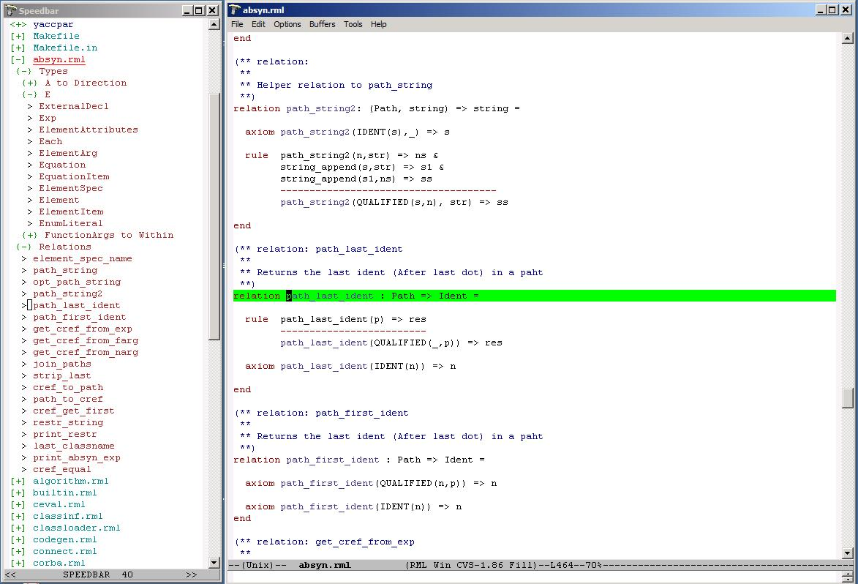
Figure 4-18. Emacs with a speedbar menu to the left, which allows clicking on file names (for expansion or closing the file contents menu). An expanded file shows all function, class, and type declarations. By clicking on one of those, you can position the editor at the appropriate definition.
Give the command M-x speedbar to start the Speedbar menu. See Section 6.1 for an explanation to the notation M-x, etc.
When you open files the speedbar menu will automatically update itself. You can double-click with the left mouse button or single-click with the middle button to expand trees, and jump between files and program definitions.
At the top you see the search path to the current directory, where you can click on the directory names at different levels to jump back and forth in the hierarchy. Subdirectories are visible in the tree as expandable nodes.
It is also possible to right-click in the speedbar window to have a menu appear.

MDT – The OpenModelica Development Tooling Eclipse Plugin

Introduction
The Modelica Development Tooling (MDT) Eclipse Plug-In integrates the OpenModelica compiler with Eclipse. MDT, together with the OpenModelica compiler, provides an environment for working with Modelica development projects.
The following features are available:
- Browsing support for Modelica projects, packages, and classes
- Wizards for creating Modelica projects, packages, and classes
- Syntax color highlighting
- Syntax checking
- Browsing of the Modelica Standard Library
- Code completion for class names and function argument lists.

Installation
The installation of MDT is accomplished by following the below installation instructions. These instructions assume that you have successfully downloaded and installed Eclipse (http://www.eclipse.org).
- Start Eclipse
- Select Help->Software Updates->Find and Install... from the menu
- Select ‘Search for new features to install’ and click ‘Next’
- Select ‘New Remote Site...’
- Enter ‘MDT’ as name and ‘http://www.ida.liu.se/labs/pelab/modelica/OpenModelica/MDT’ as URL and click ‘OK’
- Make sure ‘MDT’ is selected and click ‘Finish’
- In the updates dialog select the ‘MDT’ feature and click ‘Next’
- Read through the license agreement, select ‘I accept...’ and click ‘Next’
- Click ‘Finish’ to install MDT

Getting started

Configuring the OpenModelica Compiler
MDT needs to be able to locate the binary of the compiler. It uses the environment variable OPENMODELICAHOME to do so.
If you have problems using MDT, make sure that OPENMODELICAHOME is pointing to the folder where the Open Modelica Compiler is installed. In other words, OPENMODELICAHOME must point to the folder that contains the Open Modelica Compiler (OMC) binary. On the Windows platform it’s called omc.exe and on Unix platforms it’s called omc.

Using the Modelica Perspective
The most convenient way to work with Modelica projects is to use to the Modelica perspective. To switch to the Modelica perspective, choose the Window menu item, pick Open Perspective followed by Other... Select the Modelica option from the dialog presented and click OK.

Creating a Project
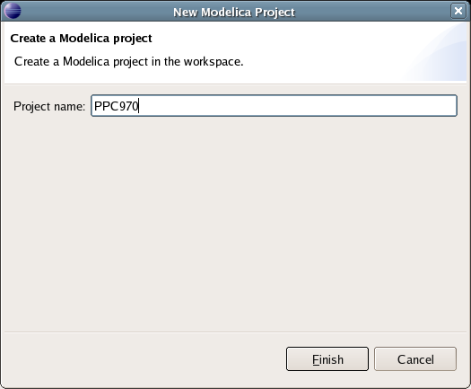
To start a new project, use the New Modelica Project Wizard. It is accessible through File->New-> Modelica Project or by right-clicking in the Modelica Projects view and selecting New->Modelica Project.

Creating a Package
To create a new package inside a Modelica project, select File->New->Modelica Package. Enter the desired name of the package and a description of what it contains.

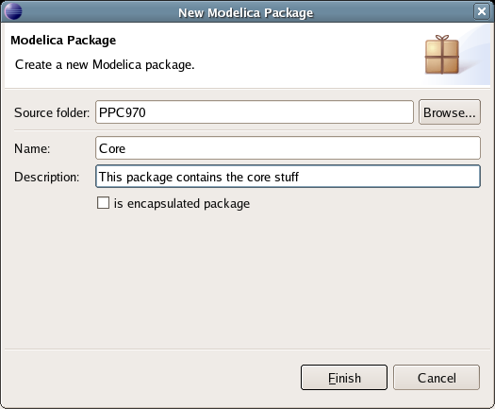

Creating a Class
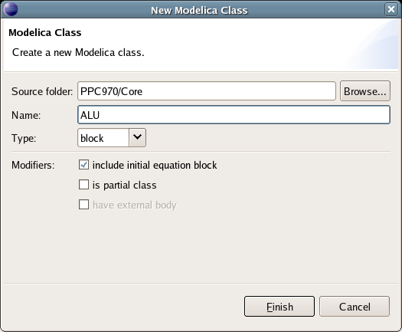
To create a new Modelica class, select where in the hierarchy that you want to add your new class and select File->New->Modelica Class. When creating a Modelica class you can add different restrictions on what the class can contain. These can for example be model, connector, block, record, or function. When you have selected your desired class type, you can select modifiers that add code blocks to the generated code. ‘Include initial code block’ will for example add the line ‘initial equation’ to the class.

Syntax Checking
Whenever a Modelica (.mo) file is saved by the Modelica Editor, it is checked for syntactical errors. Any errors that are found are added to the Problems view and also marked in the source code editor. Errors are marked in the editor as a red circle with a white cross, a squiggly red line under the problematic construct, and as a red marker in the right-hand side of the editor. If you want to reach the problem, you can either click the item in the Problems view or select the red box in the right-hand side of the editor.

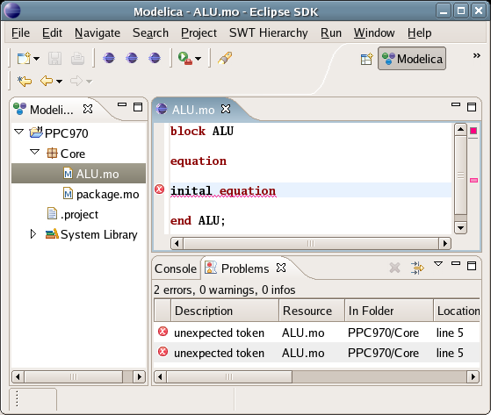

Indentation Support
MDT currently has partial support for semi-automatic indentation. When typing the Return (Enter) key, the next line is usually indented correctly. This functionality will soon be further improved.

Code Completion
MDT supports Code Completion in two variants. The first variant, code completion when typing a dot after a class (package) name, shows alternatives in a menu:

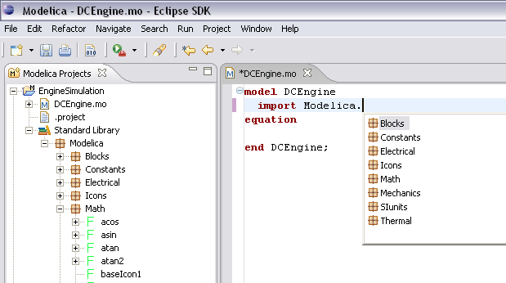
The second variant is useful when typing a call to a function. It shows the function signature (formal parameter name and type) as a popup when typing the parenthesis after the function name, here the signature Real sin(SI.Angle u) of the sin function:

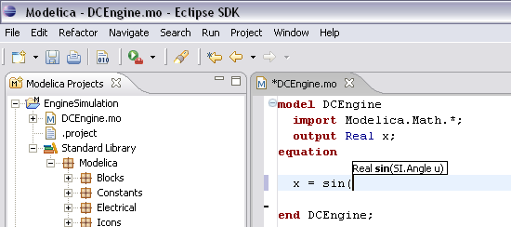

Modelica Algorithmic Subset Debugger
This chapter presents a comprehensive Modelica debugger for an extended algorithmic subset of the Modelica language. This replaces debugging of algorithmic code using primitive means such as print statements or asserts which is complex, time-consuming and error- prone.
Note: This Debugger is not yet released for general usage.There is current ongoing work in integrating the Debugger into the MDT/Eclipse plugin for Modelica.
The debugger is portable since it is based on transparent source code instrumentation techniques that are independent of the implementation platform.
The usual debugging functionality found in debuggers for procedural or traditional object-oriented languages is supported, such as setting and removing breakpoints, single-stepping, inspecting variables, back-trace of stack contents, tracing, etc.
We presents the debugger functionality by a debugging session on a short Modelica example. The functionality of the debugger is shown using pictures from the Emacs debugging mode for Modelica (modelicadebug-mode).
Note 1: The current (March 2006) implementation of the debugger only works together with the Modelica compiler version that supports an extended algorithmic subset of Modelica, without equations and simulation, but including meta-programming support. Both compiler versions will be merged into a single version in the near future. It is not yet released for general usage.
Note 2: when applying the debugger to debug the OpenModelica compiler itself, give the make debug command to compile the code with debugging turned on, or just the command: make, to compile it without debugging support.

The Debugger Commands
The Emacs Modelica debug mode is implemented as a specialization of the Grand Unified Debugger (GUD) interface (gud-mode) from Emacs. Because the Modelica debug mode is based on the GUD interface, some of the commands have the same familiar key bindings.
The actual commands sent to the debugger are also presented together with GUD commands preceded by the Modelica debugger prompt: mdb@>.
If the debugger commands have several alternatives these are presented using the notation: alternative1|alternative2|....
The optional command components are presented using notation: [optional].
In the Emacs interface: M-x stands for holding down the Meta key (mapped to Alt in general) and pressing the key after the dash, here x, C-x stands for holding down the Control (Ctrl) key and pressing x, <RET> is equivalent to pressing the Enter key, and <SPC> to pressing the Space key.

Starting the Modelica Debugging Subprocess
The command for starting the Modelica debugger under Emacs is the following:
M-x modelicadebug <RET> executable <RET>

Setting/Deleting Breakpoints
A part of a session using this type of commands is shown in Figure 6-19 below. The presentation of the commands follows.
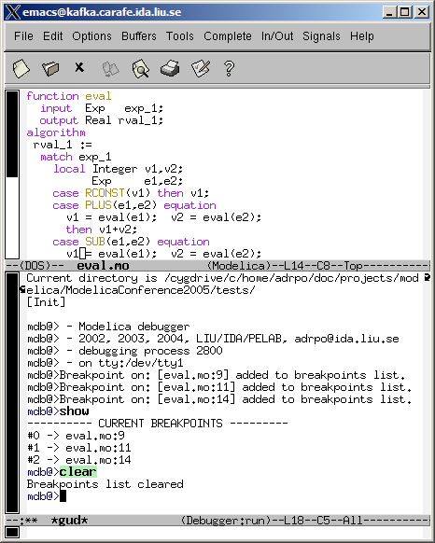
Figure 6-19. Using breakpoints.
To set a breakpoint on the line the cursor (point) is at:
C-x <SPC>
mdb@> break on file:lineno|string <RET>
To delete a breakpoint placed on the current source code line (gud-remove):
C-c C-d
C-x C-a C-d
mdb@> break off file:lineno|string <RET>
Instead of writing break one can use alternatives br|break|breakpoint.
Alternatively one can delete all breakpoints using:
mdb@> cl|clear <RET>
Showing all breakpoints:
mdb@> sh|show <RET>

Stepping and Running
To perform one step (gud-step) in the Modelica code:
C-c C-s
C-x C-a C-s
mdb@> st|step <RET>
To continue after a step or a breakpoint (gud-cont) in the Modelica code:
C-c C-r
C-x C-a C-r
mdb@> ru|run <RET>
Examples of using these commands are presented in Figure 6-20.
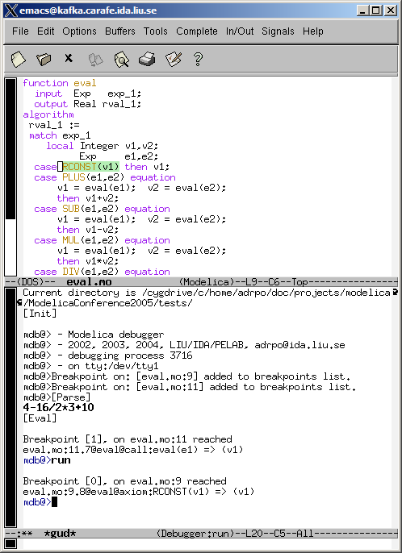
Figure 6-20. Stepping and running.

Examining Data
There are no GUD keybindings for these commands but they are inspired from the GNU Project debugger (GDB).
To print the contents/size of a variable one can write:
mdb@> pr|print variable_name <RET>
mdb@> sz|sizeof variable_name <RET>
at the debugger prompt. The size is displayed in bytes.
Variable values to be printed can be of a complex type and very large. One can restrict the depth of printing using:
mdb@> [set] de|depth integer <RET>
Moreover, we have implemented an external viewer written in Java called ModelicaDataViewer to browse the contents of such a large variable. To send the contents of a variable to the external viewer for inspection one can use the command:
mdb@> bw|browse|gr|graph var_name <RET>
at the debugger prompt. The debugger will try to connect to the ModelicaDataViewer and send the contents of the variable. The external data browser has to be started a priori. If the debugger cannot connect to the external viewer within a specified timeout a warning message will be displayed. A picture of the external ModelicaDataViewer tool is presented in Figure 6-21.
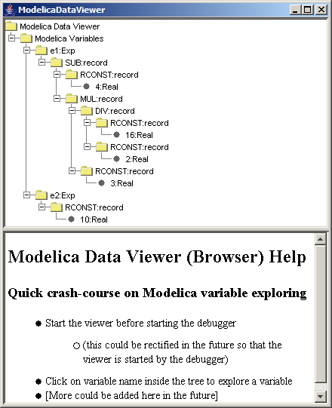
Figure 6-21. Modelica Data Viewer (Browser) for data structures, here a small abstract syntax tree.
If the variable which one tries to print does not exist in the current scope (not a live variable) a notifying warning message will be displayed.
Automatic printing of variables at every step or breakpoint can be specified by adding a variable to a display list:
mdb@> di|display variable_name <RET>
To print the entire display list:
mdb@> di|display <RET>
Removing a display variable from the display list:
mdb@> un|undisplay variable_name <RET>
Removing all variables from the display list:
mdb@> undisplay <RET>
Printing the current live variables:
mdb@> li|live|livevars <RET>
Instructing the debugger to print or to disable the print of the live variable names at each step/breapoint:
mdb@> [set] li|live|livevars [on|off]<RET>
Figure 6-22 shows examples of some of these commands within a debugging session:
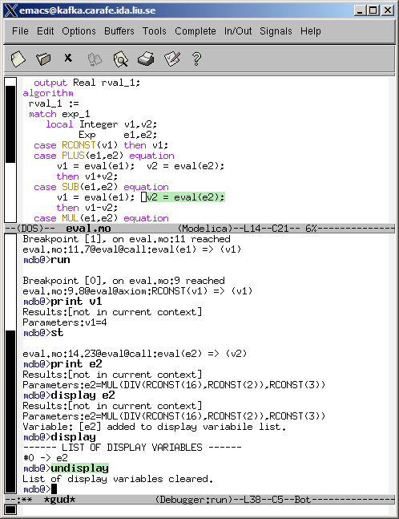
Figure 6-22. Examining variable values using print and display commands.

Additional commands
The stack contents (backtrace) can be displayed using:
mdb@> bt|backtrace <RET>
Because the contents of the stack can be quite large, one can print a filtered view of it:
mdb@> fbt|fbacktrace filter_string <RET>
Also, one can restrict the numbers of entries the debugger is storing using:
mdb@> maxbt|maxbacktrace integer <RET>
For displaying the status of the Modelica runtime:
mdb@> sts|stat|status <RET>
The status of the extended Modelica runtime comprises information regarding the garbage collector, allocated memory, stack usage, etc.
The current debugging settings can be displayed using:
mdb@> stg|settings <RET>
The settings printed are: the maximum remembered backtrace entries, the depth of variable printing, the current breakpoints, the live variables, the list of the display variables and the status of the runtime system.
One can invoke the debugging help by issuing:
mdb@> he|help <RET>
For leaving the debugger one can use the command:
mdb@> qu|quit|ex|exit|by|bye <RET>
A session using these commands is presented in Figure 6-23 below:
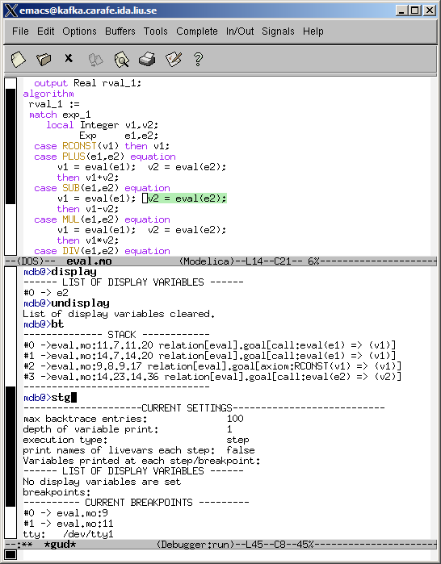
Figure 6-23. Additional debugger commands.

Hints for Debugging Large Programs
In order to faster get to an interesting place when debugging a large program such as the OpenModelica compiler itself, you can put a breakpoint at the place where you would like to start the investigation, but give the fast debug command when starting the execution from the beginning. In that case the debugger will avoid saving backtrace and variables up to this breakpoint. Then you can turn off backtrace and run the debugger as usual.

Summary of Debugger Commands
The following is a complete list of the current debugger commands
br|break|breakpoint string [on|off] Setting/unsetting breakpoints
cl|clear Clear all breakpoints
sh|show Show all breakpoints
bt|backtrace Print the backtrace (stack)
fbt|fbacktrace filter Print filtered backtrace (stack)
mb|maxbacktrace int (0=full, default=0) Set the maximum of backtrace entries (stack).
ca|callchain Print the call chain
fca|fcallchain filter Print filtered call chain
mc|maxcallchain integer Set the maximum of callchain entries. (0=full, default=100)

[set] de|depth integer Set the depth of variable printing. (0=full, default=10)
[set] ms|maxstring integer Set how may chars we print from long strings. (0=full, default=60)
set st|step [on|off] Set the execution mode.
st|step|<ENTER>|<CR> Perform one step.
ne|next Jump over next statement.
ru|run Run the program.
stg|settings Print the current settings.
he|help Showing help.
sts|stat|status Printing the status of Modelica runtime.
li|live|livevars Print the names of live variables.
[set] li|live|livevars [on|off] On/Off printing names of livevars each step.
pr|print var_name Print the live variable.
sz|size|sizeof var_name Print sizeof the live variable.
di|display var_name Display the live variable each step.
ud|undisplay var_name Un-display the live variable.
di|display Show display variables.
ud|undisplay Un-display ALL display variables.
gr|graph var_name Send the live variable to external viewer.
pty|printtype identifier Print type info on any Modelica id.
fa|fast FAST debugging: no backtrace, callchain, livevars.
qu|quit|ex|exit|by|bye Exiting the debugger/program.

- Contributors to OpenModelica
This Appendix lists the individuals who have made significant contributions to OpenModelica, in the form of software development, design, documentation, project leadership, tutorial material, etc. The individuals are listed for each year, from 1998 to the current year: the project leader and main author/editor of this document followed by main contributors followed by contributors in alphabetical order.
  - OpenModelica Contributors 2006
Peter Fritzson, PELAB, Linköping University, Linköping, Sweden.
Peter Aronsson, MathCore Engineering AB, Linköping, Sweden.
Adrian Pop, PELAB, Linköping University, Linköping, Sweden.
Bernhard Bachmann, Fachhochschule Bielefeld, Bielefeld, Germany.
David Broman, PELAB, Linköping University, Linköping, Sweden.
Anders Fernström, PELAB, Linköping University, Linköping, Sweden.
Elmir Jagudin, PELAB, Linköping University, Linköping, Sweden.
Håkan Lundvall, PELAB, Linköping University, Linköping, Sweden.
Kaj Nyström, PELAB, Linköping University, Linköping, Sweden.
Lucian Popescu, MathCore Engineering AB, Linköping, Sweden.
Andreas Remar, PELAB, Linköping University, Linköping, Sweden.
Anders Sandholm, PELAB, Linköping University, Linköping, Sweden.
  - OpenModelica Contributors 2005
Peter Fritzson, PELAB, Linköping University, Linköping, Sweden.
Peter Aronsson, PELAB, Linköping University and MathCore Engineering AB, Linköping, Sweden.
Adrian Pop, PELAB, Linköping University, Linköping, Sweden.
Håkan Lundvall, PELAB, Linköping University, Linköping, Sweden.
Ingemar Axelsson, PELAB, Linköping University, Linköping, Sweden.
David Broman, PELAB, Linköping University, Linköping, Sweden.
Daniel Hedberg, MathCore Engineering AB, Linköping, Sweden.
Håkan Lundvall, PELAB, Linköping University, Linköping, Sweden.
Kaj Nyström, PELAB, Linköping University, Linköping, Sweden.
Lucian Popescu, MathCore Engineering AB, Linköping, Sweden.
Levon Saldamli, PELAB, Linköping University, Linköping, Sweden.
  - OpenModelica Contributors 2004
Peter Fritzson, PELAB, Linköping University, Linköping, Sweden.
Peter Aronsson, Linköping University, Linköping, Sweden.
Bernhard Bachmann, Fachhochschule Bielefeld, Bielefeld, Germany.
Peter Bunus, PELAB, Linköping University, Linköping, Sweden.
Daniel Hedberg, MathCore Engineering AB, Linköping, Sweden.
Håkan Lundvall, PELAB, Linköping University, Linköping, Sweden.
Emma Larsdotter Nilsson, PELAB, Linköping University, Linköping, Sweden.
Kaj Nyström, PELAB, Linköping University, Linköping, Sweden.
Adrian Pop, PELAB, Linköping University, Linköping, Sweden.
Lucian Popescu, MathCore Engineering AB, Linköping, Sweden.
Levon Saldamli, PELAB, Linköping University, Linköping, Sweden.
  - OpenModelica Contributors 2003
Peter Fritzson, PELAB, Linköping University, Linköping, Sweden.
Peter Aronsson, Linköping University, Linköping, Sweden.
Levon Saldamli, PELAB, Linköping University, Linköping, Sweden.
Peter Bunus, PELAB, Linköping University, Linköping, Sweden.
Vadim Engelson, PELAB, Linköping University, Linköping, Sweden.
Daniel Hedberg, Linköping University, Linköping, Sweden.
Eva-Lena Lengquist-Sandelin, PELAB, Linköping University, Linköping, Sweden.
Susanna Monemar, PELAB, Linköping University, Linköping, Sweden.
Adrian Pop, PELAB, Linköping University, Linköping, Sweden.
Erik Svensson, MathCore Engineering AB, Linköping, Sweden.
  - OpenModelica Contributors 2002
Peter Fritzson, PELAB, Linköping University, Linköping, Sweden.
Levon Saldamli, PELAB, Linköping University, Linköping, Sweden.
Peter Aronsson, Linköping University, Linköping, Sweden.
Daniel Hedberg, Linköping University, Linköping, Sweden.
Henrik Johansson, PELAB, Linköping University, Linköping, Sweden
Andreas Karström, PELAB, Linköping University, Linköping, Sweden
  - OpenModelica Contributors 2001
Peter Fritzson, PELAB, Linköping University, Linköping, Sweden.
Levon Saldamli, PELAB, Linköping University, Linköping, Sweden.
Peter Aronsson, Linköping University, Linköping, Sweden.
  - OpenModelica Contributors 2000
Peter Fritzson, PELAB, Linköping University, Linköping, Sweden.
  - OpenModelica Contributors 1999
Peter Fritzson, PELAB, Linköping University, Linköping, Sweden
–
Peter Rönnquist, PELAB, Linköping University, Linköping, Sweden.
  - OpenModelica Contributors 1998
Peter Fritzson, PELAB, Linköping University, Linköping, Sweden.
David Kågedal, PELAB, Linköping University, Linköping, Sweden.
Vadim Engelson, PELAB, Linköping University, Linköping, Sweden.

Index

literate programming 35

