OMEdit Wish list

No. | Suggestions | Suggested by | Status
 | In the textual view of a model, optionally display inherited declarations and equations with headers indicating from where they come. This can e.g. be a read-only text window above the model window, or a pop-up. This was discussed a lot during our Berlin visit Monday this week, strong feedback from application modelers who are trying to understand and use models in the standard library. | Peter F | Not Started
 | Icon editor is probably already in the list, otherwise add it. | Mohsen | In Progress
 | Add: Elision of graphical and documentation annotations in the textual view, i.e., similar to Dymola, represent an annotation with some graphic character; when you click on it (toggle) the annotation is shown, otherwise it is hidden. | Mohsen | Not Started
 | Start loading the MSL immediately after start on a thread (stop the thread if the user clicks + on a tree item and resume it if user is idle for some little time).  Start with the Modelica already expanded 1 level.  Have also ModelicaServices in the LHS tree if you load it. | Adrian | Not Started
 | Have a +/- button on the left hand side pane (or available via right click) to expand everything, so you don't need to click on each item in particular. | Adrian | Not Started
 | The tool tip for the elements in the tree should include more information, like the class comment and the restriction, for example:package Modelica.Electrical.Analog "The class comment"  model ModelName "Model Comment"  getClassInformation should be used to get the class comment and all the other info. | Adrian | Done
 | For everything that does not have icons, for example:  type - use a T as icon  record - use a R as icon  block - use a B ...  connector - use a CO ....  class - use C  etc...  It would be nice to have an icon for everything and if is impossible  to have an icon at least display a question mark or something to  suggest "no icon" instead. | Adrian | Done
 | you should be able to click + even on Models and then you would display the components. Alternatively we could have an outline in the LHS bottom that displays the components of the focused opened model in the RHS (similar to Dymola or MDT). | Adrian | Done
 | Besides Icon View, Diagram View, Text View, add also: Documentation View. | Adrian | Done
 | The display of info in the top part of RHS like: Read-Only/Package/IconView is rather not intuitive, I tried to click on those several times. A better way to display this info is needed as the current way looks like non-working-tabs. | Adrian | Not Started
 | cache the strings you get from OMC so you don't ask it again if not needed. now you do ask several times the same question: getIconAnnotation(Modelica.Icons.Library). You invalidate only parts of the cached information depending on what you update/edit in the model editor. | Adrian | Done
 | Search in Modelica Text View | Martin | Done
 | Pressing Escape should close the search dialog | Martin | Done
 | Use the default Operating System font for Modelica Text View | Martin | Done
 | Change the location of OMEdit settings file to OMEdit base directory from temp directory | Martin | Done
 | Create keyboard shortcuts for zooming like Ctrl+, Ctrl- and Ctrl=/Ctrl0. Note that when zooming in you can't always scroll so much that you can see everything (cutting some icons in half even when scrolling to the bottom, etc). | Martin | Done
 | Make possible to copy text from Messages Window | Adrian | Done
 | Do not gray menus and the simulate command in text view mode. This happens when opening for example ExternalLibraries.mo file from share/doc/omc/testmodels. Also do NOT add a star in the editor tab view as there is no change to the text buffer when you just load a model! If you change anything in the model then add the star. | Adrian | Done
 | Create a tab based Messages Window where we have separate tab for each type of message. | Adeel | Done
 | Make possible to set OMEdit as program to open .mo files in Windows, i.e. if there is a .mo file given at command line, load that file in OMEdit and focus on Modelica Files tab directly, select the model and show it in the text mode directly. This will make it possible to double click on a .mo file in Windows and get it opened in OMEdit directly. | Adrian | Done
 | Support drag and drop of files in OMEdit, when you get a drop event, just load the model, focus on Modelica Files tab, select the model and show it in the text mode. | Adrian | Done
 | Detect when a file was changed externally and offer the user to reload it (you need a listener thread that checks the status of loaded files) and give it a check-box that the reload should be done automatically (without any more questions). Note that if the buffer has changed you still need to ask the user if he wants to discard his changes and reload the changed file from the disk. This way you can edit a file in Eclipse and then reload it in OMEdit and vice-versa. See:  http://www.openmodelica.org/index.php/forum/topic?id=165 | Adrian | In Progress
 | Make it able to select Plot Type: plotParameteric and then select two variables and send plotParametric(var1, var2) to OMC. | Adrian | Done
 | You must be able from the user point of view to hide information, like annotations, component annotations, html information, connections etc. | Mohsen | Not  Started
 | Better dialog for simulation is needed:  - Set C flags  - Set Library flags  - Set Library directories  - Set Include directories  - Build an executable for interactive-simulation  - Run an interactive simulation from OMEdit  - Have a pre-build step (a script textarea) to compile the needed files  - Have the normal simulation step  - Have a post-build step (a script textarea) to get results, plot, etc | Adrian | Not  Started
 | A project like structure should be created in the Modelica Files tab where you can group files into projects which have a clear place on the hard drive and you can also set a lot of settings for these project (directory, flags, files, external libraries, etc) similar to SimForge. | Adrian | Not  Started
 | Strings %NAME inside Text annotations should be replaced by the value of the parameter NAME from the model. See the difference between OMEdit and Dymola below:  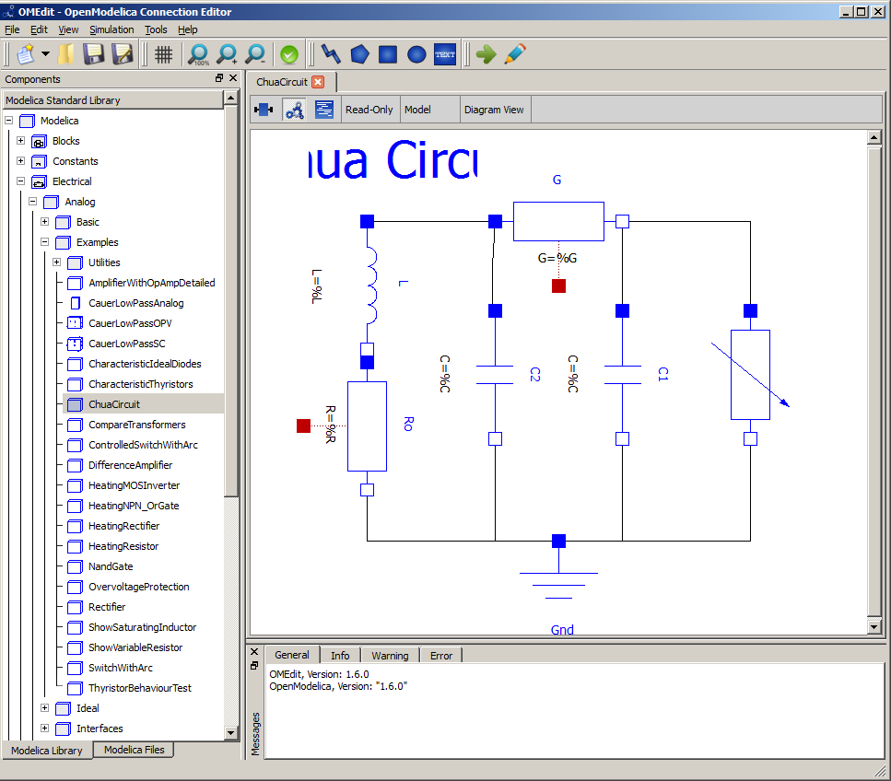  OMEdit vs. Dymola  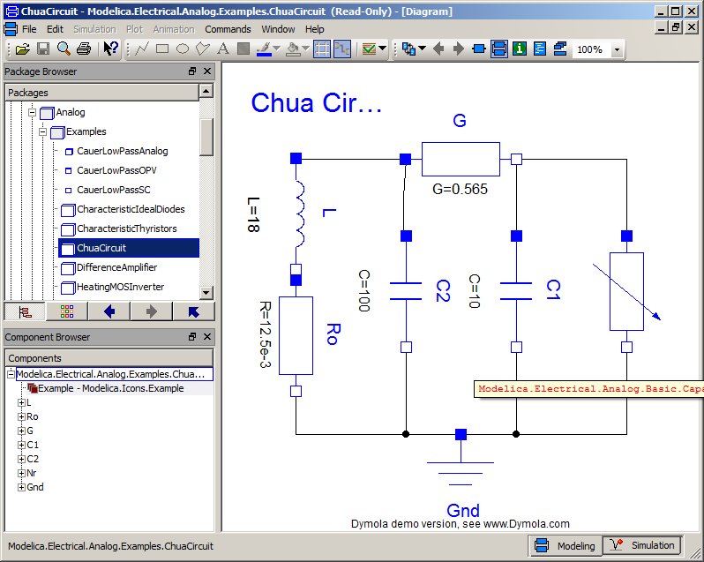 | Adrian | Done
 | In Documentation View: If the model is not read-only then user should be able to write the documentation of the model. | Adeel | Done
 | Search inside the Modelica Standard Library. | Mohsen | Done
 | Make the connector type components connect each other. | Adeel | Done
 | Drag & drop of custom models into other custom models. | Mohsen | Done
 | Copy paste of models from Modelica Tree. | Mohsen | Done
 | Copy paste of models from diagram view. | Mohsen | In Progress
 | Flipping of shapes | Mohsen | In Progress

