Moretti Test Prep & Tutoring — Brand Guide

Logo
The primary lockup pairs the target mark with the Caladea wordmark. Use the dark version on light backgrounds (cream, white) and the reversed white version on red or other dark backgrounds. Always preserve clear space around the mark roughly equal to the height of the target icon, and never stretch, recolor, or add effects to the logo.
On light backgrounds

On dark / red backgrounds — shown here on the brand red (#B0271C)
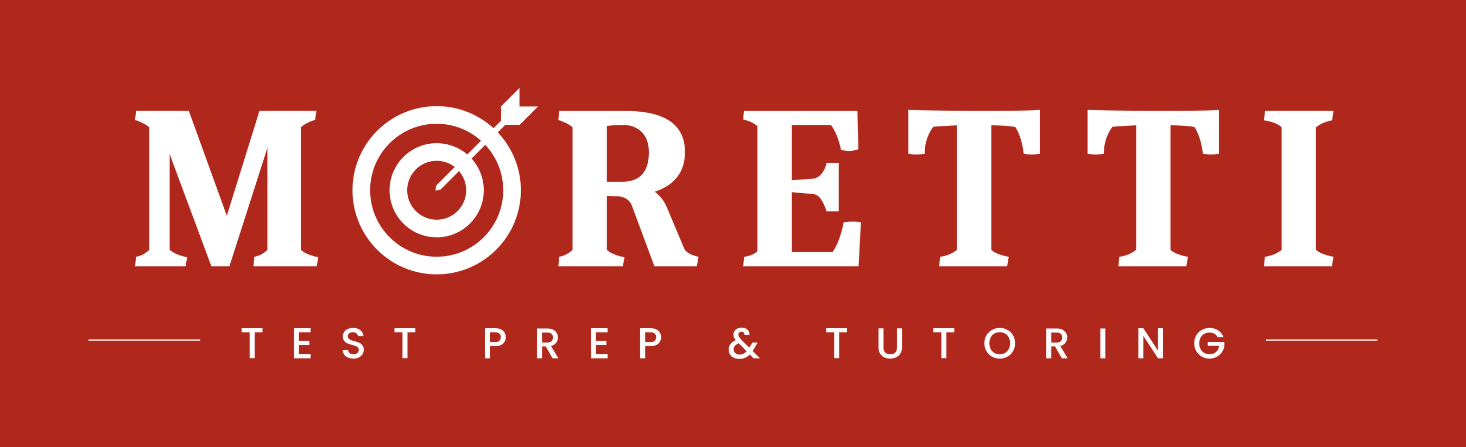
Icon mark — used as the favicon and as a standalone symbol


Color Palette
A warm, editorial palette: a confident red as the primary brand and action color, a muted gold used sparingly as an accent, and a cream background that keeps the site feeling warm rather than corporate.
Color | Hex | Usage
Moretti Red | #B0271C | Primary brand color. Nav, buttons, links, key stats, CTAs.
Gold | #C9A84C | Accent only — small numerals, italic labels, shimmer highlights on stats.
Cream | #F7F4EF | Primary page background — warmer than plain white.
Charcoal Text | #111111 | Body copy and headings on light backgrounds.
White | #FFFFFF | Reversed logo, text on red/dark backgrounds.

Typography
Two typefaces carry almost everything on the site, with a serif accent reserved for small editorial touches.
Typeface | Role | Used for
Caladea (bold) | Headings & Logo | All H1/H2 headings, section titles, the wordmark.
Poppins (light–bold) | Body & UI | Body copy, navigation, buttons, forms — weights 300 through 700.
Georgia (serif, italic) | Small accents | Step numerals (“01,” “02”…), pull-quotes, phone numbers — small editorial flourishes only.
Note: the homepage’s “EXPLORE” hero moment uses a separate, heavier display face as a one-off cinematic effect. That treatment is intentionally not part of the general type system — don’t reuse it for headings or body text elsewhere.

Voice & Tone
Direct and confident, never salesy. Claims are backed by specific numbers rather than vague superlatives, and every program is anchored to a concrete guarantee.
- Lead with outcomes and specifics — “+1500 SAT,” “+34 ACT,” “36% average increase” — not “great results.”
- “The Moretti Method” is the one proper-noun brand term — capitalize it consistently across all materials.
- The guarantee is a recurring trust device, not a one-off line: if a student’s score doesn’t improve, tutoring continues free until it does.
- Eyebrow labels (small uppercase tags above headings) are letter-spaced and preceded by a small red diamond — used to categorize a section before the headline lands.
- Copy is warm but exacting — “one-on-one, diagnostic, and exact” is the tone to aim for: personal, never generic.
A few lines pulled directly from the site:
“Complete the 12-week program and if your student’s official SAT or ACT score doesn’t improve, we keep teaching them free until it does.”
“A plan built entirely around your child’s pace and foundation — an investment in their ability to score higher.”
“My approach is different: one-on-one, diagnostic, and exact.”

Business Information
Field | Detail
Business name | Moretti Test Prep & Tutoring
Founder | Luca Moretti
Location | Cranford, NJ — in person or online
Phone | (201) 275-2791
Website | morettitutoring.com
Serving | Cranford, Westfield, Mountainside, Scotch Plains, Summit, Short Hills, New Providence, Berkeley Heights

