The SMART Study

Testing the "Block apps" step
This is the step that decides how much of the phone is blocked, and the one where parents are most likely to stop or make a mistake. These are four versions of the picture and the words, to try with parents before we settle on one.
The guides on the website show version B. To see another in context, add ?version= and the letter to a guide's address, for example guide-iphone.html?version=C.
Version | What changes | Ends with | Why try it | Watch for
A: Ten categories, listed one by one | The words and picture from the previous guides. Parents tick ten categories by name, with reasons for the two they leave. | Ten categories blocked | The baseline: the full restriction, as it's been tested so far. | A long list to work through. Parents may miss one, or tick All Apps & Categories as a shortcut.
B: Ten categories, one simple rule | The same settings as A. The instruction becomes one rule, "tick every category except two", with a number to check against, a reason, a reassurance that nothing is deleted, and what to do if one app is needed. | Ten categories blocked | One rule is easier to follow than a list of ten. Saying nothing is deleted, and pointing to a single-app exception, should stop parents unticking a whole category to keep one app. | Pointing to the exception may lead some parents to allow back more apps than they need.
C: Top three only | Block only social media, games and video (on an iPhone, the Social, Games and Entertainment categories). Everything else stays open. | Three categories blocked | The shortest ask. These three hold the apps children spend most time on, so more parents may finish. | Weaker. Creativity, shopping and other apps stay open, and on Android a parent has to find each app by hand. This changes what the study tests, not just the wording, so it needs agreeing as a trial decision before families see it.
D: Top three first, then the rest | The same end result as A and B, asked in two stages: first social media, games and video, then everything else. | Ten categories blocked (three if a parent stops halfway) | A small first ask makes sure the three that matter most are done, then asks for the rest while the parent is already on the right screen. | Some parents may stop after the first stage and end up with C.

How we'd tell them apart
- Which settings families end up with. Ask a sample of parents for a screenshot of App Limits (iPhone) or App limits (Android) once they've finished. On an iPhone it says how many categories are limited, such as "10 Categories" or "3 Categories".
- How many finish. How many tick this step as done, and how many go on to tick the last step.
- Where they get stuck. Help emails and "Tell us about a problem" messages that mention this step.
- In sessions with parents: how long the step takes, whether anyone ticks All Apps & Categories by mistake, and what they say when they reach the list of categories.

Version A: Ten categories, listed one by one
What changes. The words and picture from the previous guides. Parents tick ten categories by name, with reasons for the two they leave.
Ends with. Ten categories blocked
Why try it. The baseline: the full restriction, as it's been tested so far.
Watch for. A long list to work through. Parents may miss one, or tick All Apps & Categories as a shortcut.

iPhone

Step 4: Block apps
5 minutes · on your child's phone
Already have App Limits? Keep them, and add this one alongside.

- Open Settings → Screen Time → App Limits → Add Limit.
- Tick these categories one by one: Social, Games, Entertainment, Creativity, Productivity & Finance, Education, Health & Fitness, Shopping & Food, Travel and Other. Work down the list so you don't miss one.
- Leave Information & Reading and Utilities unticked, and don't tick Websites. Your child's phone needs these two for getting on the web at all. The websites step then limits the web to the sites on the list.
- Do not tick "All Apps & Categories" at the top. It looks like a shortcut, but it also cuts off web access, which undoes the websites step.
- Tap Next and set the limit to 0 minutes.
- Turn on Block at End of Limit. Without it there's an "Ignore Limit" button and nothing holds.
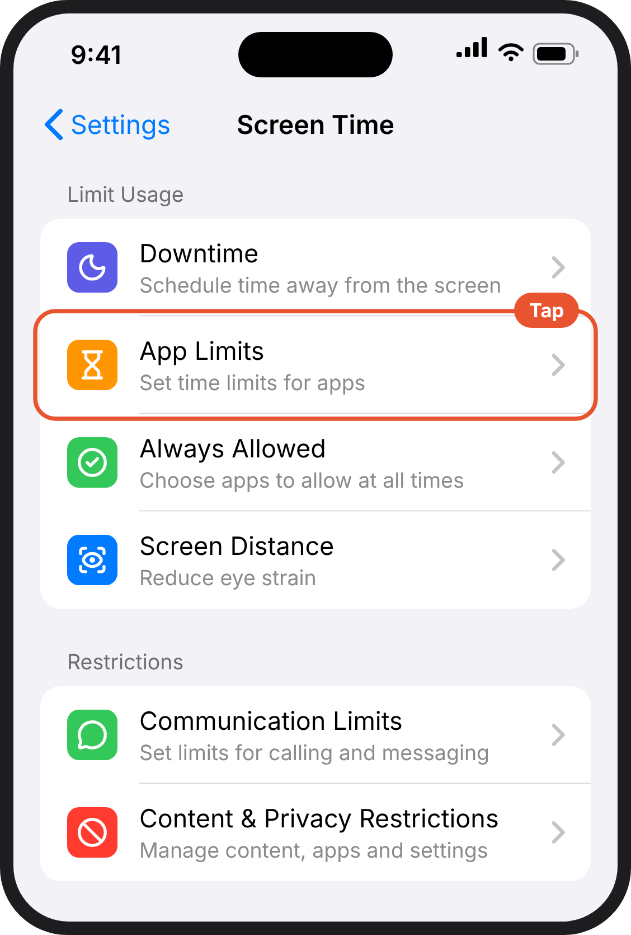  1. Your child's phone. The Screen Time page. App Limits is the second option under Limit Usage. | 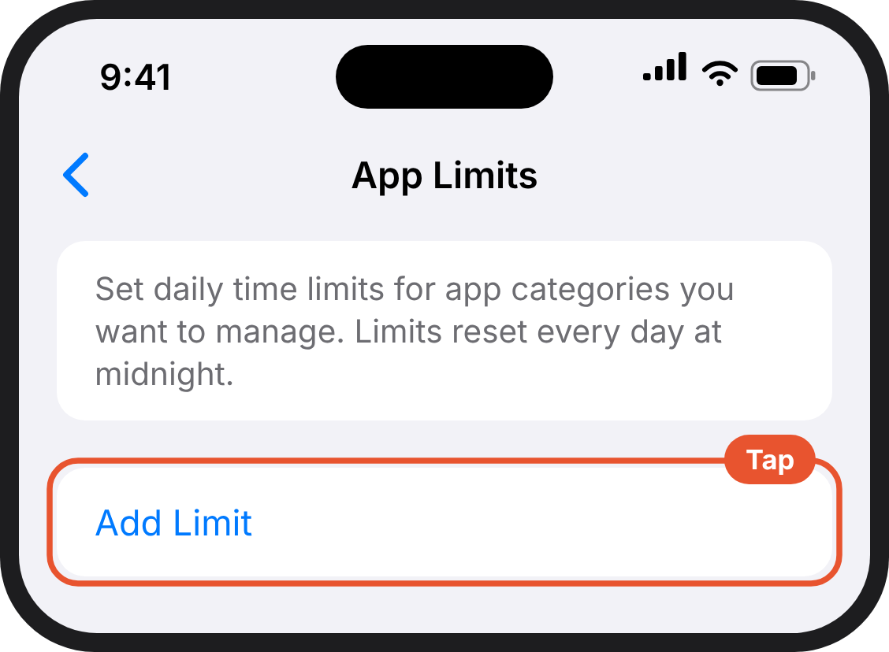  2. Your child's phone. The App Limits page with a blue Add Limit button. | 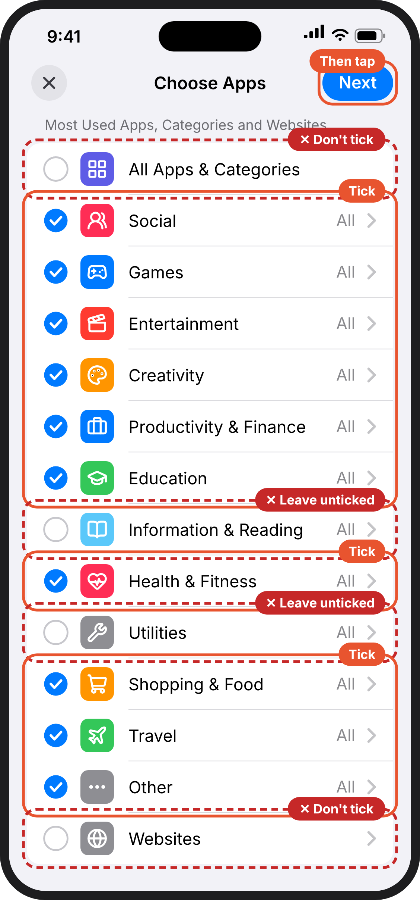  3. Your child's phone. Choose Apps. Every category from Social to Other is ticked except Information & Reading and Utilities. All Apps & Categories at the top and Websites at the bottom are not ticked either. Next is at the top right.
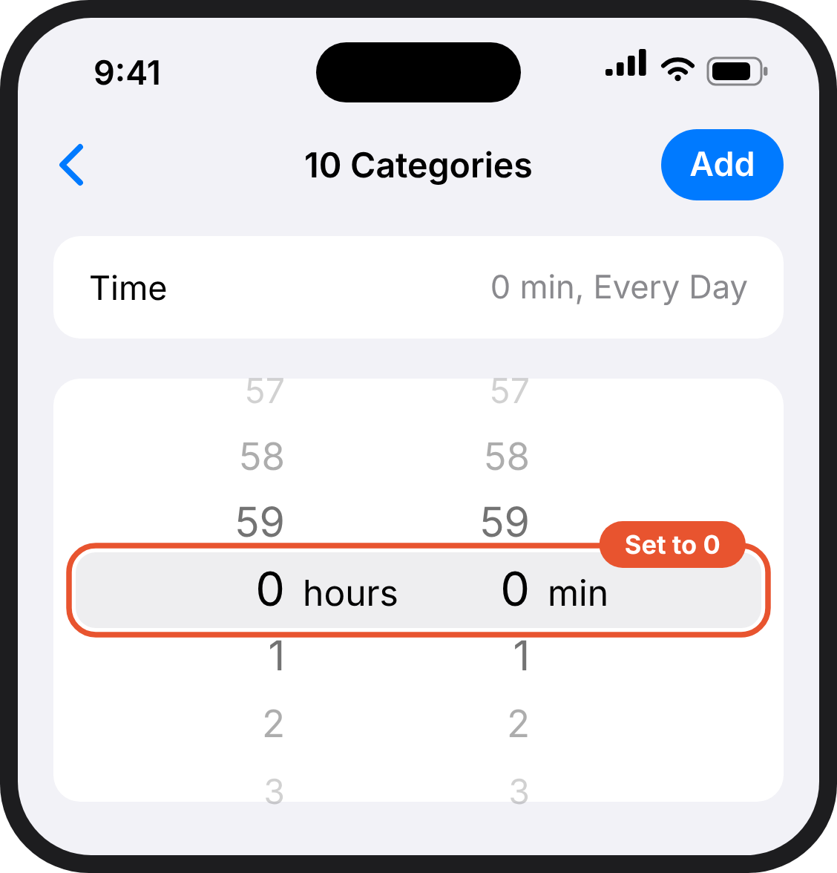  4. Your child's phone. A time picker, set to 0 hours and 0 minutes. | 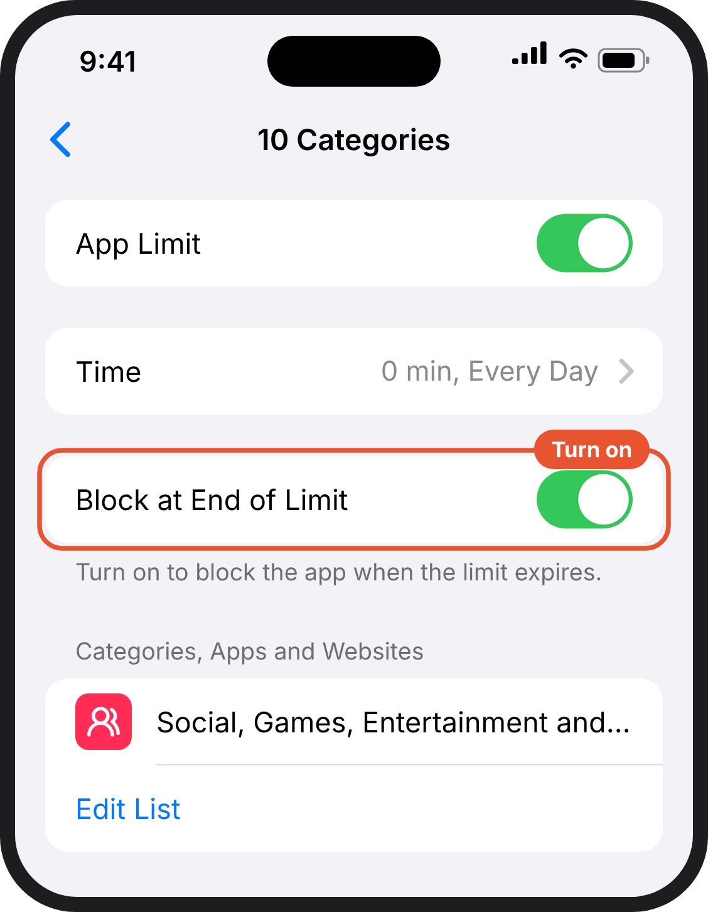  5. Your child's phone. The limit you just made. App Limit is on, Time is 0 minutes every day, and Block at End of Limit is switched on. | 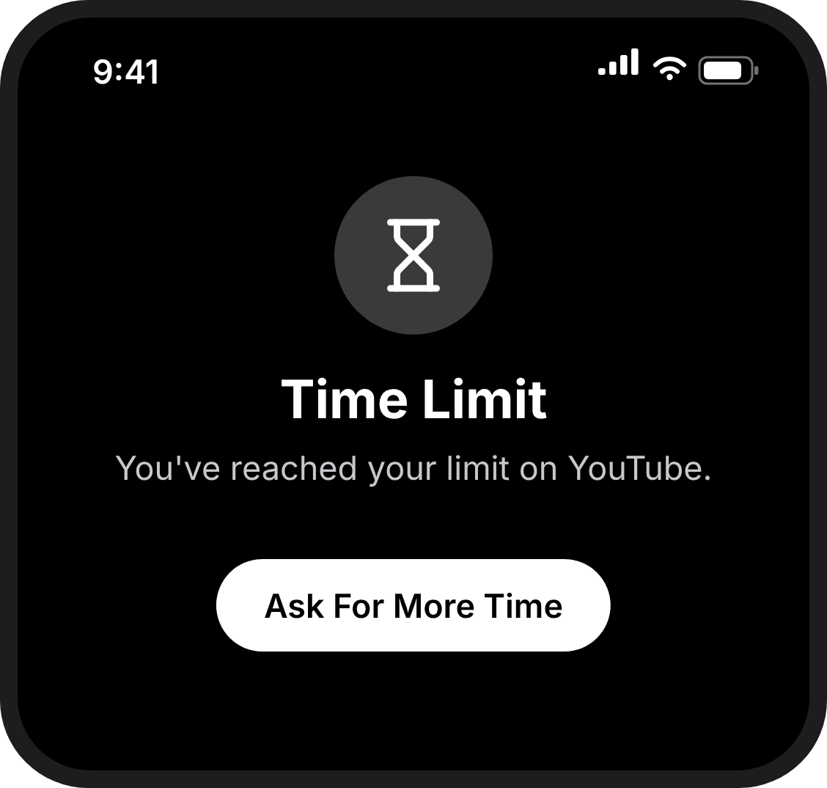  6. Your child's phone. What your child sees when they open an app that's blocked: Time Limit.

Android phone

Step 4: Block apps
5 minutes · on your phone, in Family Link
Already have downtime at bedtime? This replaces it with downtime all day. The apps you allow back next will then work at night too. If you want them off at night, email us and we'll help.

- Open Family Link. It opens on Screen time (bottom left).
- Tap Schedules. Turn on Downtime, and leave School time off.
- Tap Weekly schedule, then Mon. Check Downtime ON is switched on, set Start time to 12:00 and End time to 11:59, tick Apply to all days of the week and tap Done. Every day should now show 12:00–11:59, so downtime covers the whole day.
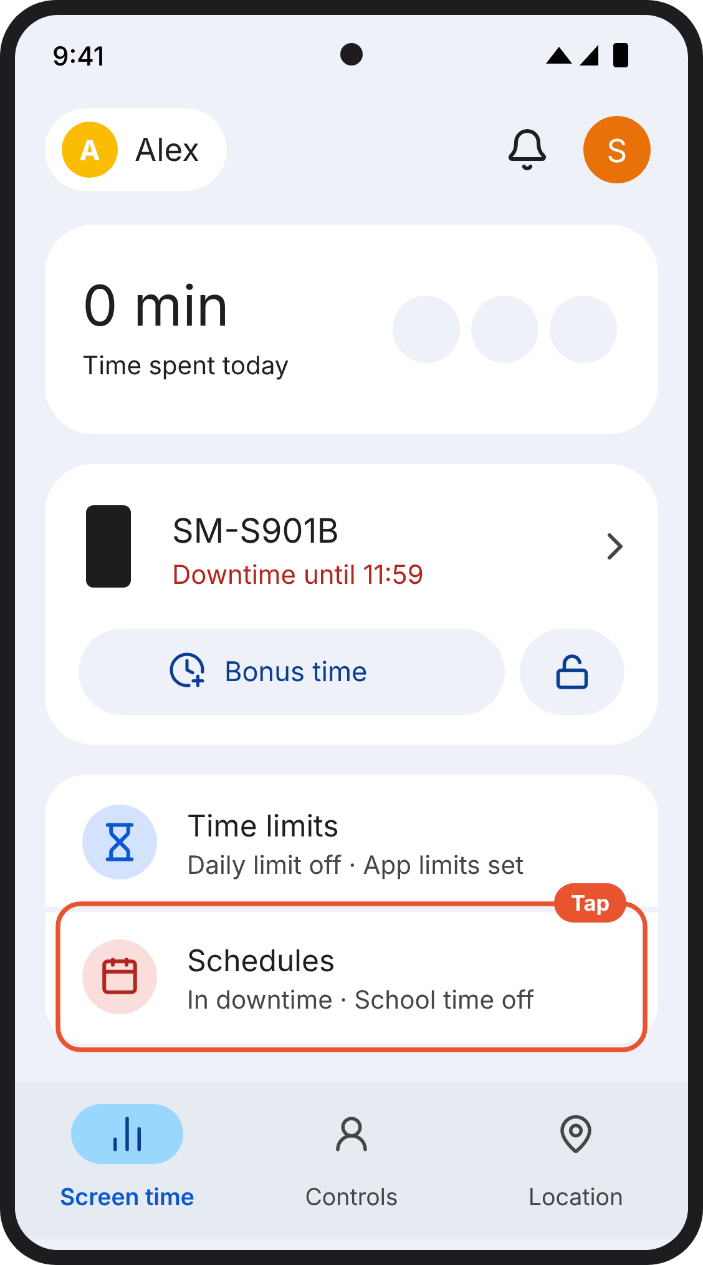  1. Your phone (Family Link). Family Link on your phone opens on Screen time. Your child's phone is shown by its model name (here SM-S901B). Schedules is below it. | 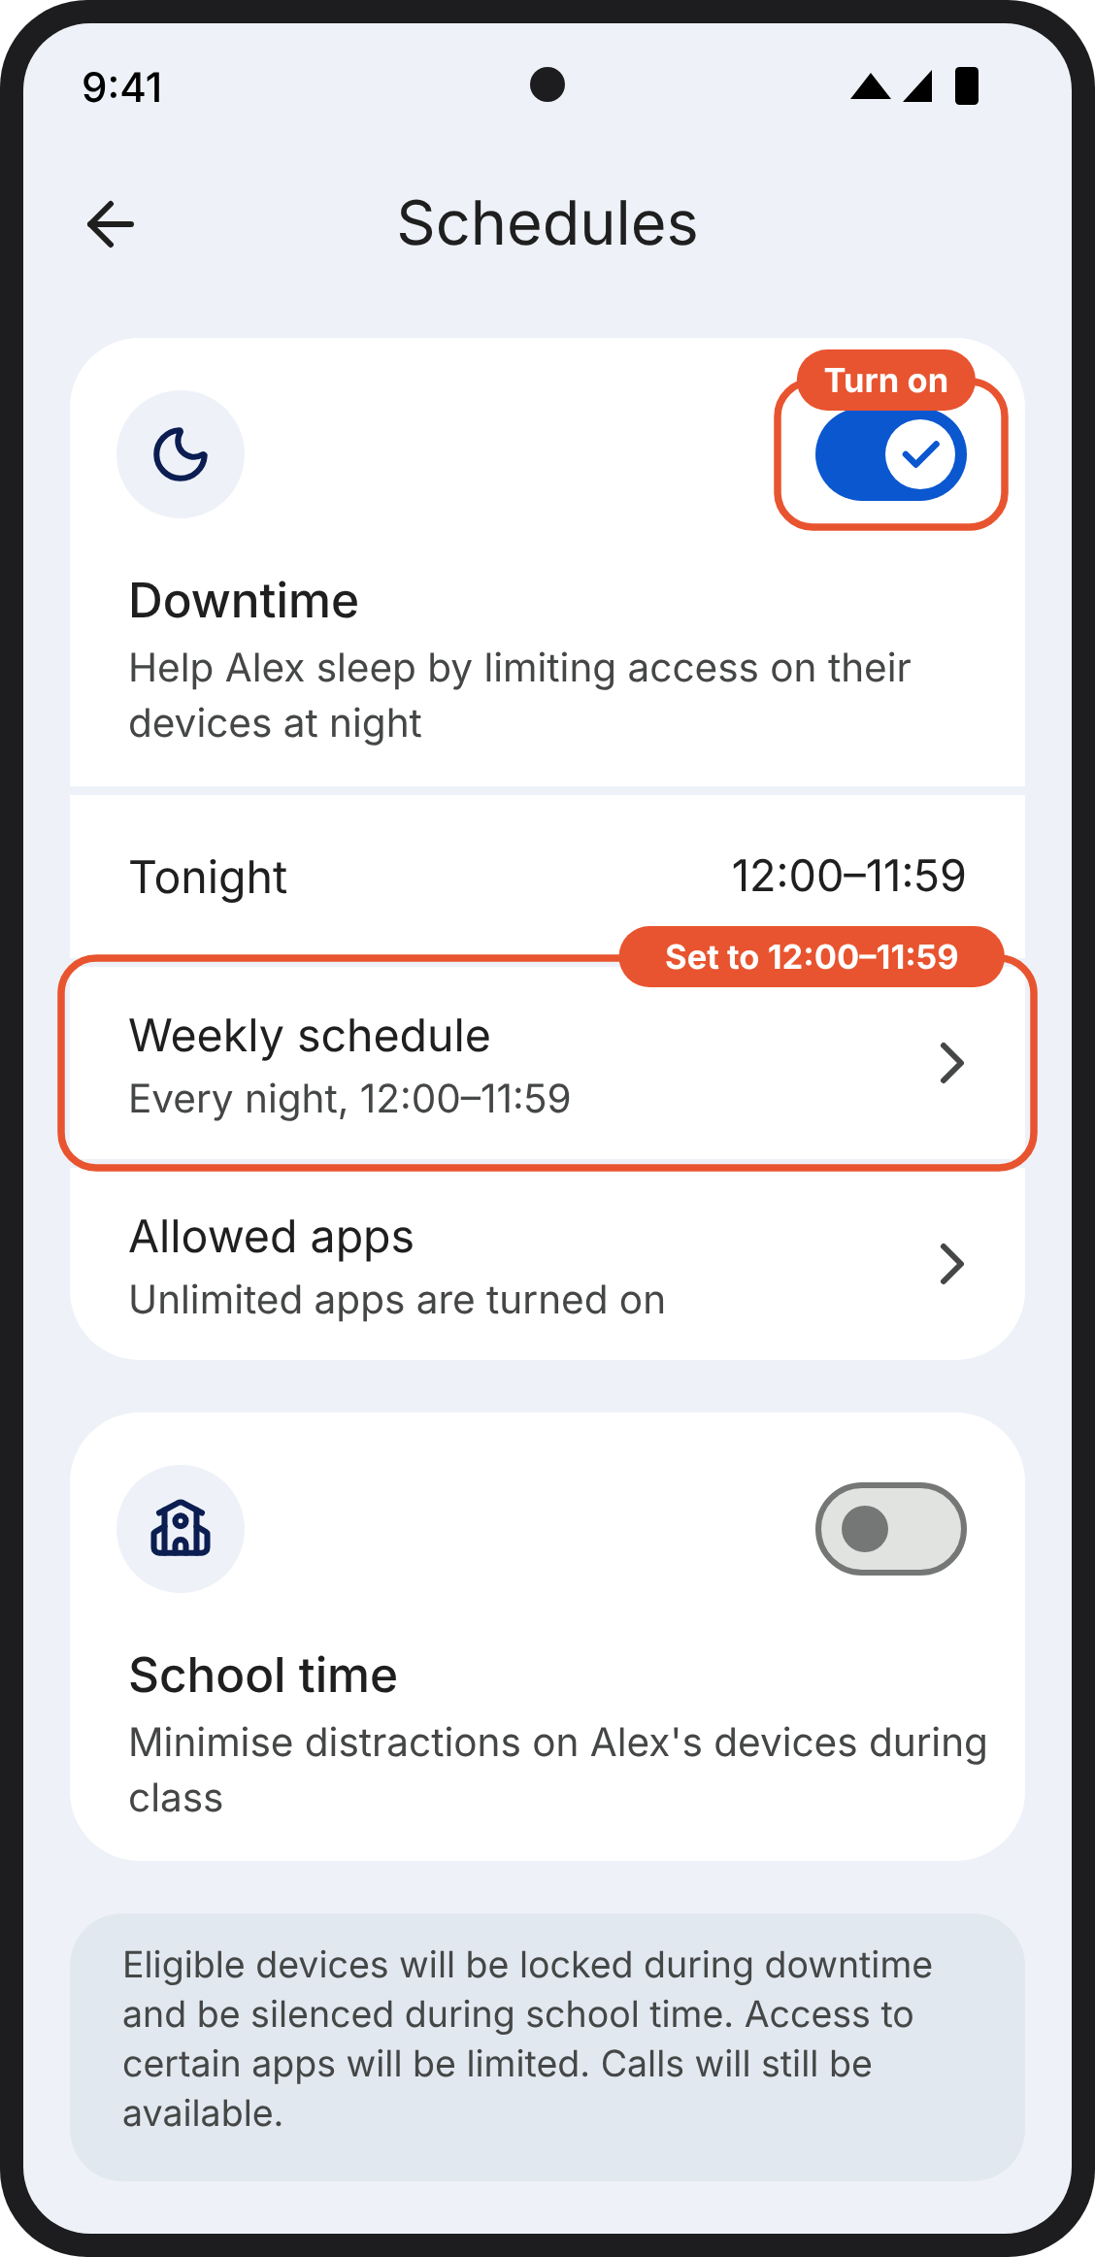  2. Your phone (Family Link). Schedules in Family Link. Turn on Downtime and set its weekly schedule to 12:00–11:59. Leave School time off. | 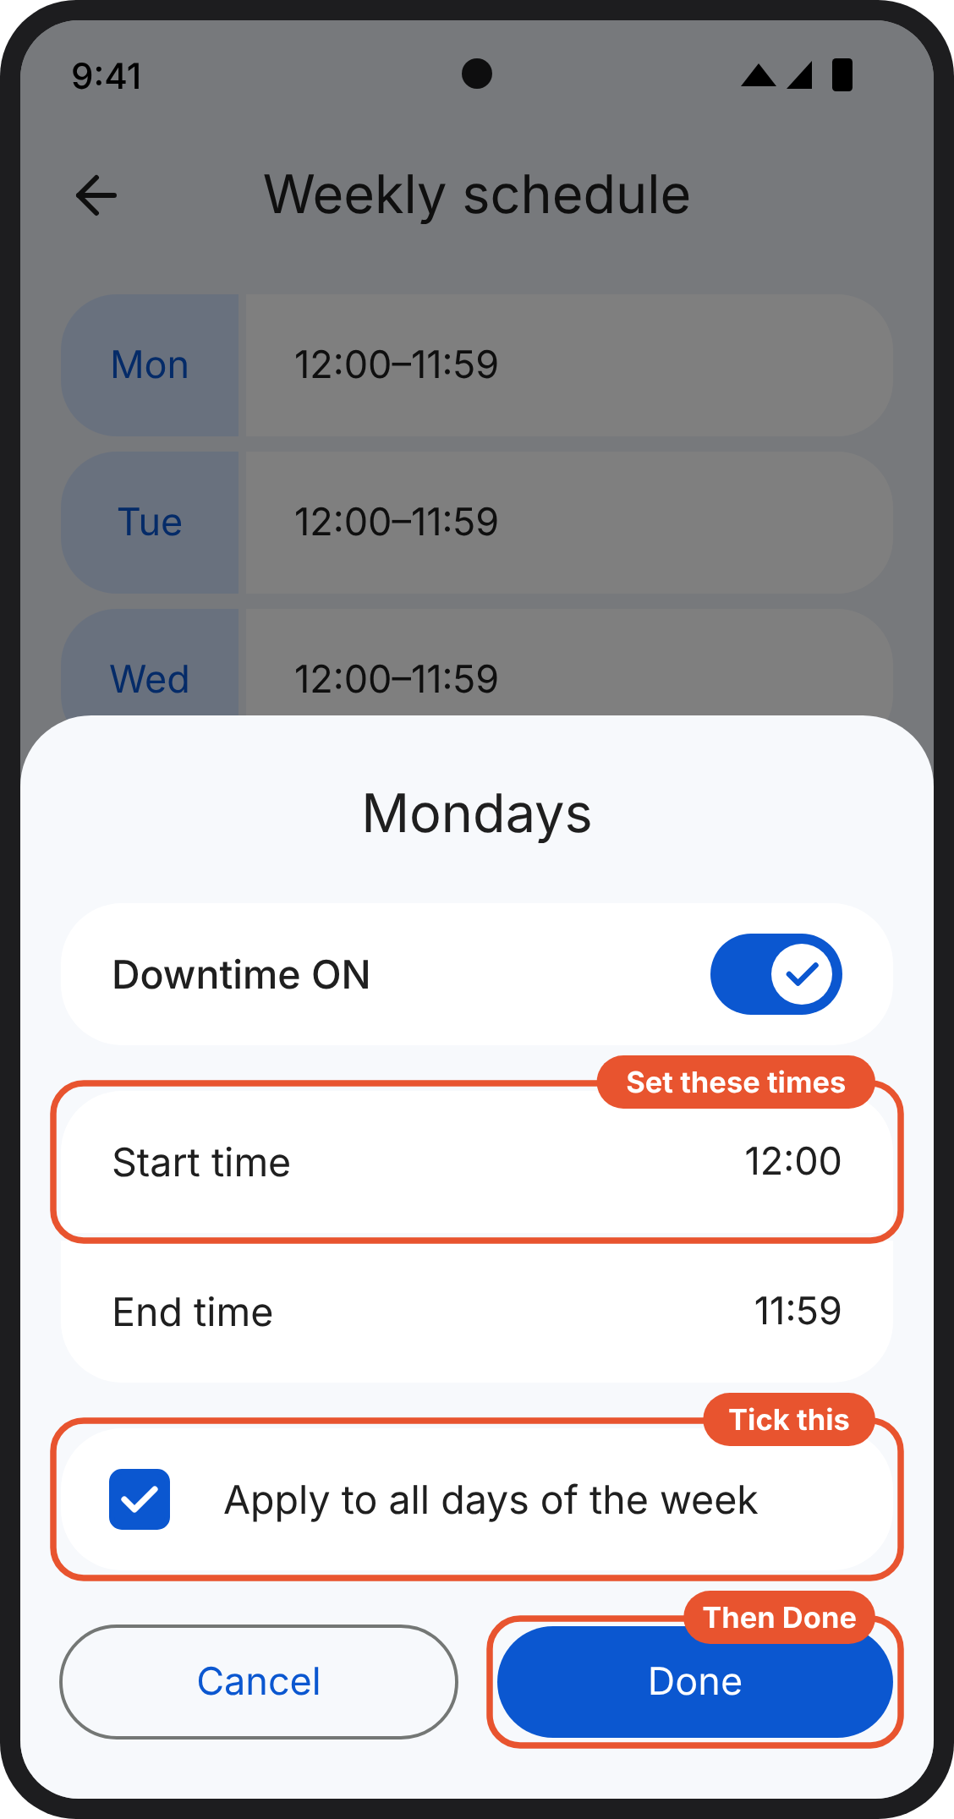  3. Your phone (Family Link). One day of the weekly schedule. Downtime ON is switched on, start time 12:00, end time 11:59, and Apply to all days of the week is ticked. Then tap Done.
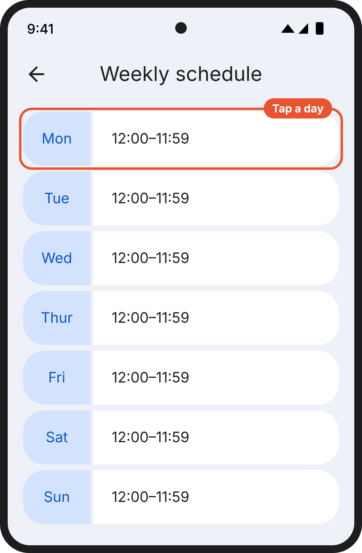
4. Your phone (Family Link). The weekly schedule. Once it is set, every day shows 12:00–11:59.

Version B: Ten categories, one simple rule (in the guides now)
What changes. The same settings as A. The instruction becomes one rule, "tick every category except two", with a number to check against, a reason, a reassurance that nothing is deleted, and what to do if one app is needed.
Ends with. Ten categories blocked
Why try it. One rule is easier to follow than a list of ten. Saying nothing is deleted, and pointing to a single-app exception, should stop parents unticking a whole category to keep one app.
Watch for. Pointing to the exception may lead some parents to allow back more apps than they need.

iPhone

Step 4: Block apps
5 minutes · on your child's phone
Already have App Limits? Keep them, and add this one alongside.

This is the step that does the work. One limit blocks whole categories of apps, including any your child installs later. In the next step you allow back the few your child needs.
- Open Settings → Screen Time → App Limits → Add Limit.
- Tick every category except two. Leave Information & Reading and Utilities unticked: the phone needs them to open any website, and Step 6 limits the web separately.
  - Don't tick "All Apps & Categories" at the top, or Websites at the bottom. They look like shortcuts, but they cut off the web too.
- Tap Next. The top of the screen should say 10 Categories. If it says a different number, go back and check the ticks.
- Set the time to 0 minutes and tap Add.
- Turn on Block at End of Limit. Without it, your child gets an Ignore Limit button and nothing holds.
Nothing is deleted. Apps, photos and messages stay on the phone, just locked. You can change any of this later with your code.
Need one app from a ticked category, such as a map or a school app? Don't untick the whole category. Allow back just that app in the next step.
1. Your child's phone. The Screen Time page. App Limits is the second option under Limit Usage. | 2. Your child's phone. The App Limits page with a blue Add Limit button. | 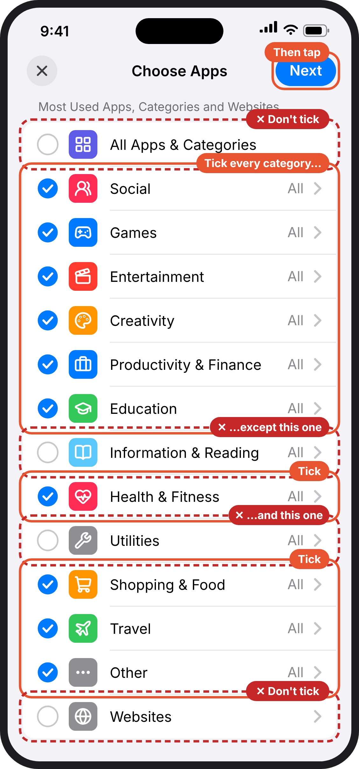  3. Your child's phone. Choose Apps. Every category is ticked except Information & Reading and Utilities. All Apps & Categories at the top and Websites at the bottom are not ticked either. Next is at the top right.
4. Your child's phone. A time picker, set to 0 hours and 0 minutes. | 5. Your child's phone. The limit you just made. App Limit is on, Time is 0 minutes every day, and Block at End of Limit is switched on. | 6. Your child's phone. What your child sees when they open an app that's blocked: Time Limit.

Android phone

Step 4: Block apps
5 minutes · on your phone, in Family Link
Already have downtime at bedtime? This replaces it with downtime all day. The apps you allow back next will then work at night too. If you want them off at night, email us and we'll help.

This is the step that does the work. Family Link doesn't group apps into categories, so the way to block everything at once, including apps installed later, is downtime for the whole day. It sounds drastic, but it's only the first half: in the next step you allow back the few apps your child needs.
- Open Family Link. It opens on Screen time (bottom left). Tap Schedules.
- Turn on Downtime. Leave School time off.
- Tap Weekly schedule, then Mon. Check Downtime ON is switched on, set Start time to 12:00 and End time to 11:59, tick Apply to all days of the week and tap Done.
- Every day should now show 12:00–11:59. That means downtime covers the whole day.
Your child's phone will lock, apart from calls, until you finish the next step. That's expected. Nothing is deleted: apps, photos and messages stay on the phone.
Need another app? You can allow it back in the next step too.
1. Your phone (Family Link). Family Link on your phone opens on Screen time. Your child's phone is shown by its model name (here SM-S901B). Schedules is below it. | 2. Your phone (Family Link). Schedules in Family Link. Turn on Downtime and set its weekly schedule to 12:00–11:59. Leave School time off. | 3. Your phone (Family Link). One day of the weekly schedule. Downtime ON is switched on, start time 12:00, end time 11:59, and Apply to all days of the week is ticked. Then tap Done.
4. Your phone (Family Link). The weekly schedule. Once it is set, every day shows 12:00–11:59.

Version C: Top three only
What changes. Block only social media, games and video (on an iPhone, the Social, Games and Entertainment categories). Everything else stays open.
Ends with. Three categories blocked
Why try it. The shortest ask. These three hold the apps children spend most time on, so more parents may finish.
Watch for. Weaker. Creativity, shopping and other apps stay open, and on Android a parent has to find each app by hand. This changes what the study tests, not just the wording, so it needs agreeing as a trial decision before families see it.

iPhone

Step 4: Block apps
5 minutes · on your child's phone
Already have App Limits? Keep them, and add this one alongside.

This is the step that does the work. You block the three categories that hold the apps children spend most time on: social media, games and video. That includes any your child installs later.
- Open Settings → Screen Time → App Limits → Add Limit.
- Tick three categories: Social, Games and Entertainment. Leave the rest unticked.
  - Don't tick "All Apps & Categories" at the top. It looks like a shortcut, but it blocks everything, the web included.
- Tap Next. The top of the screen should say 3 Categories.
- Set the time to 0 minutes and tap Add.
- Turn on Block at End of Limit. Without it, your child gets an Ignore Limit button and nothing holds.
Nothing is deleted. Apps, photos and messages stay on the phone, just locked. You can change any of this later with your code.
Messaging apps such as WhatsApp are in Social, so they're blocked too. You'll allow WhatsApp back in the next step.
1. Your child's phone. The Screen Time page. App Limits is the second option under Limit Usage. | 2. Your child's phone. The App Limits page with a blue Add Limit button. | 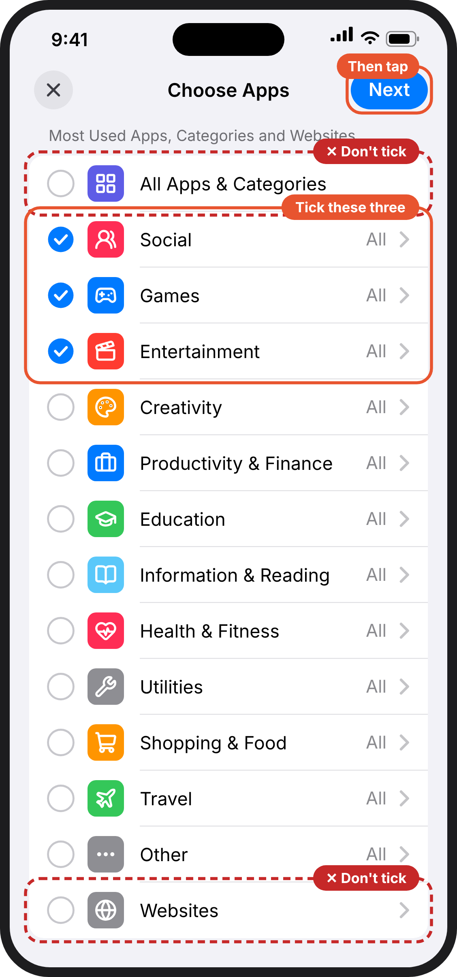  3. Your child's phone. Choose Apps. Only Social, Games and Entertainment are ticked. All Apps & Categories at the top is not ticked. Next is at the top right.
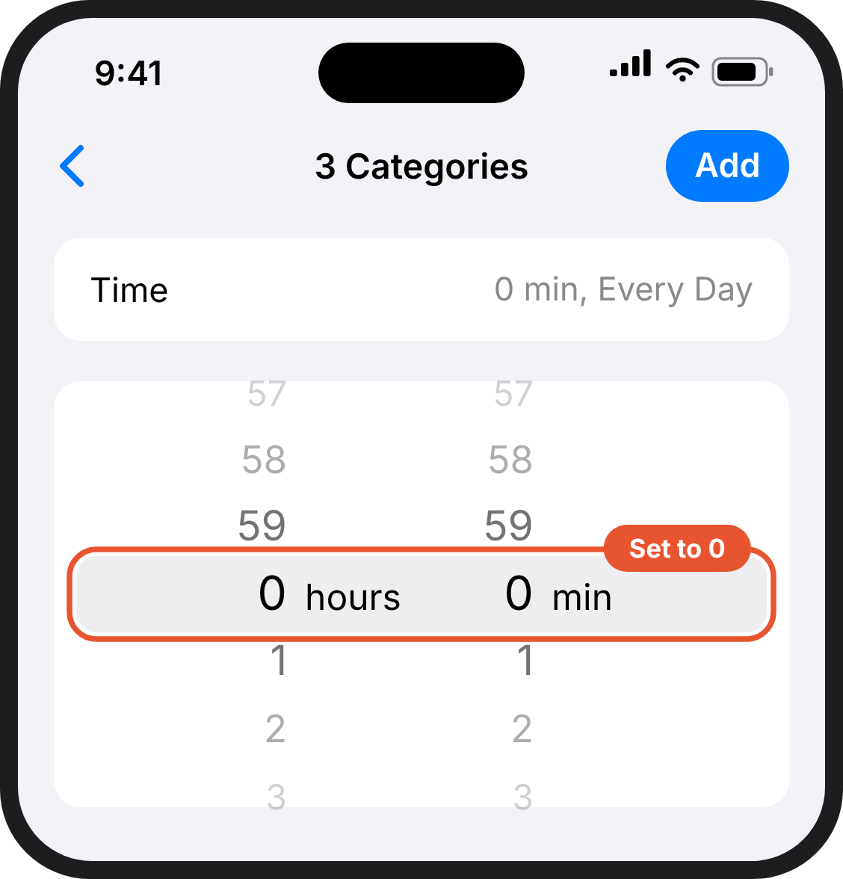  4. Your child's phone. A time picker, set to 0 hours and 0 minutes. | 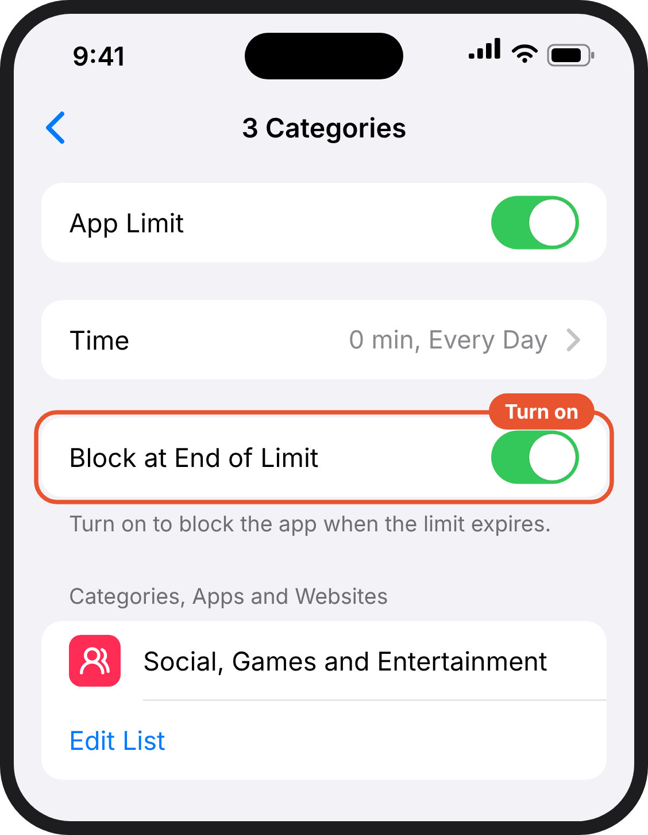  5. Your child's phone. The limit you just made. App Limit is on, Time is 0 minutes every day, and Block at End of Limit is switched on. | 6. Your child's phone. What your child sees when they open an app that's blocked: Time Limit.

Android phone

Step 4: Block apps
5 minutes · on your phone, in Family Link
Already blocked some apps? Keep them blocked. If you have downtime at bedtime, you can keep that too.

This is the step that does the work. You block the social media, game and video apps on your child's phone. These hold the apps children spend most time on.
- Open Family Link on Screen time and tap Time limits, then App limits.
- Go down the list. Tap each social media, game or video app, such as YouTube, TikTok, Snapchat or Roblox, and choose Block.
- Leave everything else as it is. You don't need downtime in this version.
New apps can't be installed without your approval once you've done Step 7, so nothing new slips in.
Nothing is deleted. A blocked app stays on the phone, just locked.
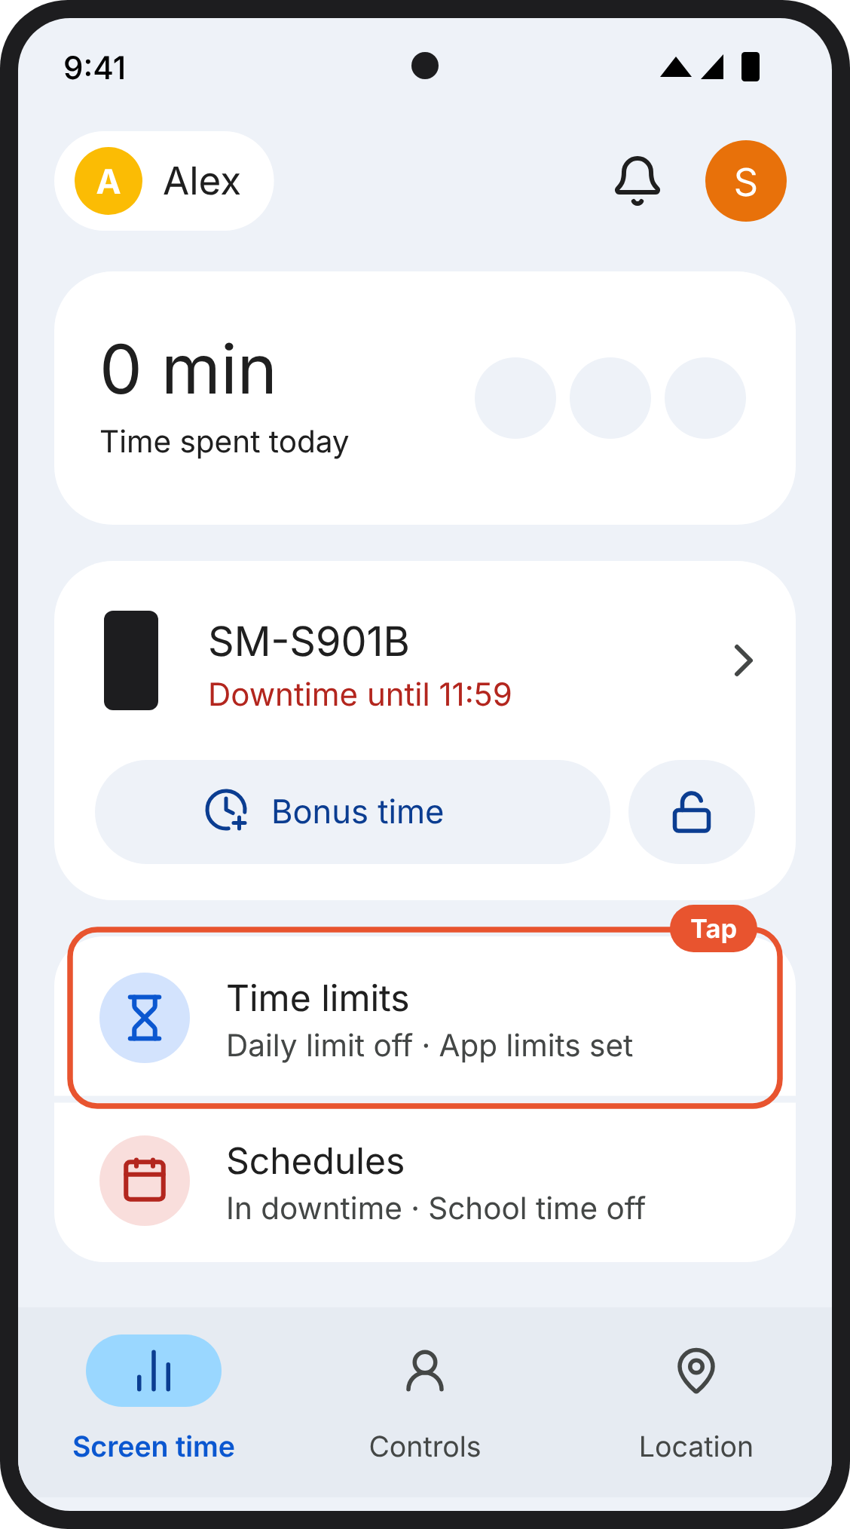  1. Your phone (Family Link). Screen time in Family Link. Time limits is below your child's phone. | 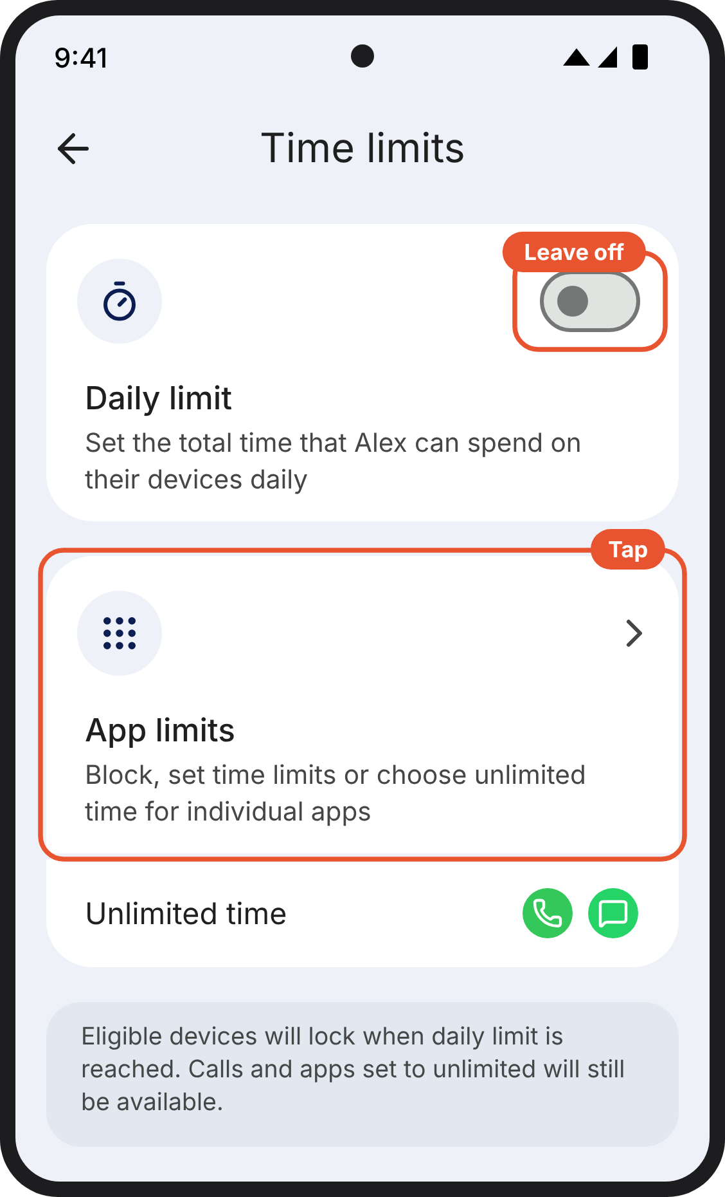  2. Your phone (Family Link). Time limits in Family Link. Leave Daily limit off and tap App limits. Apps set to Unlimited time are shown underneath. | 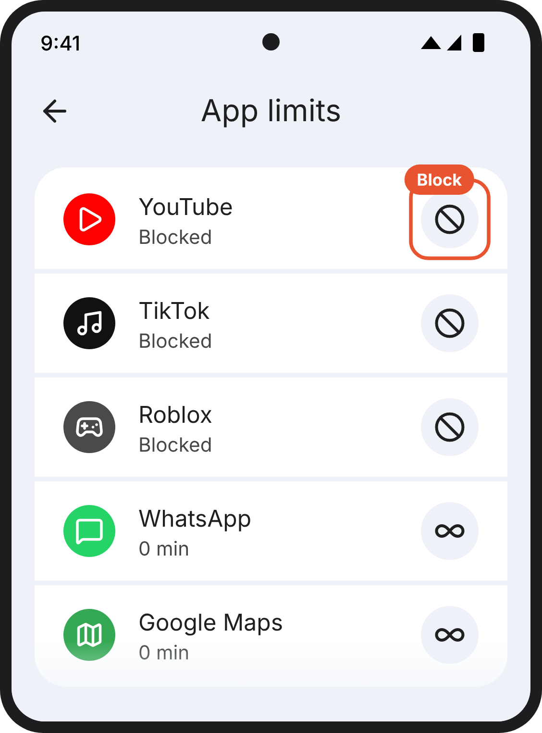  3. Your phone (Family Link). App limits in Family Link. Social media, game and video apps such as YouTube, TikTok and Roblox are set to Block. The apps your child needs keep their infinity sign.

Step 5: Allow back the apps your child needs
10 minutes · on your phone, in Family Link
Already set limits on some apps? Change the ones below to Unlimited time. Leave the rest as they are.

In this version only the apps you chose are blocked, so this is a quick check.
- In App limits, check that none of these says Blocked: Messages, WhatsApp, Google Maps, [Life360], Weather, [Moodle], [your child's school app], Camera and Clock. If one does, tap it and choose Unlimited time.
- Set Google Chrome to Unlimited time too, so the websites in the next step open.
If your child needs another app
You can allow back one more app yourself, in the same way: for example one their school or a club uses.
Please use your judgement. Will they need it most weeks? Does it have videos, a feed, games, or chat with people they don't know? If it has any of those, leave it blocked. If you're not sure, leave it blocked and ask us.
Please tell us about any app you add, at smartphonestudy@public.io. If other families need it too, we'll add it to the guide for everyone.

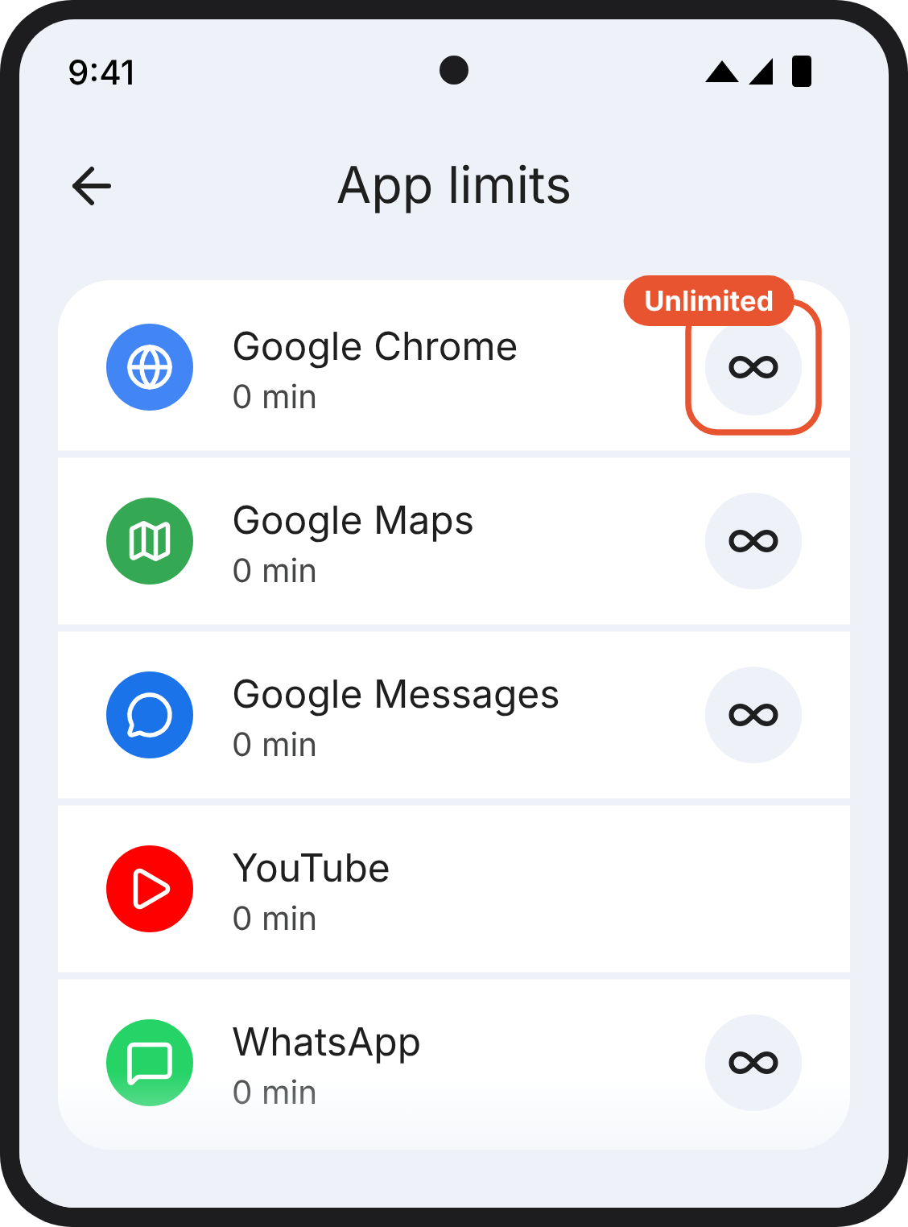
1. Your phone (Family Link). App limits in Family Link. Each app your child needs, and Google Chrome, is set to Unlimited time and shows an infinity sign. The others have no sign.

Version D: Top three first, then the rest
What changes. The same end result as A and B, asked in two stages: first social media, games and video, then everything else.
Ends with. Ten categories blocked (three if a parent stops halfway)
Why try it. A small first ask makes sure the three that matter most are done, then asks for the rest while the parent is already on the right screen.
Watch for. Some parents may stop after the first stage and end up with C.

iPhone

Step 4: Block apps
5 minutes · on your child's phone
Already have App Limits? Keep them, and add this one alongside.

This is the step that does the work. One limit blocks whole categories of apps, including any your child installs later. You tick them in two goes: the three that matter most, then the rest.
- Open Settings → Screen Time → App Limits → Add Limit.
- First, tick Social, Games and Entertainment. These hold the apps children spend most time on: social media, games and video.
- Then tick the rest, apart from Information & Reading and Utilities. The phone needs those two to open any website, and Step 6 limits the web separately.
  - Don't tick "All Apps & Categories" at the top, or Websites at the bottom. They look like shortcuts, but they cut off the web too.
- Tap Next. The top of the screen should say 10 Categories.
- Set the time to 0 minutes and tap Add.
- Turn on Block at End of Limit. Without it, your child gets an Ignore Limit button and nothing holds.
Nothing is deleted. Apps, photos and messages stay on the phone, just locked. You can change any of this later with your code.
Need one app from a ticked category, such as a map or a school app? Don't untick the whole category. Allow back just that app in the next step.
1. Your child's phone. The Screen Time page. App Limits is the second option under Limit Usage. | 2. Your child's phone. The App Limits page with a blue Add Limit button. | 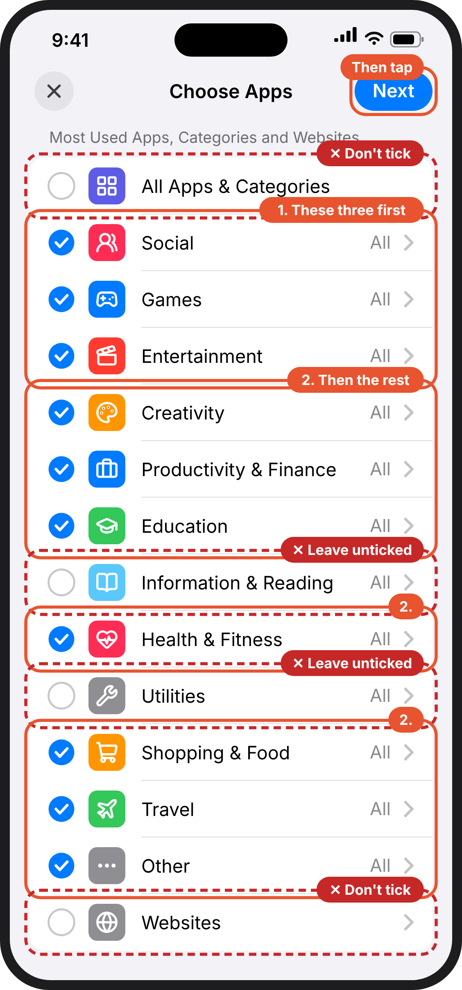  3. Your child's phone. Choose Apps. First Social, Games and Entertainment are ticked, then every other category except Information & Reading and Utilities. Next is at the top right.
4. Your child's phone. A time picker, set to 0 hours and 0 minutes. | 5. Your child's phone. The limit you just made. App Limit is on, Time is 0 minutes every day, and Block at End of Limit is switched on. | 6. Your child's phone. What your child sees when they open an app that's blocked: Time Limit.

Android phone

Step 4: Block apps
5 minutes · on your phone, in Family Link
Already have downtime at bedtime? This replaces it with downtime all day. The apps you allow back next will then work at night too. If you want them off at night, email us and we'll help.

This is the step that does the work. You do it in two goes: first the apps that matter most, then everything else.
- First, block social media, games and video. In Family Link, tap Time limits, then App limits. Tap each social media, game or video app, such as YouTube, TikTok, Snapchat or Roblox, and choose Block.
- Then block everything else, with downtime for the whole day. Go back to Screen time and tap Schedules. Turn on Downtime and leave School time off.
- Tap Weekly schedule, then Mon. Check Downtime ON is switched on, set Start time to 12:00 and End time to 11:59, tick Apply to all days of the week and tap Done.
- Every day should now show 12:00–11:59. That means downtime covers the whole day.
Your child's phone will lock, apart from calls, until you finish the next step. That's expected. Nothing is deleted.
Need another app? You can allow it back in the next step too.
1. Your phone (Family Link). App limits in Family Link. Social media, game and video apps such as YouTube, TikTok and Roblox are set to Block. The apps your child needs keep their infinity sign. | 2. Your phone (Family Link). Family Link on your phone opens on Screen time. Your child's phone is shown by its model name (here SM-S901B). Schedules is below it. | 3. Your phone (Family Link). Schedules in Family Link. Turn on Downtime and set its weekly schedule to 12:00–11:59. Leave School time off.
4. Your phone (Family Link). One day of the weekly schedule. Downtime ON is switched on, start time 12:00, end time 11:59, and Apply to all days of the week is ticked. Then tap Done. | 5. Your phone (Family Link). The weekly schedule. Once it is set, every day shows 12:00–11:59.

