The SMART Study

Setting up the restrictions on your child's phone
Editable draft, generated from the microsite content file. Edit the words here freely. The phone pictures are images; the editable versions are the SVG files in assets/guides/screens (drag them into Figma, where the text stays editable).

What we're asking you to do: spend about 25 to 30 minutes setting up a small number of settings on your child's phone, then leave them running.
Everything you need is already built into the phone. There is nothing to buy, nothing to download, and no separate app to learn.
Start here: find your child's phone, sit down with it for half an hour, and work through the one route below that matches your situation.

Before you start: three things to have ready
- Your child's phone, physically in your hands. You'll need it for part of this, even if you manage it from your own phone afterwards.
- The password for the account on your child's phone: their Apple Account password (iPhone) or their Google Account password (Android). If your child set the phone up themselves, they will know it and you may not. Ask for it now rather than halfway through.
- Somewhere to write down a new passcode. You are about to create a four-digit code that locks these settings. If you forget it, you may need to erase the phone completely. Write it where you keep other passwords, not in a note on your child's phone.
Don't use your child's birthday, your PIN, or a code your child already knows. The settings only hold if the code does.

Which route is yours?
Find the row that matches the two phones in your household.
Your child's phone | Your phone | Your route
iPhone | iPhone or iPad | Route A: set up once, manage from your own phone
iPhone | Android | Route B: set up on your child's phone, locked with your code
Android | Android or iPhone | Route C: set up once, manage from your own phone

If your child has more than one device, such as an old or second phone, do the main phone first and tell us about the others at smartphonestudy@public.io.
A note on Android phones. Samsung, Google Pixel, Xiaomi, Motorola and the rest all arrange their Settings menu slightly differently. Rather than describe a menu that might not match yours, we give you the name of the setting. Open Settings, tap the search box or magnifying glass at the top, and type the name. It will find it whatever your phone.

Route A: Your child has an iPhone, and you have an iPhone or iPad
This is the fullest version. You set the restrictions once, then you can see and change them from your own phone without asking for theirs.

Step 1: Put your child in your family group
5 minutes · on your phone
Skip this step if your child is already in your Family Sharing group.
- On your phone, open Settings and tap your name at the very top.
- Tap Family.
- Tap Add Member (or the +), then follow the prompts to add your child.
  - If your child already has their own Apple Account, choose Invite Others and invite that account.
  - If they don't have one, choose Create Child Account.
- Check the date of birth is correct. The phone uses your child's age to decide which protections apply automatically. A wrong birth year quietly switches off protections you think you have.
If your child's Apple Account was set up with an adult's age, you can now correct it and convert it to a child account from this same screen. It's worth doing.
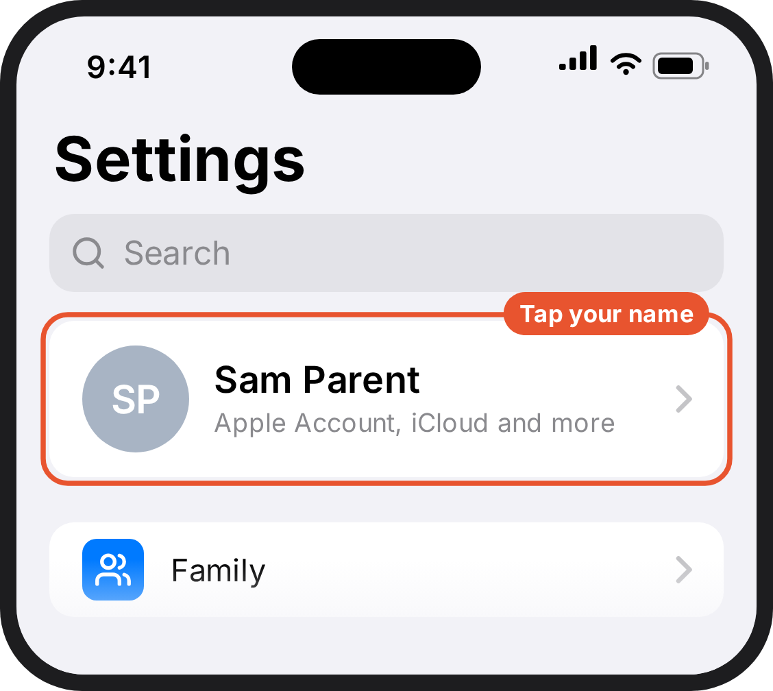  1. Your phone. The top of Settings on your phone. Your name and photo are at the top. | 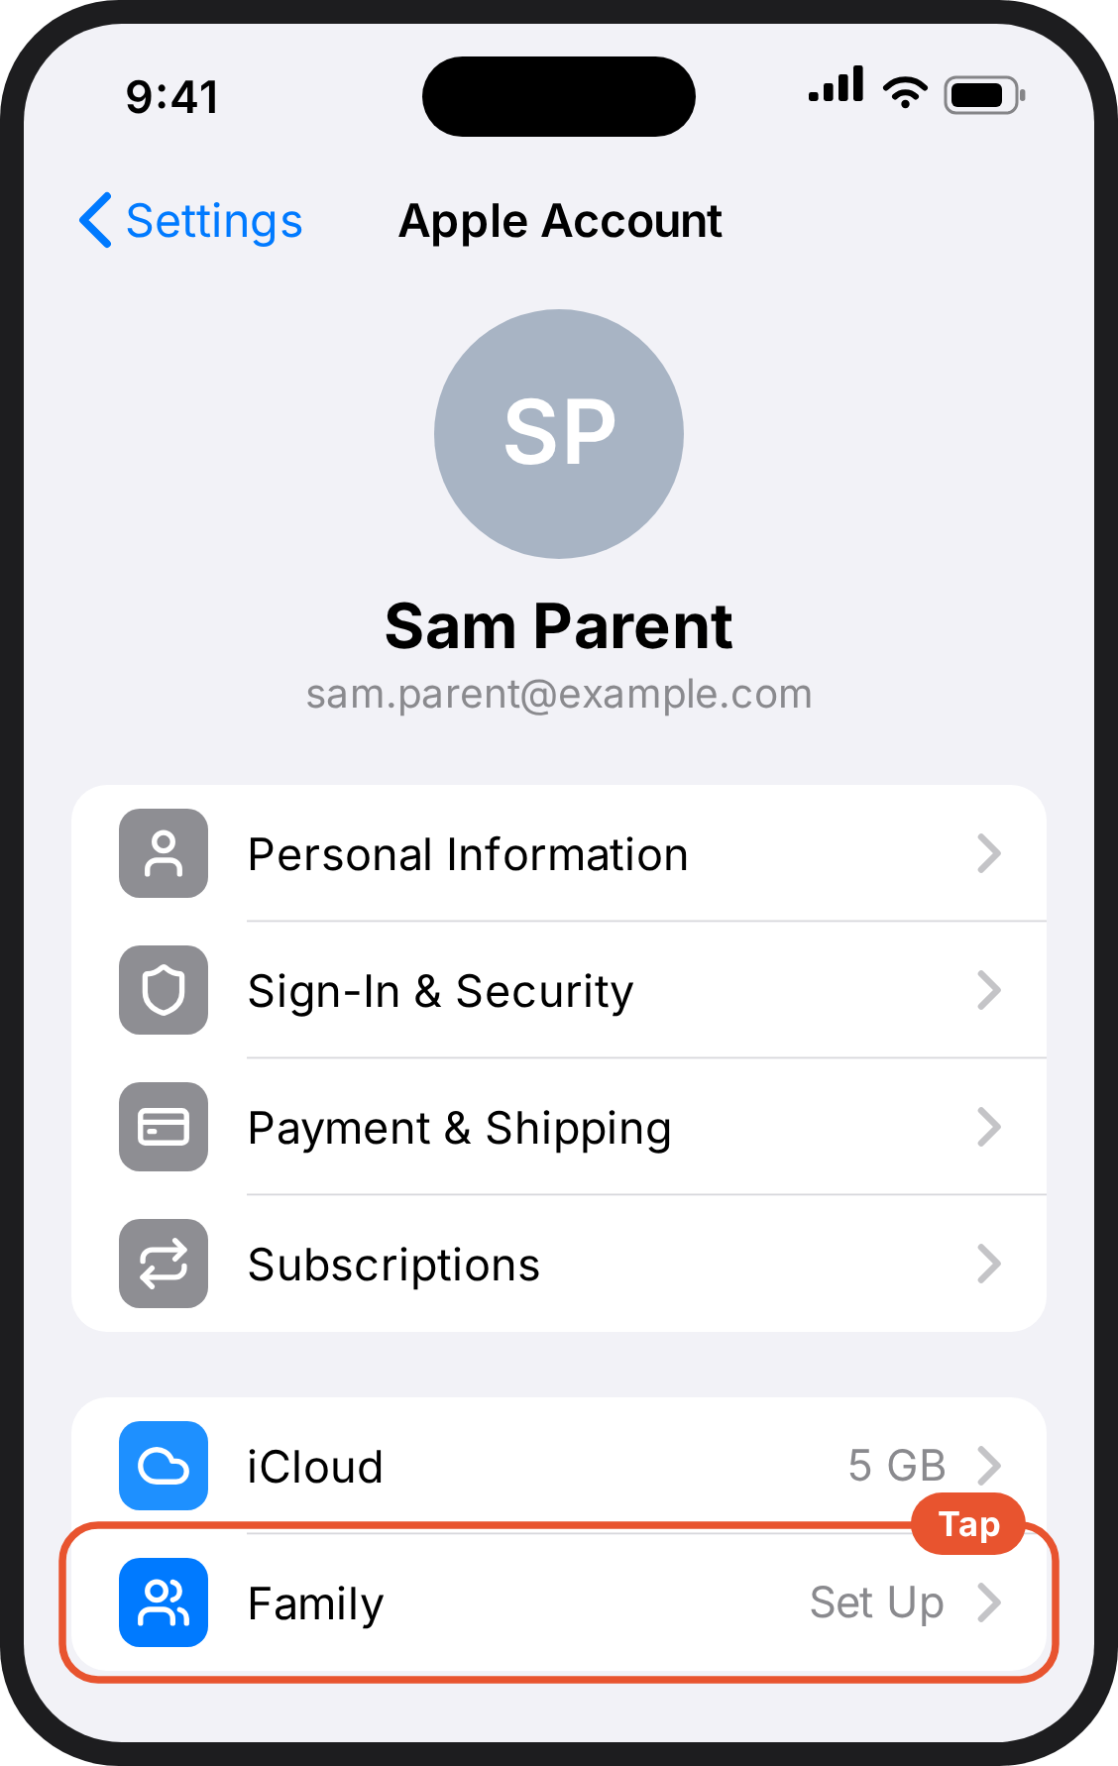  2. Your phone. Your Apple Account page. Family is at the bottom. | 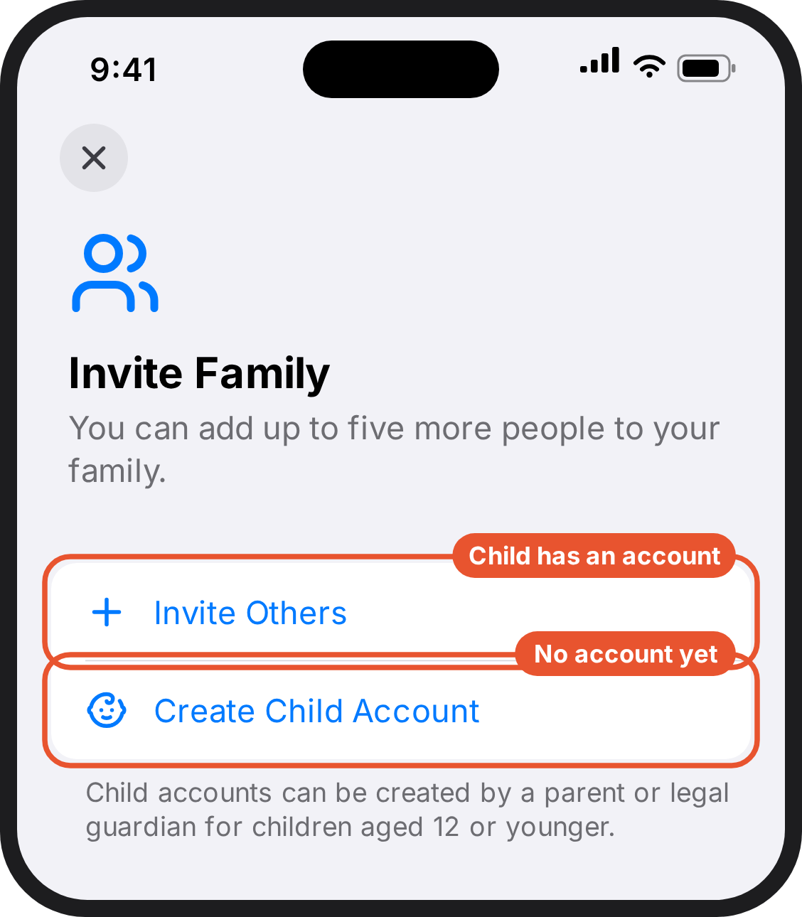  3. Your phone. Invite Family, with two options: Invite Others, or Create Child Account.
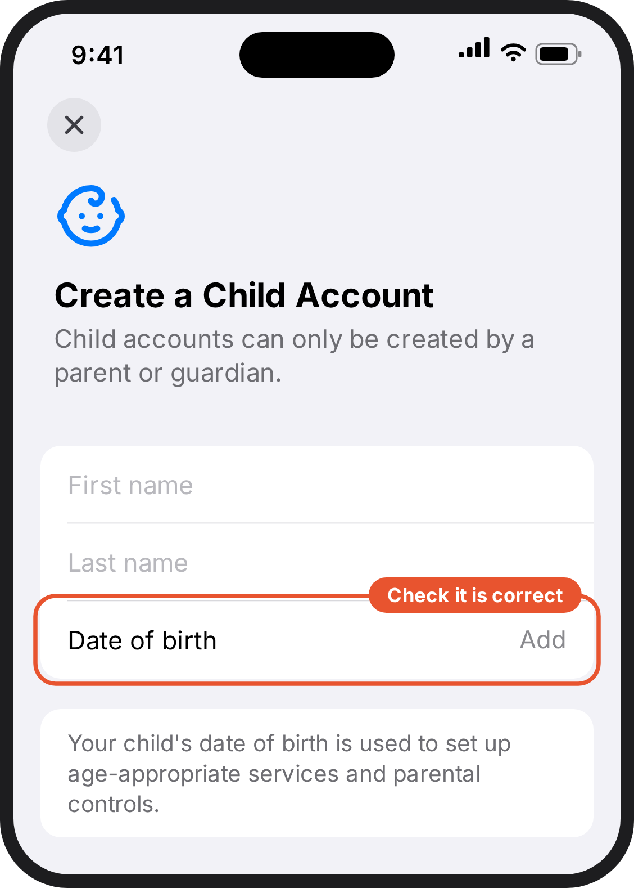
4. Your phone. Create a Child Account, with fields for first name, last name and date of birth.

Step 2: Turn on Screen Time and set your code
5 minutes · on your child's phone
- On your child's phone, open Settings and tap Screen Time.
- If Screen Time isn't on yet, turn it on.
- Tap Lock Screen Time Settings (on some phones: Use Screen Time Passcode).
- Enter a four-digit code that your child does not know, then enter it again.
- When asked for an Apple Account for recovery, enter your own, not your child's. This is how you get back in if you forget the code.
This is the step people skip, and it's the reason restrictions come off a fortnight later. Without a code, your child can undo everything in about four taps.

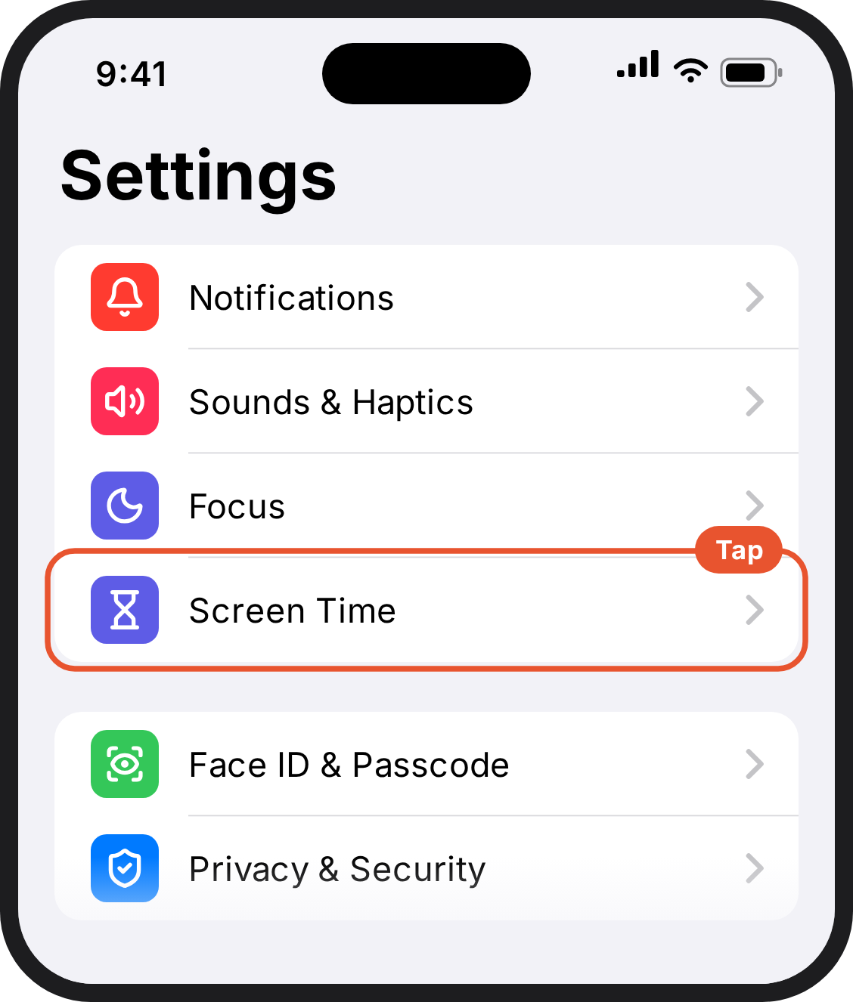  1. Your child's phone. The Settings app. Screen Time is in the list, below Focus. | 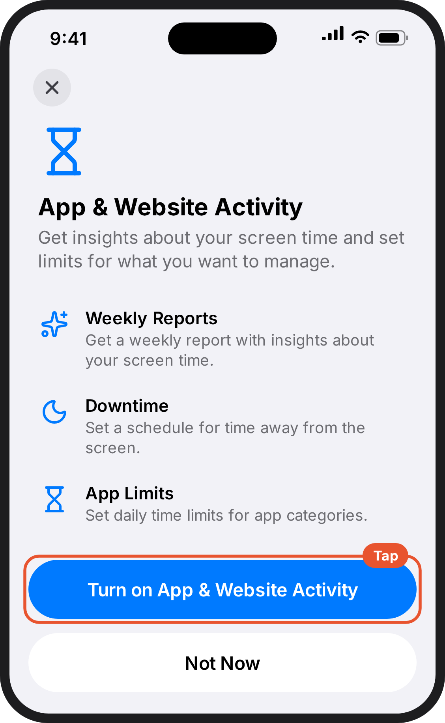  2. Your child's phone. A pop-up called App & Website Activity, with a blue button at the bottom to turn it on. | 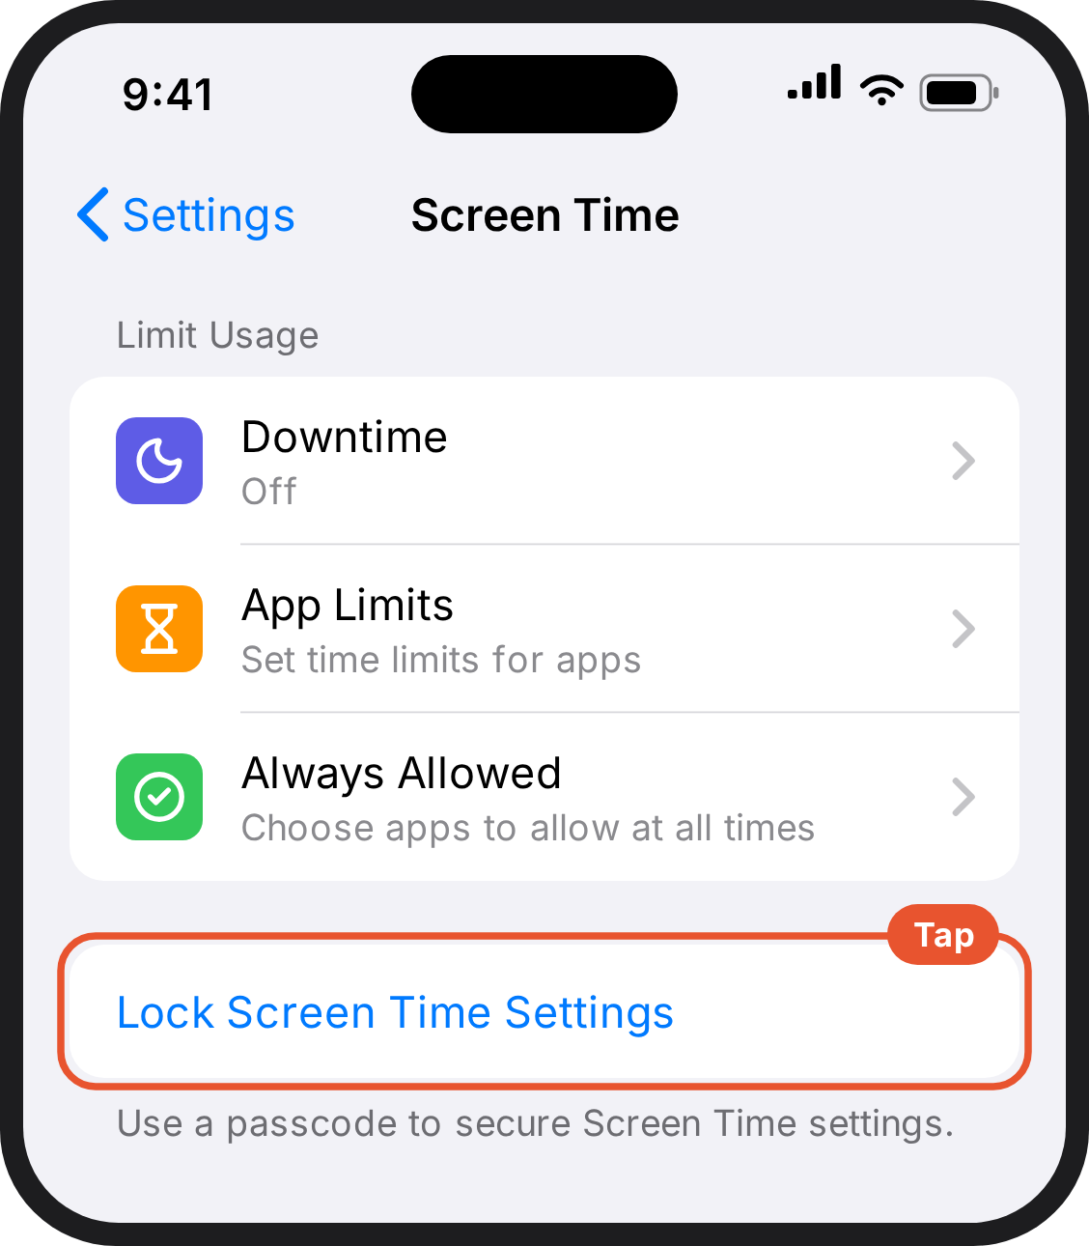  3. Your child's phone. Further down the Screen Time page there is a blue link: Lock Screen Time Settings.
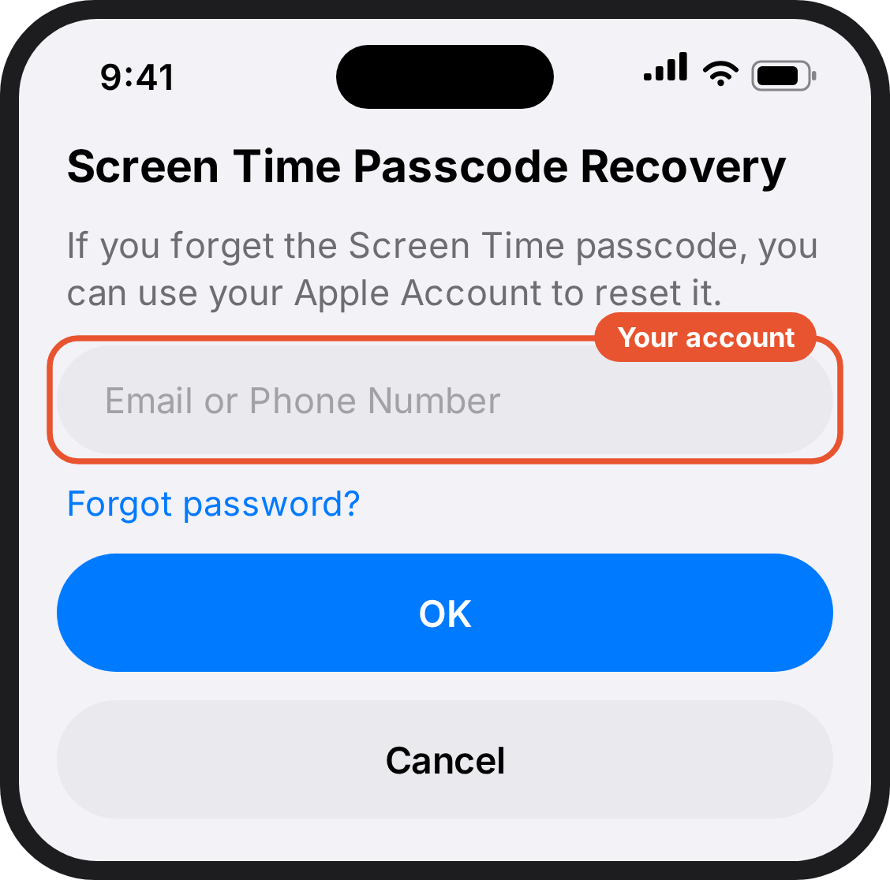
4. Your child's phone. Screen Time Passcode Recovery asks for an Apple Account email. Enter your own.

Step 3: Allow only the apps on the list
Go to The settings we're asking you to apply → iPhone: Allow only the apps on the list, below. Come back here when you're done.

Step 4: Allow only the websites they need
Go to The settings we're asking you to apply → iPhone: Allow only the websites they need, below. Come back here when you're done.

Step 5: Lock the settings
Go to The settings we're asking you to apply → iPhone: Lock the settings, below. Come back here when you're done.

Step 6: Check it reached your phone
2 minutes · on your phone
- On your phone, open Settings → Screen Time.
- Your child's name should appear. Tap it.
- You should see the settings you just made. If you don't, check both phones are signed into the right accounts and both are up to date.
From now on you can change any of these from your own phone, and you'll be told if your child tries to get around the code.
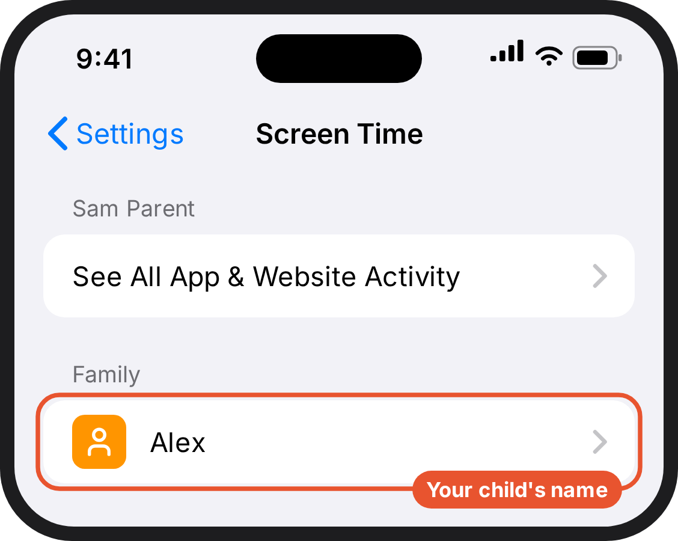  1. Your phone. Screen Time on your phone. Your child's name is listed under Family. | 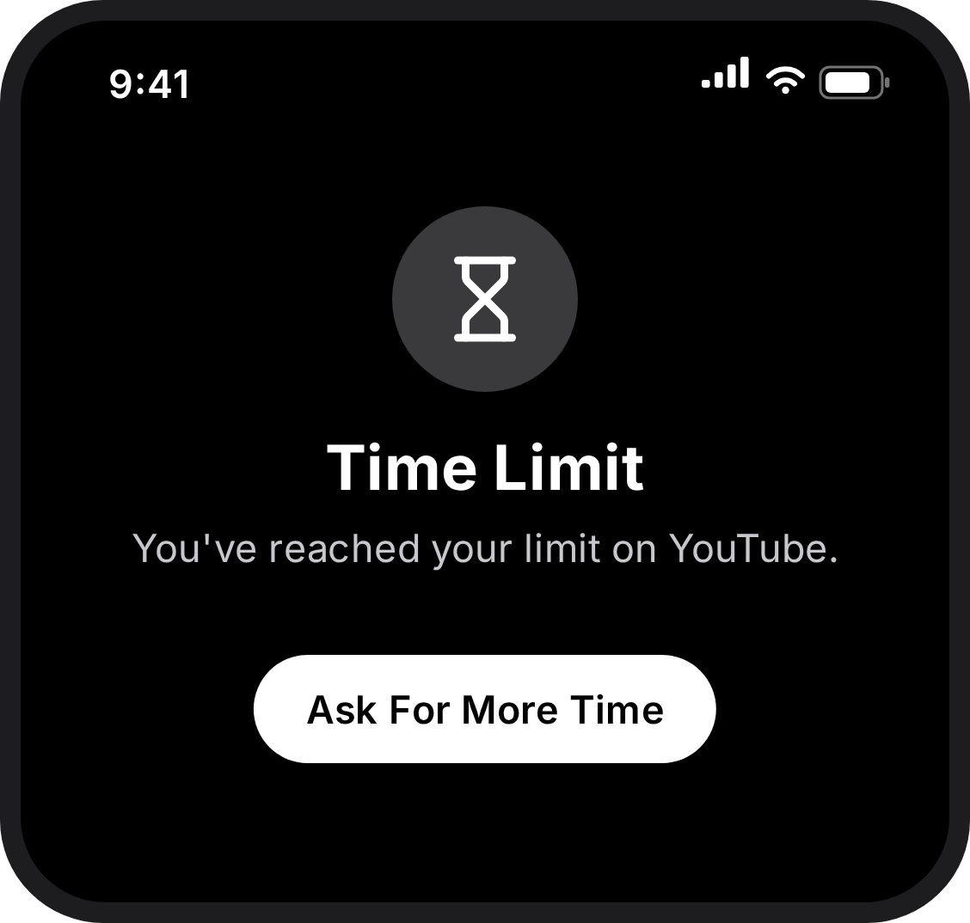  2. Your child's phone. What your child sees when they open an app that isn't on the list: Time Limit.

Route B: Your child has an iPhone, and you have an Android phone
Apple's remote controls only work from one Apple device to another. That doesn't stop you doing any of this: you set it up directly on your child's phone and lock it with a code only you know. The restrictions are exactly as strong. The only thing you lose is being able to change them later from your own phone.

Step 1: Turn on Screen Time and set your code
5 minutes · on your child's phone
- On your child's phone, open Settings and tap Screen Time.
- Turn Screen Time on if it isn't already. A screen like the one shown will pop up.
- Tap Lock Screen Time Settings (on some phones: Use Screen Time Passcode).
- Enter a four-digit code your child does not know. Enter it again to confirm.
- You'll be asked for an Apple Account so the code can be recovered.
  - If you have an Apple Account of your own, even an old one from an iPad or an old phone, use it. Do not use your child's.
  - If you don't have one, you can skip this. But then a forgotten code means erasing the phone, so write the code down properly first.
1. Your child's phone. The Settings app. Screen Time is in the list, below Focus. | 2. Your child's phone. A pop-up called App & Website Activity, with a blue button at the bottom to turn it on. | 3. Your child's phone. Further down the Screen Time page there is a blue link: Lock Screen Time Settings.
4. Your child's phone. Screen Time Passcode Recovery asks for an Apple Account email. Enter your own.

Step 2: Allow only the apps on the list
Go to The settings we're asking you to apply → iPhone: Allow only the apps on the list, below. Come back here when you're done.

Step 3: Allow only the websites they need
Go to The settings we're asking you to apply → iPhone: Allow only the websites they need, below. Come back here when you're done.

Step 4: Lock the settings
Go to The settings we're asking you to apply → iPhone: Lock the settings, below. Come back here when you're done.

Step 5: Agree how you'll check in
2 minutes · on your child's phone, together
- Because you can't see these settings from your own phone, agree a moment with your child, say Sunday evening, when you'll look at the phone together for two minutes.
- Doing it openly and on a schedule works far better than checking without telling them.
1. Your child's phone. What your child sees when they open an app that isn't on the list: Time Limit.

Route C: Your child has an Android phone, and you have an Android or iPhone
Google's Family Link works whichever phone you have, including an iPhone. Your child's phone needs to be an Android.

Step 1: Get the Family Link app
2 minutes · on your phone
- Open the Play Store (Android) or the App Store (iPhone).
- Search for Family Link and install it.
- Open it and sign in with your own Google Account (often ending in @gmail.com).
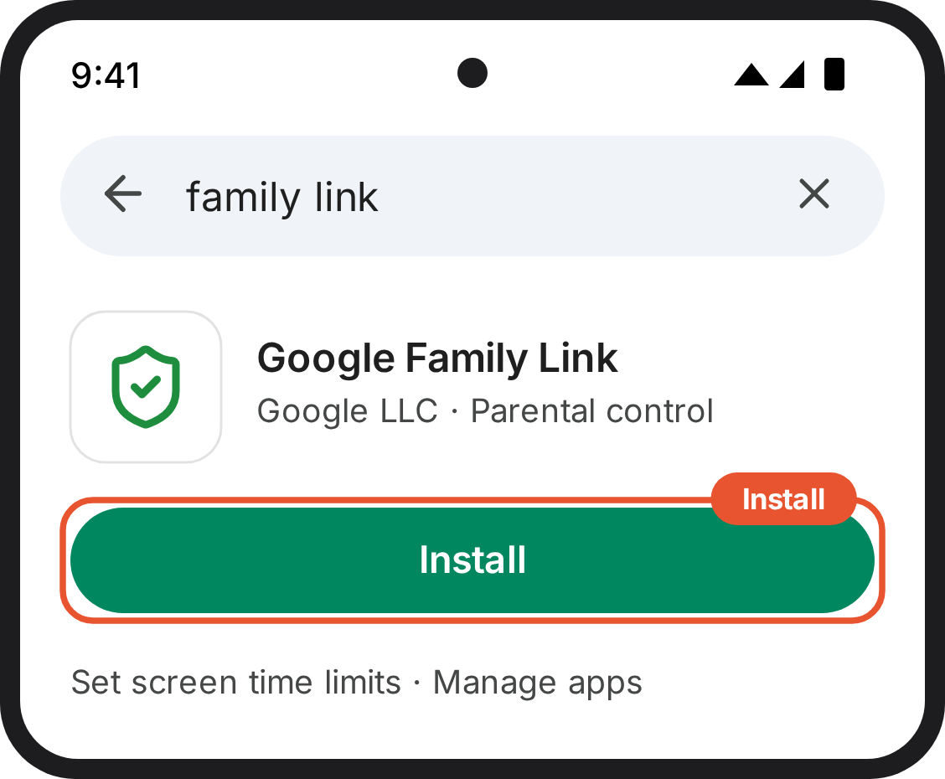
1. Your phone. The app store, showing Google Family Link with an Install button.

Step 2: Link your child's account
10 minutes · on both phones
If your child is under 13, Family Link will walk you through creating a Google Account for them, and it will be supervised from the start.
- On your child's phone, open Settings, tap Google, then All services.
- Under Kids & family, tap Parental controls.
- Tap Get started (or Let's do this) and choose your child's account.
- Follow the prompts, entering your own Google Account when asked for a parent.
- Your child taps to agree, and enters their own password to confirm.
Or from your phone: send the invitation from the Family Link app, then have your child open the email on their phone and accept it.
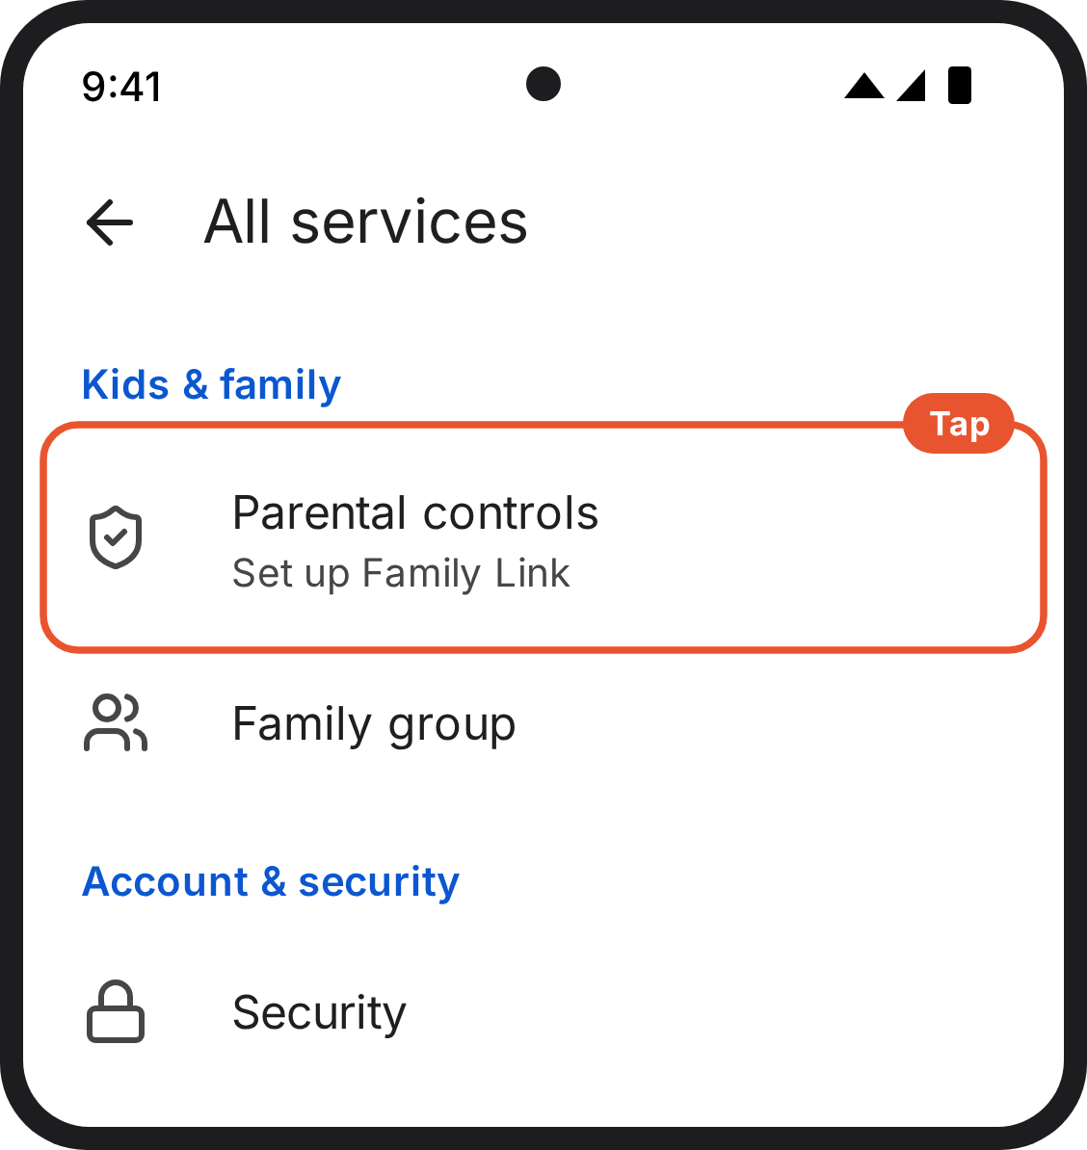
1. Your child's phone. On your child's phone: Settings, Google, All services. Parental controls is under Kids & family. Draft: check on a device.

Step 3: Allow only the apps on the list
Go to The settings we're asking you to apply → Android with Family Link: Allow only the apps on the list, below. Come back here when you're done.

Step 4: Allow only the websites they need
Go to The settings we're asking you to apply → Android with Family Link: Allow only the websites they need, below. Come back here when you're done.

Step 5: Lock the settings
Go to The settings we're asking you to apply → Android with Family Link: Lock the settings, below. Come back here when you're done.

Step 6: Check it worked
2 minutes · on your phone
- In Family Link, open your child's profile.
- If it shows their phone and recent activity, the link is live.
- If it shows nothing after a few hours, check the phone is switched on, connected, and signed into the supervised account.
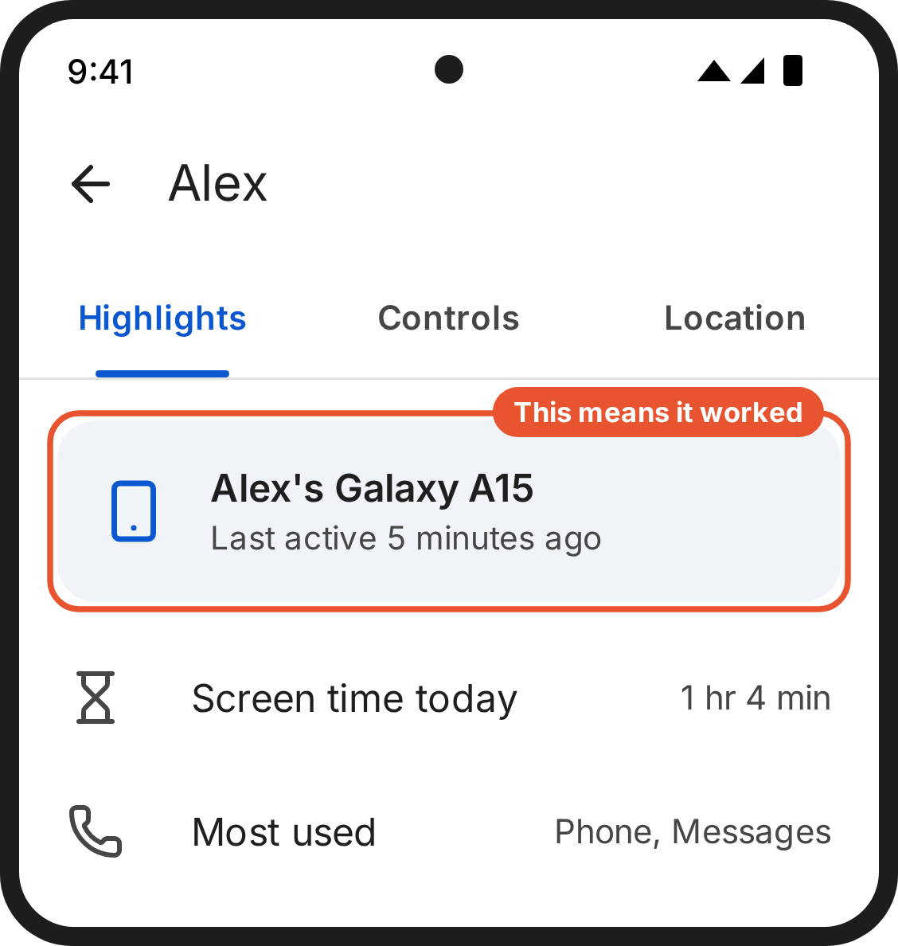
1. Your phone (Family Link). Your child's profile in Family Link, showing their phone and recent activity. Draft: check on a device.

The settings we're asking you to apply
Block everything, then allow back a short list of apps and a short list of websites. You don't need to set limits app by app.

The apps on the list
[PLACEHOLDER: replace with the co-designed list.]
App | For
Phone | Calls
Messages | Texts
WhatsApp | Family and friends
Maps | Getting around
[Life360] | Location
Weather | Weather
[Moodle] | Schoolwork
[School app] | Timetable and notices
Camera | Photos
Clock | Alarms

The websites on the list
[PLACEHOLDER: [SCHOOL DOMAIN], [Moodle], [BBC Bitesize], [others agreed with parents]]
Everything else is off: games, social media, video, shopping, and every website not on the list. Anything installed later is blocked automatically, because it isn't on the list.
If your child needs an app or a site that isn't here, email smartphonestudy@public.io. We'll answer within five working days: either it goes on the list for everyone, or we tell you why not. Parents built this list and it's still changing.

iPhone

iPhone: Allow only the apps on the list
10 minutes · on your child's phone
- Open Settings → Screen Time → App Limits → Add Limit.
- Tick every category in the list, one by one: Social, Games, Entertainment, Creativity, Productivity & Finance, Education, Information & Reading, Health & Fitness, Utilities, Shopping & Food, Travel and Other. Do not tick Websites. Work down the list so you don't miss one.
- Do not tick "All Apps & Categories" at the top. It looks like a shortcut, but it also cuts off web access, which undoes the websites step.
- Tap Next and set the limit to 0 minutes.
- Turn on Block at End of Limit. Without it there's an "Ignore Limit" button and nothing holds.
- Go back to Screen Time → Always Allowed.
- The top section is what's allowed now: Phone, Messages, FaceTime, Maps. Tap the red − on anything that isn't on your list. Phone can't be removed.
- The lower section lists everything else installed. Tap the green + on each app on your list.
Apps on the list work normally. Everything else shows a Time Limit screen.
If an app on the list is blocked, check it's in the top section of Always Allowed, not the lower one. If it still won't open, email smartphonestudy@public.io. Don't remove the category limit.

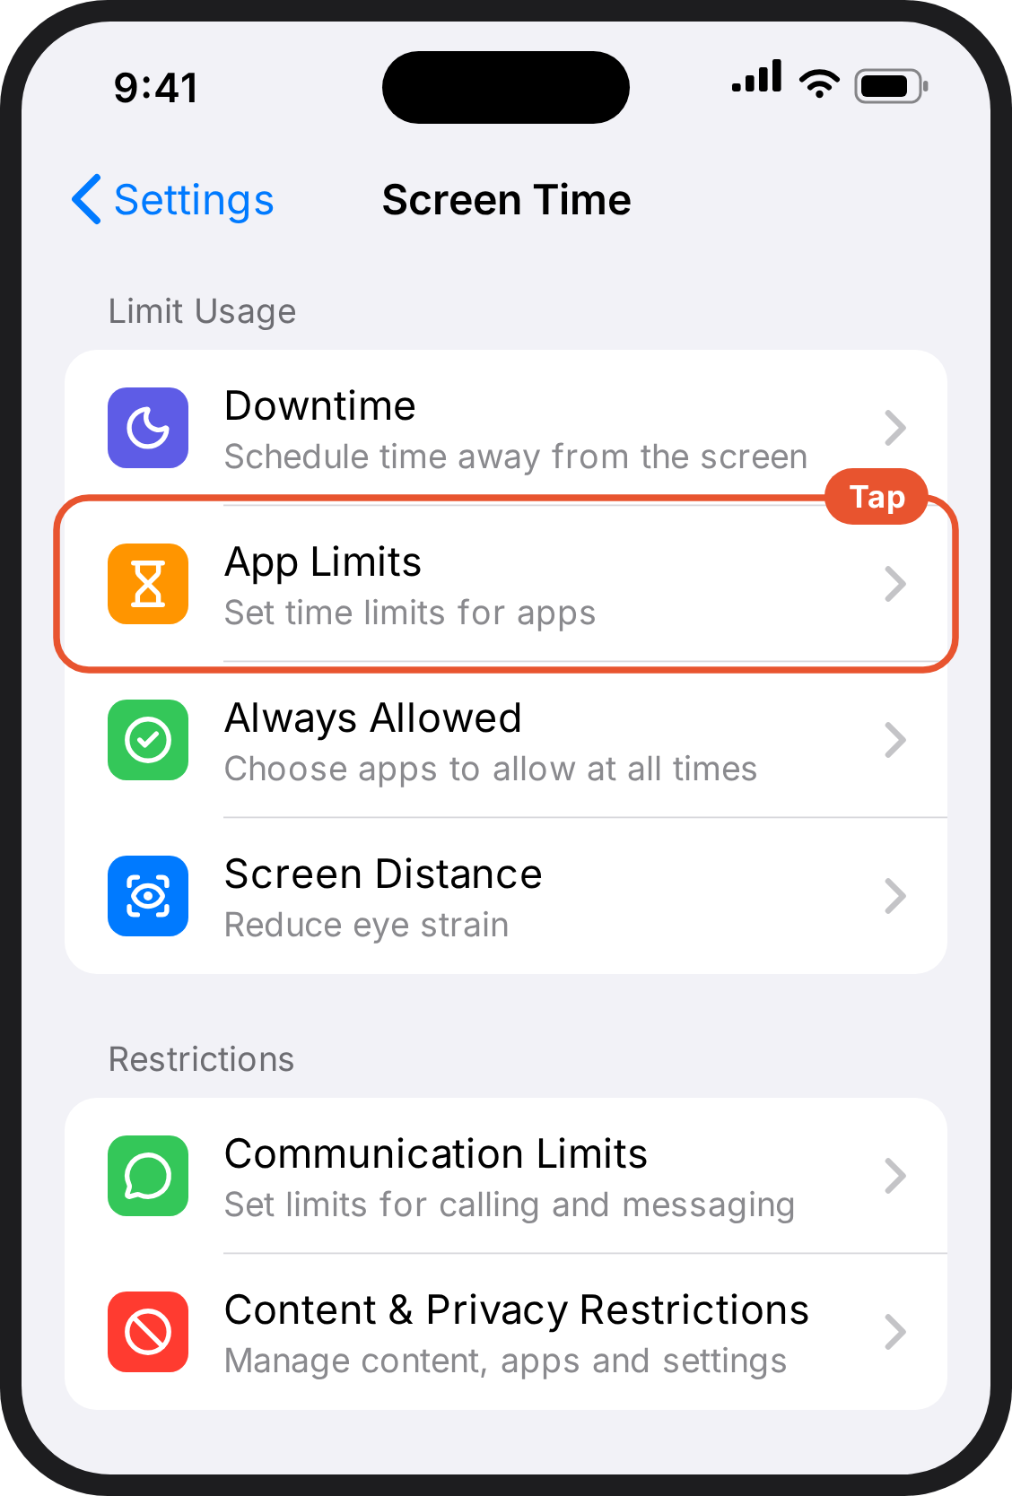  1. Your child's phone. The Screen Time page. App Limits is the second option under Limit Usage. | 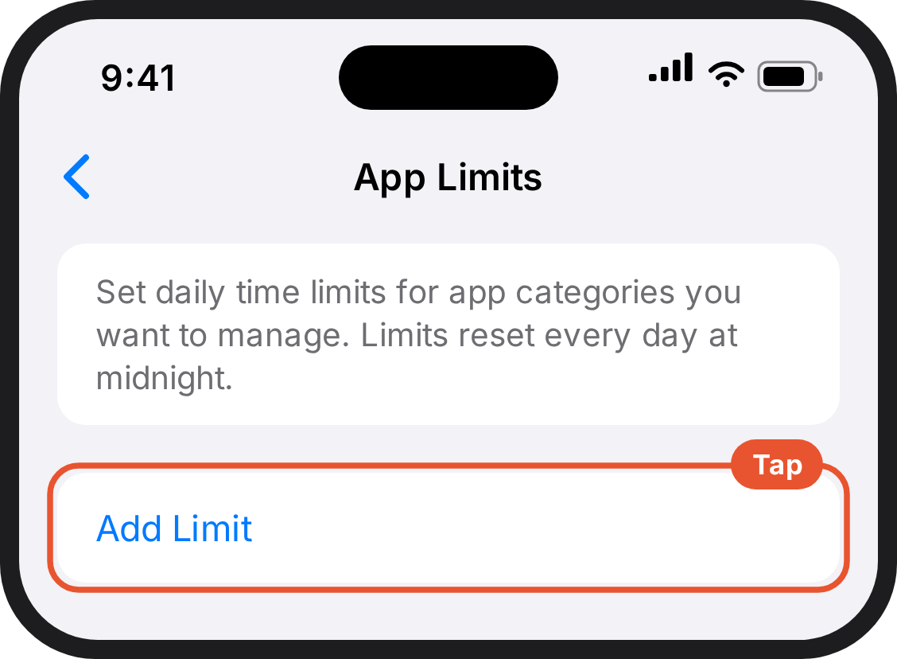  2. Your child's phone. The App Limits page with a blue Add Limit button. | 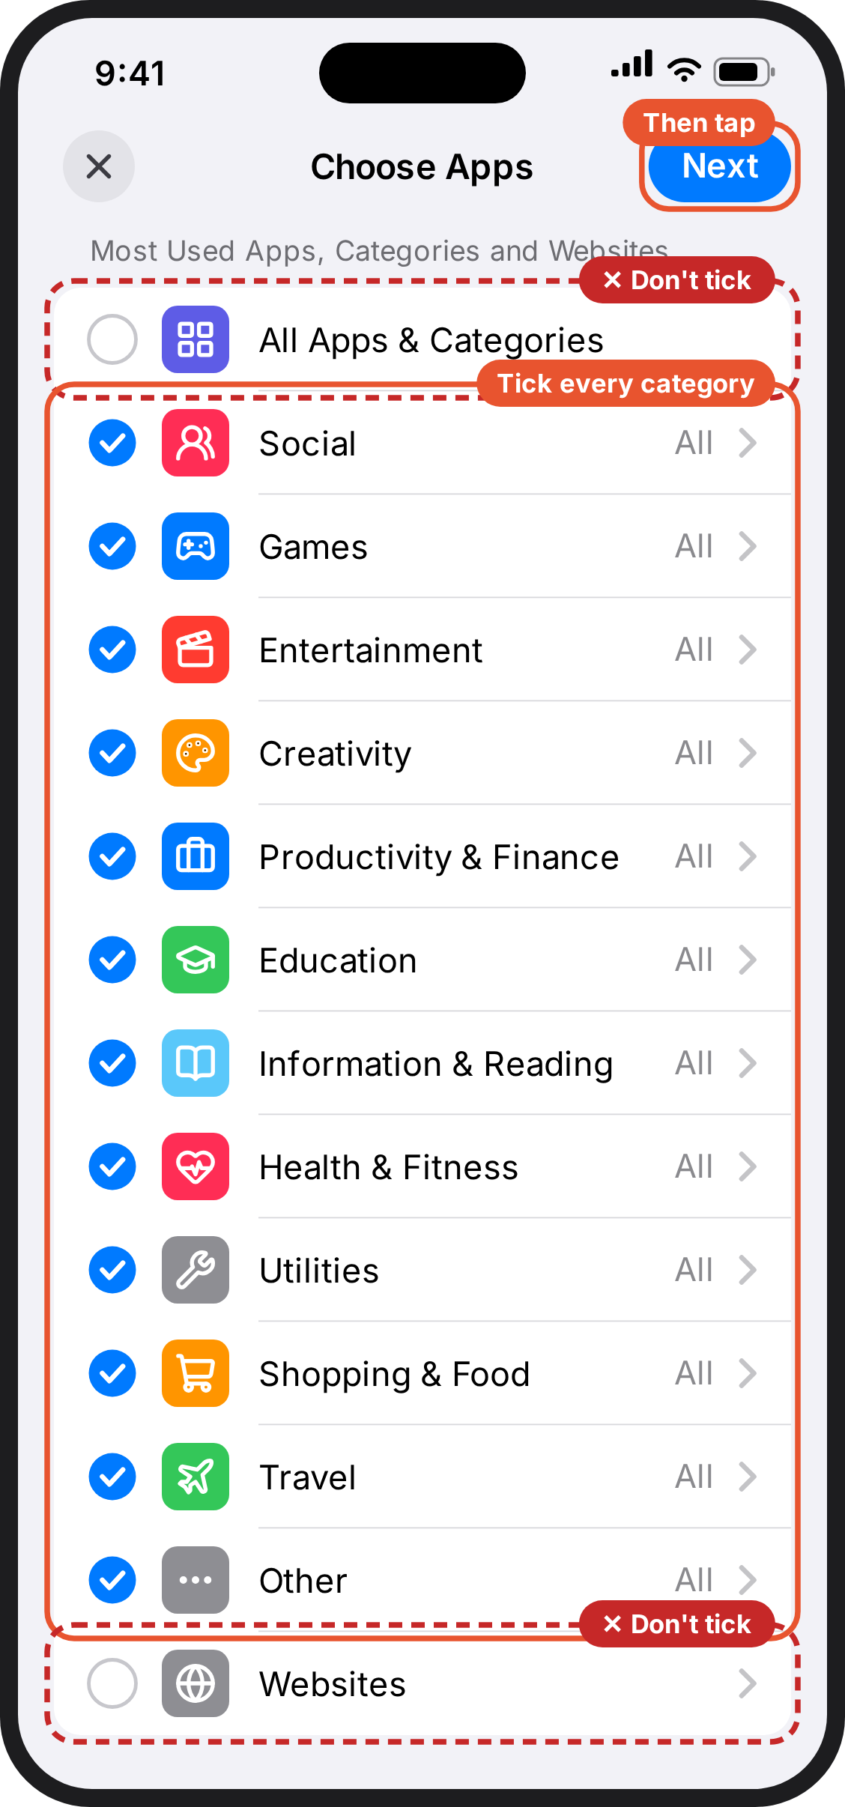  3. Your child's phone. Choose Apps. Every category from Social to Other is ticked. All Apps & Categories at the top and Websites at the bottom are not ticked. Next is at the top right.
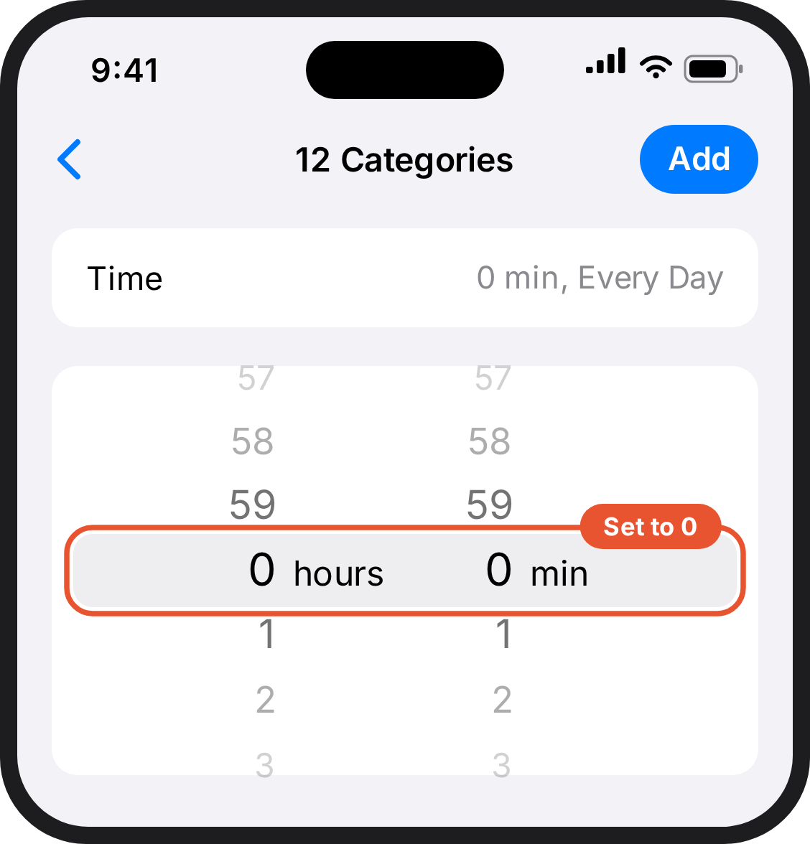  4. Your child's phone. A time picker, set to 0 hours and 0 minutes. | 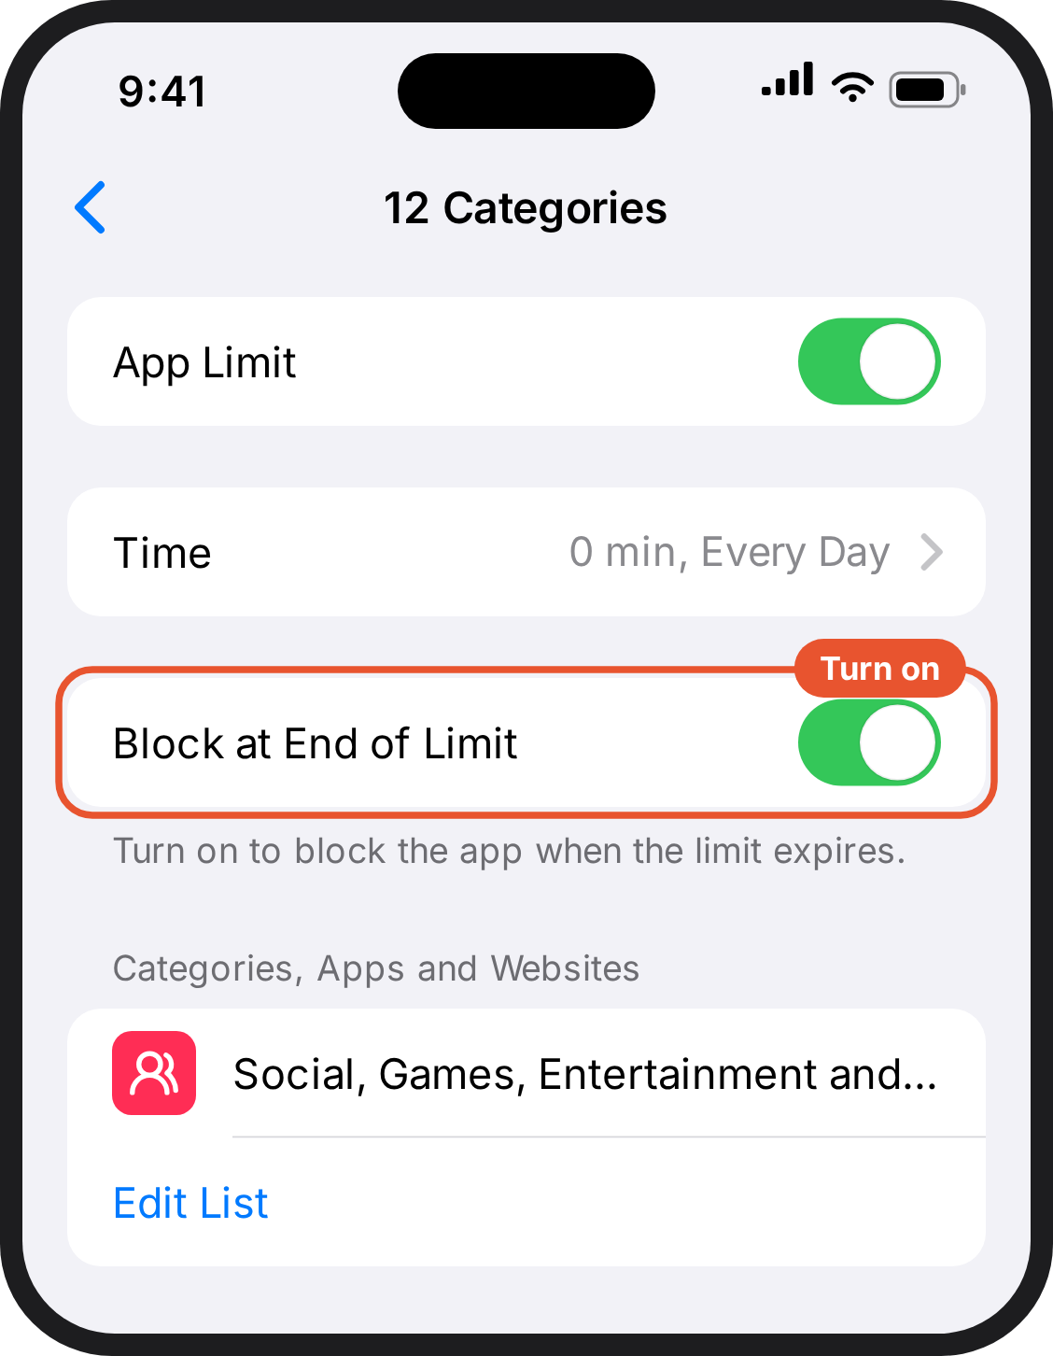  5. Your child's phone. The limit you just made. App Limit is on, Time is 0 minutes every day, and Block at End of Limit is switched on. | 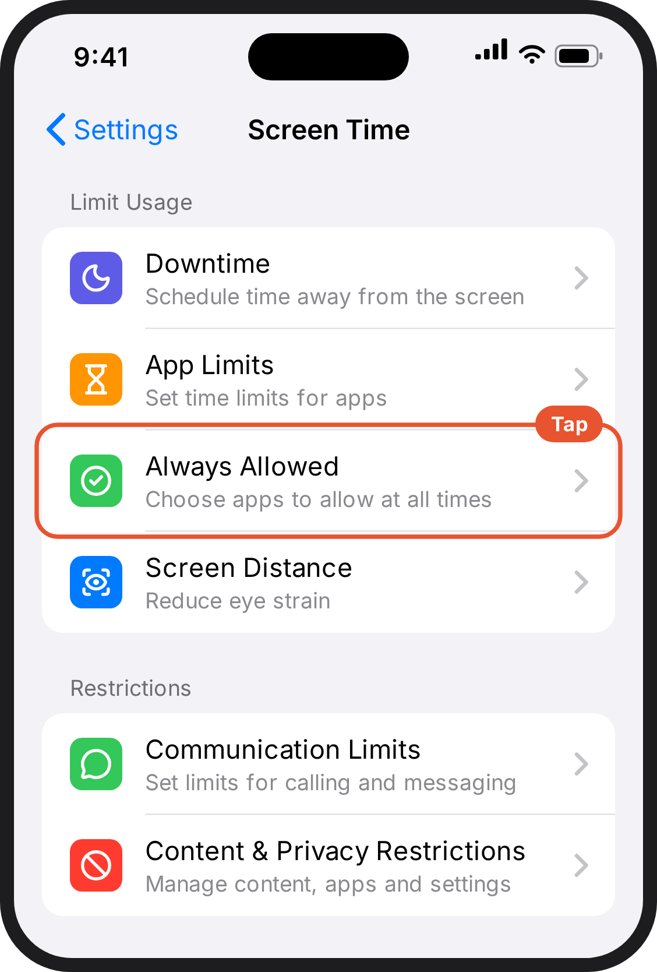  6. Your child's phone. The Screen Time page. Always Allowed is the third option under Limit Usage.
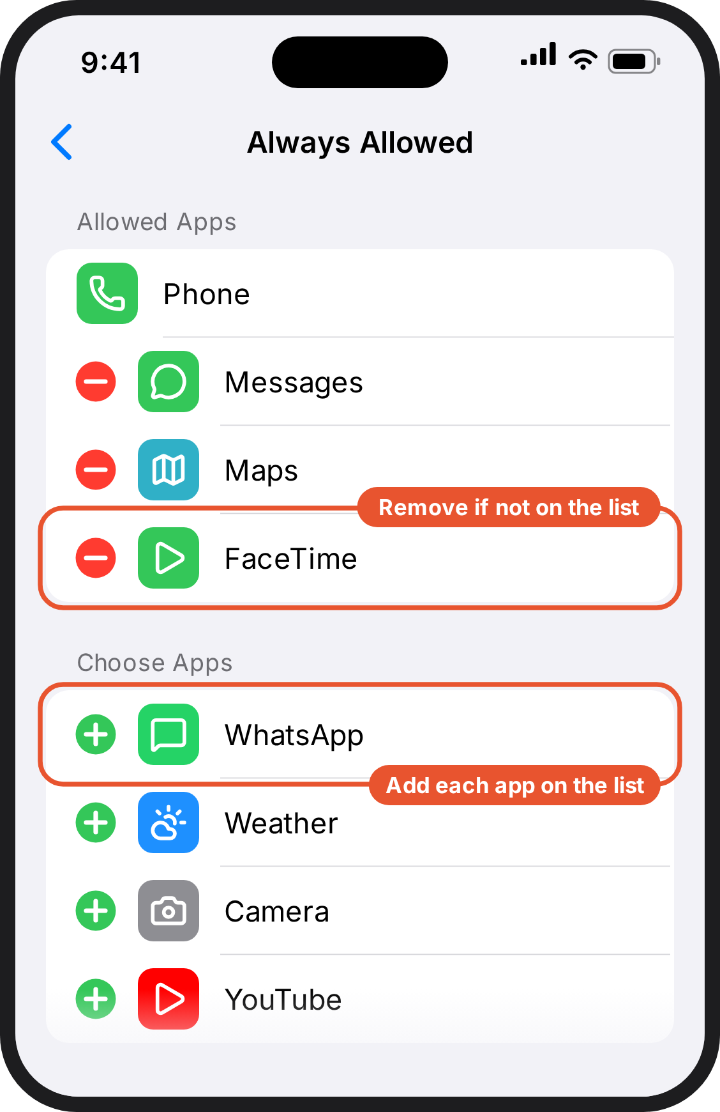
7. Your child's phone. Always Allowed. The top section lists the allowed apps, each with a red minus. The lower section lists other apps, each with a green plus.

iPhone: Allow only the websites they need
5 minutes · on your child's phone
Blocking an app doesn't block its website. This step makes the web work the same way as the apps: only what's on the list.
- Open Settings → Screen Time → Content & Privacy Restrictions and turn it on.
- Tap Allowed Apps & Features and make sure Safari is on.
- Go back, then tap App Store, Media, Web & Games → Web Content.
- Choose Only Approved Websites.
- Swipe left to delete anything on the starter list you don't want.
- Tap Add Website and enter each site from the list, exactly as written. A typo stops it working.
Check it works before you finish. Open Safari and load one of the approved sites: it should open. Then type in a site that isn't on the list, like youtube.com: it should be blocked. If the blocked site loads, stop and email smartphonestudy@public.io. Don't leave it as it is, because your child would have an unrestricted browser, where they could also reach the apps you just blocked.

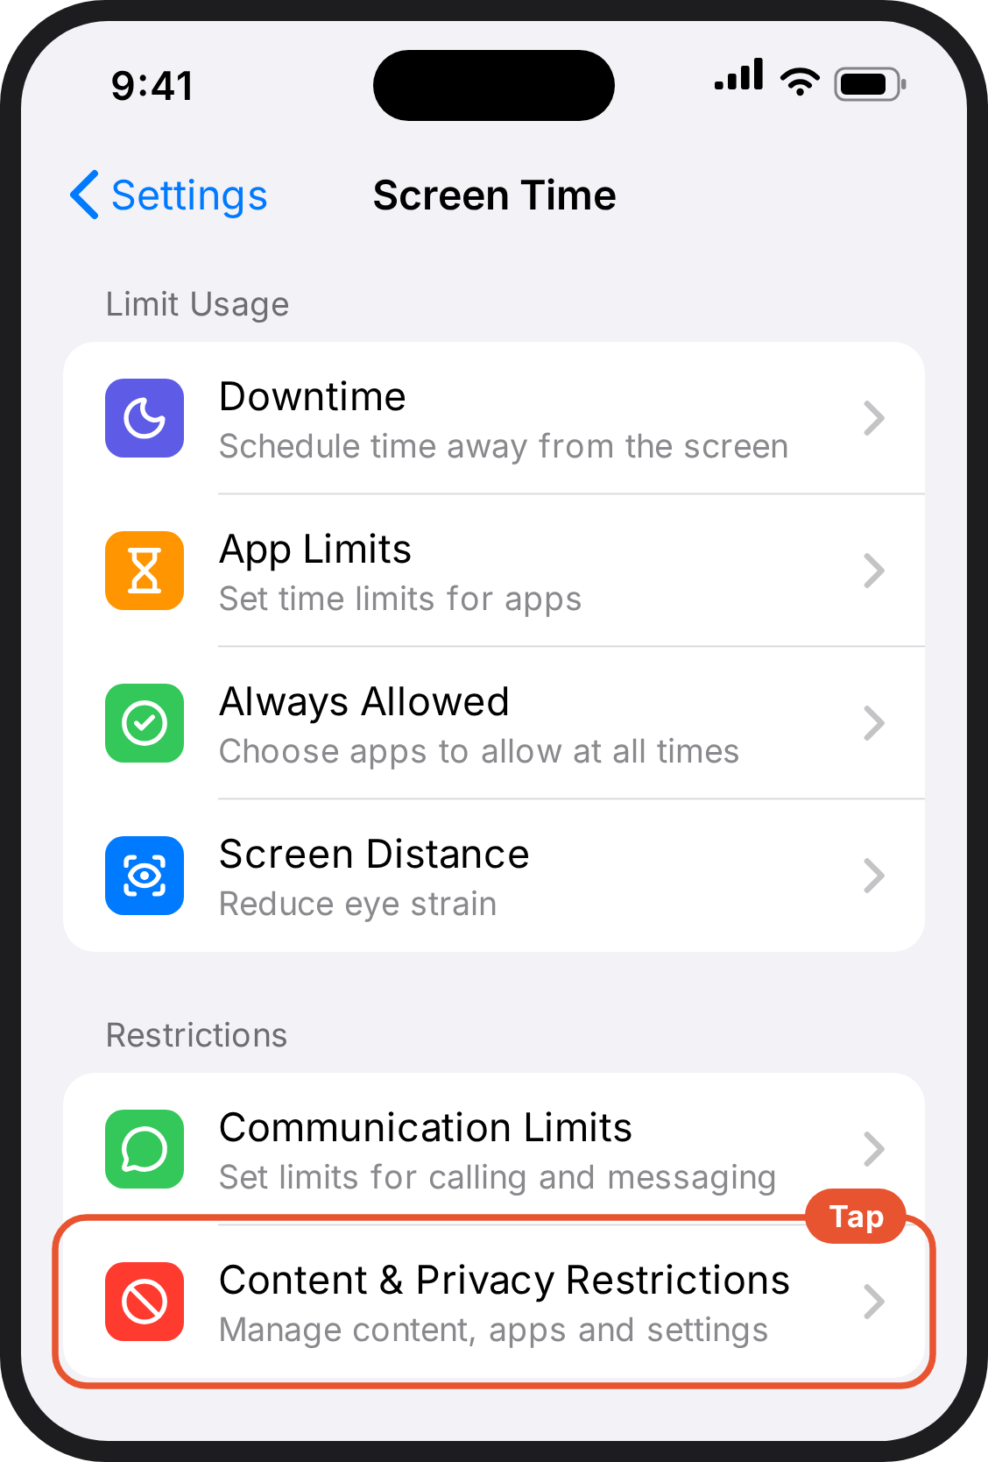  1. Your child's phone. The Screen Time page. Content & Privacy Restrictions is under Restrictions, lower down. | 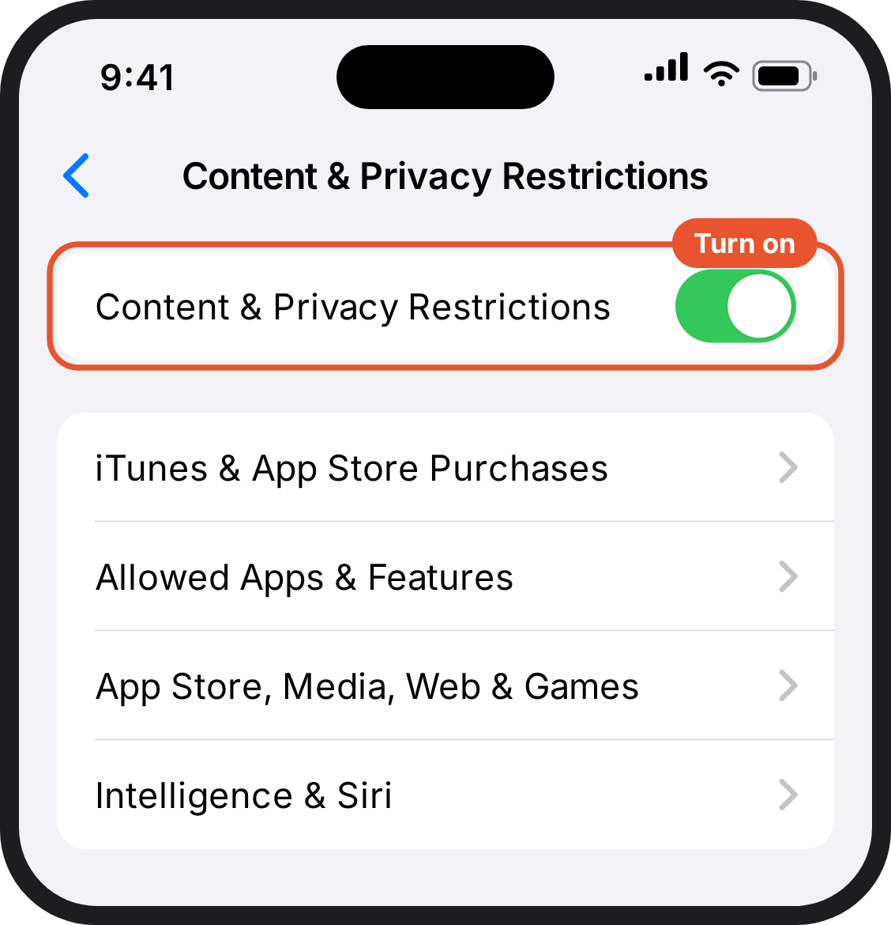  2. Your child's phone. Content & Privacy Restrictions, with the switch at the top turned on. | 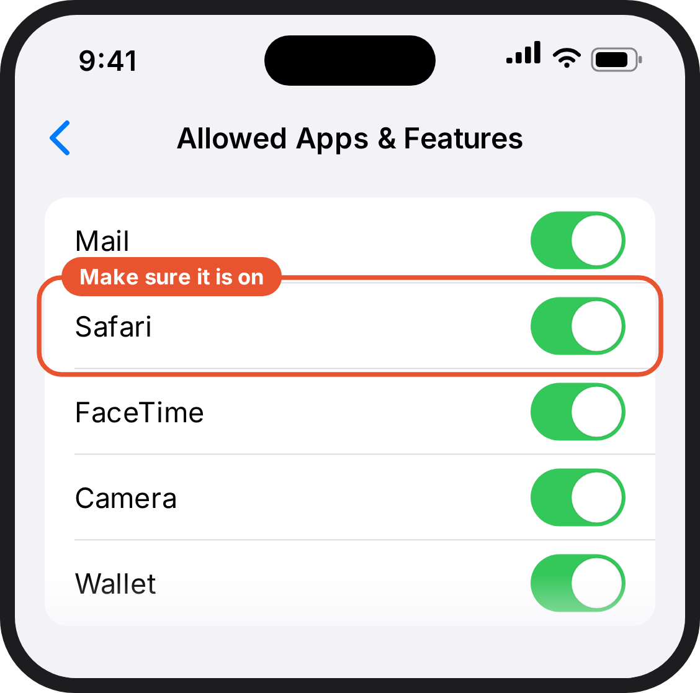  3. Your child's phone. Allowed Apps & Features. The switch next to Safari is on.
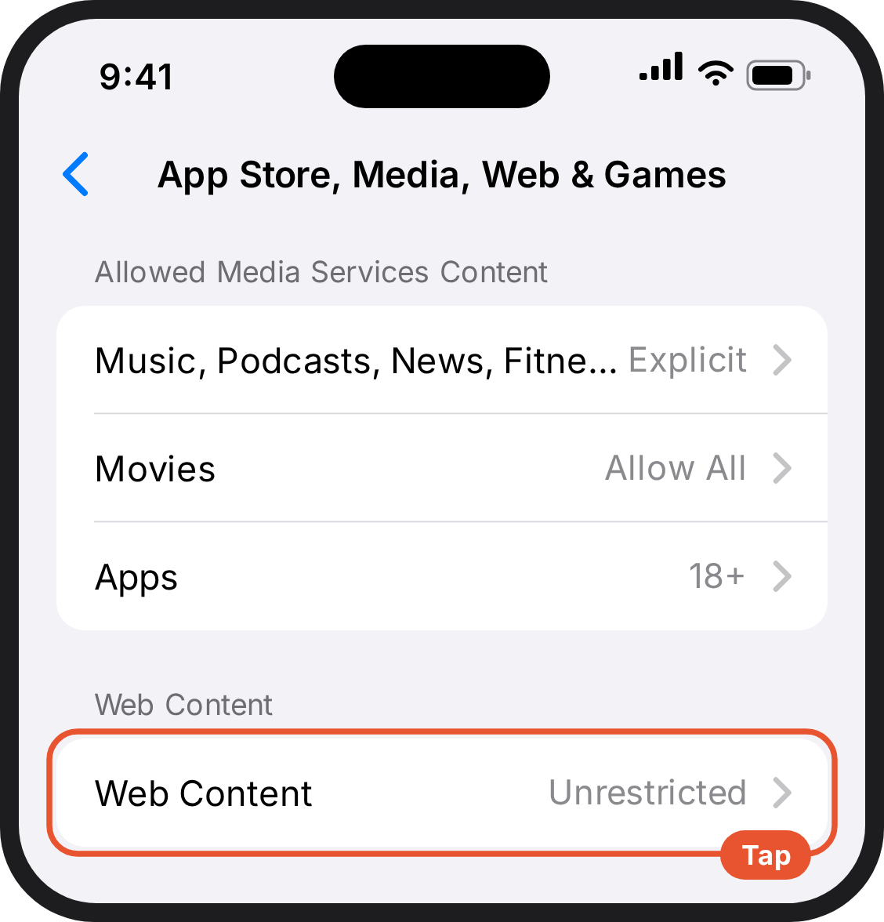  4. Your child's phone. App Store, Media, Web & Games. Web Content is near the bottom, set to Unrestricted. | 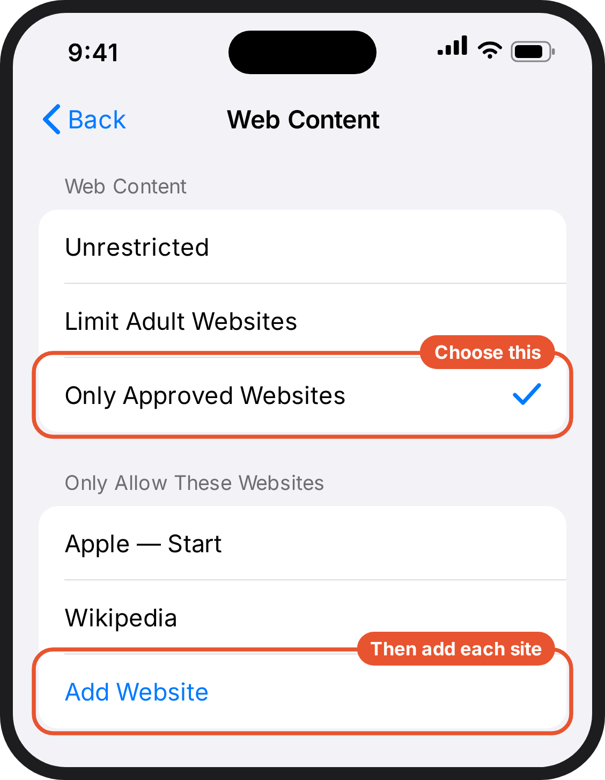  5. Your child's phone. Web Content set to Only Approved Websites, with a list of websites and an Add Website button. | 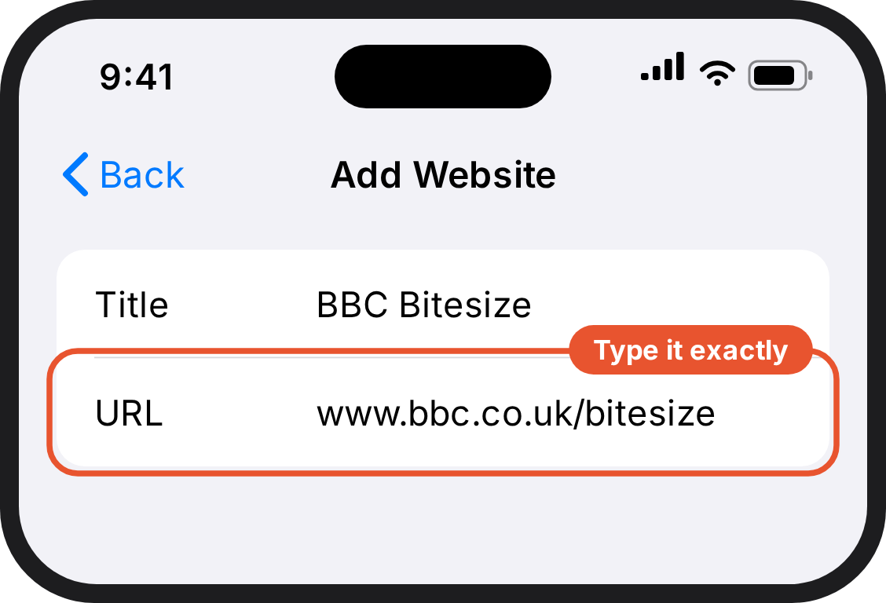  6. Your child's phone. Add Website, with a Title and a URL field.
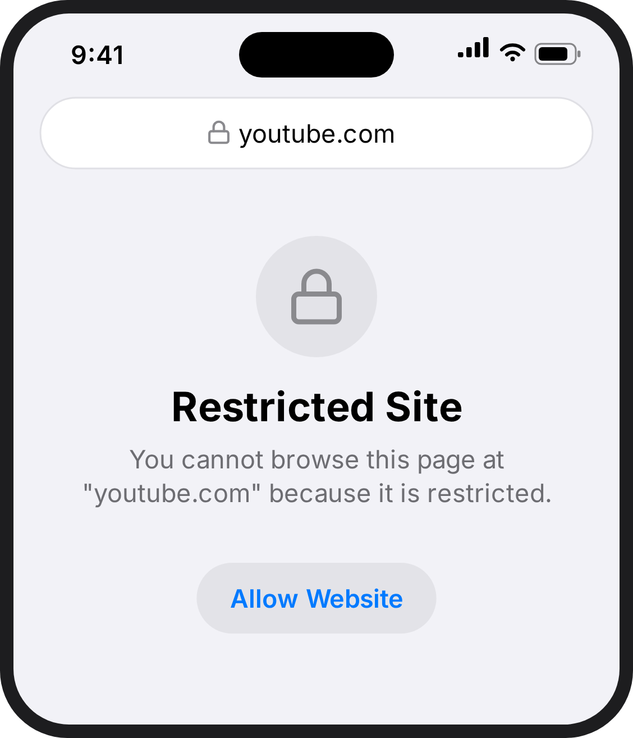
7. Your child's phone. Safari showing Restricted Site for youtube.com. This is what you want to see.

iPhone: Lock the settings
3 minutes · on your child's phone
- In Settings → Screen Time → Content & Privacy Restrictions (already on from the last step), tap iTunes & App Store Purchases.
- Set Installing Apps, Deleting Apps and In-app Purchases to Don't Allow.
- Go back and scroll down to Allow Changes. Set Passcode & Face ID and Accounts to Don't Allow.
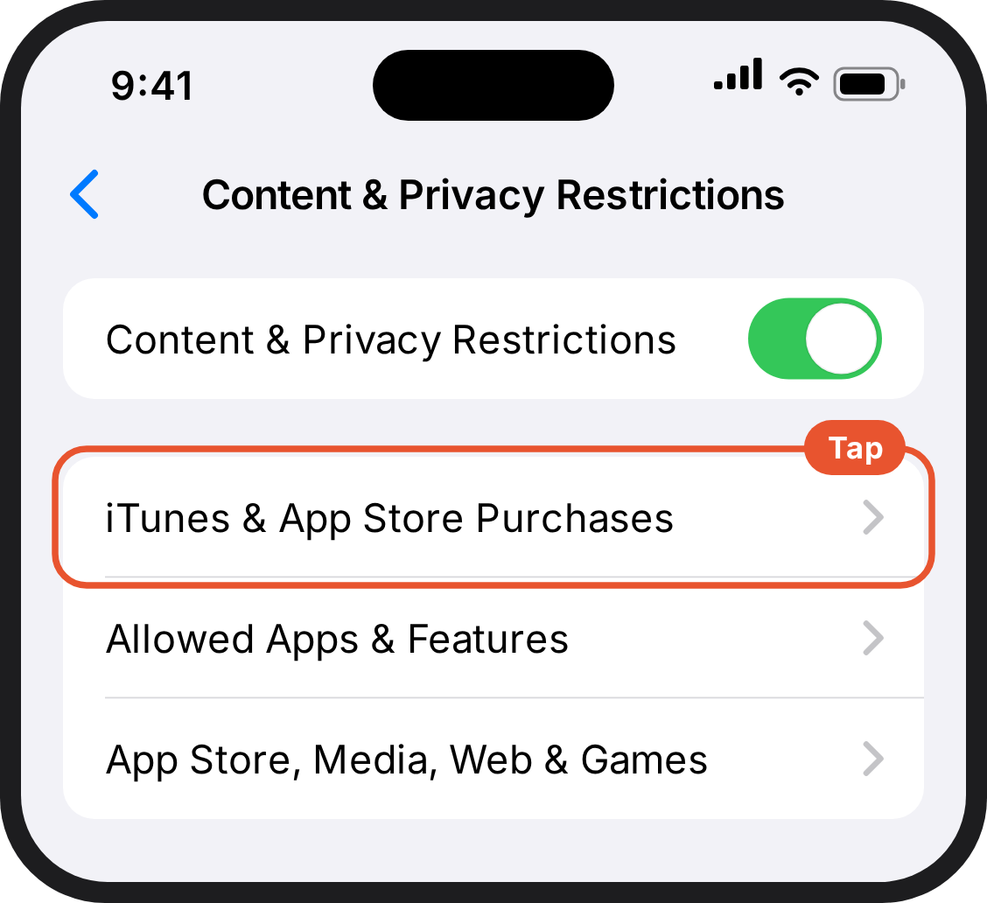  1. Your child's phone. Content & Privacy Restrictions. iTunes & App Store Purchases is the first option below the switch. | 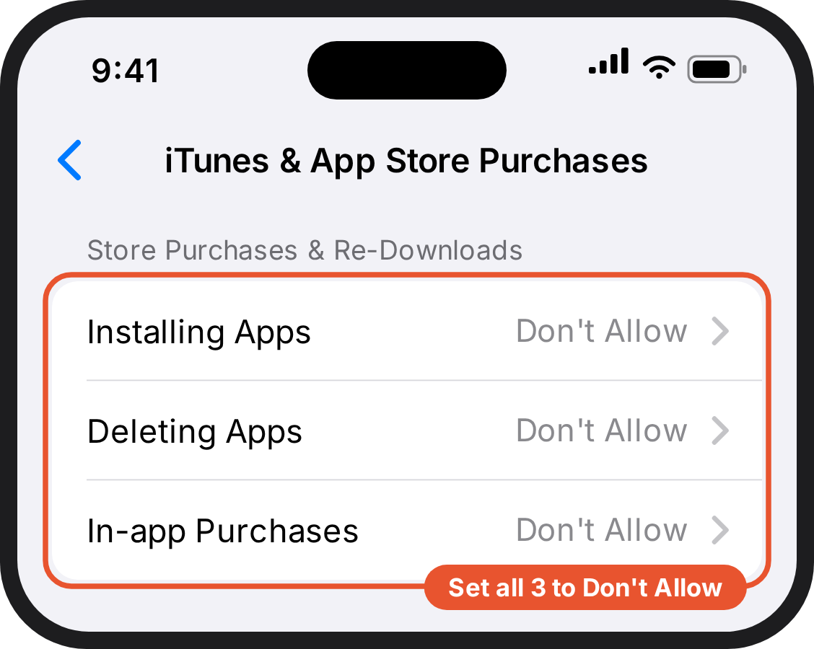  2. Your child's phone. iTunes & App Store Purchases, with Installing Apps, Deleting Apps and In-app Purchases all set to Don't Allow. | 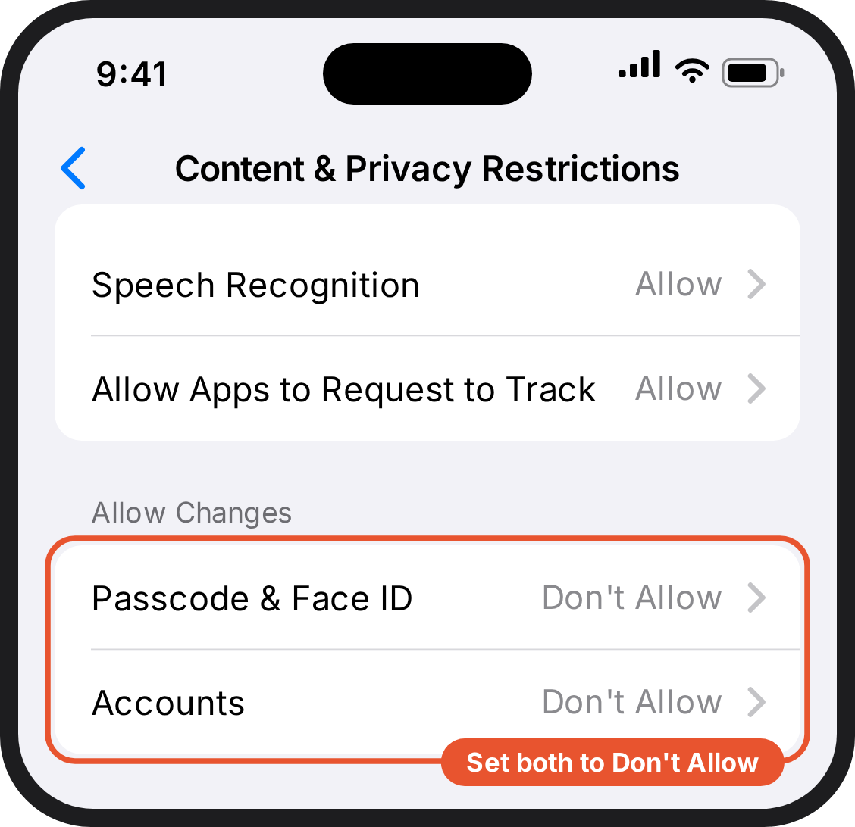  3. Your child's phone. Near the bottom of Content & Privacy Restrictions, under Allow Changes: Passcode & Face ID and Accounts, both set to Don't Allow.

Android with Family Link

Android with Family Link: Allow only the apps on the list
10 minutes · on your phone, in Family Link
- Open Family Link → your child → Controls → Screen time.
- Turn on Downtime (called School time in some versions).
- Tap Weekly schedule → choose a day → Start 12:00 AM, End 11:59 PM → Apply to all days of the week.
- Tap Allowed apps → turn on Unlimited apps → Select apps.
- Set each app on your list to Unlimited time.
To block one app outright rather than by schedule: Screen time → App limits → tap the app → turn Allowed off. Some system apps can't be blocked.
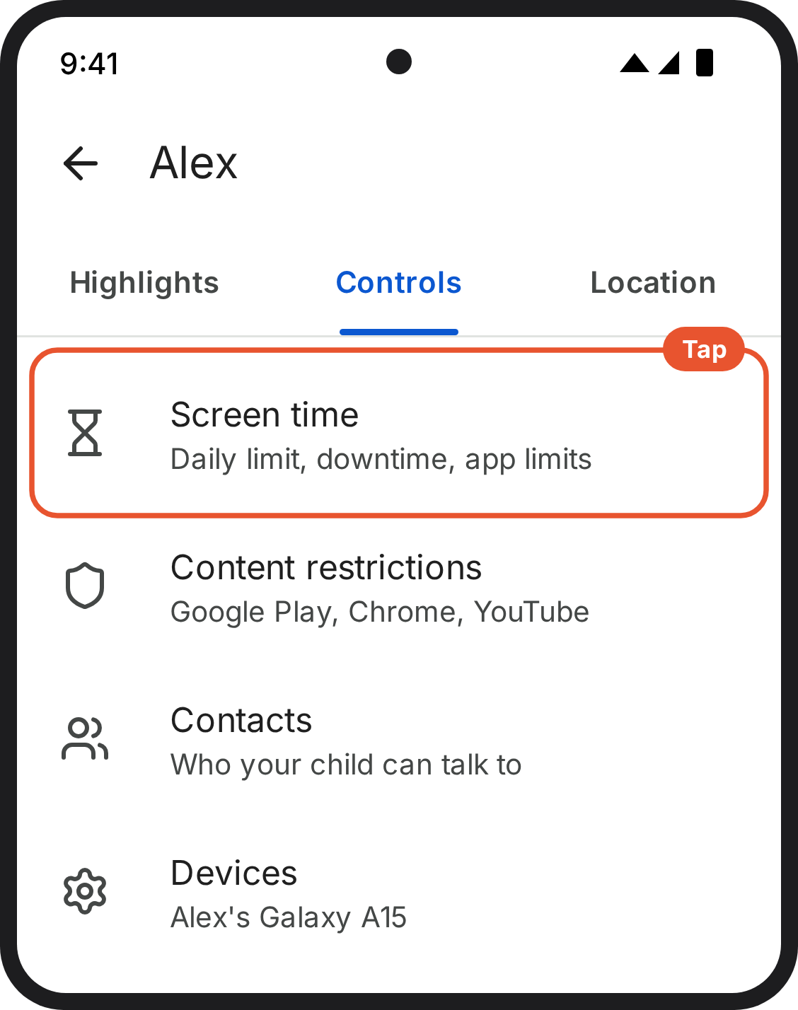  1. Your phone (Family Link). Family Link on your phone, open at your child. Controls is selected, and Screen time is the first option. Draft: check on a device. | 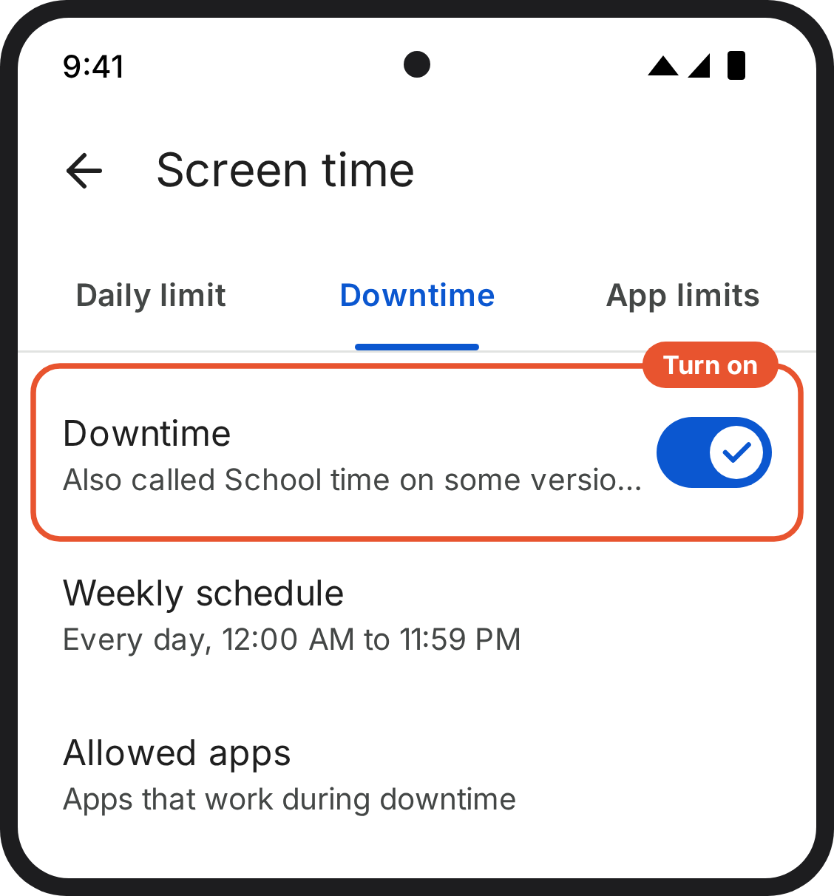  2. Your phone (Family Link). Screen time in Family Link, on the Downtime tab, with the Downtime switch turned on. Draft: check on a device. | 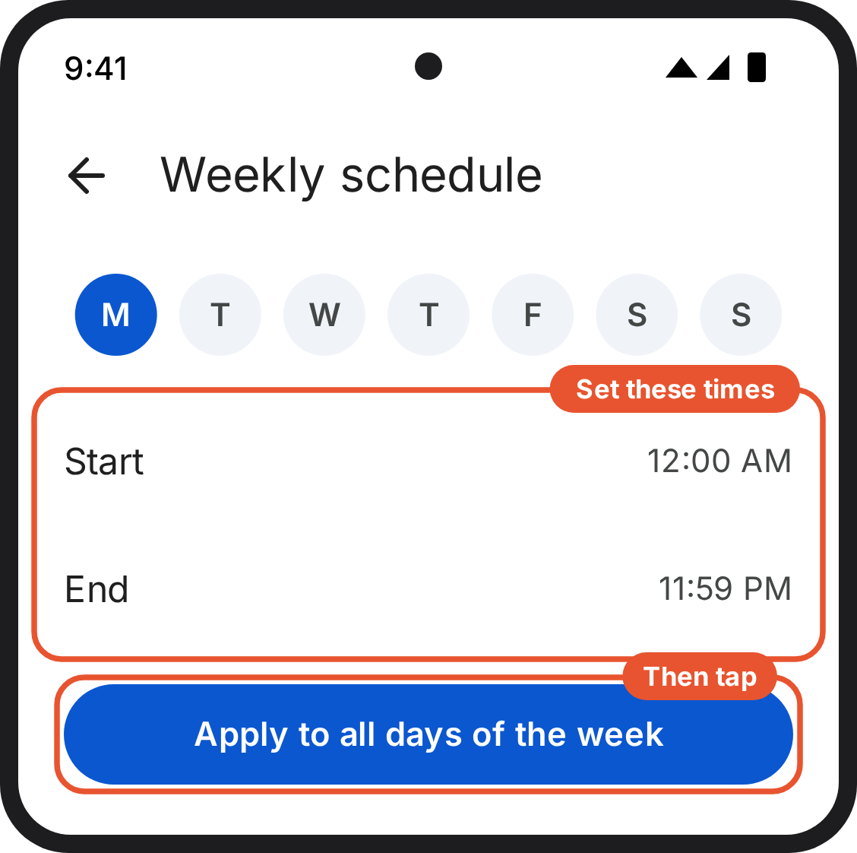  3. Your phone (Family Link). Downtime schedule: start 12:00 AM, end 11:59 PM, then Apply to all days of the week. Draft: check on a device.
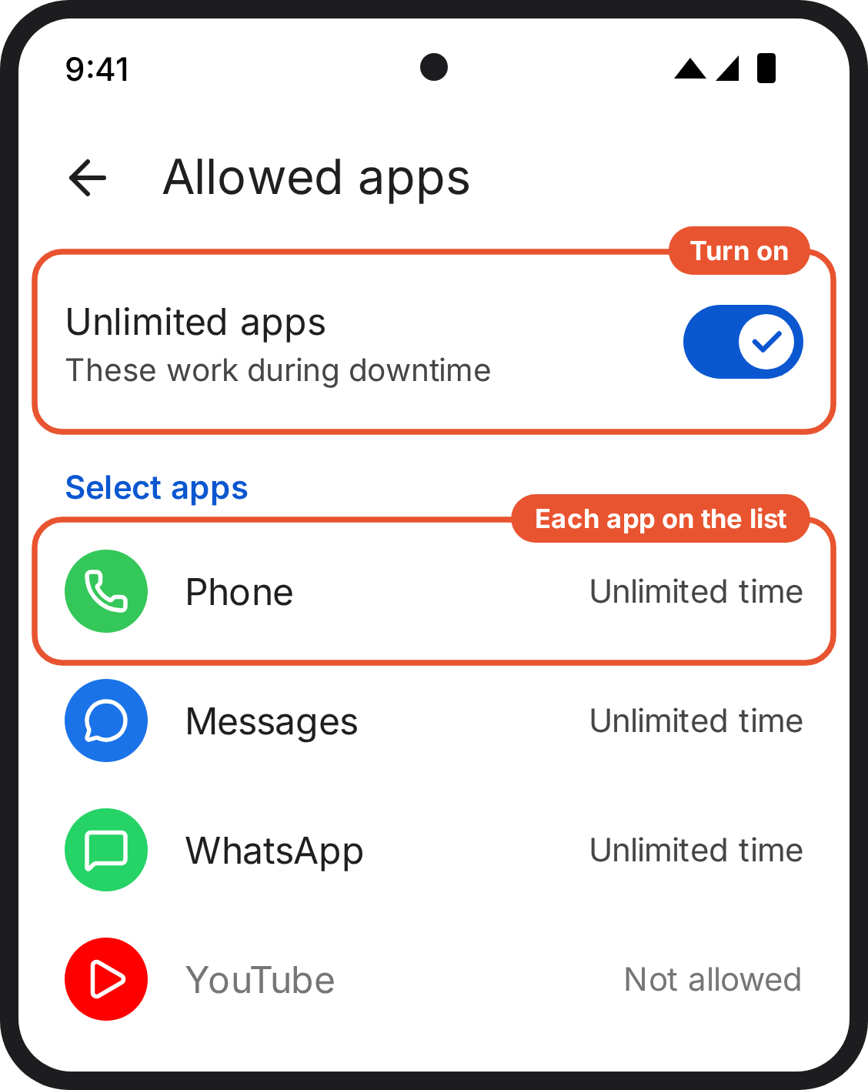
4. Your phone (Family Link). Allowed apps in Family Link. Each app on the list is set to Unlimited time. Draft: check on a device.

Android with Family Link: Allow only the websites they need
5 minutes · on your phone, in Family Link
Blocking an app doesn't block its website. This step makes the web work the same way as the apps: only what's on the list.
- In Family Link, go to Controls → Content restrictions → Google Chrome.
- Choose Only allow approved sites, then add the sites on the list under Approved sites.
- Block other browsers: Screen time → App limits → tap each browser → turn Allowed off.
If a homework site won't load, don't switch the filter off. Email smartphonestudy@public.io and we'll add it to the shared list.

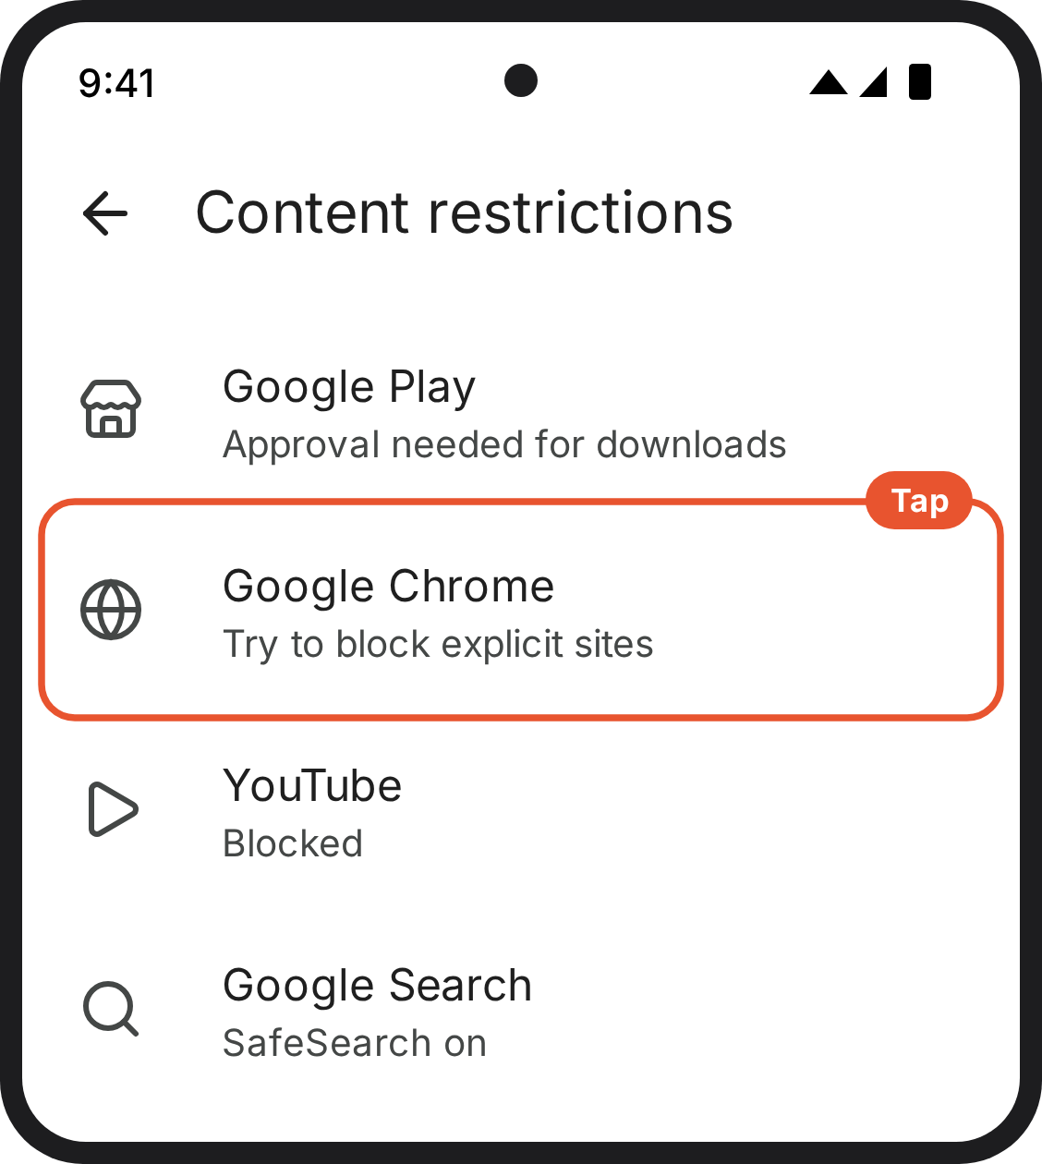  1. Your phone (Family Link). Content restrictions in Family Link, with Google Chrome highlighted. Draft: check on a device. | 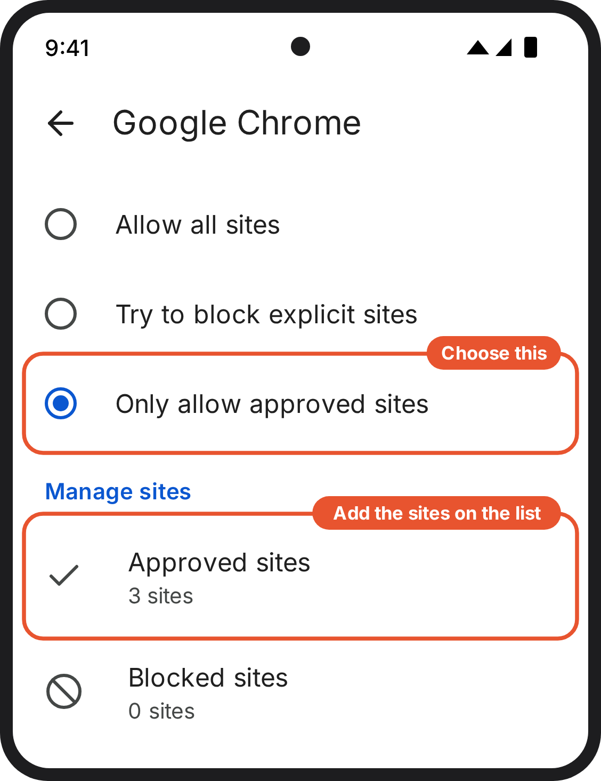  2. Your phone (Family Link). Google Chrome settings in Family Link, set to Only allow approved sites. Draft: check on a device. | 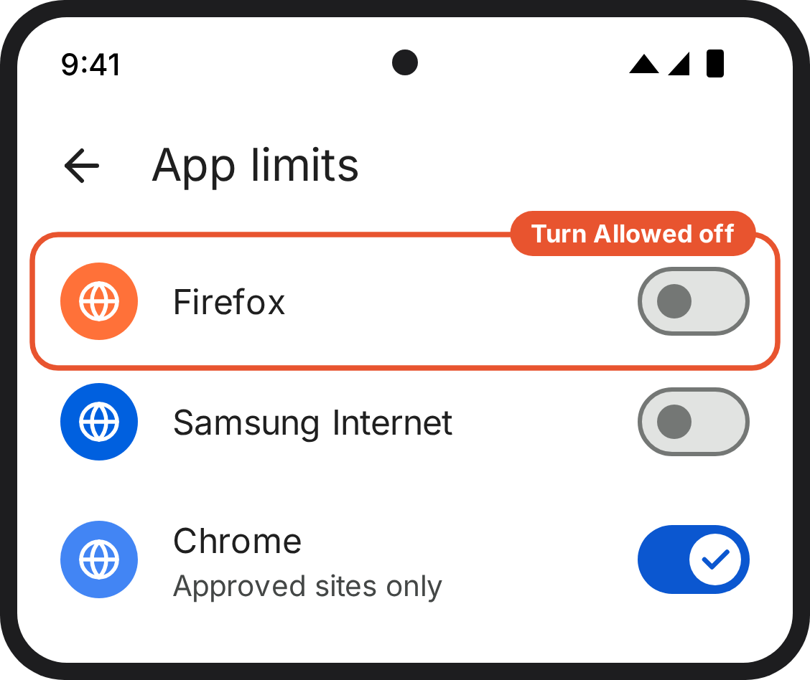  3. Your phone (Family Link). App limits in Family Link. Other browsers are switched off. Chrome stays on, limited to approved sites. Draft: check on a device.

Android with Family Link: Lock the settings
3 minutes · on your phone, in Family Link
- In Family Link, go to Controls → Content restrictions → Google Play.
- Under download approvals, choose All content, so nothing new can be installed without your approval.
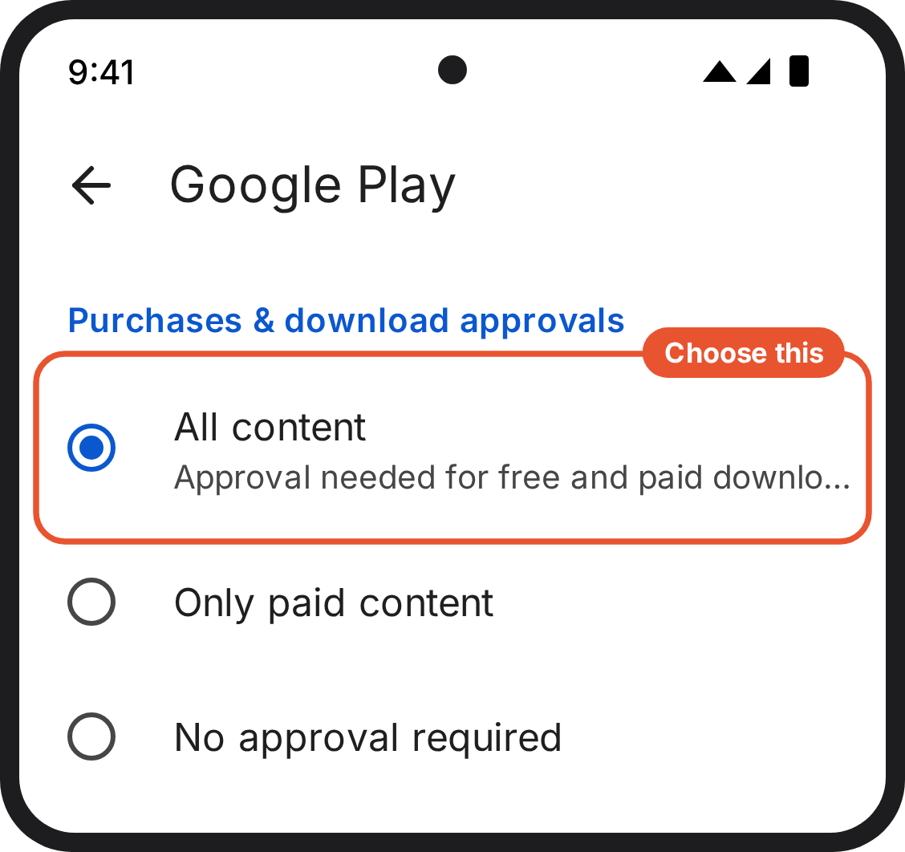
1. Your phone (Family Link). Google Play settings in Family Link, with approval needed for all content. Draft: check on a device.

Optional: time caps on apps on the list
This isn't part of what we're asking. Skip it if you're happy as things stand.
The list works by exempting apps from limits, so an app on the list will ignore a time limit you set on it, on both iPhone and Android. If you want a cap on one of them, email smartphonestudy@public.io and we'll sort out the set-up for your phone.

Review notes for the team (delete before sending)
Points found while checking the steps against the screenshots. Test each one on a real device before the pilot.
Area | Note
Labels (fixed) | The text said "Allowed Apps"; the screenshots show "Allowed Apps & Features". The text said "Account Changes and Passcode Changes"; the screenshots show "Accounts" and "Passcode & Face ID". The guide now uses the screenshot labels.
Safari after step "apps" | The category limits may also block Safari itself (it sits in one of the categories). If Safari won't open after the apps step, the websites step has nothing to work on. Test on a device. If Safari is blocked, add Safari to Always Allowed and say so in the guide.
0-minute limit | Your screenshots show 0 min saved, but the App Limits picker has historically had a 1-minute minimum. Confirm on the latest iOS that 0 holds. If the minimum is 1 minute, say so: the child gets 1 minute a day per category.
Route A, where to set it up | When a child is in Family Sharing, their Screen Time is usually managed from the parent's phone (Settings, Screen Time, the child's name), and the passcode recovery screen may not appear. Test whether steps 2 to 5 of Route A should happen on the parent's phone instead. That would also make Route A simpler.
Android wording | Family Link names ("Schedules", "Unlimited apps", "Unlimited time", "Let's do this", "All services") change often, and there were no Android screenshots to check against. The Android screens are drawn from the text and marked as drafts. They need checking on a test phone.
Support email | The guidance uses lucas.pollock@public.io; the tech spec and microsite use smartphonestudy@public.io. The guide now uses smartphonestudy@public.io. Confirm which one.
Time | "Sit down with it for twenty minutes tonight" contradicted "about 25 to 30 minutes". The guide now says half an hour.
"Almost none of this can be done from your own phone" | That isn't true for Routes A and C, where much of it is done from the parent's phone. Reworded to "You'll need it for part of this".
Child account age | The Apple screen says child accounts are for children "13 or younger" in some regions and "12 or younger" in the UK. The drawing uses 12. Check on a UK device.
Software versions | All iPhone screens follow your screenshots (iOS 18 and 26). iOS 27 changes parental controls. Check every screen on the version families will have in April 2027.

