TECHNICAL REPORT
DESIGN AND IMPLEMENTATION OF
THE HYBRID FTP APPLICATION
Reliable File Transfer over TCP Control and UDP Data Channels
Project Information | Details
Course | Internetworking Protocol
Group | [GROUP NUMBER]
Member A | [FULL NAME - STUDENT ID]
Member B | [FULL NAME - STUDENT ID]
Repository | https://github.com/lmqui23/hybrid-ftp-system
Submission Date | [DD MONTH YYYY]

Implementation language: Python 3 | Transport APIs: native socket library

Executive Summary
This report presents a Hybrid FTP client-server application that separates the control plane from the data plane. FTP commands, replies, authentication state, transfer identifiers, file sizes, and SHA-256 digests travel over TCP. Actual file payloads travel over UDP through a custom Stop-and-Wait reliable data transfer (RDT) protocol implemented from first principles.
The RDT layer provides sequence numbers, acknowledgements, CRC32 corruption detection, timeout-based retransmission, duplicate elimination, cancellation, temporary-file safety, and end-to-end SHA-256 verification. A sender window of one packet bounds in-flight data and prevents network flooding. The application supports binary transfers, Active and Passive modes, multiple concurrent TCP sessions, directory operations, and standard three-digit FTP replies.
Verification includes eight automated protocol/RDT tests and live end-to-end demonstrations of Passive upload, Active upload, Active download, directory listing, append, unique upload, and cross-host hash equality.

Document Map
Section | Purpose
1 | Application scenario and TCP/UDP protocol interaction
2 | Project-wide data structures and wire formats
3 | Functional workflows and state machines
4 | Task assignment matrix
5 | Self-assessment and peer evaluation
6 | GenAI usage and code refinement log
7 | Application demo evidence

1. Application Scenario and Protocol Interaction

1.1 System Objective
The application mirrors the architectural principle of RFC 959 by using a persistent TCP control connection and separate, short-lived UDP data sockets. TCP preserves command ordering and session state. UDP carries all file and listing payloads, while the custom RDT layer restores the reliability properties required for correct file transfer.

1.2 Component Architecture
Component | Primary responsibility | Representative modules
TCP Client | CLI, FTP commands, reply parsing, PASV/PORT negotiation | client/tcp_client/control_client.py
TCP Server | Authentication, command dispatch, path validation, session threads | server/tcp_control/tcp_server.py
FTP Adapter | Maps FTP transfers to RDT sender/receiver calls | common/ftp_shared.py
RDT | Stop-and-Wait states, ACKs, timeout, retransmission, cancellation | rdt/sender.py; rdt/receiver.py
Protocol | 32-byte header, encoding, CRC32, SHA-256 | protocol/packet.py; protocol/codec.py

1.3 Full Download Lifecycle
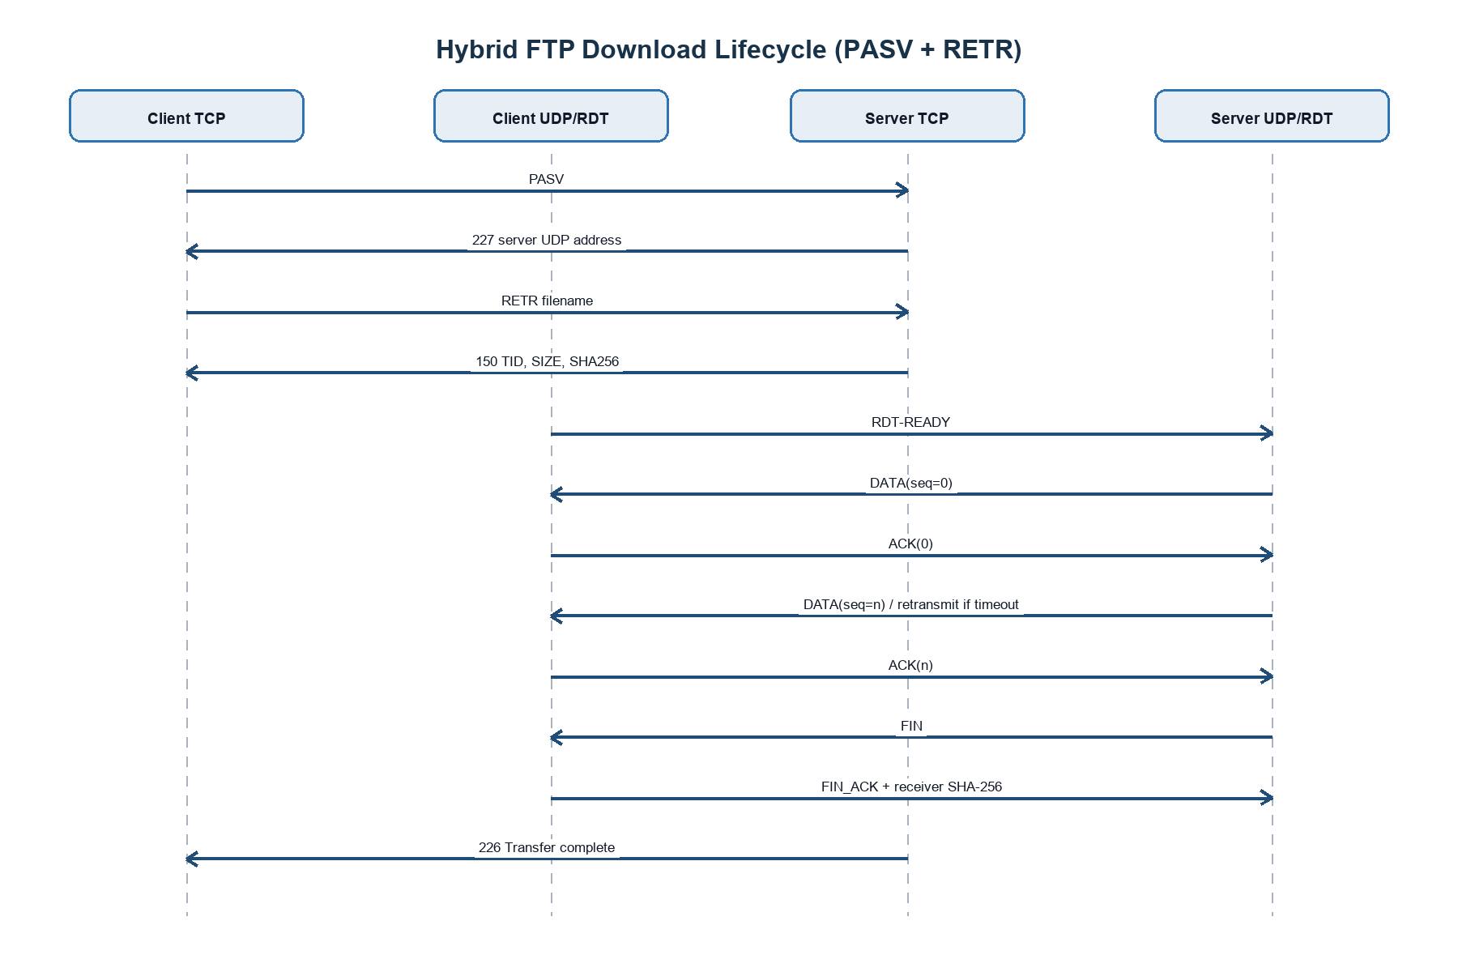
Figure 1. TCP control and UDP RDT interaction for a Passive-mode download.
The 150 reply is the synchronization boundary. It carries the transfer ID, exact size, and expected hash before either RDT endpoint processes file payload. The server issues 226 only after the sender receives FIN_ACK and verifies that the receiver-calculated hash equals the source hash.

1.4 Control and Data Separation
TCP control channel | UDP data channel
USER/PASS and session commands | DATA packet payload
PASV/PORT negotiation | ACK and retransmitted DATA
Transfer ID, size, SHA-256 | FIN, FIN_ACK, CANCEL
150/226/425/426 replies | CRC32-protected RDT datagrams

2. Project-Wide Data Structures

2.1 TCP Command and Reply Format
Commands and replies are UTF-8 text terminated by CRLF. The base command grammar is:
COMMAND [argument] CRLF
REPLY_CODE SP message CRLF

For a data transfer, the preliminary reply extends the message with machine-readable metadata:
150 TID=<uint64> SIZE=<bytes> SHA256=<64-hex-characters> [FILE=<name>] CRLF

For uploads, the current client appends SIZE and SHA256 fields to STOR, APPE, or STOU over TCP. No file payload or RDT metadata packet is sent through UDP.

2.2 UDP Custom Header
All multibyte fields use network byte order. The fixed header is 32 bytes, followed by zero to 1,024 payload bytes.
Offset | Bytes | Field | Purpose
0 | 4 | Magic | 0x52445431 (ASCII RDT1) identifies the protocol
4 | 1 | Version | Wire-format compatibility; current value 1
5 | 1 | Flags | DATA, ACK, FIN, FIN_ACK, ERROR, CANCEL
6 | 2 | Header size | Constant 32 bytes
8 | 8 | Transfer ID | Separates concurrent or stale transfers
16 | 4 | Sequence number | Orders DATA and FIN packets
20 | 4 | ACK number | Identifies the acknowledged sequence
24 | 2 | Advertised window | Fixed at one for Stop-and-Wait flow control
26 | 2 | Payload length | Exact payload bytes in this datagram
28 | 4 | CRC32 | Detects header or payload corruption

The CRC32 is computed over the complete header with its checksum field set to zero, concatenated with the payload. A receiver discards a datagram when its calculated CRC32 differs from the transmitted value.

2.3 Packet Flags and Semantics
Flag | Direction | Meaning
DATA | Sender -> Receiver | Carries one ordered file chunk
ACK | Receiver -> Sender | Confirms one DATA sequence number
FIN | Sender -> Receiver | Marks the end of the stream
FIN_ACK | Receiver -> Sender | Confirms FIN and returns receiver SHA-256
CANCEL | Either direction | Cooperatively aborts the active transfer
ERROR | Reserved | Protocol-level error signalling for extension

2.4 Session and Transfer Structures
Structure | Important fields | Role
FTPSession | authentication, root/current directory, mode, UDP target, active context | Maintains one client's TCP and data-channel state
TransferContext | transfer_id, state, config, cancel_event, statistics | Owns one independent RDT operation
RDTConfig | payload_size, RTO, idle timeout, retry limit, poll interval | Controls reliability and timing
TransferStatistics | bytes, packets, ACKs, retransmissions, duplicates, corruption, duration | Supports progress, evaluation, and debugging
RDTPacket | flags, IDs, sequence/ACK numbers, window, payload, checksum | In-memory representation of a UDP datagram

3. Functional Workflows

3.1 Server Thread Dispatch
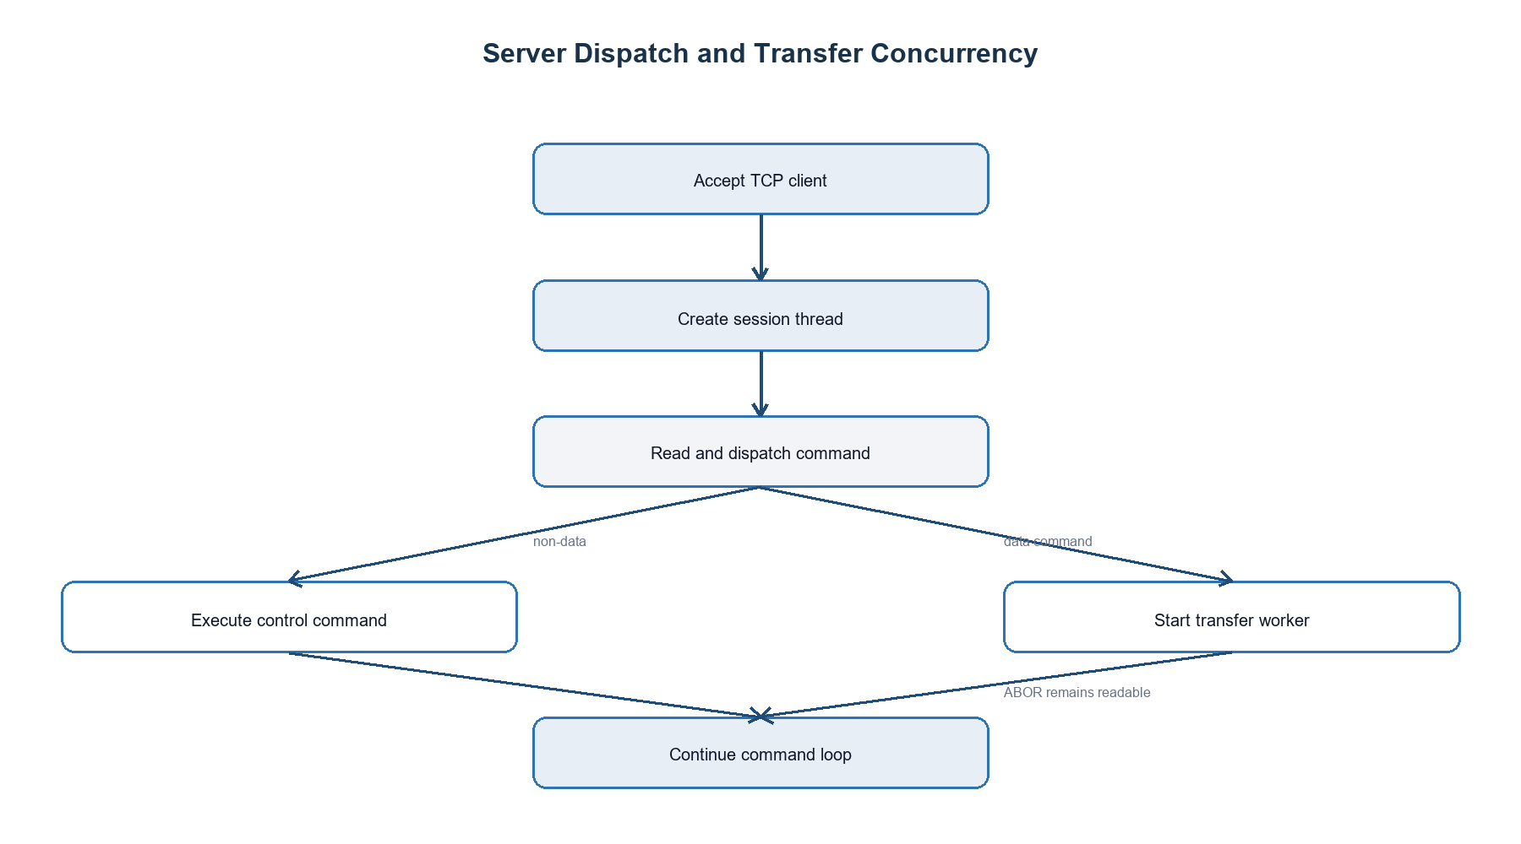
Figure 2. Per-client TCP session and independent data-transfer worker.
Each accepted TCP client receives an isolated FTPSession and daemon thread. Data commands start a second worker so the control thread can continue receiving ABOR, NOOP, or QUIT. While a transfer is active, unrelated commands receive a transient failure response.

3.2 Stop-and-Wait Sender State Machine
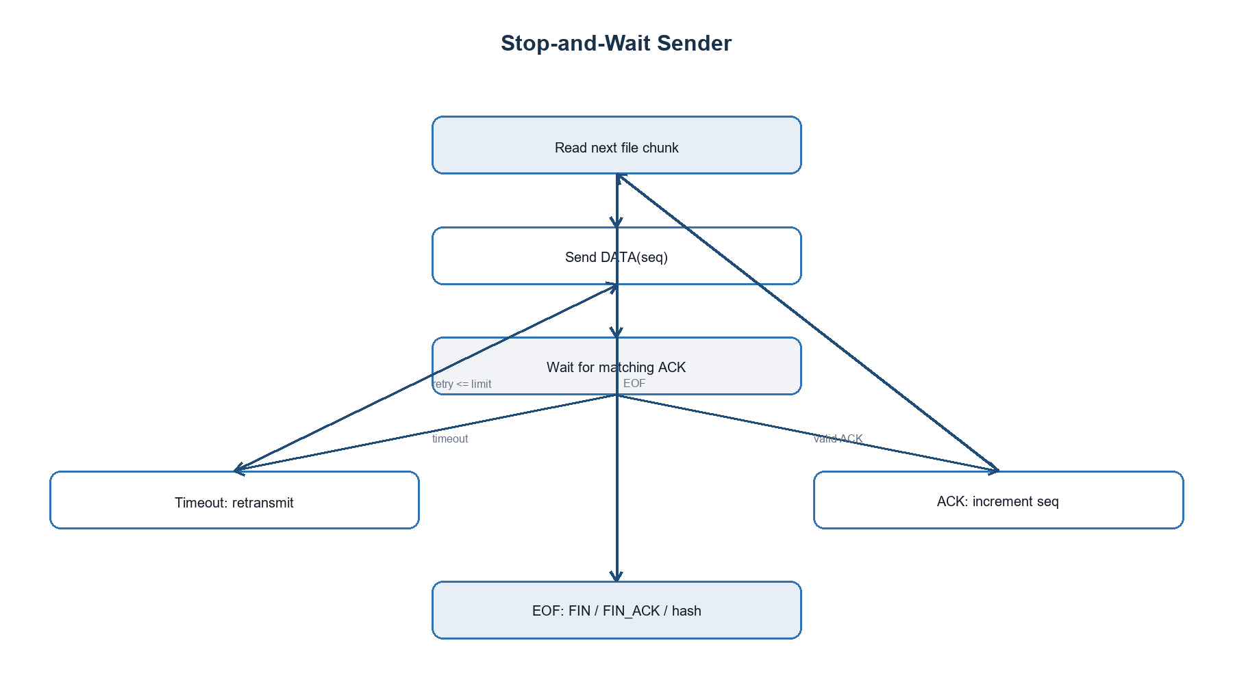
Figure 3. Sender state transitions.
At most one DATA packet is unacknowledged. This fixed one-packet window is an equivalent flow-control mechanism that prevents flooding, although it trades throughput for simplicity on high-delay links.

3.3 Stop-and-Wait Receiver State Machine
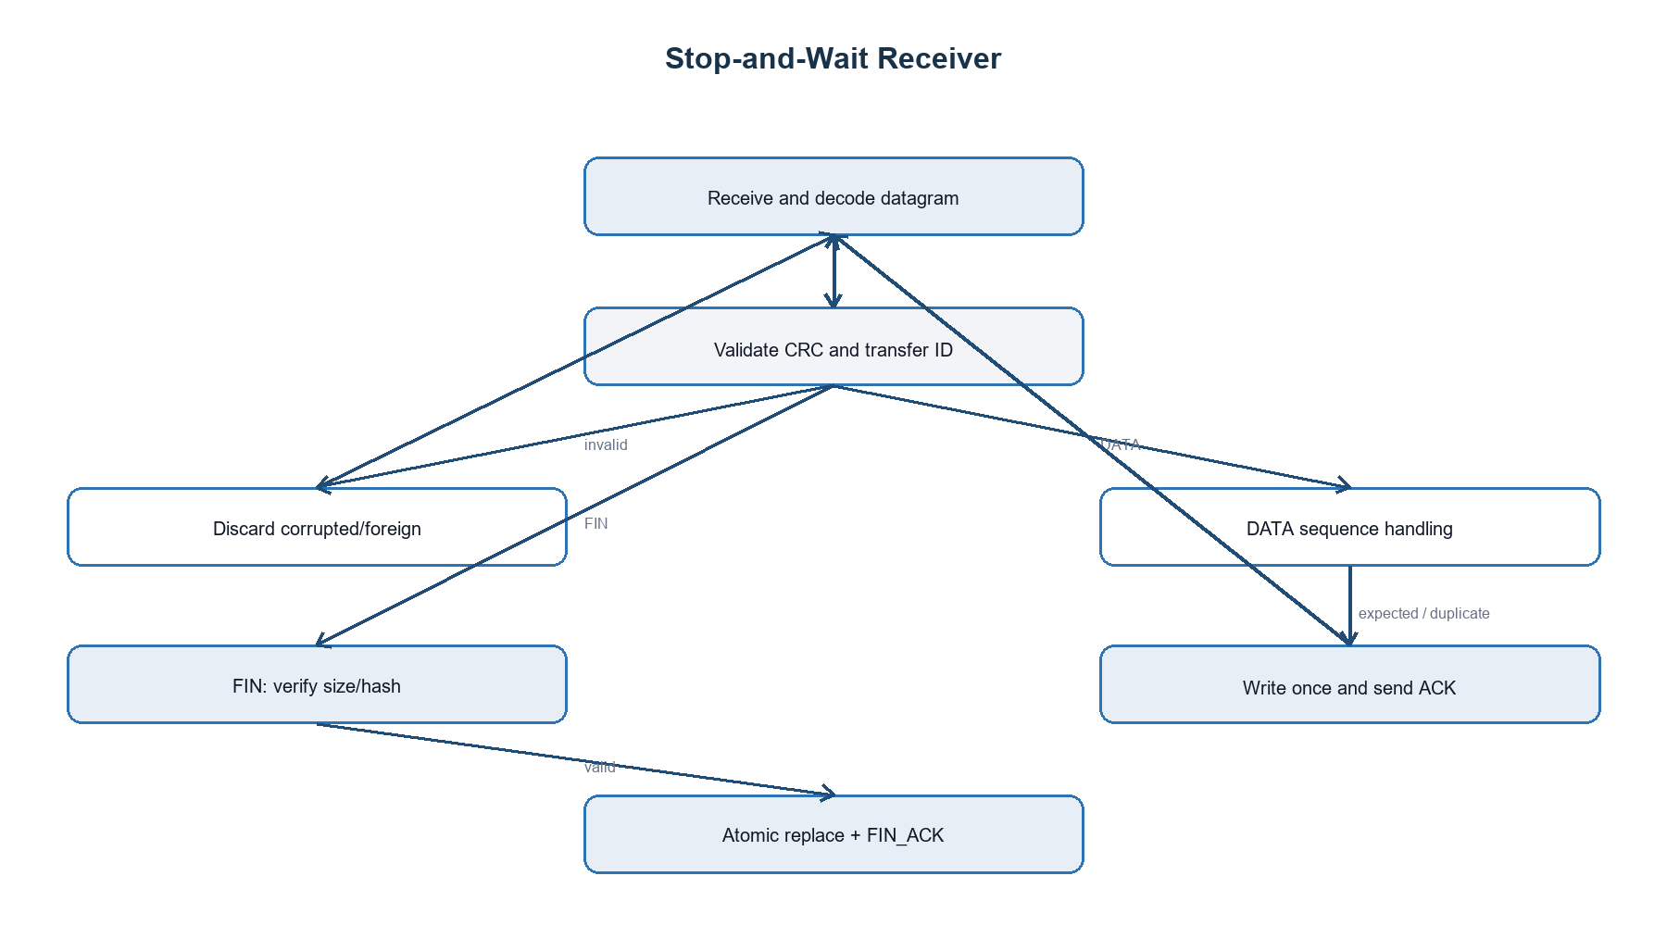
Figure 4. Receiver validation, duplicate handling, and safe commit.

3.4 Active and Passive Mode
Aspect | Passive mode (PASV) | Active mode (PORT)
UDP listener | Server binds an ephemeral UDP port | Client binds an ephemeral UDP port
TCP negotiation | Server returns 227 with IP and port | Client sends its IP and port
Peer discovery | Client sends RDT-READY when server sends | Server sends RDT-READY when client sends
Typical network behavior | More NAT/firewall friendly | Demonstrates server-initiated data contact
Socket lifetime | One transfer | One transfer

3.5 Upload, Download, Listing, and Cancellation
- RETR: server is the RDT sender; client is the receiver.
- STOR/APPE/STOU: client is the sender; server is the receiver.
- LIST/NLST: server serializes the listing to bytes and sends it through the same verified RDT path.
- ABOR: the TCP handler sets the active context's cancellation event; the RDT endpoint emits CANCEL and removes incomplete temporary data.
- APPE: the verified uploaded object is appended only after RDT reception succeeds.

4. Task Assignment Matrix
Replace the bracketed identity fields before submission. The ownership split below reflects the repository architecture and should be adjusted only if the actual work history differs.
Engineering component | Owner | Collaborator | Evidence / modules
TCP control server and FTP reply handling | Member A | Member B review | server/tcp_control/tcp_server.py
Client CLI and command dispatch | Member A | Member B review | client/tcp_client/control_client.py
Authentication and filesystem operations | Member A | - | server/tcp_control/file_system.py
Active/Passive session setup | Member A | Member B integration support | common/ftp_shared.py
UDP packet header and codec | Member B | Member A review | protocol/
Stop-and-Wait sender and receiver | Member B | Member A integration support | rdt/sender.py; rdt/receiver.py
CRC32 and SHA-256 verification | Member B | Member A TCP metadata | protocol/crc32.py; protocol/file_hash.py
Fault injection and automated RDT tests | Member B | - | rdt/fault_injector.py; tests/
End-to-end integration and demo | Both | Both | common/ftp_shared.py and live logs
Technical report and presentation | Both | Both | This document and presentation materials

5. Self-Assessment and Peer Evaluation

5.1 Member A Self-Assessment
[MEMBER A NAME] should describe the implemented TCP command engine, session isolation, filesystem safety, Active/Passive negotiation, and the debugging performed during RDT integration. Include one technical challenge, the evidence used to diagnose it, and the final resolution.

5.2 Member B Self-Assessment
[MEMBER B NAME] designed the custom 32-byte UDP header and implemented Stop-and-Wait reliability. The work includes CRC32 validation, sequence/ACK matching, timeout and retransmission, duplicate elimination, transfer-ID isolation, cancellation, temporary-file commit, SHA-256 verification, fault injection, and automated tests. The main refinement was keeping the module independent from the FTP control layer while exposing a small integration API.

5.3 Peer Evaluation and Contribution Declaration
Member | Declared contribution | Peer assessment | Signature
[MEMBER A NAME] | [__%] | [Agreed strengths and improvement notes] | [SIGN]
[MEMBER B NAME] | [__%] | [Agreed strengths and improvement notes] | [SIGN]
Total | 100% | Both members confirm this declaration.

6. GenAI Usage and Code Refinement Log
Generative AI was used as a learning, drafting, review, and debugging assistant. The team retained responsibility for validating every API, packet field, state transition, and test result. The entries below preserve representative exact prompts and summarize the raw response and subsequent human/AI-guided refinement. Before submission, append the exported full conversation if required by the instructor.
Exact prompt | Raw AI output / proposal | Critical refinement and verification
“dùng stop and wait đi, làm ngắn gọn thôi” | Proposed a Python Stop-and-Wait sender/receiver with packet, codec, context, and fault-injection modules. | Removed unnecessary service/mode/metadata layers; retained one algorithm and a one-packet sender window.
“tôi đã truyền truyền size/hash qua TCP” | Initially considered UDP metadata packets for file size and digest. | Deleted UDP metadata. Receiver now requires expected_size and expected_hash supplied by TCP.
“class UDPEndpointError... các class này có tác dụng gì” | Explained a hierarchy of endpoint-specific exceptions. | Decided the hierarchy was excessive for this project and removed the endpoint abstraction.
“code có ngắn gọn hơn được k” | Suggested consolidating results, configuration, and helpers. | Kept explicit packet/RDT boundaries but removed duplicate wrappers and unused placeholders.
“kiểm tra code hiện tại đã đạt yêu cầu excellent chưa” | Rubric review found missing receiver transfer-ID filtering and no automated tests in the active tree. | Added transfer-ID filtering, configuration validation, oversize rejection, and eight deterministic tests.
“chia checksum ra đi” | Recommended separating per-packet CRC32 from whole-file SHA-256. | Created protocol/crc32.py and protocol/file_hash.py; reran all tests.
“pull về và tiến hành xác định lỗi” | Diagnosed placeholder UDP functions, absent TCP transfer metadata, incompatible users.txt parsing, and missing PASV/PORT client state. | Confirmed the findings using source inspection, compilation, unit tests, and a direct authentication check.
“tiến hành kết nối” | Proposed mapping Part A FTP functions to Part B sender/receiver and running transfers in worker threads. | Implemented and live-tested Passive upload, Active upload/download, NLST, APPE, STOU, and SHA-256 equality.

6.1 Audit Findings and Ownership
- AI output was not accepted solely because it compiled; network behavior was verified through repeated tests and end-to-end execution.
- An early integration modified Part A too broadly. The changes were reverted, Part B was stabilized independently, and integration occurred only after explicit authorization.
- A receiver isolation bug was identified: packets were not filtered by transfer ID before peer selection. The condition was added and covered by a dedicated test.
- The initial credential parser expected whitespace while the repository used colon-separated records. A direct failing check reproduced the issue before repair.
- No third-party FTP or reliable-transport framework is used. Python standard sockets, hashing, CRC, threading, and filesystem primitives implement the protocol.

7. Application Demo Evidence

7.1 Automated Verification
python -m unittest discover -s tests -p "test_*.py" -v
Ran 8 tests in approximately 1.7 seconds
OK

Test area | Verified behavior | Result
Packet round trip | Header encoding/decoding and binary payload preservation | PASS
Corruption | Modified datagram rejected by CRC32 | PASS
Empty file | FIN handshake and empty SHA-256 | PASS
Binary file | All byte values preserved | PASS
Network faults | Loss, corruption, duplicates, and retransmission | PASS
Transfer isolation | Wrong transfer ID ignored | PASS
Cancellation | Temporary file removed and state cancelled | PASS
Configuration | Invalid payload/timeout rejected | PASS

7.2 Live Integration Results
Scenario | Observed evidence | Result
Authentication | USER admin / PASS produced 230 | PASS
Passive upload | 150 metadata followed by 226; 20,000-byte file stored | PASS
Active upload | PORT returned 200; source/server SHA-256 equal | PASS
Active download | RETR completed; client/server SHA-256 equal | PASS
NLST | Directory names delivered through verified UDP RDT | PASS
APPE | Server file size increased from 20,000 to 40,000 bytes | PASS
STOU | Server generated a unique stou_*.tmp filename | PASS

150 TID=<generated uint64> SIZE=20000 SHA256=5834dc0e...
226 Transfer complete.
Client SHA256: 5834dc0e2bb0de8ab148211525583c757407ce358afcd4d0358bd15c73f863b9
Server SHA256: 5834dc0e2bb0de8ab148211525583c757407ce358afcd4d0358bd15c73f863b9

7.3 Required Screenshot Placeholders
Insert original screenshots from the final clean-machine demonstration in the spaces listed below. Do not replace them with fabricated images.
Figure | Required screenshot | Status
A | Server startup, connected client IP, USER/PASS commands | [INSERT]
B | Passive upload showing 227, 150 metadata, and 226 | [INSERT]
C | Active download showing PORT 200 and successful RETR | [INSERT]
D | Client/server SHA-256 comparison | [INSERT]
E | Two concurrent client sessions in the server log | [INSERT]
F | Fault-injection or retransmission statistics | [INSERT]

7.4 Clean-Machine Demo Procedure
Terminal 1:
python server/tcp_control/tcp_server.py
Terminal 2:
python client/tcp_client/control_client.py
USER admin
PASS 123456
STOR sample.bin
PORT
RETR sample.bin
NLST
QUIT

Place sample.bin in storage/client_files before starting the client. The client automatically enters Passive mode when no mode has been selected. Enter PORT explicitly to demonstrate Active mode.

Conclusion
The implementation satisfies the central Hybrid FTP requirement: a reliable application-layer data protocol built directly over UDP while TCP remains responsible for control and session state. Stop-and-Wait provides bounded flow, deterministic ordering, and straightforward recovery. CRC32 protects each datagram; SHA-256 protects the complete transferred object. The modular boundary between FTP and RDT allows the protocol to be tested independently and integrated in either data direction.
The primary performance limitation is the one-packet window. Throughput is approximately payload_size / RTT when no loss occurs. A future extension could implement Go-Back-N or Selective Repeat with adaptive windows, while preserving the existing packet codec, transfer ID, checksum, and integrity workflow.

References
[1] Course Project Specification, “Design and Implementation of the Hybrid FTP Application,” 2026.
[2] J. Postel and J. Reynolds, RFC 959: File Transfer Protocol, October 1985.
[3] Python Software Foundation, Python Standard Library documentation: socket, threading, hashlib, struct, and zlib.

