MR Image Reconstruction from under-sampled measurements using local and global sparse representations

**Abstract**

In recent years, there have been methods reconstructing magnetic resonance (MR) images from under-sampled k-space data utilizing patch-level sparsity, which is sparse representation of image patches. The methods favor better performance in capturing local information of images. However, they ignore structural information of the image as a whole. In this paper, we proposed a novel imaging model combining both patch-level and global sparsity constraints to capture local and global sparse structures of MR image, to faithfully reconstruct the image from under-sampled k-space data. Firstly, the patch-level sparse representations are obtained via dictionary leaning followed by sparse coding upon leaned dictionary which are trained from specific images. And then traditional analytical dictionaries are used to promote global sparsity of the MR images. Finally, the model is solved in the compressed sensing framework with known local and global sparsity constraints. And this procedure is repeated iteratively to improve the quality of images. The performance of the proposed method is evaluated using simulated phantom and three MR images. Experimental results demonstrate a better image quality with an improvement of 1~6dBfor reduction factor up to 10.

**INTRODUCTION**

Magnetic resonance imaging (MRI) has become a powerful noninvasive diagnostic imaging technique since its invention. However, MRI is a relatively slow imaging modality due to the physical or physiological constraints [1]. To speed up the imaging process, the number of measurements required for reconstruction is reduced without degrading the image quality. Compressive sensing (CS)[2-4], which can faithfully recover signals from under-sampled measurements, fits the problem of MRI and has become very popular in recent years. Compressive sensing MRI (CS-MRI) [5] requires the image being recovered has a sparse representation in some dictionaries, which can be categorized in two ways. The first one, namely global sparse dictionary, can yield a sparse representation for whole image, such as wavelets [5], curvelets[7], singular value decomposition (SVD)[8]among others. The second one, namely local sparse dictionary, which is learned from specific image patches and can provide sparse representations for all patches of the image, such as K-SVD [10, 13, 14]. They also found applications in MRI [6, 11,16]. However, existing imaging modalities try to seek for better sparse representation in global or local dictionaries [5-8,11, 16], but not in both.

In this work, we proposed a novel imaging model named GLMRI which exploits both the local and global sparse structure of the MR images, to reconstruct the image faithfully [5]. The imaging model is split into two sub-models, namely the local and global sparse model, to capture the overall sparse structure of the image. The local sparse model attempts to represent the patches of the images sparsely by learning an over-complete dictionary using K-SVD [10]. On the other hand, the global sparse model represents the whole image sparsely using predefined or adaptive sparse transforms and is solved within the traditional CS framework [5]. The GLMRI is then evaluated using images of various structures, such as simulated phantom, MR axial brain, vessel and spine images [12]. Several important parameters of the GLMRI are evaluated and discussed.

**THEORY**

1. **Background**

Patch-based sparsity is frequently used due to its capability in capturing the image details [9] and has also found applications in medical imaging [6, 11, 16]. For example, dictionary learning MRI (DLMRI) [11] reconstructed MR images from under-sampled k-space measurements by sparsifying the images using a patch-based dictionary learned by the K-SVD [10].Generally, the methods exploiting patch-based sparsity treat the image as an array of patches, and then seek a sparse representation of the image by learning an adaptive dictionary which represents each patch of the image sparsely[6,11].

However, the patch-based sparsity method enforces the patch-level sparsity only, ignoring the information of the image as a whole, and yields the blocky effect lowering the overall quality of the image as shown in Fig.(1c), which is reconstructed by DLMRI with non-overlapping patch size 10x10.DLMRI eliminates this effect by pixel averaging, that is, all the patches are reconstructed independently and then each pixel value is obtained by averaging contributions of patches covering it to form the final image. Obviously, DLMRI does not capture the coherence between overlapping patches well and loses global structure information during image reconstruction.

On the other hand, the traditional CS-MRI sparsifies the image as a whole using the global sparse transform, such as wavelet and SVD [5, 8], to capture the sparse structure of the whole image. However, the CS-MRI loses the edges and fine features of the image, as shown in Fig. (1b).



**(c)**

**(b)**

**(a)**

**Figure 1. Comparison of images reconstructed from 10 fold under-sampled k-space data exploiting global and patch-based sparsity. (a) is the ground truth, (b) is the result of CS-MRI using wavelet(db4) as the global sparsifying transform, (c) is the result of DLMRI with non-overlapping patch size 10x10.**

1. **Imaging model**

Existing methods reconstruct the images using only the global or patch-level sparse structure of the image and exhibits some shortcomings as elaborated in the previous section. In this work, we propose an imaging model to reconstruct the image by combining both global and patch-based sparse representation of images as follows:

|  |  |  |
| --- | --- | --- |
|  |  | (1) |

Where,is the image to be reconstructed, is the under-sampled k-space measurement, andis the partial Fourier transform. The first term in holds data consistency in k-space. In second term of , is patch extraction operation, and is the learned dictionary under which the corresponding patch has sparse representation constrained by sparse level and .In the last term of , sparse representation of is obtained directly under which is the global sparse transform depicted in background. The parameters and are used to promote and balance the patch-level or global sparsity. Obviously, when or , the model degrades to the DLMRI or CS-MRI, respectively.

1. **Algorithm**

Problem is solved using two alternated procedures. First, the dictionary is learned from an initial guess of the image, and then sparse representation of each image patch is obtained. Second, image is reconstructed under the CS framework with both patch-level and global sparsity constraints. These two steps are further detailed in the following subsections.

1. **Dictionary learning**

In this step, K-SVD is used to train a dictionaryfrom fixedby solving the following sub-problem.

|  |  |  |
| --- | --- | --- |
|  |  | (2) |

Once is learnt, is determined by sparse coding onsolved by OMP [17] and [18].In our implementation, only a fraction of image patches of are randomly chosen when training . After and are obtained, we have a coarse estimation of target image as following if patches at image boundaries are wrapped around [11].

The is number of patches contributing to a pixel and can be calculated using , where is number of pixels of a patch and is the overlap stride, which measures the distance between two adjacent patches. will be the start point of the second procedure [11].

1. **Reconstruction**

GLMRI formulate the reconstruction with known and as follows:

|  |  |  |
| --- | --- | --- |
|  |  | (4) |

The falls into the CS framework [5] and can be solved using non-linear conjugate gradient method [15]. The gradient corresponding to is:

|  |  |  |
| --- | --- | --- |
|  |  | (5) |

Which can be reduced to[5,11]

These two steps can be iterated to improve the output of previous iteration, as shown in Fig. (2).

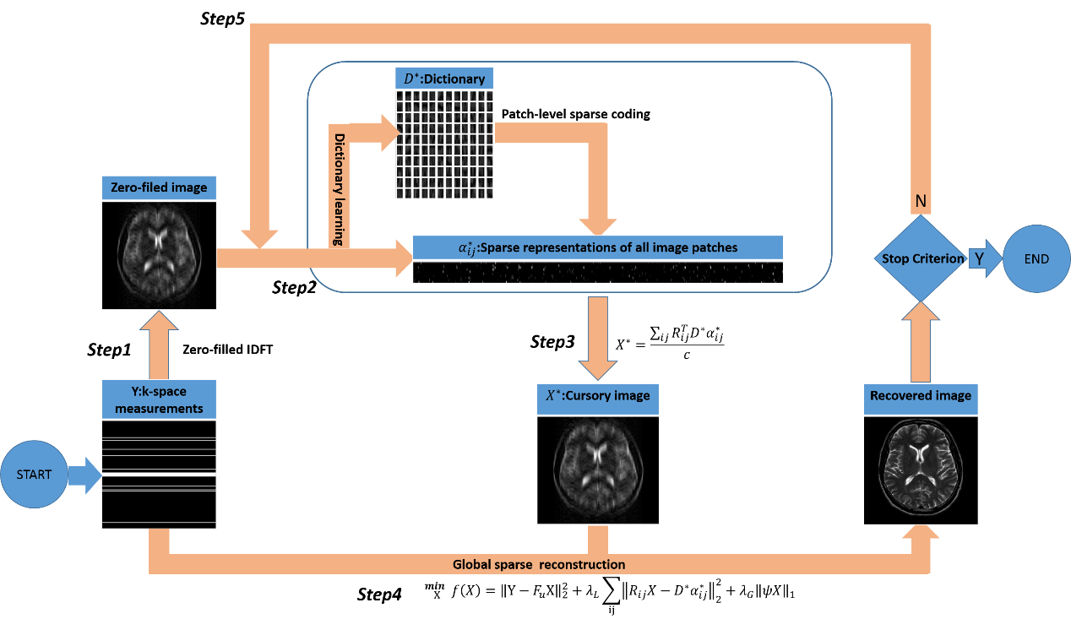

**Figure 2. Flowchart of the GLMRI reconstruction model.**

Compared to the DLMRI, the GLMRI has two improvements:

(a)DLMRI solve the equation using least squares technique. Because the is just a coarse estimation, the solution of least squares usually over-fits the and inherits the blocky effects from . While the GLMRI enforces L1 regularization to prevent over-fitting and to iteratively refine the solution from within CS framework.

(b)The least squares solution of DLMRI can be reduced to k-space back-filling, which fills the frequencies of non-sampled pixels using that of and restores the frequencies of sampled pixels by weighted averaging the frequencies of and sampled values. However, the sampled values will overwhelm the frequencies of assuming little noise when measuring.While the GLMRI solves Eq. (5) implicitly uses nonlinear conjugate gradient solver, which is more versatile and can append additional regularization terms to enforce other structural constraints, to improve .

To verify the arguments, we compared GLMRI with CS-MRI and DLMRI in the same condition as the Fig. 1 and the results are shown in Fig.3, which shows that DLMRI introduces the blocky effect when reconstructing, while GLMRI suppresses the blocky effect by balancing the weights for local and global sparsity.



**(c)**

**(b)**

**(a)**

**Figure3. Comparison of images reconstructed by CS-MRI(a)using wavelet(db4) as global sparsifying transform, GLMRI (b) and DLMRI(c)with non-overlapping patch size 10x10.The reduction factor is 10.**

**METHODS AND MATERIALS**

The GLMRI is verified using simulated phantom and three MR images, axial brain, vessel and spine with size of 512x512.The simulated phantom, which reflects the overall image structure of the brain, is generated by constructing one large ellipse and several smaller ellipses. The MR images axial brain, vessel and spine are obtained from [12].

Two sampling patterns, Cartesian random sampling along the phase-encoding direction (Fig.2a) and 2D random sampling(Fig.2b), are used in the following evaluations. They uses 1D and 2D Gaussian distributions respectively, which have denser sampling at the center of k-space [5].

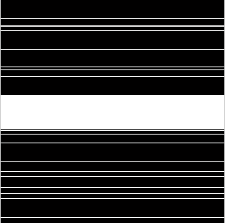 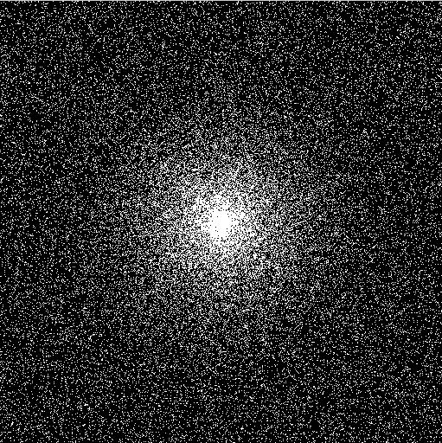

**(b)**

**(a)**

**Figure 4. Cartesian(a) and 2D (b)random sampling patterns.**

The code of K-SVD was taken from [11], and non-linear conjugate gradient solver [15] was modified from CS-MRI [5] to fit our model. All simulations and reconstructions were implemented in MATLAB R2012b (MathWorks, Natick, MA).

Several parameters of the model are fixed in the evaluations and discussed later on. The patch size was set to 6x6, dictionary size to36, overlap stride to 1, the number of patches for training to 5000.We use the Daubechies wavelet db4 as the global sparse transform [5].The quality of the recovered image is quantified using peak signal-to-noise ratio (PSNR). The GLMRI was compared with DLMRI to show improved performance and how the global sparsity constraint affects the recovered images. For this dataset, we set , which means the local sparsity is weighted50times more than the global sparsity.

**RESULTS**

***Simulated phantom***

Fig.(5)shows results for simulated phantom exploiting Cartesian random sampling at 4 fold under-sampling. Both DLMRI and GLMRI are executed 20 iterations to compares their performance. There is little visual difference between DLMRI and GLMRI as shown in Fig. (5bc). However, the difference is visual perceptible in the error maps as shown in Fig. (5fg).The error map of DLMRI has sharp edges indicating loss of edge features. Fig. (5e) shows that both DLMRI and GLMRI convergewithin20 iterations. Fig. (5h) shows that GLMRI outperforms DLMRI in about 0.8dB for each reduction factor. For 2D random sampling, the difference of PSNR is enlarged to about 1.5dB and is also reflected in the error map.

|  |  |  |  |
| --- | --- | --- | --- |
| **Truth** | **DLMRI**    **(a)**  **(b)**  **(c)**  **(d)**  **(e)**  **(f)**  **(g)**  **(h)** | **GLMRI** |  |
|  |  |  |  |

**Figure 5.Comparison of recovered phantom using DLMRI and GLMRI when reduction factor is 4. (a) is the ground truth, (b) and (c) are the output of DLMRI and GLMRI, respectively. (d) shows the curve of intensity for lines marked in (a-c). (e) shows the PSNR versus iteration. (f) and (g) are the error maps, which are multiplied by a factor of 10 for better visualization. (h) shows the PSNR versus different reduction factors.**

|  |  |  |  |
| --- | --- | --- | --- |
| **Truth** | **DLMRI**    **(a)**  **(b)**  **(c)**  **(d)**  **(e)**  **(f)**  **(g)**  **(h)** | **GLMRI** |  |
|  |  |  |  |

**Figure 6.The same as Figure 5 except that the 2D random sampling pattern was used.**

***Axial brain, vessel and spine***

All three images are real MR images taken from [12] and have rich textures. In Fig. 7, although no visual difference can be seen in recovered brain images as shown in Fig. (7bc), the Fig. (7d) exposes notable differences near the peaks and valleys. The error maps in Fig. (7fg) reveal that GLMRI recovers more details of the image than DLMRI does. And this holds true for various reduction factors as shown in Fig. (7h). When 2D random sampling pattern is used, the difference between two methods is enlarged. The GLMRI follows the ground truth very well as shown in Fig. (8d), especially at the positions near peak and valley. The output of GLMRI is stable after 6 iterations, while DLMRI gets stable output until 11 iterations. In the end, GLMRI gets 1.8dB larger in PSNR than DLMR. The error map of DLMRI contains notable structure information while that of GLMRI contains almost the random noise as demonstrated in Fig. (8fg).

|  |  |  |  |
| --- | --- | --- | --- |
| **Truth**    **(a)**  **(b)**  **(c)**  **(d)**  **(e)**  **(f)**  **(g)**  **(h)** | **DLMRI** | **GLMRI** |  |
|  |  |  |  |

**Figure 7.Comparison of recovered brain using DLMRI and GLMRI when reduction factor is 4. (a) is the ground truth, (b) and (c) are the output of DLMRI and GLMRI, respectively. (d) shows the curve of intensity for lines marked in (a-c). (e) shows the PSNR versus iteration. (f) and (g) are the error maps, which are multiplied by a factor of 10 for better visualization. (h) shows the PSNR versus different reduction factors.**

|  |  |  |  |
| --- | --- | --- | --- |
| **Truth**    **(a)**  **(b)**  **(c)**  **(d)**  **(e)**  **(f)**  **(g)**  **(h)** | **DLMRI** | **GLMRI** |  |
|  |  |  |  |

**Figure 8.The same as Figure 7 except that the 2D random sampling pattern was used.**

For the vessel dataset, Fig. (9bc) shows no much visual difference in the recovered images when exploiting Cartesian sampling pattern. Fig.(9d) shows that both methods follow the ground truth well, and get lost near the peaks and valleys. The PSNR in Fig. (9e) reveals that GLMRI outperforms the DLMRI in about 1dB, which exposes little difference in the error maps. In the case of 2D random sampling, GLMRI gets 1.9dB more than DLMRI in PSNR. The error map of DLMRI (Fig. (10f)) contains obvious structure information while the error map of GLMRI(Fig. (10g)) contains almost random noise.

|  |  |  |  |
| --- | --- | --- | --- |
| **Truth**    **(a)**  **(b)**  **(c)**  **(d)**  **(e)**  **(f)**  **(g)**  **(h)** | **DLMRI** | **GLMRI** |  |
|  |  |  |  |

**Figure 9.Comparison of recovered vessel using DLMRI and GLMRI when reduction factor is 4. (a) is the ground truth, (b) and (c) are the output of DLMRI and GLMRI, respectively. (d) shows the curve of intensity for lines marked in (a-c). (e) shows the PSNR versus iteration. (f) and (g) are the error maps, which are multiplied by a factor of 10 for better visualization. (h) shows the PSNR versus different reduction factors.**

|  |  |  |  |
| --- | --- | --- | --- |
| **Truth** | **DLMRI**    **(a)**  **(b)**  **(c)**  **(d)**  **(e)**  **(f)**  **(g)**  **(h)** | **GLMRI** |  |
|  |  |  |  |

**Figure 10.The same as Figure 9 except that the 2D random sampling pattern was used.**

For spine, although there is little visual difference in recovered images of Fig. (11bc), GLMRI catches the ground truth better than DLMRI does near the peaks and valleys as shown in Fig. (11d). The error maps in Fig. (11fg) reveal that DLMRI lost some important structure information. For 2D random sampling pattern, Fig. 12 shows that GLMRI recovers the details of image much better than DLMRI does.

|  |  |  |  |
| --- | --- | --- | --- |
| **Truth**    **(a)**  **(b)**  **(c)**  **(d)**  **(e)**  **(f)**  **(g)**  **(h)** | **DLMRI** | **GLMRI** |  |
|  |  |  |  |

**Figure 11.Comparison of recovered spine using DLMRI and GLMRI when reduction factor is 4. (a) is the ground truth, (b) and (c) are the output of DLMRI and GLMRI, respectively. (d) shows the curve of intensity for lines marked in (a-c). (e) shows the PSNR versus iteration. (f) and (g) are the error maps, which are multiplied by a factor of 10 for better visualization. (h) shows the PSNR versus different reduction factors.**

|  |  |  |  |
| --- | --- | --- | --- |
| **Truth**    **(a)**  **(b)**  **(c)**  **(d)**  **(e)**  **(f)**  **(g)**  **(h)** | **DLMRI** | **GLMRI** |  |
|  |  |  |  |

**Figure 12.The same as Figure 11 except that the 2D random sampling pattern was used.**

***Parameters selection***

In this section, we will evaluate several important parameters of GLMRI by varying one of them at a time while keeping the rests fixed to find an optimal combination of parameters. The brain data was used for evaluation under 2D random sampling at the reduction factor 4.For the overlap stride , Fig.(13a) shows that the PSNR decreases gradually with the increase of the , so the best choice is . To select best combination of and , is firstly fixed to, PSNR versus the ratio of weights for local and global sparsity , which balances the local and global sparsity, is shown in Fig. (13b). It can be seen that PSNR gets larger with the increasing of from 0, in which case GLMRI is equivalent to CS-MRI, and is stable for , then PSNR gets lower gradually as tends to be infinity, in which case the GLMRI degrades to the DLMRI. As a result, is a reasonable choice. Secondly, with fixed the trend of PSNR versus suggests as shown in Fig.(13c).



**(c)**

**(a)**

**(b)**

**Figure 13. PSNR versus (a),** (b) **and** (c).**In (b), when and , GLMRI degrades to the CS-MRI and DLMRI, respectively.**

**CONCLUSION**

This work presented a novel model to reconstruct MR images from under-sampled k-space data by enforcing patch-level and global sparsity constraints to capture local and global sparse structures of MR images. Firstly, the patch-level sparse representations are obtained via dictionary learning followed by sparse coding upon learned dictionary. And then the traditional orthonormal sparse transforms are used to promote the global sparsity of MR images. Finally, the model is solved in the framework of the compressive sensing with known local and global sparsity constraints. And this procedure is repeated iteratively to improve the quality of images. Numerical experiments on simulated phantom and MR images with various features are used to verify the performance of GLMRI and are compared to CS-MRI, which exploits only the global sparsity, and DLMRI, which exploits only the patch-level sparsity. Simulation results demonstrate that GLMRI outperforms existing methods exploiting only patch-level or global sparse structure. The rationale selecting several important parameters is also present. And the PSNR of output image is stable within 20 iterations. Future work will develop robust and efficient patch-level sparse dictionary and use adaptive global sparse transforms to further enhance the reconstruction quality.

**REFERENCES**

[1]Z. Liang and P. Lauterbur*, Principles of Magnetic Resonance Imaging: A Signal Processing Perspective*. New York: Wiley-IEEE, 1999.

[2]Donoho D L. Compressed sensing. IEEE Transactions on Information Theory, 2006, 52(4): 1289-1306.

[3] Candès E J, Romberg J, Tao T. Robust uncertainty principles: Exact signal reconstruction from highly incomplete frequency information. Information Theory, IEEE Transactions on, 2006, 52(2): 489-509.

[4] Candes E J, Tao T. Decoding by linear programming. Information Theory, IEEE Transactions on, 2005, 51(12): 4203-4215.

[5] Lustig M, Donoho D, Pauly J M. Sparse MRI: The application of compressed sensing for rapid MR imaging. Magnetic resonance in medicine, 2007, 58(6): 1182-1195.

[6]Yanhua Wang, Ying L. Compressed Sensing Dynamic Cardiac Cine MRI Using Learned Spatiotemporal Dictionary, IEEE Transactions on Biomedical Engineering, 2014, 61(4):1109-1120.

[7] Candes E, Demanet L, Donoho D, et al. Fast discrete curvelet transforms. Multiscale Modeling & Simulation, 2006, 5(3): 861-899.

[8] Hong M, Yu Y, Wang H, et al. Compressed sensing MRI with singular value decomposition-based sparsity basis. Physics in medicine and biology, 2011, 56(19): 6311.

[9] Mairal J, Bach F, Ponce J, et al. Online dictionary learning for sparse coding, Proceedings of the 26th Annual International Conference on Machine Learning, 2009: 689-696.

[10] Aharon M, Elad M, Bruckstein A. K-SVD: An algorithm for designing overcomplete dictionaries for sparse representation, IEEE Transactions on Signal Processing, 2006, 54(11): 4311-4322.

[11] Ravishankar S, Bresler Y. MR image reconstruction from highly undersampled k-space data by dictionary learning. Medical Imaging, IEEE Transactions on, 2011, 30(5): 1028-1041.

[12] http://www3.americanradiology.com/pls/web1/wwimggal.vmg/

[13]Yang J, Wright J, Huang T S, et al. Image super-resolution via sparse representation, IEEE Transactions on Image Processing, 2010, 19(11): 2861-2873.

[14] M. Aharon and M. Elad, Sparse and redundant modeling of image content using an image-signature-dictionary, *SIAM J. Imag. Sci.*, vol.1, no. 3, pp. 228–247, 2008

[15] Nocedal J, Wright S J. Conjugate gradient methods. Springer New York, 2006.

[16] Qu X, Guo D, Ning B, et al. Undersampled MRI reconstruction with patch-based directional wavelets. Magnetic resonance imaging, 2012, 30(7): 964-977.

[17] R. Venkataramani and Y. Bresler, Further results on spectrum blind sampling of 2D signals, in *Proc. IEEE Int. Conf. Image Proc. (ICIP)*,Oct. 1998, vol. 2, pp. 752–756.

[18] J. A. Tropp, Greed is good: Algorithmic results for sparse approximation, *IEEE Trans. Inf. Theory*, vol. 50, no. 10, pp. 2231–2242, Oct.2004.