

**(c)**

**(b)**

**(a)**

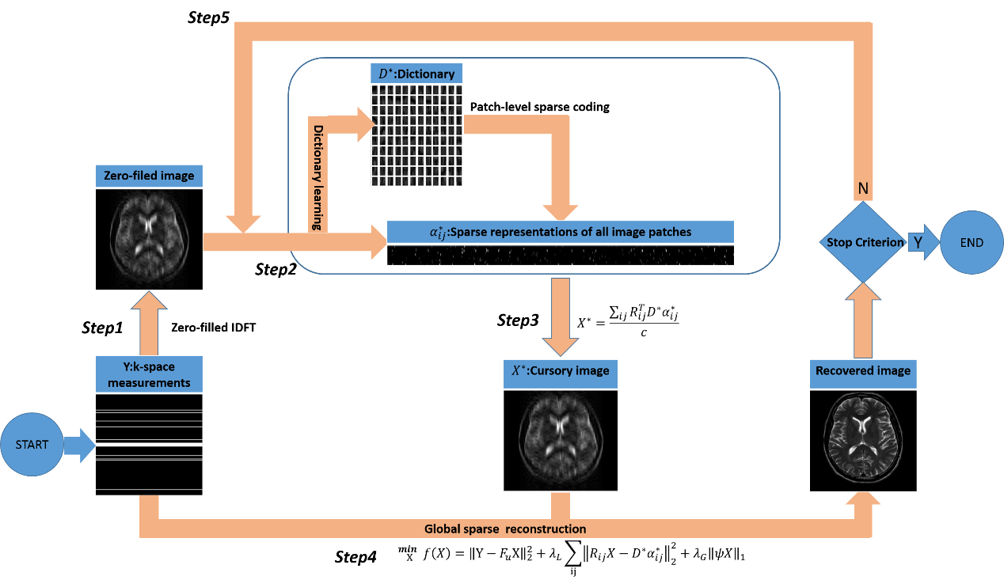



**(c)**

**(b)**

**(a)**

 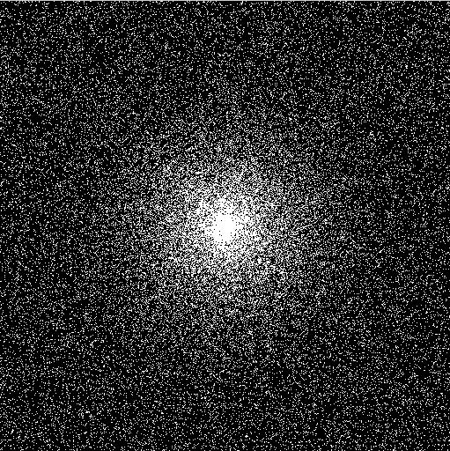

**(b)**

**(a)**

|  |  |  |  |
| --- | --- | --- | --- |
| **Truth** | **DLMRI**    **(a)**  **(b)**  **(c)**  **(d)**  **(e)**  **(f)**  **(g)**  **(h)** | **GLMRI** |  |
|  |  |  |  |

|  |  |  |  |
| --- | --- | --- | --- |
| **Truth** | **DLMRI**    **(a)**  **(b)**  **(c)**  **(d)**  **(e)**  **(f)**  **(g)**  **(h)** | **GLMRI** |  |
|  |  |  |  |

|  |  |  |  |
| --- | --- | --- | --- |
| **Truth**    **(a)**  **(b)**  **(c)**  **(d)**  **(e)**  **(f)**  **(g)**  **(h)** | **DLMRI** | **GLMRI** |  |
|  |  |  |  |

|  |  |  |  |
| --- | --- | --- | --- |
| **Truth**    **(a)**  **(b)**  **(c)**  **(d)**  **(e)**  **(f)**  **(g)**  **(h)** | **DLMRI** | **GLMRI** |  |
|  |  |  |  |

|  |  |  |  |
| --- | --- | --- | --- |
| **Truth**    **(a)**  **(b)**  **(c)**  **(d)**  **(e)**  **(f)**  **(g)**  **(h)** | **DLMRI** | **GLMRI** |  |
|  |  |  |  |

|  |  |  |  |
| --- | --- | --- | --- |
| **Truth** | **DLMRI**    **(a)**  **(b)**  **(c)**  **(d)**  **(e)**  **(f)**  **(g)**  **(h)** | **GLMRI** |  |
|  |  |  |  |

|  |  |  |  |
| --- | --- | --- | --- |
| **Truth**    **(a)**  **(b)**  **(c)**  **(d)**  **(e)**  **(f)**  **(g)**  **(h)** | **DLMRI** | **GLMRI** |  |
|  |  |  |  |

|  |  |  |  |
| --- | --- | --- | --- |
| **Truth**    **(a)**  **(b)**  **(c)**  **(d)**  **(e)**  **(f)**  **(g)**  **(h)** | **DLMRI** | **GLMRI** |  |
|  |  |  |  |



**(a)**

**(b)**



**(c)**