Local sparsity/global sparsity: 30 Local sparsity/global sparsity: 1

2.6 fold 2.6 fold

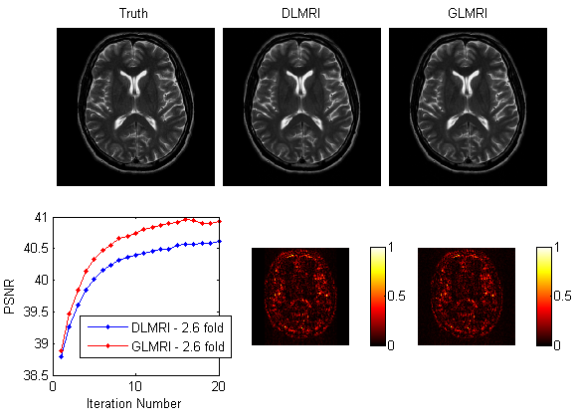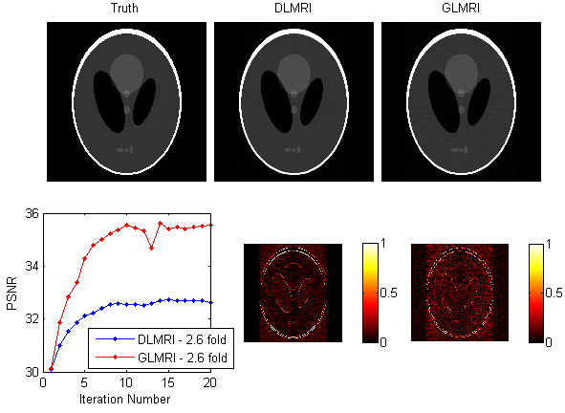

Local sparsity/global sparsity: 30 Local sparsity/global sparsity: 100

2.6 fold 2.6 fold

