**Target audience:** MRI researchers and engineers who specialize in the image reconstruction from under-sampled k-space data

**Purpose:** To develop a model capturing both local and global sparse structures of image to reconstruct quality images from under-sampled k-space data

**Method:** Sparse MRI has become a popular imaging technique to reconstruct anatomical images from under-sampled k-space data. One the most important ingredients of this technique are its effective exploitation of the sparse representation of the image1, which falls into two categories. The first method constructs the global sparsifying basis for the whole image to be reconstructed, such as predefined wavelet transform, finite difference and adaptive SVD-based transform2. The second one enforces a local sparse representation by sparsifying the patches of the image, which is usually realized by setting up a dictionary learned from existing similar images3. In this work, we proposed an imaging model that combines both local and global sparse representations. The performance of the new method is evaluated using the reconstruction of simulated phantom and MR brain images.



**Fig.1** The proposed imaging process, where $y$ is the under-sampled k-space data, $D$ is the learned dictionary, and $α$ is the patch-level sparse representation. The zf means zero-filled Fourier reconstruction.

Observing that the anatomical image exhibits both patch-level and global sparsity, we combines them into one imaging model as following ${}_{x,D,α}^{min}{ γ}\sum_{ij}{{\left\|R_{ij}x-Dα_{ij}\right\|}_{2}^{2}}+{\left\|F_{u}x-y\right\|}_{2}+{β\left\|φx\right\|}_{1},s.t.{\left\|α_{ij}\right\|}_{0}≤T_{0},∀i,j$, where $x$ is the image to be reconstructed, $R_{ij}$ is patch extraction operation, $D$ is the dictionary on which the patch $R_{ij}x$ has sparse representation $α_{ij}$, $y$ is the under-sampled k-space data, $F_{u}$ is the partial Fourier transform, $φ is$ the sparse transform to promote the global sparsity. This model can be solved by splitting it into two sub-models, the dictionary learning sub-model $P_{1}:{}_{D,α}^{min} \sum_{ij}{{\left\|R_{ij}x-Dα_{ij}\right\|}_{2}^{2}},s.t.{\left\|α_{ij}\right\|}_{0}≤T_{0},∀i,j$ and the reconstruction sub-model $P_{2}:{}_{x}^{min}{ γ}\sum_{ij}{{\left\|R_{ij}x-Dα_{ij}\right\|}_{2}^{2}}+{\left\|F_{u}x-y\right\|}_{2}+β{\left\|φx\right\|}_{1}$.Given an initial $x$, the $P_{1}$ is solved to obtain $D$ and $α_{ij}$, which are then fed into $P_{2}$ to reconstruct $x$.This process is iterated several times to further refine $x$, as shown in Fig. 1.

The proposed method is evaluated using a simulated phantom and a T2-weighted MR brain image4, and is also compared withthe DLMRI3, which exploits the patch-level sparsity only. Cartesian sampling with random phase encoding lines at the central of k-space is employed with 2.6 fold under-sampling. $P_{1}$ and $P_{2}$ are solved using K-SVD5 and nonlinear conjugate-gradient method, respectively. As for other parameters, we use a 6x6 sliding patch, the learned dictionary with 36 atoms, and the results are collected after 20 iterations. For brevity, the proposed method is named GLMRI hereafter.

**Results and Discussion:** Fig.2 shows the results of DLMRI and GLMRI for simulated phantom and MR brain image. For the phantom, we set $γ=β=0.007$, and Fig. 2(a) shows that the GLMRI has larger peak SNR (PSNR)than DLMRI after 1st iteration. In addition, from the error-maps, we can see that GLMRI preserves the edges with more details. For the MR brain image, we set $γ=0.007and β=0.00024$, and Fig. 2(b) shows that the GLMRI follows the DLMRI with improved PSNR after 1st iteration.

**Conclusion:** This work presented a new model by enforcing both local and global sparsity, which captures both the patch-level and global sparse structures of the anatomical images. Using a model split approach, the image reconstruction quality can be iteratively further improved. Our simulation results demonstrate that, the proposed method outperform those existing methods using only the patch-level or global sparse structure. Future work will improve the dictionary learning model and use adaptive global sparse transform to enhance the reconstruction quality.

**References:** [1]M. Lustig, et al,*MRM*, 58(6),2007. [2]M.J. Hong, et al, PMB, 56(19), 2011. [3]S. Ravishankar, et al, *IEEE Trans. Med*., 30(5), 2011. [4] 2013, American Radiology Services [Online]. [5] M. Aharon, et al, *IEEE Trans. Signal Process.*, 54(11), 2006.

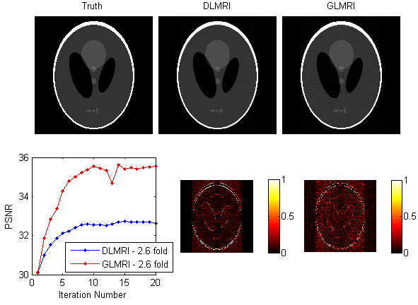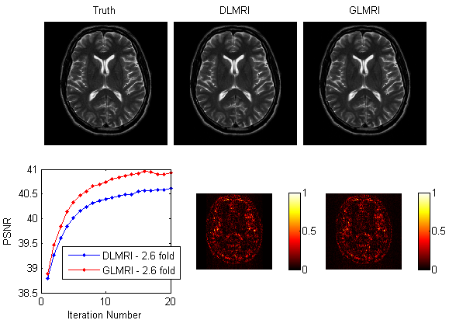

**Fig.2** The reconstructed images, PSNR over iteration and error-maps of the DLMRI and proposed method GLMRI for the simulated phantom (a) and MR brain image (b). The error-maps are multiplied by a factor of 5 for better visualization.

**(b)**

**(a)**