Laboratory work #2

Distributed banking system

Student: Yuan Chengxun  
Student HDU ID: 20321226

Mail: lmsh72238855872@gmail.com

Screenshot or copy with mail with “Passed”:

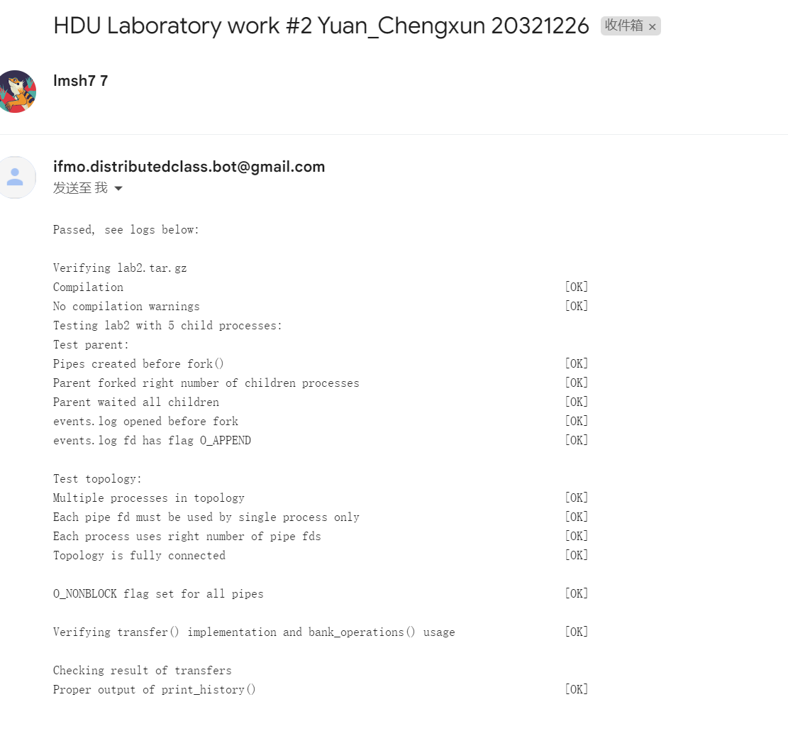

Control questions:

1. Transfer request. Is it synchronous or asynchronous in our model from point of client? Why?  
What is difference between synchronous and asynchronous operations?

Answer: I think it is synchronous, because the parent always needs to wait for each ack before starting the next transfer. The difference between synchronous and asynchronous depends on whether the client's request will be explicitly blocked by the server.

2. What will happened, if transfer operations isn’t instantaneous?  
Can we calculate total amount of money at each moment of time? Why?

Answer: If transfer operations are not instantaneous, it means there's a delay between initiating the transfer and its completion. During this delay, the total amount of money might not reflect the pending transfers. The system doesn't handle pending transfers correctly, it could lead to issues like overdrawing accounts or failing to transfer funds when there's a lack of sufficient balance.

3. Make an experiment. You can find in header banking.h function get_physical_time_skew(). Use it instead of get_physical_time(). This function provides non-synchronized clocks. Why result of execution is different?  
Answer should contain output table.

Answer: Asynchronous clocks will cause inconsistent sequence of events and deviations in amounts due to delays.

Normal:

Skew:

Source code:

1. #include <stdio.h>
2. #include <unistd.h>
3. #include <string.h>
4. #include <sys/types.h>
5. #include "labs_headers/message.h"
6. #include "labs_headers/log.h"
7. #include "labs_headers/process.h"
8. #include "labs_headers/banking.h"
9. *//export LD_LIBRARY_PATH="$LD_LIBRARY_PATH:/workspaces/HDU-CS-2023-Distributed-computing/task_lab2"*
10. *//LD_PRELOAD=./libdistributedmodel.so ./lab -l 2 -p 3 B1 B2 B3*
11. void update_history(BalanceHistory *history, timestamp_t time, balance_t amount)
12. {
13. int last_time = history->s_history[history->s_history_len - 1].s_time;
14. int last_balance = history->s_history[history->s_history_len - 1].s_balance;
15. for (int i = last_time + 1; i < time; i++)
16. {
17. history->s_history[history->s_history_len].s_time = i;
18. history->s_history[history->s_history_len].s_balance = last_balance;
19. history->s_history[history->s_history_len].s_balance_pending_in = 0;
20. history->s_history_len++;
21. }
22. history->s_history[history->s_history_len].s_balance = amount;
23. history->s_history[history->s_history_len].s_time = time;
24. history->s_history[history->s_history_len].s_balance_pending_in = 0;
25. history->s_history_len++;
26. }
27. balance_t now_balance(BalanceHistory *history)
28. {
29. return history->s_history[history->s_history_len - 1].s_balance;
30. }
31. void parent_work(int count_nodes)
32. {
33. AllHistory all_history;
34. all_history.s_history_len = count_nodes - 1;
35. */* STUDENT IMPLEMENTATION STARTED */*
36. */* Implement starting synchronization */*
37. for (int i = 1; i < count_nodes; i++)
38. {
39. Message msg;
40. receive(i, &msg);
41. if (msg.s_header.s_magic == MESSAGE_MAGIC && msg.s_header.s_type == STARTED)
42. {
43. continue;
44. }
45. }
46. */* Useful work */*
47. bank_operations(count_nodes - 1);
48. */* Implement finishing synchronization and collecting AllHistory */*
49. */* 广播 STOP 消息*/*
50. Message msg;
51. fill_message(&msg, STOP, get_physical_time(), NULL, 0);
52. send_multicast(&msg);
53. */* 收到所有 DONE 消息 */*
54. for (int i = 1; i < count_nodes; i++)
55. {
56. Message msg;
57. receive(i, &msg);
58. if (msg.s_header.s_magic == MESSAGE_MAGIC && msg.s_header.s_type == DONE)
59. {
60. continue;
61. }
62. }
63. */* 收集所有 BalanceHistory */*
64. for (int i = 1; i < count_nodes; i++)
65. {
66. Message msg;
67. receive(i, &msg);
68. if (msg.s_header.s_magic == MESSAGE_MAGIC && msg.s_header.s_type == BALANCE_HISTORY)
69. {
70. BalanceHistory *history = (BalanceHistory *)msg.s_payload;
71. memcpy(&all_history.s_history[i - 1], history,msg.s_header.s_payload_len);
72. }
73. }
74. print_history(&all_history);
75. return;
76. }
77. void child_work(struct child_arguments args)
78. {
79. */* Child arguments */*
80. local_id self_id = args.self_id;
81. int count_nodes = args.count_nodes;
82. uint8_t balance = args.balance;
83. */* BalanceHistory initialization */*
84. BalanceHistory history;
85. history.s_history_len = 1;
86. history.s_id = self_id;
87. memset(history.s_history, 0, sizeof(history.s_history));
88. history.s_history[0].s_balance = balance;
89. for (int i = 0; i < MAX_T; ++i) {
90. history.s_history[i].s_time = i;
91. }
92. */* System process identifiers used for logs */*
93. pid_t self_pid = getpid();
94. pid_t parent_pid = getppid();
95. */* STUDENT IMPLEMENTATION STARTED */*
96. char buf[BUF_SIZE];
97. Message msg;
98. timestamp_t current = get_physical_time(); *// 是 lamport 逻辑时间*
99. snprintf(buf, BUF_SIZE, log_started_fmt, current, self_id, self_pid, parent_pid, balance);
100. fill_message(&msg, STARTED, current, buf, strlen(buf));
101. send_multicast(&msg);
102. shared_logger(buf);
103. Message recv_msg;
104. int cnt = 0;
105. for (int i = 1; i < count_nodes; i++) {
106. if (i == self_id)
107. continue;
108. receive(i, &recv_msg);
109. if (recv_msg.s_header.s_magic == MESSAGE_MAGIC && recv_msg.s_header.s_type == STARTED) {
110. cnt++;
111. }
112. }
113. if (cnt == count_nodes - 2) {
114. current = get_physical_time();
115. snprintf(buf, BUF_SIZE, log_received_all_started_fmt, current, self_id);
116. shared_logger(buf);
117. }
118. */* 阶段 2 等待并处理任何 TRANSFER 和 STOP 消息 */*
119. cnt = 0;
120. while (true) {
121. Message req_msg;
122. receive_any(&req_msg);
123. if (req_msg.s_header.s_magic == MESSAGE_MAGIC && req_msg.s_header.s_type == TRANSFER)
124. {
125. TransferOrder *order = (TransferOrder *)req_msg.s_payload;
126. if (order->s_src == self_id) {
127. current = get_physical_time();
128. update_history(&history, current, now_balance(&history) - order->s_amount);
129. snprintf(buf, BUF_SIZE, log_transfer_out_fmt, current, self_id, order->s_amount, order->s_dst);
130. shared_logger(buf);
131. Message response_msg;
132. fill_message(&response_msg, TRANSFER, current, order, strlen((const char*)order));
133. send(order->s_dst, &response_msg);
134. } else if (order->s_dst == self_id) {
135. current = get_physical_time();
136. update_history(&history, current, now_balance(&history) + order->s_amount);
137. snprintf(buf, BUF_SIZE, log_transfer_in_fmt, current, self_id, order->s_amount, order->s_src);
138. shared_logger(buf);
139. Message response_msg;
140. fill_message(&response_msg, ACK, current, NULL, 0);
141. send(0, &response_msg);
142. }
143. } else if (req_msg.s_header.s_magic == MESSAGE_MAGIC && req_msg.s_header.s_type == STOP) {
144. current = get_physical_time();
145. */* 阶段 3 发送 DONE 消息 */*
146. snprintf(buf, BUF_SIZE, log_done_fmt, current, self_id, now_balance(&history));
147. shared_logger(buf);
148. Message response_msg;
149. fill_message(&response_msg, DONE, current, buf, strlen(buf));
150. send_multicast(&response_msg);
151. break;
152. } else if (req_msg.s_header.s_magic == MESSAGE_MAGIC && req_msg.s_header.s_type == DONE) {
153. cnt++;
154. }
155. }
156. */* 接收 DONE 消息 */*
157. while (cnt != count_nodes - 2)
158. {
159. Message msg;
160. receive_any(&msg);
161. if (msg.s_header.s_magic == MESSAGE_MAGIC && msg.s_header.s_type == DONE)
162. {
163. cnt++;
164. }
165. }
166. if (cnt == count_nodes - 2)
167. {
168. current = get_physical_time();
169. snprintf(buf, BUF_SIZE, log_received_all_done_fmt, current, self_id);
170. shared_logger(buf);
171. }
172. */* 发送 BALANCE_HISTORY 消息 */*
173. Message history_msg;
174. current = get_physical_time();
175. fill_message(&history_msg, BALANCE_HISTORY, current, &history, sizeof(history));
176. send(0, &history_msg);
177. }
178. void transfer(local_id src, local_id dst,
179. balance_t amount)
180. {
181. TransferOrder order = {src, dst, amount};
182. */* STUDENT IMPLEMENTATION STARTED */*
183. */* 发送 TRANSFER 消息 */*
184. Message msg;
185. fill_message(&msg, TRANSFER, get_physical_time(), &order, sizeof(order));
186. send(src, &msg);
187. */* 接受 dst 的 ACK 消息*/*
188. receive(dst, &msg);
189. if (msg.s_header.s_magic == MESSAGE_MAGIC && msg.s_header.s_type == ACK)
190. {
191. return;
192. }
193. }
194. */* STUDENTS SHOULD NOT CHANGE THIS FUNCTION */*
195. __attribute__((weak)) void bank_operations(local_id max_id)
196. {
197. for (int i = 1; i < max_id; ++i) {
198. transfer(i, i + 1, i);
199. }
200. if (max_id > 1) {
201. transfer(max_id, 1, 1);
202. }
203. }