Laboratory work #3

Lamport’s logical clocks

Student: Yuan Chengxun  
Student HDU ID: 20321226

Mail: lmsh72238855872@gmail.com

Screenshot or copy with mail with “Passed”:

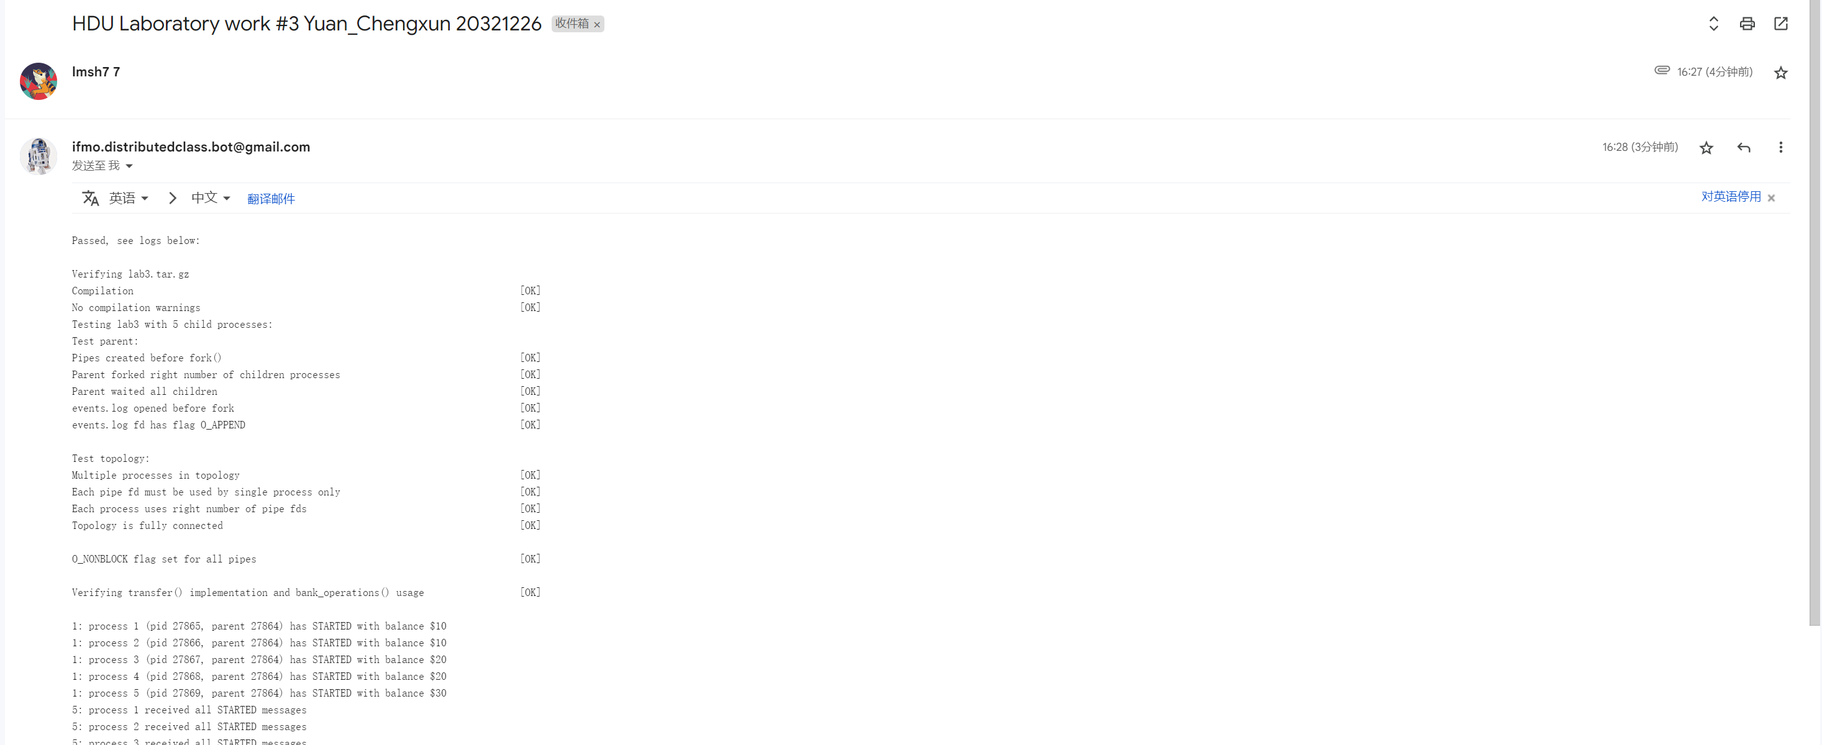

Control questions:

1. Lamport’s clocks. What does it mean, that these clocks aren’t strongly consistent?

Answer: A logical clock used to achieve logical consistency in distribution. The physical clocks of different nodes are actually inconsistent and cannot be accurately consistent, so it is unrealistic to rely on a global clock to globally calibrate the sequence of events.

2. What will happened, if parent process’s messages (e.g., TRANSFERs from parent) aren’t marked with Lamport’s clock timestamp?   
Modify your model and explain results. Attach resulted table to the report.

Answer: The child process ends on its own clock because the parent's timeline cannot affect the child.

3. Make an experiment. What will happened if we will not use s_balance_pending_field?  
Modify your model and explain results. Attach resulted table to the report.

Answer: You will find that there is still an amount hidden during the communication process of the channel because of delay.

Source code:

#include <stdio.h>

#include <unistd.h>

#include <string.h>

#include <sys/types.h>

#include "labs_headers/message.h"

#include "labs_headers/log.h"

#include "labs_headers/process.h"

#include "labs_headers/banking.h"

*//export LD_LIBRARY_PATH="$LD_LIBRARY_PATH:/workspaces/HDU-CS-2023-Distributed-computing/task_lab2"*

*//LD_PRELOAD=./libdistributedmodel.so ./lab -l 2 -p 3 10 20 30*

timestamp_t Lamport_time = 0;

**int** max(**int** a, **int** b) {

    return (a > b) ? a : b;

}

**void** update_history(BalanceHistory *history, timestamp_t pending_start_time, timestamp_t pending_end_time, balance_t amount, balance_t pending_money)

{

**int** last_time = history->s_history[history->s_history_len - 1].s_time;

**int** last_balance = history->s_history[history->s_history_len - 1].s_balance;

    for (**int** i = last_time + 1; i < pending_start_time; i++)

    {

        history->s_history[history->s_history_len].s_time = i;

        history->s_history[history->s_history_len].s_balance = last_balance;

        history->s_history[history->s_history_len].s_balance_pending_in = 0;

        history->s_history_len++;

    }

    for (**int** i = pending_start_time; i < pending_end_time; i++)

    {

        history->s_history[history->s_history_len].s_time = i;

        history->s_history[history->s_history_len].s_balance = last_balance;

        history->s_history[history->s_history_len].s_balance_pending_in = pending_money;

        history->s_history_len++;

    }

    history->s_history[history->s_history_len].s_balance = amount;

    history->s_history[history->s_history_len].s_time = pending_end_time;

    history->s_history[history->s_history_len].s_balance_pending_in = 0;

    history->s_history_len++;

}

balance_t now_balance(BalanceHistory *history)

{

    return history->s_history[history->s_history_len - 1].s_balance;

}

**void** parent_work(**int** count_nodes)

{

    AllHistory all_history;

    all_history.s_history_len = count_nodes - 1;

*/* STUDENT IMPLEMENTATION STARTED */*

*/* Implement starting synchronization */*

    for (**int** i = 1; i < count_nodes; i++)

    {

        Message msg;

        receive(i, &msg);

        Lamport_time = max(Lamport_time, msg.s_header.s_local_time) + 1;

        if (msg.s_header.s_magic == MESSAGE_MAGIC && msg.s_header.s_type == STARTED)

        {

            continue;

        }

    }

*/* Useful work */*

    bank_operations(count_nodes - 1);

*/* Implement finishing synchronization and collecting AllHistory */*

*/* 广播 STOP 消息*/*

    Message msg;

    fill_message(&msg, STOP, ++Lamport_time, NULL, 0);

    send_multicast(&msg);

*/* 收到所有 DONE 消息 */*

    for (**int** i = 1; i < count_nodes; i++)

    {

        Message msg;

        receive(i, &msg);

        Lamport_time = max(Lamport_time, msg.s_header.s_local_time) + 1;

        if (msg.s_header.s_magic == MESSAGE_MAGIC && msg.s_header.s_type == DONE)

        {

            continue;

        }

    }

*/* 收集所有 BalanceHistory */*

    for (**int** i = 1; i < count_nodes; i++)

    {

        Message msg;

        receive(i, &msg);

        Lamport_time = max(Lamport_time, msg.s_header.s_local_time) + 1;

        if (msg.s_header.s_magic == MESSAGE_MAGIC && msg.s_header.s_type == BALANCE_HISTORY)

        {

            BalanceHistory *history = (BalanceHistory *)msg.s_payload;

            memcpy(&all_history.s_history[i - 1], history,msg.s_header.s_payload_len);

        }

    }

    print_history(&all_history);

    return;

}

**void** child_work(**struct** child_arguments args)

{

*/* Child arguments */*

    local_id self_id = args.self_id;

**int** count_nodes = args.count_nodes;

**uint8_t** balance = args.balance;

*/* BalanceHistory initialization */*

    BalanceHistory history;

    history.s_history_len = 1;

    history.s_id = self_id;

    memset(history.s_history, 0, sizeof(history.s_history));

    history.s_history[0].s_balance = balance;

    for (**int** i = 0; i < MAX_T; ++i) {

        history.s_history[i].s_time = i;

    }

*/* System process identifiers used for logs */*

**pid_t** self_pid = getpid();

**pid_t** parent_pid = getppid();

*/* STUDENT IMPLEMENTATION STARTED */*

**char** buf[BUF_SIZE];

    Message msg;

    timestamp_t current = ++Lamport_time;

    snprintf(buf, BUF_SIZE, log_started_fmt, current, self_id, self_pid, parent_pid, balance);

    fill_message(&msg, STARTED, current, buf, strlen(buf));

    send_multicast(&msg);

    shared_logger(buf);

    Message recv_msg;

**int** cnt = 0;

    for (**int** i = 1; i < count_nodes; i++) {

        if (i == self_id)

            continue;

        receive(i, &recv_msg);

        Lamport_time = max(Lamport_time, recv_msg.s_header.s_local_time) + 1;

        if (recv_msg.s_header.s_magic == MESSAGE_MAGIC && recv_msg.s_header.s_type == STARTED) {

            cnt++;

        }

    }

    if (cnt == count_nodes - 2) {

        current = Lamport_time;

        snprintf(buf, BUF_SIZE, log_received_all_started_fmt, current, self_id);

        shared_logger(buf);

    }

*/* 阶段 2 等待并处理任何 TRANSFER 和 STOP 消息 */*

    cnt = 0;

    while (true) {

        Message req_msg;

        receive_any(&req_msg);

        Lamport_time = max(Lamport_time, req_msg.s_header.s_local_time) + 1;

        if (req_msg.s_header.s_magic == MESSAGE_MAGIC && req_msg.s_header.s_type == TRANSFER)

        {

            TransferOrder *order = (TransferOrder *)req_msg.s_payload;

            if (order->s_src == self_id) {

                current = ++Lamport_time;

                update_history(&history, current, current, now_balance(&history) - order->s_amount, 0);

                snprintf(buf, BUF_SIZE, log_transfer_out_fmt, current, self_id, order->s_amount, order->s_dst);

                shared_logger(buf);

                Message response_msg;

                fill_message(&response_msg, TRANSFER, current, order, strlen((**const** **char**\*)order));

                send(order->s_dst, &response_msg);

            } else if (order->s_dst == self_id) {

                current = max(Lamport_time, req_msg.s_header.s_local_time) + 1;

                update_history(&history, req_msg.s_header.s_local_time, current, now_balance(&history) + order->s_amount, order->s_amount);

                snprintf(buf, BUF_SIZE, log_transfer_in_fmt, current, self_id, order->s_amount, order->s_src);

                shared_logger(buf);

                Message response_msg;

                fill_message(&response_msg, ACK, current, NULL, 0);

                send(0, &response_msg);

            }

        } else if (req_msg.s_header.s_magic == MESSAGE_MAGIC && req_msg.s_header.s_type == STOP) {

            current = max(Lamport_time, req_msg.s_header.s_local_time) + 1;

*/* 阶段 3 发送 DONE 消息 */*

            snprintf(buf, BUF_SIZE, log_done_fmt, current, self_id, now_balance(&history));

            shared_logger(buf);

            Message response_msg;

            fill_message(&response_msg, DONE, current, buf, strlen(buf));

            send_multicast(&response_msg);

            break;

        } else if (req_msg.s_header.s_magic == MESSAGE_MAGIC && req_msg.s_header.s_type == DONE) {

            cnt++;

        }

    }

*/* 接收 DONE 消息 */*

    while (cnt != count_nodes - 2)

    {

        Message msg;

        receive_any(&msg);

        Lamport_time = max(Lamport_time, msg.s_header.s_local_time) + 1;

        if (msg.s_header.s_magic == MESSAGE_MAGIC && msg.s_header.s_type == DONE)

        {

            cnt++;

        }

    }

    if (cnt == count_nodes - 2)

    {

        current = Lamport_time;

        snprintf(buf, BUF_SIZE, log_received_all_done_fmt, current, self_id);

        shared_logger(buf);

    }

*/* 发送 BALANCE_HISTORY 消息 */*

    Message history_msg;

    current = ++Lamport_time;

    fill_message(&history_msg, BALANCE_HISTORY, current, &history, sizeof(history));

    send(0, &history_msg);

}

**void** transfer(local_id src, local_id dst,

              balance_t amount)

{

    TransferOrder order = {src, dst, amount};

*/* STUDENT IMPLEMENTATION STARTED */*

*/* 发送 TRANSFER 消息 */*

    Message msg;

    fill_message(&msg, TRANSFER, ++Lamport_time, &order, sizeof(order));

    send(src, &msg);

*/* 接受 dst 的 ACK 消息*/*

    receive(dst, &msg);

    Lamport_time = max(Lamport_time, msg.s_header.s_local_time) + 1;

    if (msg.s_header.s_magic == MESSAGE_MAGIC && msg.s_header.s_type == ACK)

    {

        return;

    }

}

*/* STUDENTS SHOULD NOT CHANGE THIS FUNCTION */*

__attribute__((weak)) **void** bank_operations(local_id max_id)

{

    for (**int** i = 1; i < max_id; ++i) {

        transfer(i, i + 1, i);

    }

    if (max_id > 1) {

        transfer(max_id, 1, 1);

    }

}