Comp135
Machine learning
Project 2

Mengtian Li
mli09
10/15/2015

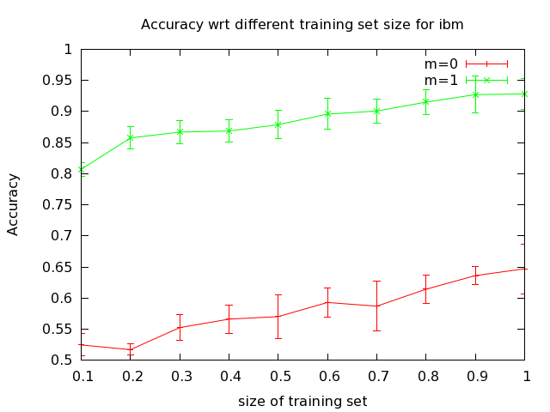
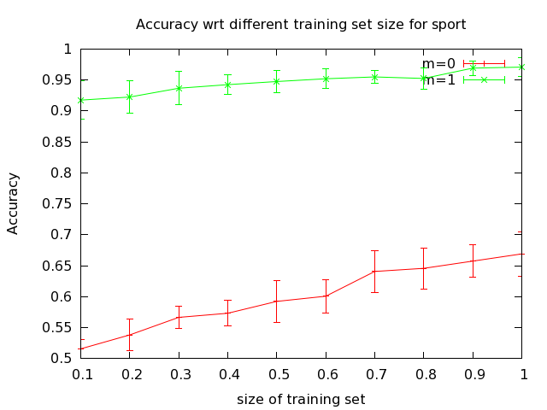

Discussion:
We have a significant improvement if we have Laplace smoothing because in this way we have fail safe probabilty. The prediction we make for sport is more accurate than prediction we make for ibmmac. I think this is because sports in words are generally more distinguishable than computer context in words.

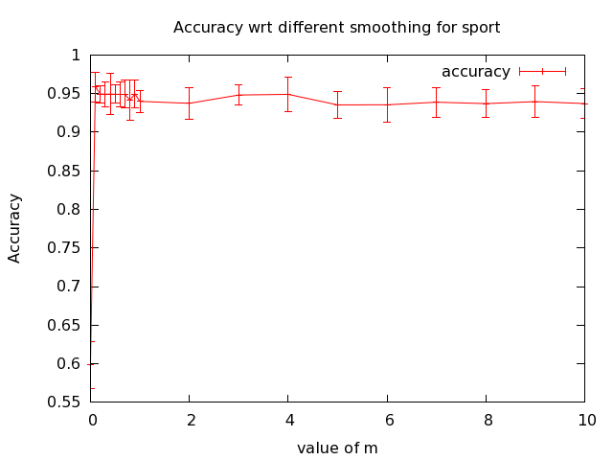
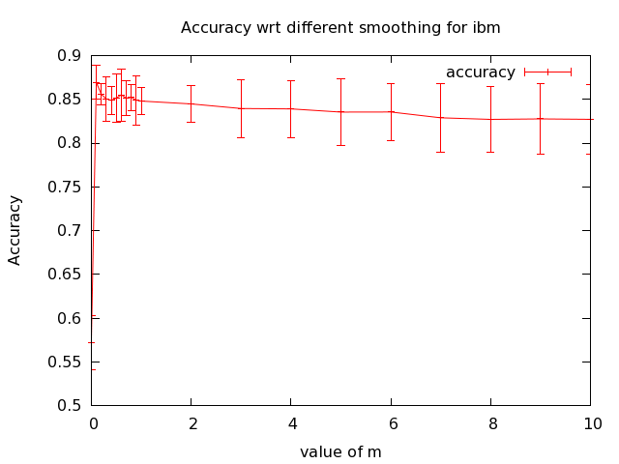

Discussion:
As long as we smooth our prediction, the accuracy is always as good as we expected.

